Massachusetts Institute of Technology
Department of Urban Studies and Planning

11.188: Urban Planning and Social Science Laboratory

11.520: Workshop on GIS (2nd half-semester)

Lab Exercise 7:
Webscraping using R

April 7, 2019

Aims of this lab
- Learn how to merge various datasets to analyse a rich urban problem or phenomenon
- Use APIs to scrape data from a website
- Consider the value and limitations of using data not created for the express purpose of research
- Gain experience with collecting your own data through fieldwork

Scraping Data
Often, information is available online, but not in publicly accessible datasets or in easily analyzable formats. Web scraping allows you to extract information and from websites and store it in a useable way. You can scrape data from websites like Zillow, Google Places, Tripadvisor. In some cases, website owners provide application programming interfaces (APIs) that establish a protocol for requesting batches of information from the website.
In our case, we will use Yelp APIs to identify points of interest within the Cambridge squares that we will visit during our field work trips.
There are a myriad of programs you can use to access APIs such as Yelp’s, but we’ll use a specific R library in this lab.
R is a powerful and popular open-source suite of statistical tools that supports many freely available software ‘libraries’ to assist in web scraping, data parsing, and outputting of data in standard formats that can be read by GIS and data analysis software.

Initialize R document
To facilitate your use of R, we will use a ‘wrapper’ called Rstudio and we provide you with an R script that is set up to extract data from Yelp using their application programming interface (API) protocols.
We start our R script by installing a ‘library’ as a ‘package’. These are basically a list of pre-programmed functions written by the R community (even you can write one!) to easily help us undertake computation we otherwise would have had to create code for from scratch
For this lab we’ll install two libraries: ‘devtools’ and ‘yelpr’.
To start the document we’ll need to set up our working directory space. These initial instructions differ if you’re using CRON machines or your own laptop due to write access issues in CRON machines, but the rest of the code is the same.
If you’re using CRON (Windows) machines follow these instructions:
REMEMBER YOU DO NOT NEED TO DONOT NEED TO RUN THIS FIRST BLOCK OF COMMANDS IF YOU ARE USING R STUDIO ON YOUR OWN MACHINE
OPTION A FOR CRON MACHINES
First go to your C: drive and create a folder called ‘rlib’. Then start Rstudio and run this code:
#Set your working directory to C:\Temp
setwd("C:\\temp\\rlib")
#change default folder to 'write' the packages to C:Temp
.libPaths( c( .libPaths(), "C:\\temp\\rlib") )
.libPaths()
#install devtools specifying directory location
install.packages("devtools",lib="C:\\temp\\rlib")
#run commands to download and install the yelpr library directly from its github repository
devtools::install_github("OmaymaS/yelpr")
OPTION B FOR PERSONAL MACHINES
If you’re using your personal machine, start Rstudio and follow these instructions:
Since you have write-access to R’s default workspace folder in your C drive, you can go ahead and install the following packages if you haven’t done so already:
#Find where R is storing this file and any output you produce later on
getwd()
#install devtools
install.packages("devtools")
#run command to download/install yelpr library directly from its github repository
devtools::install_github("OmaymaS/yelpr")

We can now initialize our R session by telling R to ‘attach’ certain libraries to this session, since we will be making use of functions in them.
Downloading and installing the libraries using either Option A or Option B needs to be done only once on one machine. During subsequent sessions using R on the same machine, you can begin with this next portion of the script to utilize the already-installed libraries.
#initiate library devtools
library("devtools")
## Warning: package 'devtools' was built under R version 3.3.3
#initiate library yelpr
library(yelpr)

Set up API Key
To scrape data from public websites we often make use of something called an API. APIs are interfaces that allow different software to talk to each other. In this case, an API will allow R to talk to Yelp’s data server and make a request for specific data based on the parameters that we provide. In response Yelp’s server provides an XML tagged list, which we then ‘translate’ into a format suitable for manipulation in R so that, eventually, we can write the data into a text file that can be viewed in a spreadsheet, ArcMap, and other applications.
To make this call we need something called an API key. This is a form of identification provided by the websites we are accessing like Yelp, so that they can keep track of the calls we make to their server.
To obtain our unique API key, we will go to Yelp’s developer section: (https://www.yelp.com/developers/documentation/v3/authentication), and request an API Key for Yelp Fusion API. This API key is a long string of characters that is unique for you and must be inserted into each of your requests for data from Yelp.
The first step is to create an ‘app’ for yourself. You may be asked to log in or create a Yelp account before you are allowed access to the App creation page shown below.
The App creation Yelp page may look something like this:
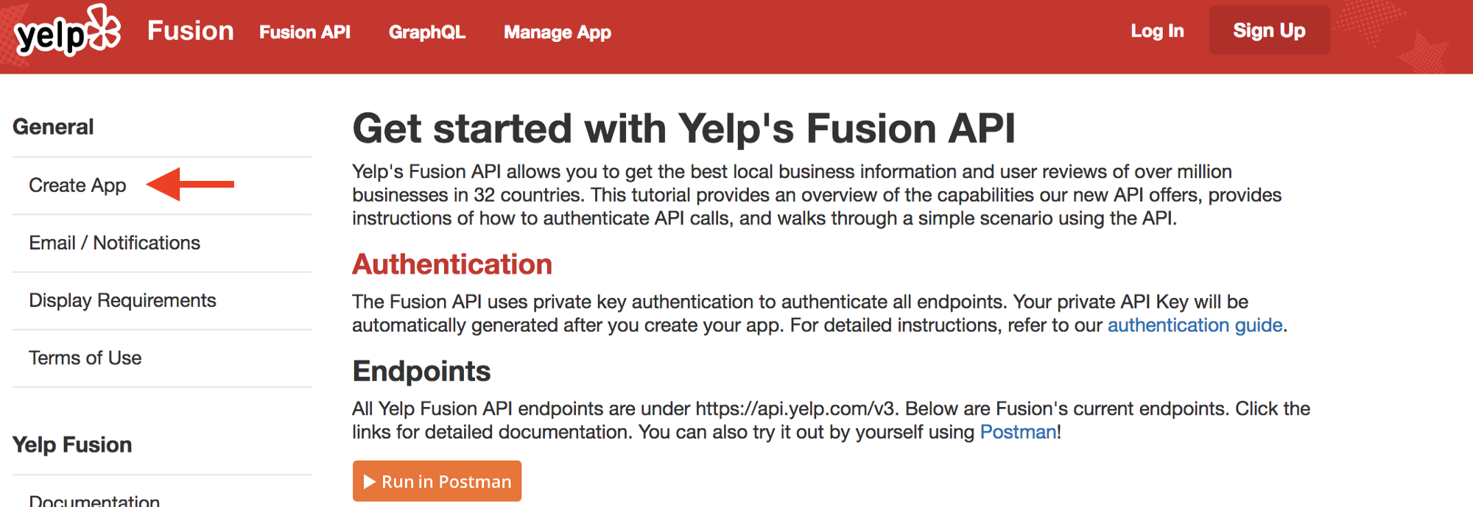
When you first sign up, you will receive an email link that must be clicked to verify your account. Once activated, you must return to this page to create your own ‘app’ and, then, your API key and Client ID will be displayed of the top of the Yelp page.

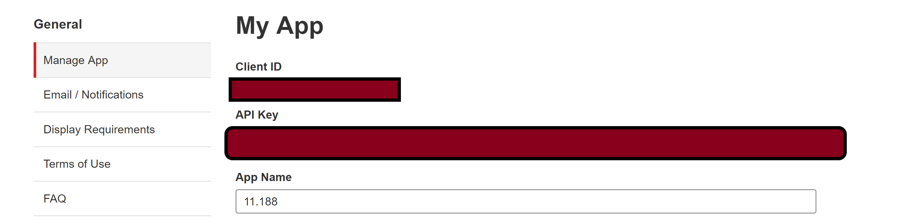

This API Key is your own personal identification. Do not share this key with anyone outside your group, because each key has a limited number of ‘calls’ to the server it can make. You don’t want to blow through your calls (though for this lab that is unlikely to happen)
Now that you have your key we are ready to get started.

Making calls to the Yelp server for data
We start our script by defining some parameter variables. This basically means we are telling R that there are some parameters like location, search radius etc. we would like to define our search with just like putting keywords in a Google Search.
It is handy to define these at the start as ‘variables’ which you can then refer to throughout your document. This way if you need to change something you can do so in one place.
In this case we will search within 400m of Kendall Square T stop’s location for the term ‘food’. An easy way to get the lat/lon of the T stop is to use maps.google.com to view Kendall Square, then right-click on the station stop, and select ‘What’s here’.
There are other ways to find lat/lon values and we can discuss them later.
Remember anything within single quotes (‘ ’) or double quotes (" “) will be treated as character strings, while objects without quotes will be treated as variables or integers. You can comment your code by using # to have the rest of that line ignored by the script, or you can enclose multiple lines of text within double quotes (” “), as long as the same quote character is not included in the intervening lines.
key<- 'Insert your API Key within these quotation marks' #insert API key
keyword<- 'food' #term to search for
lat<- 42.362491 #latitude of your location
long<- -71.085577 #longitude of your location
rad<- 400 #radius of search in meters
limit<-50 #the number of results on one page you would like to see. The max for one page is 50
Now that we have defined the variables we will use, we are ready to discuss our basic script to search Yelp API for all businesses that are tagged with the word of your choice within 400m of Kendall Square. Up to 50 entries will be returned from a single request. You can… You can search for food or restaurants to see the difference.
The function called business_search() uses the ‘yelpr’ library to request information about all businesses close to the lat/lon that you provide. Since we need to store our results for later use, we save the XML-tagged data returned by Yelp into a temporary dataframe and call it ‘results’. The ‘<-’ notation in R is used to indicate that whatever is returned from Yelp will be saved into an R dataframe to which we assign the name ‘results’.
results<-business_search(api_key = key,
term = keyword,
latitude = lat,
longitude = long,
radius=rad,
limit=limit)
## No encoding supplied: defaulting to UTF-8.
The line beginning with ‘##’ is a message to you from R. It indicates that R will use the default UTF-8 specification for character encoding when interpreting the data in your new dataframe. You may ignore this warning.
The portion of the data returned from Yelp that we want to keep is tagged as ‘businesses’. We can reference that portion of our ‘results’ dataframe by using the notation:
results$businesses
We can now store this component as a new dataframe that will be easier for us to manipulate.
res_store<-results$businesses
Lets look at the first 5 rows of the res_store dataframe we just created to get a better sense of what data we’re dealing with. Notice the notation. When you add brackets, [ ], next to the name of a dataframe that means you would like to point towards specific rows or columns in the dataframe.
res_store[1,] #first row of res_store
## id alias name
## 1 wrMG0WYZKIZX9Zp30kCFGA clover-food-lab-cambridge-8 Clover Food Lab
## image_url
## 1 https://s3-media4.fl.yelpcdn.com/bphoto/1FZMdYFh3t12_6RzEKnusQ/o.jpg
## is_closed
## 1 FALSE
## url
## 1 https://www.yelp.com/biz/clover-food-lab-cambridge-8?adjust_creative=Iu_wBl8JK0u_dhtjknjLOg&utm_campaign=yelp_api_v3&utm_medium=api_v3_business_search&utm_source=Iu_wBl8JK0u_dhtjknjLOg
## review_count
## 1 261
## categories rating
## 1 sandwiches, cafes, newamerican, Sandwiches, Cafes, American (New) 4
## coordinates.latitude coordinates.longitude transactions price
## 1 42.36026 -71.08655 $$
## location.address1 location.address2 location.address3 location.city
## 1 5 Cambridge Ctr Cambridge
## location.zip_code location.country location.state
## 1 02139 US MA
## location.display_address phone display_phone distance
## 1 5 Cambridge Ctr, Cambridge, MA 02139 147.2364
‘res_store’ dataframe is basically a spreadsheet table where each row has the same structure and the columns contain numbers or strings with various meanings. Here are the commands to examine just the first column, the first row, the first five rows, etc.
res_store[,1]#first column of res_store
res_store[1,1]#first row, first column
res_store[1:5,] #first 5 rows of res_store
However notice how many unneccessary columns we have which we dont need for our analysis. So we can tell R to recreate our dataframe with just the columns we need.
res_neat<-res_store[,c("name","review_count","rating","price")]
Lets look at the first 5 rows of this new dataframe now
res_neat[1:5,]
## name review_count rating price
## 1 Clover Food Lab 261 4.0 $$
## 2 CAVA 17 4.5 <NA>
## 3 Tatte Bakery & Cafe 508 4.0 $$
## 4 Vester 34 4.0 <NA>
## 5 Dumpling Daughter 60 3.0 <NA>
That looks better, though we do need important location information which we didn’t include! If you look at the original dataframe res_store we can see location and coordinate information stored, though column names have a period (.) in the middle: e.g., coordinates.longitude
This indicates that these are stored in a subsection of the original list that we can access directly.
coord<-results$businesses$coordinates
add<-results$businesses$location$address1 #accessing the column address1 stored in table location, stored in the businesses component of 'results'
We can now merge all these columns together in one final dataset through the command cbind which adds columns to datasets.
yelp_data_combine<-cbind(res_neat,coord,add)
yelp_data_combine[1:5,]
## name review_count rating price latitude longitude
## 1 Clover Food Lab 261 4.0 $$ 42.36026 -71.08655
## 2 CAVA 17 4.5 <NA> 42.36321 -71.08796
## 3 Tatte Bakery & Cafe 508 4.0 $$ 42.36492 -71.08267
## 4 Vester 34 4.0 <NA> 42.36186 -71.08831
## 5 Dumpling Daughter 60 3.0 <NA> 42.36186 -71.08831
## add
## 1 5 Cambridge Ctr
## 2 82 Ames St
## 3 318 Third St
## 4 73 Ames St
## 5 73 Ames St
You’ll notice though that our results were limited to ‘’50’ rows. This did not pose a problem with this particular exercise since we only seemed to have 42 results but could be a problem with other places which are more dense. So for that, we would need to insert something called offset which is a way to tell the Yelp API to basically turn the page. If our limit (i.e. page size) is 50, we would add an offset of the same size, until we reach the end of our search, or return 1000 results (which is the maximum allowed by Yelp for one search of their API).
However, for larger searches constantly adding offset then saving it in a dataset, then doing it all over again and again would be cumbersome. So we can write a loop which would ask R to extract data from Yelp in batches of 50, and store them in a dataset till we get an empty call or hit a 1000 results.
So lets try that.
We are writing a ‘for’ loop which assigns ‘offset’ a value everytime it runs. The seq function defines (start value, end value, increment) so offset would be 0, 50, 100, 150 etc. till we hit an empty call or a 1000 searches. In our case we will hit an empty call right after the first call has been executed.
Notice that within the for-loop we have nested an if-statement, which will continue to add more data to our dataset until temp$businesses does has a length of 0
loop_yelp<-data.frame() #creating an empty dataframe
for (offset in seq(0,1000,50)) {
#temporary storage container for our call to the server
temp <- business_search(api_key = key,
term = keyword,
latitude = lat,
longitude = long ,
radius=rad,
limit=limit,
offset=offset)
#use if statement to execute the next part if temp$businesses is not empty
if (length(temp$businesses)!=0) {
#store results of call in a dataframe called temp1
temp1<-temp$businesses
#select columns we want
temp1<-temp1[,c("name","review_count","rating","price")]
#retrieve coordianates and address
geom<-temp$businesses$coordinates
add<-temp$businesses$location$address1
#bind columns together
merge<-cbind(temp1,geom,add)
#append rows generated by the loop to the loop_yelp dataframe
loop_yelp<-rbind(loop_yelp,merge)
}
# you are done when you get this far, so break out of the loop
break
} # end of the outer 'for' loop
We can now compare both datasets: the one we got with the loop and without the loop. One way to do this is check their ‘dimensions’. In this case since we had less than 50 results to scrape, the datasets both would be the same:
dim(yelp_data_combine)
dim(loop_yelp)
You can now save your final dataframe in a comma separated value (CSV) format.
write.csv(loop_yelp, file = "Yelp_kendall.csv")
Your file will be saved in your working directory. If you are not sure where this directory is located, type the command getwd() to display the path. If you want to change the working directory location, use the setwd() command.

Displaying results in ArcMap
So far in class we have only used pre-made shapefiles to display point data. However, you can create your own shapefile as long as you have lat/long data available.
- Inspect your newly created csv file.
- Make sure the longitude (X) and Latitude(Y) columns are formatted as NUMBER, with a minimum of 8 decimal places.
- Highlight the latitude/longitude columns and click on the menu option which reads ‘General’ as shown below:
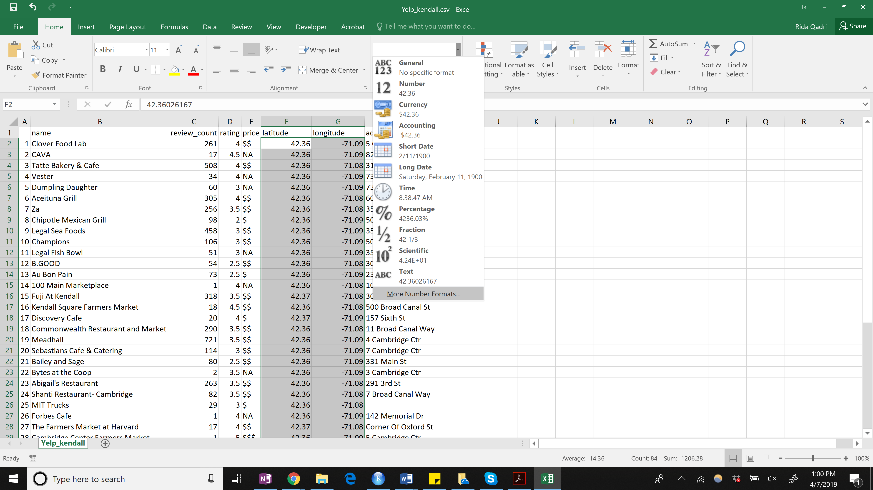
- From the dropdown list, select More Number Formats
- Choose the Number format, and increase decimal places to 8 as shown below: 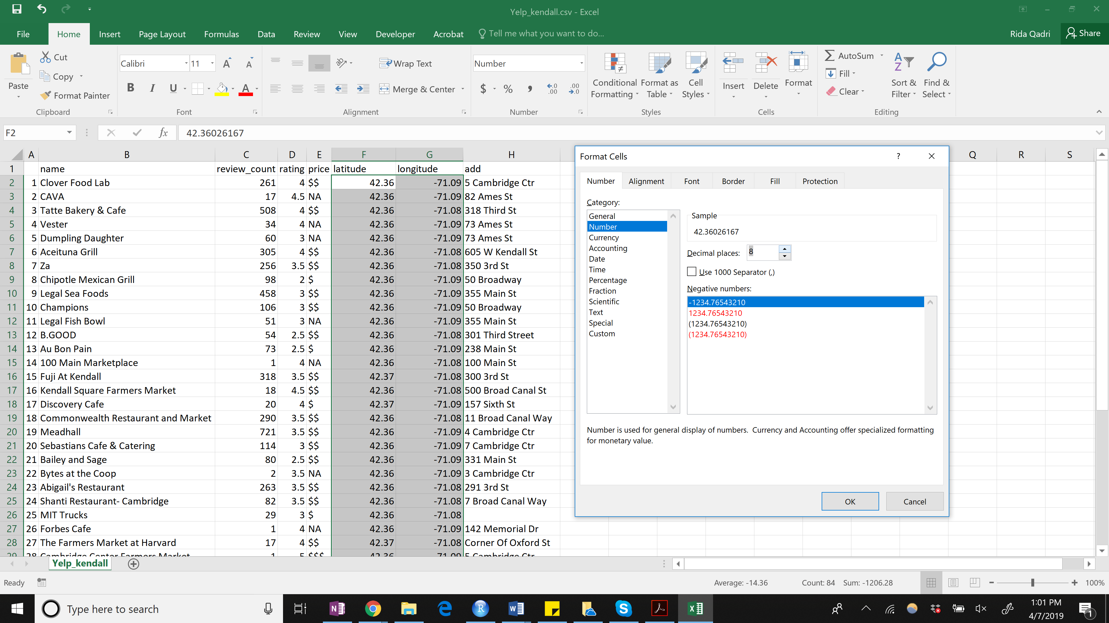
- Save your file as an .xlsx workbook to preserve formatting
- Now open a new session of ArcMap and add a Cambridge shapefile (blockgroup level or just the boundaries) in to ArcMap
- Now add your Yelp_Kendall excel file into the session.
- Right click on the newly added table and select Display XY Data
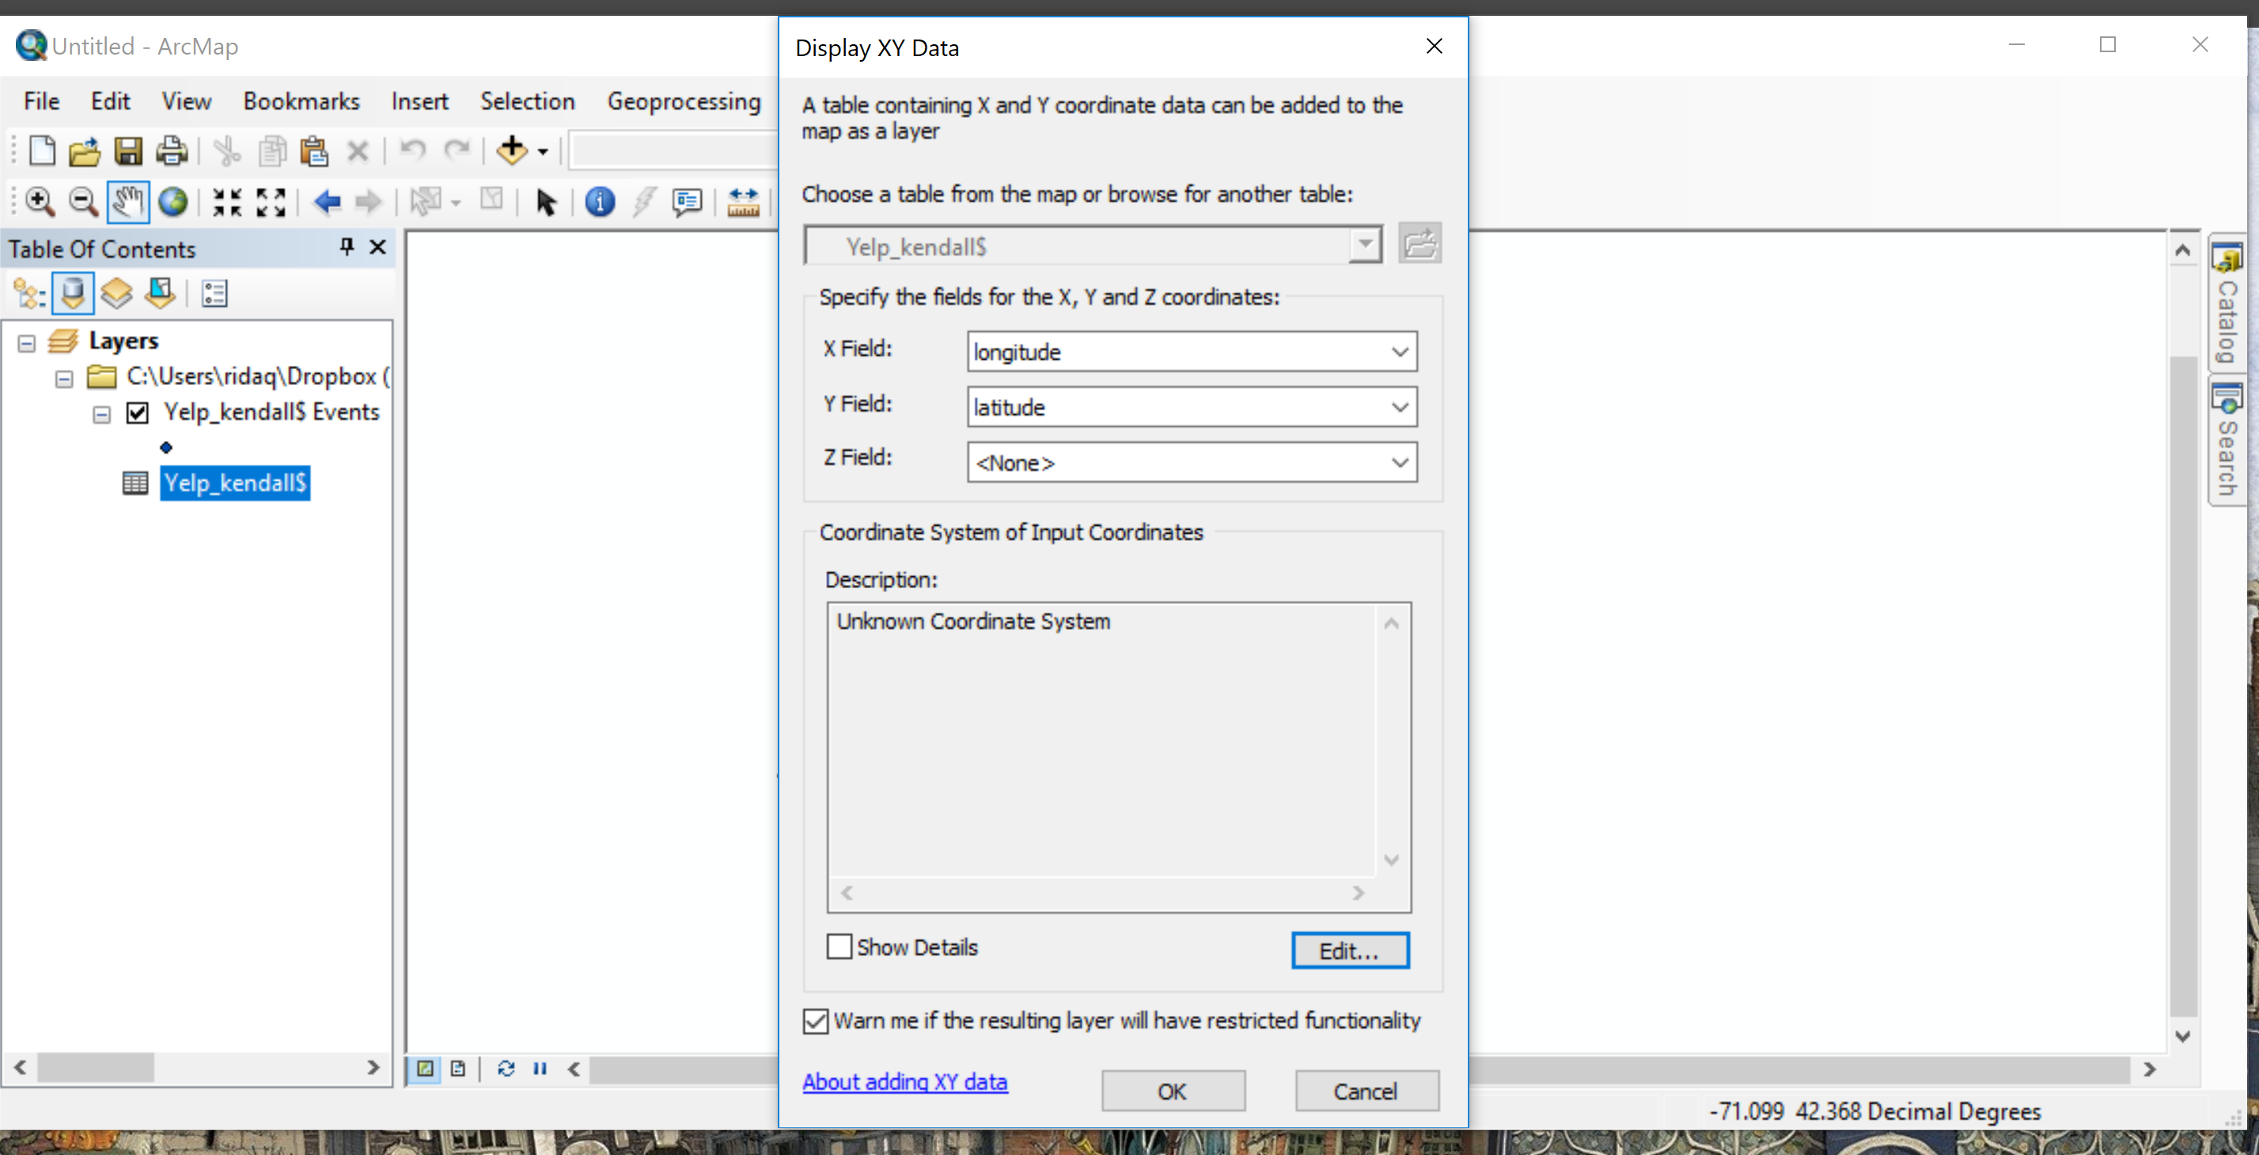
- Check that X is set to longitude and Y is set to latitude.
- To tell ArcMap where you would like to place the point data on the map, we have to identify the spatial reference system of our X/Y points.
- Click the Edit button under Coordinate Systems of Input Coordinates
- Navigate to Geographic Coordinate Systems–> World –> WGS 1984
- Set this as the coordinate system of the point data layer
- Check that your points are displaying correctly on your Cambridge shapefile
- The newly creaed $Events layer is *not* a shapefile however, and cannot be used for analysis.
- To create a shapefile out of this layer right click on Yelp_kendall $Events, select Data Export Data and save your layer data as a shapefile.
- Add it back to your map
- You can now run analysis on this shapefile

Your Task
We have given you the script for scraping restaurant data in Kendall Square. You should now change the script to search for restaurants in the area you have been assigned and analyze the data. Think about how you would do this.
Each group should submit one lab report, listing names of each group member as well as each person’s primary contribution to the report.

Part 1: Analyzing the data (Due Wednesday, April 17)
- Note the number of restaurants in your area.
- Note the average user rating for all restaurants in the area
- Note the average price level
- Also create a frequency table of :
  - Number of restaurants in each price category
  - Number of restaurants for each ‘rating’ level
- Use the csv created through the exercise to create a map of the restaurants:
  - Show one map with restaurants classified by price level
  - Show one map with restaurants classified by user ratings
  - Notice any clusters in terms of location of restaurants, price and user ratings.
- Now we would like you to think about whether the presence of certain kinds of commercial consumption opportunity can indicate something about neighborhood quality. Given what you have seen regarding quality and price of restaurants from the data, write down some preliminary hypotheses of what you think the overall neighborhood quality is and how it would vary street to street in the 400m radius we have given you.
- Note down the markers of neighborhood quality that you feel are relevant. These may include for instance:
  - Greenery
  - Street furniture presence and maintenance
  - Quality of street/roads
  - Building maintenance level
Submit Task 1 in ONE document with your group members names and their primary contribution to the report by Wednesday, April 17 before 2:30PM

Part 2: Fieldwork and Data Collection (Due Monday, April 22)

  - Follow the instructions for fieldwork we have sent you (Lab7-Fieldwork.pdf) to collect data on neighborhood quality in your assigned area.
  - Once your data collection is done, we will send you your records as a shapefile. Create one map with your photos and the restaurant data.
  - Now that you have created your maps and done fieldwork answer the following questions:
    - Reflect on the characteristics you chose in Q7 of Part 1. Were they mostly about urban form? Or were they about more social variables?
    - Note your impressions of the neighborhood. Consider whether the characteristics you had decided were important for neighborhood quality in Q7, were really relevant for your visit or not?
    - Were your preliminary hypotheses of the neighborhood quality correct?
    - Is this neighborhood quality uniform across the 400m? Where does it change?
    - Is there a relationship between higher priced or higher quality (as defined by user reviews) restaurants and neighborhood quality as your scored it?
    - How could we quantify or operationalize neighborhood quality using the data you have collected? What other datasets could we add to make this measure richer?
    - How did the evaluation of neighborhood quality vary for different people in your group?

Submit Part 2 by Monday, April 22 before 230PM

Last Modified on 7 April 2019 by Rida Qadri
Back to the 11.188 Home Page.
Back to the CRON Home Page.

