NAME: ___________________________

12.001 QUIZ 1: ROCKS AND MINERALS
FEBRUARY 29, 2008

ANSWER ALL QUESTIONS IN THIS QUIZ BOOKLET AND HAND IN NOTHING BUT THIS BOOKLET.

YOU HAVE UNTIL 1:55 TO COMPLETE THIS QUIZ.

Minerals ___/25
Rocks ___/40
Definitions ___/20

Question 1 ___/10
Question 2 ___/10
Question 3 ___/10
Question 4 ___/10
Question 5 ___/10
Question 6 ___/10
Question 7 ___/10
Question 8 ___/10
Question 9 ___/10
Question 10 ___/25

Total ___/200
Part I: Identification of Rocks and Minerals

You have 5 mineral specimens and 8 rocks to identify and describe. Samples will be spaced around the room for you to quietly go to and study. Budget your time between the samples and other test questions.

Minerals (25 pts): Write the name of the mineral (2 pts), any important distinguishing features (1 pt), and its compositional formula (2 pts).

If you’re not sure about a sample, write down your observations and what you do know for partial credit.

Be sure to write in the correct field! Match the sample number to the number on your sheet.

 | Mineral Name | Features | Formula
1
2
3
4
5

Rocks (40 pts): Identify whether the rock is igneous, metamorphic or sedimentary (2 pts), write its name (1 pt) and make observations: list any important features or minerals you can identify (2 pts).

If you’re not sure about a sample, write down your observations and what you do know for partial credit.

Be sure to write in the correct field! Match the sample number to the number on your sheet.

 | Ig./Meta./Sed. | Rock Name | Observations/Minerals/Features
1
2
3
4
5
6
7
8
Part II: Definitions (2 Pts each)

- Any single large crystal set in a groundmass of much finer crystals in an igneous rock:

- Two names for kinds of igneous rocks derived from lava poured out or ejected onto the earth's surface:

- Igneous texture referring to relatively large isolated crystals in a mass of fine texture:

- The original rock from which a metamorphic rock was formed by metamorphism:

- Descriptive term for the way obsidian fractures:

- Layering of metamorphic rocks caused by the parallel alignment of minerals:

- Characteristic of sedimentary rocks in which parallel planar surfaces separate layers of different grain sizes or compositions deposited at different times (several terms are possible here):

- The igneous rock most often formed at midocean ridges:

- List three minerals that are formed by the evaporation of sea water:

- List four features of a rock that show definitively that the rock is sedimentary:

Part III: Short Answer (10 pts each, except question 10, which is 25 pts)

Be concise. You may answer in very short paragraph or outline form. You may include drawings. Use only the space provided in the box below each question.

Question 1: What is a mineral?

Question 2: For two silicate minerals of your choice: Explain how crystal form and cleavage relate to silicate crystal structure.

Question 3: List the eight most common mineral-forming elements and their most common ionic charges.

Question 4: What is the age of the Earth? How do you think we know it?

Question 5: Why do volcanoes commonly occur over subduction zones?

Question 6: Label the vertices with the three end-member feldspar names and chemical compositions. Label the plagioclases. Draw two sets of phase boundaries: One for high temperature, and one for low temperature.

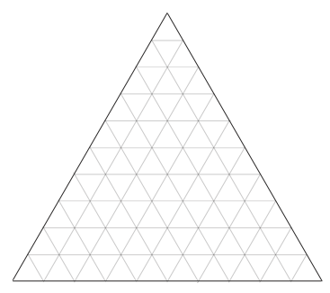

Question 7: Draw Bowen’s reaction series for igneous rocks. Include as many specific temperature, mineral names, and compositions as you can.

Question 8: Explain how silica content of the remaining magma changes throughout Bowen’s reaction series, and explain why the reaction series probably does not explain the prevalence of granite in the crust.

Question 9: Explain how fossils may be used to determine relative rock ages, and explain what is used to determine absolute rock ages.

Question 10: This is a cross-section of the Earth. Along the vertical axis label the depths of the boundaries. Along the bottom, name the layers. Inside the diagram, indicate whether each layer is solid or liquid, and say something about composition.

