Using Stata’s Windows Interface from Home
- Install X-Win32 2012 from http://ist.mit.edu/xwin32/2012/win
  - Make sure you click through to license key so that you can enter the key when prompted.
- Install SecureCRT
To Run Stata for Windows Users
- Open X-Win32. Do not start a new session. Win32 is running if there is a blue and white icon at the bottom right of your screen.
  - The first time you open X-Win32, you’ll be prompted for an activation key. You can get that key by clicking on a link from the download page, or by using this link: https://web.mit.edu/software/mit/licenses/xwin32-2012readme2012.txt
- Log into Athena using SecureCRT.
  - Click on the Options tab at the top of the screen.
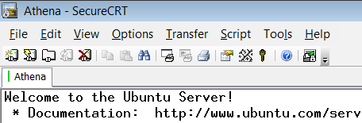
  - Select Session Options.
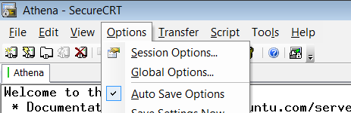
  - When the Session Options window opens, click on Connection > Port Forwarding > Remote/X11.
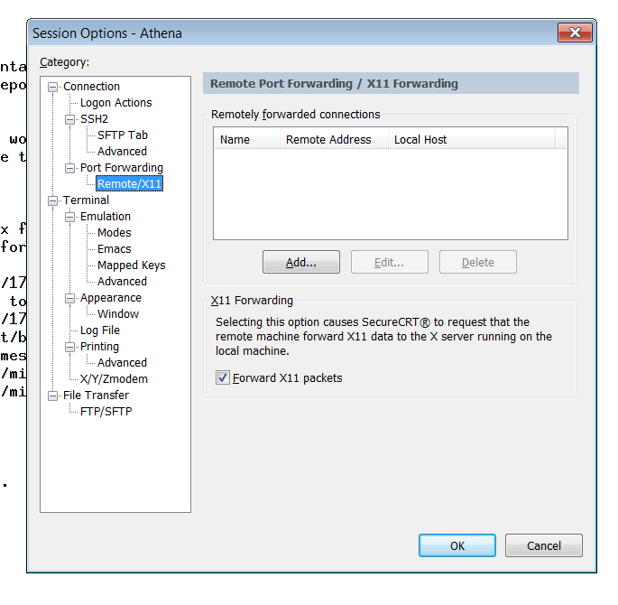
  - CRUCIAL STEP: make sure the box next to “Forward X11 packets” is checked. (This is what enables windows to appear on screen.) You can also make this change by going into settings once already logged into Athena. You will need to restart your Athena session for the change to take effect.
- Once in Athena, type the following
  - add stata
  - xstata & (If you set everything up correctly, Stata should open in a new window)
File-Sharing
- All files will need to be saved to your Athena folders.
- Please download SecureFX and configure it for Athena as well
Mac Instructions
- If you have a Mac, open the “X11” application in Applications/Utilities. It comes with the OS, so you don’t need to download anything new. (Unless you have OS 10.3, then follow instructions on http://kb.mit.edu/confluence/pages/viewpage.action?pageId=3907239)
- Type “ssh -Y username@athena.dialup.mit.edu”
  - Be sure that the “Y” is capitalized. It won’t work otherwise.
  - You will then be prompted for your password
- When you get the Athena prompt, type
  - add stata
  - xstata

