2A Thesis Proposal

This Document is a Template for a 2A Thesis Proposal. Replace this paragraph with a Focused Thesis Proposal Title, e.g. not “A Study of Jerk,” instead “A Simple Algebraic Model of Load Rate during Arrest of a Falling Climber.” Be sure to include a specific, “verb-like” word to indicate exactly what you are doing, for example: measure, design, construction, model, prototype, optimization.

Your big name in lights,
and maybe even your e-mail address.
(E.g. Dave Custer, custer@mit.edu)

Your thesis advisor’s name
and contact info
(email, MIT inter-departmental mail address)

Summary: Include a one paragraph summary of your project. Include problem, motivation, and methods information. Avoid context/background information; stick such info in the introduction. Near the end of the summary, hint at the utility of your proposed work. E.g. “Because the strength of ice anchors is, in part, a function of the strain rate of the applied load, the jerk of the decelerating climber affects anchor strength; higher jerks reduce the anchor strength. To provide a rule of thumb estimate of the jerk imparted to a climbing anchor during fall arrest, this thesis develops a simple, algebraic formula for jerk that is based on energy conservation of the potential energy of the falling climber before the fall and the spring energy that has been imparted to the rope at the end of the fall. The resulting formula will be couched as “the jerk factor,” which in combination with the fall factor can provide ice climbers with an indication of the severity of a fall. The research requires a bazillion dollar expense account in the Cayman Islands and will be completed by either May 2007 or a few months after my suntan is fully developed.”
Introduction:

Start your introduction with a phrase that precisely identifies the problem you are solving or the tidbit of information you are setting out to find. Doing so puts your work in the most significant stress position of the document. Use your pithy problem statement to lead direction to context information at the level of your work. If you are inventing a medical device to keep artificial heart valves clean, develop the importance of clean heart valves first and bury the worldwide incidence of cardiovascular disease in a position of low stress.

Instead of:
“Heart disease is the leading killer of people worldwide [1].” => “A medical device that would keep artificial heart valves clean would be a good thing.”

focus the thesis on the thesis topic rather than the context:

“Blood clot formation is the most significant limitation to the use of artificial heart valves.” => “Artificial heart valves are a leading cause of heart disease, the leading killer of people worldwide [1].” => Back to your (general) problem—keeping artificial heart valves free of blot clots.

Develop your “problem.”; details might include context, motivation, general problem, specific problem. At the end of the introduction, hint at your solution.

Change your header and footer info from MSWord View>Header & Footer

Background:

Your background is an overview of other work that has succeeded, especially similar problems, similar solutions, and models of how things should be.Use subheadings to introduce your structure here (you might also want to do so in the introduction).

Subheadings:
Pick a structure that permeates your thesis and indicate the structure with subheadings. If you think italics are a geeky way to indicate a subheading, feel free to delineate subheadings via font size change (Heading => Subheading) or a numbering scheme (1 Heading => 1.1 Subheading). Some folks find the colon at the end of the heading/subheading to be redundant; I happen to like the colon but realize this penchant is a personal foible.

Some stray thoughts on font:
I’m using Times New Roman here because it is boring. I discourage the use of any exciting font for your thesis proposal. If you are picky about fonts, pick one that is easy to read. American readers like serif fonts. (European readers are a little more tolerant of sans-serif, though the small letters here are too tall for anyone to read very far in this font.) Pick a font that is a little bit stuffy; after all, the thesis proposal is a formal document. 12 points is about the right size for a wide page; I don’t recommend breaking your page into columns as many journals do to reduce the font size and crank up the information density. Google (scholar) HOW TO USE FIVE LETTERFORMS TO GAUGE A TYPEFACE'S PERSONALITY: A RESEARCH-DRIVEN METHOD by Jo Mackiewicz for a short overview of font choice criteria. Don’t lose sleep over font choice.
How I like to do figures and tables:
I encourage you to include graphics to support your arguments.

Below are some examples of how I like to do tables and figures (Table 1 and Figures 1 & 2). I like keeping the figure/table caption/heading together as part of a table. To do so, I get rid of the lines on the cell that contains the heading/caption. Mouse on Table, Table Properties, Borders and Shading, Borders, point and click a few times until you get the hang of it.

I keep the figure/table from splitting across page boundaries by selecting the table, Format>Paragraph>Line & Page Breaks> Keep with Next.

Oh, and be sure to cite your figure source if you are not the source of the figure. This citation is particularly important because one cannot put quotation marks around figures to indicate the difference between precise quotation and paraphrasing. If you are “quoting” a figure, say “from reference X”; if you are “paraphrasing” a figure, say “adapted from reference X” or “based on reference X.”
Table 1 Equipment Strength Bands Based on Situation (used by permission of me)
Strength Rating (F_{max}) | For Belay Anchor | For Running Anchor
F_{max} ≥ 20 kN  e.g. Bolts and Carabiners Closed Gate/Long Axis | If Used Correctly (IUC), will hold. | IUC, will hold.
20 kN > F_{max} ≥12 kN  e.g. Most Cams and Nuts | IUC, will hold. | IUC, will hold, presuming a dynamic belay.
12 kN > F_{max} ≥ 7 kN  e.g. Smaller Cams, Nuts, and Open Gate Carabiners | Sketchy, even IUC. Requires additional, equalized gear | IUC, usually holds, presuming a dynamic belay. Will NOT hold severe falls.
7 kN > F_{max} ≥ 3 kN  e.g. Twinkie Cams and Small Nuts | Not suitable. | Even IUC, cannot be relied on. May hold benign falls. Best to backup and/or equalize.
3 kN > F_{max}  e.g. Ice Ax Picks and Thin Aluminum Rappel Rings | Extremely most not suitable. | Surely will NOT hold a fall. For upward progress (aid) only—or maybe rappelling.

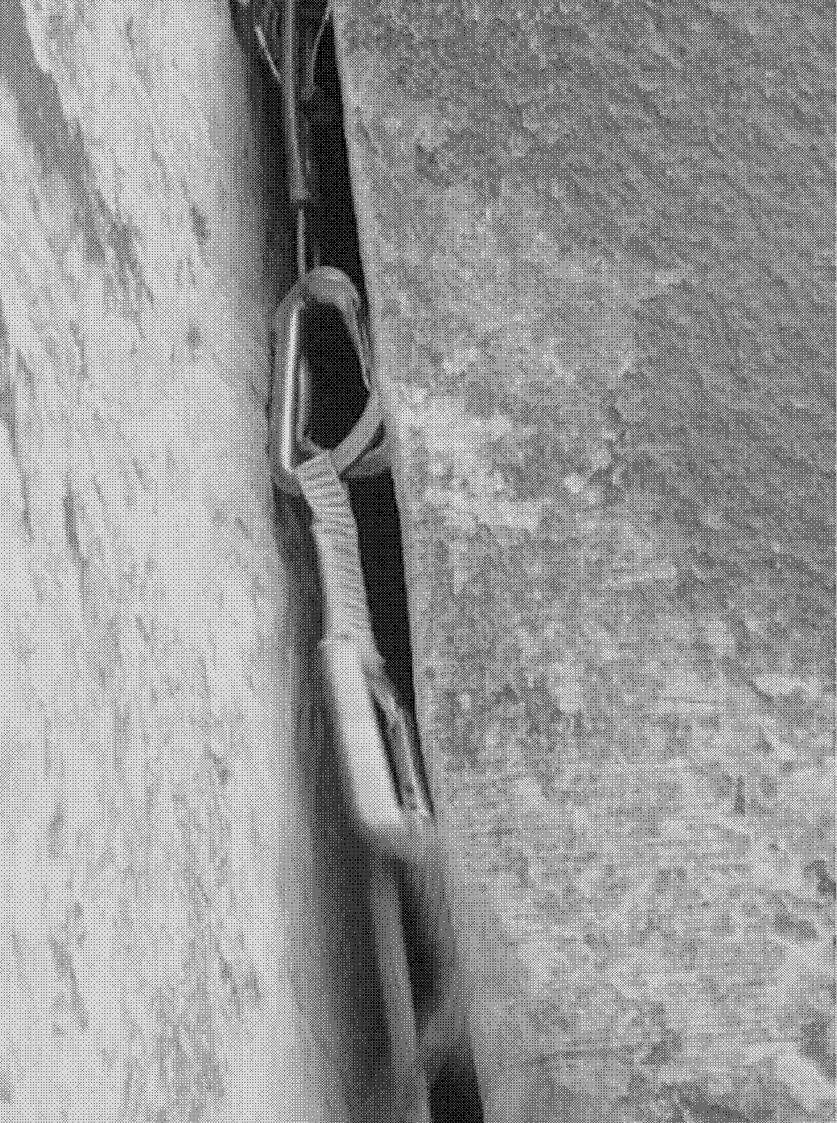 | 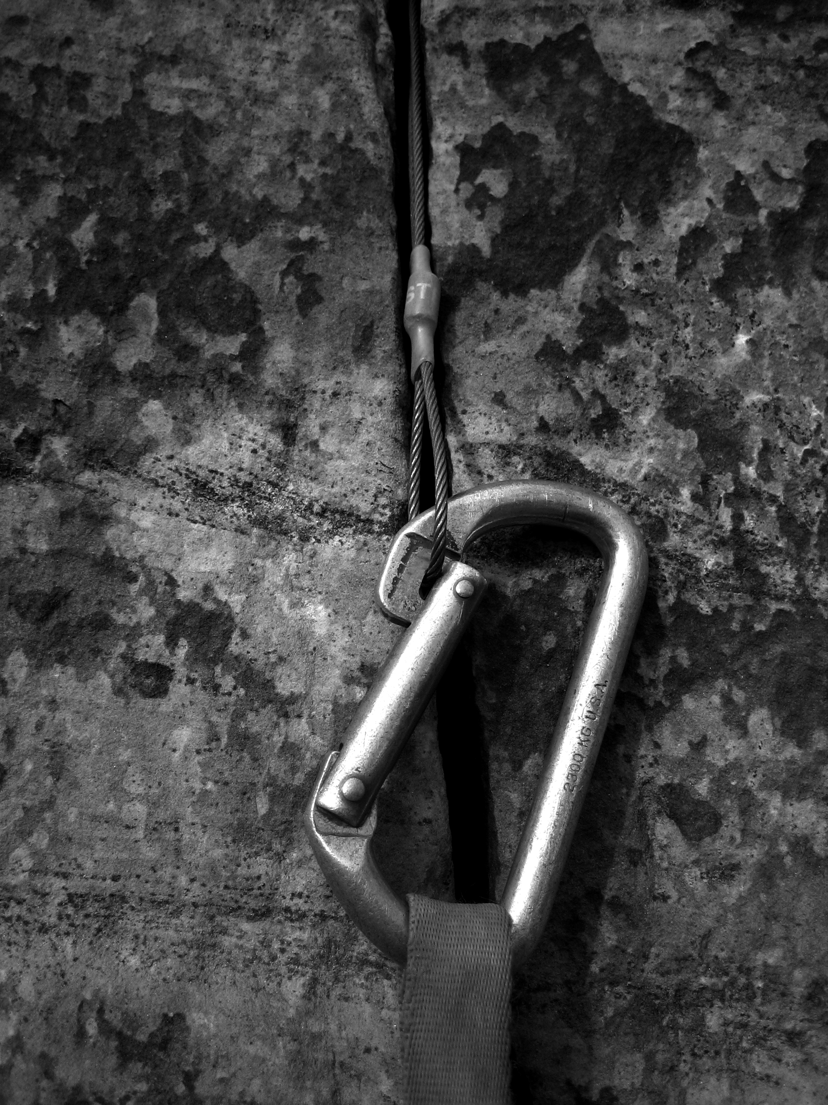
Figure 1 Video clip frame of a carabiner gate rubbing against a crack edge during a simulated fall. (stolen by my permission from an article that I wrote for the American Alpine Club) | Figure 2 Carabiner gate notch caught on gear. (again, this figure is already mine, so I don’t have to say that it is shamelessly stolen from myself….)

How I like my equations:

Different specialties have different expectations of equations. As a first pass, recognize how equations are used by the folks in your field. As a second pass, realize that readers switch from “text mode” to “equation mode” with great difficulty. Most readers skip the equations embedded in text unless the equations are very common or easy to see. For example, everyone can handle the fact that 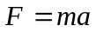without too much trouble. And Newtons law (Equation 1) would be pretty easy to understand.
(1)
But many folks would have heavily glazed eyes looking at Equations 2 through 6, even if I had an argument that the reader could follow, and even though this equation layout is the norm for many publications.
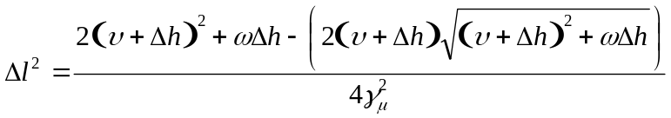 (2)
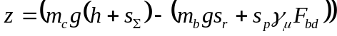, 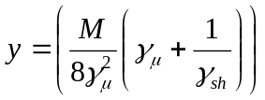 (3)
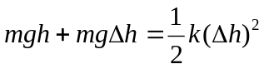 (4)
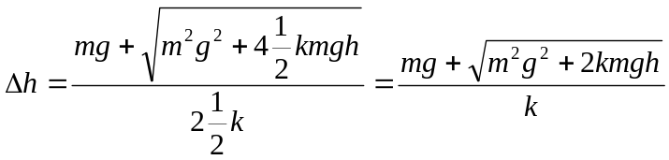 (5)
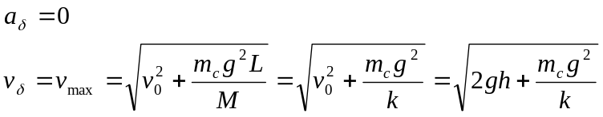 (6)

When writing for less mathematically inclined folks, consider thinking about your equations as if they are figures. Doing so forces you to develop an argument in the text and may keep some readers from getting lost switching between text and math modes. For example:

The stiff rope model of EAS performance compares the energy of EAS deployment to the additional potential energy (PE_{clmber}) gained by the climber as the EAS deploys; the algebra is developed in Figure 3. The EAS energy absorption comes in two forms: opening of the EAS (U_{EAS}) and friction heat (U_{μ}) due to the rope being pulled over the carabiner. The difference (ΔU) between the EAS deployment energy and the climber’s additional potential energy represents the net energy absorbed by EAS deployment, and this energy can be expressed in terms of a fall height whose energy can be absorbed by EAS deployment.
  Energy Components
  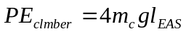
  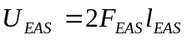
  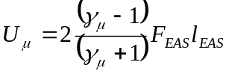
  Net Energy Absorbed by EAS Deployment
  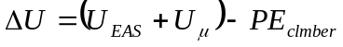
  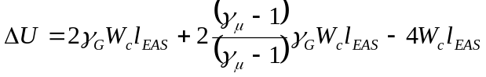
  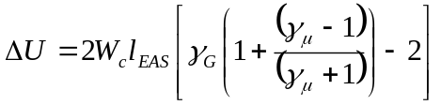
  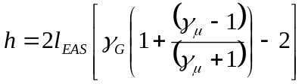
  Definition of the Break-even Point
  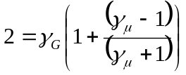
  Figure 3: Algebraic development of stiff rope
  energy absorption model

Citations & source usage:

MIT’s librarian Tracy Gabridge has a checklist of guidelines for strong information use in academic theses, thesis proposals, reports and journal articles (Table 2).

Table 2 Tracy’s checklist of guidelines for information use in academic writing
Expectation | Implication for thesis proposal
When appropriate, include a predominance of peer-reviewed references | In general, a bibliography of URL references does not suffice.
Citations contain complete information in order that others can find the sources again (also, web pages include the date the site as viewed) | Keep copies of web pages that you cite in case the web pages disappear.
The thesis does not rely heavily on web sites in citations. Web sites are only included when nothing else will do. Alternatively, URLs may be used as place holders for more robust sources. | A bibliography of URL references does not suffice.
Citations come from reputable sources (credible authors, solid publications, verifiable sources) | Elvis sightings should not guide your thesis work.
Citations are based on current information (not out-of-date or obsolete information) | Some useful information was discovered a long time ago, so some citations may predate the internet.
Citations are referenced appropriately within the text and every claim in paper is properly credited. | Support contentions, especially in the introduction and background via citation.
Appropriate sources of information are used for the purpose of the claim (e.g. handbook versus research article for basic background information, never using a wikipedia citation as a credible source)
In the aggregate, citations show a balanced use of information. Are some claims supported by many sources, while other claims aren't supported at all?
Citations are used effectively within the text (information from the
citation truly supports the claims made).
References to citations in the text accurately use the information cited. Information that is cited isn't used in ways that are inappropriate to the original author's intention.

Useful characters:

No break space:
I approve of separating units from numbers with a space to prevent the units from (e.g. 3 kN) breaking across a line; connect the number and the units with a no-break space: 3 kN.
As a minor exception, on my account, you may omit the space with temperatures, for example 31°C, though some publications include the space even though it looks strange without expert typesetting, e.g. 31 °C.

N-dash:
The n-dash is longer than a hyphen, shorter than a m-dash, and vertically spaced differently than a minus sign. Best to use the minus sign or the n-dash to indicate negative numbers or ranges of numbers. For example: a grade of A−, −2 km/s, 3–5 pages (rather than A-, -2 km, 3-5 pages.) [hyphen -][minus sign −][n-dash –][m-dash —]

Methods:

Your methods go here. I encourage you to structure your methods according to the master plan as outlined by subheadings in the background section. Avoid writing an outright recipe or narrative structure; if you develop such a detailed procedure, it is probably best hidden in an appendix. Develop your methods according to the important underlying ideas rather than the order of occurrence in time.

Time line, deliverables, budget, & resources:

Include this info at the end.

References:

There are a number of common ways to use citations. Pick one and run with it. More can be found in the Mayfield Handbook of Technical Writing, available wherever MIT certificates are accepted: https://web.mit.edu/21.guide/www/doc-stys.htm

