Shielding

Mission Statement
The objective of the shielding group is to design a shielding system that will reduce the nominal radiation dose received from the reactor core to crew and radiation-sensitive instrumentation to as reasonably low a level as possible.

Background
The objective of the shielding group is to design a shielding system that will reduce the nominal radiation dose received from the reactor core to crew and radiation-sensitive instrumentation to as reasonably low a level as possible.

While the question of how much radiation is too much is contentious, the occupational guidelines of the United States Department of Energy offer a suitable limit. These rules stipulate that a radiation worker cannot receive greater than 5000 mrem in a year (or an average dose rate of 0.57 mrem/hr) [1]. This value very nearly approaches the estimated 0.6 mrem/hr for naturally occurring radiation on the lunar surface due to galactic cosmic radiation [2]. NASA stipulates a maximum occupational dose of 50 rem/yr (5.9 mrem/hr). Thus, if the core radiation output is reduced to a compromise magnitude of 2.0 mrem/hr, the same system that protects crew from natural ionizing radiation can be used to protect them from the remaining core radiation.

Goals
It is true that if the crew is receiving 0.6 mrem/hr from GCR and 2.0 mrem/hr from the reactor core, they will in fact be receiving 2.6 mrem/hr. The reason that 2.0 mrem/hr will be our target rather than 1.4 mrem/hr or less is that to attenuate radiation by a multiplicative requires adding a particular thickness whereas attenuating radiation by multiple orders of magnitude requires multiplying the available shielding thickness. For both the above reasons, 2.0 mrem/hr will be the chosen target for maximum radiation output of the combined core/shielding system.

Criteria
To achieve the declared limit, the shielding group will have to make several key design decisions. These include: whether to construct the shield on Earth and launch it into space, whether to shield gamma rays with the same unit used to shield neutrons, what materials to use, and what geometry to implement.

To reach these decisions, the shielding group will have to focus on several design constraints, which include module weight tolerance, radiation emitted from fissioning nuclei in core (both neutrons and gammas), radiation output from daughter nuclei, and effects of neutron reflection on core reactivity.

By paying due attention to these elements and the shield’s impact on other systems, the shielding group will develop a design that accomplishes the stated goal while still permitting plausible integration with the other surface reactor systems.

Shielding Options
There are several types of shielding for space systems, however in this context, shielding is primarily to protect against biologically damaging ionizing radiation resulting from fissions and fission product decay. Ionizing radiation includes charged particles (protons, alpha and beta particles), neutrons and gamma rays. Each type of radiation reacts uniquely with different types of materials, and the attenuation of each must be considered separately.

The secondary function of shielding is to protect the reactor against transients from incoming radiation, from natural forces (i.e. temperature swings and dust storms), and from corrosion due to energetic particle bombardment. While the secondary functions are important, detailed analyses in these areas are out of the immediate scope of this shielding design and will be an area for further work.

Radiation Interactions
In this section we will examine the interaction of various types of radiation with matter in order to lay the groundwork for choosing appropriate shielding materials. Charged particles are easily attenuated, or absorbed, and are thus inconsequential in shielding analysis. Gamma rays, on the other hand, are the most challenging to attenuate, as photons penetrate matter more effectively than particulate radiation at a given energy. Neutrons, while slightly easier to shield than gammas, make up the most potentially damaging radiation component due to high and varying LET and due to neutron activation of nuclei.

Materials composed of low Z elements slow neutrons primarily via elastic scattering. Collisions of neutrons with nuclei similar in mass to that of a neutron transfer more energy per scatter than collisions with heavy nuclei, and so require fewer scattering events for the same energy loss. Thus, hydrogenous materials, such as concrete and water, are often utilized to shield neutrons.

Materials comprising high Z elements contain a high electron density, which is needed for gamma attenuation. Gamma rays interact primarily via photoelectric absorption, Compton scattering and electron-positron pair production. In this type of reactor, with high Z fuel elements, a fast neutron spectrum and a fission spectrum, pair production will dominate the modes of energy transfer of photons [3]. By offering more loci for photon-electron interactions, high Z materials generally attenuate gammas most effectively. Neutron attenuation produces secondary photons through inelastic scattering events with nuclei. These secondary gammas must also be stopped, so it is imperative that the gamma-shielding layer be the outermost layer of any design.

Since neutrons and gamma rays make up the primary sources of ionizing radiation from a reactor, both low and high Z materials must be used in a shielding system. Two separate systems or a single two-component system will likely have to be used in developing a shield for both types of radiation.

Artificial Shielding
One possible shielding approach is to develop and launch shielding constructed on Earth. The advantage of this approach is that any viable material and fabrication technique demonstrated in the past is available for use in the shield. The disadvantage is that this material will have to be launched and will take up weight in the module where weight capacity is at a premium.

Table 1.2-1 gives a summary of gamma and neutron attenuation properties for potential shielding materials.

Table 1.2-1: Material Properties for Gamma and Neutron Interactions
Material | Density at 293K and 1 atm (g/cm³) | Attenuation coefficient for 2MeV gammas (cm²/g) [4] | Pros | Cons
Lead | 11.350 | 0.070 | High gamma attenuation | Poor neutron absorption
Concrete | 2.320 | 0.0203 | Inexpensive, high neutron moderation | High volume
Water | 1.0 | 0.018 | Inexpensive, high neutron moderation | Vapor unless pressurized
Lithium | 0.533 | 0.016 | High neutron absorption, low mass | Poor gamma absorption
Boron | 2.31 | 0.01368 | Good neutron absorption | Poor gamma absorption
Cadmium | 8.642 | 0.04587 | Good neutron absorption | High mass
Carbon | 2.250 | 0.01575 | Low mass, good neutron moderation | Poor gamma attenuation

Earth-based Reactor Shields
Standard power reactors provide an appropriate first look in designing extraterrestrial-viable shielding. Most terrestrial reactors employ a standard design of steel thermal plates that act both as shielding and as radiator. Walls of steel alternated with water-filled gaps surround the entire reactor vessel. The steel reduces neutron energy, transferring the neutron’s kinetic energy as heat to nearby cooling water in the adjacent gaps [5]. Lead shielding further attenuates gamma ray intensity, and in many cases, large concrete shields are built around the reactor to enclose and contain it.

Space travel and extraterrestrial environments impose limitations on traditional shielding design feasibility. Land-based reactor shielding designs are not practical for a space mission due to their large mass and volume. Due to strict launching constraints, a limited mass and volume must be balanced with effective shielding capability.

Gamma Shield
Clearly, from Table 1.2-1, the obvious choice for gamma shielding in Earth-based reactors is lead; but the choice becomes more complex as we consider launchable mass limits. Lead would not only protect the reactor from the Martian environment but it would also provide protection to the crew from radiation. Lead has the highest linear attenuation coefficient, thus minimizing the volume of material required to reduce the dose due to gammas. Five centimeters of lead can attenuate a flux of 2 MeV gammas by over ninety-eight percent. Despite its many favorable properties, lead is so heavy that launching a sufficient amount for effective shielding is anticipated to be impractical: a hollow half sphere of lead with thickness of 5 cm and outer radius of 175cm will have a mass of 10,611 kg. When taken in conjunction with the rest of the reactor system, this mass exceeds launching and landing capabilities.

Concrete attenuates gammas and is not nearly as heavy as lead is, but neither is it as effective. For properly attenuating gammas, one would need to use more mass with concrete than with lead for the same attenuation. Other, lighter, but less absorbing, materials that could be used in gamma shielding are cadmium and tantalum; though this type of shielding is unproven, it would have the added benefit of high neutron scattering and absorption cross sections.

Neutron Shield
For neutron shielding, compounds are needed that slow neutrons to thermal energies so that they can be absorbed by a variety of other materials. As seen in table 1, materials with relatively high fast neutron scattering cross sections include: lithium-6, lithium-7, boron-10 and cadmium-114 [6], which have cross sections near 1 barn for 1MeV neutrons. Fast neutron capture cross sections tend to be lower than thermal cross sections, thus thermalizing the neutrons will increase absorption rates, and if this proves desirable given other engineering considerations, water, boron, and carbide compounds are excellent candidates for slowing down and absorbing neutrons.

Water, an excellent moderator of neutrons, requires pressure or heat to be effective as it may be prone to freezing in the Martian environment or vaporizing in the lunar environment. Solid materials such as concrete have the advantage over fluids of material stability. Boron, lithium and cadmium are attractive candidates given that these materials are solid and have high absorption cross-sections and/or attenuation ability.

For neutrons of a given energy, Table 1.2-2 and Table 1.2-3 summarize the relative probabilities for interaction in various materials.

Table 1.2-2: Fast Neutron (2 MeV) Capture Cross Sections
Material | Nuclide density (nuclei/cm³) | Microscopic capture cross section (cm²) [6] | Macroscopic capture cross section (cm⁻¹) | Microscopic scatter cross section (cm²) [6] | Macroscopic scatter cross section (cm⁻¹)
Water | 3.346*10²² | 2.5*10⁻²⁹ | 8.36*10⁻⁷ | 5.0*10⁻²⁴ | 0.1673
Lithium-6 | 5.33*10²² | 1.0*10⁻²⁹ | 5.33*10⁻⁷ | 2.0*10⁻²⁴ | 0.1066
Boron-10 | 1.391*10²³ | 8.0*10⁻²⁹ | 1.11*10⁻⁵ | 1.0*10⁻²⁴ | 0.01391

Table 1.2-3: Thermal Neutron (0.025 eV) Capture Cross Sections
Material | Nuclide density (nuclei/cm³) | Microscopic absorption cross section (cm²) [6] | Macroscopic absorption cross section (cm⁻¹) | Fractional attenuation through 10 cm material
Water | 3.346*10²² | 3.32*10⁻²⁵ | 0.1111 | 0.6708
Lithium-6 | 5.33*10²² | 3.85*10⁻²⁶ | 2.052*10⁻³ | 0.0203
Boron-10 | 1.391*10²³ | 5.0*10⁻²⁵ | 6.955*10⁻² | 0.05012

Natural Shields
A second possible shielding approach is to utilize the materials available on the extraterrestrial surfaces on which the reactor will land. This method will free up substantial weight on the landing module, however it will limit available materials to the surface composition and require bringing machines capable of digging and transporting hundreds of metric tons of Lunar or Martian rock.

The limiting factor for deploying any shielding technology is launch mass. Therein lies the problem of cost: launching cost is estimated at several thousands of dollars per kilogram [7]. To launch a shield massive enough to sufficiently attenuate ionizing radiation from the reactor core, the price tag could easily be in the millions. In light of the cost-prohibitive nature of heavy and bulky shielding systems, the use of a “natural” shielding system becomes attractive. The possibility remains of the use of a “mixed” system of artificial shielding to stop most of the radiation and surrounding it with a natural barrier for bringing the dose down to our specified limit of 2.0 mrem/hr.

Natural Shielding on the Moon
By utilizing material already existing on the moon’s surface, the staggering cost and encumbering weight requirement will fall substantially. Given its barren landscape, interspersed with mountains and valleys, and a surface comprising a powdery soil, the moon offers little for a make-shift shielding system other than the bare ground itself. With basalt rock of an average density of 3.4 g/cc [8], a shield of arbitrary thickness can, in principle, be constructed without the need for launching any extra weight, other than the tools used for digging or blasting into the surface.

Lunar rocks of various oxides are not unlike the composition of rock on Earth (see Section X for a detailed description of Lunar soil composition). These include many oxides mostly based on silicon, but also including refractory elements including calcium, aluminum, and titanium, all of which are difficult for working and digging [8]. Approximating the moon’s surface to be SiO₂ at a density of 3.4 g/cc and emitted gamma radiation of 2 MeV and higher, any dug up material will exhibit a macroscopic removal cross section for gamma rays of 0.152 cm⁻¹. Thus, a thickness of half a meter can reduce the intensity of the flux from the reactor by 99.9% [9]. To construct a hemispheric shield of Lunar surface material at the above thickness large enough to cover the core, neutron shield, and other relevant systems (approx. radius of ~10 m) would require moving 1,000 MT of lunar dirt.

One method for generating the raw dirt is to detonate some form of an explosive on the surface, construct the base inside the resulting hole and then replace the displaced dirt on top of the reactor. While a possibility for the Mars base, this technique will be more difficult to implement on the Moon. First, any activity on the lunar surface, will stir up dust that will later fall and deposit on any equipment present. A layer of moon surface powder on a structure will raise its thermal absorptivity. On the daytime side of the moon, where the surface is sufficiently hot to thermally radiate in the infrared spectrum, the structure will absorb this thermal energy and heat up, leading to deleterious performance issues. For example, during lunar surface expeditions for Apollo 17, astronauts were required to regularly brush off their Lunar Rover to prevent equipment overheating [10].

Also, the moon’s small surface gravity, 1.62 m/s^2 [11], will limit the amount of dirt available for refilling over the base. The detonation of an explosion on the surface will spread material over a much wider range than a similar explosion on Earth, and with an escape velocity of 2.38 km/s, there is no guarantee that any of the dirt will return to the moon’s surface. This dispersion will leave the base with a hole but a limited amount of dirt with which to refill it. It may even bear a resemblance to many common lunar surface features, namely craters, of which there is clearly no short supply on the Moon. Instead, a more feasible solution may be to use the topology of the moon as a shield. Mountains, craters and cliffs present numerous potential locations where the reactor can be placed with emitted radiation obstructed by a geographical landmark. For example, the reactor can rest at the bottom of a crater with the human habitat behind the crater edge with tens of meters of Lunar surface material between radiation-sensitive equipment (including people) and the reactor. Issues with this solution include rejecting the energy that may be absorbed from emitted infrared radiation emanating from the face of the elevated surface. During Apollo 15 and 17, thermal radiation from nearby mountains measurably raised temperatures of equipment at least ten degrees Celsius [10].

Natural Shielding on Mars
One problem with using material available on the Moon is that this same material will largely not be available on Mars, thus negating the advantage of demonstrating this portion of the technology on the Moon in the first place. However, the most abundant Martian surface material, ferrous oxide, has a slightly higher density but somewhat lower mass attenuation coefficient than silicon oxide. Total net attenuation, then, for gamma rays is comparable on the Moon and Mars though the materials differ. The option of blasting a hole in the Lunar surface was eliminated for reasons delineated above. With twice the gravity, an appreciable though modest atmosphere and limited surface features including few craters on most parts of the Martian surface, the detonation of an explosive on Mars remains a reasonable option for use as a reactor shield.

Reducing radiation dose is the primary goal for the shielding system. If ionizing radiation output from the reactor can be reduced to the natural background dose, the remaining radiation can be attenuated by the necessary systems that shield habitat occupants from naturally occurring radiation. From the above options, the chosen shielding system will best meet this goal, as presented in the mission statement, of reducing radiation from the reactor to 2.0 mrem/hr.

Neutron Shielding
Future long term manned missions to the Moon and Mars will require the use of a nuclear reactor to sustain a habitat. Unfortunately in order for the power to conveniently be supplied to the habitat, the nuclear reactor must be relatively close to the habitat. Unfortunately with the use of nuclear power comes the production of radiation in the forms of high-energy photons, neutrons and charged particles. Neutrons in particular are a difficult problem to deal with because they require a large amount of shielding to stop since they may travel with a very high energy and exhibit no electromagnetic charge (though they do have an electric dipole moment and thus may interact with matter but not as strongly as charged particles).

Design Summary and Neutron Shielding Goals
As explained in Section 1.2.1, neutrons also have the ability to produce high-energy photons and charged particles when interacting with various media. It is necessary to develop a shielding model that will protect Martian and Lunar environments as well as keep the inhabitants of the habitat safe from the neutrons and associated radiation produced by the reactor. Furthermore, it will also be necessary to map exclusion zones around the reactor where the neutron shielding is unable to reduce the dose to safe levels. Another consideration that one must contend with is keeping the shield as light as reasonably achievable in order to meet Lunar module mass requirements. It is the goal of the shielding group to keep the mass of the neutron shield under one metric ton.

The following sections outline the project team’s shield design and choice for protection from fission-borne neutrons. The shielding team chose a cylindrical shell of boron carbide (B₄C) of thickness 21.1 cm to serve as the primary neutron shield.

Dose Rates without Shielding
At a thermal power of one megawatt, a bare core and reflector with no shielding radiates a neutron current J₀ of 3.23*10¹¹ neutrons ranging in energy from slightly epithermal ~100 keV to very fast neutrons upwards of 10 MeV. Thermal neutrons are not observed in the core due to specifications of the reactor. Any sporadic thermal neutrons that are in the core are unlikely to penetrate far into the shield.

Core design studies delivered a neutron output spectrum divided into thirty-two energy groups. The design team approximated the output current as the output spectrum equally distributed over a reflector surface area of 11.7*10³ cm². Estimates of the dose rate relied on modeling the energy-absorbing material by the ICRU-44 convention of a four-component tissue model [12].
(1.3-)
The dose rate R_{fn} for each energy group results from Equation, where J_{n} is the current rate, E_{n} is the group energy, Σ_{s}/ρ is the scattering cross section of tissue. Quality factors Q are included because neutrons of high energies exhibit Q=10 [5]. Additionally, at high energies the neutron scattering imparts the vast majority of the dose. Absorption cross-sections for fast neutrons in tissue are very small. Tissue energy absorption is largely dependent on the concentration of ¹⁴N in the tissue. This is because the major contributor to dose is from the reaction shown in Equation

¹⁴N + ¹n → ¹⁴C + ¹p (1.3-)

Summing the dose component of each group at the reflector boundary, results in a dose equivalent of 2.4*10⁷ mrem/hr. At distances much greater than the radius of the reactor core (51 cm), this dose decays with the inverse square of the distance from the center of the reactor. This fact is significant in that it will allow the shielding mass parameters to be reasonable. It will not be necessary to completely shield the reactor considering that after several meters, the dose will decay to safe levels. As is visible in Figure 1.3-1, the dose falls to 2.0 mrem/hr at a distance of about 14 m from the edge of the reflector and to the equivalent of lunar surface galactic cosmic ray background (0.6 mrem/hr) after about 44 m.

Surrounding the reactor with a neutron shield of a low Z material that has a high fast neutron scattering cross section would be beneficial to the mission by allowing the crew to safely work within a few meters of the reactor.
Figure 1.3-1: Neutron Dose Equivalent without Shielding

Launched Material Selection
Neutron attenuation through media occurs via elastic scattering, inelastic scattering and absorption interactions with nuclei. In general, the lighter the nuclei, the greater the probability a neutron will impart a greater portion of its energy on the target nuclei and thus losing energy itself. Thus, lower Z materials attenuate neutrons more effectively than higher Z elements since atoms of those materials have a mass closer to that of a neutron.

Subsequently the neutron cross section also plays a role in neutron attenuation. The energy dependent neutron cross section is defined as the interaction probability per unit atom density and distance. Consequently, when considering materials for a neutron shield, one must look at materials that are not only light, but also have a high cross section at fast energies.

Obvious choices for neutrons shielding lie at the top of the periodic table where masses are lowest. It is easy to reject all transition metals; the density is far too high and the masses too great. One would need a large amount of this large material to attenuate the neutrons and a large amount of this material would be impractical due to weigh restrictions of the landing module. It is easy to also reject elemental gases, hydrogen, which is the best material for attenuating neutrons in non-gaseous form, has a very low density like all gases. A very low-density material will do little to attenuate neutrons despite having a low mass.

After removing heavy elements and gases from consideration one must look at other factors including cross sections, melting temperature, and stability. The first and most obvious neutron moderating material considered was water. Water is widely used in land based thermal reactors however is not practical for fast reactors due to the risk of reflecting thermal neutrons back into the fast core. Furthermore, water would not work on the extreme Lunar and Martian environments; the water would need to be kept pressurized to keep from evaporating at the reactor operating temperature of 1500K.

The next group of materials considered was lithium-based materials. Lithium (Z=3) has a very low atomic density making it very lightweight. Lithium also has a high neutron scattering cross section at fast energies (~1 barn at 10 MeV). However, elemental lithium is an alkali metal and subsequently extremely reactive, therefore one must look at lithium compounds for shielding purposes. Furthermore, elemental lithium melts at 453K [13], again far too low for reactor shielding purposes The salt lithium hydride (LiH) is an obvious choice, however, much like elemental lithium, the melting point is still too low at 953K [14]. This problem was recurrent with most lithium compounds examined; furthermore, the only lithium compounds with high melting points had undesirable masses or cross sections.

The final group of materials considered was boron-based compounds. Elemental boron has a very high thermal and fast cross section, a melting temperature of 2348K [13], and a high resistance to thermal expansion. Elemental boron however is a very brittle material and would not make a good shield alone. However, boron-based compounds appeared very attractive and they are widely used in fast reactors around the world.

The first boron-based compound examined was borane (BH3). Unfortunately, borane is an extremely reactive substance widely used in organic chemistry [15]. The next compound examined was boral (B4CAl). Boral is widely used for terrestrial fast reactor shielding. Boral has a high scatter and absorption cross-section because it is approximately 40% boron by weight. Boral also has a much higher melting point than lithium based compounds. The downside to boral is that the aluminum matrix gives excess weight without much moderation ability.

Logically the next compounds that were considered were borated graphite and boron car-bide (B4C). Borated graphite was removed from consideration because it is essentially a graphite matrix with 4% boron [16]. Although borated graphite is very strong, chemically inert and has a high melting point, its neutron moderating ability is mitigated by the fact it does not have a large amount of boron. Boron carbide (B4C) has all the neutron attenuation benefits of a boron rich material (78.5%) [17], but does not carry excess weight like boral. Boron carbide also is the third hardest material known to exist and extremely stable and chemically inert in the harshest conditions. The melting point of boron carbide is an astounding 2718K [17].

In order to evaluate effectiveness of each of the boron shielding candidates, the shielding group compared the moderation power of the maximum thickness (due to weight limits) of shielding of each material. The definition of the maximum thickness of each material is the maximum thickness of a cylindrical shell surrounding and flush with the reactor core reflector. By solving Equation for a mass of one metric ton, the maximum shield thickness results. Even if the ultimate geometry of the material does not conform to this model, the resulting choice of shield will be maximally flexible because the cylindrical model represents the heaviest possible configuration of the shield.

Mass = height*ρ*[π(thickness + radius)² – π(radius)²] (1.3-)

The calculation of attenuation of neutron current utilizes an exponential function using the macroscopic removal cross section for each energy group from the Kaeri chart of the nuclides online database [18].

Table 1.3-4: Neutron Attenuation of Materials at Neutron Shield Weight of 1 MT
Material | Maximum thickness (cm) | Dose Rate at shielding edge (mrem/hr) | Dose rate at 10 m (mrem/hr)
Unshielded | N/A | 2.40*10⁷ | 10.29
Boral (B₄CAl) | 20.3 | 1.24*10⁵ | 0.1242
Borated Graphite (BC) | 22.7 | 4.28*10⁴ | 0.0427
Boron Carbide (B₄C) | 21 | 3.57*10⁴ | 0.0357

Table 1.3-4 outlines the thickness of the modeled materials that would result in a mass of 1 metric ton and the attenuation power of shields of that thickness. Also included for reference is the unshielded dose. At distances greater than ten times the radius of the reactor, the core can be approximated as a point source and the neutron dose decays as a factor of (r/r₀)². This does rate estimation neglects buildup factors as this quantity becomes less important with distance.
(1.3-)

Because of its much greater boron density, boron carbide outperforms both boral and borated graphite for a cylindrical geometry. While the dose rates given in Table 1.3-4 appear rather high, at the shielding edge, the rates drop off significantly as one moves away from the reactor. In the case of a boron carbide shield, the dose 1 meter from the reactor is only 1.53 mrem/hr, well below the allowance of 2.0 mrem/hr. At a distance of 2 meters, the dose falls to 0.38 mrem/hr, well below the galactic background dose of 0.6 mrem/hr. This rate remains the design team’s primary goal.

Boron Carbide Performance and Burn-Up Modeling
It is now possible to predict the final mass and configuration of the neutron plus gamma shields. The logical geometry would be to have the neutron shield of cylindrical geometry immediately surrounding the core. The boron carbide neutron shield would stop the majority of the neutrons by absorption or scattering before they even reached the tungsten gamma shield. The boron shield would also absorb thermal neutrons that would have been created due to the attenuation. Very few thermal neutrons would return to the core since the absorption cross section of boron at 0.025eV is 3840 barns [18]. The tungsten shield surrounding the boron carbide shield would then absorb the prompt low energy gammas produced from the neutron scattering. A thickness of 21.1cm of boron carbide will have a mass of 1000 kg. A subsequent 10.6 cm tungsten gamma shield surrounding the neutron shield will have a mass of approximately 5000 kg, bringing the total reactor shielding mass to 6000 kg. Certainly decreasing the thickness of the neutron shield will greatly decrease the gamma shield mass. Under appropriate mission parameters, this arrangement may be preferable because the dose rate from neutrons at any significant distance (10+ m) from the reactor will be very small.

The dose from scattered neutrons was not taken into consideration when calculating the dose and can ultimately be neglected from all dose calculations. Although the resulting current of thermal neutrons (<1 eV) produced will be sizable 2.62*10¹¹ neutrons*cm^{-2 *}sec⁻¹ (81% of total current), this current can largely be neglected since the thermal capture cross section is 3840 barns. Virtually all of these neutrons will be absorbed by boron in the shield and will not penetrate the outer surface. This assumes the neutrons lose energy by scattering but take a straight path (21 cm) through the shield. This is unlikely since the neutrons scatter nearly forward off of boron and carbon meaning the path a neutron takes through the shield will likely be considerable more than 21 cm. Furthermore, many of the neutrons will be scattered down to the planet’s surface or up into space where they will pose no threat. Thermal neutrons that do make it through the boron carbide shield will likely be absorbed by the tungsten shield, which has a thermal, capture cross section of 25.27 barns. All these factors make it conservative to ignore the thermal neutron current.

Throughout the rest of this section, dose calculations with distance result from compromises between the (r/r₀)² dose dependence at large distances when the core can be approximated as a point source and the r/r₀ dose dependence at small distances when the core can be approximated as an infinite cylinder. Figure 1.3-2 illustrates dose rate as a function of distance and shield thickness for a boron carbide shield. As is visible in the graph, dose rate decreases exponentially with increasing shield thickness, thus optimizing geometry is crucial in obtaining an effective shielding system.
Figure 1.3-2: Neutron Dose Rate with Distance for Boron Carbide

Boron Burn-up Analysis
It is intuitively obvious that boron carbide be selected as the neutron shielding material. Boron carbide outperforms all of its competitors in terms of melting point, neutron attenuation ability, strength and mass. However, known issues must be addressed when using the boron carbide option. The first known issue is the manufacturing of boron carbide. Boron carbide is easily synthesized by various boric acid reactions to form a fine black powder. It is then necessary to sinter the material into a sizable solid structure. Sintering will involve the addition of additives such as epoxy resins in order to hold a coherent structure. The additives will consist of less than 2% of the shield by mass. Furthermore, the reason why a large B₄C shield is observed on conventional land based reactors is that the sintering process of B₄C is very expensive. Price aside, it is possible to sinter B₄C to a density of 97% of theoretical density. For calculation purposes the effective density of 2.45g/cm³ was used however the theoretical density for B₄C is 2.52g/cm³ [19].

The other major issue with B₄C that must be addressed is the burn-up rate of boron. Boron-10 undergoes the transformation given in Equation.

¹⁰B + ¹n → ⁷Li +⁴He (1.3-)

This reaction occurs greater than 99% of the time at energies less than 1eV [18]. The burn-up rate of boron in the shield is characterized by Equation.

(1.3-)

After 5 years of reactor operation conservatively assuming full power, the percentage of boron left will be approximately 82.2%, yielding a total burn-up of 17.8% over 5 years. This rate should not significantly affect the dose to the habitat over time. The burn-up of boron also produces helium that can lead to swelling in the shield. However, this will not be an issue because the shield is only constrained on two sides and still has four degrees of freedom to swell.
Figure 1.3-3: Neutron Dose Rate with Distance After 5 Years of Operation
Based on the data presented in Figure 1.3-3, the dose rate due to neutrons emanating from the shield approximately doubles after 5 years of operation. This is a significant increase in dose as time increases; however, it should not impact the shielding design or compromise mission parameters. The dose is still small enough to not be of concern to the crew of the habitat. For example, the dose rate at distance of 50 meters at t=0 is 1.43*10⁻³ mrem/hr while after 5 years the dose rate is 2.95*10⁻³ mrem/hr, still well within operation and safety limits. It should be noted that this again is a worst-case scenario, considering this dose rate does not take into account the significant additional stopping power of lithium produced after neutron capture in boron.

Gamma Shielding
The following sections outline the design team’s selection for fission-borne gamma ray shielding. The shielding team chose a cylindrical shell of tungsten of thickness 12 cm to serve as the primary gamma shield. For regions where the tungsten shield is insufficient for reducing dose rates, the implementation of exclusion zones prevents people on the Lunar or Martian surface from accumulating unnecessarily risky amounts of dose.

Design Summary and Gamma Shielding Goals
As outlined in the mission statement in Section 1.1.2, the shielding design aims to reduce crew radiation dose to 2 mrem/hr as a compromise between NASA’s existing occupational dose limit for astronauts at 5.9 mrem/hr (50 rem/yr) and the naturally occurring galactic cosmic radiation dose of 0.6 mrem/hr. In the models below, the shielding team considered these limits in light of both extremes in choosing an appropriate shielding material.

In addition, landing vehicle mass constraints limits the shield mass to about three metric tons. Three metric tons of any material is insufficient for a complete gamma shield, given the core design, so the shielding constraints require a hybrid shield comprised of a high Z material coupled with material available on the lunar or Martian surface. The following sections describe the design of such a system.

Core design analyses with MCNP code determined the gamma output current at the reflector boundary. The reflector design comprises a series of rotating drums of poisoning material. To be conservative, the design team modeled shielding for a fully reflected core because this configuration is the state in which the core radiates gammas maximally.

Gamma Dose Rates without Shielding
At a thermal power of one megawatt, a bare core with no shielding radiates a photon current Φ₀ of 5.3*10¹³ photons ranging in energy from soft gammas ~10 keV to high energy photons upwards of 9 MeV. Photons below these energies do appear in the core but those photons are subject to substantial attenuation by fuel elements since core materials are mostly of high atomic number.

Core design studies delivered a gamma output spectrum divided into thirty-two energy groups. The design team approximated the output flux as the output spectrum equally distributed over a reflector surface area of 11.7*10³ cm². Estimates of dose rate relied on modeling the energy-absorbing material by the ICRU-44 convention of a four-component tissue model [12].

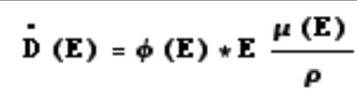 (1.4-)

The dose rate D for each energy group results from Equation, where Φ is the flux rate, E is the group energy and μ(E)/ρ is the mass energy absorption coefficient of tissue. Quality factors, Q, are neglected because photons of all energies exhibit Q=1. Tissue energy absorption cross sections vary more or less linearly with energy over the relevant range. Summing the dose component of each group at the reflector boundary, results in a dose equivalent of 7.8*106 mrem/hr. At distances much greater than the radius of the re-actor core (51 cm), this dose decays as the inverse square of the distance from the center of the reactor. As is visible in Figure 1.4-4, the dose does not fall to 2.0 mrem/hr until a distance of about a kilometer and to the equivalent of Lunar surface GCR background (0.6 mrem/hr) only after 1.8 km.

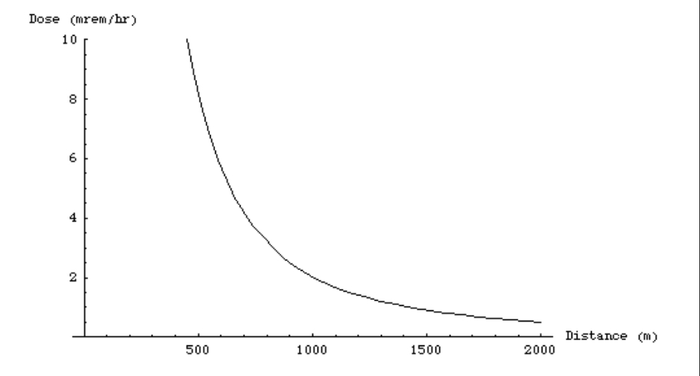
Figure 1.4-4: Dose Equivalent Rate for a Core without Shielding
It is clear that the chosen reactor core design requires additional shielding since power transmission to a distance of several kilometers would be unwieldy. Instead, surrounding the core and reflector with a high Z material is a preferable option.

Launched Material Selection
Photon attenuation through media occurs through electromagnetic interactions with nuclei and electrons. Thus, higher Z materials attenuate photons more effectively than lower Z elements since atoms of those materials have more charged particles.

Obvious choices for gamma shielding lie at the bottom of the periodic table where mass density is highest. It is easy to reject materials with atomic number higher than that of bismuth for reasons of either nuclear instability or unacceptably high reactivity. For example, polonium is naturally radioactive and so is less effective as a radiation shield than materials of similar atomic number. The same is true of radon; an additional issue with radon is that is a gas and would have to stay under pressure to achieve densities high enough for useful shielding.

Similar considerations leave bismuth (Z=83) and lead (Z=82) as the highest Z elements with suitable material properties. However, both these elements melt at temperatures much less than the operating temperature of the reactor, 1800 K. Bismuth melts at 544 K and lead melts at 600 K. If the shield falls in contact with the reactor or near the reactor such that thermal radiation heats it, these materials will melt. If used, these materials will have to remain in containers that can tolerate these temperatures. The containers will also have to tolerate the expansion of the metals during phase changes. On melting, the volume of lead expands about 5.7 % and bismuth expands about 2.7 percent [21]. Vacuum-filled voids must exist in the containers for the melting of lead or bismuth if they are to be part of the gamma shield implementation. The expansion will also lower the density of the shield, requiring additional compensation in initial shield thickness.

A container must also be comprised of highly attenuating, high Z materials. These may include the several refractory metals in the same group as lead and bismuth on the periodic table (Z=72 through Z=77). Rhenium (Z=75), osmium (Z=76) and iridium (Z=77) exhibit the highest densities but they are very difficult to manufacture Earth. While it may be reasonable to construct fuel cladding from rhenium, obtaining enough rhenium for a shield within a reasonable cost is unfeasible. Similarly, both osmium and iridium are not easy to fabricate in high volumes: osmium because it forms very toxic airborne oxides and iridium because it is not abundant on Earth [22]. However, iridium does exist in much higher concentrations on extraterrestrial bodies. If an option for asteroid mining becomes available, iridium would become the most attractive choice for a shield material or shield container. The most dense and most attenuating refractory metal that remains of these is tungsten.

To determine the shielding effectiveness of each of the remaining material candidates, the shielding group compared the attenuation power of the maximum thickness (due to weight limits) of shielding of each material. The definition of the maximum thickness of each material is the maximum thickness of a cylindrical shell surrounding and flush with the reactor core. By solving Equation (weight eq. from neutron chapter) with a mass of three metric tons, the maximum shield thickness results. Even if the ultimate geometry of the material does not conform to this model, the resulting choice of shield will be maximally flexible as this model exhibits the highest weight penalty for a thicker shield.

The calculation of attenuation of gamma flux utilizes an exponential function using attenuation cross sections for each energy group from NIST’s XCOM online database [9]. Table 1.4-5 outlines the thickness of the modeled materials and their attenuation power. At the output of the shield, photon current is also lower due to an additional multiplicative factor of r/r₀ because the same flux spreads out over a wider area proportional to the radius. At even further distances, this factor changes to (r/r₀)², since at large distances, the core appears to be a point source. Section 1.4.4 further explains the consequences of changes in distance. The dose rate results from Equation (dose equiv. rate from neutron chapter) with Φ from Equation (below). This does rate estimation neglects buildup factors as this quantity becomes less important with distance.

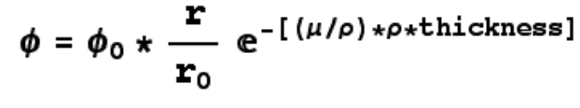 (1.4-)
Because of its greater density, tungsten outperforms both lead and bismuth for a cylindrical geometry in spite of its lower mass attenuation coefficients. While the dose rates given in Table 1.4-5 appear rather high, simple revisions of geometry can further reduce these rates. For example, only half the reactor surface or less needs shielding because the habitat will only be on one side of the reactor. A reduction in size of a half will permit roughly twice the prior thickness. In the case of a tungsten shield with a new thickness of 19.7 cm, the dose rate at 90 cm from the shield will fall to 0.36 mrem/hr, well below the goal of 2.0 mrem/hr. The full shell with dose rates of several hundred mrem/hr remains the design team’s first approximation.

Table 1.4-5: Gamma Attenuation of Single Materials at Gamma Shield Weight of 3 MT
Material | Maximum thickness (cm) | Dose rate at 90 cm (mrem/hr)
Lead (Pb) | 17.1 | 594.66
Bismuth (Bi) | 19.4 | 599.88
Tungsten (W) | 10.6 | 480.00

Gamma Shield Performance Modeling
Shield thickness and thus weight will vary depending on numerous mission parameters including required proximity of crew to reactor, limitations of Lunar or Martian surface area that may be excluded to entry by humans, and other similar issues related to mission goals. Thus, characterizing the shield performance at a range of thicknesses and distances is vital to the continued flexibility of the current models.

Throughout the rest of this section, dose calculations with distance result from compromises between the (r/r₀)²-dose dependence at large distances when the core can be approximated as a point source and the r/r₀ dose dependence at small distances when the core can be approximated as an infinite cylinder. The representation of intermediate values is a hybrid of the two systems such that at all distances the dependence factor is a continuous function. This function f(r) appears in Figure 1.4-5; this function is continuous but not differentiable at points where the dependence mode changes.

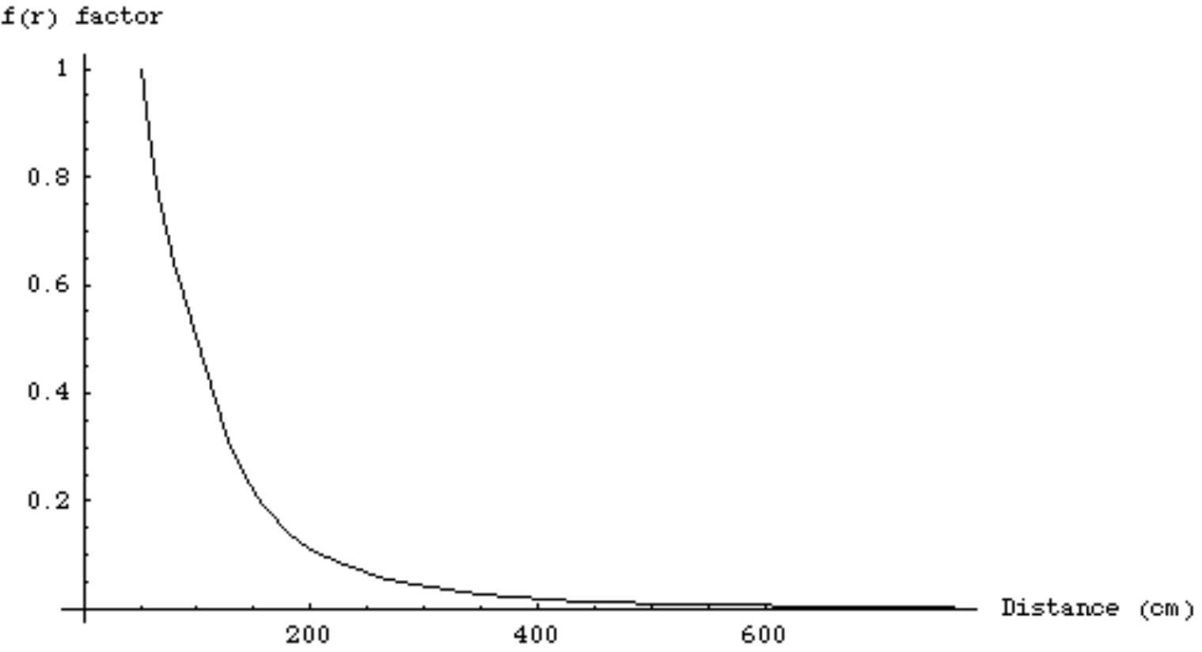
Figure 1.4-5: Distance dependence f(r) with distance
Figure 1.4-6 illustrates dose rate as a function of distance and shield thickness for a tungsten shield. As is visible in the graph, dose rate decreases exponentially with increasing shield thickness, thus optimizing geometry is crucial in obtaining an effective shielding system.
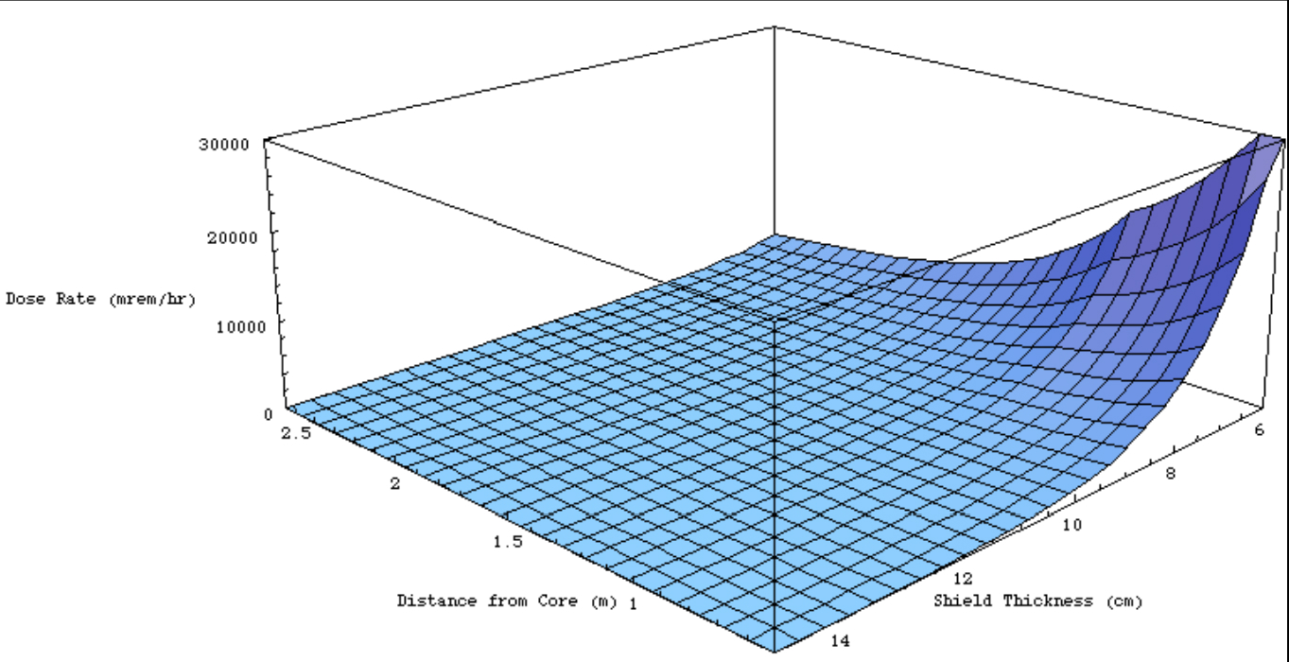
Figure 1.4-6: Dose Rate with Distance and Shielding Thickness for Tungsten

In the case where dose rate is too high even with the existing shield, the implementation of an exclusion zone becomes necessary. In this region, the dose rate is too high for crew to occupy for extended periods without risking the deleterious effects of high, though not acute, radiation exposure. Figure 1.4-7 displays a plot of which areas are noteworthy for radiation dose for a tungsten shield of various thicknesses at the given distances.

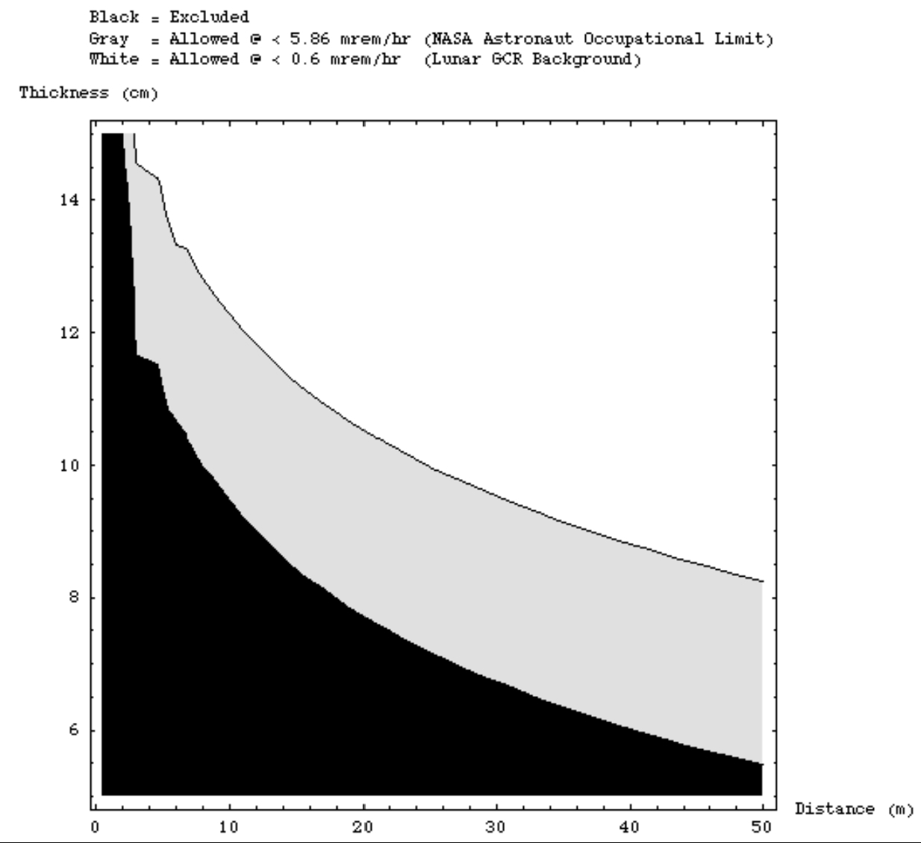
Figure 1.4-7: Excluded and Allowed Zones for Tungsten Shield
Appropriate boundaries for a location for a habitat fall within the gray zone of Figure 1.4-7. The exclusion zone is still safe for crew to enter since radiation dose rates do not reach a few hundred mrem/hr except very near the core. However, this is still an environment where prudence requires radiation dosimetry for those entering.

Shielding Design

Summary
The following section details the full shielding system’s implementation and the justification for the relevant selected options.

As illustrated in Figure, the surface reactor shield is in the shape of a semi-cylindrical shell, covering eighty degrees of arc, effectively a shadow shield. The habitat must fall within the region protected by the shield. Crew must avoid entering areas near the reactor on the unshielded side to avoid high radiation exposure. Gamma dose greatly exceeds neutron dose from both the shielded and unshielded sides of the reactor. Thus, the dose equivalent rate from the unshielded side can be approximated as that given in Figure 1.4-4. Similarly, one can approximate the dose equivalent rate from the shielded side with only the gamma dose after passing through 12 cm of tungsten as shown in Figure 1.5-8. For example, the dose equivalent rate at 10 m is about 0.5 mrem/hr on the shielded side rather than several hundred mrem/hr on the unshielded side.

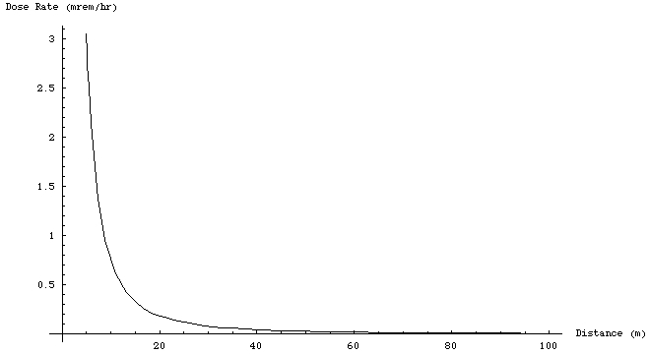
Figure 1.5-8: Dose rate with Distance for 12 cm Thick Tungsten Shield
The shield system consists of two separate but identical pieces, each covering the full height of the reactor. Each piece covers forty degrees of arc of the radial reflector surface. Depending on mission requirements, each piece can move around the reactor via a mechanical system. Shielding movements may be necessary to protect radiation-sensitive equipment and crew who may need to explore or enter otherwise unshielded regions.

Each of the forty degree segments of the shield comprises two layers: a 21 cm thick cylindrical shell of boron carbide (B₄C) falling flush against the reflector, and a 12 cm thick cylindrical shell of metallic tungsten (W) placed immediately outside the boron carbide layer.

This arrangement will bring total radiation dose due to core radiation below the magnitude of background radiation on the moon (0.6 mrem/hr) at a distance just under fifteen meters from the core.

Geometry
Layers
The boron carbide layers serves to reduce radiation dose due to neutrons emitted during fission events in the reactor. The purpose of the tungsten layer is to attenuate photons produced in the core. In absorbing and scattering the neutrons, the collision events in the boron carbide layer will result in the emission of secondary radiation, particularly ionizing photons.

Several mechanisms for the generation of secondary radiation exist. When a nucleus absorbs a neutron, it may end up in an excited state. The nucleus relaxes through the emission of high-energy gamma photons. In addition, particularly at high energies, inelastic scattering of neutrons from nuclei will result in recoil photons.
This shielding schematic filler text will not appear due to shielding team incompetence.

Figure 1.5-9: Overhead Schematic of Shielding Implementation
Other particles can be produced in particle emission events such as (n,p) and (n, alpha) reactions in the shield. These heavy charged particles deposit their energy within a very short range, and so these species will not escape the neutron shield in any significant number; the only type of secondary radiation in need of mitigation are gamma rays [3].

The secondary photon flux will not exceed the core-produced gamma radiation flux, so the tungsten layer designed to absorb the core gamma radiation will be more than sufficient shielding for these secondary photons. Thus, the gamma shield must lie outside the neutron shield, notwithstanding further complications in design (see alternate design in Section 1.6.1).

It is true that by placing the denser tungsten shield outside the core the mass of tungsten will increase for any given protected range and gamma attenuation. However, it is a necessary penalty to bear because of the secondary gamma radiation produced in the neutron shield. Placing the tungsten shield inside the boron carbide layer would leave this radiation without attenuation.

Shielding Extent
This shield design, as outlined above, does not cover the entire core, owing to landing module mass constraints. Consequently, the unprotected side will be freely releasing radiation into the environment in the exposed direction as illustrated in Figure 1.4-4. Given material constraints for radiation attenuation and weight constraints for extraterrestrial landing capabilities, no shielding system can surround the entire reactor without violating one of these two criteria. A system with the given thicknesses surround the core would have a mass of 8.47 metric tons, which when added to the mass of other system components would exceed the landing capability limit of 10-15 MT imposed by available technology.
This chart filler text will not appear due to shielding team incompetence.

Figure 1.5-10: Plot of Habitat and Potential Landing Zone
Instead, the design team chose a set of objectives for a region protecting the crew habitat given technology limitations. Available precision landing technology can land units to within less than a kilometer of a chosen target. Assume that a module will land within a radius of one kilometer of the habitat, and has an equal probability of landing at any given point within this range. Then, with the habitat at the origin of a Cartesian plane, the probability of landing the reactor at a given point is given by Equation.

P(x,y) = 1/(π*(1 km)²) for x² + y² < (1 km)² (1.5-)

Then, the probability of landing at a given distance r from the habitat is given by Equation.

P(r) = 2*r/(1 km)² (1.5-)

Thus, on average, the reactor would land at a distance of 666.7 meters from the habitat. To be conservative, suppose the reactor lands at one-fourth this distance, or 166.7 meters.

Even at this distance, the shield must still protect the habitat and crew. Assuming the longest edge of the habitat will be no more than 30 meters in length, the shield must protect a zone, again being conservative, ten times this length for astronauts to travel near the habitat without worrying about the radiation exposure from the MSR. As is visible in Figure 1.5-11, to accomplish this, the shield will extend over an angle of eighty degrees around the core.
This triangle geometry picture filler text will not appear due to shielding team incompetence.

Figure 1.5-11: Chart of Reactor and Habitat Edge
Even with a thirty-meter wide habitat, the reactor could still land to within as close as sixteen meters (the use of a mechanism for moving the shields around the core so they fall between the habitat and the reactor core is postulated later in this section) and still have sufficient shielding to protect crew and instrumentation. However, regions immediately outside and in front of the habitat would have doses high enough that crew should avoid prolonged exposure. Still, under the above assumptions, the probability of landing the reactor within 16 meters is just over one in four thousand. To be sure radiation scattered off the axial reflectors does not reach crew, the shield will extend 6.5 cm above and below the vertical bounds of the core. This size of a shield exhibits a mass of 1.72 metric tons, well within the bounds of available extraterrestrial landing technology even when coupled with the mass from the rest of the MSR system.

Shield Mobilization
One caveat of using a directional-based shielding system is that the reactor may not land with the shield facing the habitat. In such a case, some mechanism must exist to realign the shield with the habitat so it can protect the crew and radiation-sensitive equipment.

Additionally, there are many potential missions where shielding a triangular segment of space near the reactor will be insufficient to accomplish mission objectives. Crew may need to explore regions of the Lunar or Martian surface away from the habitat, and these may lie in regions that are unprotected in the initial alignment of the shield.

To address this issue, the shield comprises 2 identical pieces, each covering forty degrees of the reactor surface. These pieces can move around the reactor allowing mission planners to choose in which direction the shield will protect, when the reactor initially lands.

The precise nature of the mobilization and choice of a system with sufficient reliability will depend on mission parameters and remain as future work for mission planners according to their objectives. The movement to initially align the shield with the habitat needs only function once at the beginning of the mission. Afterwards, the shield can stay in one place. If the shield needs adjustment throughout the mission, the development and confirmation of a particular robust system will be necessary, as each segment will weigh at least 860 kg.

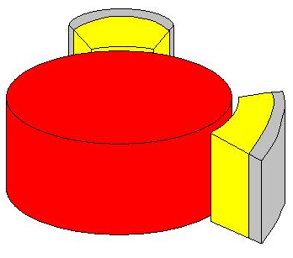
Figure 1.5-12: Shielding Mobility Demonstration (after)

Design Discussion
The design elucidated above satisfies all criteria. The neutron shield brings neutron dose down to a magnitude where it is negligible relative to gamma dose. This is ideal because complicating issues such as neutron activation and neutron buildup factors will not need to be considered in estimating dose. All those factors will be smaller than gamma dose.

That being said, gamma dose several meters beyond the shield is at an innocuous level. On the shielded side, humans can approach the core safely, for limited periods. This limitation can be easily overcome with the use of the mobilize shield units, which can accommodate virtually any mission parameters.

In addition, since this design does not depend upon exact surface composition and the materials involved are not particularly reactive, this shielding system exhibits scalability from Lunar environment applications to Martian deployment with limited alterations to design (see Section 1.6.2 for comparison of attenuation ability of Lunar and Martian soil).

Furthermore, the redundancy of a two layer shield, both layers exhibit some ability of attenuating both types of penetrating radiation (gammas and neutrons) greatly improves the robustness of the above design.

Alternative Designs
Given the substantial variability of mission parameters and design, other approaches and designs may be preferred. For example, if there is insufficient load available on the landing module owing to another mission-critical payload, the constructed shield may have to be sacrificed for another system requiring transport of much less mass. In addition, other geometries may further optimize the performance of the above design.
This three-layer shield filler text will not appear due to shielding team incompetence.

Figure 1.6-13: Three-Layer Shield Schematic

Three-Layer Shield
One such design involves a three-layer shield, two tungsten layers, one thick (inside) and one thin (outside) sandwiching a boron carbide layer of the same thickness as the above design (see Figure 1.6-13). In the main design described above, the primary reason for keeping the gamma-attenuating tungsten layer on the outside was so that it could shield two gamma sources: photons emitted after fissions in the core and secondary photons emitted during neutron interactions in the boron carbide layer. As the secondary photon flux is much smaller than the core flux, only a thin layer of tungsten would be necessary to shield the secondary flux.

If a thin layer of tungsten were kept outside the boron carbide layer, and a thicker layer were inside the boron carbide layer, the shield would stop the same radiation while reducing the mass. The inside layer would have a 12 cm thickness but exhibit a mass of only 1.085 MT as opposed to the tungsten mass of 1.46 MT in the original design. The boron carbide layer would weigh slightly more at 306 kg for the three-layer design, instead of 259 kg as in the original design. Even so, as long as the thin tungsten layer does not need to be more than 2.47 cm thick, a three-layer design would be more effective per unit mass than the above two-layer design.

Because the analysis of secondary radiation in the neutron shield is rather complex and necessary approximations would place any result at too great an uncertainty, the design team still recommends the two-layer design and leaves the analysis of a three-layer shield as future work. Furthermore, the two-layer design fits within the mass constraints of the current objects and thus there is no present need to complicate the design and sacrifice its current simplicity and robustness.

Shielding with Lunar Surface Material
The proposed shielding method requires launching 1-2 metric tons of shielding to the Moon and to Mars. If launching this large amount of mass is not a feasible option, shielding material can be found in the extraterrestrial environments.

Previous volcanic activity covered the moon with igneous rock of density 3.3 g/cc. As the bulk density (the soil per unit volume) of the moon is 3.4 g/cc, research indicates the Moon must be made almost entirely composed of rock. Earth, in contrast, has a larger bulk density of 5.5 g/cc due to the dense iron core [8][23].

Figure 1.6-14: Relative Sizes of Earth's Core and the Moon's Core

The rock on the crust of the Moon is predominantly composed of alkaline and metal oxides, of which SiO₂ is most abundant [24]. An outline of the most common materials on the Lunar surface appears in (See Appendix Table ___).

Gamma ray attenuation coefficients of the oxide mixture are calculated (See Appendix Table ___) and neutron removal cross sections are used to determine the effectiveness of Moon rock in absorbing radiation. Biological dose from neutrons is neglected, as its contribution to the total dose is negligible compared to the gamma radiation dose (Appendix Table _____).

A dose of 2.0 mrem/hr was previously chosen to be conservatively below the occupational dose limit of 5.4 mrem/hr. The thickness of the shield necessary to maintain this dose is plotted with the distance from the center of the reactor.
This surface material distance vs dose filler text will not appear due to shielding team incompetence.

Figure 1.6-15: Distance from Reactor to Maintain 2.3 mrem/hr Dose as a Function of Shield Thickness

Even within a 10 m radius from the reactor, the design team prefers the dose to be under the 2.0-mrem/hr limit. As seen in the graph above, this requires 0.8-1 m of surface material shielding. The plot below of the radiation dose as a function of the distance from the reactor given a 1 m shield thickness illustrates the very small dose even at distances very close to the reactor (see Figure 1.6-15).

The shield would be a hollow cylinder with an outer radius of 2m, an inner radius of 1m, and a height of 1m surrounding the core; the shield volume is 9.425 m³ (see Figure 1.6-16). A shield of this size requires transporting nearly 32,000 metric tons of rock to build walls of shielding around the reactor, a non-trivial endeavor. Dirt and rock excavation and transportation equipment will be needed.

The surface of the moon is marked with craters of varying sizes, which can be taken advantage of for their shielding advantages. To shield moon explorers while maximizing the area range for which exploration is safe from high radiation exposure, the reactor can be placed in the side of a crater (see Figure 1.6-17 (left)) or any geological feature that drops down below surface level (see Figure 1.6-17 (right)). As the reactor is 42 cm in height, the minimum depth of the crater or cavity should be 49 cm to surround all parts of the lateral surface of the core. A foundation would be constructed into the surface upon which the reactor could be set up in the rock shield, and the radiation would then be confined to the chasm and beneath the moon’s surface.

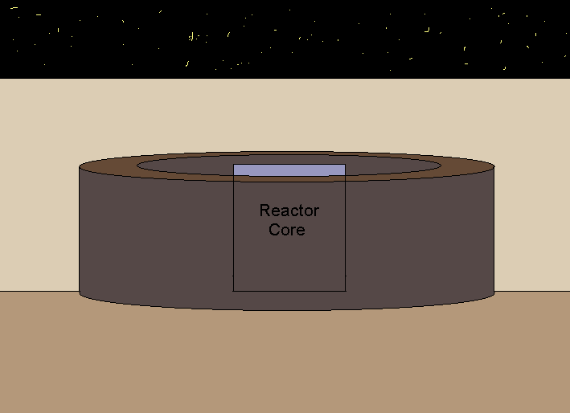
Figure 1.6-16: Core Surround by Surface Material Shields (side view)

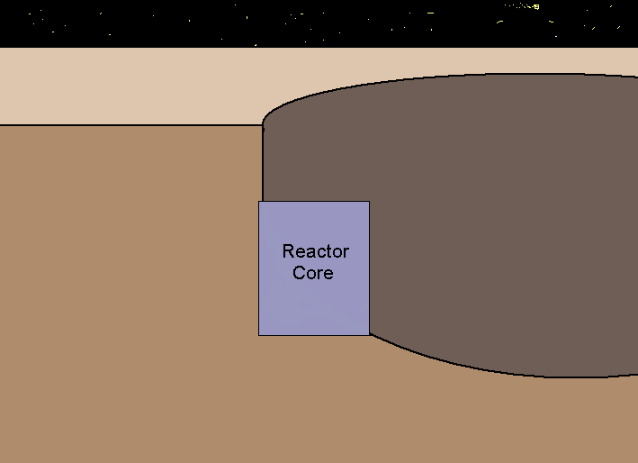 | 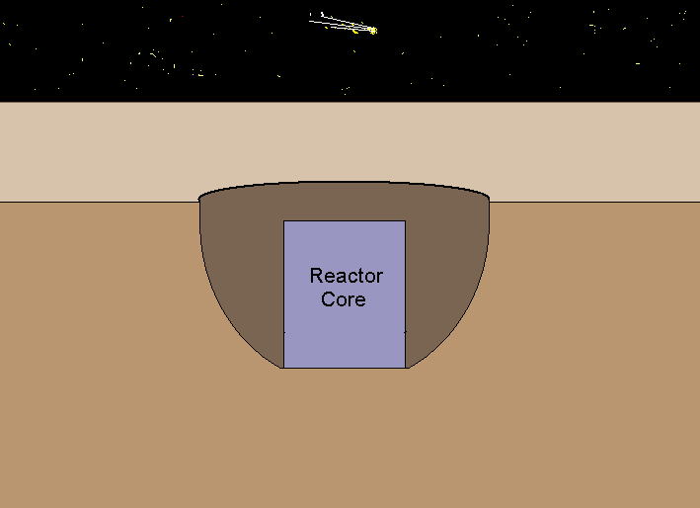
Figure 1.6-17: Reactor Built into Side of Crater (left), Reactor Below Surface (right)

Shielding Options on Mars
Mars has a crust with an oxide composition similar to that of the Moon according to soil analysis data (See Appendix Table ___) [25]. Radiation attenuation is nearly identical (attenuation data in Appendix), and the rock shield thickness of 1m keeps the dose below the 2.0 mrem/hr limit.

Mars is not dotted with craters as abundantly as is the Moon. Concave geological features can be sought out, craters can be dug, or, if complications arise in situating the reactor below ground level, the rock shield can be constructed around the reactor.

Though the surface shielding option appears appealing, the difference in surface geology between the Moon and Mars cause concern. Any implementation into the Moon crust cannot be scaled to Mars, as geological features on the Moon are not guaranteed to be present and convenient on Mars. Dug or above-surface shields would have similar material and attenuation characteristics on both planets, but as difficulties in constructing these shields on extraterrestrial ground have not yet been assessed, the research team is not considering shields of surface materials as a major option. Research in extraterrestrial excavation and construction might prove very useful in future work.

Limitations and Future Work
As is inherent with all scientific research and calculations, there is always a small degree of uncertainty. The research and calculations done on the shield were not an exception. As a result, it was necessary to be very conservative when doing many of the calculations. Worst-case scenarios were always assumed when calculating dose or neutron current emanating from the reactor. The conservative estimates and calculations used allowed for maximum consideration for safety. Furthermore, it also left the possibility of fully optimizing the shield during future work.

The first example of where conservative estimates were used would be when dose calculations from neutrons were done. When calculating dose for neutron interactions with tissue, a quality factor is assigned to account for the extra damage a fast neutron can do by additionally slowing down in tissue rather than being absorbed quickly like a thermal neutron. The quality factor is determined by the energy of the neutron and the type of tissue the neutron interacts with. To err on the side of caution, a quality factor of 10 was assigned to all of the 32 energy groups of neutrons. All of the neutrons were relatively fast (>0.1MeV) but may not have warranted a quality factor of 10.

The next example of where our dose calculations were conservative was when dealing with attenuation in non-idealized material. Essentially, the neutron dose calculations did not account for additional neutron attenuation when passing through the tungsten shield and likewise the gamma dose calculations did not account for gamma attenuation through the boron carbide shield.

The second major issue addressed that used the most conservative estimates was the boron burn-up calculation over the lifetime of the reactor. The highest flux for each energy group was used rather than using a time dependent flux that would ultimately decrease over the 5 year lifetime of the reactor. As a result, a maximal amount of burn-up was calculated. Furthermore, when calculating the dosage increase due to boron burn-up, the lithium-7 production that would take the place of boron-10 was not taken into account. Lithium-7 also has a reasonably high cross section at fast and thermal energies. The dosage increase due to boron burn-up will likely decrease when lithium production is taken into account.

All of these conservative estimates and calculation strategies were done purposefully to account for a worst-case scenario when dealing with dose from radiation. If the shield can effectively protect the inhabitants of a Lunar or Martian colony from the highest dose imaginable, then it can effectively protect the most likely scenario. It is important to utilize the methodology of preparing for the worst when dealing with safety from radiation environments. However, this methodology leaves open the possibility for optimization of the shield and the calculation of a likely operating dosage scenario.

Summary
Component | Number | Material | Height | Coverage | Thickness | Weight | Thermal tolerance
Gamma Shield | 2 | W | 55 cm | 40 degrees of arc | 12 cm | 1.46 MT | < 3790 K
Neutron Shield | 2 | B₄C | 55 cm | 40 degrees of arc | 21 cm | 259 kg

References
- U.S. Department of Energy, “Occupational Radiation Protection, Final Rule,” Code of Federal Regulations, Title 10, Part 835, December 14, 1993.

- “Radiation Protection and Instrumentation” Biomedical Results of Apollo, Section 2, Chapter 3, NASA SP-368, NASA Life Sciences Data Archive.
- Turner, James E. (1995). Atoms, Radiation, and Radiation Protection, 2nd ed. Oak Ridge, TN: John Wiley & Sons, Inc.
- Knoll, Glenn F. (2000) Radiation Detection and Measurement, 3rd ed. Ann Arbor, MI: John Wiley & Sons, Inc.
- Knief, Ronald Allen. (1992) Nuclear Engineering: Theory and Technology of Commercial Nuclear Power, 2nd ed. Mechanicsburg, PA: Hemisphere Publishing Corporation.
- Nuclear Data Evaluation Laboratory, Korea Atomic Energy Research Institute.

- “Space Plane Set for 2003 Launch,” http://science.howstuffworks.com/news-item262.htm October 3, 2000.

- “Surface Properties of the Moon.” Lecture Notes from Astronomy 161: The Solar System. Department of Physics and Astronomy. University of Tennessee.

- “NIST XCOM: Photon Cross Sections Database,” http://physics.nist.gov/PhysRefData/Xcom/Text/XCOM.html. Accessed November 7, 2004.
- “Luna’s (Earth’s Moon) Thermal Environment.” (2003) Thermal Environments. Jet Propulsion Laboratory D-8160. National Aeronautics and Space Administration.
- “Moon Fact Sheet,” (2004) National Space Science Data Center. Goddard Space and Flight Center. Greenbelt, MD.
- International Commission on Radiation Units and Measurement (1989), “Tissue Substitutes in Radiation Dosimetry and Measurement,” Report 44 of the International Commission on Radiation Units and Measurements. Bethesda, MD.
- Varga, T.K. Bello, C. (1994). The Periodic Table of the Elements. Concord, Ontario: Papertech Marketing Group Inc.
- “International Chemical Safety Cards,” http://www.itcilo.it/actrav/actrav-english/telearn/osh/ic/7580678.htm, Accessed November 3, 2004.
- Wade, L.G. Jr. (2002). Organic Chemistry, 5th edition. Princeton, NJ, Prentice Hall Publishing Inc.
- “Nuclear Power Fundamentals,” http://www.tpub.com/content/doe/h1017v2/css/h1017v2_76.htm, Accessed November 10, 2004.

- “Boron Carbide Properties,” http://www.azom.com/details.asp?ArticleID=75, Accessed November 12, 2004.

- “Table of the Nuclides,” http://atom.kaeri.re.kr/ Accessed October 4, 2004.

- “Sintering Aids in the Consolidation of Boron Carbide (B4C) by the Plasma Pressure Compaction (P2C) Method,” http://www.dekker.com/servlet/product/DOI/101081AMP200028083, Accessed November 13, 2004.

- Hubble, J.H. & Seltzer, S.M. (1996). “Tables of X-Ray Mass Attenuation Coefficients and Mass Energy-Absorption Coefficients from 1 keV to 20 MeV for Elements Z=1 to 92 and 48 Additional Substances of Dosimetric Interest,” Ionizing Radiation Division, Physics Laboratory, National Institute of Standards and Technology Gaithersburg, MD.

- “Density of Molten Elements and Representative Salts,” http://www-d0.fnal.gov/hardware/cal/lvps_info/engineering/elementdens.pdf Accessed November 7, 2004.

- “Webelements.com” http://www.webelements.com, Accessed November 8, 2004.

- http://www.geology.iupui.edu/research/SoilsLab/procedures/bulk/Index.htm. Accessed 6 November 2004.

- Smales, A. A., D. Mapper, M.S.W. Webb, R. K. Webster, J.D. Wilson. Science, New Series, Vol 167, No. 3918, The Moon Issue (Jan. 30, 1970), 509-512.

- McSween, H. Y. and K. Keil, 2000, Geochemica et Cosmochimica Acta, 64, 2155-2166.

