Accessing Course Reserves
Course reserve reading list can be accessed by going to: https://arc.bc.edu/reserves/login
You will need to use your BC User Name and BC Password, then click Submit Query
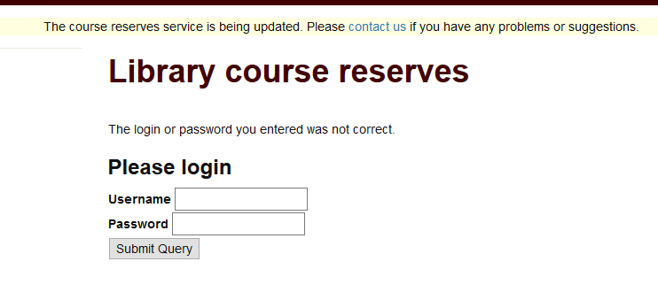
You will need to add your Course Number- ex. SJSTH615.01, then click Submit Query. If there is no reading list it will look like this.
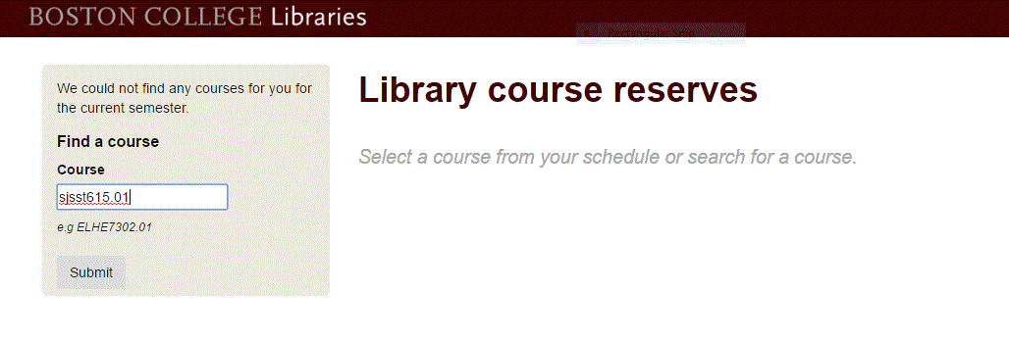
and if there is a reading list you will get a page looking like this.
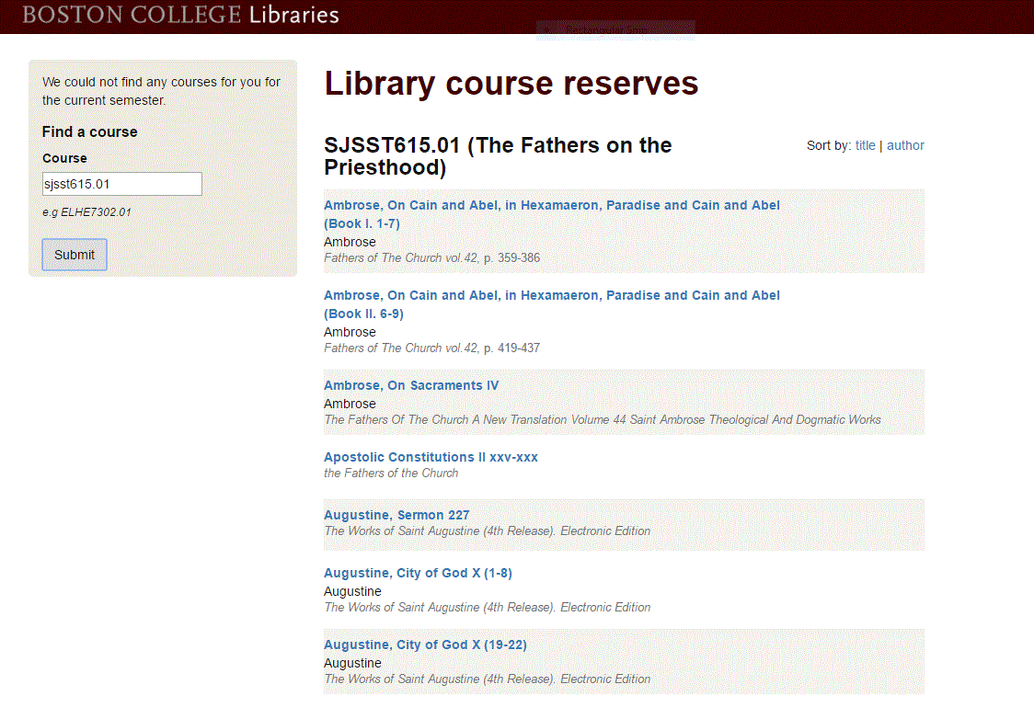
Click on link: to find Call # for the book which you can check out at the circ desk or read the article online.

