Assisi Episode 8 URLS
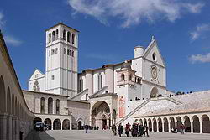
http://en.wikipedia.org/wiki/Basilica_of_San_Francesco_d%27Assisi

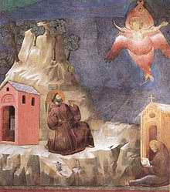
Giatto, St. Francis Stigmata
http://en.wikipedia.org/wiki/Francis_of_assisi
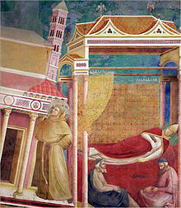
Giotto, Innocent III dreaming about St. Francis supporting Church
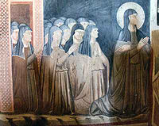
Fresco San Damiano
http://en.wikipedia.org/wiki/San_Damiano,_Assisi

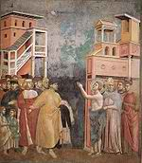
Francis returning his clothes to his father
http://en.wikipedia.org/wiki/Poverty

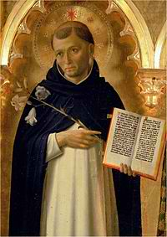
St. Dominic by Fra Angelica
http://en.wikipedia.org/wiki/Dominican_Order

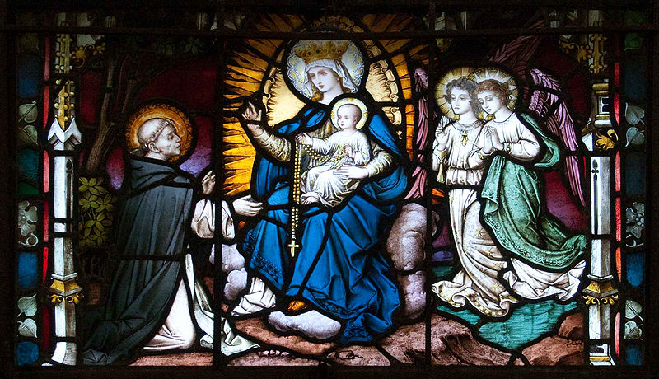
St. Dominic receiving the Rosary from Mary, Carlow Cathedral, Ireland
http://en.wikipedia.org/wiki/File:Carlow_Cathedral_St_Dominic_Receives_the_Rosary_from_the_Virgin_Mary_2009_09_03.jpg

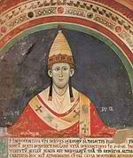
http://en.wikipedia.org/wiki/Pope_Innocent_III
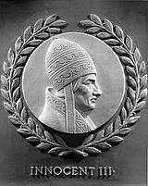
Commemoration of Innocent III as one of world’s great law givers in US House of Representatives
http://en.wikipedia.org/wiki/Pope_Innocent_III

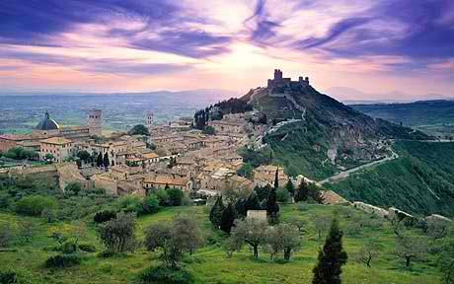
Assisi, Italy
http://www.telegraph.co.uk/property/overseasproperty/7707131/Property-in-Italy-Under-an-Umbrian-sunset.html

