Episode 1 URLs

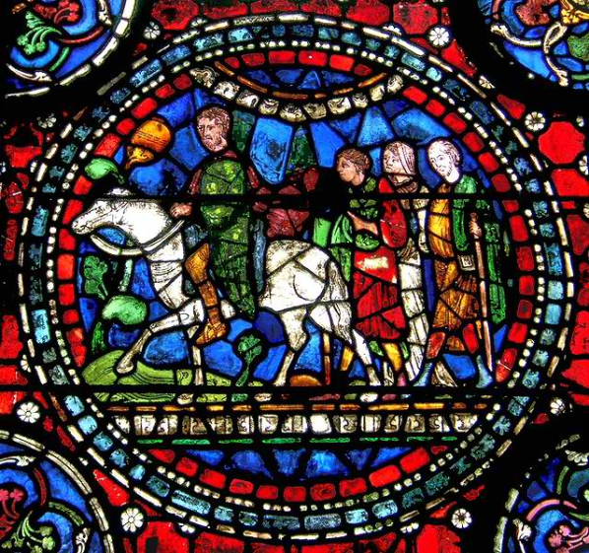
http://www.teachingcollegeenglish.com/2011/03/page/3/

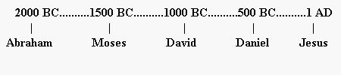
http://www.biblestudy.org/beginner/learn-basic-bible-timeline/chapter8.html

- The Cenacle
- 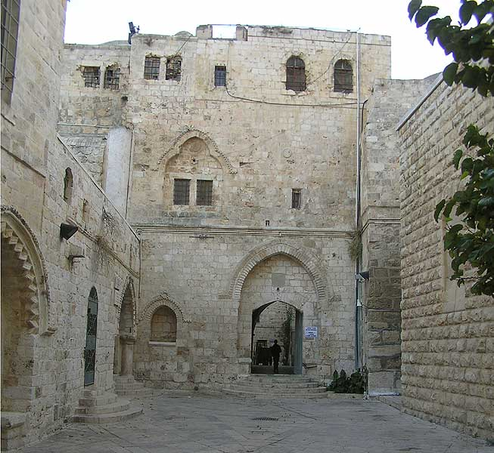 http://www.eons.com/photos/group/catholics-50-3/photo/540666-Cenacle-Jerusalem?context=group

The Coliseum
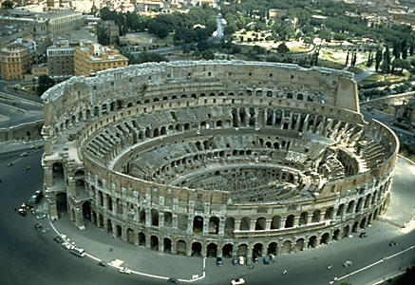 http://scienceblogs.com/framing-science/2008/02/framing_science_from_rome_ital.php

St. John Lateran Baptistery
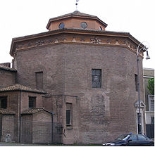 http://www.answers.com/topic/baptistery
Hagia Sophia, Istanbul
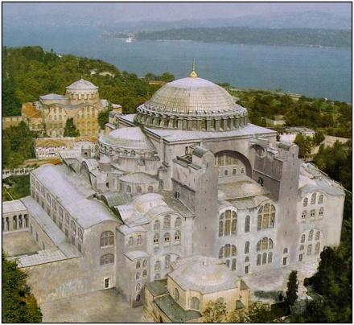 http://www.skyscrapercity.com/showthread.php?t=1284623

Iona
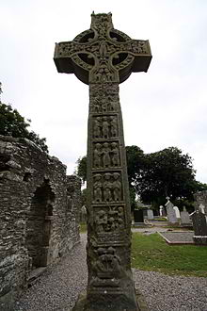
http://en.wikipedia.org/wiki/Celtic_cross

Monte Cassino
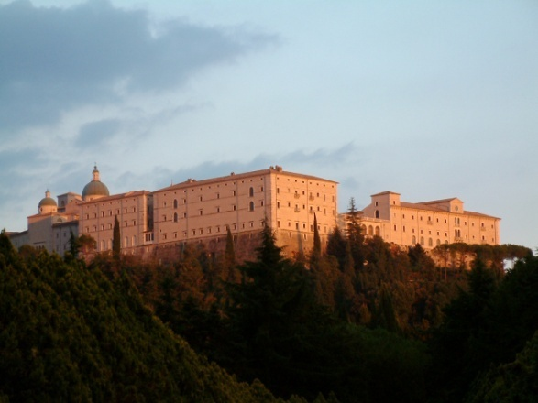
http://m.wikitravel.org/en/Monte_Cassino

Aachen Cathedral
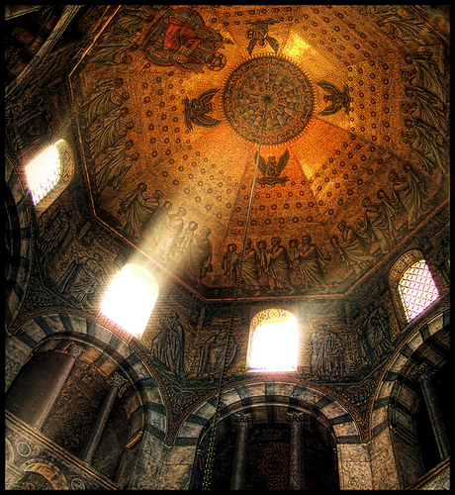 http://www.flickr.com/photos/joeproosen/2241727127/

St. Francis Basilica, Assisi
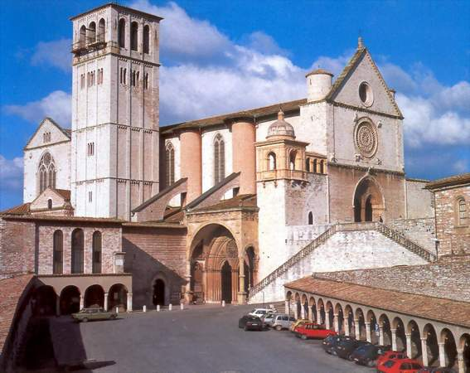 http://www.costadelloco.it/english/activitates-residence-costa-del-loco.html

Notre Dame, Paris
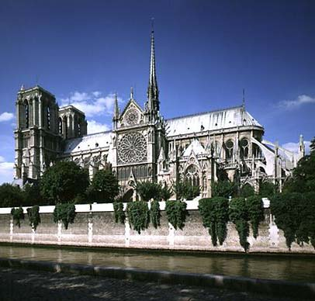 http://www.destination360.com/europe/france/paris/cathedrale-notre-dame-de-paris

Sistine Chapel, Rome
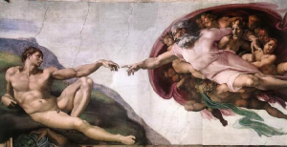 http://www.openculture.com/2010/03/a_virtual_tour_of_the_sistine_chapel.html

Church of the Gesu, Rome
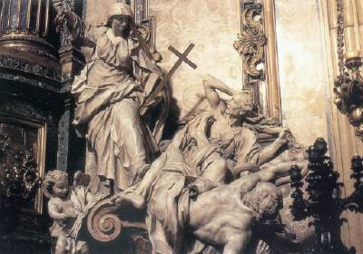
http://www.traditioninaction.org/SOD/j069sdAldalbert4-23.htm

Our Lady of Guadalupe
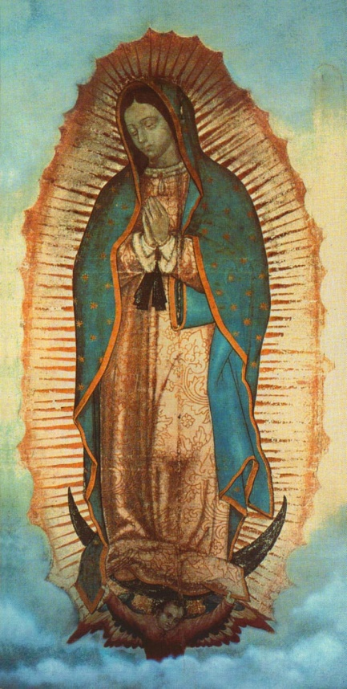
http://tobtoday.com/2011/01/09/our-lady-of-guadalupe-an-icon-for-life-love-and-the-new-evangelization/

Vatican
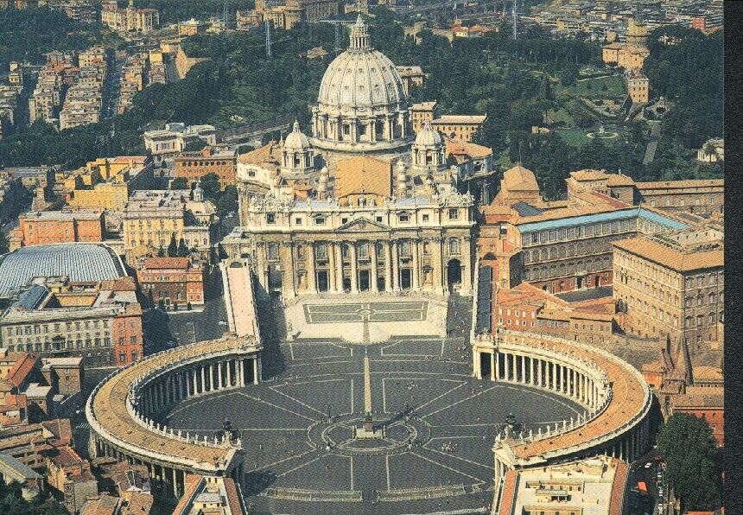 http://www.hotelsinrome-italy.com/st-peters-basilica-the-most-pious-christian-church.html

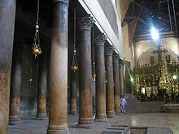
Church of the nativity, Bethlehem
http://en.wikipedia.org/wiki/Church_of_the_Nativity

