Episode 11 Gesu urls
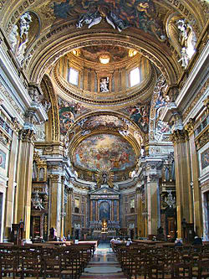
Interior of Gesu
http://en.wikipedia.org/wiki/Church_of_the_Gesu

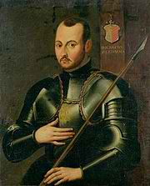
St. Ignatius Loyola in Knight’s armor
http://en.wikipedia.org/wiki/File:Ignatius_of_Loyola_(militant).jpg

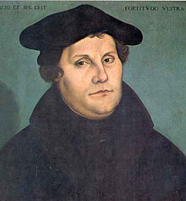
Lucas Cranach, Martin Luther
http://en.wikipedia.org/wiki/Martin_Luther

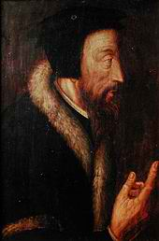
John Calvin
http://en.wikipedia.org/wiki/John_Calvin
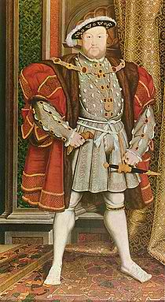
Henry VIII, Hans Holbein
http://en.wikipedia.org/wiki/Henry_viii

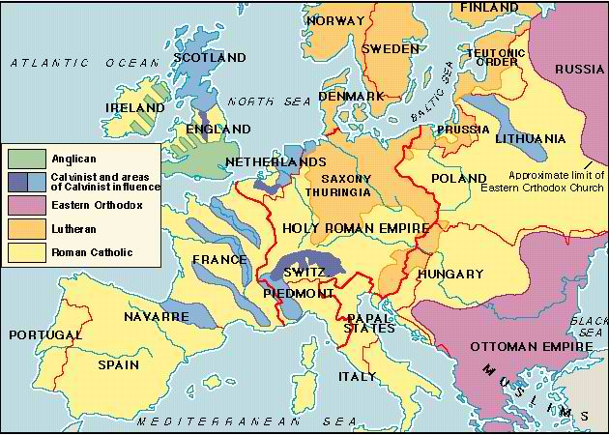
http://www.wwnorton.com/college/history/ralph/resource/religion.htm


http://en.wikipedia.org/wiki/Society_of_Jesus

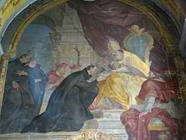
Pope Paul III giving Ignatius Loyola Bull of Approval
http://en.wikipedia.org/wiki/Society_of_Jesus

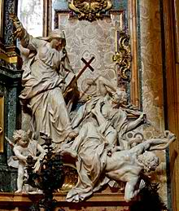
Church of Gesu, Religion overthrowing heresy, Luther and Calvin
http://en.wikipedia.org/wiki/Pierre_Legros

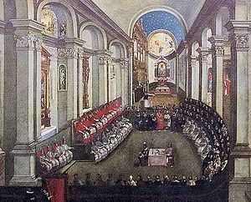
Council of Trent
http://en.wikipedia.org/wiki/Council_Trent

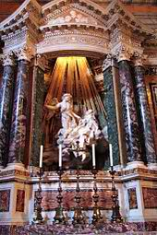
Bernini, St. Teresa of Avila
http://en.wikipedia.org/wiki/Teresa_of_%C3%81vila

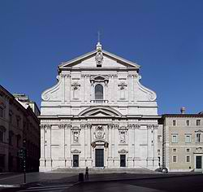
Entrance Church of Gesu
http://en.wikipedia.org/wiki/Church_of_the_Gesu

