Episode 12 urls Guadalupe
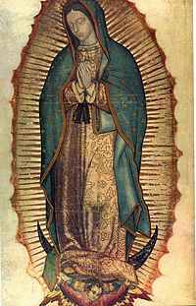
Our Lady of Guadalupe
http://en.wikipedia.org/wiki/Our_Lady_of_Guadalupe

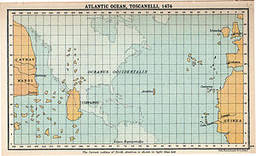
15th C map of the world
http://en.wikipedia.org/wiki/Christopher_Columbus

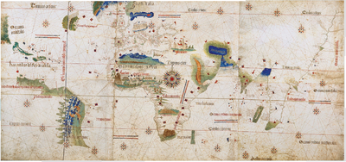
Columbus discoveries of ‘India’
http://en.wikipedia.org/wiki/Age_of_Discovery

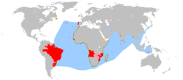
Portuguese Empire 16th C
http://en.wikipedia.org/wiki/Portuguese_Empire

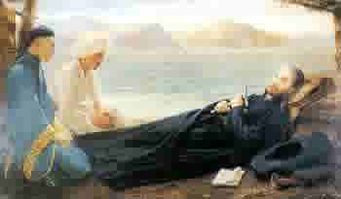
Death of St. Francis Xavier in Japan
http://fatherdoyle.com/category/spiritual-exercises/

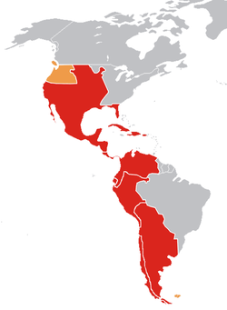
Spanish colonies 18th C
http://en.wikipedia.org/wiki/Spanish_colonization_of_the_Americas

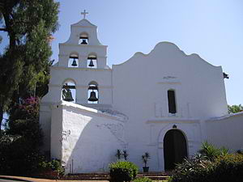
San Diego Mission, San Diego California
http://en.wikipedia.org/wiki/Mission_San_Diego_de_Alcala

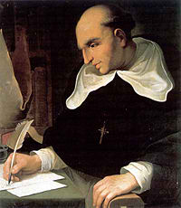
Bortolomeo de las Casa
http://en.wikipedia.org/wiki/Bartolom%C3%A9_de_las_Casas

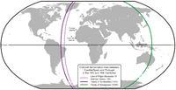
Line of Demarcation Pope Alexander VI
http://en.wikipedia.org/wiki/Age_of_Discovery

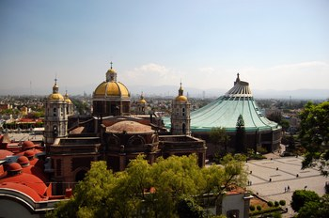
Old and New Bailica of Our Lady of Guadalupe
http://www.sacred-destinations.com/mexico/mexico-city-basilica-guadalupe

