Episode 3 URLs Coliseum
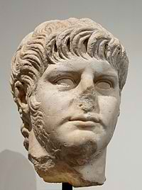
Bust of Nero
http://en.wikipedia.org/wiki/File:Nero_Palatino_Inv618.jpg

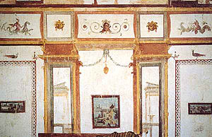
Domus Aurea
http://en.wikipedia.org/wiki/Domus_Aurea

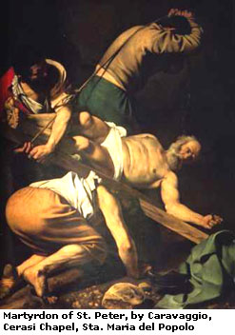
Crucifixion of St Peter, Caravaggio
http://en.wikipedia.org/wiki/Crucifixion_of_St._Peter_(Caravaggio)

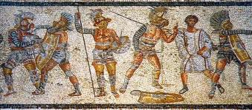
http://en.wikipedia.org/wiki/Roman_gladiators

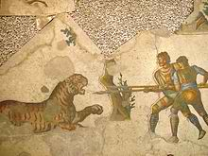
http://en.wikipedia.org/wiki/Roman_gladiators
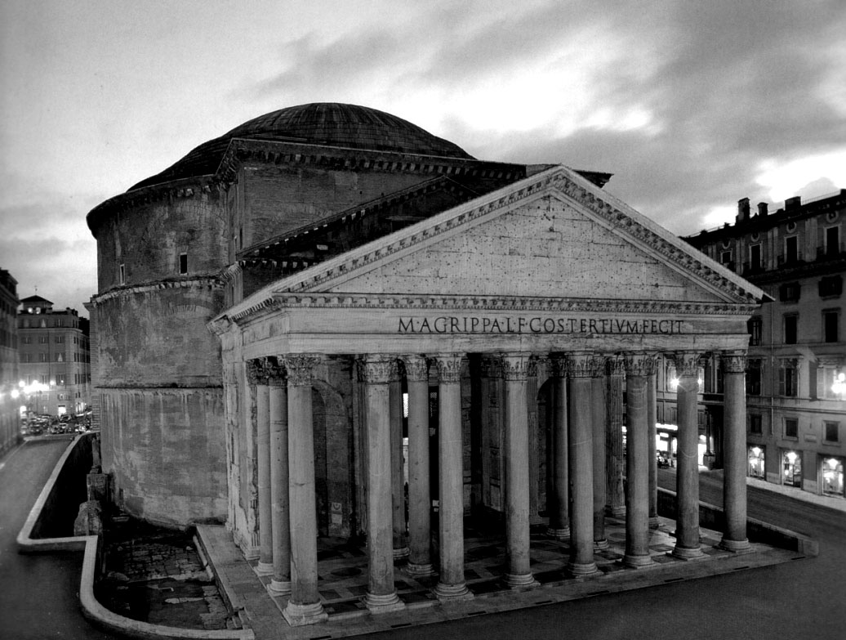
Panthenon

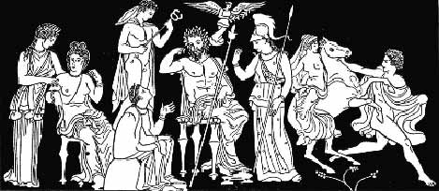
Roman gods
http://www.crystalinks.com/romegods.html

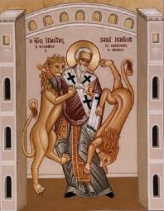
http://en.wikipedia.org/wiki/Ignatius_of_Antioch

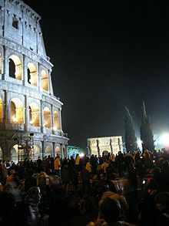
Good Friday Way of the Cross
http://en.wikipedia.org/wiki/Good_Friday

