Episode 4 URLs
St. John Lateran Baptistery
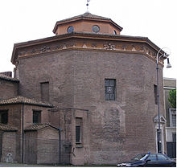 http://www.answers.com/topic/baptistery

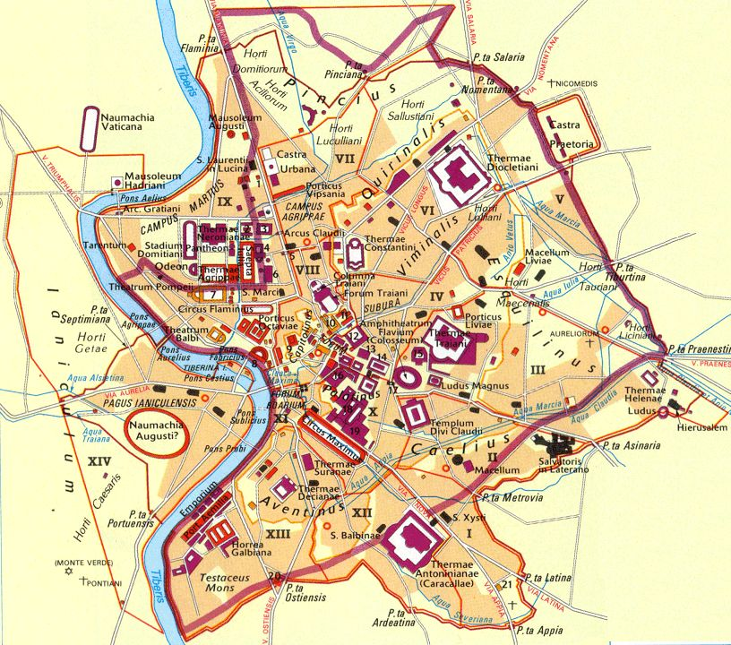

http://www.google.com/imgres?imgurl=http://imagerepository.net/images/a/n/21/ancient-rome-city-map/3-ancient-rome-city-map.jpg&imgrefurl=http://www.mytigi.com/8641.html&usg=__Q1ueRi6iSm-Y7aUyo860IGL6W7I=&h=720&w=816&sz=171&hl=en&start=28&sig2=s5LbjTuEB5diJAq_5dy8Vw&zoom=1&tbnid=odV3ygUPCiDYMM:&tbnh=159&tbnw=180&ei=x_XQTf-PC8rDgQfp28mhDA&prev=/search%3Fq%3Dmap%2Bancient%2Brome%2Bcity%26um%3D1%26hl%3Den%26biw%3D1659%26bih%3D844%26tbm%3Disch0%2C886&um=1&itbs=1&iact=hc&vpx=1050&vpy=284&dur=2935&hovh=211&hovw=239&tx=161&ty=126&page=2&ndsp=28&ved=1t:429,r:18,s:28&biw=1659&bih=844
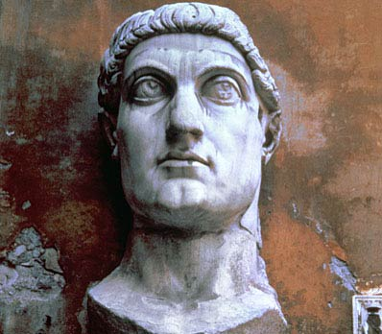
http://www.bbc.co.uk/history/ancient/romans/romespivotalemperors_gallery_06.shtml

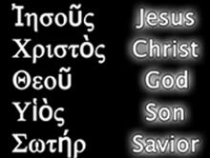

http://www.lutheransonline.com/servlet/lo_ProcServ/dbpage=page&mode=display&gid=20052995655655607101111555&pg=20053040942236960101111555

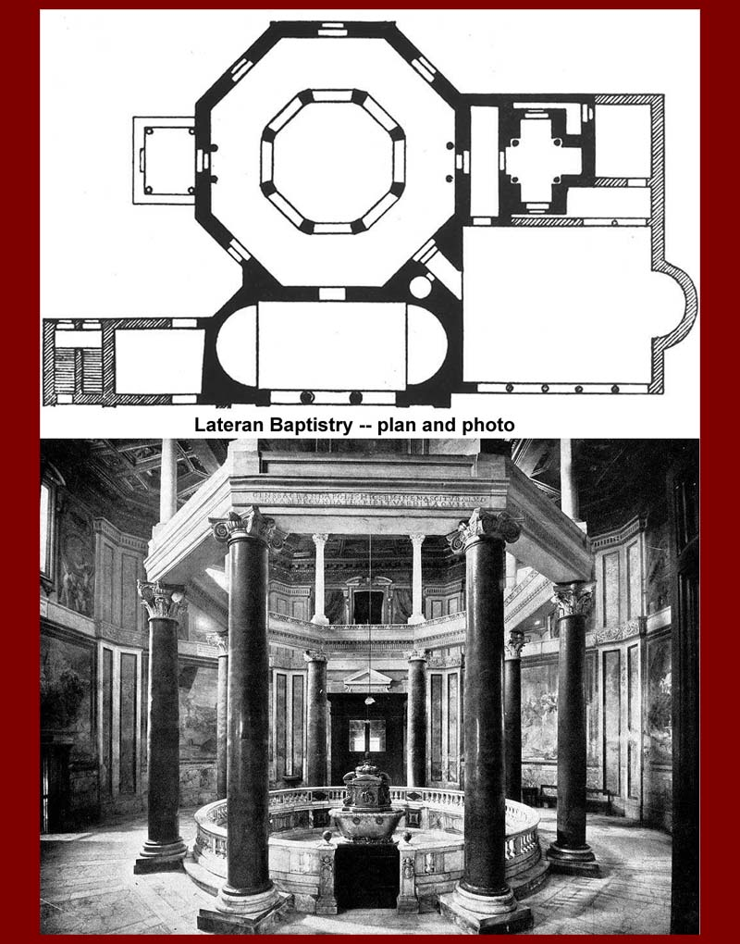 http://www.mmdtkw.org/MedRom0130-LateranBaptistry.jpg

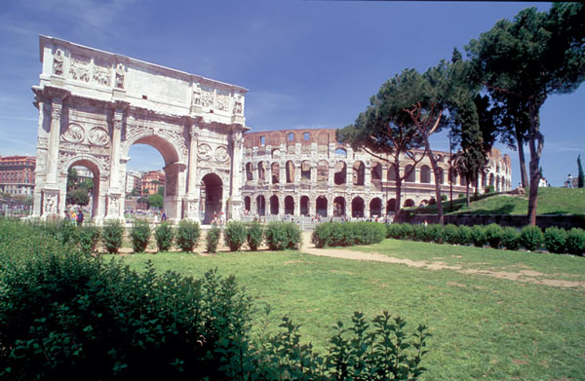
http://www.theodora.com/wfb/photos/italy/italy_photos_3.html
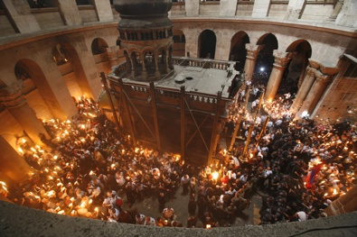
http://www.gojerusalem.com/article_1086/The-Church-of-the-Holy-Sepulchre----Virtual-Tour

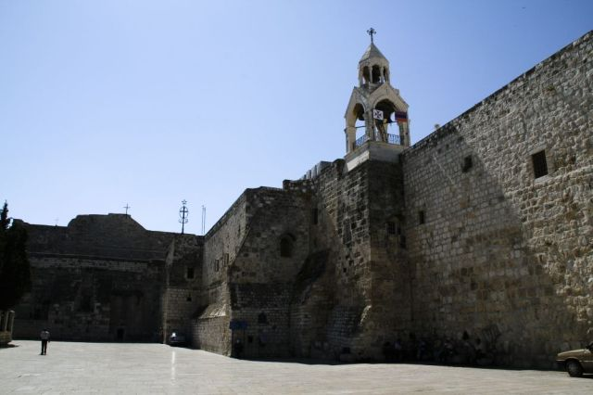
http://en.wikipedia.org/wiki/File:Bethlehem-03-Church_of_the_Nativity.jpg

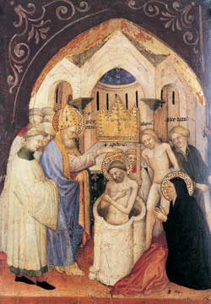
Nicolai Di Pietro, St. Ambrose Baptizing St. Augusitne
http://www.google.com/imgres?imgurl=http://www.breviary.net/images/ambroseandaugustine.jpg&imgrefurl=http://www.breviary.net/propsaints/propsaints12/propsaints1207.htm&usg=__cqYXMoeJXDgfGA8_UMSr89pg2Oo=&h=360&w=250&sz=18&hl=en&start=0&sig2=rKpshBS_fBceTt4IsuY-qA&zoom=1&tbnid=VQto6BRbSUph8M:&tbnh=160&tbnw=111&ei=t53wTZDsJojDgQepmPSPAw&prev=/search%3Fq%3Dst.%2Bambrose%2Bbaptizing%2Bst.%2BAugustine%26um%3D1%26hl%3Den%26sa%3DN%26biw%3D1659%26bih%3D844%26tbm%3Disch&um=1&itbs=1&iact=hc&vpx=322&vpy=419&dur=2347&hovh=270&hovw=187&tx=91&ty=169&page=1&ndsp=39&ved=1t:429,r:21,s:0&biw=1659&bih=844

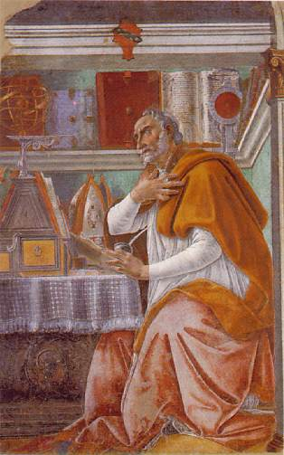
St. Augustine, Sandro Botticelli
http://www.1902encyclopedia.com/A/AUG/saint-augustine.html

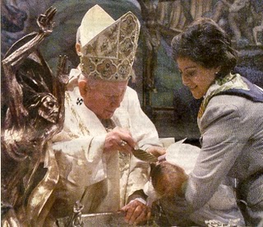
http://stlouiscatholic.blogspot.com/2007/07/archdiocesan-newspaper-clarifies-its.html

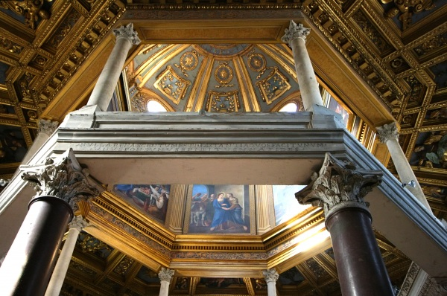

http://www.historic-places.com/italy/san-giovanni-fonte-lateran-baptistery-rome


St. Jerome
http://en.wikipedia.org/wiki/File:St.-Jerome-In-His-Study.jpg

