Episode 5 Monasteries
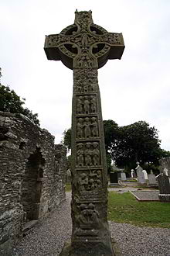
Celtic Cross
http://en.wikipedia.org/wiki/Celtic_cross

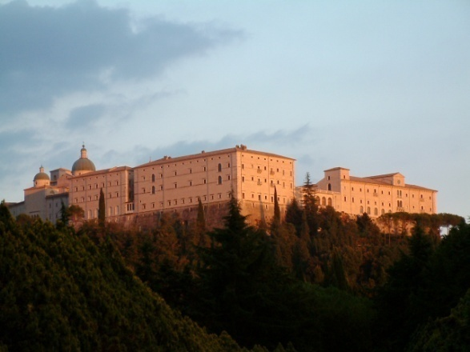
Monte Cassino
http://en.wikipedia.org/wiki/Monte_Cassino

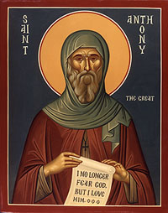
http://orthodoxwiki.org/Anthony_the_Great

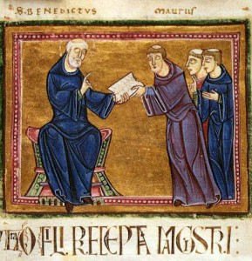
http://medievalminds.com/?tag=saint-benedicts-rule

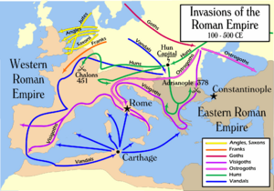
http://www.google.com/imgres?imgurl=http://library.kiwix.org:4201/I/300px_Invasions_of_the_Roman_Empire_1.png&imgrefurl=http://library.kiwix.org:4201/A/Early_Middle_Ages.html&usg=__gEiXThbrGLjY3g_qUZvoK1ESJx4=&h=210&w=300&sz=69&hl=en&start=60&sig2=Zgxt8MqQYny1dm43H3w-Vg&zoom=1&tbnid=NATfJg0M7uMJzM:&tbnh=154&tbnw=220&ei=E63wTbTMM4jrgQei4sGHAw&prev=/search%3Fq%3Dmap%2Bgermanic%2Binvasions%2B5th%2Bc%2Beurope%26um%3D1%26hl%3Den%26sa%3DG%26biw%3D1659%26bih%3D844%26tbm%3Disch&um=1&itbs=1&iact=hc&vpx=866&vpy=244&dur=3687&hovh=168&hovw=240&tx=101&ty=89&page=3&ndsp=29&ved=1t:429,r:10,s:60&biw=1659&bih=844

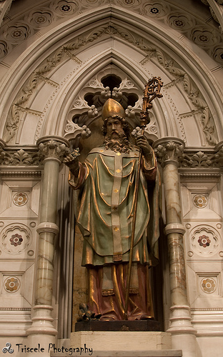
St. Patrick in Holy Cross Cathedral, Boston
http://www.flickr.com/photos/ajabrams/sets/72157610371904776/detail/

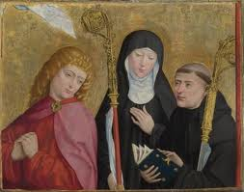
http://vultus.stblogs.org/2010/02/

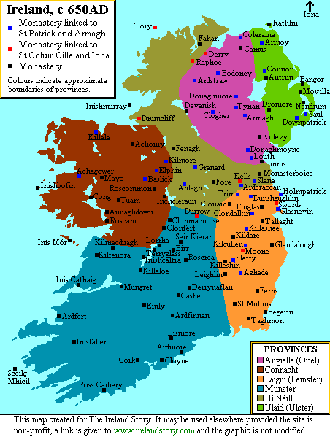

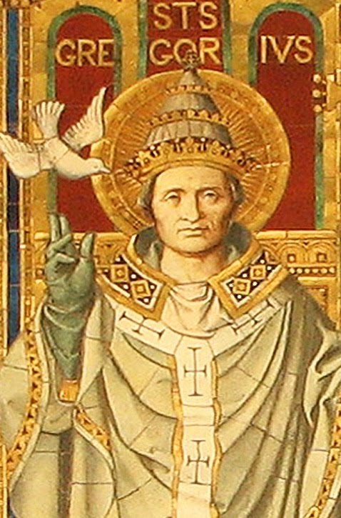
http://aesaintsoftheday.blogspot.com/2010/09/pope-st-gregory-great.html

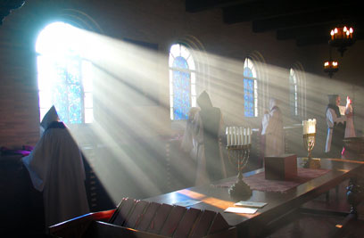
St. Joseph’s Monastery, Spencer, MA
http://www.spencerabbey.org/

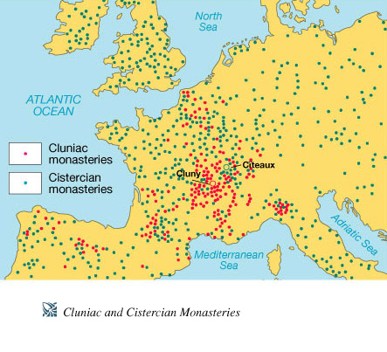
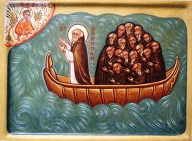
St. Brendon
http://osbnanglican.org/about.shtml

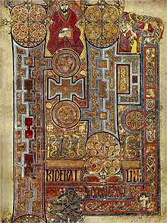
Book of Kells
http://en.wikipedia.org/wiki/Iona

