Episode 7 Charlemagne

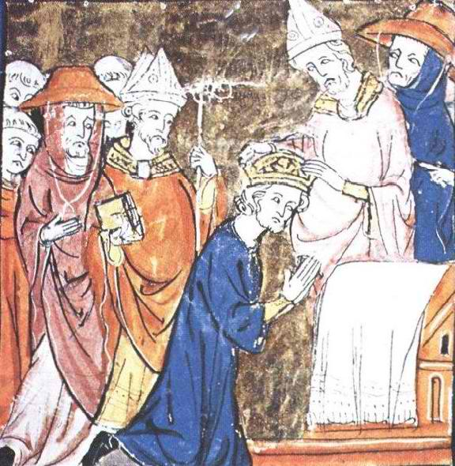
http://www.uncp.edu/home/rwb/lecture_mid_civ.htm

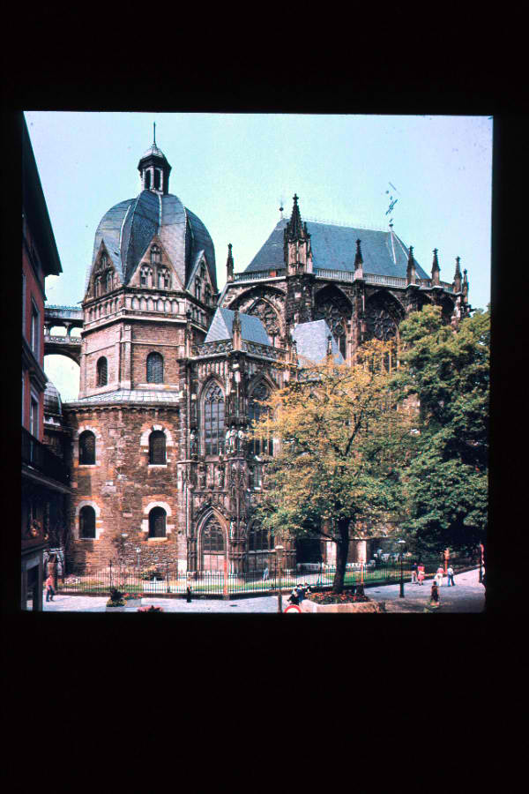
http://www.uncp.edu/home/rwb/lecture_mid_civ.htm

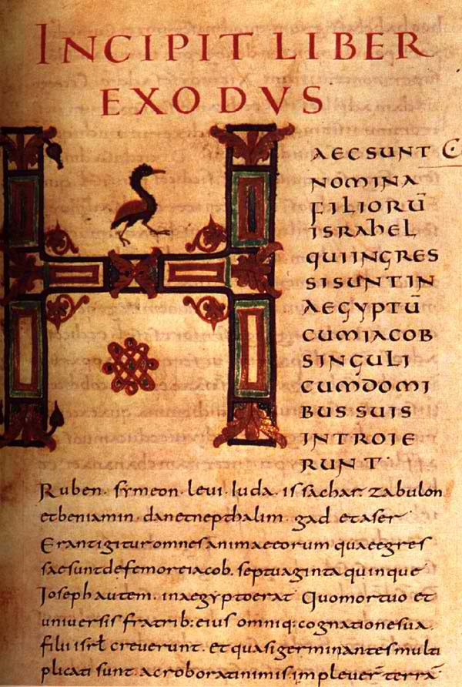
http://www.uncp.edu/home/rwb/lecture_mid_civ.htm

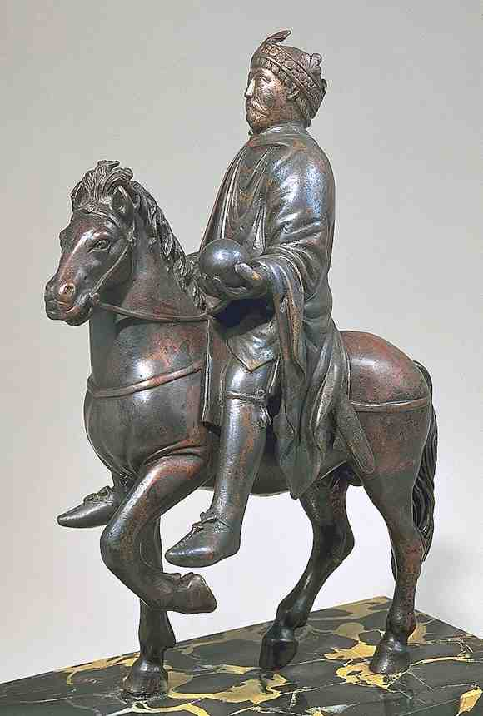
http://www.shafe.co.uk/art/Equestrian_statue_of_Charlemagne_(Paris-_Louvre).asp

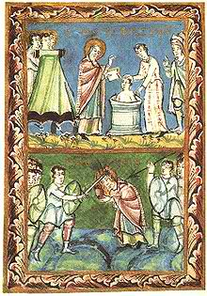
http://en.wikipedia.org/wiki/Saint_Boniface

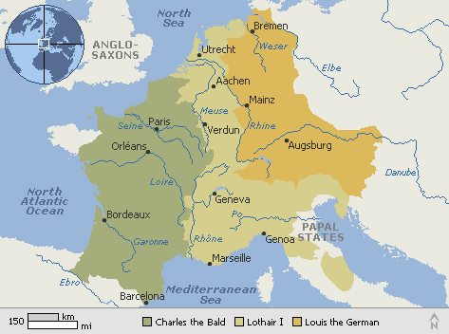
http://mrgranito.wordpress.com/2009/05/08/dividing-charlemagnes-empire/

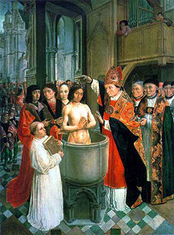
http://schools-wikipedia.org/wp/h/History_of_Christianity.htm

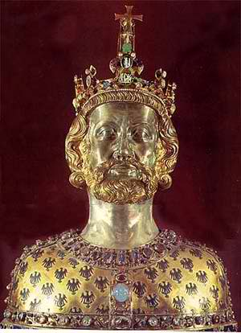
http://www.shafe.co.uk/art/Reliquary_Bust_of_Charlemagne-_Aachen_Treasury.asp

