Episode 9 Notre Dame
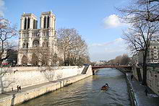
http://en.wikipedia.org/wiki/Notre_Dame_de_Paris
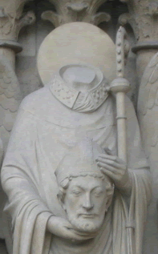
St. Denis on left portal of Notre Dame
http://en.wikipedia.org/wiki/Denis

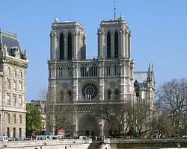
Square in front of Notre Dame
http://en.wikipedia.org/wiki/Notre_Dame_de_Paris

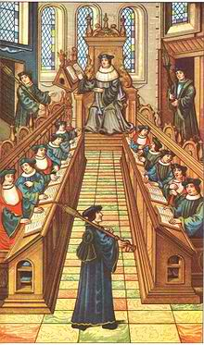
Meeting of doctors at University of Paris, Medieval manuscript
http://en.wikipedia.org/wiki/University_of_Paris

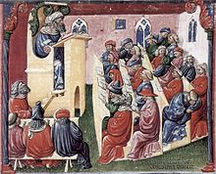
http://en.wikipedia.org/wiki/Medieval_university

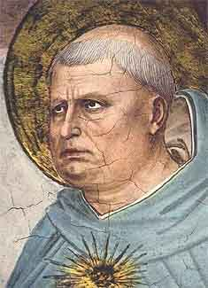
Thomas Aquinas by Fra Angelico
http://en.wikipedia.org/wiki/Thomas_Aquinas

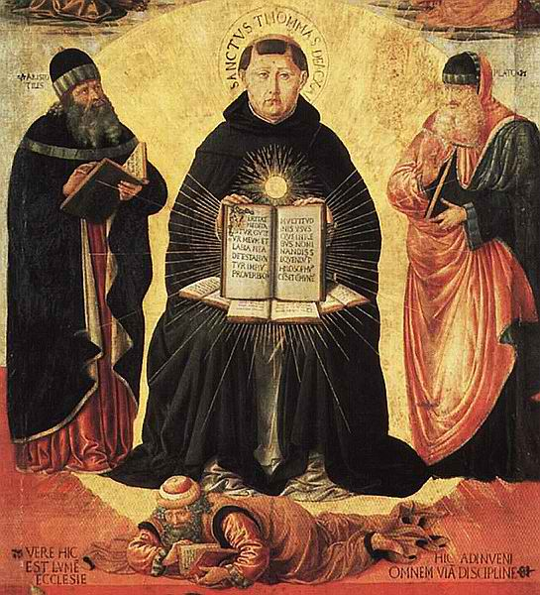
Aquinas flanked by Aristotle and Plato with Averroes below, by Benozzo Gozzoli
http://en.wikipedia.org/wiki/File:Benozzo_Gozzoli_004a.jpg

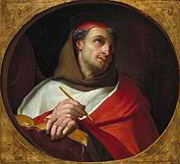
St. Bonaventure
http://en.wikipedia.org/wiki/St_Bonaventure

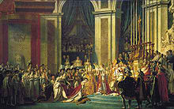
Napoleon in Notre Dame by Jacques-Louis David
http://en.wikipedia.org/wiki/Notre_Dame_de_Paris

