Hagia Sophia URLs
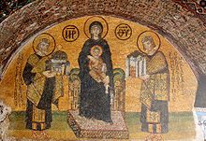
Constantine and Justinian presenting Hagia Sophia to Mary and child Jesus, Hagia Sophia
http://en.wikipedia.org/wiki/Hagia_Sophia

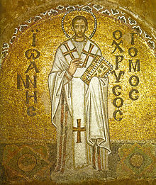
St. John Chrysostom, patriarch Constantinople; icon in Hagia Sophia
http://en.wikipedia.org/wiki/Hagia_Sophia

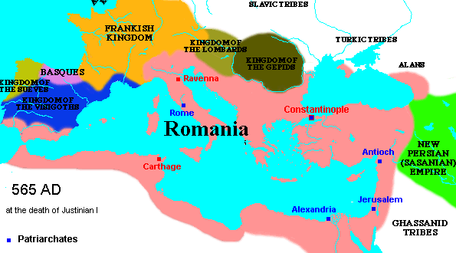
http://www.uncp.edu/home/rwb/lecture_mid_civ.htm

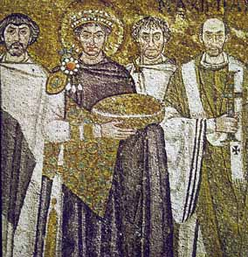
Justinian mosaic in San Vitale, Ravenna
http://www.uncp.edu/home/rwb/lecture_mid_civ.htm

Quote from Procopius at http://www.fordham.edu/halsall/source/procop-deaed1.html
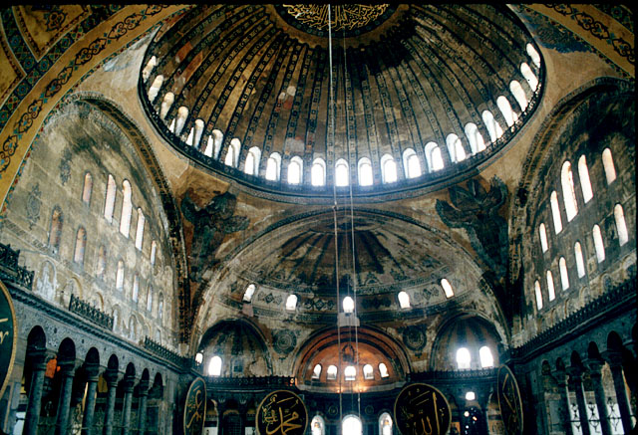

http://www.turkeyvacationplaces.com/hagia-sophia.html

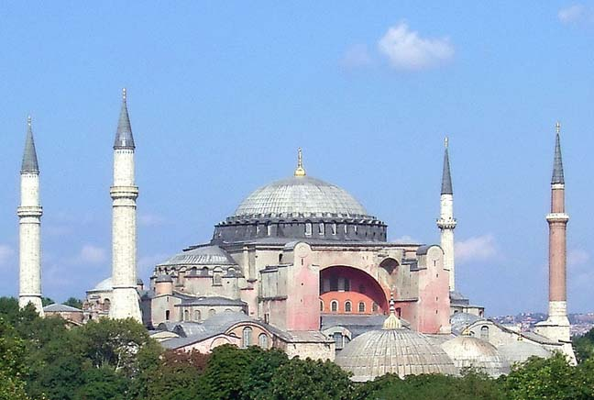
http://www.islamic-architecture.info/WA-TU/istanbul/WA-TU-IST-004.htm

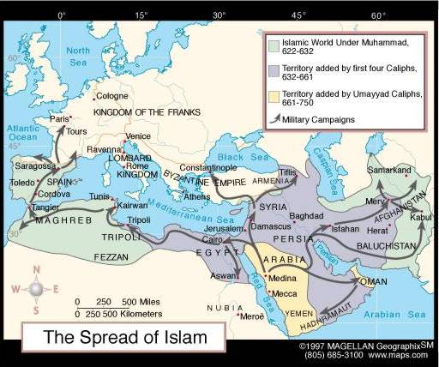
http://www.csa.com/discoveryguides/medieval/review3.php

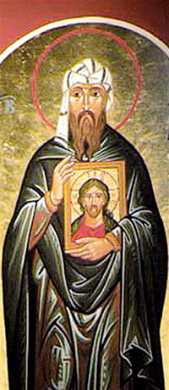
http://archbishopterry.blogspot.com/2010/12/om-st-john-of-damascus-priest-and.html

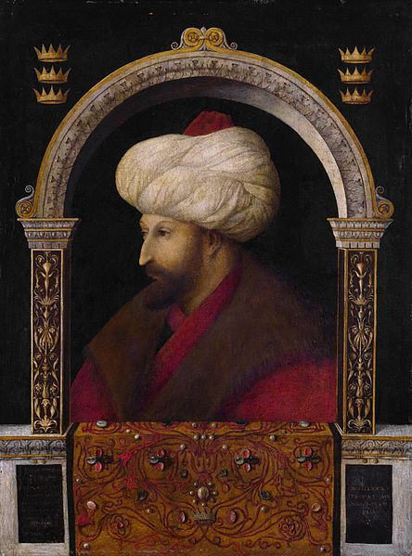
http://en.wikipedia.org/wiki/File:Gentile_Bellini_003.jpg

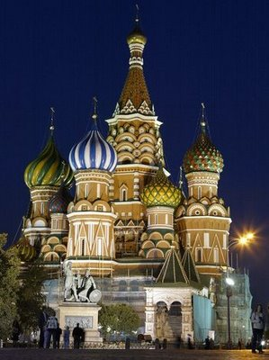
http://www.freeprintable.com/view/print-body.html?id=1990

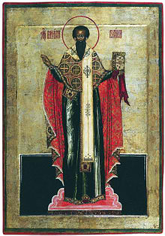
Russian icon of St. Bail the Great
http://en.wikipedia.org/wiki/Basil_of_Caesarea

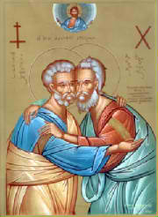
http://www.oltv.tv/
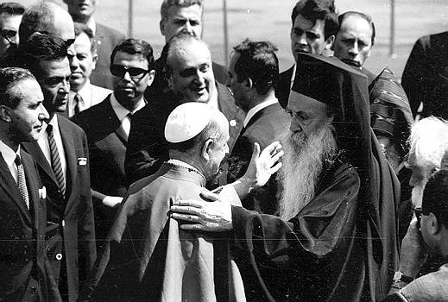
http://64.19.142.12/lh3.ggpht.com/_2Jq-SJYrBeY/TAlIgRcsGcI/AAAAAAAABsY/gEvJ8JEtivE/Athenagoras_Paulus_Istanbul_1.jpg

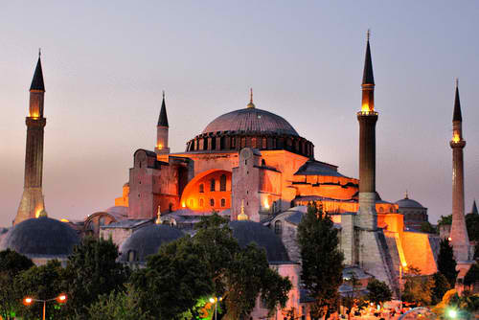
http://www.flickr.com/photos/dspender/3836504118/

