Predictors for Human Temperature Comfort

mark feldmeier

Introduction

All homes and offices have environmental control systems. These usually consist of a source of hot or cold air, and a thermostat located nearby which turns the source on or off to regulate the temperature of the room. Unfortunately, the inhabitants of most spaces are not located near the thermostat, so the system does not adequately regulate the temperature for their comfort. The system also does not know whether or not a person is in the room, requiring that the ventilation run continuously, regardless of its demand. A more energy efficient and effective environmental control system can be achieved by placing the thermostat on the person, creating a more personalized and responsive space which knows when people enter a room, and what their current comfort level is.

The objective of this work is to determine the ability of a simple sensor system to predict human temperature comfort. Our perceived comfort level is a function of many factors: metabolic rate, stress, fatigue, activity level, etc. It is possible that there is no clear correlation between ambient air temperature and our perception of hot or cold. Exactly how does our body express its comfort level? Further more, for this wearable thermostat to be economically and socially acceptable, it must contain a minimum complement of sensors to keep costs down, and have these sensors located on the body in such a fashion as to not bother the user. In the ideal case, a single sensor would be worn as a button on the user's shirt, and transmit the user's preference wirelessly to the environmental control system.

Methodology

There are many possible locations and types of sensors which could be of use to the wearable thermostat. The locations chosen for this work are based upon places on the body which are currently ornamented: finger (rings), wrist (watches), neck (necklaces), chest (necklaces), shirt exterior (pendants). And, although there are many sensors which may be relevant, temperature and humidity sensors were chosen as the most likely candidates for predicting environmental comfort. To this end, a wearable temperature and humidity logging device (see Figure 1) was developed which would record the time of day, all sensor readings, and the user's comfort level. Every five minutes, a pager motor on the device would vibrate, queuing the user to input his preference. One button represented 'hot' (+1), the other 'cold' (-1), and both pressed at the same time represented 'neutral' (0). 'hot' and 'cold' were determined by the user as states where, if given the option, an outer layer of clothing would be added or removed to help improve thermal comfort. A sample of the raw sensor data can be seen in Figure 2. The system was worn and trained for a single user, as thermal comfort patterns are different for each person, and a wearable thermostat would have to learn the preferences of its owner.
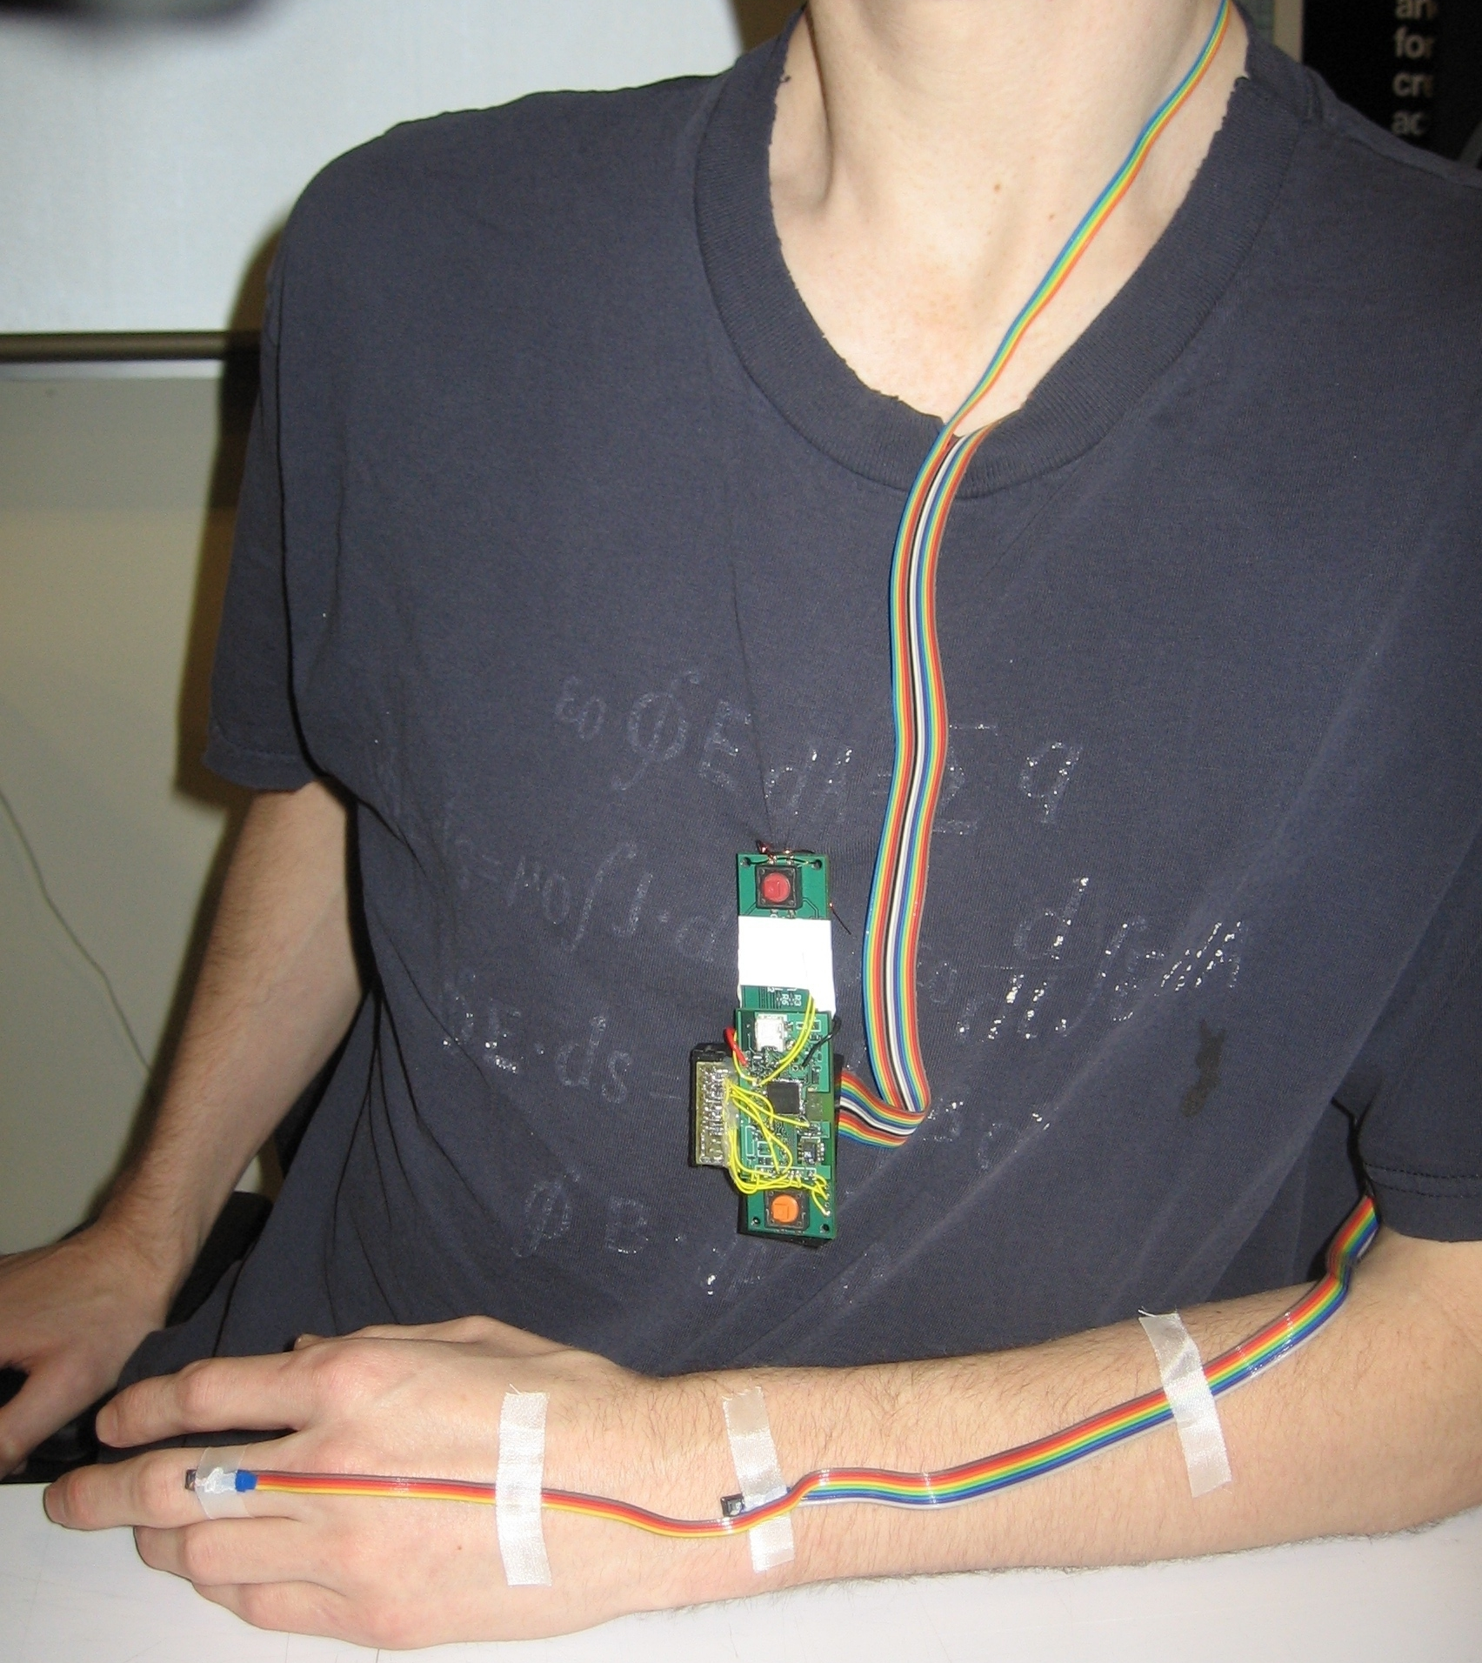Figure 1: Sensor system as worn by user

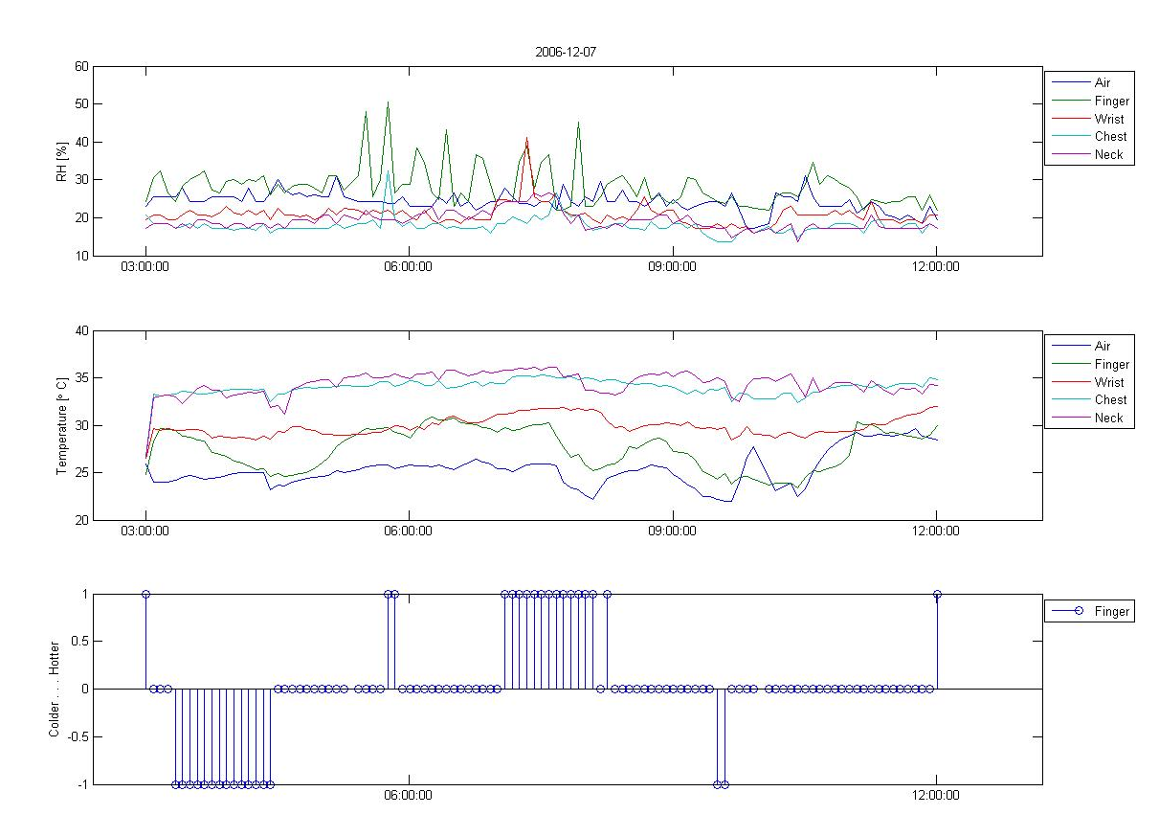Figure 2: Raw data from sensors (Humidity, Temperature, Preference)

Hardware

The core of the sensing system (see Figure 3) is based upon the CARGONET environmental data logging board developed by Mateusz Malinowski. It has a TI MSP430, low power micro controller which communicates with the sensors, logs the data, and uploads these data to a computer via USB. It also has a real time clock for logging time and waking up the system from sleep mode every five minutes. Finally, it has an on board temperature and humidity sensor. All sensors in the system are the Sensirion SHT15 (see Figure 4), which is extremely small, has a fast response time (<4s), combines both humidity and temperature sensing in one package, and has humidity accuracy of +/-2% RH and temperature accuracy of +/-.3 degrees Celsius. Four of these sensors were tethered via ribbon cable to be mounted to the body at the aforementioned locations with medical tape, and the fifth sensor was located on the board to gather ambient air temperature at the user's location. This gives a total of 10 sensors at five locations.

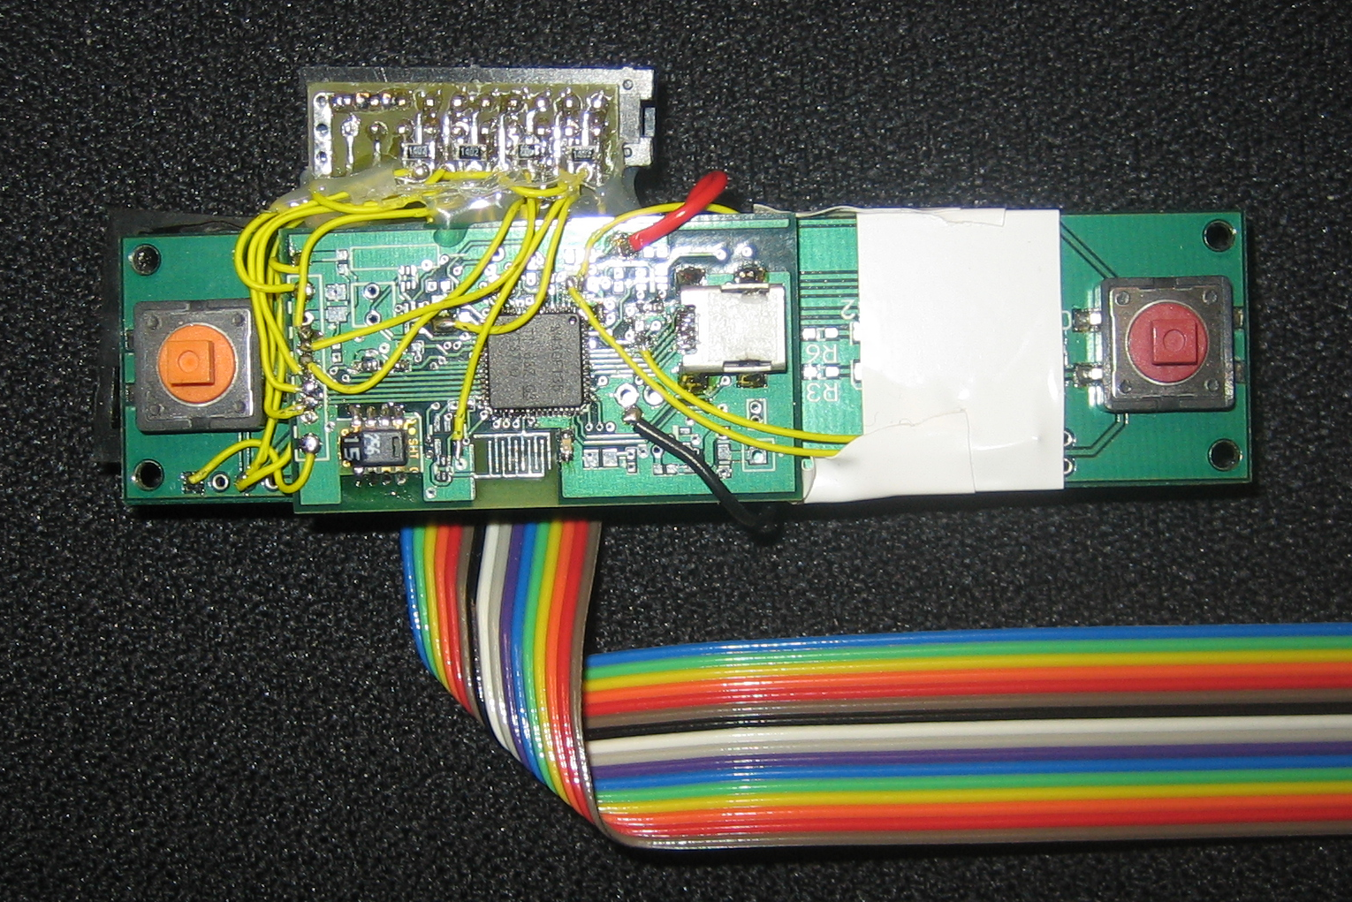Figure 3: Data logging system
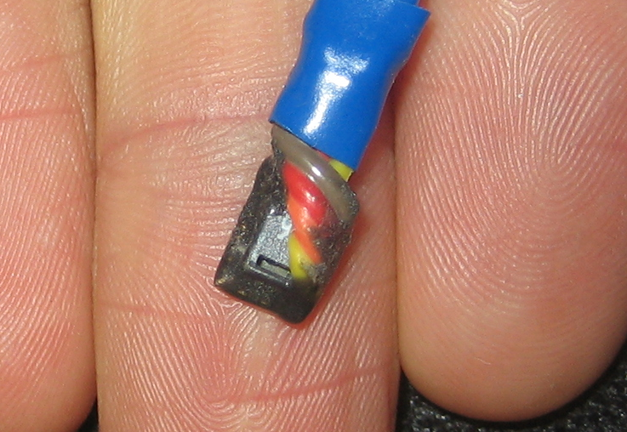Figure 4: SHT15 temperature and humidity sensor

Data Analysis

Data was collected for four days, giving 360 data points. Given the large dimensionality of the data set, this is a relatively small set of data points. To help reduce non-representative results given this small data set, the results were averaged over the entire data set. This was done by dividing the data into ten random sets without replacement. The algorithms were then trained on 9 of these sets and tested on the remaining one. This was then repeated for all 10 permutations of the sets, and the testing results were averaged over these permutations. The time data was not used, as the moving between hot and cold environments required to gather enough data points in each class produced a time series which did not relate to the current level of comfort.

Two different algorithms were chosen to test the ability of the system to predict the thermal comfort of the user. The first was a Gaussian model which simply took the mean and covariance of each of the sets of the training data marked by the user as hot, cold, and neutral. The testing data points were then inputted to each of the models, and each testing data point would receive the class of the model which returned the maximum value. The accuracy of the system was determined by the total number of correct labellings, divided by the total number of testing data points. The second algorithm was a K-Nearest Neighbor algorithm which was trained with a leave one out strategy. The tested data point would assume a class label which represents the average of the K nearest neighbors' class labels. Since the system rounded .5 up to 1 and -.5 down to -1, this broke ties by favoring either 'hot' or 'cold' over neutral, assuming that there would generally not be a tie between 'hot' and 'cold'. The value of K was chosen as the value, less than 10, which returned the highest accuracy on the training data, when trained on all possible permutations of which data point was left out. K was chosen to be less than 10 to keep processing time down, as 10 was the maximum value observed for a few runs which were allowed to test values of K up to the number of data points in the training set.

Results

These two algorithms were then tested on all possible sensor combinations. The top ten sensor combinations for each quantity of sensors were returned, along with the accuracies associated with these combinations (see Figure 6). A plot of the maximum accuracy versus sensor quantity can be seen in Figure 5. The K-Nearest Neighbor algorithm was more accurate than the Gaussian model, although they both showed a maximum accuracy with seven sensors. The dotted line in Figure 5 shows the maximum accuracy achievable with each model given the number of body positions rather than the number of sensors. For example, 1 represents one sensor at one point on the body, 2 represents two sensors at the same location on the body, and 7 represents seven sensors at 4 locations on the body.

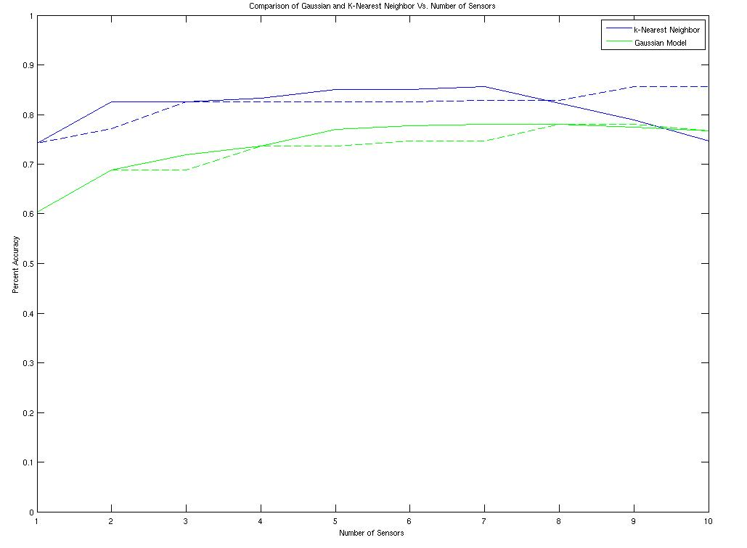Figure 5: Maximum accuracy versus number of sensors for Gaussian model and K-Nearest Neighbors

From Figure 6 it can be seen that the wrist temperature sensor was the best single sensor, with the chest humidity sensor being the next best sensor to add. The chest temperature sensor was the third best sensor to add, with minimal improvements in accuracy from adding more sensors. Both algorithms concur on which sensors have the strongest correlation with thermal comfort.

Sensor Number Sensor Location / Type

1 hand / humidity
2 hand / temperature
3 wrist / humidity
4 wrist / temperature
5 chest / humidity
6 chest / temperature
7 neck / humidity
8 neck / temperature
9 air / humidity
10 air / temperature

Sensor Number(s) K-NN Accuracy Sensor Number(s) Gaussian Accuracy

8 0.6028 9 0.3333
7 0.6250 2 0.3417
9 0.6417 3 0.3667
1 0.6583 10 0.3972
10 0.6611 8 0.3972
6 0.6806 6 0.4361
2 0.6833 7 0.4417
3 0.6861 5 0.5250
5 0.7222 1 0.5806
4 0.7417 4 0.6028

4 7 0.7556 1 9 0.6000
4 9 0.7556 4 9 0.6083
5 9 0.7583 3 4 0.6250
2 4 0.7583 4 7 0.6333
3 4 0.7611 1 4 0.6417
4 10 0.7639 5 8 0.6472
5 6 0.7722 4 5 0.6528
4 8 0.7806 4 8 0.6778
4 6 0.8194 4 6 0.6861
4 5 0.8250 5 6 0.6889

2 4 5 0.7806 3 5 6 0.6889
2 3 5 0.7861 1 5 6 0.6944
4 5 9 0.7861 2 4 6 0.6944
2 4 6 0.7944 5 6 8 0.6944
3 4 5 0.7972 3 4 6 0.6944
4 5 8 0.8056 1 4 6 0.6972
4 5 10 0.8083 4 6 9 0.6972
4 6 10 0.8083 4 6 8 0.7000
4 6 8 0.8111 4 6 7 0.7167
4 5 6 0.8250 4 5 6 0.7194

4 5 7 10 0.8028 1 4 6 8 0.7194
4 7 9 10 0.8083 2 4 5 6 0.7222
2 4 6 10 0.8083 1 4 6 9 0.7222
4 5 9 10 0.8083 1 4 5 6 0.7250
2 4 6 8 0.8139 1 4 6 7 0.7250
2 4 5 7 0.8139 3 4 6 8 0.7250
2 4 5 8 0.8139 3 4 5 6 0.7278
3 4 5 10 0.8194 4 6 7 8 0.7278
2 4 5 6 0.8222 4 6 8 9 0.7361
4 5 6 10 0.8333 4 5 6 8 0.7361

2 4 5 6 8 0.8194 4 6 7 8 9 0.7333
2 4 5 8 10 0.8194 1 3 4 5 6 0.7361
4 5 6 7 10 0.8194 1 4 6 7 8 0.7389
4 5 6 8 9 0.8194 4 5 6 7 8 0.7389
4 5 7 8 10 0.8194 1 3 4 6 8 0.7417
2 3 5 6 10 0.8222 2 4 5 6 8 0.7444
4 5 6 8 10 0.8278 2 3 4 5 6 0.7472
2 3 4 5 8 0.8306 3 4 5 6 8 0.7472
2 4 5 7 8 0.8333 1 4 6 8 9 0.7500
2 4 5 7 10 0.8500 1 4 5 6 8 0.7694

2 4 5 6 9 10 0.8167 4 5 6 7 8 10 0.7500
4 5 7 8 9 10 0.8167 1 3 4 6 8 9 0.7528
2 3 4 5 8 10 0.8194 1 4 6 7 8 9 0.7528
4 5 6 8 9 10 0.8194 3 4 5 6 8 9 0.7528
2 4 5 6 7 8 0.8222 1 2 4 5 6 8 0.7556
2 3 4 5 6 10 0.8361 1 3 4 5 6 8 0.7583
2 4 5 7 8 10 0.8361 1 4 5 6 8 9 0.7639
2 3 4 5 6 8 0.8389 1 4 5 6 7 8 0.7750
2 4 5 6 7 10 0.8500 2 4 5 6 7 8 0.7778
2 4 5 6 8 10 0.8500 1 4 5 6 8 10 0.7778

2 3 4 5 7 8 10 0.8000 1 2 3 4 6 8 9 0.7611
2 3 4 5 6 8 9 0.8000 1 4 6 7 8 9 10 0.7611
4 5 6 7 8 9 10 0.8056 3 4 5 6 7 8 10 0.7611
2 3 4 6 7 9 10 0.8083 3 4 5 6 8 9 10 0.7667
2 4 5 7 8 9 10 0.8083 2 4 5 6 7 8 10 0.7694
2 3 4 5 6 8 9 0.8111 1 3 4 5 6 7 8 0.7694
3 4 5 6 7 8 10 0.8278 1 2 3 4 5 6 8 0.7722
2 3 4 5 6 7 10 0.8306 1 4 5 6 7 8 10 0.7750
2 4 5 6 7 8 10 0.8389 1 2 4 5 6 8 10 0.7778
2 3 4 5 6 8 10 0.8556 1 2 4 5 6 7 8 0.7806

2 3 4 5 6 7 9 10 0.7639 1 3 4 6 7 8 9 10 0.7639
1 2 3 5 6 7 8 10 0.7694 1 2 3 4 6 8 9 10 0.7667
2 3 4 5 6 7 8 9 0.7750 2 3 4 6 7 8 9 10 0.7667
2 3 4 5 7 8 9 10 0.7778 3 4 5 6 7 8 9 10 0.7694
3 4 5 6 7 8 9 10 0.7833 1 2 4 6 7 8 9 10 0.7694
1 2 3 4 5 6 7 10 0.7889 1 3 4 5 6 7 8 9 0.7750
1 2 3 4 5 7 8 10 0.7889 2 3 4 5 6 7 8 10 0.7750
2 4 5 6 7 8 9 10 0.8028 1 2 4 5 6 7 8 10 0.7778
2 3 4 5 6 7 8 10 0.8167 1 3 4 5 6 7 8 10 0.7778
2 3 4 5 6 8 9 10 0.8222 1 2 3 4 5 6 7 8 0.7806

1 2 3 4 6 7 8 9 10 0.7194 1 2 3 5 6 7 8 9 10 0.7111
1 2 3 5 6 7 8 9 10 0.7278 1 2 3 4 5 7 8 9 10 0.7333
1 2 3 4 5 6 7 9 10 0.7333 1 2 3 4 5 6 7 9 10 0.7333
1 2 3 4 5 6 7 8 9 0.7361 1 2 3 4 5 6 8 9 10 0.7583
1 2 3 4 5 7 8 9 10 0.7389 1 2 4 5 6 7 8 9 10 0.7611
1 3 4 5 6 7 8 9 10 0.7444 1 2 3 4 6 7 8 9 10 0.7694
1 2 3 4 5 6 8 9 10 0.7583 2 3 4 5 6 7 8 9 10 0.7722
1 2 4 5 6 7 8 9 10 0.7639 1 2 3 4 5 6 7 8 9 0.7722
2 3 4 5 6 7 8 9 10 0.7806 1 2 3 4 5 6 7 8 10 0.7722
1 2 3 4 5 6 7 8 10 0.7889 1 3 4 5 6 7 8 9 10 0.7750

1 2 3 4 5 6 7 8 9 10 0.7472 1 2 3 4 5 6 7 8 9 10 0.7667

Figure 6: Tablature of 10 most accurate sensor combinations for each quantity of sensors

Conclusions and Future Work

These preliminary results show that a wearable thermostat has the possibility of being accurate enough to regulate a building's ventilation system for a user's comfort. Although the system only reached a maximum accuracy of 85%, further work which took into account the time series data could possibly improve upon this. Also, gains could be made by changing the voting algorithm for the K-Nearest Neighbor algorithm. Since the human body works to regulate its own temperature, it is more likely that a user will be 'neutral' rather than 'hot' or 'cold', so perhaps the algorithm should favor 'neutral' classification.

