1.040/1.401

Project Management

Spring 2007

Assignment 3

To Bid or Not To Bid

To Buy or Not To Buy

Project Organization

Due: March 9, 2007

Instructor:
SangHyun Lee
Samuel Labi
Fred Moavenzadeh

Lectures: Mon & Fri 1:00 PM – 2:30 PM Rm. 1-371
Recitations: Mon 4:00 PM – 5:00 PM Rm. 1-371
Office Hours: Mon & Fri 3:00 PM – 4:00 PM Rm. 1-174

Notes:

In this assignment you are required to work INDIVIDUALLY

Assignment Submission. The assignment should be submitted via STELLAR

Questions? I encourage you to come talk to me or to send email!

Part I – Bidding Decision Based on Bonding Capacity & Other Factors (30 PT)

You are the Chief Estimator for MIT Concrete Inc. Your boss asks you to help her decide if the company should bid for the job advertised in Appendix A. The owners of the Company are split in their opinions on whether or not they want more work. MIT Concrete Inc. is very busy right now and is quite profitable. However, BHD is a General Contractor they have all wanted to work with for a long time and this looks like a good opportunity.

Facts about MIT Concrete Inc:

        - Bonding Capacity is $5,000,000

        - Current Projects in which it is a Subcontractor
          - Quincy Bridge (Total contract $2,000,000; 50% complete)
          - Harvard Gymnasium (Total Contract $750,000; 0% complete)
          - CA/T Tunnel (Total Contract $3,000,000; 75% complete)

        - Current Project in which it is a General Contractor
          - Mass Turnpike Bridge Repairs (Total Contract $1,500,000; 25% complete)

        - Management Staff is composed of:
          - 1 Owner / President
          - 1 Chief Estimator
          - 1 Project Manager
          - 1 General Superintendent
          - 2 Field Engineers
          - 2 Office Engineers
          - 2 Office Administrators
          - 3 General Foremen

        - MIT Management always aims to have a General Foreman for each project. On the other hand, the Field Engineers, Office Engineers and Office Administrators could work in maximum 2 or 3 projects depending on the size, location, and complexity of the projects. The management also thinks that the Project Manager and General Superintendent can manage up to 5 projects without assistants.

Questions

- What is the amount of Bonding Capacity available to MIT Concrete to bid on the Storm Water Pump Station project? (15 PT)
[Hint: Remember that for projects in which MIT is the general contractor, they are required to secure payment bonds in addition to other necessary bonds according to the Miller Act of 1935.]

The subcontractor is required by BHD to provide a Performance Bond equal to 100% of the subcontract value; i.e., $1,000,000. This is the amount of bonding required from the surety company to cover this job for MIT. This bond value doesn’t include the expenses of the crane and concrete pumps since that would be under an alternate add.

Now, MIT Concrete has a total bonding capacity of $5,000,000, some of which is held to furnish bonds towards its other projects. Specifically, MIT has to cover

- Performance bonds (corresponding to 100% of the remaining contract value)
- Payment bonds for projects for which it is a general contractor (corresponding to 40% of the remaining contract value per the Miller Act of 1935 as contract values lies between $1mil and $5mil).

Therefore, MIT has to be able to cover $3,625,000 in performance bonds, calculated as 2,000,000×(1-50%) + 750,000×(1-0%) + 3,000,000×(1-75%) + 1,500,000×(1-25%). Furthermore, MIT is the general contractor in the Chicago Bridge Repairs, for which it has to cover payment bonds worth 1,500,000×(1-25%)×0.4 = $450,000, according to the Miller Act of 1935. That leaves MIT concrete with a residual bonding capacity of $5,000,000 - $3,625,000 - $450,000 = $925,000.

- With the information given to you about the company and your answer to question (1), what would you recommend - To bid or not to bid? If you decide to bid, do MIT need to hire more people? (10 PT)

The Bond available to MIT Concrete is $75,000 less than the bond (performance bond) required by Barletta, so formally, MIT cannot bid.

However, $75,000 is not a significant amount compared to the size of its jobs. If MIT wants this job, it might be able to convince the surety company to cover the entire $1m. MIT’s good track record and reputation might convince the surety company to take that risk.

Nevertheless, to make the final decision, there are many additional factors MIT’s officials should consider. These factors will surely also be considered by the surety company when deciding to grant the $1m bond.

- The work they will be contracting falls within their area of expertise.
- The project is located in Boston, which is very convenient because most of their projects are close to the area, eliminating the overhead cost of transporting equipment. This could also allow for economy of scale if MIT Concrete, Inc. buys materials in bulk for all the projects in the area.
- The company is handling several projects at the same time. Thus, it seems that it is trying to expand and grow. They are also tackling different kinds of jobs (bridge, tunnel, gymnasium), which gives them even more room to expand. This new job could be a great opportunity for the company to continue growing.
- Being able to work with a company like Barletta will open up more opportunities to boost their growth.
- MIT Concrete, if awarded the contract, will not have to spend money and resources trying to get licenses, since they will be furnished by Barletta.

Notice that this list of factors consists of nothing more than elements that either increase the value of the project for MIT, or reduce the project’s risk. There are, however, some elements that don’t play in MIT’s favor for taking the new job:

- The time frame of the contract coincides with its other projects. Running 5 projects in different locations at the same time could be difficult for them.
- The field engineering staff of MIT Concrete would be quite limited to serve 5 projects at the same time (assuming none of the MIT’s four current projects are completed before the proposed contract begins), especially since two of these projects (CA/T tunnel and Quincy bridge) are large compared to what they are accustomed to. A third field engineer may be needed.
- On the other hand, we can assume that the engineers already covering the work in Boston may be able to pick up the new project. If sharing personnel in this manner works out, it will actually be in favor of MIT because it will reduce the extra human resources required for the project.
- The foremen are already stretched thin, with three of them covering four projects (though one has not begun yet). Adding another project may cause delays if no foremen are available to work on the other projects.

Please note that this bidding question did not have a single right/wrong answer. In such situations, it is important that you account for all the risks and opportunities that lie ahead, and then make an educated decision. This will, at least, ensure that the potential risks are identified at an early stage, and more attention is paid to them. Then, the estimator will have to convince the company’s officials that the project is (or isn’t) worth bidding for. Also, you may count on the surety company to give you a “second opinion”. If they agree to cover the missing $75,000, it will mean that they (and the “market”) consider that the risk factors are manageable, and that you should bid for the project.

Reference: Halpin, Daniel, W., and Woodhead, Ronald, W., “Construction Management’, John Wiley and Sons, New York, 1998, 2nd Edition. Chap 2 and Appendix B

- Write a memo based on the responses to questions 1 and 2 to your boss with your decisions and recommendations. Support your answer by a good and clear analysis, taking into consideration what was discussed in class or any other information you have researched. Make assumptions if necessary and state them clearly in your submission. (5 PT)

MIT Concrete
Memo
To: Dr. SangHyun Lee
From: Student
CC: Dr. Sam Labi, Dr. Fred Moavenzadeh
Re: AS 3 – To Bid or Not to Bid
I have reviewed the information on the pump station invitation to bid by Barletta Heavy Division and I recommend MIT Concrete Inc. bidding on this project.
Our available bonding capacity is currently below the $1 million required by the contract, but I am confident that our surety company will risk the small amount that we are short. We have $925,000 of our $5,000,000 bonding capacity available after considering our current projects (for details, see AS3Student.xls), and by the time the BHD contract begins we will be even closer to the requirement. I believe that our solid reputation should convince the surety company to issue a bond.
In addition, this project will help us start a relationship with BHD that could provide us an opportunity to grow as a company. We are experienced in the work required by this contract and will be able to provide a finished product that helps obtain more work through BHD in the future. This project will also allow us to extend our expertise without having to acquire licenses, as they will be covered by BHD. Moreover, the project is located in Boston, where we currently have most projects underway.
On the other hand, we are a very busy company right now. There is a small probability that our current projects will fall behind, and we may not be able to handle another project without expanding our resource pool. Thus, we may be under a very tight schedule if we pick up this project, particularly if we also have any equipment failures or lose any workers, making it extremely difficult to complete this project in a quality fashion and still stay within our budget. In that case, there is a slight chance that we could get ourselves into trouble by obtaining this contract. However, after thoroughly examining our company and talking with the RE’s, I believe that these are risks we could take, making this a good time for MIT Concrete, Inc. to go after more work and expand as a company.
Overall, I think that the advantages of getting this contract outweigh the risks we would be assuming and we should bid on this project.

Part II – Rent or Buy Analysis Based on NPV Calculations (70 PT)

Now wear the hat of the chief estimator of RedSox Construction. RedSox is a local commercial building contractor, which builds roughly 1,000,000 SF of built space per year, but now, it just won several new contracts with a total built space area of 2,500,000 SF. Your boss is contemplating investing in five 32-foot scissor aerial lifts (Figure 1), and needs your advice.

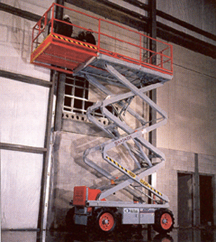

Figure 1: 32’ Scissor Aerial Lift

In other contracts, where you have rented similar equipment, you have observed that the use of aerial lift cuts costs, especially in high-ceiling commercial structures with plenty of fixtures and finishes (e.g., lighting and ventilation pipes) on the ceiling. Table I provides historical cost data from some previous contracts in which either scaffolding or an aerial lift was used.

Table 1: Equipment and Labor Cost Data from past projects

Project | Area (SF) | Aerial Lifts *  (operating costs) | Scaffolding **  (assembly costs) | Person-Hours ***  (expenses) | Materials ****  (expenses)
Project 1 | 1,000,000 | $243,902 |  | $1,073,500 | $380,504
Project 2 | 1,200,000 |  | $288,900 | $1,300,000 | $456,605
Project 3 | 200,000 | $40,650 |  | $187,500 | $76,100
Project 4 | 500,000 |  | $107,100 | $558,750 | $190,252

(*) Total Operating expense of Aerial Lift (does not include rental, purchasing or maintenance costs);
(**) Total assembly expense of Scaffolding (does not include rental, purchasing or maintenance costs);
(***) Total Cost of Person-hours spent on the work done using the scaffolds or the aerial lift;
(****) Total Cost of the Materials used on the work done using the scaffolds or the aerial lift.

It costs RedSox Construction $150/day/aerial left for renting five aerial lifts, which, based on the productivity achieved by their use, translates roughly into a rental cost of $0.10/S.F. of built space. It costs RedSox Construction roughly $ 0.05 /S.F. of built space to rent scaffolding. Also there is no maintenance cost for renting aerial lifts as well as scaffolding since it is taken care of by the rental company.

You also know that if you buy new scaffolding, it cannot be used forever. In fact, scaffolding has an expected lifetime of 5 years. This means, that at the end of 5 years, you will need to buy new scaffolding. It will cost roughly $3,000 to buy the new scaffolding needed (year 0) for the new projects and you do not expect to spend any money on maintenance. You also do not expect any salvage value from the old scaffolding.

On the other hand, buying the five aerial lifts will cost you $75,000 ($15,000 each) at the start of the project (year 0). You can plan to use the lifts for 15 years, during which an additional 10% of their initial cost will need to be spent annually on maintenance expenses. At the end of the 15 years the five aerial lifts will EACH have a $1,000 salvage value.

Finally, your projection of the future contracts RedSox Construction can win over the next 15 years, in terms of work volume in square feet, is shown in Table 2. You also know that in their estimates, RedSox prices the work done using either aerial lifts or scaffolding at $ 1.90 per SF.

Table 2: Projected growth of contracts for the next 15 years.

Year | Projected Work Volume (SF)
1 | 2,500,000
2 | 1,050,000
3 | 1,102,500
4 | 1,157,600
5 | 1,215,500
6 | 1,276,300
7 | 1,340,100
8 | 1,407,100
9 | 1,477,500
10 | 1,551,300
11 | 1,628,900
12 | 1,710,300
13 | 1,795,900
14 | 1,885,600
15 | 1,979,900

Questions

- Using the data from past projects (Table 1), derive an estimated average cost per SF for work done in commercial buildings (undertaken by RedSox Construction) using aerial lifts and the average cost per SF for commercial building using scaffolding. Include the operational, assembly, material and person-hour expenses for both modes of construction operations. (5 PT)
[Hint 1: In order to get the average cost for all projects, your first need to know the cost for each project.]
[Hint 2: The Historical cost for projects using aerial lifts account for all the aerial lifts used on the project. It does not relate to only one aerial lift.]

From Table 1 we can derive the total cost (including the operational, material, assembly and person-hours expenses related to either scaffolding or the aerial lift) for each past project:

Project | Area (SF) | Aerial Lifts | Scaffolding | Person-Hours | Materials | Total Cost
Project 1 | 1,000,000 | $243,902 |  | $1,073,500 | $380,504 | $1,697,906
Project 2 | 1,200,000 |  | $288,900 | $1,300,000 | $456,605 | $2,045,505
Project 3 | 200,000 | $40,650 |  | $187,500 | $76,100 | $304,250
Project 4 | 500,000 |  | $107,100 | $558,750 | $190,252 | $856,102

Then, divide the total cost for each project by its area to get the total cost per SF. Average the costs for the Projects 1 & 3 to get an estimate of the average cost per SF when using the aerial lift:

Avg. cost per SF for work done on Aerial Lift = [$1,697,906/ 1,000,000 SF + $304,250/ 200,000 SF] / 2 = $1.609 / SF

Find the average of the costs for the Projects 2 & 4 to get the average cost per SF for construction using scaffolding:

Avg. cost per SF for work done using Scaffolding = [$2,045,505/ 1,200,000 SF + $856,102/ 500,000 SF] / 2 = $1.708 / SF

We included the expense of person-hours spent because we assumed that the productivity of the labor working on an aerial lift is different than working on scaffolding, apart from the extra effort in setting up the scaffolding. On the other hand, the aerial lift requires that it is moved from place to place, that only one group of people can work at a height at each time, and that it has to be raised and lowered according to need and so forth. These different ways crews work with each solution are captured in this item.

Note also that you should first get cost per square foot per project and then get the average of these costs. You should not just add the costs of both projects and then divide by the square foot of both projects combined. That will give you the wrong answer since the two calculations are not mathematically the same [(A/B) + (C/D)] /2 ≠ [(A+C) / (B+D)] / 2.

- Calculate the Net Present Value of buying and using scaffolding for RedSox’s construction over the next 15 years based on the sales volume projection in Table 2. Remember to include the investment and replacement costs of scaffolding over the 15-year period and factor in straight-line depreciation and taxes on their related income. For your calculations, assume a discount rate of 8% and a tax rate of 30% annually. Assume that all payments and income occur at the end of each year. Do not consider inflation for this question. Remember to document all the steps of your calculations clearly, listing formulas. You may calculate NPV using MS Excel as explained in AS3_Tutorial.doc. (10 PT)

Using an Excel spreadsheet is the most effective way to calculate this. The following steps to be taken:

- A $3,000 Payment should be included at 0, 5 and 10 years for new scaffolding.
- The cost per square foot for using scaffolding should then be multiplied by the projected volume for each year to calculate Annual Costs. (Remember that there is no maintenance cost associated with the scaffolding).
- Income is calculated as the earnings per SF multiplied by the projected work volume for each year.
- Next calculate the Before Tax Net Cash Flow per year based on these 3 values.
- Depreciation on the initial investment cost should then be calculated and spread over the life span of the equipment.
- Calculate annual taxes on the Taxable Income each year (BF Tax Net CF – Depreciation).
- Then subtract the tax amount from the BF Tax CF to arrive at the After Tax Net Cash Flow for each year.
- Finally, the Net Present Value of those costs should be calculated, either using the NPV function in Excel or by manually working it out.

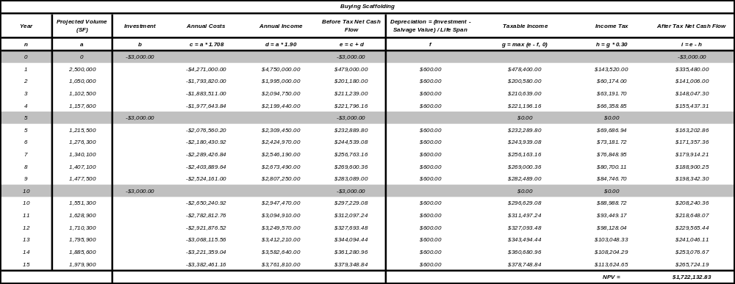

- Calculate the Net Present Value of renting and using scaffolding for RedSox’s construction over the next 15 years based on the sales volume projection in Table 2. Remember to include the rental costs of scaffolding over the 15-year period and taxes on their related income. Also, factor in straight-line depreciation if necessary. For your calculations, assume a discount rate of 8% and a tax rate of 30% annually. Assume that all payments and income occur at the end of each year. Do not consider inflation for this question. Remember to document all the steps of your calculations clearly, listing formulas. You may calculate NPV using MS Excel as explained in AS3_Tutorial.doc. (10 PT)

Using an Excel spreadsheet is the most effective way to calculate this. The following steps to be taken:

- Since the scaffolding is being rented, the investment value is 0$.
- Annual costs comprises of cost of using the scaffolding as well as the rental charges. This is computed by multiplying the sum of the cost per square foot for using scaffolding and their rental cost per SF. by the projected volume for each year.
- Annual Income is calculated as the earnings per SF multiplied by the projected work volume for each year.
- Next calculate the Before Tax Net Cash Flow per year based on these 3 values.
- Depreciation is 0 in this case, since the scaffolding is rented.
- Calculate annual taxes on the Taxable Income each year (BF Tax Net CF – Depreciation).
- Then subtract the tax amount from the BF Tax CF to arrive at the After Tax Net Cash Flow for each year.
- Finally, the Net Present Value of those costs should be calculated, either using the NPV function in Excel or by manually working it out.

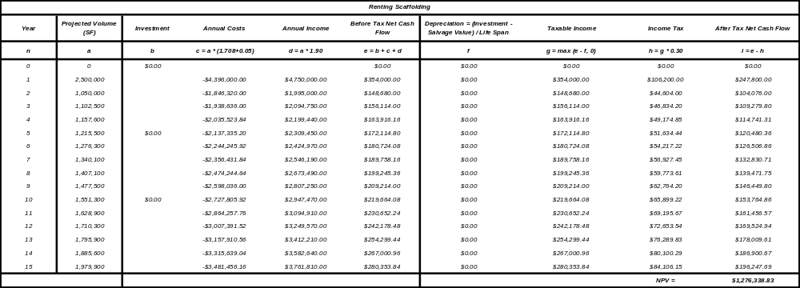

- Based on the sales volume projection (Table 2), calculate the Net Present Value of the aerial lifts for the next 15 years if you purchase them. Remember to factor in all appropriate investment costs, maintenance costs, income, depreciation and taxes in your calculations. The Aerial lifts should also be depreciated on a straight-line basis and use a discount rate of 8% and a tax rate of 30%. Do not consider inflation for this question. Remember to document all the steps of your calculations clearly, listing formulas. You may calculate NPV using MS Excel as explained in AS3_Tutorial.doc. (10 PT)

Using an Excel spreadsheet is the most effective way to calculate this. The following steps to be taken:

- A $75,000 Payment should be included at year 0 for the new lifts and a salvage value of $5,000 must be considered at year 15.
- The cost per square foot for using aerial lifts should then be multiplied by the projected volume and this should be added to 10% of 75,000$ for each year to calculate Annual Costs. (Remember that there is a maintenance cost associated with the aerial lift which is 10% of its cost).
- Income is calculated as the earnings per SF multiplied by the projected work volume for each year.
- Next calculate the Before Tax Net Cash Flow per year based on these 3 values.
- Depreciation on the initial investment cost should then be calculated and spread over the life span of the equipment.
- Calculate annual taxes on the Taxable Income each year (BF Tax Net CF – Depreciation).
- Then subtract the tax amount from the BF Tax CF to arrive at the After Tax Net Cash Flow for each year.
- Finally, the Net Present Value of those costs should be calculated, either using the NPV function in Excel or by manually working it out.

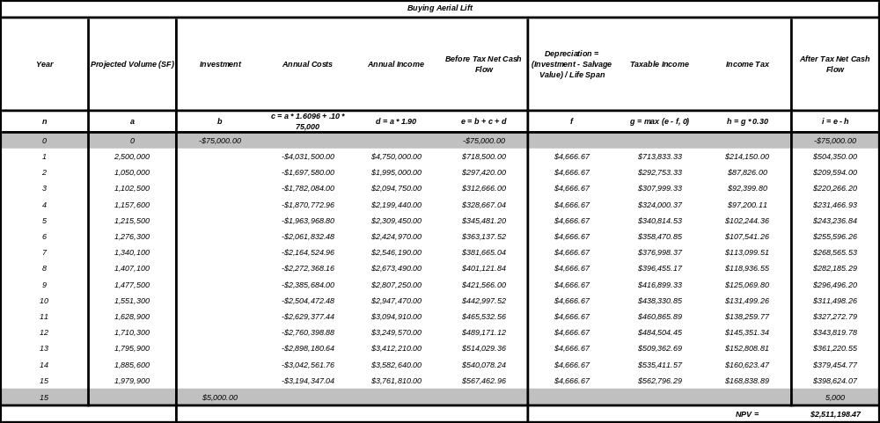

- Based on the sales volume projection (Table 2), calculate the Net Present Value of the aerial lifts for the next 15 years if you rent them. Remember to factor in all appropriate rental costs, income, and taxes in your calculations. Also, include depreciation if necessary. The Aerial lifts should also be depreciated on a straight-line basis and use a discount rate of 8% and a tax rate of 30%. Do not consider inflation for this question. Remember to document all the steps of your calculations clearly, listing formulas. You may calculate Net Present Value using MS Excel as explained in AS3_Tutorial.doc. (10 PT)

Using an Excel spreadsheet is the most effective way to calculate this. The following steps to be taken:

- Since the aerial lifts are being rented, the investment value is 0$.
- Annual costs comprises of cost of using the lifts as well as the rental charges. This is computed by multiplying the sum of the cost per square foot for using the lifts and their rental cost per SF. by the projected volume for each year.
- Annual Income is calculated as the earnings per SF multiplied by the projected work volume for each year.
- Next calculate the Before Tax Net Cash Flow per year based on these 3 values.
- Depreciation is 0 in this case, since the lifts are rented.
- Calculate annual taxes on the Taxable Income each year (BF Tax Net CF – Depreciation).
- Then subtract the tax amount from the BF Tax CF to arrive at the After Tax Net Cash Flow for each year.
- Finally, the Net Present Value of those costs should be calculated, either using the NPV function in Excel or by manually working it out.
.
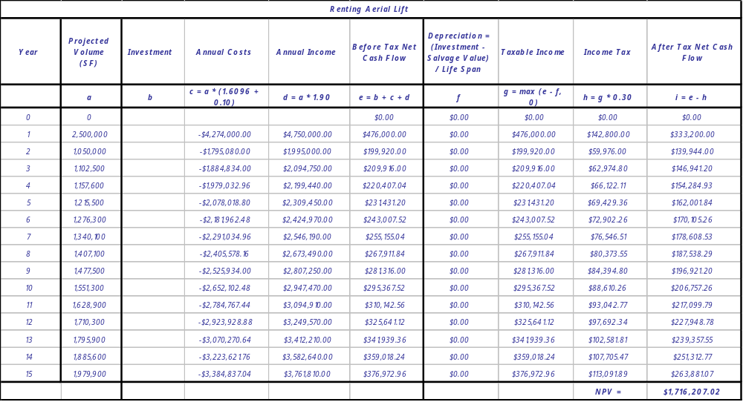

- Based on your Net Present Value calculations in questions 2, 3, 4 & 5, which option would you recommend to your boss at RedSox Construction – (a) Continue renting scaffolding, (b) buy scaffolding, (c) rent out aerial lifts, or (d) buy five aerial lifts?. (5 PT)

Comparing the 4 NPV values, the option to buy and operate your own aerial lifts works out to have the greatest NPV (renting scaffolding = $ 1.2 M, buying scaffolding = $ 1.72 M, buying lifts = $ 2.60 M, renting lifts = $ 1.72 M), considering the assumed volume of work in the next 15 years.

- If management has already made a decision to buy five aerial lifts equipment in future projects, after accounting for the inflation rate of 3%, what would be the NPV? Assume that your investment, annual costs and income are in constant today dollars. Include a cash flow diagram for this investment series in your submission. (You can either draw the cash diagram in hand and scan it or do it using Excel or any other graphing tool but SHOULD include it either way, on the word document as a figure.) (10 PT)

Using an Excel spreadsheet is the most effective way to calculate this. The following steps to be taken:

- A $75,000 Payment should be included at year 0 for the new lifts and a salvage value of $ 5,000 must be considered at year 15.
- The cost per square foot for using the lifts should then be multiplied by the projected volume for each year and this is to be added to the maintenance cost ( 10% of 75,000) to calculate Annual Costs for each year (c = a * cost per SF + 0.10 * cost of lifts).
- Income is calculated as the earnings per SF multiplied by the projected work volume for each year (d = a * earnings).
- Next calculate the Before Tax Net Cash Flow per year based on these 3 values (e = b + c + d).
- This value must then be converted to current dollars (f = e * (1+interest rate)^n).
- Depreciation on the initial investment cost should then be calculated and spread over the life span of the equipment (g = (investment – salvage value) / life span).
- Calculate the Taxable Income (BF Tax Net CF – Depreciation) (h = f – g).
- Calculate Income Tax on the Taxable Income each (I = h * tax rate).
- Then subtract the tax amount from the BF Tax CF to arrive at the After Tax Net Cash Flow for each year (j = f – i).
- This value must then be converted back to constant dollars (k = j / (1 + interest rate)^n).
- Finally, the Net Present Value of those costs should be calculated, either using the NPV function in Excel or by manually working it out( NPV = NPV(discount rate in %, Constant ATNCF years 1-15) + Constant ATNCF year 0).
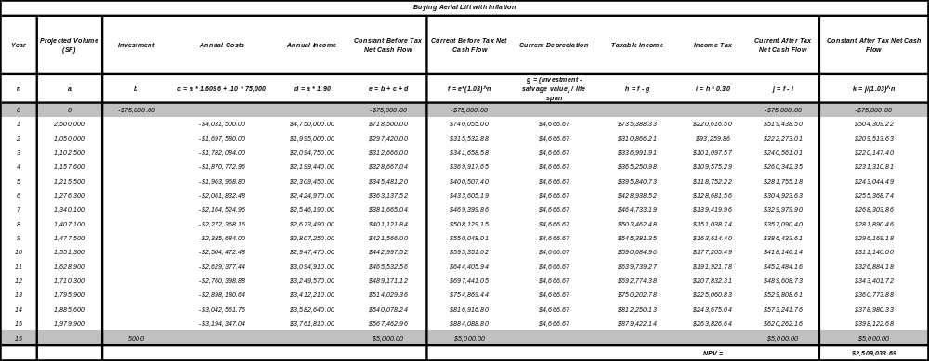

Note: Letters a-k refers to column names in the excel sheet.

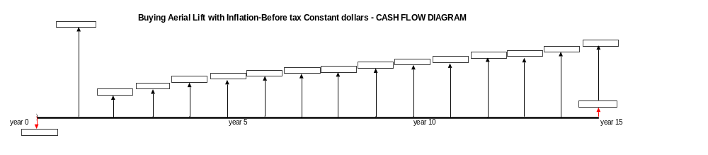
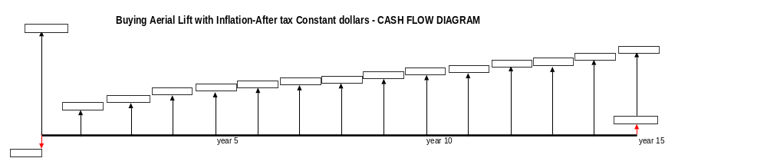
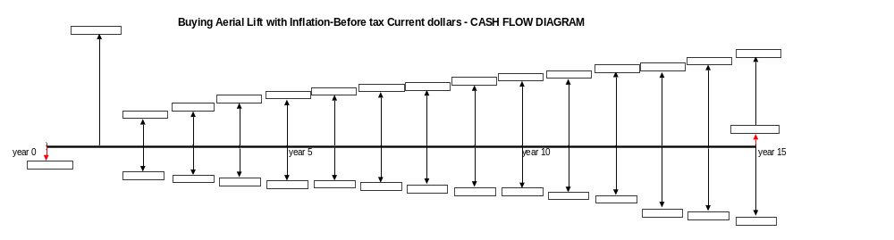
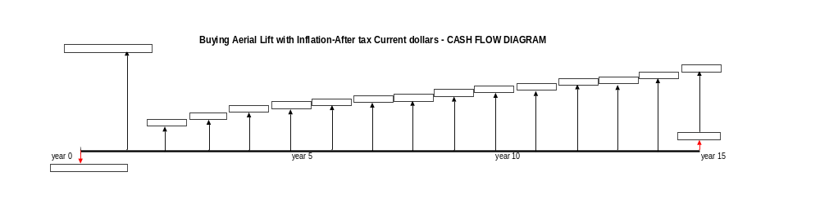

- What other cost and savings factors did you not consider (because you did not have the data)? What are the assumptions in this problem that you are not sure of (i.e., they are subject to uncertainty)? How important do you think they are, and how do they affect your decision? (5 PT)

Insurance costs for the lift is one of the factors that we have not considered. Another factor that could be considered is the increased capacity that RedSox would have to handle larger projects if they bought an aerial lift. In addition, though the NPV projections predict that the aerial lift will be cheaper over 15 years, this is based on prices from past years’ performances and quantities from future projects, and we cannot be sure of how representative the past projects are for the future ones. We also need to determine how sure we are, that we will get the future projects.

Thus, let’s assume that RedSox Construction did not win several new contracts. If their sales volume does not increasingly rise or they do not move up to a bigger market segment, they may find the aerial lifts to be white elephants which they cannot afford to keep. They are hoping to recover the lift’s initial cost from uncertain cash flows alone!

Moreover, there are other uncertainties that might keep RedSox owners from getting a good night’s sleep: we cannot be certain that the discount rate used is the right one. Remember, the risk premium added to the risk-free rate to derive the discount rate should not be evaluated based on the preferences of the company, but on the market’s and industry’s perception of risk associated with the specific project (i.e., the purchase or rental of an aerial lift). This is quite hard to pinpoint in this case!

That aside, there is no question as to whether we should buy the equipment or not, because, as it was shown, the initial investment will be made up in the 2,500,000 SF project recently won for certain! This “confirmed” project essentially makes more profit by purchasing the aerial lift – much more than the cost of the aerial lift.

- Please write a Memo to your boss on your recommendations for equipment purchasing and use on future projects. It should be professionally written with proper back-up and reference. Use your work from Part II Questions 1 to 7 as a back-up to your memo as well as any other information you have used. (5 PT)

redsox Construction

Memo
To: Dr. SangHyun Lee
From: Student
CC: Dr. Sam Labi, Dr. Fred Moavanzadeh
Re: AS 3 – To Buy or Not to Buy aerial lifts
Regarding your request to evaluate the proposal of buying five aerial lifts for our construction projects, it is recommended that we buy the new aerial lifts. Using the data from the projects we executed between 1999 and 2003, the average cost for using aerial lifts is $1.6096 per square foot, while the cost for using scaffolding is $1.708 per square foot. Based on this simple analysis, it may seem appropriate to use aerial lifts in our future projects.
A net present value analysis comparing the costs of using rented scaffolding, purchased scaffolding, rented aerial lifts, and purchased aerial lifts for our project volume over the next 15 years also found that purchasing aerial lifts is the most profitable route. Using the projected sales volume, an 8% discount rate, and not taking into consideration inflation, the NPV of each option is shown below:
- Purchasing Scaffolding: $ 1,722,132.83
- Renting Scaffolding: $ 1,276,338.83
- Purchasing aerial lifts: $ 2,511,198.47
- Renting aerial lifts: $ 1,716,207.02
As such, we should purchase aerial lifts in order to maximize our profit. Detailed calculations for these 4 NPV option analyses can be found in the Scaffolding, Aerial Lift, and Aerial Lift with Inflation tabs in PS1Student.xls.
It should be noted that these analyses did not consider insurance costs for any of the equipment. It is likely that the insurance will be much more for a purchased aerial lift than for scaffolding. We also did not consider how purchasing aerial lifts would affect our workload capacity. It is possible that owning aerial lifts would allow us to take on more and/or larger projects.
In addition, we assumed for the purposes of these analyses that the data from the past projects represents what we can expect in terms of productivity in our future projects. If this data has changed, it is possible that the average cost of using aerial lifts is now cheaper than using scaffolding when considering the simple analysis of cost per square foot.
We also assumed that our future sales projection is accurate. Although it is unlikely this would affect the decision between using aerial lifts and using scaffolding when using the net present value analysis, the future sales volume could affect whether we should rent aerial lifts rather than buy them. This is because the primary means of comparing the aerial lifts to the scaffolding is the average profit associated with using them, while the primary difference between purchasing and renting aerial lifts is the initial investment compared to the rental costs. If the square footage were low, the rental costs could become lower, and may not justify the initial investment of buying lifts. However, the contract that we have already obtained covers the initial investment.

Part III - Project Organization (50 PT)

Celtics Construction serves as a general contractor and project consultant to private companies and government agencies regarding construction planning issues. Your boss just got a new project for Celtics Construction and she has asked you to study it and advise the client on selecting the best project delivery system, financial contract type, and procurement method for the project.

The project information is presented by a series of facts and assumptions. Remember that there will be more than one way to select the ‘best’ project delivery system, financial contract type, and procurement method. This selection depends on what you consider the most important factors related to the project (e.g., time, budget, quality, risk, …). The key is to have a logical and systematic analysis that is consistent with your client’s overall needs.

Figure 2 is an example of an evaluation matrix, which will help you study the project information and assign priorities or weights to various selection criteria (totaling up to 100). You are required to use this matrix when you document your answers and provide a detailed explanation of your decisions regarding the project delivery system, financial contract type and procurement method selection. Please document all the assumptions you make and explain, in a very professional way, each number you assign to every cell in the matrix.

Goals/ Criteria | Criteria Weight | Project Delivery Systems
Goals/ Criteria | Criteria Weight | Method 1 |  | Method 2 |  | Method 3
Goals/ Criteria | Criteria Weight | Score | Weighted Score | Score | Weighted Score | Score | Weighted Score
Criteria 1 | 25 | 4 | 100 | 6 | 150 | 8 | 200
Criteria 2 | 30 | 5 | 150 | 8 | 240 | 6 | 180
Criteria 3 | 10 | 8 | 80 | 6 | 60 | 5 | 50
Criteria 4 | 35 | 6 | 210 | 5 | 175 | 7 | 245
 | 100 | --- | 540 | --- | 625 | --- | 675*
Figure 2: Project Delivery System Evaluation Matrix
(* Method 3 is the best selection considering all the selection criteria.)
(** Remember that the score is the numerical value (between 1 and 10) you will assign to a given criterion as you analyze, perceive or believe it to perform against that criterion. For a given delivery method, the weighted score is the multiplication of the criterion weight times the score you provided for that criterion. Please also remember that each one of these numbers should have a very clear and professional explanation.)

- Project Information
Interstate I-15 is the premier North-South route that traverses Salt Lake City, Utah. Over 140,000 vehicles traverse the road each day. The freeway was originally constructed in 1960s and was designed for a 20-year life span. By 1980, the end of its designed service life, the infrastructure was showing visible signs of wear and tear. The freeway was also incapable of handling the increased traffic from two decades of growth in the area. In an area of rapid growth that has deemed the highway insufficient for growing demand and with an existing infrastructure that has weathered over 3 decades of exposure, the reconstruction of I-15 was a major undertaking.
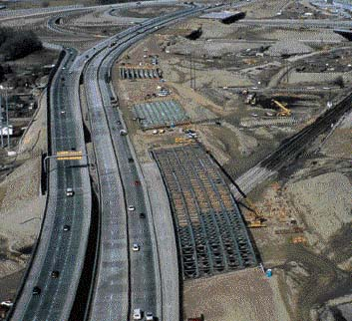

Figure 3: Widening the Existing I-15 Freeway

After an intensive selection process performed by UDOT (Utah Department of Transportation), the $1.35 billion I-15 Reconstruction project was awarded to Wasatch Construction, jointly with other contractors. Beginning with the award of the contract in March of 1997, the difficult task of demolishing and reconstructing nearly 16 miles of I-15 began and the work affected the daily lives of many individuals. After a massive demolition undertaking, the reconstruction process included widening the new freeway from 6 to 12 lanes (see Figure 3), reconstructing 142 bridges (three of which were prominent freeway-to-freeway interchanges), increasing the vertical clearances, and constructing auxiliary lanes between interchanges. The new and improved highway introduced an innovative traffic management system (ATMS), the state’s first HOV lanes (commuter lanes), veiled sound barriers, and aesthetic lighting and landscape treatments.

To expedite construction operations, a full-service soil sampling and materials testing lab was established onsite, and 3 concrete batch plants were created to facilitate concrete placement. Furthermore, a steady flow of traffic was maintained by providing alternative traffic routes with the construction of 2 temporary lanes on I-215, a route that circles the city to the west. For the purposes of manageability, the project was divided into 3 geographical segments, namely Downtown, Jordan, and Cottonwood. The budget for the project was estimated at a little more than $ 1.07 billion. The infrastructure support for ATMS amounted to $67 million; $110 million for pavements, $197 million in earthwork, $104 million for engineering and design, $565 million for the construction of 142 bridge structures, 7 interchanges and 3 interstate junctions, and finally $32.5 million set aside as a performance incentive.

The organizational structure for the I-15 project was incredibly complex. The project was composed of three very large prime contractors, two very large design firms, three consultants, and two hundred subcontractors. Each group brought with them a unique way of doing business and a distinct company culture. Dividing up the project and deciding who oversaw which portions of the work was also very complex. With so many different entities participating in the construction, it could be very easy for things to slip through the cracks and for finger-pointing to ensue. Meshing cultures and processes into one cohesive unit was a challenge. Therefore, the selection of an appropriate Project Organization was extremely important.

At the beginning, several contractors who were interested in this project included Peter Kiewit Sons, Granite Construction, and Morrison Knudsen. However, the bonding and working capacity that the project required was so high that none of these contractors would have been able to take on the whole job alone. Hence all the three prime contractors together created Wasatch Construction, a joint-venture company, which was awarded the primary contract for the project.

UDOT hired two design teams to work with its in-house engineers and owner-retained consultants. Besides the contractors and the designers, UDOT also hired two consulting companies to provide technical and management expertise: Parsons Brinckerhoff Quade & Douglas Inc. (New York, NY), and Carter & Burgess Inc. (Fort Worth, Texas). Parsons Brinckerhoff Quade & Douglas Inc. was the lead responsible for communicating with the design team to ensure that the work was up to par. This allowed UDOT to be fairly detached from the project, performing only ‘spot-checks’ on quality and reviewing the design teams’ work through ‘over-the-shoulder’ reviews. Parsons Brinckerhoff Quade & Douglas were the technical and management experts while Carter & Burgess was in charge of design oversight.

There were also about 200 subcontractors that bid on specialty jobs. In order to ensure that local firms would be employed, subcontracting assignments were established based upon a Competitive Procurement Process for any contract in excess of $3 million. In addition, joint subcontractor ventures were greatly favored by disallowing prime contractors from performing more than 30% of the work. This clause was largely the result of lobbying efforts on the part of the Associated General Contractors of America (AGC).

UDOT set up an integrated management team from all the project participants, which was comprised of 7 UDOT Engineers, representative employees from UDOT’s prime consultant (Parsons Brinkerhoff Quade & Douglas Inc.) who developed Request for Qualifications (RFQ) and Request for Proposal (RFP) packages with the aid of the UDOT Technical Support Manager, Mr. K.N. Gunalan; and other consultants (including Carter Burgess, UDOT’s design consultant) and an Oversight Team, which consisted of UDOT upper management. The integrated management team also included a project manager (Mr. John Bourne), a contracts manager (Mr. John S. Higgins), and a Traffic Management Organizer (Mr. John Leonard) all from UDOT, as well as an FHWA (Federal Highway Administration) representative.

Lastly, there were extensive uses of performance specifications in the RFP (Request for Proposals); and UDOT assigned the responsibility to the builders to monitor the quality for all quantities of work related to their approaches.

- Project Challenges
There were five main challenges faced by this project:
- Building on poor soil quality in the area (due to an ancient lake bed) that could settle considerably. Soil stabilization techniques included the use of wick drains and geo-foam fill.
- Maintaining a fast-track schedule, while controlling costs.
- Prioritizing the safety of workers and the public by diverting traffic from I-15.
- Creating a unified cohesive team at the management level that included several individuals from the owner, UDOT, Wasatch Construction, and many other organizations.
- Meeting the deadline for the 2002 Winter Olympics, while setting an industry standard for future design-build projects. For UDOT, it was extremely important that the 2002 Winter Olympics could be held as scheduled in February 2002. However, originally, it was estimated that the project would require an 8-year period to complete. (i.e., March 2005)

History and Timeline of the Project

The I-15 project in Salt Lake City, Utah is one of the largest highway projects in the history of the United States. The following is a historical timeline for the I-15 project:
- Mid to late 1980s - (UDOT) recognized that the time had come to take action to address some of the problems with I-15 in Salt Lake County
- Early1990s - A Draft Environmental Impact Study (DEIS) was issued. In this DEIS it was concluded that additional capacity was needed on I-15.
- June 1995 – Salt Lake City was awarded the 2002 Winter Olympics.
- December 1995 – Utah’s first Growth summit that focused the state’s resources to address infrastructure improvements.
- February 1996 - Creation of the Centennial Highway Endowment Fund (CHEF), which established initial funding and a 10-year commitment of $2.6 billion in additional revenues for highways. The I-15 reconstruction project was the centerpiece of the CHEF.
- February 1996 - UDOT hires Parsons Brinckerhoff to develop RFQ (Request for Qualifications), RFP (Request for Proposals).
- March 1996 - Request for Letters of Interest.
- June 1996 - FHWA approves project under SEP-14 (guidelines for federal aid projects)
- July 1996 - Request for Qualifications (RFQ) issued.
- August 1996 - Record of Decision approved by FHWA.
- October 1, 1996 – Request for Proposals (RFP) issued.
- January 15, 1997 - Initial proposals submitted to UDOT.
- February 21, 1997 - BAFOs (Best and Final Offer) requested.
- March 1997 – UDOT announced winning contractor team(s).
- April 1997 - UDOT issues Notice to Proceed.
- April 1997 – Ground-breaking.
- October 2000 – Completion of first segment and concrete work.
- May 2001 – Freeway opened for public use.
- July 2001 – Substantial Completion.
- October 2001 – Anticipated Completion Date/Project Closeout.
- Feb 2002 – 2002 Winter Olympics.

Questions - Design Project Organization for UDOT
- Please recommend the best project delivery method for the I-15 project (from the list provided) based on the criteria that are crucial to this project. The types of delivery methods that need to be evaluated are Design-Bid-Build, Design-Build and CM@Risk. Please remember to document all your assumptions and rationale for the selection of the project delivery system. Particular attention should be paid in justifying the criteria, weights, and scores given to each element of the selection matrix. (12 PT)

Project Delivery Method

- The Evaluation Matrix for the I-15 Highway Project Delivery Method

GOALS / CRITERIA | CRITERIA WEIGHT | PROJECT DELIVERY METHODS
GOALS / CRITERIA | CRITERIA WEIGHT | Design-Bid-Build (DBB) |  | Design-Build(DB) |  | CM@Risk
GOALS / CRITERIA | CRITERIA WEIGHT | Score | Weighted Score | Score | Weighted Score | Score | Weighted Score
Project Delivery Speed | 45 | 4 | 180 | 9 | 405 | 8 | 360
Seamless Communication | 35 | 3 | 105 | 9 | 315 | 7 | 245
Cost Control | 15 | 6 | 90 | 3 | 45 | 7 | 105
Work with Local subcontractors | 5 | 8 | 40 | 6 | 30 | 6 | 30
Total | 100 | --- | 415 | --- | 795 | --- | 740

- Project Considerations:

  - Project delivery speed (45%) since it is critical that the work be completed for the 2002 Winter Olympics being held in Salt Lake City, Utah.
  - It’s a large and complex project, and the work was divided into three geographical areas. The project required seamless communication (35%) within the team even though every project participant has their own way of doing business.
  - Cost control is essential since this is a public project with lots of media attention (15%)
  - Work with local subcontractors (5%) is important since this is a public project

- Project Delivery Speed:

  - In a traditional delivery method DBB, work tends to move slowly. There is a long process of submittals and if any change in scope of work is made, there can be long delays. Also, overlapping of design and construction is not plausible (4)
  - DB allows for a faster construction process since the project is being designed as it is built (9)
  - CM@Risk offers the ability to overlap certain portions of work through phased construction and the early ordering of long lead times (8)

- Seamless Communication:

  - A traditional system was given a low score of (3) since a lot of different entities are coming together that may have never worked together before. Differences in the way these firms communicate, document issues, perform reviews, run meetings and arrange other things can be a hurdle to seamless communication. These issues can be overcome, but they are most apparent in this project delivery system.
  - The DB firm has internal communications mechanisms already in place, and it also pulls together a team of architects, engineers and builders into one group that have possibly worked together on different projects in the past (9)
  - A construction manager at risk will tend to use contractors that he/she has worked with in the past, with which he/she has established a relationship. Since the CM holds all of the subcontracts, he/she can select the contractors that he/she communicates well from his/her past experiences. Also, a qualified construction manager provides leadership to the entire project team (7)

- Cost Control:

  - Traditional method scores a (6) since the construction and design costs are set upfront in the bid allowing for tight cost control, but unforeseen site conditions and change orders can cause the cost to escalate.
  - DB does not establish the costs up front, making the governmental agency a bit nervous about approving money if there is no clear idea of how high costs might go (3)
  - CM@Risk shifts risk to the construction manager, giving him/her more incentive to control costs while maintaining some of the advantages of the traditional method. (7)

- Work with Local Subcontractors:

  - The traditional method encourages the most participation of varied and diverse local subcontractors since it allows for bidding on different packages for the project (8)
  - A DB firm uses its preferred subcontractors based on previous projects and established relationships, limiting the number of subcontractors who would be able to participate in the project. However, the contracts may require then to open up and bring to the team local sub-contractors (6)
  - Like a DB firm, CM@Risk would prefer to use his/her established relationships with subcontractors as he/she holds the contracts (6)

- Conclusion:

  - Project Delivery System: The Design-Build approach (Score: 795 PT) is recommended because with such a large project, seamless communication is the key to the project success when working with a complex project team that involves multiple business organizations. Also, design-build allows phased-construction and can shorten the project duration.

- Using the project information given, draw the project organizational chart as described, showing the working relationships between different project-participants. (4 PT)

Project Organization Chart

- The contractors formed a Joint-Venture since no one could take the job alone
- To draw the organizational chart, three main groups of entities were identified: the UDOT, the owner retained consultants and the design-build entity
- UDOT has various managers, engineers and the oversight team working together under the UDOT umbrella. The FHWA representative communicates with UDOT directly.
- The communication line for the Technical Support Manager and the Prime Consultant is denoted on the chart
- The design-build entity and owner retained consultants are linked contractually to UDOT via the contracts manager.
- The prime consultant holds the contracts for the other two consulting firms.
- The design firms are contractually tied to UDOT but communicate with the Wasatch Construction.
- Wasatch Construction is the prime contractor and therefore holds the contracts for Peter Kiewit and Morrison Knudsen.
- Some subcontractors are grouped under Wasatch Construction, but it is assumed that Peter Kiewit and Morrisson Knudsen will hire their own subcontractors also.

OVERSIGHT TEAM
UDOT Upper Management
Owner Oversight
PROJECT MANAGER
John Bourne
Project Coordination
U.S. GOVERNMENT
FHWA Representative
Federal Gov’t Oversight
UDOT

TECHNICAL SUPPORT MGR
K.N. Gunalan
Technical Support
CONTRACTS MANAGER
John S. Higgins
Contract Coordination
TRAFFIC MGMT ORGANIZER John Leonard
Traffic Coordination
ENGINEERING
Engineers
In-House Design

CONSULTANT
Carter & Burgess, Inc.
Design Oversight

PRIME CONSULTANT
Parsons Brinckerhoff
Quade & Douglas

CONTRACTOR
Peter Kiewit & Sons
Highway Construction
CONTRACTOR
Morrison Knudsen
Highway Construction
DESIGNERS
Design Firm 1
Design
DESIGNERS
Design Firm 2
Design
PRIME CONTRACTOR
Wasatch Construction
Highway Construction
Sub-Contractors
CONTRACTOR
Granite Construction
RFQ & RFP Development
Tech & Mgmt Experts

OWNER RETAINED CONSULTANTS

Sub-Contractors
Sub-Contractors
(*Solid line represents contractual relationships; dotted line represents the communication relationships)

- Please evaluate and recommend the best financial contract type for the I-15 (from the list provided) project based on the criteria that are crucial to this project. The types of contract that need to be evaluated are Lump sum contract, Guaranteed Maximum Price Contract and Cost Plus Fixed Fee Contract. Particular attention should be paid in justifying the criteria, weights, and scores given to each element of the selection matrix. (12 PT)

Project Financial Contract Type

- The Evaluation Matrix for the I-15 Highway Financial Contract Type (I included Unit Price in this solution to make you taste it)

GOALS / CRITERIA | CRITERIA WEIGHT | FINANCIAL CONTRACT TYPES
GOALS / CRITERIA | CRITERIA WEIGHT | Lump Sum |  | Unit Price |  | GMP |  | CPFF*
GOALS / CRITERIA | CRITERIA WEIGHT | Score | Weighted Score | Score | Weighted Score | Score | Weighted Score | Score | Weighted Score
Project Delivery Speed | 45 | 5 | 225 | 3 | 135 | 5 | 225 | 9 | 405
Cost Control | 25 | 5 | 125 | 6 | 150 | 8 | 200 | 1 | 25
Quality Work | 25 | 4 | 100 | 4 | 100 | 4 | 100 | 6 | 150
Risk Sharing | 10 | 5 | 50 | 7 | 70 | 9 | 90 | 8 | 80
Total | 100 | --- | 500 | --- | 455 |  | 615 | --- | 660

*CPFF = Cost Plus Fixed Fee
- Project Characteristics:

  - Project delivery speed (40%) since it is critical that the work be completed for the 2002 Winter Olympics being held in Salt Lake City, Utah.
  - Cost control (25%) is essential since this is a public project with lots of media attention
  - UDOT employed extensive uses of performance specifications in the RFP and UDOT assigned the responsibility to the builders to monitor the quality for all quantities of work related to their approaches. Some contract types provide more incentives to the contractors to achieve quality work (25%) than others.
  - The project is a major undertaking and lots of different parties are involved. It is essential that the contractor and owner share the risk of making the I-15 project a success – risk sharing (10%).

- Project Delivery Speed:

  - Lump sum usually cannot be fast tracked because the budget is not established yet. But lump-sum does provide the contractor a high incentive to finish early because he/she is trying to lower his/her cost and maximize his/her profit. Unfortunately, a lump sum contract usually cannot be fast tracked (5).
  - With unit price the contractor doesn’t have much incentive to reduce the schedule, but can instead take their time since they are getting paid by the quantity of work they deliver (3).
  - GMP can be fast tracked, but since this project involves lot of parties, co-ordination could be a problem. Also, GMP alone does not provide an incentive to finish early because the contractor would prefer to continue to work until his/her GMP is met (5)
  - Cost Plus fixed Fee allows for fast-tracking, and provides a high incentive to finish early, because a contractor receives the same fee regardless of when he/her completes the project. It is in his/her best interest to finish it as soon as possible to minimize his/her costs and maximize his/her profit (9)

- Cost Control:

  - A lump sum contract seems like a good way to go for a project like this where the cost needs to be kept under control. The problem is that even a small change in the project or an escalation in material prices could result in a change order being issued to the owner. The owner takes their chances under these circumstances, so therefore lump sum comes with its disadvantages for the I-15 project (5).
  - A Unit Price contract delivers good cost control since the cost of each item is established upfront in the contract. The way to make unit price work for I-15 is to have regular inspection of completed work in order to keep the contractors honest. If UDOT does not inspect the work closely, or finds it difficult to quantify the work completed, the total cost for the owner can be greater than planned (6).
  - A GMP contract gives the incentive to a contractor to keep the cost under the maximum price, providing an inherent control of costs. The contractor would assume the additional costs after the ceiling is reached (8).
  - Cost plus Fixed Fee does not provide a ceiling to the cost for the owner. There is no financial insurance of ultimate cost, which is not suitable for the publicly financed I-15 project (1).

- Product Quality:

  - A lump sum contractor strives to provide good quality in his/her work. But a problem could occur if the project could potentially exceed the lump sum amount that the contractor bid, giving him/her incentive to cut back on his/her quality of product (4).
  - A unit price contractor will strive to provide good quality in his/her work since all the costs are taken care of by the owner. But should the project potentially exceed the estimated amount for a particular item, compromises in quality can be made (4).
  - In GMP, the contractor has to bear all the costs, ensuring that it is well below the fixed cap amount. Therefore quality may be sacrificed. (4)
  - With CPFF varying qualities of work are all rewarded equally, but there is no penalty for high quality since the owner pays all the costs (6).

- Risk Sharing:

  - Lump sum is high risk for the contractor in case of any unforeseen problems. But a lump sum contract does provide the flexibility to incorporate performance incentives in addition to the fixed price established between UDOT and the contractor (5.)
  - With a unit price contract, the contractor can make his/her profit since payment is based on actual quantities but he/she can also lose money in the same way. The risk of accurately pricing the units and incorporating their overhead in their prices is on the contractor. The risk that the quantity of work needed is higher than expected is on the owner. Also, the performance incentive money set aside would fit in nicely with a unit price contract since the contractor now has an incentive to keep the quantity of work contained and he/she is rewarded in turn (7).
  - In GMP contracts, the risk is shared between the owner and the contractor almost equally. GMP has more incentive to contain costs under the cap and the contractor is at risk for the additional costs after the “ceiling” point is reached (9).
  - In a CPFF contract, there exists a level of risk sharing between the owner and the contractor, but the risk is higher to the owner that the cost might escalate (8).

- Conclusion:

    - CPFF seems to be the most appropriate contracting method due to its advantages in project delivery speed and quality of work. (660 Points)

- Please evaluate and recommend the best procurement method for the I-15 (from the list provided) project based on the criteria that are crucial to this project. The types of procurement that need to be evaluated are Competitive, Negotiated and Best Value. Particular attention should be paid in justifying the criteria, weights, and scores given to each element of the selection matrix. (12 PT)

Project Procurement Method

- The Evaluation Matrix for the I-15 Highway Procurement Method

GOALS / CRITERIA | CRITERIA WEIGHT | PROCUREMENT METHOD
GOALS / CRITERIA | CRITERIA WEIGHT | Competitive |  | Negotiated |  | Best Value
GOALS / CRITERIA | CRITERIA WEIGHT | Score | Weighted Score | Score | Weighted Score | Score | Weighted Score
Project Delivery Speed | 45 | 1 | 45 | 9 | 405 | 7 | 315
Product Quality | 35 | 1 | 35 | 5 | 175 | 9 | 315
Selection Flexibility | 20 | 5 | 100 | 3 | 60 | 9 | 180
Total | 100 | --- | 140 | --- | 640 | --- | 810

- Project Considerations:

  - The project needs to be fast-tracked since it is essential to the project before the 2002 Winter Olympics – project delivery speed (45%).
  - UDOT employed extensive uses of performance specifications in the RFP and UDOT assigned the responsibility to the builders to monitor the quality for all quantities of work related to their approaches. Some procurement methods place higher value on reputation and quality work (35%) than others.
  - UDOT is a public entity who is using government funds for the I-15 highway project, so they have to incorporate qualified local and minority owned subcontractors into the project. UDOT also needs the flexibility to choose a qualified contractor who will keep the overall project schedule, quality and cost under control. The procurement method must also allow for evaluation of design-build firms who will form a joint-venture to tackle the project– selection flexibility (20%).

- Project Delivery Speed:

  - Competitive bidding is a time consuming process involving a bidding period as well as a bid evaluation & review period prior to issuing notice to proceed with construction (1).
  - For negotiated contracts, a contractor is typically pre-selected on the basis of reputation and overall qualifications for the job. This allows the process to move quickly (9).
  - Best Value procurement involves releasing an RFP and reviewing the proposals received, which takes more time than a negotiated contract but less time than competitive bidding (7.)

- Product Quality:

  - In competitive bidding, work awarded to lowest bidder and the project is constructed with the specified quality at lowest price. The problem is that the quality specifications are not yet completely defined and are subject to change. Also, the lowest bidder doesn’t necessarily provide top-notch quality (1).
  - For negotiated contracts, a contractor is typically pre-selected because they have successfully worked on a job with the owner in the past and their quality has been proven to the owner. But unlike Best Value procurement, the contractor may not have to specify the technical factors involved with the project and how they will approach them in order to achieve the quality desired by the owner (5).
  - Best Value procurement involves reviewing a firm or contractor based on their technical merit, as well as the price. It is important that UDOT get the most qualified contractor or design-build firm so that the construction runs smoothly (9).

- Selection Flexibility:

  - UDOT can use competitive bidding to attract the most local and minority owned firms to bid on the project, providing a large pool of contractors to bid. For the prime contract, one firm does not exist with the capability to handle the I-15 project alone, requiring contractors to form a joint-venture. This in turn reduces the pool of bids that UDOT could evaluate. For the positive and negative aspects of competitive bidding under these circumstances, it receives a mid-level score of (5).
  - For negotiated procurement, a contractor is typically pre-selected because they have successfully worked on a job with the owner in the past. The problem with negotiated procurement in this case is that UDOT is a public entity who may need to allow for a great level of competition in order to justify the selection of a specific contractor for this size project (3).
  - Best Value procurement involves reviewing a firm or contractor based on their technical merit, as well as the price. It is important that UDOT get the most qualified contractor for the I-15 so that the construction runs smoothly. With best value procurement, UDOT can place high value on the project schedule and on the performance specifications in the RFP (9).

- Conclusion:

  - Procurement Method: Use Best-Value procurement (Score = 810 PTS) for selecting the design-build team and evaluate the best value depending on proposed project cost (lump-sum), project schedule & past project experiences (for pre-qualification). The firm with the best credentials and highest value should be chosen, regardless of whether they are the lowest bidder.

- Under the recommended delivery system, financial contract type, procurement method, and organizational charts, how would you ensure that the time, cost, and quality of the delivered project will satisfy the project goals? (4 PT)

Comments on Time, Cost, & Quality

The project time can be greatly shortened because of the adoption of design-build project delivery approach, which allows fast-track construction. By using the Best Value procurement method, timely completion of the project and bidder prequalification can both be included as important evaluation criteria. Because of the high emphasis on project delivery speed and product quality, CPFF contracting method is recommended, which ensures IDOT that final project cost is delivered at the required time, with good quality. The recommended project organization chart has dedicated lines of authority, which establishes clear work scope and responsibility.

- Please write a memo as a cover sheet for your recommendation. The memo should provide a brief introduction to the project and an executive summary of the recommendation you are providing. (6 PT)

CELTICS CONSTRUCTION
Memo
To: Dr. SangHyun Lee
From: Student
CC: Dr. Sam LAbi, Dr. Fred Moavenzadeh
Date: March 9, 2007
Re: Utah Highway I-15 Project - Recommendation
The I-15 reconstruction project in Salt Lake City, Utah is one of the largest highway projects in the history of the United States. UDOT has requested a recommendation for the best suitable project delivery system, organizational structure, financial contracting type and procurement method in order to meet their time, cost and quality goals for I-15.
All of the project drivers and owner and marketplace characteristics have been taken into account in order to provide UDOT with a recommendation for the project delivery system, organizational structure, financial contract type and procurement method best suitable for the I-15 Highway project.

recommendation

UDOT should proceed with a Design-Build (DB) project delivery system since this is such a significant undertaking in which seamless communication is the key to project success. The project team will consist of multiple business organizations which should form a joint-venture, due to the fact that no one entity has the bonding capacity or labor force to handle the job alone. Please refer to the attached project organization chart for details on how the organization should be formed. The recommended project organization chart has dedicated lines of authority, which establish clear work scope and responsibility.

It is also recommended that UDOT contract on a CPFF basis using a Best-Value procurement approach. The firm with the best credentials and highest value should be chosen, even in the case that they are not the lowest bid. The CPFF bid amount would include the design and build phases of the project. To review details of how these recommendations were formulated, please refer to the evaluation matrixes for the project delivery method, financial contract type and procurement method in the attached documents.

The important indicators used by UDOT to determine success on this project are time, cost and quality. The project time can be shortened significantly by adopting a design-build project delivery approach that allows for fast-track construction. For quality control, selection of a highly qualified bidder via the best value procurement method would set the stage for timely completion of the project and meeting quality specifications. The CPFF method allows for fast-track construction without compromising on product quality. Please refer to the Time, Cost & Quality section of the attached recommendation for more details.

In developing your strategies for the organization of this project, consider all the information available to you (i.e., the internet and the library). Your solutions need not use the same ideas and strategies that were used in the description of the project.

Part IV – Grading Criteria Sheet For AS 3

Problem Set 1 – Grading
Segment | Grade / Max |  | Comments
Part I
1) Bonding Capacity Calculations |  | 15
2) Recommendation and analysis on bidding. |  | 10
3) Memo |  | 5
Total Part I |  | 30
Part II
1) Avg. Cost / SF of Lifts and Scaffolding |  | 5
2) NPV of Scaffolding (Buying) |  | 10
3) NPV of Scaffolding (Renting) |  | 10
4) NPV of Aerial Lifts (Buying) |  | 10
5) NPV of Aerial Lifts (Renting) |  | 10
6) Comparison and analysis of 4 options (Buying/renting scaffolding Vs. Buying/renting aerial lifts). |  | 5
7) NPV after purchase of aerial lifts considering inflation effects. |  | 10
8) Comment on assumptions and unaccounted costs. |  | 5
9) Memo. |  | 5
Total Part II |  | 70
Part III
1. Project Delivery |  | 12
2. Project Organization Chart |  | 4
3. Contract Type |  | 12
4. Procurement Strategy |  | 12
5. Critique on Time, Cost & Quality |  | 4
6. Memorandum |  | 6
Total Part III |  | 50
Assignment 3 TOTAL |  | 150

Appendix A - Advertisement

Barletta Heavy Division (BHD) has just been awarded a $205,000,000.00 Project from the Mass Turnpike Authority on the Central Artery Project.

One part of this project is the construction of a storm water pump station. Barletta, who normally does its own concrete work, is tight on resources and has chosen to put the concrete work for the Pump Station out for bid to subcontractors.

BHD has told all the subcontractors the following:

- The Bid should include furnishing & installation of Concrete, Formwork & Reinforcing Steel for the Pump Station.

- Installation of all miscellaneous imbeds such as; Pipe Sleeves, Pipes, Anchor Bolts, Metal Angles, Etc.

- Cranes & Concrete Pumps to be included in Subcontractor Price as an alternate add.

- All Permits, Licenses, Fees & etc to be furnished by BHD.

- Coordination with other Subcontractors that affect the concrete work will be done by BHD, but BHD is not responsible for these other subcontractors being late or for the quality of their work.

- Subcontractor responsible for all appropriate submittals such as shop drawings.

- Performance bond equal to 100% of subcontract value required.

- Payment bond per the Miller Act of 1935 required.

- ESTIMATED SIZE / BUDGET - $1,000,000.00 (without Cranes & Concrete Pumps)

- BID DATE: March 9, 2007

- SCHEDULE: October 1, 2007 to October 1, 2008

- Job is located at Logan Airport.

Appendix B – Sample Memo

MIT Concrete
Memo
To: dr. SangHyun Lee
From: Student
CC: TA
Date: Submit Date
Re: AS 3 – To Bid or Not to Bid
- First section - Describe the problem and your recommendations

- Second section - Provide arguments and facts to support your recommendations

- Third section - Provide arguments and facts that may contradict your recommendations

- Fourth section - Present your conclusions supporting your recommendations.

Note: Each of the sections can be one or more paragraphs.

Please refer to Appendix B as a sample
This is just a simplification.
Special thanks go to Prof. Keith Molenaar from the Dept. of Civil, Environmental and Architectural Engineering, University of Colorado at Boulder for sharing part of this assignment with us.

