Executive Summary

Development Proposal

Broadway Center is a proposed 78,400 square foot neighborhood shopping center on 5.5 acres at the border between Lawrence and Methuen, Massachusetts. The center will be anchored by a mid-sized grocery store tenant like Hannaford or Stop & Stop. A 10,640 square foot single pad site located at the northeast corner of the property will be designated for a pharmacy tenant. The remaining in-line retail space of approximately 22,860 square feet will include convenience-oriented establishments such as a retail bank, fast food or sit-down restaurant, café, beauty salon, and dry cleaning. Within this mix, locally owned businesses will further cater to the surrounding Hispanic population. Securing a pre-lease of both the grocery store and pharmacy tenants is essential to move forward with the development proposal as these tenants will drive the remaining in-line retail tenancy. The site layout will accommodate 404 parking spaces, reflecting a parking ratio of approximately 5 spaces per 1,000 square feet of retail.

Location

Broadway Center will enjoy good visibility and adequate parking on busy Broadway (Route 28) in front of the new Malden Mills Polartec factory. This location connects the cities of Methuen and Lawrence and is just over 1 mile from Route 213 and less than 2 miles from Interstate 93. See Exhibits 1 and 2 for proximity maps and an aerial photograph. Commercial neighbors include locally owned convenience-oriented retailers (e.g., laundromats, convenience stores), Dunkin’ Donuts, small restaurants, the Malden Mills factory, a church, and the expanding Methuen community center. Adjacent and to the south side of the site is a WinnCompanies proposed conversion of vacant warehouse buildings into 500-600 units of affordable housing. See Exhibit 3 for a map of adjacent uses.

Site History

The site enjoys a rich and dramatic history. In 1995, when the original Malden Mills building burned to the ground, Aaron M. Feuerstein, a third-generation owner, rebuilt and reopened the mill on the same location and continued to pay mill workers despite the fact that they were not working. This gesture earned Mr. Feuerstein national acclaim and recognition from the Clinton administration for protecting the community and its workers. However, within six years of the factory’s reconstruction, poor company profits sadly forced Mr. Feuerstein to file for bankruptcy in December 2001. We would like to capture Mr. Feuerstein’s commitment to the Lawrence and Methuen communities by placing a commemorative plaque in the large green space we have set aside along Broadway Street.

Market Overview

Analysis of the surrounding trade area, delineated by a five-minute driving radius from the site, indicates an unmet demand for a grocery-anchored neighborhood center on the site. This trade area includes 12,500 households with a median household income of $28,486. Seventy percent (70%) of residents in the trade area are of Hispanic origin and 40% are single-mother families. Residents in our trade area, 30% of whom do not own a car, currently either ride the bus or take a taxi to the nearest grocery store (Stop and Shop in the Loop, Market Baskets on Essex Street or Haverhill Street, or Shaw’s in Salem, NH), or visit one of the 46 locally owned convenience stores within 1 mile of our site. A capture rate of 20% for food-at-home spending within our trade area (including convenience stores) results in sales per square foot of $320, which is in line with estimated sales from the surrounding grocery stores in the area. , We feel this estimate is conservative as there is no traditional supermarket within our trade area and capture rates could be substantially higher than 20% of grocery spending. City officials from both Lawrence and Methuen, and members of Lawrence Community Works, a nonprofit community activist group, are residents of the trade area and have further confirmed the need for a grocery store.

Zoning & Regulatory Information

The site straddles the Lawrence-Methuen town line and is zoned “light industrial” (IL and I-2) in both cities. This entails setback and use restrictions which would require rezoning the land before proceeding with the proposed retail development. The City of Lawrence is currently working with Malden Mills and other area land owners to create an overlay district which would allow for mixed-use development on our site and the surrounding industrial and retail area southward along Broadway. We have spoken with the planning departments of both Methuen and Lawrence, and neither department foresees any roadblocks in attaining the required approvals to promote retail development. However, Methuen will require community approval for the site plan and we believe the entitlement process could last 9-12 months. During the entitlement process, both Lawrence and Methuen will require a traffic study evaluating our development’s impact on Broadway and other neighborhood streets feeding to our site. City officials also indicated the traffic study would need to address possible concerns from residents.

Financial Summary

Broadway Center will cost approximately $13.4 million ($170 psf) to acquire and build, assuming a land purchase price of $1.3 million. We estimate 9-12 months to complete the entitlement process and 12 months to complete construction. Upon stabilization, the center will produce Net Operating Income of roughly $1.1 million, resulting in a Yield-to-Cost of 8.5%. This assumes current triple net rents of $9 psf for the grocery anchor, $24 psf for the pharmacy pad and $12 for the in-line retail space, resulting in a weighted average rent of $11.91 psf. Exhibit 4 details the financial analysis of the project.

Market Rents
Commercial space in the area rents for as low as $1.25 NNN per square foot (low-end industrial buildings) to about $19 NNN per square foot (the Loop shopping center in Methuen). Office space currently rents for $8 - $10 per square foot, newly constructed in-line retail about $12 - $14 per square foot, and grocery store space for $8 - $10 per square foot, all NNN. Our pharmacy tenant research indicated typical NNN rental rates of $23 to $35. In creating our financial model, we estimate the grocery store will earn $9 per square foot (middle of the range), the pharmacy will earn $24 per square foot, and the in-line retail will earn $12 per square foot (low end of the range).

Development Costs
We estimate hard construction costs to be $100 per square foot to build the grocery store, $120 per square foot for the pharmacy pad, and $110 per square foot for the in-line retail spaces. An additional $10 per square foot is allowed for each of the buildings to cover soft costs such as architectural and engineering fees. Site work is estimated to be $4 per land square foot and taxes and operating expenses will be $5 per building square foot. Utilities are present on the site, and we do not anticipate significant utilities work. Total construction interest, assuming a cost of debt of at 6.0%, is approximately $500,000. Applying a cash-on-cash hurdle rate of 10%, we can support a land value of $1,333,000.

Additional Financing
Based on data from brokers, it is unlikely that the current residual land value of $1,333,000 is sufficient for the land owner. With that in mind we are examining New Markets Tax Credits I the form of a 1% subordinate loan on 22% of the total development costs. To gain access to these funds, we would partner with an experienced third-party institution which would provide us the loan and handle the administrative work with the United States Department of the Treasury. We would also need to partner with a local community group as part of the requirement to gain access to the funds. This program has frequently been used for neighborhood centers of this type. Other less significant financial assistance opportunities exist and are summarized in Exhibit 5.

Site Plan

The site plan addresses the following concerns: 1) buildings should define the street edge in a similar way as the existing commercial buildings in the area; 2) the center should be accessible to vehicles and pedestrians; 3) shoppers should feel comfortable and compelled to visit multiple stores in during a single visit; 4) retail space should be visible to through traffic on Broadway; 5) parking should be sufficient but not excessive; 6) entrances and exits should relate to each other and connect to adjacent streets; 7) plaza space that gives presence and identity to the center should be visible and face south. See Exhibit 6 for a site plan.

Site History

The site was assembled by Malden Mills after a devastating fire in December 11, 1995. The chemical fire that incinerated the textile factory complex was described as the worst fire this century in Massachusetts.

After the fire, Malden Mills CEO Aaron Feuerstein continued to pay his employees while the factory remained idle and vowed to rebuild in Lawrence. Malden Mills had been founded by his grandfather Henry Feuerstein in 1906. He faced widespread criticism that textile manufacturing in New England was dead, and that he should take the $300 million in insurance proceeds and run. Malden Mills ultimately spent approximately $450 million to rebuild the factory and equipment and keep the employees on payroll, creating a state-of-the-art facility directly behind the site. However, ultimately forced to declare bankruptcy in 2001, Feuerstein lost control of the company to creditors.

Feuerstein’s courageous decision to stay in Lawrence won him accolades from political figures in Massachusetts and nationally, including guest appearances with President Clinton and being mentioned in the 1996 State of the Union Address. It also won him the tremendous appreciation of his employees and surrounding community.

“The fundamental difference is that I consider our workers an asset, not an expense… I have a responsibility to the worker, both blue-collar and white-collar, I have an equal responsibility to the community. It would have been unconscionable to put 3,000 people on the streets and deliver a deathblow to the cities of Lawrence and Methuen. Maybe on paper our company is worth less to Wall Street, but I can tell you it’s worth more.” –A. Feuerstein.

The Feuerstein story is legendary and we plan to acknowledge his legacy to the community by creating a neighborhood shopping center of which the area residents can be proud and including a commemorative plaque in the main plaza to pay public tribute to his courage.
Site Analysis

Strengths of the proposed site on Broadway include:
- Visibility: 450 feet of Broadway street frontage with high visibility.
- Existing consumer base: Proximity to residential neighborhood [see # Exhibit].
- Adjacent uses to support retail:
  - Presence of 1,000 factory workers (working on three shifts) from adjacent Malden Mill’s state of the art facility.
  - Winn Companies’ plan to construct 500-600 units of new mixed income housing in adjacent 19th century mill buildings.

Challenges of the Broadway site include:
- Access: Requires a left turn for drivers coming from Lawrence with no existing signal.
- Traffic: Retail traffic is only 11,000 cars per day on average, whereas other parts of Broadway have upwards of 25,000. We believe this is because we are on the town line which separates two very different communities who do most of their errands locally. This is exacerbated by the fact that our site has been vacant hole on Broadway since the fire in 1995 and has thus not drawn any traffic of its own.

Figure 1

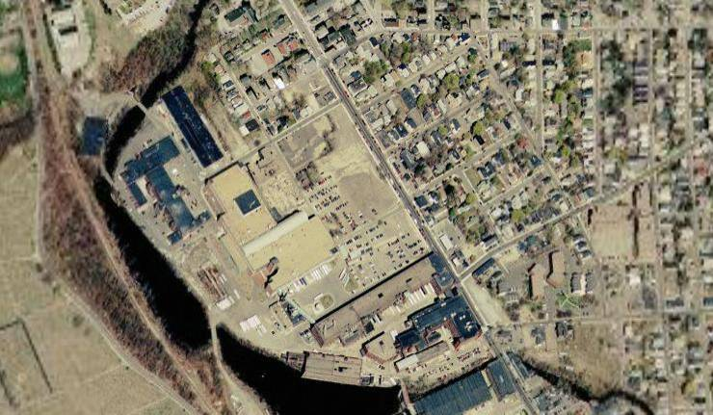
Proposed development site
Nearby residential neighborhood
Proposed apartment complex
Existing Streets

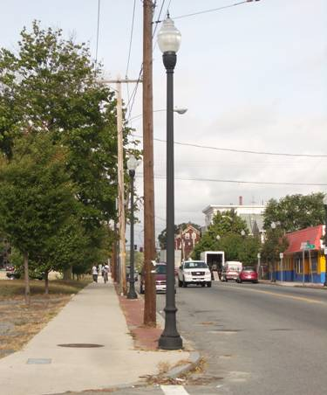
The site is bounded by Broadway on the east, Stafford on the south,
(looking north on Broadway from Stafford)
French on the west and Chase on the north. Except for Stafford, all
of these streets have sidewalks and granite curbs. Broadway and Chase
Streets are in very good condition, and Broadway is also clearly painted. Broadway’s newly renovated sidewalk is the widest and includes a brick strip and pedestrian-scale lighting; however, above-ground utility poles and wires somewhat diminish the ambiance these sidewalks and lighting were designed to create.

Broadway includes parking on both sides and a lane in either direction. The other streets have one lane of traffic in each direction and are not used for parking. These streets may have room for one lane of parking on one side of the street. Additionally, Stafford Street could be
substantially modified as its sidewalk and curbs are basically no longer
existent.

Chase and Stafford Streets will continue to be used as throughways for heavy trucks transporting products from the nearby manufacturing plants. It is our understanding from Yanni Tsipis, broker from Meredith and Grew, that the volume of the heavy trucks will have little, if any, effect on the success of our planned development.

Implications
Broadway possesses the most valuable retail frontage. With that in mind, the site plan will provide as much retail within sight of Broadway as possible. The design will also take advantage of access available through surrounding streets. On Broadway, one section of parking could be replaced with a turning lane.
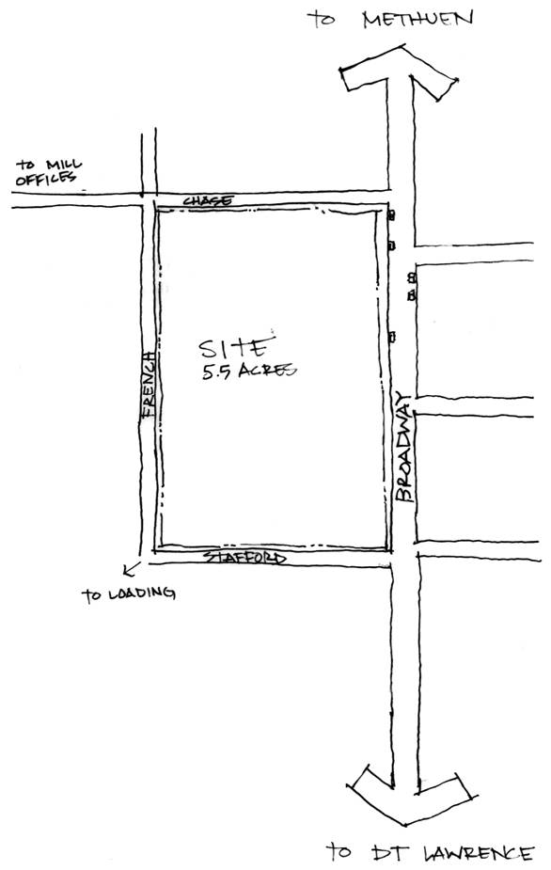

Topography

Generally speaking, water flows from the northeast corner of the site to the southwest corner. On the back of the site there is a significant grade change of 9 feet (71 to 62 feet) from the northern edge of the site. As shown in the picture below, this grade change is dramatic on the site and more gradual on the sidewalk and street.
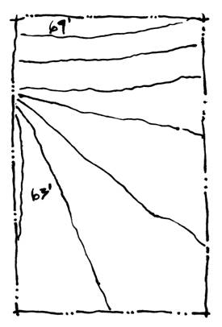

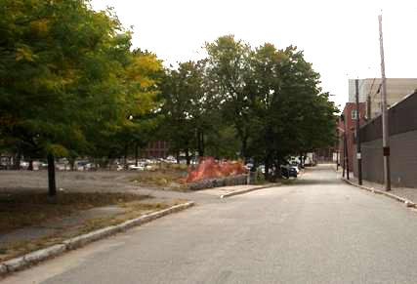

(looking south on French street from Chase)

Implications
Careful site planning will include landscaping at the Southwest corner of the site. Additionally, a significant grade shift must be accomplished at the back of the site.

Trees

There are over 30 existing trees on the site of varying quality and size. Broadway has a consistent row of young trees set back three feet from the sidewalk and spaced at about 14 foot intervals. Chase has three small but mature trees along its western edge which have been boxed in, presumably for preservation during demolition. The other trees on the site are larger and some what sporadically situated in the middle and back edge of the site. A tree of particular note sits prominently at the southwest corner of the site (see picture below).
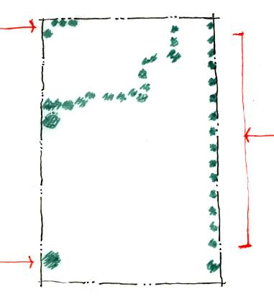

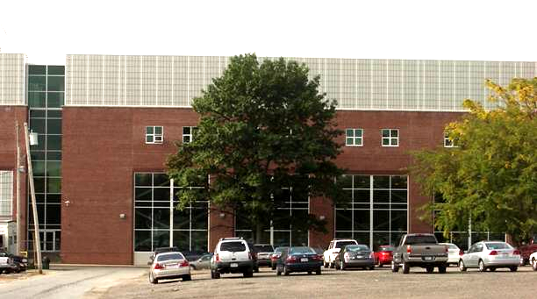

(tree locations; looking down Stafford)

Implications
It will not be appropriate to retain all of the trees on the site. However, some may contribute significantly to the shopping center and are included in the plan where possible. Specifically, the trees at the back of the site correlate well with needed retention area, those at the front provide a formal streetscape, and those at the north east serve to act as a buffer to neighboring residential buildings

Neighbors

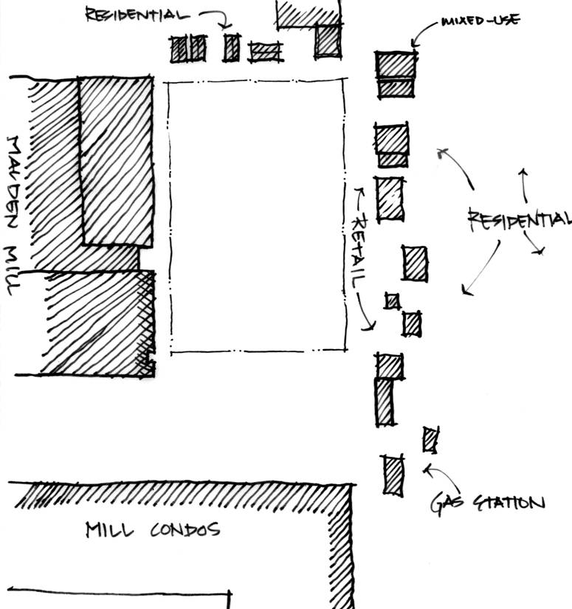
A mix of residential, retail, industry, and commercial surround the site. On the northern border (Chase Street) are single family homes, a Dunkin’ Donuts regional bakery and a Dunkin’ Donuts retail store. According to the City of Methuen, Dunkin’ Donuts is planning to relocate the regional bakery to the northern border of Methuen. Neighbors on the eastern border include a wide range of independent businesses, including small restaurants and cafés, a florist, automobile services store, and more.

In addition to the retail neighbors, two not-for-profit organizations are on Broadway: the Methuen Community Center and a Pentecostal church. The City of Methuen will be expanding the community center within the next year or so to meet the needs of the local patrons.

On the southern border of the site, WinnCompany has plans to convert an older mill building into 600 rental units (80% affordable) over the next four years. Between these historic mill buildings and the proposed Broadway site will be a parking lot for the residential mill building.

The $400 million Polartec manufacturing facility abuts our site to the west. This facility employs 1,000 workers, broken into three shifts (at any one time, 400 workers are present at the facility).

Implications
It is important that the shopping center welcome potential customers from the mill redevelopment project to the south. Because the façade of the new mill building is of a higher quality than an older building just north of it, efforts to expose the former and diminish the presence of the latter are appropriate. Additionally, it would seem wise to complement and benefit from the existing retail space across Broadway--despite the fact that their presently vitality is questionable. Funds are available to improve the neighboring stores’ facades.

Environmental Soil Conditions

Historical Sanborn maps indicate that the site consisted of residential, commercial and light industrial uses. Regarding potential soil contamination, the site previously contained gas stations on both the northeast and southeast corner of the site. In the case of the southeast corner, the station was accompanied by an “auto service and sales” operation. Just north of this corner was a Pepsi-Cola bottling plant. Fortunately, the site was cleaned of contaminants when purchased by Malden Mills. Three underground storage tanks have also been removed. A phase II environmental site assessment was completed in March 2005, which found that a condition of “No Significant Risk” exists on the site. Additionally, the criteria for a Class A-2 Response Action Outcome have been satisfied, and “Permanent Solution” has been reached without any limitation on the redevelopment of the site.

Implications
Despite suspect former uses, the site is clean and will not require environmental remediation.

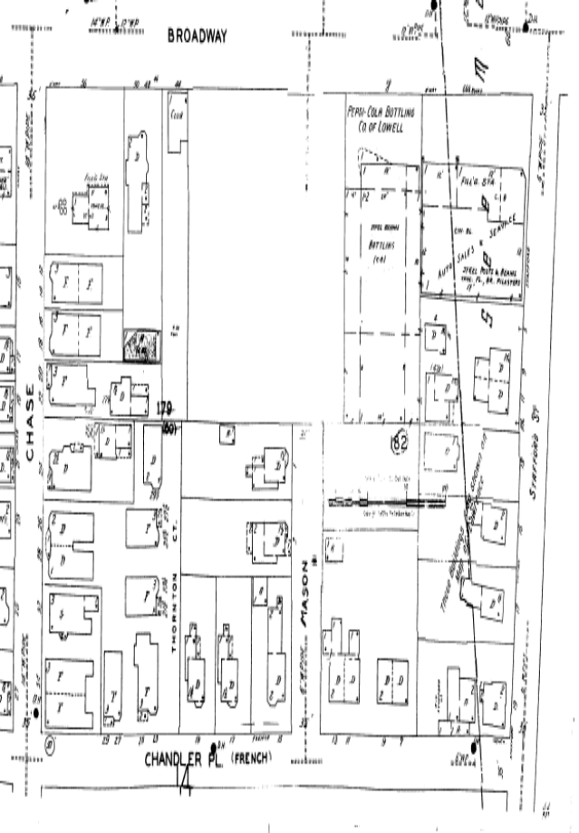
(1949 Sanborn insurance map)

Infrastructure and Utilities

Given the history of the site, major utilities (water, sewer and electricity) are present and do not pose any significant challenges. The survey below shows a 14” water pipe on Chase Street, an 8” pipe on French and a 10” pipe on Stafford. Each has multiple taps in place. Sewer lines also surround the site and there are several existing fire hydrants on the edges of the site. Future iterations of our site plan should take into account the water easement at the southeast corner of the site.

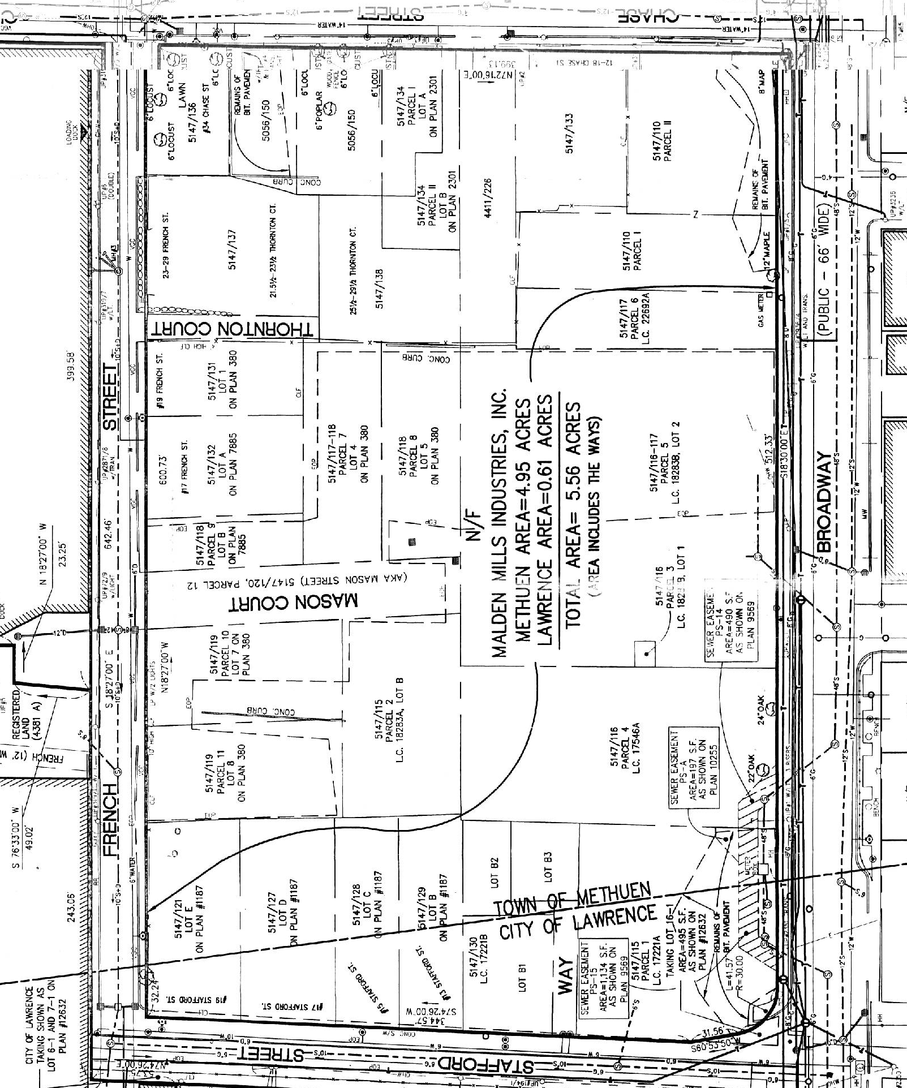
Zoning and Regulatory Information

Due to the site’s location across the Methuen and Lawrence town border, we must consider the community goals and regulatory requirements for both towns. In general, learning each town’s regulatory process has given us insights into how smaller towns operate versus large cities. For example, little information is available online. In-person visits to each city are the only way to really obtain substantive information. However, since these small towns are financially strapped, the planning offices are thinly staffed and it can take weeks, or even months to schedule an appointment with a planning staff member.

The Methuen portion of the site, containing approximately 86% of the total site acreage, is currently zoned IL, or Limited Industrial. The Lawrence portion of the site, containing the remaining 14% of the site, is zoned I-2 or General Industrial. While the Lawrence zoning district I-2 is more flexible than the Methuen IL counterpart, the proposed development project is not permissible as of right under current zoning in either city. The following sections explain in further detail the zoning restrictions of each city and the necessary steps to obtain the appropriate entitlements.

Methuen, MA

Limited Industrial is intended to accommodate light industrial uses only, with residential uses prohibited and retail uses permitted by special permit only. Thus, under this zoning, our project is not permitted by right. All specific zoning information is sourced from either the Director of the Community Board, Nancy Colbert, or from the City of Methuen, Comprehensive Zoning Ordinance, effective August 1989 and last revised October 2005.

Step 1: Obtain Special Permit from Community Development Board (“CD Board”)
Since retail uses are allowed by special permit only on the site, we have outlined the process whereby to obtain a special permit. First, under City of Methuen zoning guidelines, our project most closely fits the description of “Shopping Center”, which includes one or more buildings containing allowed or allowable retail or service business uses, including 20,000 or more square of building floor space, and off-street parking in accordance with zoning guidelines. Based on this definition, the Special Permit Granting Authority for a Shopping Center Special Permit is the Community Development Board.

While the CD Board reviews the application for special permitting with respect to several factors including availability of utility service, infrastructure capacity, and consistency with neighborhood character, several key criteria are emphasized:

- Traffic generation. The CD Board is responsible for ensuring that no project causes an undue strain on the surrounding roads and neighborhoods. Ms. Colbert indicated that a project of our scale would require a separate traffic study performed by traffic engineers to confirm adequate roadway capacity.

- Parking requirements. Of the possible retail uses on our site, we have applied the highest parking requirements across the total building square footage. While the city distinguishes parking requirements for traditional retail from other uses such as drive-thru restaurants and banks, the traditional retail space requirements are the highest. Thus, since our site plan is still in flux, we are focusing on the highest requirement:

Traditional retail: 4 spaces per 1,000 square feet plus 1 space per 2 employees at maximum shift.

Based on our base case scenario square footage, which contains the maximum square footage of the viable site plan options, we are required to have 4 spaces * 92.9 = 371 spaces. As we currently supply 408 spaces, this leaves an excess of 37 spaces. Using the above formula for required employee parking, this allows a total of 74 employees at maximum shift. Until we know for sure the retail tenants likely to occupy the space, we are assuming that 74 employees will ultimately satisfy the requirements of the retailers.

- Other special retail uses. Other special uses such as daycare, drive thru restaurants and hair salons will require additional special permitting. For example, daycare facilities must be in conformance with minimum play area and health board requirements. Drive thru restaurants must have access that does not interfere with local traffic or other parking areas and are not permitted to be open after 11pm.

- Setbacks. Under IL zoning, front setbacks of 60’ from the property line to the building line are required. Secondly, side and rear setbacks of 30’ are required when abutting residential or multi-family uses. These setback requirements will need to be adjusted or waived via special permitting.

- Building coverage. Most business or retail zoning guidelines in the ordinance allow a maximum site coverage of 40%. Our highest building coverage of the site is the 92,920 scenario, which translates into a 38% coverage of the 5.5 acres. Thus, the proposed project is within these guidelines.

- Building height. Most business or retail structures have a maximum height allowed of 40’ or 3 stories. This restriction does not impact our current site plan scenarios as our most viable site plans include only single-story structures.

- Screens or Buffers. Screen Buffers can be in the form of fences or landscaping. For Shopping Center special permits, the CD Board may require landscape or other screening up to 6’ in height and 10’ in width. We anticipate this requirement to only be relevant should we have a retail configuration that is undesirable to the CD Board. For example, we have discussed building a landscaping buffer to offset the town’s resistance to a parking lot fronting on Broadway. However, reduced visibility for the retailers from this screen must be taken into account.

Once the special permits have been granted, ‘substantial use’ of the development must occur within two years or the special permit(s) expire.

The documentation and corresponding fees required for special permit application are as follows:

One original and eleven (11) copies of a site plan drawn at 1” = 40’ scale, prepared by appropriate Massachusetts engineers, architects and landscape architects. The location of all utilities, easements, infrastructure and right-of-ways must be shown, as well as all building locations and corresponding square footages. The parking configuration, number of parking spaces, and configuration of building uses, among other aspects, must be shown on the site plan.

The CD Board strongly recommends that the developer meet with the CD Board prior to filing an application for special permits should the project require additional documentation.

Once complete, the application is to be filed with the CD Board and with the City Clerk. The fee for such application is $250.00. Once filed, special permits issued by the CD Board require a two-thirds (2/3) vote if the board contains more than five (5) members and a vote of at least (4) members of a five (5) member board. Though unlikely, if the CD Board fails to act within ninety (90) days, the application for a special permit is deemed granted.

Step 2: Obtain Site Plan Approval from CD Board

Once requisite special permits have been obtained, Site Plan Approval is required for any project containing non-residential buildings greater than 5,000 square or containing two or more buildings on the site. The Community Development Review Board performs the Site Plan Approval process, which includes a public hearing.

Ms. Colbert indicated that the developer would typically meet on an informal basis with the city planner at least one week before submitting documents to the Board. In this way, the planner can be better informed and help the developer make his or her case in front of the Board. Ms. Colbert did not foresee any necessary concessions or immediate challenges with our proposed development plan, although she did mention that the “Board would not be excited to approve anything with a big parking lot in front.” In light of this, we have tried to create a pedestrian-friendly environment in our site plan that would conform to the Board’s wishes.

Since Site Plan approval involves a public hearing, we asked Ms. Colbert if we should anticipate any community resistance to the proposal. In general, we gained the sense that the Methuen approvals process does not seem to be as influenced by community groups as its neighboring counterpart, Lawrence. The City of Methuen has a very organized and seemingly effective and proactive planning board that is sufficiently rigorous in reviewing proposed plans that community groups, other than the one joint group between Lawrence and Methuen (below), may not be as active.

The purpose of site plan approval is stated as follows:

- To protect the health, safety and welfare of the public;
- To insure attractive and well-designed developments;
- To protect the interests of adjoining property owners;
- To create a better living environment in Methuen; and
- To preserve the natural resources of the City.

The process for obtaining site plan approval is as follows:

Submit one original and 15 copies of an application and site plan to the Community Development Board for approval. The site plan must be drawn to a scale of 1”=40’ and be prepared by a Massachusetts professional engineer, registered architect, or registered landscape architect. Similar to special permitting, the site plan must show utilities, trash collection strategy, easements, and building locations, uses and square footages. The site plan should also show proposed landscaping, topography and parking lot lighting.

The CD Board meets on the 2nd Wednesday of each month in the Searles Building. Documents for submittal must be received by noon on the previous Wednesday of the month. Meeting dates for 2006 have not yet been released.

The fee for Site Plan Approval is $250.00 or $0.03 per square foot of building, whichever is greater. Thus, the highest fee based on our site plan scenarios is $2,787.60. Should we plan to pursue a day care center, an additional fee of $125.00 would be required.

Step 3: Zoning & Inspections Committee

Once the development has received requisite special permits and site plan approval from the Community Development Board, it is then submitted to zoning and inspections for actual building permit applications and final confirmation of conformance to zoning requirements.

In total, Nancy Colbert, Director of the Community Board, indicated that our proposed project should take 9-12 months to complete the permitting process, including special permitting and site plan approval.

Lawrence, MA

Obtaining zoning information for Lawrence was a similar experience to gaining information in Methuen. Specifically, nearly 2 months went by before being able to meet with a member of the Lawrence Planning Board and zoning guidelines are not available online. All zoning information contained herein is sourced from the Lawrence Revised Zoning Ordinance, last revised April 5, 2005.

The Lawrence portion of the site, approximately 14% of the total acreage, is currently zoned as I-2, which is designed to permit the most intense industrial uses of the city, as long as these uses are safe and healthy.

Under the current zoning, the proposed retail development project is not permitted as of right. In order to obtain permitting, similar steps would be required as those for the City of Methuen, including obtaining special permits and site plan review. One key difference, however, is that the Lawrence site plan review does not include a public hearing and the Planning Board has more of an advisory role, as opposed to outright approval rights.

Lawrence is currently working on a key initiative whereby all I-2 districts in the City would receive ‘Overlay District’ zoning. Since Lawrence is currently engaged in various revitalization efforts, the City Planning Board is attempting to streamline the permitting process by establishing an overlay on various sections of the city. Under this overlay zoning, all uses permitted by the underlying zoning district would continue to be allowed. In addition, new uses would also be permitted via the overlay. The intent is that once in place, the overlay will expedite development approval and permitting.

After speaking with Dan McCarthy, attorney for the City of Lawrence, we understand that the proposed development site will be included in the next overlay district, which he anticipates being finalized within the next year. Once complete, the permitting process would require only site plan review and no public hearing.

Consistent with the City of Methuen, the proposed project fits the definition of Shopping Center, which would be permissible under the overlay district. Shopping Centers have the following specific requirements:

- Parking requirements. The objective of the parking requirements is to promote traffic safety by providing adequate off-street parking and maximize the traffic-carrying capacity of adjacent roadways. Similar to the Methuen parking analysis, we have applied the highest parking requirement of the various retail uses proposed. Shopping Centers as a general category have the highest parking requirement, namely 3.33 spaces per 1,000 square feet of building area.

- Screens or Buffers. Similar to Methuen, the Lawrence Planning Board reserves the right to require buffers around retail uses to protect neighboring uses.

- Drive-thru facilities. Should we locate a drive-thru on the Lawrence side of the parcel, we will have to comply with various guidelines including a maximum of 2 curb cuts at the site and a minimum building setback of 40’ from the front lot line.

- Traffic Study. Even with the overlay district zoning, a traffic study may still be required due to the scale of the project and the size of Broadway. It is conceivable that one traffic study should satisfy the requirements of both Lawrence and Methuen. Specific study guidelines are articulated in the Lawrence Revised Zoning Ordinance.

To apply for site plan review under the overlay district, we are supposed to meet first with the Lawrence Planning Board and confirm substantial conformance with the application requirements and zoning guidelines. Following this meeting, twelve copies of an application for site plan review are submitted to the planning board, each accompanied by a site plan. The site plan must be prepared by a registered architect or engineer and should be on sheets no larger than 24”x36”at a scale of 1” = 40’. Representative information to be included on the site plan includes boundaries of the property, setback lines, location of current utilities, easements and infrastructure, location and square footage of proposed buildings and corresponding uses. Several pages of additional specific site plan requirements are contained in the Lawrence Revised Zoning Ordinance. The fee for site plan review is $200.

Achieving Public Goals – Lawrence and Methuen

We believe that almost any development will be an improvement over the current gaping lot on Broadway, a key thoroughfare through these two towns. Lawrence, in particular, seems thrilled to permit almost any new development. However, both Methuen and Lawrence have a similar idea on what kinds of development would really bring progress and a sense of identity to the area. Most of these ideas revolve around various community uses, including community theatre space, a museum, and a community park.

While a new neighborhood shopping center may meet the immediate retail needs of the surrounding community, it would be difficult to use this type of real estate product to truly generate a unique sense of cultural identity or place, which both Lawrence and Methuen would like. So, while our proposed retail development could be an improvement and it is unlikely there would be community opposition to the project, it is not clear that the project meets any specific public goals by fostering a sense of community or cultural identity.

Based on a meeting with Sharon DuBois at the Lawrence City Planning Office, our retail concept would be approved for this site with little opposition from community groups. Although it does not appear that the overlay district zoning requires a public hearing, should a public hearing be required at any point, it may be necessary to carefully evaluate the influence of community organizations. For example, Ms. DuBois mentioned that it will be necessary to gain the support of various community organizations, in particular the Lawrence-Methuen Community Coalition and the Lawrence Community Works. Both of these organizations are grassroots coalitions that are very active and highly opinionated.

We recently met with Tamar Kotelchuck of Lawrence Community Works (“LCW”) and, while no opposition was expressed towards the proposed retail concept, Ms. Kotelchuck did express interest in LCW acquiring the site for residential development.

Thus, other than LCW expressing an interest in acquiring the site themselves, we are not aware of any other required concessions or local opposition at this point. Should public hearings be necessary, we anticipate the community groups will seek community benefits to be included with the retail development, particularly since many of the proposed site plan scenarios lack a clear community development initiative. For example, perhaps the community organization will require the development to include a small amount of community open space or contain a minimum percentage of local entrepreneurs. One offsetting factor to these community concessions in Lawrence may be the fact that only 14% of the total site is actually in Lawrence. Thus, the community groups may not be as concerned about less than 1 acre in area.

Conclusion

Broadway Center connects the Methuen and Lawrence neighborhoods, revitalizes a blighted area for both cities, serves the immediate and long-term needs of the existing and future residents, and can achieve investment return requirements. Broadway Center also provides an opportunity to recognize the profound commitment Mr. Feuerstein demonstrated to his employees and each municipality. In addition to carefully selecting the proper tenant mix, coordinating our efforts with WinnCompanies, local community groups, and city officials from Lawrence and Methuen will make this unique opportunity a reality.

One of our biggest challenges is to find a grocer interested in opening a mid-sized store. Based on recent meetings and conversations, the grocery store anchor concept is challenged. Specifically, we received negative feedback from Market Basket, our primary target, on the proposed site. Market Basket’s specific reasons for turning down the site including size and existing market saturation. Market Basket is seeking sites at least 10 acres in size to house a minimum 60,000 sf store. In addition, Market Basket currently maintains 7 profitable stores within a 5-mile radius and does not see any need to expand.

Secondly, we received negative feedback on our second choice grocery anchor, Hannaford. Hannaford has stores that are in the 40,000 sf range, but we learned recently that they do not like to locate near their most-feared competitor, Market Basket. Market Basket is perceived as being able to undercut any store’s prices and due to the saturation of Market Baskets in the area, Hannaford would be unlikely to choose our site.

Thirdly, we also learned that the Wal-Mart Neighborhood Center, a new concept started by Wal-Mart whereby 45,000 square foot smaller grocery stores are built to fit in smaller sites or complement the latest urban planning trends, has not yet reached Massachusetts. Wal-Mart has no plans at the moment to extend this concept into the New England area.

Smaller grocery stores such as Shop-Rite and Save-a-Lot are really more convenience stores, approximately 30,000 square feet or less in size. These convenience stores would not really meet the community need of a grocery store and would likely have difficulty competing with the numerous other local and ethnic convenience stores in the area.

Many of the remaining grocery store chains are currently focusing on large-scale footprints of 60,000 square feet or larger. Given the 5.5 acre size, we do not feel our site could accommodate a larger grocery store; however, Stop & Shop did recently open a mid-sized store in Dorchester, Massachusetts, in the Grove Hall shopping center. Grove Hall could be considered analogous to Broadway Center in size, tenant mix, and in demographics. We are interested in further pursuing the possibility for Stop & Shop to become our anchor grocery store.

In contrast to the difficulties in finding a suitable grocery store anchor, we have repeatedly received positive feedback on the pharmacy anchor. Walgreen’s is our top candidate at this point as they already maintain one store in the Lawrence area. We have heard that Walgreen’s is a bit slow-moving on the transaction front; however, they could be looking to expand in the area. Rite Aid is also a possibility for the site. CVS is no longer an option for the site as they recently chose a nearby location in Methuen (less than 0.5 miles) to expand. Brooks Pharmacy is also not an option as they recently purchased the Eckerd’s chain of pharmacy stores. In addition, Brooks Pharmacy typically seeks to renovate and occupy existing structures, rather than participate in new development opportunities. We will continue to pursue both Walgreen’s and Rite Aid as potential anchor tenants.

Once we have solidified the anchor tenants, we believe the in-line retail tenants will quickly follow. The challenges we face with the in-line retail consist of carefully orchestrating the tenant mix to help ensure the longevity of the project. For example, according to the Urban Land Institute (“ULI”), some of the highest sales volume in-line tenants include coffee shops, Mexican fast food, liquor and wine stores, cafes, and mailing and packaging stores. Low-performing stores include mobile telephone stores, tanning salons, and nail salons. We will also pursue stores in this category, but at an initially lower priority.

We believe that the rich history of our site, its location, and the surrounding demographics combine to provide investors, residents, community groups, and municipalities an opportunity to create a center that will drive surrounding development.

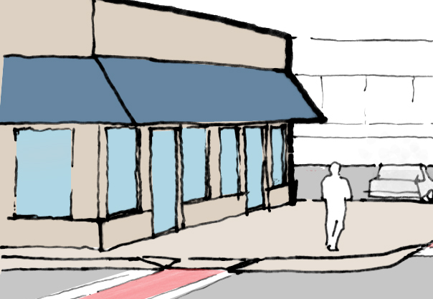

Exhibit 5
Other Potential Local & Public Assistance

The following represent alternative financing opportunities, either through community development lending and investing (via commercial banks or community development investment funds) or through governmental grants and funds. These are not essential for the success of the project, but rather represent opportunities to either augment returns or improve the condition of existing commercial buildings in the area.

Renewal Communities Program
Lawrence is one of forty cities nationwide to receive the Renewal Communities designation. As part of this designation, Lawrence businesses are eligible for various subsidized financing options, including tax deductions, employment credits, or construction deductions (credited as a tax deduction for store renovations, etc.). This program is known as being particularly complicated to utilize, however, it is a program we will be pursuing as part of our subsidized financing strategy.

Small Business Revolving Loan Fund
The Small Business Revolving Loan Fund is designed to promote the growth of businesses committed to Lawrence through gap financing. The activity undertaken must benefit persons of low and moderate income and/or aid in the prevention or elimination of slum and blight. This program is expected to leverage, but not replace, private sector financing through a partnership in the overall financing requirement. This program may benefit some of our potential in-line retail tenants.
Max Loan - $50,000
Min Loan - $5,000
Term - 5 years
Interest Rate - Tied to prime rate
Uses - Real Estate or Equipment Purchases, Working and Start Up Capital

Section 108 Financing
Section 108 Financing is large project financing at below market rates and provides communities with a source of financing for economic development projects. All projects and activities must either principally benefit low- and moderate-income persons, or aid in the elimination or prevention of slums and blight, or meet urgent needs of the community. Since our site is located in a moderate income census tract, it may qualify for this financing. The principal security for the loan guarantee is a pledge by the City of its current and future CDBG funds. Additional security will also be required to assure repayment of the guarantee obligations, including assets financed by the guaranteed loans. The maximum repayment period for a Section 108 loan is 20 years. This program is expected to leverage, but not replace, private sector financing through a partnership in the overall financing requirement.

Facade Improvement Program
The Facade Improvement Program provides up to 50% of the funding (to a maximum of $5,000) for commercial loan improvements for businesses to improve their facades. Eligible improvements include exterior painting, repainting, cleaning; replacement of original architectural features; removal of existing signs; installation of new signs; landscaping; and architectural and related fees not exceeding 10% of total facade renovation cost. The Facade Improvement Program provides 5 year deferred loans (grants if still at that location after 5 years) of up to a $5,000 maximum to each property. This program could be utilized by prospective new tenants or to encourage retail across the street to improve their facades.

Economic Opportunity Area Tax Incentive Program
For projects located within an Economic Opportunity Area (EOA) which retain or create jobs and create additional tax value in that property, a company may apply for certification of the project. Certification by the City and State will qualify the company for State and Municipal tax incentives. Additional incentives are given for projects which are aimed at abandoned buildings.

District Improvement Financing Program
The District Improvement Financing Program (DIF) is a public financing alternative available to all cities and towns in the Commonwealth that have projects meeting DIF regulations and guidelines. It enables municipalities to fund public works, infrastructure, and development projects by allocating future, incremental tax revenues collected from a predefined district to pay project costs.

DIF is locally driven and approved by the Economic Assistance Coordinating Council (EACC). The municipality must define the district and document a development program describing, among other things, how the DIF will encourage increased residential, commercial and industrial activity within the district. It must also detail the project improvements, financing plans, and community benefits. After the local public hearings and approvals, the municipality must submit an application to the EACC for final approval prior to implementing the program.

Hannaford stores average 48,200 square feet; Stop & Shop recently opened a 43,200 square foot grocery store in the Grove Hall shopping center in Dorchester, Massachusetts. Wal-Mart also develops mid-sized neighborhood grocery stores, but is not currently targeting the New England area.
This does not include 94 on-street parking spaces on the streets adjacent to the site. While on-street parking is already permitted, zoning regulations do not permit those spaces to be included in the development calculation. A variance will be required if it is necessary to include those spaces to meet parking demand.
In researching the demand for a new supermarket, we have relied on data from local real estate developers, brokers, city officials, grocery store managers, and other professionals in the industry. Data providers include U.S. census, State of Massachusetts, Cities of Lawrence and Methuen, Claritas, Regis, InfoUSA, and the Urban Land Institute, just to name a few; Industry professionals: local developers include Tom Maher of Eastern Development and Linear Retail; real estate broker Yanni Tsipis from Meredith and Grew; city officials from Methuen include Nancy Colbert, Director of City Planning, and Carolyn Finlay, Office of City Planning; city officials from Lawrence include Dan McCarthy, Sharon DuBois, and Orlando Salazar; local super market managers include store managers from Market Basket, Stop and Shop, and Shaw’s (in Salem, NH).
Source data: Claritas
Estimated sales are derived from a conversation with the Shaw’s store manager in Salem, NH, and from InfoUSA revenue estimates of the surrounding grocery stores.
Tamar Kotelchuck of Lawrence Community Works, Sharon DuBois of Lawrence City Planning, Carolyn Hall Finlay of Methuen City Planning.
Should the overlay zoning not be achieved in Lawrence, community approval would be required for the proposed site plan. See Zoning & Regulatory section for more information.
Reference sources for rents: Tom Maher, Eastern Development, Linear Retail, and CIMLS: Commercial Real Estate Listing Service.
Yanni Tsipis, Meredith & Grew, indicated that the target residual land value is greater than $1MM, but less than $5MM.
Google Earth elevation measurement.
Conversation with Brian Leaf and Carolyn Hall, Office of Planning and Community Development, November 8, 2005.
Ibid. The center has attracted upwards of 60 youth on a busy day.
Conversation with Yanni K Tsipis.
Conversation with the Lawrence Planning Department.
Underground storage tanks of 2,600, 4,000 and 10,000 gallons were removed prior to 1998.
Email from Yanni K. Tsipis November 14, 2005
Conversation with Yanni K Tsipis.
Conversation with Brian Leaf and Carolyn Hall, Office of Planning and Community Development, November 8, 2005.
City of Methuen, Comprehensive Zoning Ordinance, effective August, 1989, p.40.
City of Methuen, Site Plan Approval for Non-Residential Buildings, Section XII
Only convenience stores have a higher requirement of 5 spaces per 1,000 square feet. Since we are not contemplating a convenience store at this time, we have not applied this ratio. Grocery store requirements are not specifically broken out in the parking code, so we have applied the highest general category of 3.33 spaces per 1,000. Should higher parking be required to accommodate the grocery store, we plan on applying for ‘Shared Parking’ permission, under which we can make the argument that not all uses will have equal frequency during various times of day and thus, the overall parking requirement can be reduced. In addition, we may make the case that adjacent on-street parking (total 94 spaces) could be included in our overall parking ratio analysis, thereby meeting the higher requirements.
Source
Linear Retail, conversation 12/14/05
Linear Retail, conversation 12/14/05
ULI Dollars & Cents of Convenience Shopping Centers, 2004.
ULI Dollars & Cents of Convenience Shopping Centers, 2004.
Tamar Kotelchuck, Lawrence Community Works. Also Merrimack Economic Development Council: http://www.merrimackvalley.info/realEstate/renewal-comm.html.

