3. Market Analysis

OVERVIEW

Our market analysis begins by analyzing general characteristics of Merrimack Valley region, followed by micro analysis of the Lawrence and Methuen Municipalities. Next, we define our site’s trade area based on local traffic patterns and on distances to competing uses. Once the trade areas have been defined, we estimate potential consumer expenditures and sales for our two anchors, a grocery store and a pharmacy. In this section we also consider traffic count and market rent information. We will also study the location, characteristics, and sales of competitive retail centers in the trade areas, as well as availability and absorption of retail space.

GENERAL CHARACTERISTICS OF THE MARKET

EMPLOYMENT

Broadway center is located 35 minutes north of Boston in the Merrimack Valley Planning Council (“MVPC”) region. The MVPC includes 15 municipalities and supports major industry clusters in fields such as telecommunications, biomed/biotech, textiles/apparel, and high technology. Once a thriving industrial center, the City of Lawrence now enjoys only a small textile/apparel sector, including Malden Mills, the producer of Polartec fleece; New Balance, the developer of sneaker shoes; and Southwick Clothing, the handmade suit designer for famous persons like John Kerry, Cary Grant, and George Bush. Methuen also enjoys a rich industrial history and its industrial parks house tenants such as Colombo, McKesson, MicroTouch, and Nabisco. The Malden Mills buildings adjacent to the west and south of our site will directly affect Broadway Center’s surrounding environment. The following is a map of the Merrimack Valley region and highlights the cities of Methuen and Lawrence.

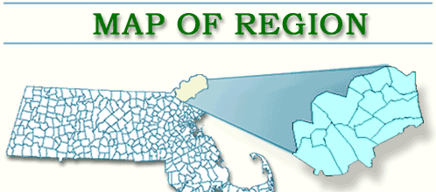
Methuen
Lawrence

Almost one-third of those employed in the MVPC region work in manufacturing. Education and Health Services and Trade, Transportation, and Utilities are the next two highest types of employment in the region. Professional and Business Services, Information, and Financial Activities include the smallest portions of employment in the valley. The following table provides a breakdown of employment in the region.

MVPC, Methuen, and Lawrence Employment
 | MVPC Region | Methuen | Lawrence
Education and Health Services | 22% | 29% | 31%
Financial Activities | 5% | 3% | 2%
Government | 5% | 5% | 4%
Information | 4% | 2% | 1%
Leisure and Hospitality | 7% | 8% | 3%
Manufacturing | 27% | 15% | 26%
Natural Resource, Mining, Construction | 4% | 7% | 2%
Other Services | 3% | 2% | 4%
Professional and Business Services | 10% | 7% | 15%
Trade, Transportation and Utilities | 14% | 22% | 12%
TOTAL | 100% | 100% | 100%
Source: 2000 Census Data

The above employment breakdown further emphasizes the MVPC region’s heavy involvement in manufacturing. More specifically, the economies of Methuen and Lawrence also rely heavily on manufacturing, with 15% and 26%, respectively. Though Methuen relies almost half as much on manufacturing as does Lawrence, its 22% of employment in Trade, Transportation, and Utilities is 60% more than MVPC’s portion and almost 200% as much as Lawrence. These data reveal each city’s heavy reliance on “blue collar” employment.

Between 2000 and 2030, the MVPC forecasts contrasting employment trends for the cities of Methuen and Lawrence. Forecasters estimate Methuen’s employment to grow 16% from 13,663 to 15,824, with strong growth in Natural Resources, Mining, and Construction, Professional and Business Services, and other services. In contrast, Lawrence’s employment is expected to decline 17% from 23,330 in 2000 to 19,370 in 2030. Leading the decline in Lawrence’s employment will be manufacturing and current forecasts do not project employment in this sector to be completely replaced by other sectors.

The dramatic decline in manufacturing throughout the MVPC could reasonably add millions of more vacant manufacturing space to the current millions of vacant square feet in the area. We see current effects of the declining manufacturing industry through the numerous conversions prevalent in Lawrence, including WinnCompanies’ apartment conversion abutting our parcel’s the south perimeter. If Malden Mills eventually vacates Lawrence, our site will further suffer from vacant manufacturing space directly behind (to the west) of our site.

The MVPC believes that the region was hit especially hard by the recent downturn high tech manufacturing area. Unemployment rates in the MVPC historically have been on average of 1.1% higher than the Massachusetts Commonwealth average and typically move in-step with the state’s unemployment rate. Exceptions to this historical relationship occurred in 2002 and 2003, when unemployment in the MVPC region rose to 2.5% higher than the state average in each year. This spike in unemployment occurred when Lucent Technologies, one of the region’s flagship high tech manufacturing companies, slashed jobs in its North Andover plant from 5,000 in 20001 to 700 today. According to the MVPC, Lucent Technologies at one point employed 13,000 workers in the region and has slowly cut its work force over the years. Lucent Technologies’ actions illustrate how the region’s heavy reliance on manufacturing will continue to pose real economic risks.

MVPC Region vs. Massachusetts Unemployment Rates
Source: Massachusetts Department of Workforce Development (http://lmi2.detma.org/lmi/town_comparison.asp)

METHUEN AND LAWRENCE DEMOGRAPHICS

Population: 70,200
Median Income: $28,000
Unemployment: 12.0%
Hispanic/Latino: 59.7%
White: 34.1%
Female Householder: 25.7%
Median Age: 29.5 years
School District: 277 out of 278
Ambience: Extremely depressed economically; Proliferation of auto repair shops and empty mill buildings
Population 40,000
Median Income: $50,000
Unemployment:7.1%
Hispanic/Latino: 9.6%
White: 85.8%
Female Householder: 12.2%
Median Age: 37.5 years
School District: 236 out of 278
Ambience: Historic New England town
METHUEN
LAWRENCE
Source: http://www.mass.gov

Methuen and Lawrence represent a modern telling of the classic story “A Tale of Two Cities.” Strengths in Methuen’s median income levels, school districts, employment, and ambience are polarizing weaknesses in Lawrence. Despite having 85% of our site in Methuen, a Lawrence-like environment penetrates the surroundings. A Lawrence-like “feel” is an economically depressed area with barred windows, empty mill buildings, graffiti, abysmal public education, and run-down retail buildings servicing a poor, mostly Latino population. In contrast, Methuen’s ambience possesses the charm of a historic New England town with a well-diversified work-force, strong median income, good public schooling, and a regional retail center, “the Loop.” A representative from the Methuen planning department even commented that citizens applying for affordable housing in Methuen refuse to locate near our site and would rather take their chances in waiting for a better location.

POPULATION TRENDS

- Lawrence’s 50 year population decline halted in 1980’s with influx of Latino immigrants, mostly of Puerto Rican and Dominican descent
- Very modest population growth of 0.5% in recent years
- Statewide housing boom has let to new housing starts in Lawrence and Methuen, as residents seek less expensive living
- Population is like a revolving door – people coming and going all the time

UNEMPLOYMENT

Unemployment remains a big problem in Lawrence, and a challenge for our site in terms of both retail spending and potentially security. Historical employment data indicate that on average Lawrence’s unemployment rate is 4.7% higher than that of the MVPC region and 5.8% higher than the Massachusetts Commonwealth. In contrast, Methuen’s unemployment rate is very similar to the region as a whole (0.7% higher) and 1.8% higher than the state average. However, like other MVPC municipalities, both cities suffered acutely from larger than normal unemployment rates in 2002 and 2003.

MVPC Region, Methuen, and Lawrence Unemployment Rates

Source: Massachusetts Department of Workforce Development (http://lmi2.detma.org/lmi/town_comparison.asp)

SCHOOL DISTRICTS

Methuen and Lawrence both run sub-par school districts, each ranked in 2005 at the bottom third of the state. Methuen’s performance ranking of 236 out of 278 school districts on the 10th grade Massachusetts Comprehensive Assessment System (“MCAS”) tied it with Revere and placed it just below cities such as Peabody and Attleboro. The ranking is based on the combined passing rates each district had for English and Math. Methuen 10th graders earned an 89% pass rate in English and an 82% pass rate in Math. Lawrence students performed even worse, placing the school district second to last and ahead of only Champion Charter School in Brockton. Andover, Springfield, and Fall River each ranked just ahead of Lawrence. Lawrence 10th graders earned a 68% pass rate in English and a 54% pass rate in Math. The Massachusetts state median pass rates were 92.5% for both English and Math and included cities such as Brookline, Danvers, and North Attleborough. Such low performance on standardized exams will continue to impede migration into Methuen and Lawrence. Given that the immediate area surrounding our site possesses a Lawrence-like feel, the challenge of attracting new families will even be greater. Also, due to the strong ethnic ties in our area, in-migration will most likely occur with friends and families of the existing Hispanic and Latino families, thus further exacerbating the challenge of improving school performance to attract new, non-immigrant families into the area.

SUMMARY OF MVPC, METHUEN, AND LAWRENCE

Economic Trends
- Long-term decline of MVPC industrial base
- Some corporate growth and industrial/high tech industry in neighboring suburbs, e.g. Andover
- Downtown Lawrence continues to struggle economically
- Methuen has been more resilient but also slow growth
- Both towns suffer disproportionately in a recessionary environment
- Methuen and Lawrence focusing redevelopment efforts in their respective downtown areas, polarized away from our site
- Of the 3,325,000 sq. ft. of recent and ongoing redevelopment activity of Lawrence, 81 percent is planned to be mixed-use (condos, office, and retail), compared with only 4% dedicated solely to commercial. Most of these developments are industrial building conversions

What This Means
- We cannot count on a rising tide of population or job growth to lift our boat, we have to find a niche that appeals to existing customers
- Modest housing growth will be helpful to retail but we cannot assume that that housing prices will remain so high and continue to drive people for cheaper solutions
- A recession could be very costly

TRADE AREA

The next step in our analysis focused on selecting a market and demographic profile the site could feasibly attract to our neighborhood retail center. In defining this trade area, we took into consideration demographics, driving habits, nearby competition and cognitive barriers such as major highways and rivers. Based on this analysis, we identified the following trade area:

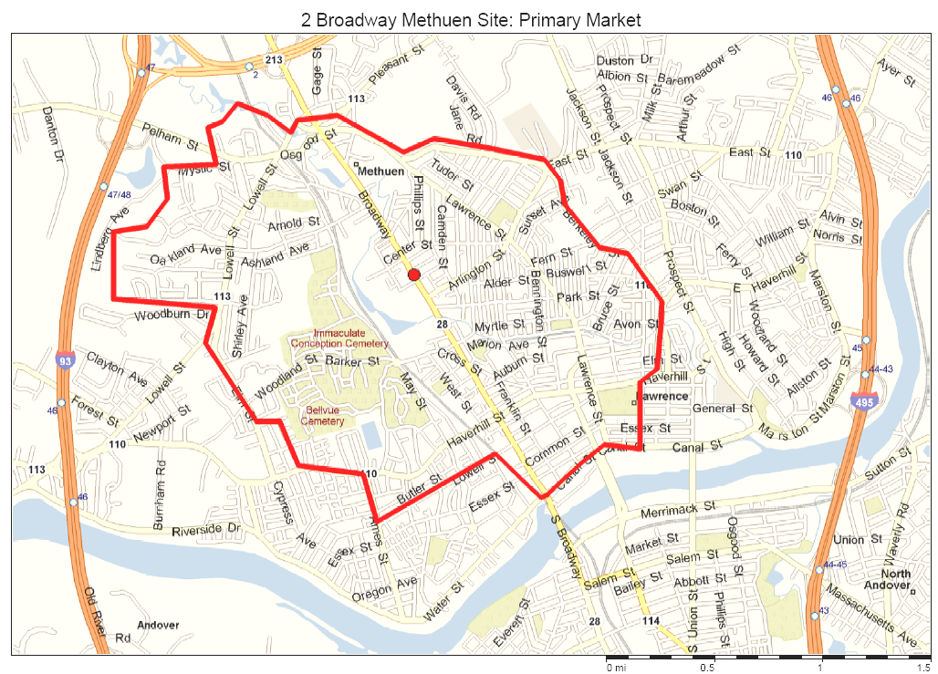
This trade area takes into account the Merrimack River, I-93 and Route 213, each of which acts as a cognitive barrier that people are reluctant to cross in finding their nearest shopping center. A large portion of the trade area to the west of Broadway is composed of industrial areas, the Spicket River and surrounding wooded area, and the Immaculate Conception Cemetery. The core of our traffic-based trade area is to the east of our site.

AVERAGE DAILY TRAFFIC (“ADT”) COUNT: 13,200

Broadway has experienced construction over the past few years, resulting in depressed traffic counts in front of our site. On August 22, 2005, the MVPC conducted its most recent traffic count study over a 48-hour period on the Methuen/Lawrence city line. The ADT count for this study was 13,200 total cars. According to the MVPC, continued construction on Broadway not longer significantly affects traffic counts in this section of the road. Another explanation for the low traffic count relates to the polarization of traffic in each direction away from our site. Most retailers, especially our targeted anchors, typically require at least an ADT of 20,000. The shortfall of traffic passing our site can somewhat be adjusted to account for the large portion of the surrounding population without a vehicle. According the US Bureau of Labor Statistics, 88% of the households in the US own or lease a vehicle. Adjusting the 13,200 ADT for 70% vehicle ownership or lease to the 88% US average increases the estimated ADT in front of our site to 16,600. Despite this adjustment, the traffic count is still below the typical 20,000 ADT count.

Traffic Summary
- Traffic Counts at site are approximately 13,200 cars per day.
  - Low Traffic Counts due to—
    - 450-foot gaping hole on Broadway (our site)
    - Recent road construction
- We are at the border of Methuen and Lawrence and it appears that there is not a tremendous amount of transit between these cities.
- Traffic on Broadway at certain intersections within both Lawrence and Methuen reaches 25,000 cars per day, indicating that people are making local trips within their towns.

MARKET RENTS

Retail Real Estate Market
- New developments demanding $15-20 per sq. ft.
- Blighted single-level retail buildings charging about $1-1.25 per sq. ft.
- Industrial conversions in the downtown receiving $8-16 per sq. ft.
- Office Rents: $8-$10, NNN
- Anchor Stores: $8-$10, NNN
- In-line Retail: $12-$15, NNN
- Pharmacy Pad: $24-$35, NNN

One of the challenges facing the site is the ability to charge adequate rent to cover construction costs and earn a reasonable profit. The above NNN rent ranges are based on extensive on-line research and various discussions with representative from Linear Retail. According the Linear Retail, grocery store anchors may be willing to pay much more than $8-$10 per square foot to make the deal work—perhaps in the mid-to-high teens—given an adequately good location and market potential. Linear retail further commented that though our trade area possesses a strong market potential, its location and lack of a large intersection may depress the additional rent a grocery would be willing to pay.

DEMOGRAPHICS

Surrounding the site is a fairly dense, low-income community composed of almost 70% Hispanic or Latino residents predominantly from the Dominican Republic and Puerto Rico. The population enjoys a growing Hispanic- and Latino-based economy where relationships and family play an important role in day-to-day activities.

General Area Household Density
 | Number of Households
1-mi | 8,848
3-mi | 37,051
5-mi | 57,000

At first glance, the high population density seems to imply that the surrounding area could successfully support a new neighborhood shopping center. Many retailers consider population density as a first step towards feasibility, but many other factors such as income and education attainment levels also play a critical role.

To gain a deeper understanding of our trade area’s demographics, we next profiled the area’s population.

Trade Area Population Summary
2005 Population | 36,748
2005-2010 Pop. Growth | 0.77%
Hispanic/Latino Origin | 69.61%
Median Age | 30.92
Education Attainment, Age 25 and Over with at least an Associates Degree | 14.64%

At the population level, our trade area is expected to experience almost no growth over the next five years. Though the population is relatively young at a median age of 30.92 years, education attainment does not reflect its youth. With only 14.64% of the age 25 and over population segment having earned some type of college degree, the area will continue to struggle to break the viscous cycle of labor-intensive and minimum wage employments. This fact is compounded by the brain-drain reality that those with higher education rarely return to the area.

With almost three quarters of the population of Hispanic and Latino origin, Puerto Rico and the Dominican Republic represent the two most common countries of origin. This culturally close community will also struggle attracting out-of-area businesses and patrons who do not share their same heritage. Remaining sensitive to the dominant Hispanic culture will be essential to the success of our shopping center. Opportunities may ranges from Hispanic- or Latino-oriented banks, retail space reserved set aside for locally owned businesses, cultural events sponsored by the center, and working with local leaders to find the optimal tenant mix. Creating a sustainable development will hinge greatly on our ability to connect with the dominate cultures within our trade area. The local culture can be summed as follows:

Local Culture
- City official quips that Broadway should be renamed “Hispanic Road”
- Strong support of Hispanic shops around the site
- Hispanic stores tend not cater to the non-Hispanic population

We next analyzed the representative household data for our trade area, as summarized by the following table.

Trade Area Household Summary
2005 HH | 12,509
Median HH income | $28,486
Average HH income | $39,091
Average HH Size | 2.88
Female Householder | 24.23%
HH with No Vehicle | 29.46%
Median All Owner-Occupied Housing Value | $185,164
Dominant Age of Dwelling Unit | ≤1939
Dominant Number of Units in Structure | 3-19

Median household income is very low. Just this one statistic drives away many potential developers and investors. For a community center to work in the long run, households must have sufficient disposable income to support the retail. An income level this depressed will severely limit the number and type of potential retailers for our site. A positive data point, on the other hand, is the percentage of households without a vehicle. Because 30% of the households must currently either walk or use public transportation to perform day-to-day errands, our site’s convenient location will ensure a very captive spending audience. Having 24% of the households led by females will further support the success of our neighborhood shopping center because in this area’s context we understand that grocery shopping is predominately done by the female in the household. Our captive audience, then, will be predominantly female, many of whom will be the head of their respective households. Catering to this segment of the area’s population will enable us to create loyal customers seeking a convenient, pedestrian-friendly shopping experience.

The previous table also includes housing statistics to further portray the trade area’s environment. As noted in the table, the predominant age of dwelling units is fast approaching at least 70 years. Housing in our area is geriatric and relatively few units have been built since the 1980s. This partially explains the relatively low median housing value for owner-occupied units at $185,000. Many of the older homes have been converted into multiple, single-level apartments (e.g., one apartment per level), and currently the dominant number of units per structure is somewhere between 3 and 19. In driving around the area, we presume that perhaps a more accurate range would be between 3 and 10 units per structure. Regardless of house or apartment, most dwelling units require major renovation and landscaping work.

Finally, we considered our trade area on the family level.

Trade Area Family Summary
2005 Families | 8,249
Median Family Income | $34,875
Average Family Income | $44,520
Income Above Poverty Line | 76.83%
Income Below Poverty Line | 23.17%

Interestingly, at the family level, both median and average incomes increase from those estimated at the household level. The higher income levels are most likely due to dual-income households combining into one family. These levels, though still depressed, underscore the importance of analyzing data from various angles. The number of families below the poverty line is also quite high at 23.17%, with median family income 50% of the Massachusetts mark of $74,400. For comparison, the Massachusetts average percent of families below the poverty line is 7.1%

Our analysis of the trade area demographics enabled us to begin formulating our development concept. To create a sustainable neighborhood shopping center, our tenant mix will need to cater to low-income households of Hispanic and Latino origins with little education beyond high school. We will also need to incorporate a pedestrian-friendly shopping environment due to the large percentage of households without a vehicle. Finally, the presence of a large share of female-led households will play an important role in the planning process.

GROCERY STORE AND PHARMACY DEMAND

Our next step preparing a neighborhood shopping center development was to determine which unmet needs our trade area has. By analyzing the consumer spending and retail supply, we compared the spending types most likely leaking out of our trade area. This analysis quickly identified unmet demand for grocery store and pharmacy spending.

Essential to this analysis was determining the capture rates our grocery store and pharmacy could expect based on geographic proximity to potential competing anchors. Based on these capture rates, we can then estimating current sales of the area grocery stores and comparing those sales with consumer expenditures in the area.

In our immediate area, 40+ convenience and food stores line Broadway in both directions. Most of these establishments are smaller ethnic grocery stores and fast food / ethnic restaurants. Locally owned, these smaller stores command fierce cultural loyalty and some do quite well. El Rincon, one of the most successful ethnic-oriented food stores, is estimated to have $550,000 in annual sales. In speaking with Lawrence Community Works and local developers, these ethnic food stores will not directly compete with a grocery store or pharmacy because of their niche in foreign-based product lines. For this reason, we will not include ethnic convenience stores in market analysis.

GROCERY STORE COMPETITION

Our trade area contains no traditional grocery store. Data sources indicate that a typical grocery store requires the presence of at least 5,000 households in its trade area and typically earns $300 in sales per gross square foot of floor area. ,

We first analyzed grocery store sales leakage by estimating how much the trade area currently captures in grocery store spending versus what the potential consumer purchasing power may be. According to this analysis, we found that of the $62.4 million ($4,991 per HH) of annual grocery store buying power, our trade area only captures $34 million (54%).

Assuming that a grocery store on this site could capture around 54% of sales in our trade area, we performed a Reilly Factor gravitational analysis to check the reasonableness of this rate. Developed in 1929, the Reilly Factor is a simple measure based solely on the distance between two locations and each location’s surrounding population density. The following table summarizes the Reilly Factor calculations based on the four competing grocery stores.

The first step in calculating a Reilly Factor is to determine the location of competing grocery stores and the distance from each to our site. The two most prominent grocery store competitors to our site are Stop & Shop and the Market Basket / DeMoula’s (“Market Basket”) supermarket chain. The nearest Stop & Shop in the area is located in Methuen’s newly constructed retail center named “the Loop.” The Market Basket chain operates five profitable stores within 5 miles of our site, with two stores located within 2.5 miles. Market Basket stores cater specifically to the dominant Hispanic and Latino populations. Goya is the most popular brand in these stores and most labels and signage are written in both English and Spanish. The two Market Basket stores within our trade area are quite dated, with one 40+ years old and the other 20+ years. Based on Reilly Factor calculations, the capture area for a grocery store on the site is approximately 1.1 miles. To be conservative, we defined the Reilly Factor-based trade area to be 1.0 miles (8,848 households). The following diagram locates each of the four competing supermarkets and superimposes our traffic- and Reilly Factor-based trade areas, all with relation to the site.

Capture Rate (Reilly Factor-based)
Competitor | Distance to Competitor | Reilly Factor Distance | Capture Rate  (Reilly Factor / Actual)
Market Basket (on Pleasant Valley) | 2.5 | 1.3 | 54%
Super Stop & Shop | 2.5 | 1.4 | 55%
Market Basket (on Essex) | 1.3 | 0.6 | 49%
De Moula's (on Haverhill) | 1.8 | 1.0 | 55%
Average Distance | 2.0 | 1.1 | 53%

Grocery Store Trade Area Analysis

First multiplying the number of households within 1 mile of our site (8,848) by the average household grocery store spending power ($4,991), and then multiplying by the estimated 54% capture rate yields an estimate of $24 million in annual grocery store sales for our site. This is slightly above the current competitor average of $22.3 million. We believe this estimate is very realistic given the lack of grocery store in close proximity to our site, and given the high percentage of households without a vehicle nearby.

PHARMACY COMPETITION

The pharmacy competition the site would face is fierce, with the national chains CVS and Walgreens flanking the site on Broadway. Additionally, Brooks to the west and a local pharmacy called “Conlin’s” to both pose realistic threats. Pharmacy competition has increased in the last few years due to strip centers recently developed both to the north and south of our site. The following diagram and table summarize the pharmacy Reilly Factor calculation.

Pharmacy Trade Area Analysis

Capture Rate (Reilly Factor-based)
Primary Trade Area | Distance to Competitor | Reilly Factor Distance | Capture Rate  (Reilly Factor / Actual)
CVS | 0.6 | 0.3 | 54%
CVS, Walgreens | 0.9 | 0.4 | 48%
Conlin's, Walgreens (on Jackson) | 1.1 | 0.6 | 51%
Brooks (on Haverhill) | 1.8 | 1.0 | 55%
Average Distance | 1.1 | 0.6 | 52%

Due to data limitations, estimating the potential sales of a pharmacy on our site involved a slightly different calculus than that employed for the grocery store. In this case, we performed a market share analysis. According to InfoUSA, the pharmacies in the trade area experienced a combined annual sales volume of $25.6 million, averaging $4.3 million per store. If sales were to remain the same but with a new pharmacy at our location, the expected average sales per store would drop to $3.7 million. The Reilly Factor trade area distance of 0.6 miles includes 3,444 households, which is 28% of our trade area total (12,509). Applying the 28% to the total pharmacy sales ($25.6m), we estimate a pharmacy at our location could experience as much as $7.1 million in sales. Thus, we believe it is reasonable for a pharmacy on our site to enjoy annual sales somewhere between $3.7 and $7.1 million.

Both a grocery store and a pharmacy can be expected to earn above-average sales due to the location and the demographic profile directly surrounding the site. The key issue in putting together this neighborhood shopping center will be to identify a grocery store and a pharmacy that would be will to co-locate on our site.

IN-LINE RETAIL OPTIONS

Completing the tenant mix for Broadway Center will include a careful selection of service- and convenience-oriented retail. Once we have solidified the anchor tenants, we believe the in-line retail tenants will quickly follow. The challenges we face with the in-line retail consist of carefully orchestrating the tenant mix to help ensure the longevity of the project. For example, according to the Urban Land Institute (“ULI”), some of the highest sales volume in-line tenants include coffee shops, Mexican fast food, liquor and wine stores, cafes, and mailing and packaging stores. Low-performing stores include mobile telephone stores, tanning salons, and nail salons. We will also pursue stores in this category, but at an initially lower priority.

A total of 24 establishments operate along the border of our site, 18 of which represent current in-line retail tenant mix in our trade area. Of the 18 businesses, the top performers include mailing and packaging ($745,000), a coffee shop ($560,000), real estate ($536,000), and the automobile radio and stereo services store ($456,000). Other strong performers include two Mexican restaurants, a retail furniture dealer, and a cellular phone center. Low performing stores (under $100,000 in sales) include a nail salon, barber, pizza restaurant, photography, and legal services. The following is a summary of the in-line retail business bordering our site.

Bordering In-line Retail
Type | Number of Establishments | Estimated Sales | Average Employee Size
Food | 5 | 1,552,000 | 10 to 19
Retail Services | 10 | 2,822,000 | 1 to 4
Professional Services | 3 | 870,000 | 1 to 4
Total | 18 | 5,244,000

Growth in consumer spending in a particular segment acts as a driver for possible retailers to become tenants of a shopping center in a particular area. In reviewing the our trade area’s growth in various retail segments, we found that Health and Personal Care Stores are currently forecasted to experience the most growth within the next five years (8.70%). The following table lists the types of retailers expected to experience at least 4.00% growth over the next five years.

Retail Stores with Highest Expected Growth, 2005-2010

 | Expected Growth, 2005-2010
Health and Personal Care Stores | 8.70%
Gasoline Stations without Convenience Stores | 5.88%
Hobby, Toy, and Game Shops | 4.73%
Luggage & Leather Goods Stores | 4.34%
Source: Claritas, November 2005

Within the Health and Personal Care Stores, prescriptions drug expenditures represent the highest growth of any segment in the area at 13.13%. Such growth further supports the idea of placing a pharmacy into our neighborhood center. Though gasoline represents a strong growth area, this does not fit into our current concept of creating a pedestrian-friendly shopping center. Segmenting the Hobby, Toy, and Game Shops growth reveals strong area growth in sports and recreational equipment (4.64%), travel expenses (4.29%), and pet expenses (4.97%).

Local officials and residents have offered further insights into unmet community needs and potential business opportunities. On the resident’s wish list for the site is a retail bank. Though there is a Sovereign Bank located near the site, providing an alternative banking option could benefit the area. From the developer’s standpoint, a retail bank could greatly enhance the profitability and sustainability of the project. Local officials have commented that a large portion of the population in our trade area send money back to their countries of origin. Including a Western Union or similar business in our retail mix could easily capture a portion of this market.

We also considered including an urgent care health clinic or targeting independent doctors and dentists to locate in our site. Within 1 mile of our site are 15 dental offices and within 3 miles of our site are 6 hospitals. Because of Lawrence’s low income levels, dental and independent medical providers are unlikely to be able to afford much more than the current office rents ($8-$10 per square foot, NNN). Relocating a dentist or doctor into our shopping center will provide a useful draw if we can find a professional willing to pay at least the rent the retail space is paying.

In addition to the hospitals, the Greater Lawrence Family Health Center (“GLFHC”) also serves Lawrence’s public health needs with a network of 13 entities. According to the Lawrence Planning Department, GLFHC is unlikely interested in moving to a new location. However, we believe initiating contact with them may prove fruitful due to our site’s central location.

Discussions with Lawrence Community Works, a local community group, yielded further, community-focused ideas such as a day care center. In researching the day care center idea, we found 9 centers within 1 mile of our site and 36 centers within 3 miles. When we voiced the concern of a saturated day care center market, the community group responded by noting that some of the day care centers in the area are in need of expansion and might very well be interested in new space. Almost in the same breath, however, the community group also confirmed that such centers would most likely not be able to pay market rents. Though a day care center may be needed, sub-market rents would require financial subsidies to keep the deal profitable.

Setting aside space for ethnic businesses will believe will be an essential component to the local acceptance of our neighborhood shopping center. Our challenge will be to create as much value as possible for the local residents without driving current ethnic stores out of business. With a shopping center of this scale in this neighborhood, we have a high probability causing some business owners to close their doors. An immediate challenge we face in reserving retail space for locally owned retail is the rent difference. According to city officials in Lawrence, many of the retailers pay rents well below those required for a new shopping center and could not afford to move into our center without a break in the rent price. In fact, rents for many of the ethnic shops range between $1.00 and $6.00, NNN, per square foot. Like the possible day care center, some type of subsidy would be required to enable us to reserve space for such a tenant.

The in-line retail analysis strongly supports the pharmacy as one anchor in our center and suggests other likely tenants to be sporting goods, travel service, mailing and packaging services, pet supplies, hobby, and video games. Including a coffee shop, professional services such as real estate, and dental and medical offices will further solidify the mix. Catering to locally owned businesses and a day care center will be difficult without outside financial assistance due to their inability to pay market rents.

Regardless of the tenant mix, absorption will play a key role determining the successfulness of Broadway Center. According to local developers, once we have a strong anchor tenant, the in-line retail should be filled within one year. To confirm this, we considered the absorption of the recently developed strip centers within Broadway, all of which have remained lease-out since the initial lease-up. On Broadway, the competing strip centers have followed the traditional format of automobile-oriented layouts with set-back buildings. South of us, for example, is a strip center anchored by CVS on the front corner complimented with typical convenience-oriented stores. We believe Broadway Center’s focus on pedestrian-friendly access will provide a competitive advantage over competing strip centers and further strengthening our position will be the mid-sized grocery store. Our developer contacts confirmed that these centers had “no problem” leasing up within one year. For this reason, we will assume a relatively conservative 1-year lease up period for the in-line retail after we have contracts with the anchor tenants.

Targeted Tenant Mix

Anchor: Grocery Store, Pharmacy
In-line Retail:

- Retail Bank
- Coffee Shop
- Ethnic Restaurant
- Fast Food Restaurants
- Automobile Supplies
- Sporting Goods
- Travel Service
- Mailing and Packaging
- Pet Supplies
- Hobby
- Video Games
- Money Wiring Service
- Cellular Phone Outlet
- Day Care Center
- Dental Professionals
- Medical Professionals

- The following describes the data on grocery stores contained on Exhibits 1 & 2:

Blue dots: Large grocery store chains

- Grocery Stores: Market Basket, Super Stop & Shop
- Location: 70 and 90 Pleasant Valley Rd – The Loop Mall
- Other stores at The Loop:
Wal-Mart, Home Depot, Old Navy, Borders, Loews Movie theatre, Zoots, Burger King, TGI Fridays, K& B Toys, Macaroni Grill, Famous Footwear, Chuck E Cheese, Ann Taylor Loft
- General observations:
Much more upscale and well-kept than the rest of the neighborhood strip centers, likely has larger regional draw, parking lot was very full near movie theatre ad appears to be primary draw. Driving time from the Loop Mall to our site is approx. 10 minutes. This location is not ideally located for the car-constrained population around our proposed site.

The following are pictures of the grocery and other stores at The Loop Mall:
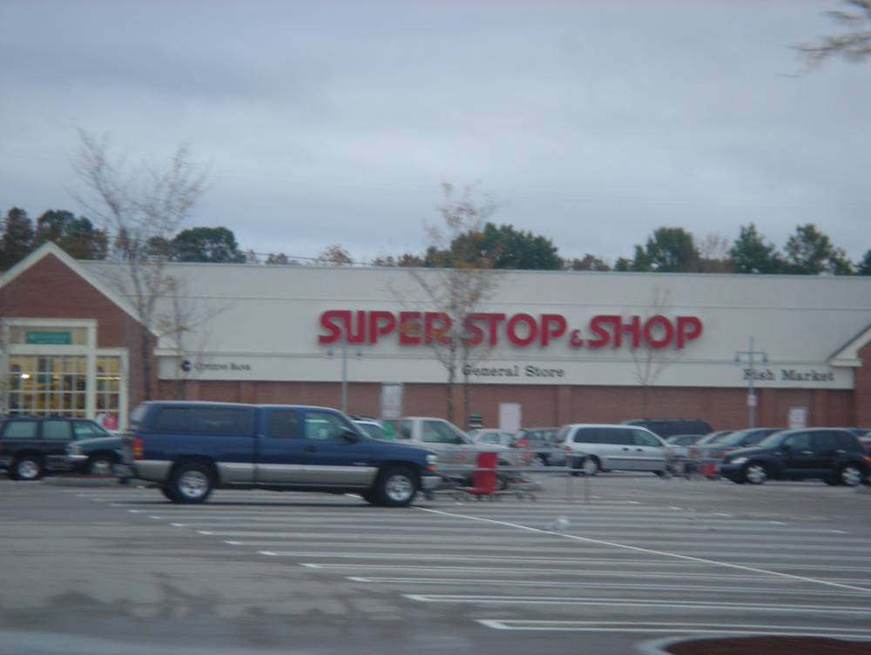

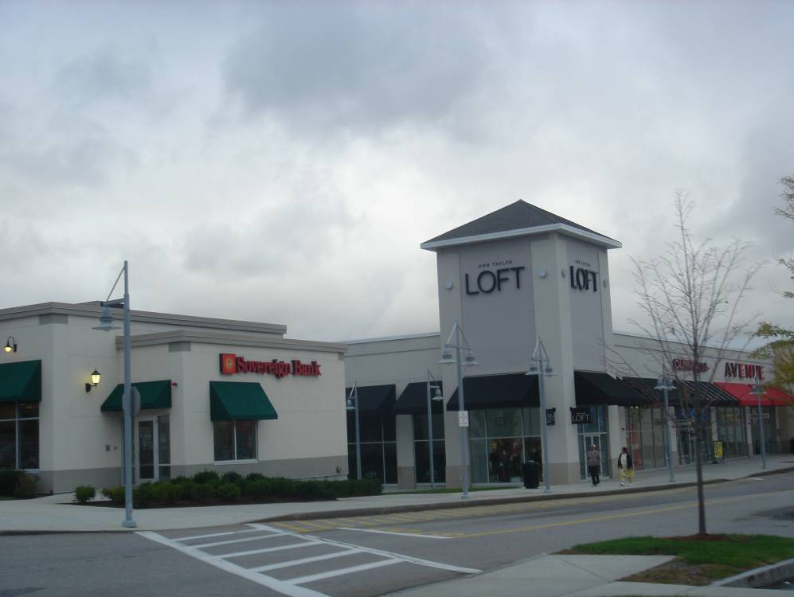

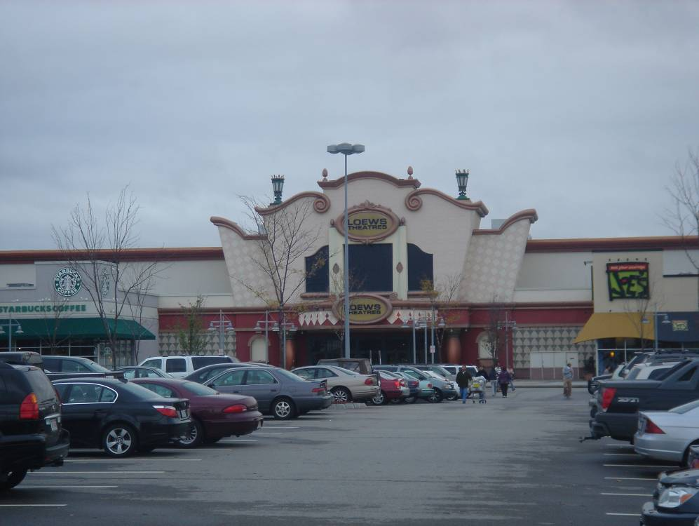

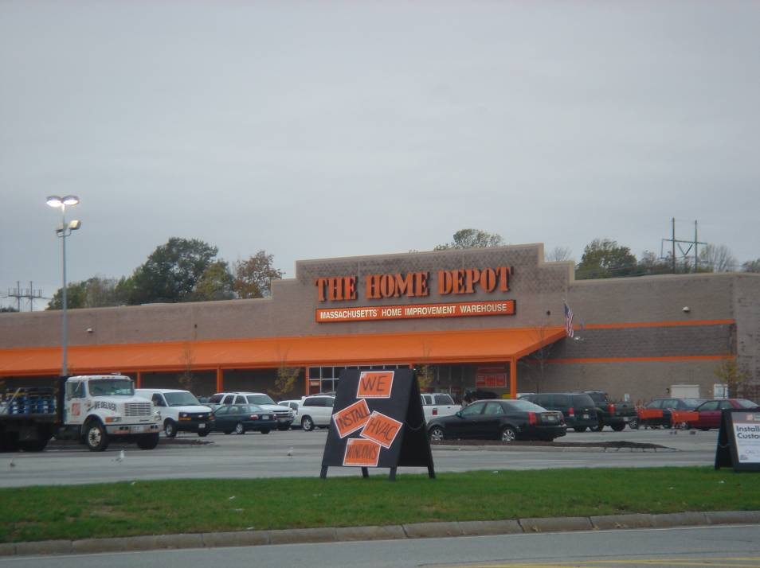

- Grocery Store: Market Basket
- Location: 700 Essex Street, Lawrence
- Other stores in strip center:
Payless Shoes, Family Dollar, Tello’s (discount clothing store)
- General observations:
While strip itself was somewhat depressing and the parking lot appeared only 50-60% full, the grocery store inside was very busy. We later learned from the assistant manager of the grocery store that many patrons walk or take cabs to the grocery store. Clientele and workers seemed to be almost 100% Hispanic. High concentration in Hispanic grocery products, across from fairly rundown apartment complex.

The following are pictures from this neighborhood strip center:

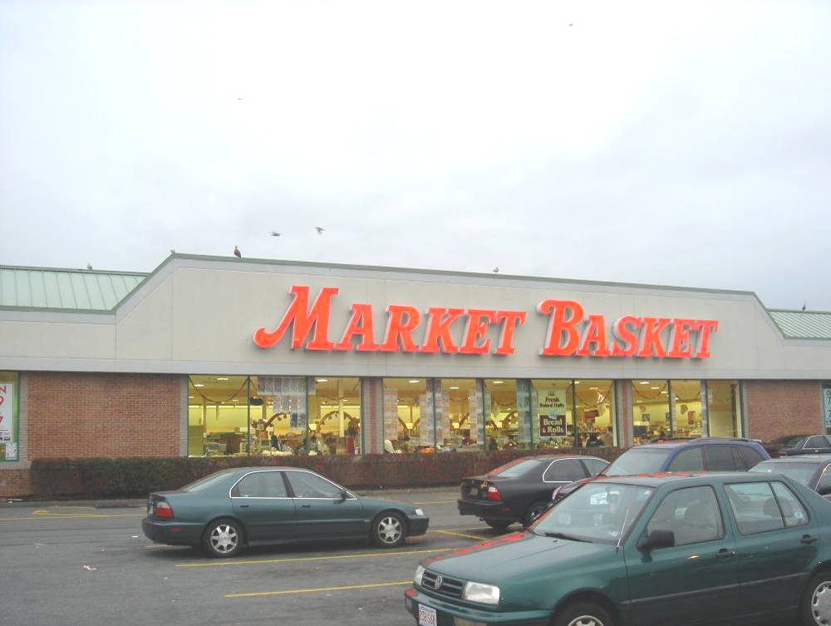

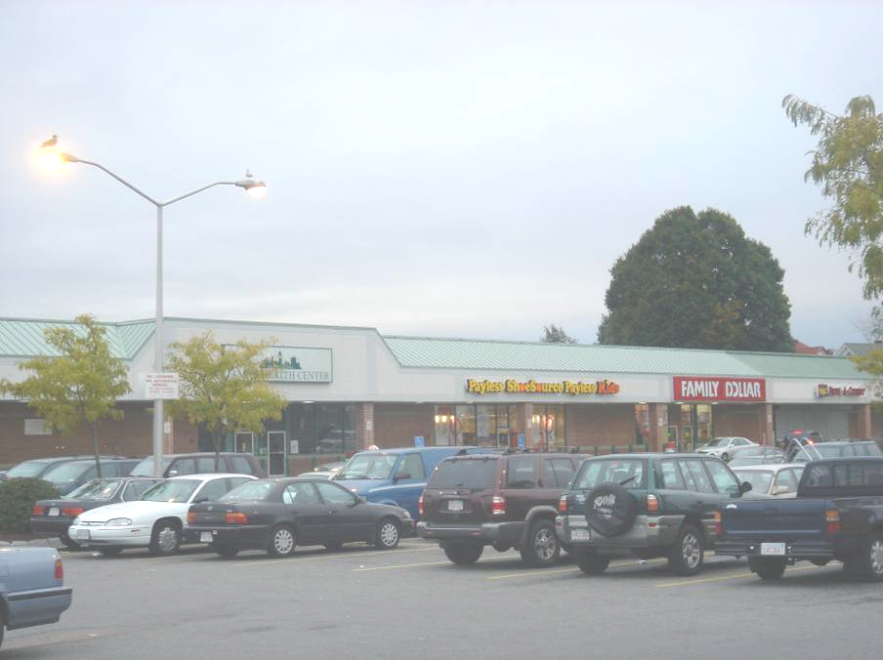

The Market Basket at this location clearly catered to the Hispanic community with bulk Hispanic foods.

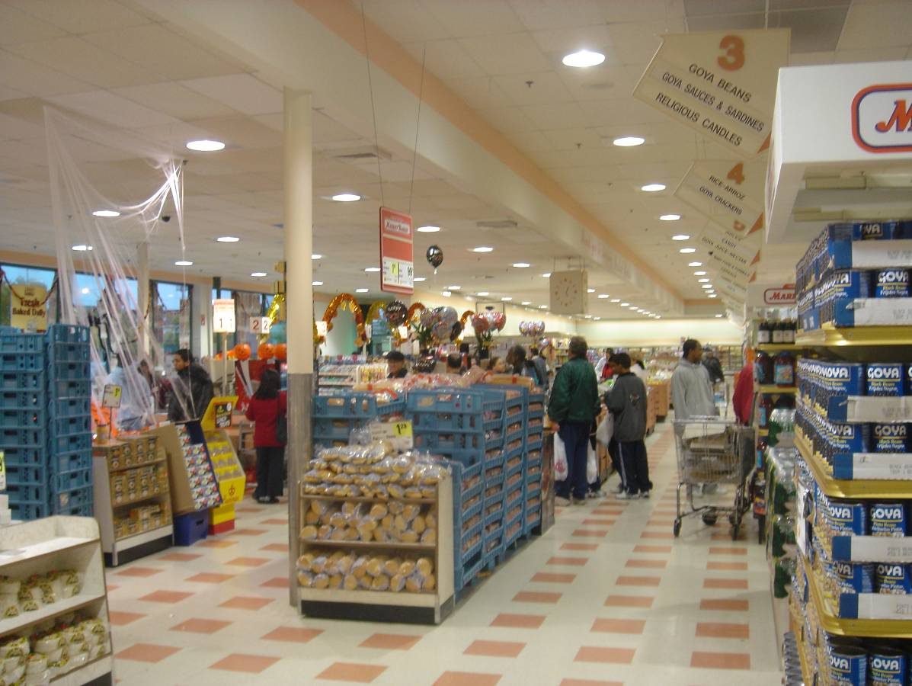
Interior of Market Basket at 700 Essex Street.
Notice the signage for Aisle 3: “Goya Beans, Goya Sauces & Sardines, Religious Candles”; Aisle 4 signage: “Rice – Arroz, Goya Crackers”

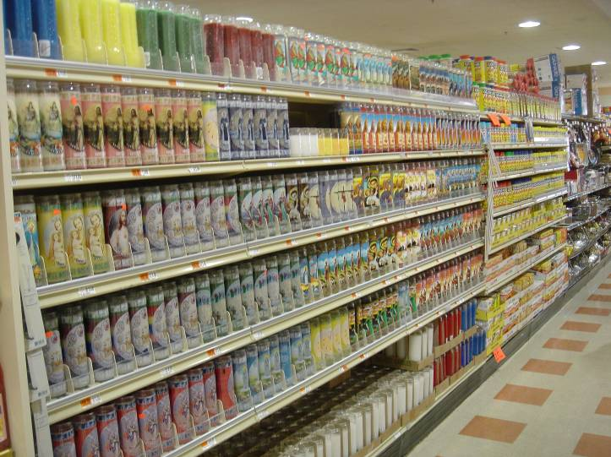
Nearly ½ of this aisle was devoted to the sale of religious candles, targeted to its Hispanic clientele.

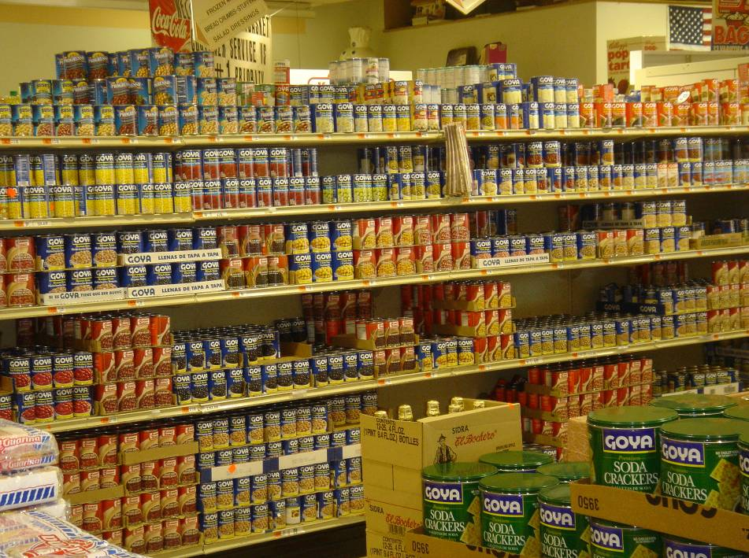
Goya, Goya and more Goya products…

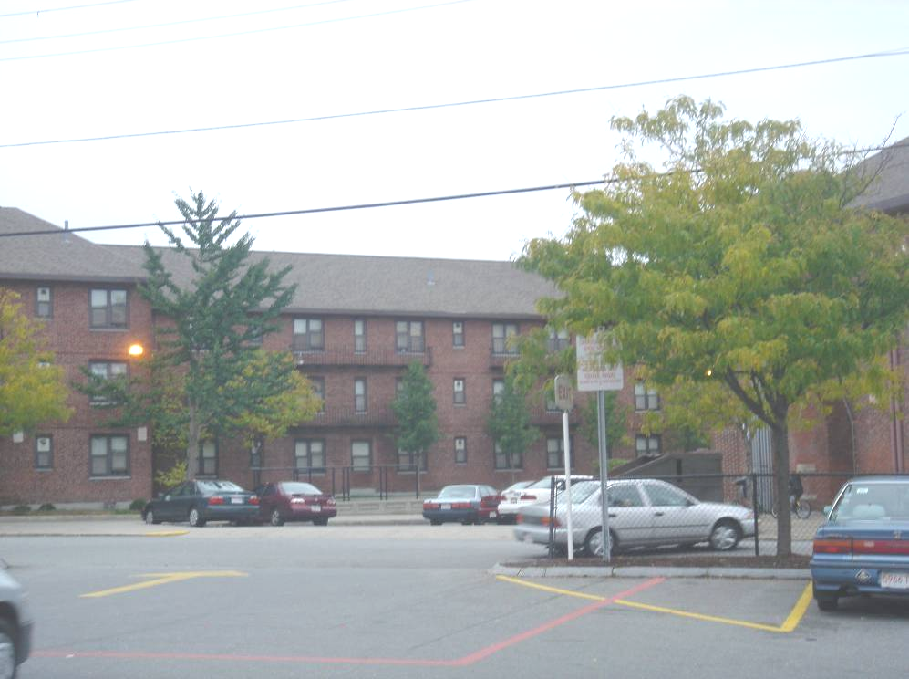
Somewhat rundown apartment complex across the street. Apartments did not appear to be fully leased as lot was fairly empty on Sunday afternoon. However, perhaps this is due to low car ownership.

- Grocery Store: Market Basket
- Location: 186 Haverhill Street, Methuen
- Other stores in strip center:
Dollar Tree, Payless, Liquor Store, Brooks, Dots (clothing), AJ Wright’s, Papa Gino’s
- General observations:
Felt like a long drive to get there (not much to look at, run-down auto shops, etc), but probably only 7-8 min drive. Patronage was mostly Hispanic and very crowded parking lot, busy area, perhaps a bit nicer, but felt very similar to Essex Street / Lawrence location. Across street from Dunkin Donuts, McDonald’s

The following are pictures from this neighborhood strip center:

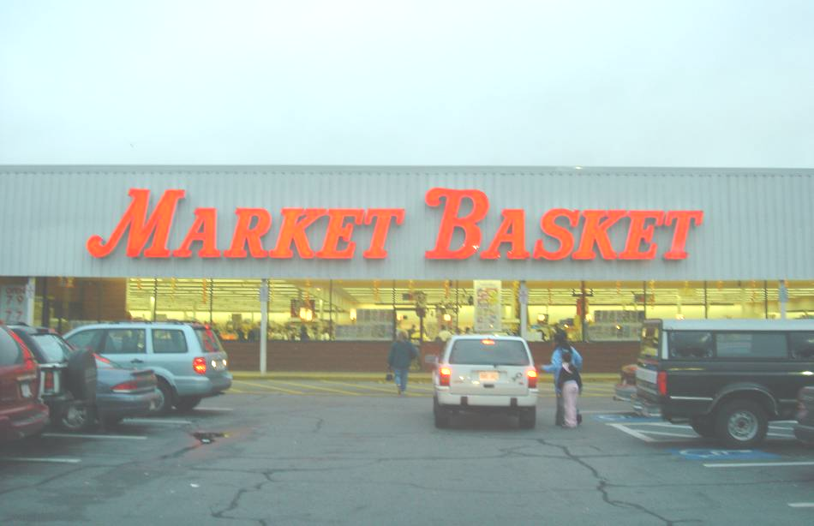

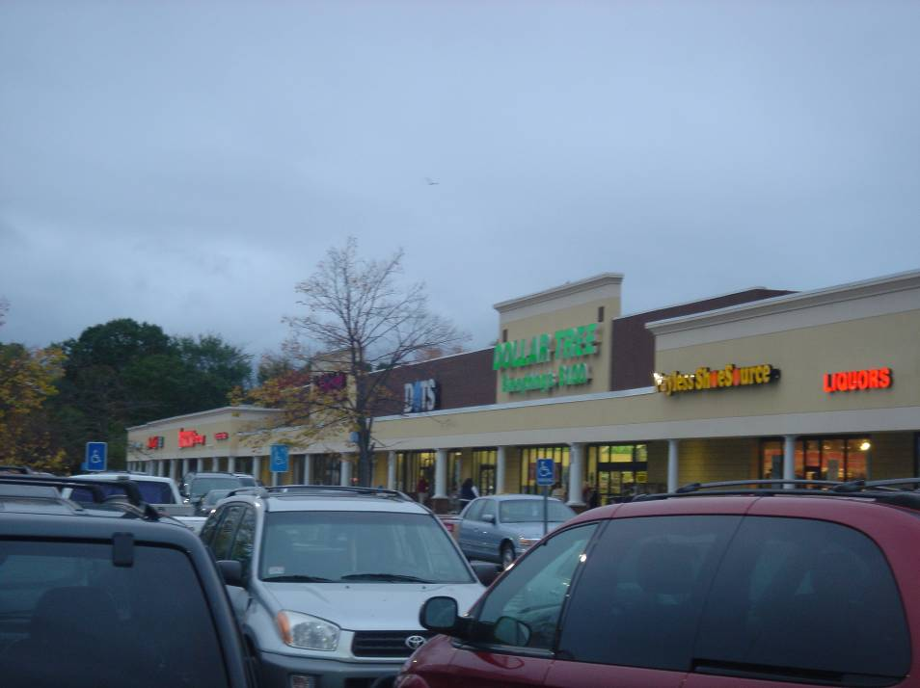
The other stores at this strip center appeared to have higher patronage than the previous strip center in Lawrence.

Yellow dots: Convenience store chains

- Convenience store: Store 24
- Location: 389 Broadway, Lawrence
- General observations: $1.1MM in annual sales, Store was open, but parking lot completely empty

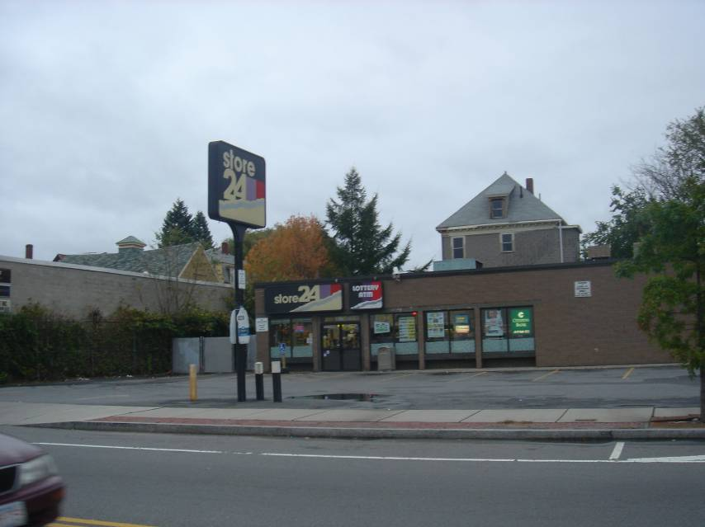

- Convenience store: 7-Eleven
- Location: 370 Broadway, Lawrence
- General observations: $1.3MM in annual sales, fairly full parking lot, newer strip center
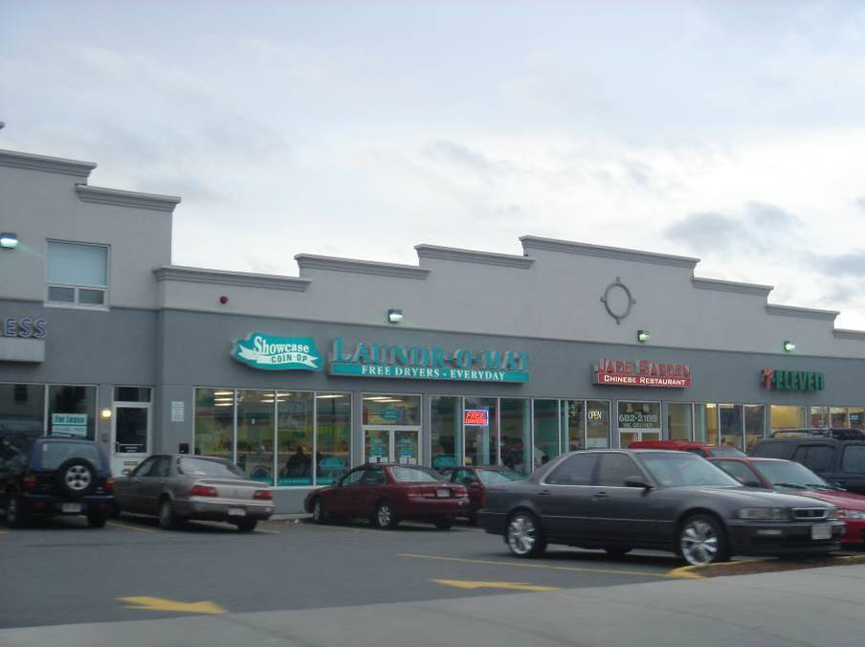
Green dots: Local / ethnic grocery stores

- Grocery store: Thwaites Market
- Location: 36 Railroad Street, Methuen
- General observations: $2.2MM in sales! Unusual grocery store hours: closed Sundays, Wed hours: 7am-noon, MTThFS: business hours: 8:30 – 5:30pm, prepared foods & meat, family / owner appears to live upstairs, looked run down, but appears to be successful. Locals walked up while I was there, had driven for a while specifically to shop at that store, and were disappointed to find it closed.

The following are pictures of Thwaites Market:
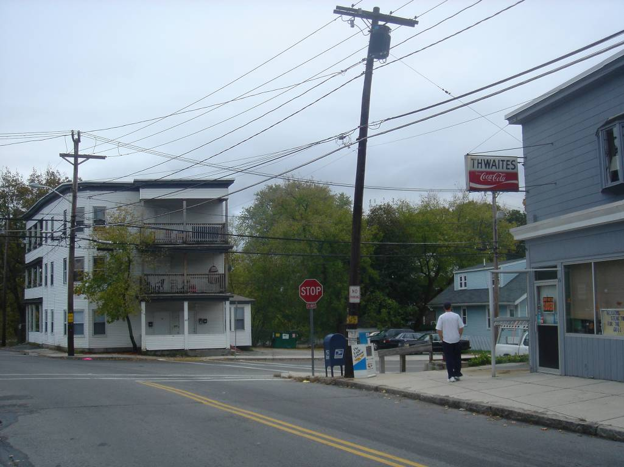

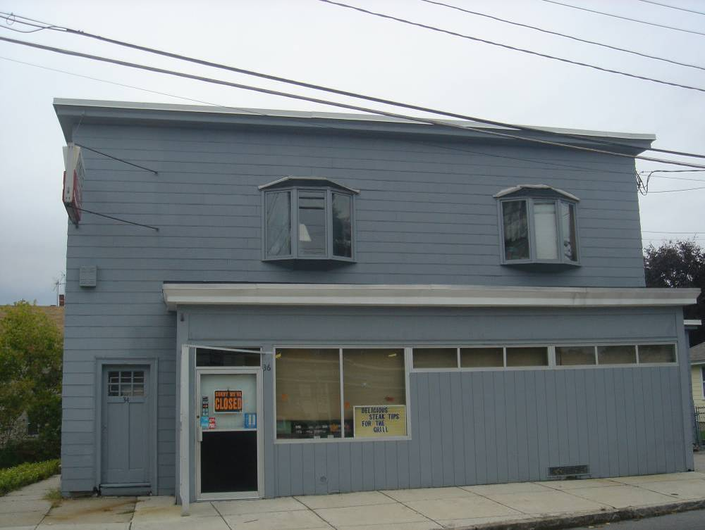

- Grocery store: El Rincon Supermarket
- Location: 205 Broadway, Lawrence
- General observations: $364K in sales. Pretty shady-looking shopping center…

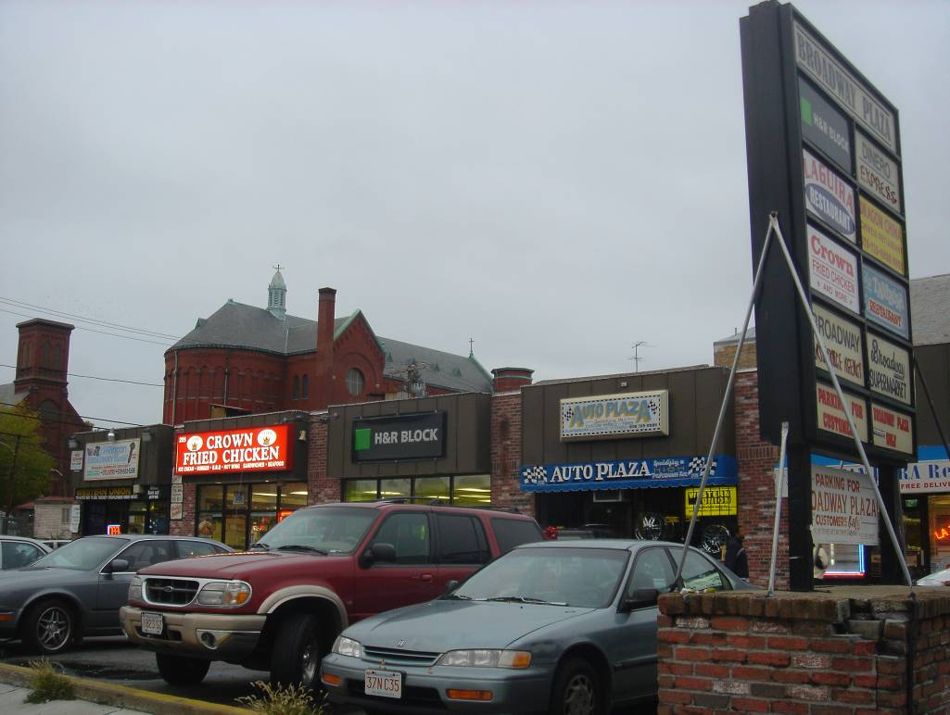
El Rincon is in left-most corner
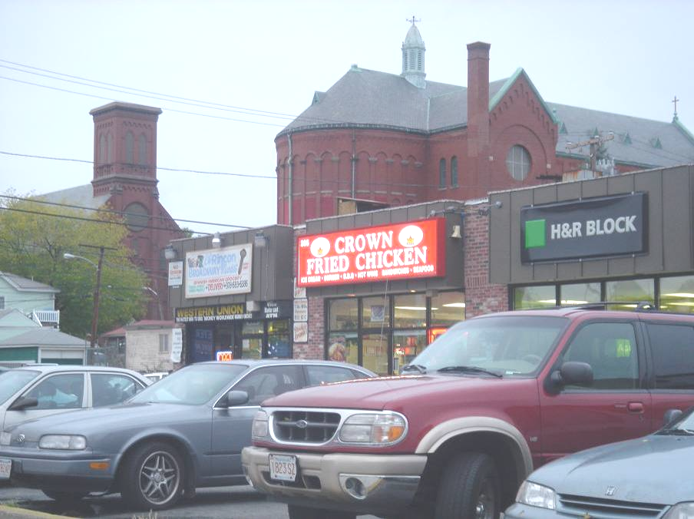

- Grocery store: El Rincon Supermarket
- Location: 473 Haverhill, Lawrence
- General observations: $728K in sales. Very bright neon signs, pretty well frequented, small parking lot about 12 spaces

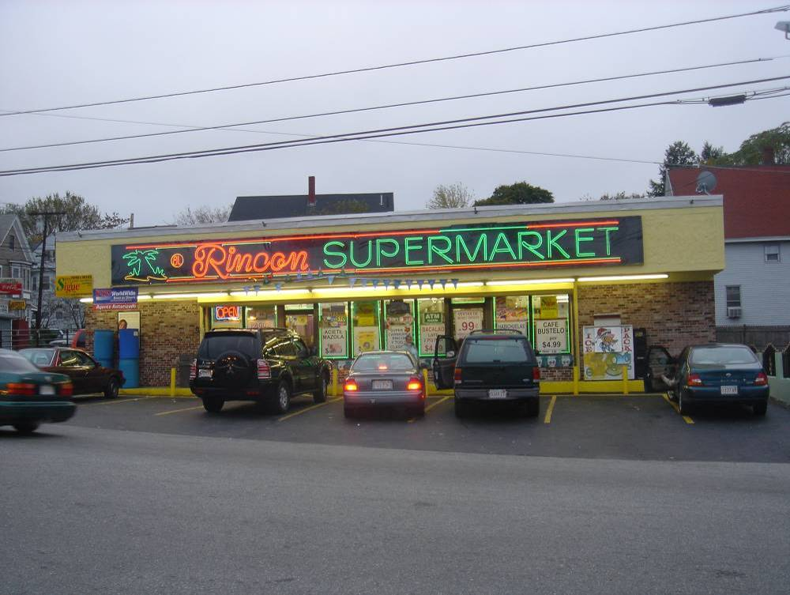

Municipalities include Amesbury, Andover, Boxford, Georgetown, Groveland, Haverhill, Lawrence, Merrimac, Methuen, Newbury, Newburyport, North Andover, Rowley, Salisbury, and West Newbury.
http://www.mvpc.org
As defined by the MVPC, “Blue Collar” jobs include Farming, Fishing, Forestry; Construction, Extraction, Maintenance; Production, Transportation, and Material Moving
Conversation with MVPC, March 16, 2006.
Loop anchors include Super Stop & Shop Supermarket, Home Depot, Borders, Old Navy, Loews Theater, and Marshalls; major restaurant chains include Macaroni Grill, T.G.I. Fridays, and Bugaboo Creek. See http://www.attheloop.com for more information.
Conversation with Methuen City Planner, Fall 2005.
http://www.boston.com/education/mcas/scores2005/10th_grade_passing_trend.htm
MVPC traffic specialist.
Linear Retail contacts included William J. Beckeman (President and CEO), Aubrey Cannuscio (Partner, Senior VP – Acquisitions), and James Clifford (VP – Acquisitions). Online sources included CoStar, Black’s Guide, and LoopNet.
Conversation with William J. Beckman, President and CEO of Linear Retail, March 13, 2006.
Claritas reports ages of dwelling units by decade back through the 1940s, but prior to this decade, it lumps all dwelling units into one category—built in or before 1939.
Massachusetts Department of Workforce Development, MassStats, estimated 2005 median family income (http://massstats.detma.org/websaras/index.asp)
US Census, 2004 American Community Survey.
InfoUSA estimate, 2005.
Economic and Planning Systems, Inc., August 2004.
Food Marketing Institute website, October 2005
Claritas Report, pp. 20, 39.
Reilly Factor formula is: = [(Distance between two locations) / (1 + (Pop A / Pop B) ^ (1 / 2))], where Pop A is the larger population. The result is the smaller density location’s distance it is able to capture retail sales. For a more detailed description, see Benjamin T. Brubaker’s 2004 MSRED thesis entitled, “Site Selection Criteria in Neighborhood shopping Centers: Implications for Real Estate Developers.”
Market Basket executive.
Household figure estimate from InfoUSA.
Competitor sales data from InfoUSA.
ULI Dollars & Cents of Convenience Shopping Centers, 2004.
ULI Dollars & Cents of Convenience Shopping Centers, 2004.
Non-retail establishments include a Methuen community center, a church, cab service, apartments, automobile body repair shop, and a recycling center.
InfoUSA estimated sales volume based on reported sales taxes.
Claritas data, November, 2005.
Conversations with MassInnovation and Lawrence Community Works representatives who live in the trade area (Fall 2005). Sovereign Bank is located at 555 Broadway in Lawrence, Massachusetts.
Lawrence and Methuen Planning Departments, Fall 2005.
InfoUSA, March 18, 2006.
Claritas Holy Family Hospital, Lawrence General Hospital, Merrimack Valley Dialysis Center, Northeast C-Med, Northeast Rehabilitation Health Center, and Yankee Alliance. Source: InfoUSA, March 18, 2006.
http://www.glfhc.org
Various conversations with Lawrence Community Works throughout Fall of 2005.
InfoUSA, March 18, 2006.
Lawrence Planning Department, Fall 2005.
Conversations with Eastern Development, MassInnovation, and Linear Retail during the Fall of 2005.

