Phoenix Partners LLC

Broadway Center – Methuen and Lawrence, MA

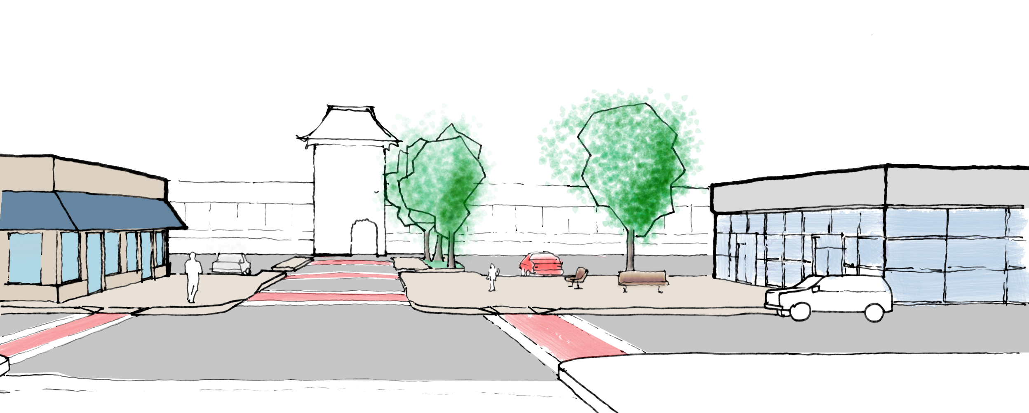

David Hansen
Amy Merritt
Yew Chin Tan
Thacher Tiffany

March 23, 2006
Table of Contents

Executive Summary P. 1

- Team Objectives P. 3

- Site Analysis P. 6

- Market Overview P. 7

- Zoning and Regulatory Information P. 24

- Financial Analysis and Feasibility P. 32

- Site Plan P. 47

- Conclusions P. 50

Appendix A: Competing Shopping Centers
Appendix B: Other Potential Public Assistance
Appendix C: Residual Land Value Analysis
Appendix D: 10-Year Cash Flow Analysis (without NMTC)
Appendix E: 10-Year Cash Flow Analysis (with NMTC)
Executive Summary

Development Proposal

Broadway Center is a proposed 81,200 square foot neighborhood shopping center on 5.5 acres at the border of Lawrence and Methuen, Massachusetts. The development project will facilitate revitalization of an evolving industrial area, meet an unmet resident need for groceries and pharmacy products, and generate modest returns to equity investors. Broadway Center also provides an opportunity to recognize the profound commitment Mr. Feuerstein, former owner of Malden Mills, demonstrated to his employees and each municipality. Carefully selecting the proper tenant mix and coordinating our efforts with local community groups, the adjacent mill restoration, and city officials will make this unique opportunity a reality.

The center will be anchored by a 45,000 square foot mid-sized grocery store tenant such as Stop & Shop.¹ A 13,440 square foot single pad site located at the northeast corner of the property will be designated for a pharmacy tenant such as Walgreens or Rite Aid. Remaining in-line retail space of approximately 22,760 square feet will include convenience-oriented establishments such as a retail bank, fast food or sit-down restaurant, café, beauty salon, and dry cleaning. Within this mix, locally owned businesses will further cater to the surrounding population. To enhance our project’s ability to qualify for sub-market financing, specifically the New Market Tax Credit, the project will include a job training center to link job creation with opportunities for neighboring residents.² Securing pre-lease agreements from both the grocery store and pharmacy tenants is essential to move forward with the development proposal as these tenants will drive the remaining in-line retail tenancy. The site layout will accommodate 366 parking spaces, reflecting a parking ratio of approximately 4.5 spaces per 1,000 square feet of retail.³

Location

Broadway Center will enjoy excellent visibility and adequate parking on busy Broadway (Route 28) in front of the new Malden Mills Polartec factory. This location connects the cities of Methuen and Lawrence and is just over 1 mile from Route 213 and less than 2 miles from Interstate 93. The Average Daily Traffic (ADT) count directly in front of our site is estimated at 13,200.⁴ Commercial neighbors include locally owned convenience-oriented retailers (e.g., laundromats, convenience stores), Dunkin’ Donuts, small restaurants, the Malden Mills factory, a church, and the expanding Methuen community center. WinnCompanies has proposed to convert vacant warehouse buildings adjacent and to the south of our site into 5 00-600 units of for-rent affordable housing. The following figures diagram the site’s neighbors and provide an aerial photograph.

Site History

The site enjoys a rich and dramatic history. In 1995, when the original Malden Mills building burned to the ground, Aaron M. Feuerstein, a third-generation owner, rebuilt and reopened the mill on the same location and continued to pay mill workers despite the fact that they were not working. This gesture earned Mr. Feuerstein national acclaim and recognition from the Clinton administration for protecting the community and its workers. Within six years of the factory’s reconstruction, however, poor company profits regretfully forced Mr. Feuerstein to file for bankruptcy in December 2001. We would like to capture Mr. Feuerstein’s commitment to the Lawrence and Methuen communities by placing a commemorative plaque in the plaza we have created along Broadway Street.

Market Overview

Analysis of the surrounding trade area indicates an unmet demand for a grocery-anchored neighborhood center on the site.⁵ The trade area boundaries are based on a driving time of 5 minutes, with rivers to the north our south of our site acting as cognitive boundaries to further shrink the trade area. This trade area includes 12,500 households with a median household income of $28,500. Seventy percent of residents in the trade area are of Hispanic origin and 40% are single-mother families. Residents in our trade area, 30% of whom do not own a vehicle, must currently either ride the bus or take a taxi to the nearest grocery store (Stop & Shop in the Loop, Market Baskets on Essex Street or Haverhill Street, or Shaw’s in Salem, NH), or visit one of the 40+ locally owned convenience and grocery stores within 1 mile of our site.

Our trade area currently captures only 38% of consumer purchasing power for food-at-home. Assuming a similar capture rate for the grocery anchor at Broadway Center, we estimate annual grocery store sales of $27,431,000. We also calculated a capture rate based on the Reilly Factor, a simply sales gravity calculation based solely on populations surrounding two competing stores and the distance between them. This analysis yielded the slightly lower expected grocery store sales of $27,135,000. Both approaches estimate sales amounts slightly higher than the current average of $22,300,000. We believe our grocery store anchor can perform slightly better than current grocery stores due to its new construction, the lack of a traditional grocery store within 1 mile of our site, and severely limited ability for competitors to move into the area on a comparable site.⁶ City officials from Lawrence and Methuen and members of the nonprofit community activist group, Lawrence Community Works—all of whom live within the trade area—have further confirmed the need for a grocery store.⁷

Our pharmacy anchor’s Reilly capture distance is 0.57 miles, or about half the distance of the grocery store. CVS currently operates stores less than ½ mile to the north and south of our site; to the east of our site are Conlin’s (0.3 miles) and Walgreens on Jackson St (0.8 miles); Brooks Pharmacy on Haverhill Street is located 1 mile to the west. Within our 0.57 mile capture area are 3,444 households, which represent 30% of our driving pattern-based trade area. Applying this ratio to the estimated $23,607,000 pharmacy sales in the trade area yields estimated annual sales of $6,500,000 for our new pharmacy. Assuming no new spending is created from opening the pharmacy, dividing the $23 million in current sales by 6 stores instead of 5 provides a $3,935,000 sales estimate. Similar to the benefits enjoyed by the grocery store, we believe that additional spending will occur due to the new pharmacy. Taking the average of the two sales estimates yields a reasonable forecast of $5,217,010 for the new pharmacy. The following is the summary table of the capture rate analysis for the pharmacy anchor.

Zoning & Regulatory Information

The site straddles the Lawrence-Methuen town line and is zoned “light industrial” (IL and I-2) in both cities. This entails setback and use restrictions which would require rezoning the land before proceeding with the proposed retail development. The City of Lawrence is currently working with Malden Mills and other area land owners to create an overlay district which would allow for mixed-use development on our site and the surrounding industrial and retail area southward along Broadway. We have spoken with the planning departments of both Methuen and Lawrence, and provided that the site plan engages the street front and does not provide for a large parking lot at the front of the site, neither department foresees any roadblocks in attaining the required approvals to promote retail development. However, Methuen will require community approval for the site plan and we believe the entitlement process could last 9-12 months.⁸ During the entitlement process, Lawrence and Methuen city officials will require a traffic study evaluating our development’s impact on Broadway and other neighborhood streets feeding to our site. City officials indicated that we would need to address and resolve resident concerns arising from the traffic study.

Financial Summary

Broadway Center will cost approximately $14.2 million ($175 psf) to acquire and build, assuming a land purchase price of $1.33 million.⁹ After the 9-12 month entitlement process, we estimate 12 months to complete construction.

Development Costs
We estimate hard construction costs to be $100 per square foot to build the grocery store, $120 per square foot for the pharmacy pad, and $110 per square foot for the in-line retail spaces. An additional $11 per square foot is allowed for each of the buildings to cover soft costs such as architectural and engineering fees. Site work and landscaping are estimated to be $4 per land square foot and taxes and operating

Market Rents
Commercial space in the area rents for as low as $1.25 NNN per square foot (low-end industrial buildings) to about $19 NNN per square foot (the Loop shopping center in Methuen). Office space currently rents for $8 - $10 per square foot, newly constructed in-line retail about $12 - $14 per square foot, and grocery store space for $8 - $10 per square foot, all NNN. Our pharmacy tenant research indicated typical NNN rental rates of $23 to $35. In creating our financial model, we estimate the grocery store will earn $9 per square foot (middle of the range), the pharmacy will earn $24 per square foot (low end of the range), and the in-line retail will earn $12 per square foot (low end of the range).¹⁰

New Market Tax Credit
New Market Tax Credits make this project possible. Our analysis indicates that the most profitable market use for this site is drive-through “pad” retail, and not the neighborhood center that we have proposed. As such, it will be difficult to compete with other developers for the land without sub-market financing. NMTC’s come in several forms and are allocated competitively. Most of the allocations in the state of Massachusetts are received by the Massachusetts Housing Investment Corporation (“MHIC”). While it is possible to apply for these credits directly from the federal government, it seems easiest to seek funding through MHIC. MHIC provides subordinate loans at 1% to selected applicants.¹¹ Selection depends on both federal funding and MHIC’s evaluation of the project’s economic impact. The development team must apply to MHIC by September of any given year; decisions on qualification are determined in May of the following year.

Project Capital Structure
The capital structure for the project includes three forms of debt and equity investors. The three loans include a traditional construction loan, the NMTC loan as previously described, and a permanent loan to be funded once the asset is stabilized. The equity, representing 20% of the total capitalization of the project, will be comprised of one 90% equity partner and an additional 10% in equity from the development team.¹²

Site Plan

The site plan addresses the following concerns: 1) buildings should define the street edge in a similar way as the existing commercial buildings in the area; 2) the center should be accessible to vehicles and pedestrians; 3) shoppers should feel comfortable and compelled to visit multiple stores in during a single visit; 4) retail space should be visible to through traffic on Broadway; 5) parking should be sufficient but not excessive; 6) vehicular entrances and exits should relate to each other and connect to adjacent streets; 7) plaza space that gives presence and identity to the center should be visible and prominent.

1. Team Objectives

Phoenix Partners LLC (“Phoenix Partners”) is a newly formed development company that plans to develop a new neighborhood shopping center in Lawrence, MA. Phoenix Partners is comprised of four active managing members and one silent partner. The team members are as follows:
David Hansen
Amy Merritt
Yew Chin Tan
Thacher Tiffany
Joshua Benaim (silent partner)

The four managing members bring diverse backgrounds and skill sets to the development project. Specifically, David Hansen brings expertise in development and market analysis. Amy Merritt’s area of focus is in financial analysis. Yew Chin Tan is the team’s legal advisor and Thacher Tiffany is the resident expert on the New Markets Tax Credit and is the team’s site planner. Lastly, Joshua Benaim, while functioning as a “silent partner,” acts in an advisory capacity to the team on matters such as financial analysis and strategy on an as-needed basis.

The primary objective of Phoenix Partners is to create a financially viable retail development on the 5.5 acre site located in Lawrence and Methuen. Additionally, as part of achieving successful financial returns, Phoenix Partners hopes to understand the New Markets Tax Credit program and its applicability to Broadway Center. Lastly, the team hopes to create an attractive retail center that will improve the shopping options for residents in this underserved area.

2. Site Analysis

Overview

Strengths of the proposed site on Broadway include:
- Visibility: 450 feet of Broadway street frontage with high visibility.
- Existing consumer base: Proximity to residential neighborhood.
- Adjacent uses to support retail: Presence of 1,000 factory workers (working on three shifts) from adjacent Malden Mill’s state of the art facility and Winn Companies’ plan to construct 500-600 units of new mixed income housing in adjacent 19th century mill buildings.

Challenges of the Broadway site include:
- Access: Requires a left turn for drivers coming from Lawrence with no existing signal.
- Traffic: Retail traffic is only 13,200 cars per day on average, whereas other parts of Broadway have upwards of 20,000. We believe this is because we are on the town line which separates two very different communities who do most of their errands locally.

History

The site was assembled by Malden Mills after a devastating fire in December 11, 1995. The chemical fire that incinerated the textile factory complex was described as the worst fire this century in Massachusetts.

After the fire, Malden Mills CEO Aaron Feuerstein continued to pay his employees while the factory remained idle and vowed to rebuild in Lawrence. Malden Mills had been founded by his grandfather Henry Feuerstein in 1906. He faced widespread criticism that textile manufacturing in New England was dead, and that he should take the $300 million in insurance proceeds and run. Malden Mills ultimately spent approximately $450 million to rebuild the factory and equipment and keep the employees on payroll, creating a state-of-the-art facility directly behind the site. However, ultimately forced to declare bankruptcy in 2001, Feuerstein lost control of the company to creditors.

Feuerstein’s courageous decision to stay in Lawrence won him accolades from political figures in Massachusetts and nationally, including guest appearances with President Clinton and being mentioned in the 1996 State of the Union Address. It also won him the tremendous appreciation of his employees and surrounding community.

“The fundamental difference is that I consider our workers an asset, not an expense… I have a responsibility to the worker, both blue-collar and white-collar, I have an equal responsibility to the community. It would have been unconscionable to put 3,000 people on the streets and deliver a deathblow to the cities of Lawrence and Methuen. Maybe on paper our company is worth less to Wall Street, but I can tell you it’s worth more.” –A. Feuerstein.

The Feuerstein story is legendary and we plan to acknowledge his legacy to the community by creating a neighborhood shopping center of which the area residents can be proud and including a commemorative plaque in the main plaza to pay public tribute to his courage.

Existing Streets

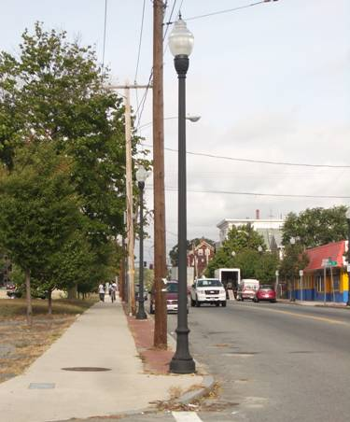
The site is bounded by Broadway on the east, Stafford on the south, French on the west and Chase on the north. Except for Stafford, all of these streets have sidewalks and granite curbs. Broadway and Chase Streets are in very good condition, and Broadway is also clearly painted. Broadway’s newly renovated sidewalk is the widest and includes a brick strip and pedestrian-scale lighting; however, above-ground utility poles and wires somewhat diminish the ambiance these sidewalks and lighting were designed to create.

Broadway includes parking on both sides and a lane in either direction. The other streets have one lane of traffic in each direction and are not used for parking. These streets may have room for one lane of parking on one side of the street. Additionally, Stafford Street could be substantially modified as its sidewalk and curbs are basically no longer existent.
(looking north on Broadway from Stafford)
Chase and Stafford Streets will continue to be used as throughways for heavy trucks transporting products from the nearby manufacturing plants. It is our understanding from Yanni Tsipis, broker from Meredith and Grew, that the volume of the heavy trucks will have little, if any, effect on the success of our planned development.

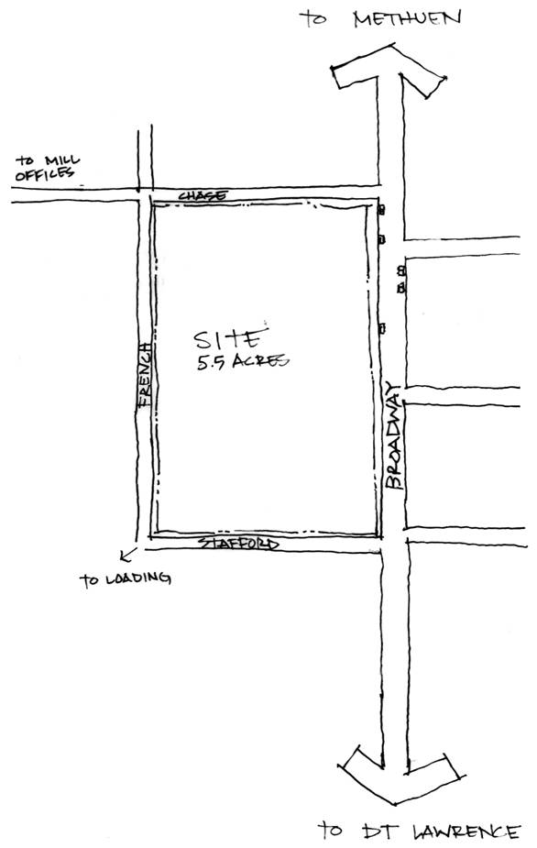
Implications
Broadway possesses the most valuable retail frontage. With that in mind, the site plan will provide as much retail within sight of Broadway as possible. The design will also take advantage of access available through surrounding streets. On Broadway, one section of parking could be replaced with a turning lane.

Topography

Generally speaking, water flows from the northeast corner of the site to the southwest corner. On the back of the site there is a significant grade change of 9 feet (71 to 62 feet) from the northern edge of the site. As shown in the picture below, this grade change is dramatic on the site and more gradual on the sidewalk and street.
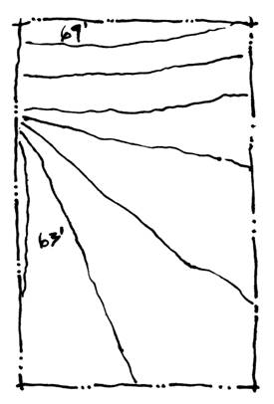

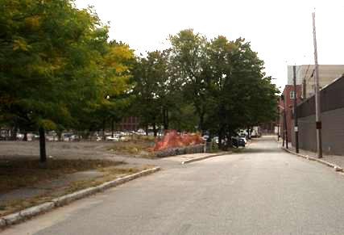

(looking south on French street from Chase)

Implications
Careful site planning will include landscaping at the Southwest corner of the site. Additionally, a significant grade shift must be accomplished at the back of the site.

Trees

There are over 30 existing trees on the site of varying quality and size. Broadway has a consistent row of young trees set back three feet from the sidewalk and spaced at about 14 foot intervals. Chase has three small but mature trees along its western edge which have been boxed in, presumably for preservation during demolition. The other trees on the site are larger and some what sporadically situated in the middle and back edge of the site. A tree of particular note sits prominently at the southwest corner of the site (see picture below).
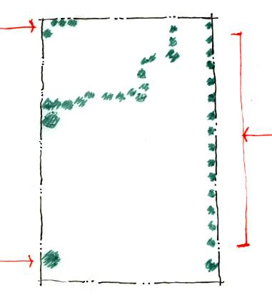

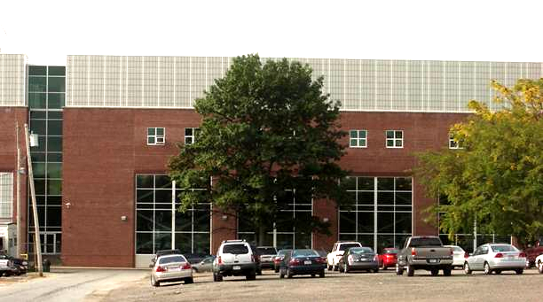

(tree locations; looking down Stafford)

Implications
It will not be appropriate to retain all of the trees on the site. However, some may contribute significantly to the shopping center and are included in the plan where possible. Specifically, the trees at the back of the site correlate well with needed retention area, those at the front provide a formal streetscape, and those at the north east serve to act as a buffer to neighboring residential buildings

Neighbors

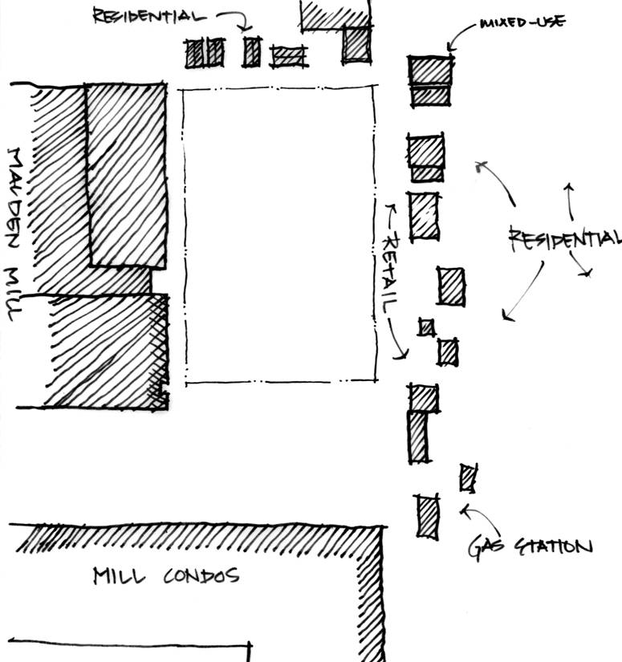
A mix of residential, retail, industry, and commercial surround the site. On the northern border (Chase Street) are single family homes, a Dunkin’ Donuts regional bakery and a Dunkin’ Donuts retail store. According to the City of Methuen, Dunkin’ Donuts is planning to relocate the regional bakery to the northern border of Methuen. Neighbors on the eastern border include a wide range of independent businesses, including small restaurants and cafés, a florist, automobile services store, and more.

In addition to the retail neighbors, two not-for-profit organizations are on Broadway: the Methuen Community Center and a Pentecostal church. The City of Methuen will be expanding the community center within the next year or so to meet the needs of the local patrons.

On the southern border of the site, WinnCompany has plans to convert an older mill building into 600 rental units (80% affordable) over the next four years. Between these historic mill buildings and the proposed Broadway site will be a parking lot for the residential mill building.

The $400 million Polartec manufacturing facility abuts our site to the west. This facility employs 1,000 workers, broken into three shifts (at any one time, 400 workers are present at the facility).

Implications
It is important that the shopping center welcome potential customers from the mill redevelopment project to the south. Because the façade of the new mill building is of a higher quality than an older building just north of it, efforts to expose the former and diminish the presence of the latter are appropriate. Additionally, it would seem wise to complement and benefit from the existing retail space across Broadway--despite the fact that their presently vitality is questionable. Funds are available to improve the neighboring stores’ facades.

Environmental Soil Conditions

Historical Sanborn maps indicate that the site consisted of residential, commercial and light industrial uses. Regarding potential soil contamination, the site previously contained gas stations on both the northeast and southeast corner of the site. In the case of the southeast corner, the station was accompanied by an “auto service and sales” operation. Just north of this corner was a Pepsi-Cola bottling plant. Fortunately, the site was cleaned of contaminants when purchased by Malden Mills. Three underground storage tanks have also been removed. A phase II environmental site assessment was completed in March 2005, which found that a condition of “No Significant Risk” exists on the site. Additionally, the criteria for a Class A-2 Response Action Outcome have been satisfied, and “Permanent Solution” has been reached without any limitation on the redevelopment of the site.

Implications
Despite suspect former uses, the site is clean and will not require environmental remediation.

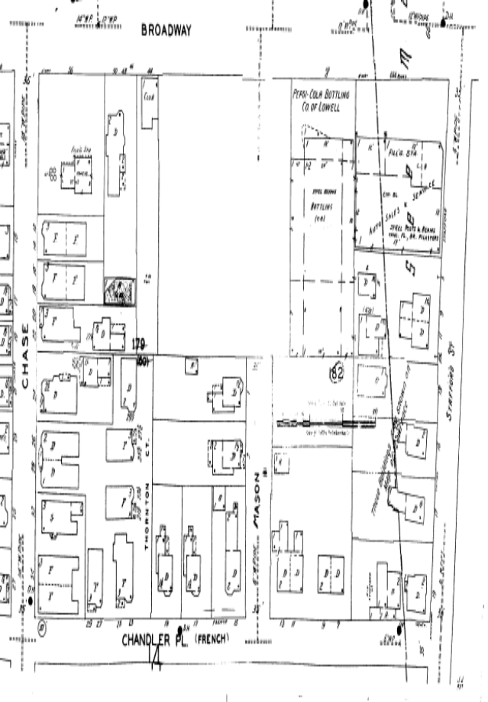
(1949 Sanborn insurance map)

Infrastructure and Utilities

Given the history of the site, major utilities (water, sewer and electricity) are present and do not pose any significant challenges. The survey below shows a 14” water pipe on Chase Street, an 8” pipe on French and a 10” pipe on Stafford. Each has multiple taps in place. Sewer lines also surround the site and there are several existing fire hydrants on the edges of the site. Future iterations of our site plan should take into account the water easement at the southeast corner of the site.

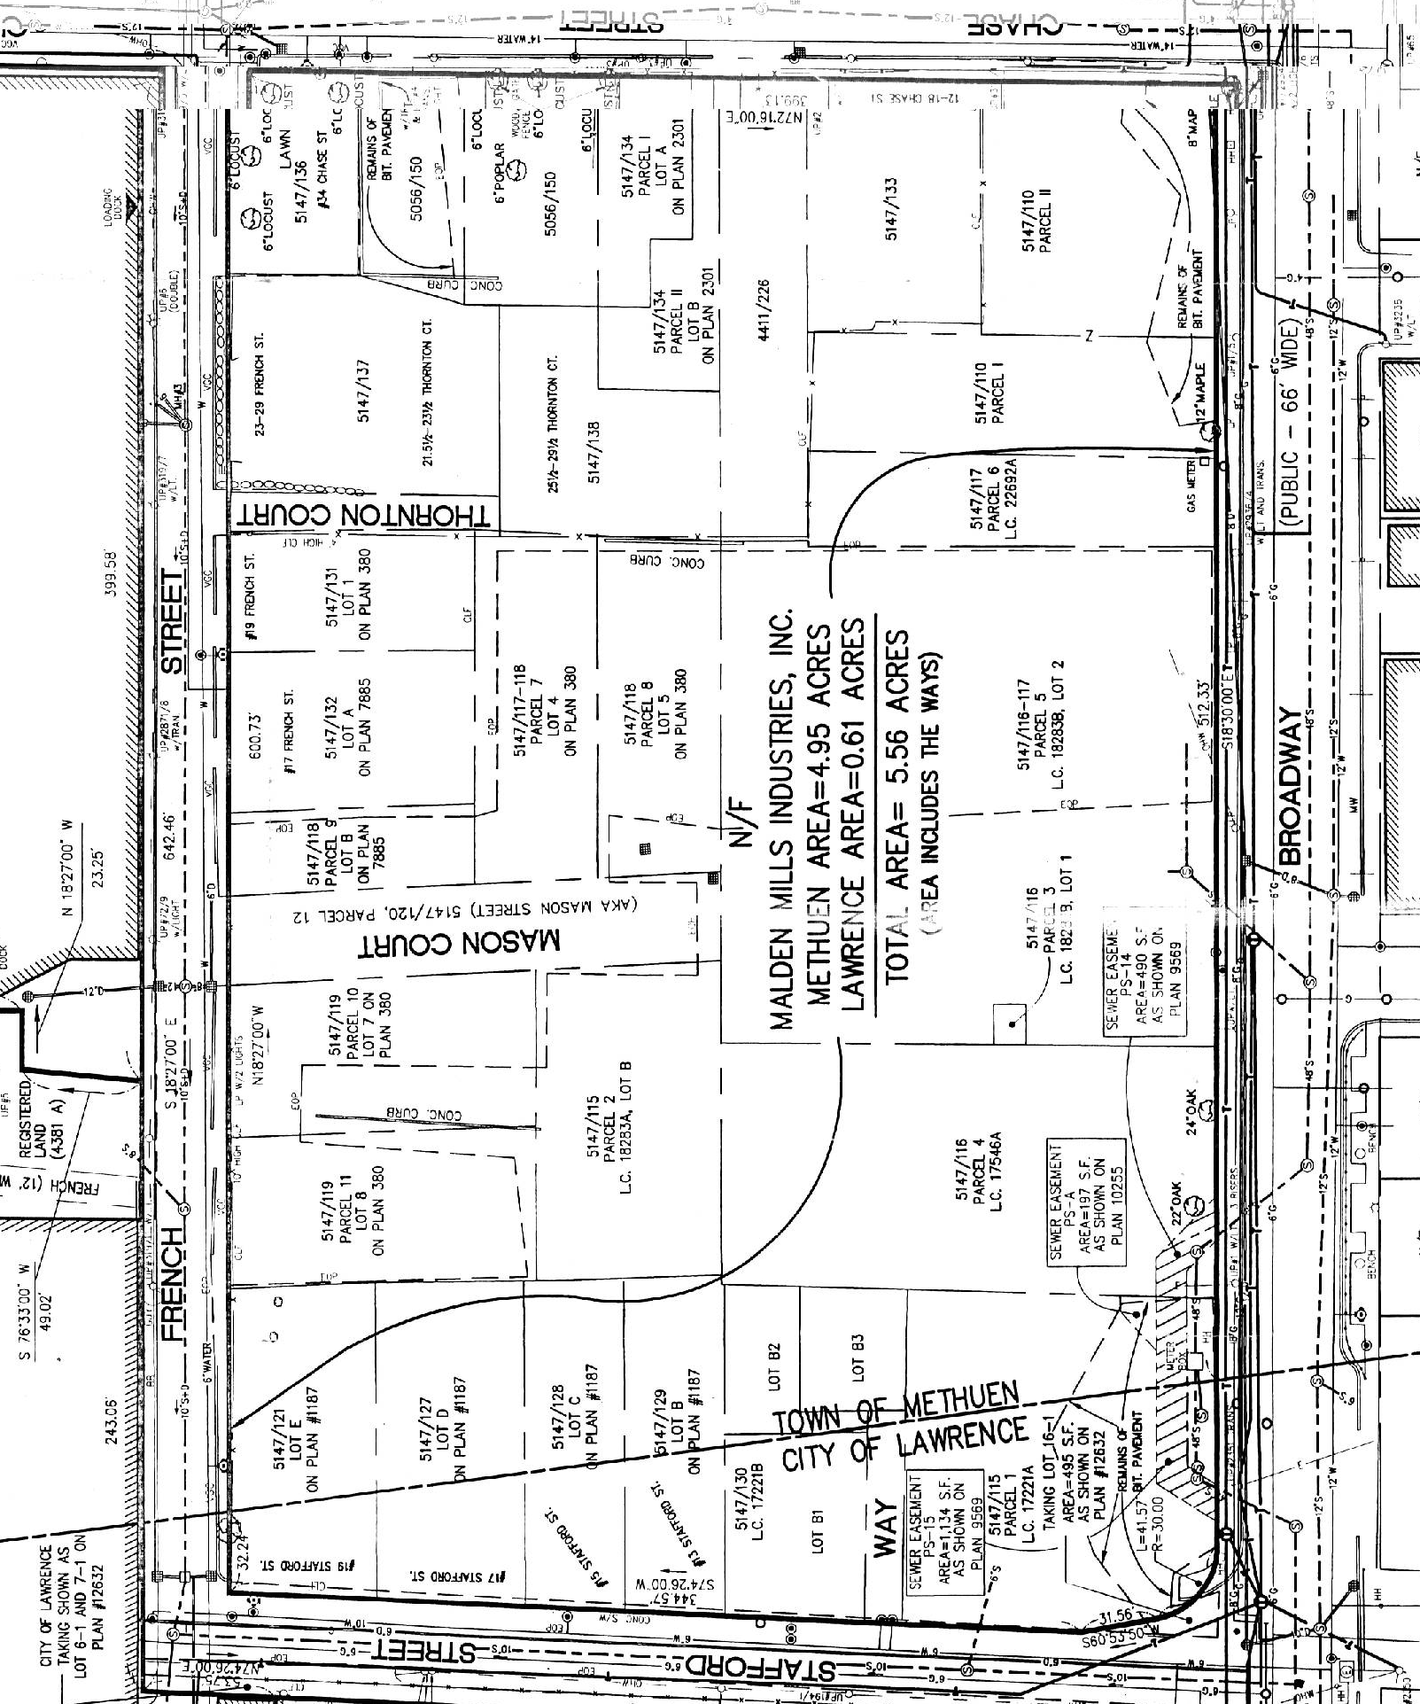
3. Market Analysis

OVERVIEW

Our market analysis begins by analyzing general characteristics of Merrimack Valley region, followed by micro analysis of the Lawrence and Methuen Municipalities. Next, we define our site’s trade area based on local traffic patterns and on distances to competing uses. Once the trade areas have been defined, we estimate potential consumer expenditures and sales for our two anchors, a grocery store and a pharmacy. In this section we also consider traffic count and market rent information. We will also study the location, characteristics, and sales of competitive retail centers in the trade areas, as well as availability and absorption of retail space.

GENERAL CHARACTERISTICS OF THE MARKET

EMPLOYMENT

Broadway center is located 35 minutes north of Boston in the Merrimack Valley Planning Council (“MVPC”) region. The MVPC includes 15 municipalities and supports major industry clusters in fields such as telecommunications, biomed/biotech, textiles/apparel, and high technology. Once a thriving industrial center, the City of Lawrence now enjoys only a small textile/apparel sector, including Malden Mills, the producer of Polartec fleece; New Balance, the developer of sneaker shoes; and Southwick Clothing, the handmade suit designer for famous persons like John Kerry, Cary Grant, and George Bush. Methuen also enjoys a rich industrial history and its industrial parks house tenants such as Colombo, McKesson, MicroTouch, and Nabisco. The Malden Mills buildings adjacent to the west and south of our site will directly affect Broadway Center’s surrounding environment. The following is a map of the Merrimack Valley region and highlights the cities of Methuen and Lawrence.

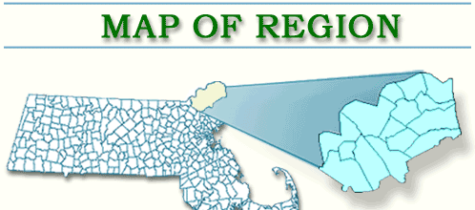
Methuen
Lawrence

Almost one-third of those employed in the MVPC region work in manufacturing. Education and Health Services and Trade, Transportation, and Utilities are the next two highest types of employment in the region. Professional and Business Services, Information, and Financial Activities include the smallest portions of employment in the valley. The following table provides a breakdown of employment in the region.

MVPC, Methuen, and Lawrence Employment
 | MVPC Region | Methuen | Lawrence
Education and Health Services | 22% | 29% | 31%
Financial Activities | 5% | 3% | 2%
Government | 5% | 5% | 4%
Information | 4% | 2% | 1%
Leisure and Hospitality | 7% | 8% | 3%
Manufacturing | 27% | 15% | 26%
Natural Resource, Mining, Construction | 4% | 7% | 2%
Other Services | 3% | 2% | 4%
Professional and Business Services | 10% | 7% | 15%
Trade, Transportation and Utilities | 14% | 22% | 12%
TOTAL | 100% | 100% | 100%
Source: 2000 Census Data

The above employment breakdown further emphasizes the MVPC region’s heavy involvement in manufacturing. More specifically, the economies of Methuen and Lawrence also rely heavily on manufacturing, with 15% and 26%, respectively. Though Methuen relies almost half as much on manufacturing as does Lawrence, its 22% of employment in Trade, Transportation, and Utilities is 60% more than MVPC’s portion and almost 200% as much as Lawrence. These data reveal each city’s heavy reliance on “blue collar” employment.

Between 2000 and 2030, the MVPC forecasts contrasting employment trends for the cities of Methuen and Lawrence. Forecasters estimate Methuen’s employment to grow 16% from 13,663 to 15,824, with strong growth in Natural Resources, Mining, and Construction, Professional and Business Services, and other services. In contrast, Lawrence’s employment is expected to decline 17% from 23,330 in 2000 to 19,370 in 2030. Leading the decline in Lawrence’s employment will be manufacturing and current forecasts do not project employment in this sector to be completely replaced by other sectors.

The dramatic decline in manufacturing throughout the MVPC could reasonably add millions of more vacant manufacturing space to the current millions of vacant square feet in the area. We see current effects of the declining manufacturing industry through the numerous conversions prevalent in Lawrence, including WinnCompanies’ apartment conversion abutting our parcel’s the south perimeter. If Malden Mills eventually vacates Lawrence, our site will further suffer from vacant manufacturing space directly behind (to the west) of our site.

The MVPC believes that the region was hit especially hard by the recent downturn high tech manufacturing area. Unemployment rates in the MVPC historically have been on average of 1.1% higher than the Massachusetts Commonwealth average and typically move in-step with the state’s unemployment rate. Exceptions to this historical relationship occurred in 2002 and 2003, when unemployment in the MVPC region rose to 2.5% higher than the state average in each year. This spike in unemployment occurred when Lucent Technologies, one of the region’s flagship high tech manufacturing companies, slashed jobs in its North Andover plant from 5,000 in 20001 to 700 today. According to the MVPC, Lucent Technologies at one point employed 13,000 workers in the region and has slowly cut its work force over the years. Lucent Technologies’ actions illustrate how the region’s heavy reliance on manufacturing will continue to pose real economic risks.

MVPC Region vs. Massachusetts Unemployment Rates
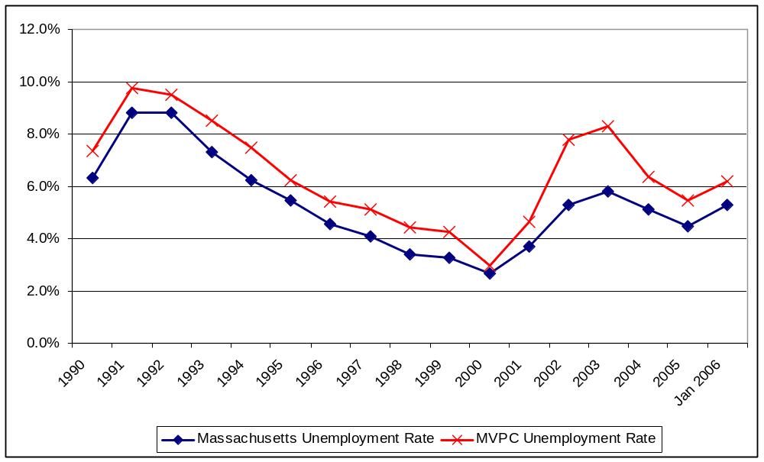
Source: Massachusetts Department of Workforce Development (http://lmi2.detma.org/lmi/town_comparison.asp)

METHUEN AND LAWRENCE DEMOGRAPHICS

Population: 70,200
Median Income: $28,000
Unemployment: 12.0%
Hispanic/Latino: 59.7%
White: 34.1%
Female Householder: 25.7%
Median Age: 29.5 years
School District: 277 out of 278
Ambience: Extremely depressed economically; Proliferation of auto repair shops and empty mill buildings
Population 40,000
Median Income: $50,000
Unemployment:7.1%
Hispanic/Latino: 9.6%
White: 85.8%
Female Householder: 12.2%
Median Age: 37.5 years
School District: 236 out of 278
Ambience: Historic New England town
METHUEN
LAWRENCE
Source: http://www.mass.gov

Methuen and Lawrence represent a modern telling of the classic story “A Tale of Two Cities.” Strengths in Methuen’s median income levels, school districts, employment, and ambience are polarizing weaknesses in Lawrence. Despite having 85% of our site in Methuen, a Lawrence-like environment penetrates the surroundings. A Lawrence-like “feel” is an economically depressed area with barred windows, empty mill buildings, graffiti, abysmal public education, and run-down retail buildings servicing a poor, mostly Latino population. In contrast, Methuen’s ambience possesses the charm of a historic New England town with a well-diversified work-force, strong median income, good public schooling, and a regional retail center, “the Loop.” A representative from the Methuen planning department even commented that citizens applying for affordable housing in Methuen refuse to locate near our site and would rather take their chances in waiting for a better location.

POPULATION TRENDS

- Lawrence’s 50 year population decline halted in 1980’s with influx of Latino immigrants, mostly of Puerto Rican and Dominican descent
- Very modest population growth of 0.5% in recent years
- Statewide housing boom has let to new housing starts in Lawrence and Methuen, as residents seek less expensive living
- Population is like a revolving door – people coming and going all the time

UNEMPLOYMENT

Unemployment remains a big problem in Lawrence, and a challenge for our site in terms of both retail spending and potentially security. Historical employment data indicate that on average Lawrence’s unemployment rate is 4.7% higher than that of the MVPC region and 5.8% higher than the Massachusetts Commonwealth. In contrast, Methuen’s unemployment rate is very similar to the region as a whole (0.7% higher) and 1.8% higher than the state average. However, like other MVPC municipalities, both cities suffered acutely from larger than normal unemployment rates in 2002 and 2003.

MVPC Region, Methuen, and Lawrence Unemployment Rates

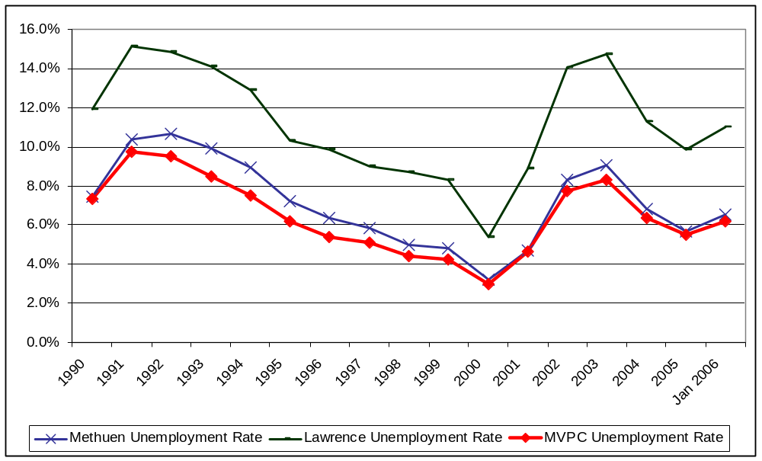
Source: Massachusetts Department of Workforce Development (http://lmi2.detma.org/lmi/town_comparison.asp)

SCHOOL DISTRICTS

Methuen and Lawrence both run sub-par school districts, each ranked in 2005 at the bottom third of the state. Methuen’s performance ranking of 236 out of 278 school districts on the 10th grade Massachusetts Comprehensive Assessment System (“MCAS”) tied it with Revere and placed it just below cities such as Peabody and Attleboro. The ranking is based on the combined passing rates each district had for English and Math. Methuen 10th graders earned an 89% pass rate in English and an 82% pass rate in Math. Lawrence students performed even worse, placing the school district second to last and ahead of only Champion Charter School in Brockton. Andover, Springfield, and Fall River each ranked just ahead of Lawrence. Lawrence 10th graders earned a 68% pass rate in English and a 54% pass rate in Math. The Massachusetts state median pass rates were 92.5% for both English and Math and included cities such as Brookline, Danvers, and North Attleborough. Such low performance on standardized exams will continue to impede migration into Methuen and Lawrence. Given that the immediate area surrounding our site possesses a Lawrence-like feel, the challenge of attracting new families will even be greater. Also, due to the strong ethnic ties in our area, in-migration will most likely occur with friends and families of the existing Hispanic and Latino families, thus further exacerbating the challenge of improving school performance to attract new, non-immigrant families into the area.

SUMMARY OF MVPC, METHUEN, AND LAWRENCE

Economic Trends
- Long-term decline of MVPC industrial base
- Some corporate growth and industrial/high tech industry in neighboring suburbs, e.g. Andover
- Downtown Lawrence continues to struggle economically
- Methuen has been more resilient but also slow growth
- Both towns suffer disproportionately in a recessionary environment
- Methuen and Lawrence focusing redevelopment efforts in their respective downtown areas, polarized away from our site
- Of the 3,325,000 sq. ft. of recent and ongoing redevelopment activity of Lawrence, 81 percent is planned to be mixed-use (condos, office, and retail), compared with only 4% dedicated solely to commercial. Most of these developments are industrial building conversions

What This Means
- We cannot count on a rising tide of population or job growth to lift our boat, we have to find a niche that appeals to existing customers
- Modest housing growth will be helpful to retail but we cannot assume that that housing prices will remain so high and continue to drive people for cheaper solutions
- A recession could be very costly

TRADE AREA

The next step in our analysis focused on selecting a market and demographic profile the site could feasibly attract to our neighborhood retail center. In defining this trade area, we took into consideration demographics, driving habits, nearby competition and cognitive barriers such as major highways and rivers. Based on this analysis, we identified the following trade area:

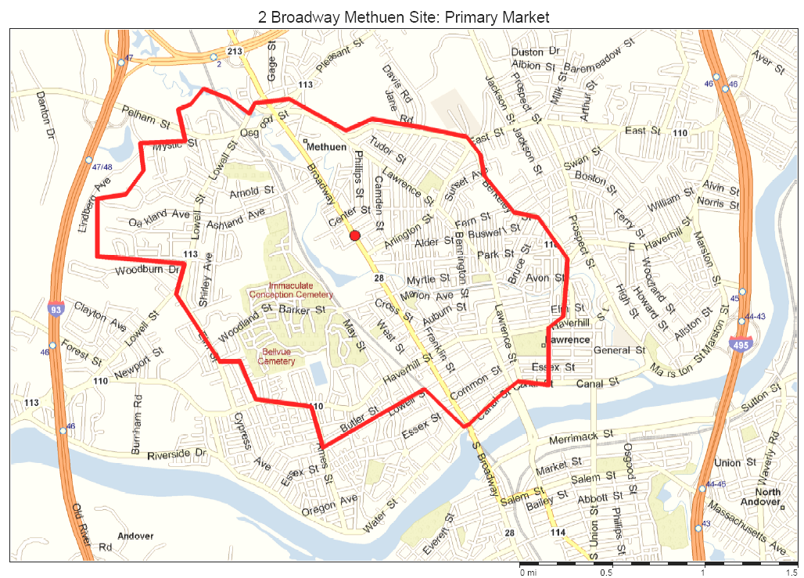
This trade area takes into account the Merrimack River, I-93 and Route 213, each of which acts as a cognitive barrier that people are reluctant to cross in finding their nearest shopping center. A large portion of the trade area to the west of Broadway is composed of industrial areas, the Spicket River and surrounding wooded area, and the Immaculate Conception Cemetery. The core of our traffic-based trade area is to the east of our site.

AVERAGE DAILY TRAFFIC (“ADT”) COUNT: 13,200

Broadway has experienced construction over the past few years, resulting in depressed traffic counts in front of our site. On August 22, 2005, the MVPC conducted its most recent traffic count study over a 48-hour period on the Methuen/Lawrence city line. The ADT count for this study was 13,200 total cars. According to the MVPC, continued construction on Broadway not longer significantly affects traffic counts in this section of the road. Another explanation for the low traffic count relates to the polarization of traffic in each direction away from our site. Most retailers, especially our targeted anchors, typically require at least an ADT of 20,000. The shortfall of traffic passing our site can somewhat be adjusted to account for the large portion of the surrounding population without a vehicle. According the US Bureau of Labor Statistics, 88% of the households in the US own or lease a vehicle. Adjusting the 13,200 ADT for 70% vehicle ownership or lease to the 88% US average increases the estimated ADT in front of our site to 16,600. Despite this adjustment, the traffic count is still below the typical 20,000 ADT count.

Traffic Summary
- Traffic Counts at site are approximately 13,200 cars per day.
  - Low Traffic Counts due to—
    - 450-foot gaping hole on Broadway (our site)
    - Recent road construction
- We are at the border of Methuen and Lawrence and it appears that there is not a tremendous amount of transit between these cities.
- Traffic on Broadway at certain intersections within both Lawrence and Methuen reaches 25,000 cars per day, indicating that people are making local trips within their towns.

MARKET RENTS

Retail Real Estate Market
- New developments demanding $15-20 per sq. ft.
- Blighted single-level retail buildings charging about $1-1.25 per sq. ft.
- Industrial conversions in the downtown receiving $8-16 per sq. ft.
- Office Rents: $8-$10, NNN
- Anchor Stores: $8-$10, NNN
- In-line Retail: $12-$15, NNN
- Pharmacy Pad: $24-$35, NNN

One of the challenges facing the site is the ability to charge adequate rent to cover construction costs and earn a reasonable profit. The above NNN rent ranges are based on extensive on-line research and various discussions with representative from Linear Retail. According the Linear Retail, grocery store anchors may be willing to pay much more than $8-$10 per square foot to make the deal work—perhaps in the mid-to-high teens—given an adequately good location and market potential. Linear retail further commented that though our trade area possesses a strong market potential, its location and lack of a large intersection may depress the additional rent a grocery would be willing to pay.

DEMOGRAPHICS

Surrounding the site is a fairly dense, low-income community composed of almost 70% Hispanic or Latino residents predominantly from the Dominican Republic and Puerto Rico. The population enjoys a growing Hispanic- and Latino-based economy where relationships and family play an important role in day-to-day activities.

General Area Household Density
 | Number of Households
1-mi | 8,848
3-mi | 37,051
5-mi | 57,000

At first glance, the high population density seems to imply that the surrounding area could successfully support a new neighborhood shopping center. Many retailers consider population density as a first step towards feasibility, but many other factors such as income and education attainment levels also play a critical role.

To gain a deeper understanding of our trade area’s demographics, we next profiled the area’s population.

Trade Area Population Summary
2005 Population | 36,748
2005-2010 Pop. Growth | 0.77%
Hispanic/Latino Origin | 69.61%
Median Age | 30.92
Education Attainment, Age 25 and Over with at least an Associates Degree | 14.64%

At the population level, our trade area is expected to experience almost no growth over the next five years. Though the population is relatively young at a median age of 30.92 years, education attainment does not reflect its youth. With only 14.64% of the age 25 and over population segment having earned some type of college degree, the area will continue to struggle to break the viscous cycle of labor-intensive and minimum wage employments. This fact is compounded by the brain-drain reality that those with higher education rarely return to the area.

With almost three quarters of the population of Hispanic and Latino origin, Puerto Rico and the Dominican Republic represent the two most common countries of origin. This culturally close community will also struggle attracting out-of-area businesses and patrons who do not share their same heritage. Remaining sensitive to the dominant Hispanic culture will be essential to the success of our shopping center. Opportunities may ranges from Hispanic- or Latino-oriented banks, retail space reserved set aside for locally owned businesses, cultural events sponsored by the center, and working with local leaders to find the optimal tenant mix. Creating a sustainable development will hinge greatly on our ability to connect with the dominate cultures within our trade area. The local culture can be summed as follows:

Local Culture
- City official quips that Broadway should be renamed “Hispanic Road”
- Strong support of Hispanic shops around the site
- Hispanic stores tend not cater to the non-Hispanic population

We next analyzed the representative household data for our trade area, as summarized by the following table.

Trade Area Household Summary
2005 HH | 12,509
Median HH income | $28,486
Average HH income | $39,091
Average HH Size | 2.88
Female Householder | 24.23%
HH with No Vehicle | 29.46%
Median All Owner-Occupied Housing Value | $185,164
Dominant Age of Dwelling Unit | ≤1939
Dominant Number of Units in Structure | 3-19

Median household income is very low. Just this one statistic drives away many potential developers and investors. For a community center to work in the long run, households must have sufficient disposable income to support the retail. An income level this depressed will severely limit the number and type of potential retailers for our site. A positive data point, on the other hand, is the percentage of households without a vehicle. Because 30% of the households must currently either walk or use public transportation to perform day-to-day errands, our site’s convenient location will ensure a very captive spending audience. Having 24% of the households led by females will further support the success of our neighborhood shopping center because in this area’s context we understand that grocery shopping is predominately done by the female in the household. Our captive audience, then, will be predominantly female, many of whom will be the head of their respective households. Catering to this segment of the area’s population will enable us to create loyal customers seeking a convenient, pedestrian-friendly shopping experience.

The previous table also includes housing statistics to further portray the trade area’s environment. As noted in the table, the predominant age of dwelling units is fast approaching at least 70 years. Housing in our area is geriatric and relatively few units have been built since the 1980s. This partially explains the relatively low median housing value for owner-occupied units at $185,000. Many of the older homes have been converted into multiple, single-level apartments (e.g., one apartment per level), and currently the dominant number of units per structure is somewhere between 3 and 19. In driving around the area, we presume that perhaps a more accurate range would be between 3 and 10 units per structure. Regardless of house or apartment, most dwelling units require major renovation and landscaping work.

Finally, we considered our trade area on the family level.

Trade Area Family Summary
2005 Families | 8,249
Median Family Income | $34,875
Average Family Income | $44,520
Income Above Poverty Line | 76.83%
Income Below Poverty Line | 23.17%

Interestingly, at the family level, both median and average incomes increase from those estimated at the household level. The higher income levels are most likely due to dual-income households combining into one family. These levels, though still depressed, underscore the importance of analyzing data from various angles. The number of families below the poverty line is also quite high at 23.17%, with median family income 50% of the Massachusetts mark of $74,400. For comparison, the Massachusetts average percent of families below the poverty line is 7.1%

Our analysis of the trade area demographics enabled us to begin formulating our development concept. To create a sustainable neighborhood shopping center, our tenant mix will need to cater to low-income households of Hispanic and Latino origins with little education beyond high school. We will also need to incorporate a pedestrian-friendly shopping environment due to the large percentage of households without a vehicle. Finally, the presence of a large share of female-led households will play an important role in the planning process.

GROCERY STORE AND PHARMACY DEMAND

Our next step preparing a neighborhood shopping center development was to determine which unmet needs our trade area has. By analyzing the consumer spending and retail supply, we compared the spending types most likely leaking out of our trade area. This analysis quickly identified unmet demand for grocery store and pharmacy spending.

Essential to this analysis was determining the capture rates our grocery store and pharmacy could expect based on geographic proximity to potential competing anchors. Based on these capture rates, we can then estimating current sales of the area grocery stores and comparing those sales with consumer expenditures in the area.

In our immediate area, 40+ convenience and food stores line Broadway in both directions. Most of these establishments are smaller ethnic grocery stores and fast food / ethnic restaurants. Locally owned, these smaller stores command fierce cultural loyalty and some do quite well. El Rincon, one of the most successful ethnic-oriented food stores, is estimated to have $550,000 in annual sales. In speaking with Lawrence Community Works and local developers, these ethnic food stores will not directly compete with a grocery store or pharmacy because of their niche in foreign-based product lines. For this reason, we will not include ethnic convenience stores in market analysis.

GROCERY STORE COMPETITION

Our trade area contains no traditional grocery store. Data sources indicate that a typical grocery store requires the presence of at least 5,000 households in its trade area and typically earns $300 in sales per gross square foot of floor area. ,

We first analyzed grocery store sales leakage by estimating how much the trade area currently captures in grocery store spending versus what the potential consumer purchasing power may be. According to this analysis, we found that of the $62.4 million ($4,991 per HH) of annual grocery store buying power, our trade area only captures $34 million (54%).

Assuming that a grocery store on this site could capture around 54% of sales in our trade area, we performed a Reilly Factor gravitational analysis to check the reasonableness of this rate. Developed in 1929, the Reilly Factor is a simple measure based solely on the distance between two locations and each location’s surrounding population density. The following table summarizes the Reilly Factor calculations based on the four competing grocery stores.

The first step in calculating a Reilly Factor is to determine the location of competing grocery stores and the distance from each to our site. The two most prominent grocery store competitors to our site are Stop & Shop and the Market Basket / DeMoula’s (“Market Basket”) supermarket chain. The nearest Stop & Shop in the area is located in Methuen’s newly constructed retail center named “the Loop.” The Market Basket chain operates five profitable stores within 5 miles of our site, with two stores located within 2.5 miles. Market Basket stores cater specifically to the dominant Hispanic and Latino populations. Goya is the most popular brand in these stores and most labels and signage are written in both English and Spanish. The two Market Basket stores within our trade area are quite dated, with one 40+ years old and the other 20+ years. Based on Reilly Factor calculations, the capture area for a grocery store on the site is approximately 1.1 miles. To be conservative, we defined the Reilly Factor-based trade area to be 1.0 miles (8,848 households). The following diagram locates each of the four competing supermarkets and superimposes our traffic- and Reilly Factor-based trade areas, all with relation to the site.

Capture Rate (Reilly Factor-based)
Competitor | Distance to Competitor | Reilly Factor Distance | Capture Rate  (Reilly Factor / Actual)
Market Basket (on Pleasant Valley) | 2.5 | 1.3 | 54%
Super Stop & Shop | 2.5 | 1.4 | 55%
Market Basket (on Essex) | 1.3 | 0.6 | 49%
De Moula's (on Haverhill) | 1.8 | 1.0 | 55%
Average Distance | 2.0 | 1.1 | 53%

Grocery Store Trade Area Analysis
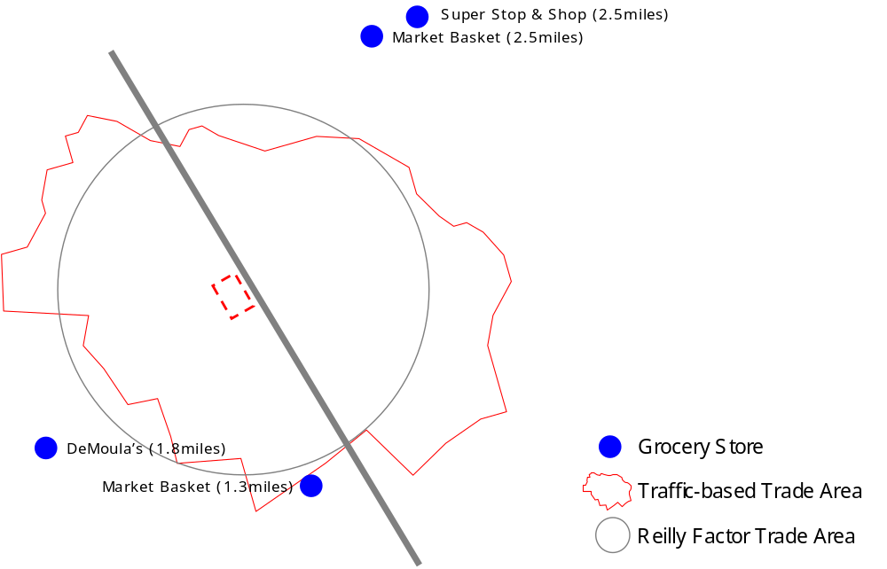

First multiplying the number of households within 1 mile of our site (8,848) by the average household grocery store spending power ($4,991), and then multiplying by the estimated 54% capture rate yields an estimate of $24 million in annual grocery store sales for our site. This is slightly above the current competitor average of $22.3 million. We believe this estimate is very realistic given the lack of grocery store in close proximity to our site, and given the high percentage of households without a vehicle nearby.

PHARMACY COMPETITION

The pharmacy competition the site would face is fierce, with the national chains CVS and Walgreens flanking the site on Broadway. Additionally, Brooks to the west and a local pharmacy called “Conlin’s” to both pose realistic threats. Pharmacy competition has increased in the last few years due to strip centers recently developed both to the north and south of our site. The following diagram and table summarize the pharmacy Reilly Factor calculation.

Pharmacy Trade Area Analysis
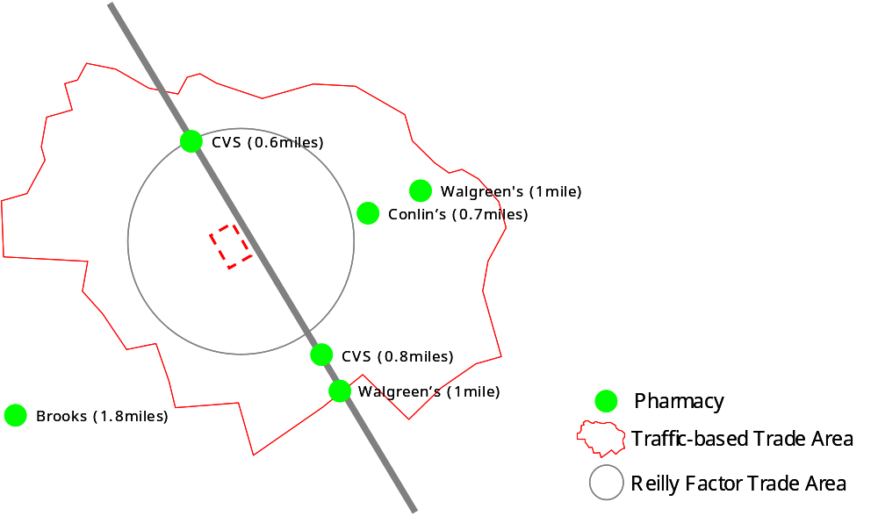

Capture Rate (Reilly Factor-based)
Primary Trade Area | Distance to Competitor | Reilly Factor Distance | Capture Rate  (Reilly Factor / Actual)
CVS | 0.6 | 0.3 | 54%
CVS, Walgreens | 0.9 | 0.4 | 48%
Conlin's, Walgreens (on Jackson) | 1.1 | 0.6 | 51%
Brooks (on Haverhill) | 1.8 | 1.0 | 55%
Average Distance | 1.1 | 0.6 | 52%

Due to data limitations, estimating the potential sales of a pharmacy on our site involved a slightly different calculus than that employed for the grocery store. In this case, we performed a market share analysis. According to InfoUSA, the pharmacies in the trade area experienced a combined annual sales volume of $25.6 million, averaging $4.3 million per store. If sales were to remain the same but with a new pharmacy at our location, the expected average sales per store would drop to $3.7 million. The Reilly Factor trade area distance of 0.6 miles includes 3,444 households, which is 28% of our trade area total (12,509). Applying the 28% to the total pharmacy sales ($25.6m), we estimate a pharmacy at our location could experience as much as $7.1 million in sales. Thus, we believe it is reasonable for a pharmacy on our site to enjoy annual sales somewhere between $3.7 and $7.1 million.

Both a grocery store and a pharmacy can be expected to earn above-average sales due to the location and the demographic profile directly surrounding the site. The key issue in putting together this neighborhood shopping center will be to identify a grocery store and a pharmacy that would be will to co-locate on our site.

IN-LINE RETAIL OPTIONS

Completing the tenant mix for Broadway Center will include a careful selection of service- and convenience-oriented retail. Once we have solidified the anchor tenants, we believe the in-line retail tenants will quickly follow. The challenges we face with the in-line retail consist of carefully orchestrating the tenant mix to help ensure the longevity of the project. For example, according to the Urban Land Institute (“ULI”), some of the highest sales volume in-line tenants include coffee shops, Mexican fast food, liquor and wine stores, cafes, and mailing and packaging stores. Low-performing stores include mobile telephone stores, tanning salons, and nail salons. We will also pursue stores in this category, but at an initially lower priority.

A total of 24 establishments operate along the border of our site, 18 of which represent current in-line retail tenant mix in our trade area. Of the 18 businesses, the top performers include mailing and packaging ($745,000), a coffee shop ($560,000), real estate ($536,000), and the automobile radio and stereo services store ($456,000). Other strong performers include two Mexican restaurants, a retail furniture dealer, and a cellular phone center. Low performing stores (under $100,000 in sales) include a nail salon, barber, pizza restaurant, photography, and legal services. The following is a summary of the in-line retail business bordering our site.

Bordering In-line Retail
Type | Number of Establishments | Estimated Sales | Average Employee Size
Food | 5 | 1,552,000 | 10 to 19
Retail Services | 10 | 2,822,000 | 1 to 4
Professional Services | 3 | 870,000 | 1 to 4
Total | 18 | 5,244,000

Growth in consumer spending in a particular segment acts as a driver for possible retailers to become tenants of a shopping center in a particular area. In reviewing the our trade area’s growth in various retail segments, we found that Health and Personal Care Stores are currently forecasted to experience the most growth within the next five years (8.70%). The following table lists the types of retailers expected to experience at least 4.00% growth over the next five years.

Retail Stores with Highest Expected Growth, 2005-2010

 | Expected Growth, 2005-2010
Health and Personal Care Stores | 8.70%
Gasoline Stations without Convenience Stores | 5.88%
Hobby, Toy, and Game Shops | 4.73%
Luggage & Leather Goods Stores | 4.34%
Source: Claritas, November 2005

Within the Health and Personal Care Stores, prescriptions drug expenditures represent the highest growth of any segment in the area at 13.13%. Such growth further supports the idea of placing a pharmacy into our neighborhood center. Though gasoline represents a strong growth area, this does not fit into our current concept of creating a pedestrian-friendly shopping center. Segmenting the Hobby, Toy, and Game Shops growth reveals strong area growth in sports and recreational equipment (4.64%), travel expenses (4.29%), and pet expenses (4.97%).

Local officials and residents have offered further insights into unmet community needs and potential business opportunities. On the resident’s wish list for the site is a retail bank. Though there is a Sovereign Bank located near the site, providing an alternative banking option could benefit the area. From the developer’s standpoint, a retail bank could greatly enhance the profitability and sustainability of the project. Local officials have commented that a large portion of the population in our trade area send money back to their countries of origin. Including a Western Union or similar business in our retail mix could easily capture a portion of this market.

We also considered including an urgent care health clinic or targeting independent doctors and dentists to locate in our site. Within 1 mile of our site are 15 dental offices and within 3 miles of our site are 6 hospitals. Because of Lawrence’s low income levels, dental and independent medical providers are unlikely to be able to afford much more than the current office rents ($8-$10 per square foot, NNN). Relocating a dentist or doctor into our shopping center will provide a useful draw if we can find a professional willing to pay at least the rent the retail space is paying.

In addition to the hospitals, the Greater Lawrence Family Health Center (“GLFHC”) also serves Lawrence’s public health needs with a network of 13 entities. According to the Lawrence Planning Department, GLFHC is unlikely interested in moving to a new location. However, we believe initiating contact with them may prove fruitful due to our site’s central location.

Discussions with Lawrence Community Works, a local community group, yielded further, community-focused ideas such as a day care center. In researching the day care center idea, we found 9 centers within 1 mile of our site and 36 centers within 3 miles. When we voiced the concern of a saturated day care center market, the community group responded by noting that some of the day care centers in the area are in need of expansion and might very well be interested in new space. Almost in the same breath, however, the community group also confirmed that such centers would most likely not be able to pay market rents. Though a day care center may be needed, sub-market rents would require financial subsidies to keep the deal profitable.

Setting aside space for ethnic businesses will believe will be an essential component to the local acceptance of our neighborhood shopping center. Our challenge will be to create as much value as possible for the local residents without driving current ethnic stores out of business. With a shopping center of this scale in this neighborhood, we have a high probability causing some business owners to close their doors. An immediate challenge we face in reserving retail space for locally owned retail is the rent difference. According to city officials in Lawrence, many of the retailers pay rents well below those required for a new shopping center and could not afford to move into our center without a break in the rent price. In fact, rents for many of the ethnic shops range between $1.00 and $6.00, NNN, per square foot. Like the possible day care center, some type of subsidy would be required to enable us to reserve space for such a tenant.

The in-line retail analysis strongly supports the pharmacy as one anchor in our center and suggests other likely tenants to be sporting goods, travel service, mailing and packaging services, pet supplies, hobby, and video games. Including a coffee shop, professional services such as real estate, and dental and medical offices will further solidify the mix. Catering to locally owned businesses and a day care center will be difficult without outside financial assistance due to their inability to pay market rents.

Regardless of the tenant mix, absorption will play a key role determining the successfulness of Broadway Center. According to local developers, once we have a strong anchor tenant, the in-line retail should be filled within one year. To confirm this, we considered the absorption of the recently developed strip centers within Broadway, all of which have remained lease-out since the initial lease-up. On Broadway, the competing strip centers have followed the traditional format of automobile-oriented layouts with set-back buildings. South of us, for example, is a strip center anchored by CVS on the front corner complimented with typical convenience-oriented stores. We believe Broadway Center’s focus on pedestrian-friendly access will provide a competitive advantage over competing strip centers and further strengthening our position will be the mid-sized grocery store. Our developer contacts confirmed that these centers had “no problem” leasing up within one year. For this reason, we will assume a relatively conservative 1-year lease up period for the in-line retail after we have contracts with the anchor tenants.

Targeted Tenant Mix

Anchor: Grocery Store, Pharmacy
In-line Retail:

- Retail Bank
- Coffee Shop
- Ethnic Restaurant
- Fast Food Restaurants
- Automobile Supplies
- Sporting Goods
- Travel Service
- Mailing and Packaging
- Pet Supplies
- Hobby
- Video Games
- Money Wiring Service
- Cellular Phone Outlet
- Day Care Center
- Dental Professionals
- Medical Professionals
4. Zoning and Regulatory Information

Due to the site’s location across the Methuen and Lawrence town border, we must consider the community goals and regulatory requirements for both towns. In general, learning each town’s regulatory process has given us insights into how smaller towns operate versus large cities. For example, little information is available online. In-person visits to each city are the only way to really obtain substantive information. However, since these small towns are financially strapped, the planning offices are thinly staffed and it can take weeks, or even months to schedule an appointment with a planning staff member.

The Methuen portion of the site, containing approximately 86% of the total site acreage, is currently zoned IL, or Limited Industrial. The Lawrence portion of the site, containing the remaining 14% of the site, is zoned I-2 or General Industrial. While the Lawrence zoning district I-2 is more flexible than the Methuen IL counterpart, the proposed development project is not permissible as of right under current zoning in either city. The following sections explain in further detail the zoning restrictions of each city and the necessary steps to obtain the appropriate entitlements.

Methuen, MA

Limited Industrial is intended to accommodate light industrial uses only, with residential uses prohibited and retail uses permitted by special permit only. Thus, under this zoning, our project is not permitted by right. All specific zoning information is sourced from either the Director of the Community Board, Nancy Colbert, or from the City of Methuen, Comprehensive Zoning Ordinance, effective August 1989 and last revised October 2005.

Step 1: Obtain Special Permit from Community Development Board (“CD Board”)
Since retail uses are allowed by special permit only on the site, we have outlined the process whereby to obtain a special permit. First, under City of Methuen zoning guidelines, our project most closely fits the description of “Shopping Center”, which includes one or more buildings containing allowed or allowable retail or service business uses, including 20,000 or more square of building floor space, and off-street parking in accordance with zoning guidelines. Based on this definition, the Special Permit Granting Authority for a Shopping Center Special Permit is the Community Development Board.

While the CD Board reviews the application for special permitting with respect to several factors including availability of utility service, infrastructure capacity, and consistency with neighborhood character, several key criteria are emphasized:

- Traffic generation. The CD Board is responsible for ensuring that no project causes an undue strain on the surrounding roads and neighborhoods. Ms. Colbert indicated that a project of our scale would require a separate traffic study performed by traffic engineers to confirm adequate roadway capacity.

- Parking requirements. Of the possible retail uses on our site, we have applied the highest parking requirements across the total building square footage. While the city distinguishes parking requirements for traditional retail from other uses such as drive-thru restaurants and banks, the traditional retail space requirements are the highest. Thus, since our site plan is still in flux, we are focusing on the highest requirement:

Traditional retail: 4 spaces per 1,000 square feet plus 1 space per 2 employees at maximum shift.

Based on our base case scenario square footage, which contains the maximum square footage of the viable site plan options, we are required to have 4 spaces * 92.9 = 371 spaces. As we currently supply 408 spaces, this leaves an excess of 37 spaces. Using the above formula for required employee parking, this allows a total of 74 employees at maximum shift. Until we know for sure the retail tenants likely to occupy the space, we are assuming that 74 employees will ultimately satisfy the requirements of the retailers.

- Other special retail uses. Other special uses such as daycare, drive thru restaurants and hair salons will require additional special permitting. For example, daycare facilities must be in conformance with minimum play area and health board requirements. Drive thru restaurants must have access that does not interfere with local traffic or other parking areas and are not permitted to be open after 11pm.

- Setbacks. Under IL zoning, front setbacks of 60’ from the property line to the building line are required. Secondly, side and rear setbacks of 30’ are required when abutting residential or multi-family uses. These setback requirements will need to be adjusted or waived via special permitting.

- Building coverage. Most business or retail zoning guidelines in the ordinance allow a maximum site coverage of 40%. Our highest building coverage of the site is the 92,920 scenario, which translates into a 38% coverage of the 5.5 acres. Thus, the proposed project is within these guidelines.

- Building height. Most business or retail structures have a maximum height allowed of 40’ or 3 stories. This restriction does not impact our current site plan scenarios as our most viable site plans include only single-story structures.

- Screens or Buffers. Screen Buffers can be in the form of fences or landscaping. For Shopping Center special permits, the CD Board may require landscape or other screening up to 6’ in height and 10’ in width. We anticipate this requirement to only be relevant should we have a retail configuration that is undesirable to the CD Board. For example, we have discussed building a landscaping buffer to offset the town’s resistance to a parking lot fronting on Broadway. However, reduced visibility for the retailers from this screen must be taken into account.

Once the special permits have been granted, ‘substantial use’ of the development must occur within two years or the special permit(s) expire.

The documentation and corresponding fees required for special permit application are as follows:

One original and eleven (11) copies of a site plan drawn at 1” = 40’ scale, prepared by appropriate Massachusetts engineers, architects and landscape architects. The location of all utilities, easements, infrastructure and right-of-ways must be shown, as well as all building locations and corresponding square footages. The parking configuration, number of parking spaces, and configuration of building uses, among other aspects, must be shown on the site plan.

The CD Board strongly recommends that the developer meet with the CD Board prior to filing an application for special permits should the project require additional documentation.

Once complete, the application is to be filed with the CD Board and with the City Clerk. The fee for such application is $250.00. Once filed, special permits issued by the CD Board require a two-thirds (2/3) vote if the board contains more than five (5) members and a vote of at least (4) members of a five (5) member board. Though unlikely, if the CD Board fails to act within ninety (90) days, the application for a special permit is deemed granted.

Step 2: Obtain Site Plan Approval from CD Board

Once requisite special permits have been obtained, Site Plan Approval is required for any project containing non-residential buildings greater than 5,000 square or containing two or more buildings on the site. The Community Development Review Board performs the Site Plan Approval process, which includes a public hearing.

Ms. Colbert indicated that the developer would typically meet on an informal basis with the city planner at least one week before submitting documents to the Board. In this way, the planner can be better informed and help the developer make his or her case in front of the Board. Ms. Colbert did not foresee any necessary concessions or immediate challenges with our proposed development plan, although she did mention that the “Board would not be excited to approve anything with a big parking lot in front.” In light of this, we have tried to create a pedestrian-friendly environment in our site plan that would conform to the Board’s wishes.

Since Site Plan approval involves a public hearing, we asked Ms. Colbert if we should anticipate any community resistance to the proposal. In general, we gained the sense that the Methuen approvals process does not seem to be as influenced by community groups as its neighboring counterpart, Lawrence. The City of Methuen has a very organized and seemingly effective and proactive planning board that is sufficiently rigorous in reviewing proposed plans that community groups, other than the one joint group between Lawrence and Methuen (below), may not be as active.

The purpose of site plan approval is stated as follows:

- To protect the health, safety and welfare of the public;
- To insure attractive and well-designed developments;
- To protect the interests of adjoining property owners;
- To create a better living environment in Methuen; and
- To preserve the natural resources of the City.

The process for obtaining site plan approval is as follows:

Submit one original and 15 copies of an application and site plan to the Community Development Board for approval. The site plan must be drawn to a scale of 1”=40’ and be prepared by a Massachusetts professional engineer, registered architect, or registered landscape architect. Similar to special permitting, the site plan must show utilities, trash collection strategy, easements, and building locations, uses and square footages. The site plan should also show proposed landscaping, topography and parking lot lighting.

The CD Board meets on the 2nd Wednesday of each month in the Searles Building. Documents for submittal must be received by noon on the previous Wednesday of the month. Meeting dates for 2006 have not yet been released.

The fee for Site Plan Approval is $250.00 or $0.03 per square foot of building, whichever is greater. Thus, the highest fee based on our site plan scenarios is $2,787.60. Should we plan to pursue a day care center, an additional fee of $125.00 would be required.

Step 3: Zoning & Inspections Committee

Once the development has received requisite special permits and site plan approval from the Community Development Board, it is then submitted to zoning and inspections for actual building permit applications and final confirmation of conformance to zoning requirements.

In total, Nancy Colbert, Director of the Community Board, indicated that our proposed project should take 9-12 months to complete the permitting process, including special permitting and site plan approval.

Lawrence, MA

Obtaining zoning information for Lawrence was a similar experience to gaining information in Methuen. Specifically, nearly 2 months went by before being able to meet with a member of the Lawrence Planning Board and zoning guidelines are not available online. All zoning information contained herein is sourced from the Lawrence Revised Zoning Ordinance, last revised April 5, 2005.

The Lawrence portion of the site, approximately 14% of the total acreage, is currently zoned as I-2, which is designed to permit the most intense industrial uses of the city, as long as these uses are safe and healthy.

Under the current zoning, the proposed retail development project is not permitted as of right. In order to obtain permitting, similar steps would be required as those for the City of Methuen, including obtaining special permits and site plan review. One key difference, however, is that the Lawrence site plan review does not include a public hearing and the Planning Board has more of an advisory role, as opposed to outright approval rights.

Lawrence is currently working on a key initiative whereby all I-2 districts in the City would receive ‘Overlay District’ zoning. Since Lawrence is currently engaged in various revitalization efforts, the City Planning Board is attempting to streamline the permitting process by establishing an overlay on various sections of the city. Under this overlay zoning, all uses permitted by the underlying zoning district would continue to be allowed. In addition, new uses would also be permitted via the overlay. The intent is that once in place, the overlay will expedite development approval and permitting.

After speaking with Dan McCarthy, attorney for the City of Lawrence, we understand that the proposed development site will be included in the next overlay district, which he anticipates being finalized within the next year. Once complete, the permitting process would require only site plan review and no public hearing.

Consistent with the City of Methuen, the proposed project fits the definition of Shopping Center, which would be permissible under the overlay district. Shopping Centers have the following specific requirements:

- Parking requirements. The objective of the parking requirements is to promote traffic safety by providing adequate off-street parking and maximize the traffic-carrying capacity of adjacent roadways. Similar to the Methuen parking analysis, we have applied the highest parking requirement of the various retail uses proposed. Shopping Centers as a general category have the highest parking requirement, namely 3.33 spaces per 1,000 square feet of building area.

- Screens or Buffers. Similar to Methuen, the Lawrence Planning Board reserves the right to require buffers around retail uses to protect neighboring uses.

- Drive-thru facilities. Should we locate a drive-thru on the Lawrence side of the parcel, we will have to comply with various guidelines including a maximum of 2 curb cuts at the site and a minimum building setback of 40’ from the front lot line.

- Traffic Study. Even with the overlay district zoning, a traffic study may still be required due to the scale of the project and the size of Broadway. It is conceivable that one traffic study should satisfy the requirements of both Lawrence and Methuen. Specific study guidelines are articulated in the Lawrence Revised Zoning Ordinance.

To apply for site plan review under the overlay district, we are supposed to meet first with the Lawrence Planning Board and confirm substantial conformance with the application requirements and zoning guidelines. Following this meeting, twelve copies of an application for site plan review are submitted to the planning board, each accompanied by a site plan. The site plan must be prepared by a registered architect or engineer and should be on sheets no larger than 24”x36”at a scale of 1” = 40’. Representative information to be included on the site plan includes boundaries of the property, setback lines, location of current utilities, easements and infrastructure, location and square footage of proposed buildings and corresponding uses. Several pages of additional specific site plan requirements are contained in the Lawrence Revised Zoning Ordinance. The fee for site plan review is $200.

Achieving Public Goals – Lawrence and Methuen

We believe that almost any development will be an improvement over the current gaping lot on Broadway, a key thoroughfare through these two towns. Lawrence, in particular, seems thrilled to permit almost any new development. However, both Methuen and Lawrence have a similar idea on what kinds of development would really bring progress and a sense of identity to the area. Most of these ideas revolve around various community uses, including community theatre space, a museum, and a community park.

While a new neighborhood shopping center may meet the immediate retail needs of the surrounding community, it would be difficult to use this type of real estate product to truly generate a unique sense of cultural identity or place, which both Lawrence and Methuen would like. So, while our proposed retail development could be an improvement and it is unlikely there would be community opposition to the project, it is not clear that the project meets any specific public goals by fostering a sense of community or cultural identity.

Based on a meeting with Sharon DuBois at the Lawrence City Planning Office, our retail concept would be approved for this site with little opposition from community groups. Although it does not appear that the overlay district zoning requires a public hearing, should a public hearing be required at any point, it may be necessary to carefully evaluate the influence of community organizations. For example, Ms. DuBois mentioned that it will be necessary to gain the support of various community organizations, in particular the Lawrence-Methuen Community Coalition and the Lawrence Community Works. Both of these organizations are grassroots coalitions that are very active and highly opinionated.

We recently met with Tamar Kotelchuck of Lawrence Community Works (“LCW”) and, while no opposition was expressed towards the proposed retail concept, Ms. Kotelchuck did express interest in LCW acquiring the site for residential development.

Thus, other than LCW expressing an interest in acquiring the site themselves, we are not aware of any other required concessions or local opposition at this point. Should public hearings be necessary, we anticipate the community groups will seek community benefits to be included with the retail development, particularly since many of the proposed site plan scenarios lack a clear community development initiative. For example, perhaps the community organization will require the development to include a small amount of community open space or contain a minimum percentage of local entrepreneurs. One offsetting factor to these community concessions in Lawrence may be the fact that only 14% of the total site is actually in Lawrence. Thus, the community groups may not be as concerned about less than 1 acre in area.

5. Financial Analysis and Feasibility Study

- Land Value Analysis

As part of the financial analysis for Broadway Center, we began with identifying a realistic land residual based on development revenue and cost estimates (to be described in further detail below). By approximating Year 1 stabilized NOI for the property and applying a market cap rate, we were able to net out project costs and obtain a residual land value. We performed this simplistic analysis on the four site plan scenarios we generated in initially determining the best retail mix and layout for the site.

We analyzed these scenarios to determine which would support the highest land value. Our Base Case scenario offered a land residual of $138k despite using a somewhat aggressive 7% stabilized cap rate. We considered a 2-story scenario whose higher costs and lower rents only made matters worse. We determined that a three pad scenario anchored by a drug store would support a land value of $1.7 million, but might impose additional permitting risk. Lastly, the Hybrid model with a grocery anchor, pharmacy pad and inline yielded a land value of $1.3 million. This assumes that exclusionary clauses in the grocery lease would not preclude a pharmacy on the same site. Detailed financial analysis and site plans for each of the scenarios can be found in the Appendix.

Due to the hybrid case having the highest residual land value without substantial permitting risk, we ultimately selected this site plan as the model for Broadway Center. To confirm that the hybrid plan residual land value of $1.33 million was an acceptable price, we spoke with brokers, local community organizations and developers.

A local broker indicated the land value should be between $1 and $5 million. Lawrence Community Works, a non-profit community development organization in Lawrence indicated that they would be able to pay approximately $1.5 million should the entire property be in Lawrence. Lastly, in asking developers what they would pay for the land, we repeatedly received the response: “Not much.” Thus, we felt assuming a land value of $1.33 million, which was on the low end of the broker’s estimate, was acceptable for purposes of this analysis.

- Development Costs

Development cost estimates were obtained by speaking to developers and brokers and consulting construction cost estimating tools such as RS Means. We are planning a standard retail product with attractive facades, but with overall simple finishes and design so that the project is profitable in a challenged demographic area. The total development budget includes the cost of land, hard costs, soft costs, including architectural, engineering and legal fees, a developer fee, construction interest and a construction loan guarantee fee. Total project costs are $14.5 million or $179 per buildable square foot.

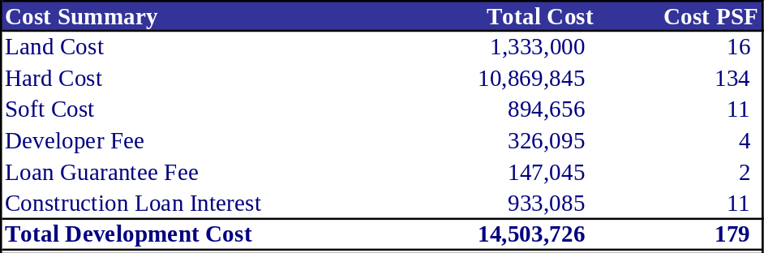

Hard costs include the construction of a “white box” and tenant-specific build out requirements (TI allowance) of $10 per building square foot. Major contracts will include foundation, concrete, asphalt surfacing, electrical, plumbing, HVAC, windows and roofing.

Soft costs include traditional consulting and design fees. Since this is a fairly standard project we believe consultant costs can be kept to a reasonable minimum. Architectural design costs are estimated above. Engineering will likely include a traffic study required by the municipalities. A Phase I environmental report has already been commissioned by the seller with the results showing that the site is free of environmental contaminants. We will examine this during our due diligence to determine whether we can rely upon its conclusions.

A construction management fee of approximately $30,000 has been built into the budget for the 12-month construction period. F,F&E is not applicable for this project. Legal fees are estimated at $100,000 with an additional allowance of $160,000 for entitlements and permitting fees. Fees for leasing, construction and permanent financing are about $100,000 each. Lastly, we have provided for a 10% soft cost contingency should any of these costs increase.

A developer fee in the amount of 3% of total hard costs has been provided to cover overhead costs for the development team. 4% fees are common in the industry, however, due to our team’s relatively thin development experience, we have reduced this fee to 3%. Also, the development fee is not funded until construction starts.

To obtain a guarantee on the construction loan, we have provided for a construction loan guarantee fee of approximately $150,000. Lastly, the construction financing is expected to have a 7.0% interest rate, with 50% of the funds outstanding for 50% of the construction period. It is assumed that the construction loan will be for approximately 80% of total project costs and could be provided by traditional construction financing lenders such as Bank of America.

With permanent financing available from various sources at 200-300 bps over the 10-year treasury, the interest rate on our permanent loan could range from 6.5% to 7.5% (10-year treasury closed at 4.50% March 18th, 2006). The mortgage constant for our 10-year 30-year amortization permanent financing could range from 8.9%. Given our projected NOI and a 1.25x Debt Service Coverage Ratio, this gives us a total take-out loan of approximately $10.9 million, leaving the balance of $2.7 million to be financed with equity. The permanent loan is fully amortizing over a 25 year period.

While we would most likely have to use a national construction lender for the construction loan, for the permanent loan we could choose a national player such as Bank of America or a conduit CMBS lender, or a local player such as Sovereign Bank, Citizens’ Bank and TD Bank North. We could source equity via partnership with regional developers in Boston or other real estate opportunity funds in the area. Further information about the project’s capital structure is in the next section.

The detailed development cost budget is as follows:

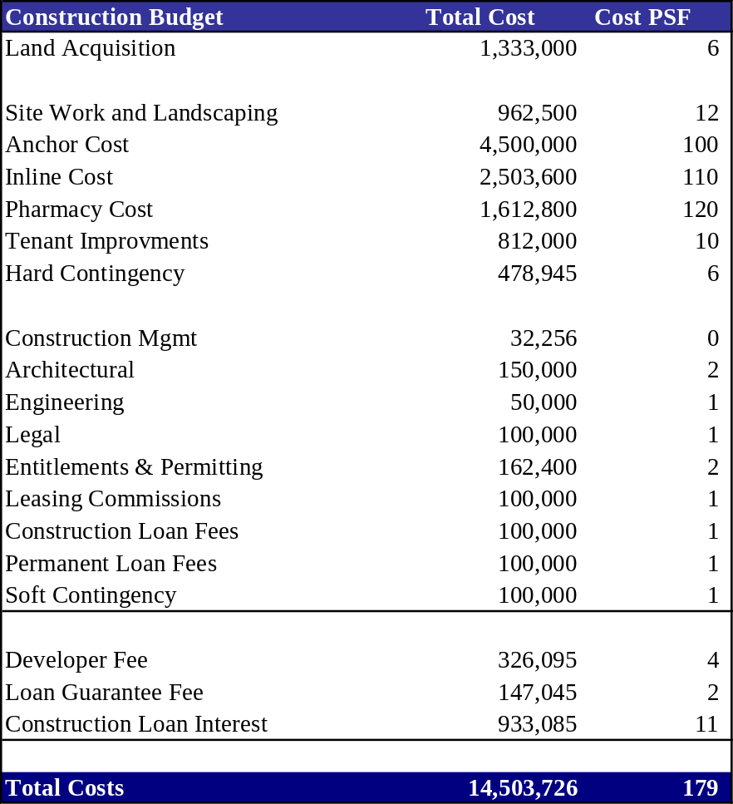

- Revenue Estimates

Retail rental rates in the Lawrence & Methuen areas were estimated using sources such as realtor listings online and local developers. For the grocery anchor, we received rental rate estimates between $8 and $10 per square foot, triple net. Pharmacy pad tenants pay significantly higher rental rates of $23 to $35 per square foot. Lastly, inline retail tenants ranged from the low to high teens per square foot. Based on these estimates and recognizing that Broadway Center is in an economically challenged area, we applied the following rental rates to estimate revenues:

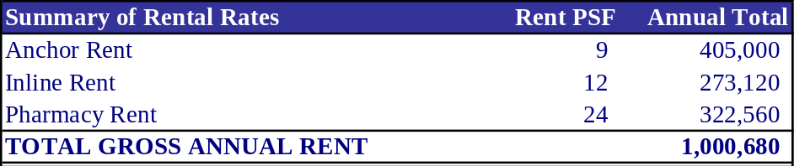

Other assumptions for retail revenue included vacancy, lease renewal probabilities, lease terms and operating expenses. Detailed assumptions can be found below:

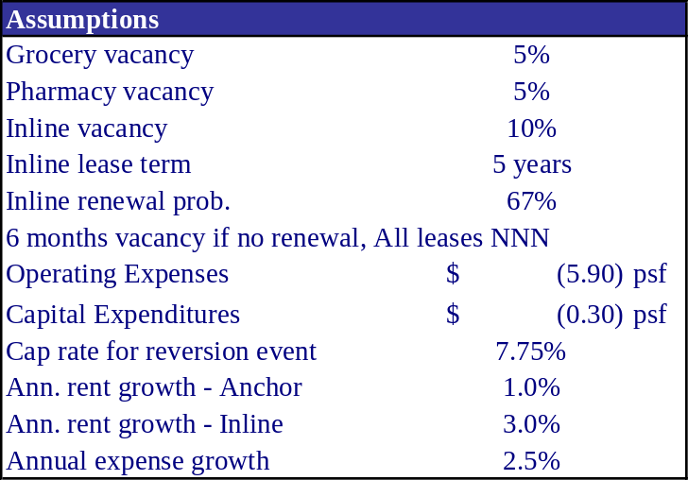

- Capital Structure

The capital structure for Broadway Center is fairly straightforward. We have assumed an 80%-20% construction debt to equity ratio. The 20% equity is funded primarily by an opportunistic equity partner and 10% from the developer. The debt to equity ratio remains 80%-20% throughout the long-term hold of the project and the equity partners can remain constant or be taken out upon construction completion.

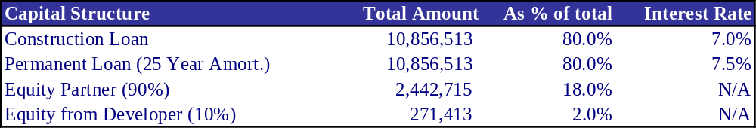
- DCF Analysis

To complete a full DCF analysis, we estimated a project timeline including a 3-year construction and leaseup phase with a 10-year long-term hold.

Total Construction & Leaseup Timeline: 36 months
    - Due Diligence / Negotiation: 3 months
    - Permitting / Planning: 12 months
    - Sitework: 6 months
    - Construction: 12 months
    - Leaseup: 12 months

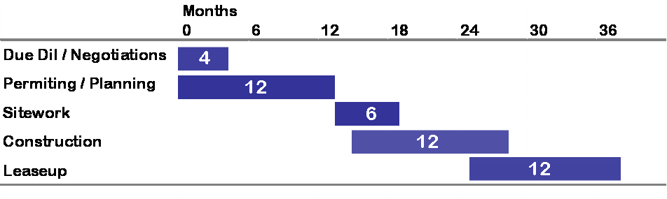
We estimate the construction process to take 9-15 months. Approvals in Lawrence and Methuen require community board approval and could take approximately a year. We would not proceed with construction without leases in place for the anchor and at least major interest in the in-line. Given the dearth of new retail space in the trade area we believe leasing could proceed during construction and would be completed within six to twelve months following receipt of a Certificate of Occupancy.

To quantify rental revenue during the 12-month leaseup period, we have assumed that the grocery and pharmacy anchors begin paying rent upon construction completion as those properties were pre-leased. For the inline tenants, we assume quarterly leaseup in the amount of 25% of the retail inline space per quarter so that by year-end, the inline space is 100% leased.

The results of the DCF analysis, including all cost, revenue, operating, capital structure and sales assumptions above are as follows:

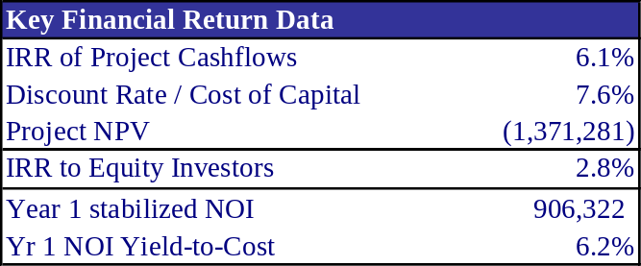

Since the IRR at the project level (6.1%) is less than the project’s cost of capital (7.6%), the NPV of the project is negative in the amount of -$1.37 million. Additionally, the IRR to equity investors of 2.8% is insufficient to attract equity capital. The YR 1 NOI Yield-to-cost is on the low side, but could be acceptable for institutional-quality retail properties.

Due to these poor financial results, we will need alternative financing to be able to proceed with the project and attract traditional equity capital. One possibility for sub-market financing is the federal New Markets Tax Credit program. Because the proposed Broadway Center is located in a low income census tract, the project is eligible for this program.

[Insert New Markets Tax Credit section]

Results from New Markets Tax Credit Financing

We replaced the maximum allowable 22% of debt financing for the proposed Broadway Center development with the NMTC subsidized loan that is subordinate to the traditional construction loan and long-term permanent financing. Because this subsidized loan charges only 1% interest, the financial results of the project were substantially altered.

The revised capital structure for the project is as follows:

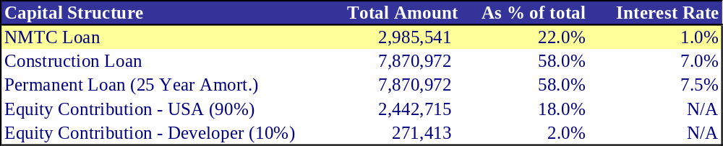

Additionally, because the amount and length of time that the construction loan was being used decreased, the total construction interest charged on the project also decreased. Total project costs decreased to $14.2 million, or $175 per square foot. This represents almost $300,000 in savings, or approximately $4 per square foot. Also, the overall results on the long-term hold benefited substantially from the 7-year NMTC subsidized financing. Results of the revised DCF analysis are as follows:

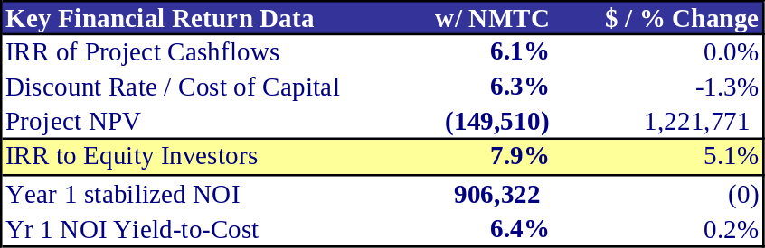

Two key things to note from these financial results are that the returns to equity investors increased more than 500 bps and the cost of capital to the project decreased by 1.3% causing the overall project NPV to become closer to zero.

While these numbers represented a vast improvement over the scenario without subsidized NMTC financing, we recognized that the equity IRR of 7.9% was still unlikely to attract traditional equity capital. Thus, we ran several sensitivity analyses to determine at what point we may be able to achieve market equity returns.

The first sensitivity analysis we performed was on the land value. Specifically, we analyzed the effect a reduction in land price had on overall returns to equity. The results are as follows:

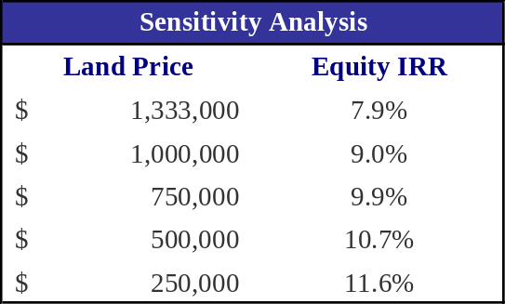

Even as the land price approached zero, the returns to equity were still barely reaching the threshold of market requirements. Thus, we recognized that a reduction in land price was unlikely to assist us in achieving financial feasibility.

Second, we tested the effect of a change in inline retail assumptions on overall returns to equity. Since we had received indication from some developers that inline rental rates in the low to mid teens could be achieved, we decided to test those scenarios. The results of this sensitivity analysis on rental rates are as follows:

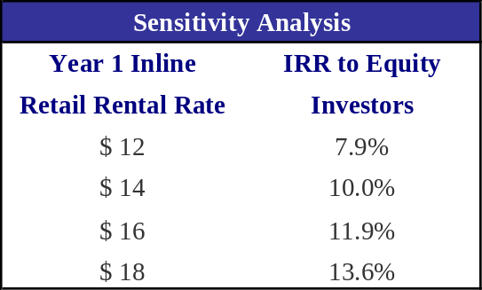

Unfortunately, the equity returns did not attain market required returns until rental rates were at least $18 per square foot. Given the existing market in Lawrence, we believe it is highly unlikely that rental rates of this level could be achieved.

Conclusion of Financial Analysis

Based on our financial analysis and anecdotal evidence gained from the various market participants interviewed, we got the impression that the project should have been feasible given the overall development strategy. In speaking with Bill Beckeman of Linear Retail after the presentation last week, we learned of a recent transaction in Dorchester whereby a Stop & Shop was paying $12 per square foot as a grocery anchor tenant, far exceeding our estimate of $9 per square foot. This retail center was not unlike the concept we had proposed and the area demographics were comparable. Furthermore, we learned of an additional development in New Bedford, MA where a Price Right grocery anchor was paying $13 per square foot.

Using these two inputs, we ran one more sensitivity analysis on the revised grocery anchor rents to quantify the effect on equity and overall project level returns. These results are as follows:

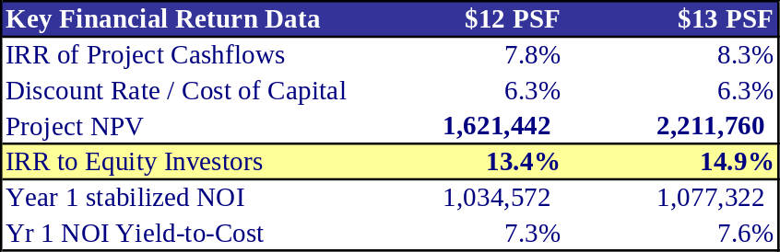

Thus, from these results, it is evident that by identifying and securing a lease with a grocery anchor at $12 or $13 per foot (holding other original assumptions constant), Broadway Center becomes feasible and generates attractive returns with a positive project level NPV.

Detailed representations of the DCF analyses can be found in the Appendix.
6. Site Plan

In designing the center the primary concerns were that 1) appropriate sized buildings were provided for the projected uses, 2) the stores were visually and physically accessible to both pedestrians and cars. These primary concerns were balanced with efforts to identify an appropriate place for a commemorative plaza and address the potential concerns of surrounding uses.
The resulting design places the shopping center at the back of the site. This allows the loading dock to be located near other mill loading docks on French Street, and the entrance to be both visible from the street and easily accessible from Broadway, the parking lot and other stores. At 45,000 square feet, the building provides for typical midsized grocery stores. There is room on the site to widen the building, but the low rent projected for the anchor tenant precludes such an increase.
Discussions with retailers and observation indicated that inline retail is ideally between 50 and 80 feet deep, with that in mind the inline retail building on the site has depths of both 80 and 50 feet. The deepest section of the building is on Broadway—the high value location—and the shallowest section is on Stamford Street. The inline retail is located at the front of the site. This poses several challenges which we believe are justified by the nature of the site and the needs of the surrounding community. The first challenge is that it is not possible to provide a covered walkway between the inline retail and the anchor tenant. The second is that inline stores must have two doors or sacrifice access from the street or the parking lot, which is difficult given security, loading and back-room needs. However, placing all of the inline retail at the back of the site would not be possible without stretching some of it along the bottom or top edge of the site. This would close off visibility to the fragile small scale retail and hamper vehicular access from side streets. Additionally, as mentioned, over a third of the households of the identified trade area do not have a car. To compete successfully for their patronage store fronts must be in close proximity to their daily movements up and down Broadway. Most importantly, as mentioned in the zoning section, the project will not be built as-of-right and will require review in Methuen and Lawrence. Because these cities envision a revitalized Broadway as a whole, they will seek to create a shopping center that fits in with the character of the surrounding pedestrian oriented environment. In sum, by pulling the inline retail to the front of the site and completing the pedestrian environment on Broadway we lower the entitlement risk for the project.
The approach is similar regarding the pharmacy pad, and requires less defense as it has more precedence. The most important consideration was that the drive-through be located such that a line of cars would not back out into Broadway. Ideally the entrance to the building would be on the southern edge of the building—providing equal access from the street and parking lot.

[actual site plan]

7. Conclusion

In general, the Broadway Center proposal is a successful project in that it meets most of our team’s goals for this class. Specifically, our team gained understanding of the retail development process and clarification on the New Markets Tax Credit program and its forms of implementation. Also, we feel that the proposal meets many of the cities’ objectives in addressing the street edges of Broadway and filling a vacant parcel with retail that meets an underserved area’s needs.

Where we feel there may have been room for further exploration, however, is in financial feasibility and additional site planning considerations. First, with respect to financial feasibility, had we learned earlier that grocery rents could have been in the low teens, our prospects for financial success would have been much greater. Additionally, to boost financial returns and balance concerns about a pharmacy exclusion from the grocery anchor, we could have pursued a bank or fast food user for the single pad site on Broadway. It is our expectation that, given additional time for research, one of these tenants may have paid approximately the same rent per square foot as the pharmacy and consequently boosted returns without jeopardizing the grocery anchor concept. Additionally, rather than evaluating a long-term hold scenario, we could have explored selling the pad site right away to one of these national tenants and used those proceeds to assist in financing the balance of the project.

Another concern with financial implications that we could have researched further given additional time was that of a new traditional grocery store possibly hurting the business of the locally owned convenience stores. While those stores that are more ethnically focused would likely retain their competitive advantage, those that are more traditional convenience stores would likely lose business to a new grocer. To counterbalance negative community feedback from this attrition, we could have further pursued the area’s primary local grocery chain, El Rincon, as a potential expansion candidate for the site. Our initial conversations with El Rincon indicated that they were not interested in expanding, however, perhaps further discussion could have shed more light as to why or what could change to encourage expansion.. To have El Rincon as the primary anchor, we would need to explore some type of credit support, such as a personal guarantee on the lease, since El Rincon would lack the national credit we would likely need to achieve reasonable project financing.

In addition to tenant mix and financial feasibility, there are a few areas in site planning that we could have explored a little further. Specifically, we learned during our presentation that our site plan presented some access challenges for both pedestrians and loading. While we had difficulty getting much information from potential tenants, if we had more time, perhaps we could have secured more detailed information on the kinds of access and loading areas these tenants would have needed. Additionally, because we are trying to address city concerns by keeping inline retail at the street edge, we also start to have pedestrian access challenges as they compete with cars driving to the grocery anchor and pad site. By reorienting some of the inline retail, we may have been better able to address these access concerns.
In spite of these additional areas for exploration, however, we feel pleased with the ultimate proposal for Broadway Center and believe that its implementation in Lawrence and Methuen, with some minor modifications, could be very likely.

Appendix A: Competing Shopping Centers

Blue dots: Large grocery store chains

- Grocery Stores: Market Basket, Super Stop & Shop
- Location: 70 and 90 Pleasant Valley Rd – The Loop Mall
- Other stores at The Loop:
Wal-Mart, Home Depot, Old Navy, Borders, Loews Movie theatre, Zoots, Burger King, TGI Fridays, K& B Toys, Macaroni Grill, Famous Footwear, Chuck E Cheese, Ann Taylor Loft
- General observations:
Much more upscale and well-kept than the rest of the neighborhood strip centers, likely has larger regional draw, parking lot was very full near movie theatre ad appears to be primary draw. Driving time from the Loop Mall to our site is approx. 10 minutes. This location is not ideally located for the car-constrained population around our proposed site.

The following are pictures of the grocery and other stores at The Loop Mall:
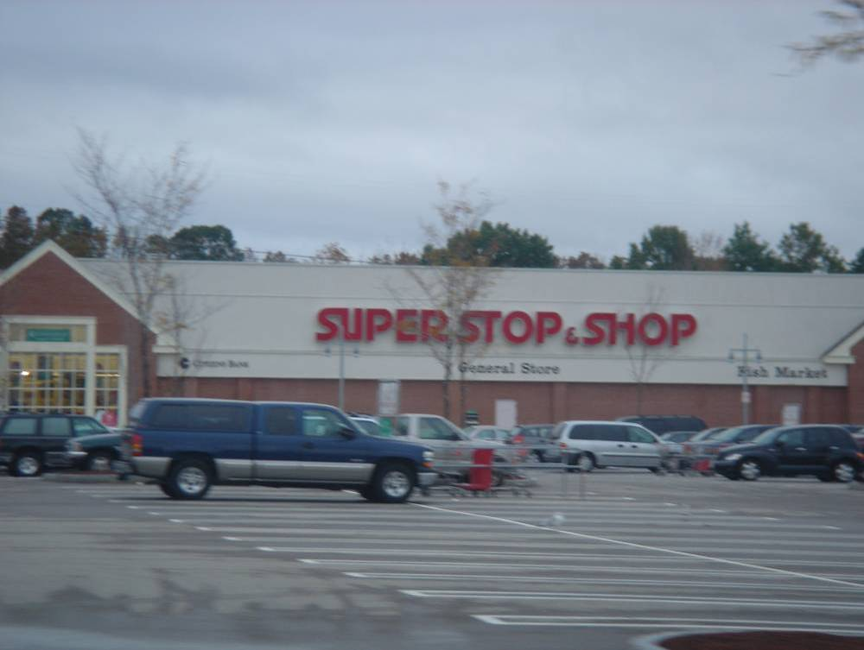

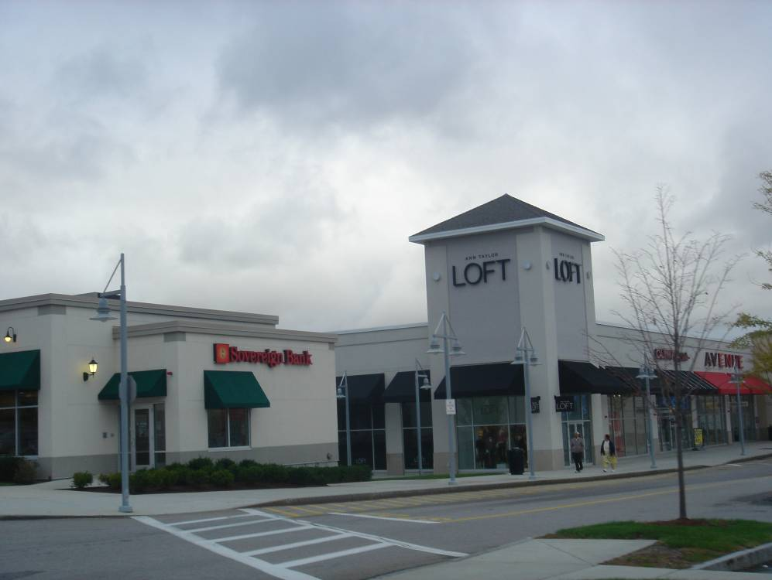

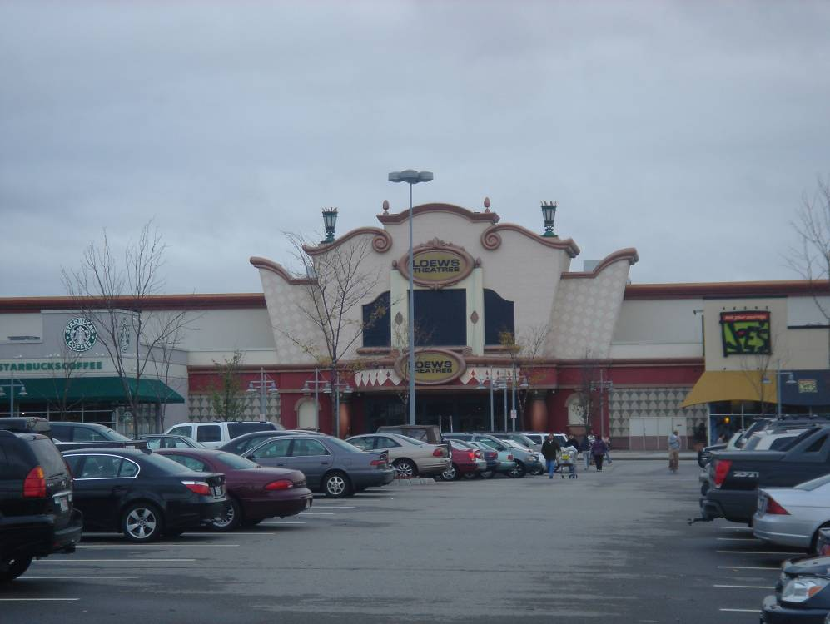

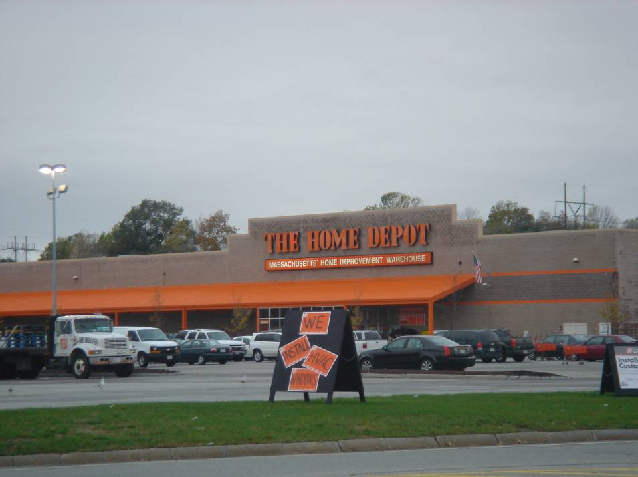

- Grocery Store: Market Basket
- Location: 700 Essex Street, Lawrence
- Other stores in strip center:
Payless Shoes, Family Dollar, Tello’s (discount clothing store)
- General observations:
While strip itself was somewhat depressing and the parking lot appeared only 50-60% full, the grocery store inside was very busy. We later learned from the assistant manager of the grocery store that many patrons walk or take cabs to the grocery store. Clientele and workers seemed to be almost 100% Hispanic. High concentration in Hispanic grocery products, across from fairly rundown apartment complex.

The following are pictures from this neighborhood strip center:

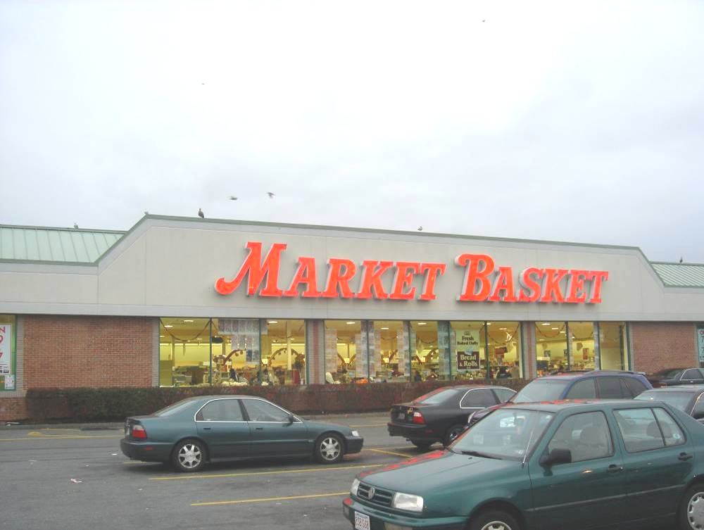

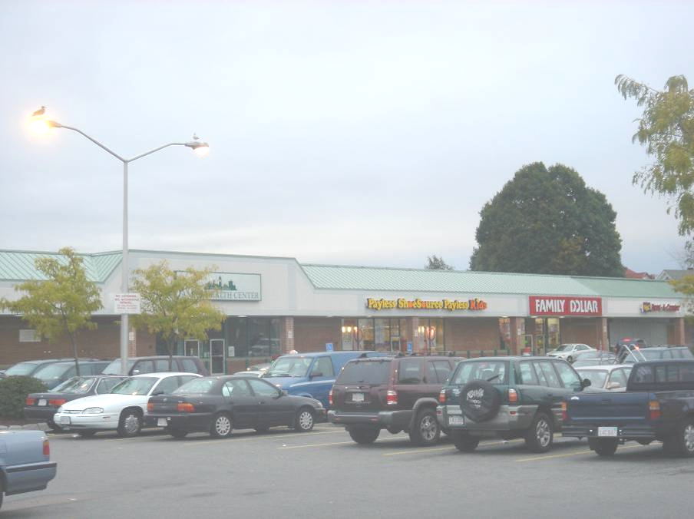

The Market Basket at this location clearly catered to the Hispanic community with bulk Hispanic foods.

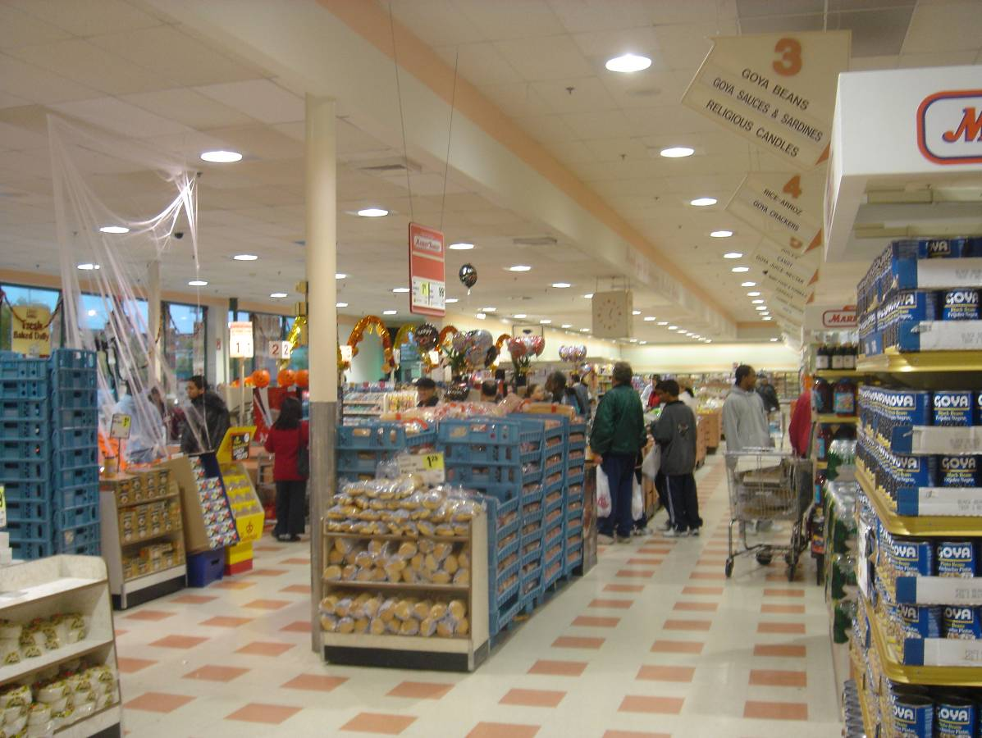
Interior of Market Basket at 700 Essex Street.
Notice the signage for Aisle 3: “Goya Beans, Goya Sauces & Sardines, Religious Candles”; Aisle 4 signage: “Rice – Arroz, Goya Crackers”

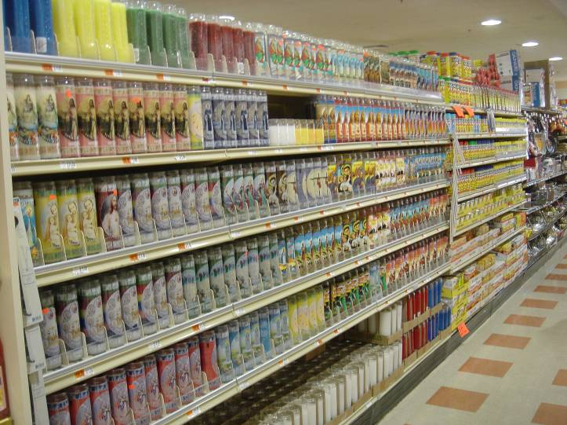
Nearly ½ of this aisle was devoted to the sale of religious candles, targeted to its Hispanic clientele.

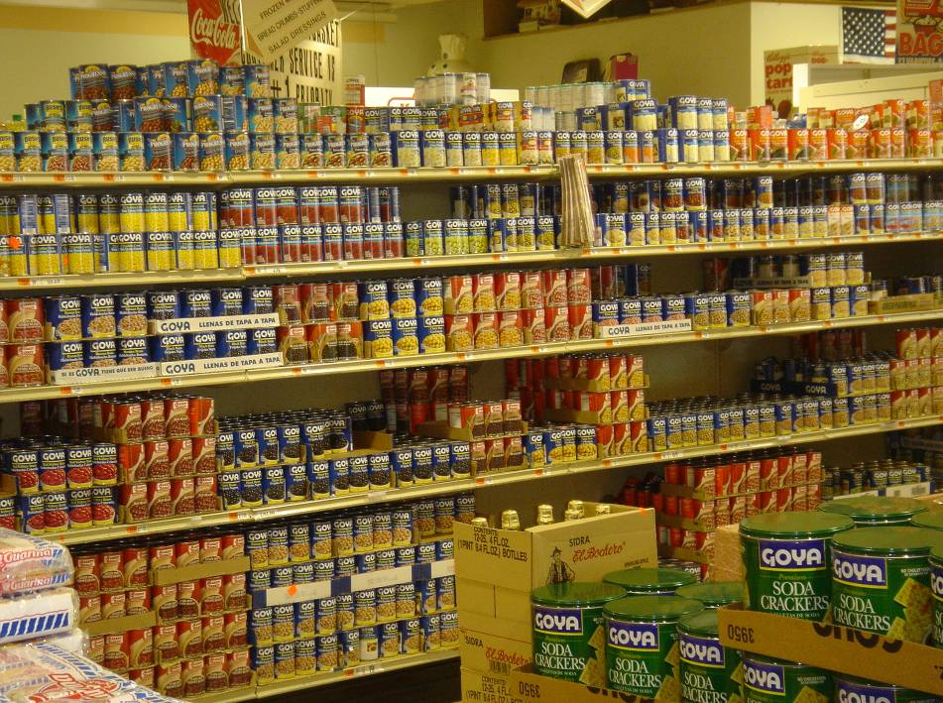
Goya, Goya and more Goya products…

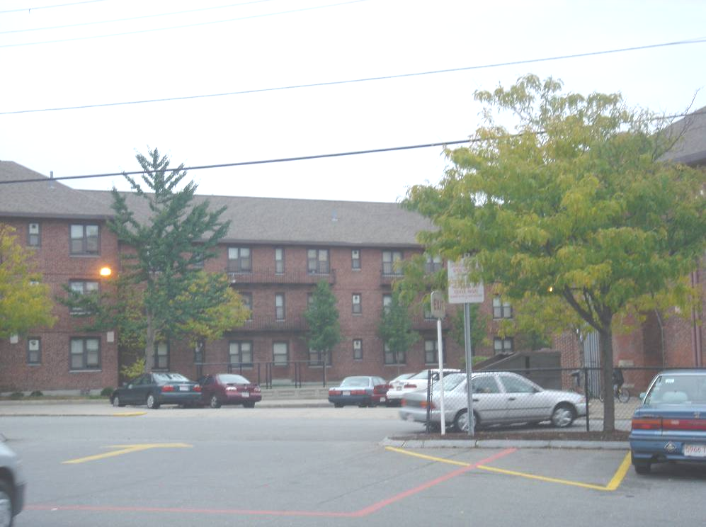
Somewhat rundown apartment complex across the street. Apartments did not appear to be fully leased as lot was fairly empty on Sunday afternoon. However, perhaps this is due to low car ownership.

- Grocery Store: Market Basket
- Location: 186 Haverhill Street, Methuen
- Other stores in strip center:
Dollar Tree, Payless, Liquor Store, Brooks, Dots (clothing), AJ Wright’s, Papa Gino’s
- General observations:
Felt like a long drive to get there (not much to look at, run-down auto shops, etc), but probably only 7-8 min drive. Patronage was mostly Hispanic and very crowded parking lot, busy area, perhaps a bit nicer, but felt very similar to Essex Street / Lawrence location. Across street from Dunkin Donuts, McDonald’s

The following are pictures from this neighborhood strip center:

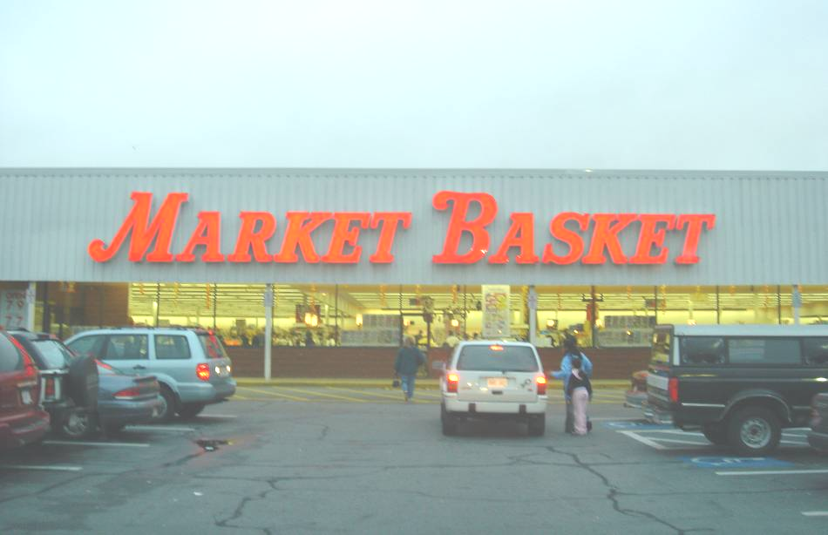

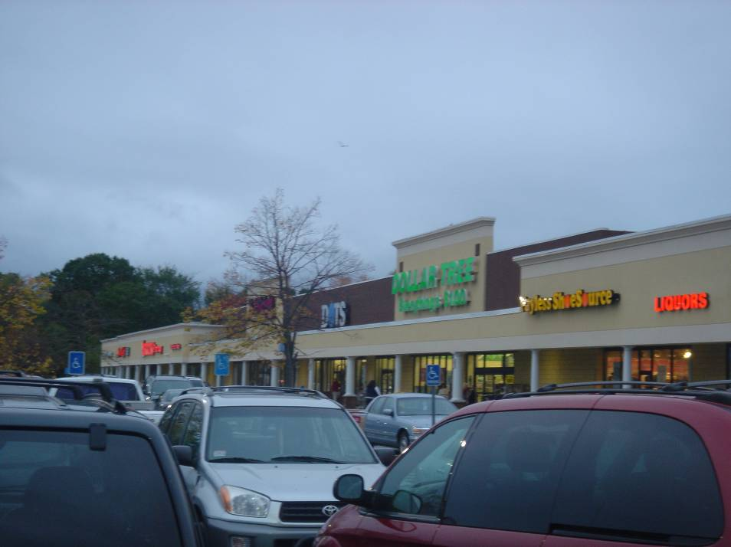
The other stores at this strip center appeared to have higher patronage than the previous strip center in Lawrence.

Yellow dots: Convenience store chains

- Convenience store: Store 24
- Location: 389 Broadway, Lawrence
- General observations: $1.1MM in annual sales, Store was open, but parking lot completely empty

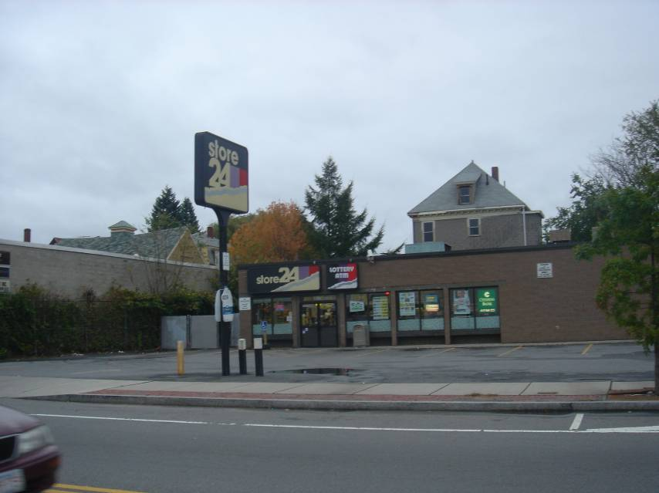

- Convenience store: 7-Eleven
- Location: 370 Broadway, Lawrence
- General observations: $1.3MM in annual sales, fairly full parking lot, newer strip center
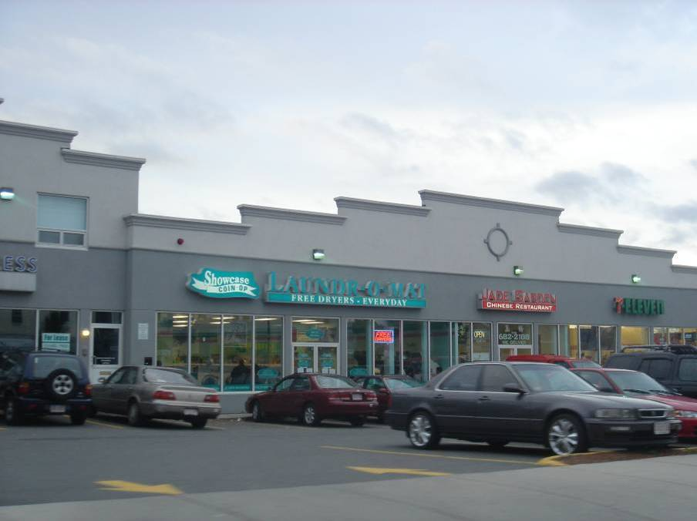
Green dots: Local / ethnic grocery stores

- Grocery store: Thwaites Market
- Location: 36 Railroad Street, Methuen
- General observations: $2.2MM in sales! Unusual grocery store hours: closed Sundays, Wed hours: 7am-noon, MTThFS: business hours: 8:30 – 5:30pm, prepared foods & meat, family / owner appears to live upstairs, looked run down, but appears to be successful. Locals walked up while I was there, had driven for a while specifically to shop at that store, and were disappointed to find it closed.

The following are pictures of Thwaites Market:
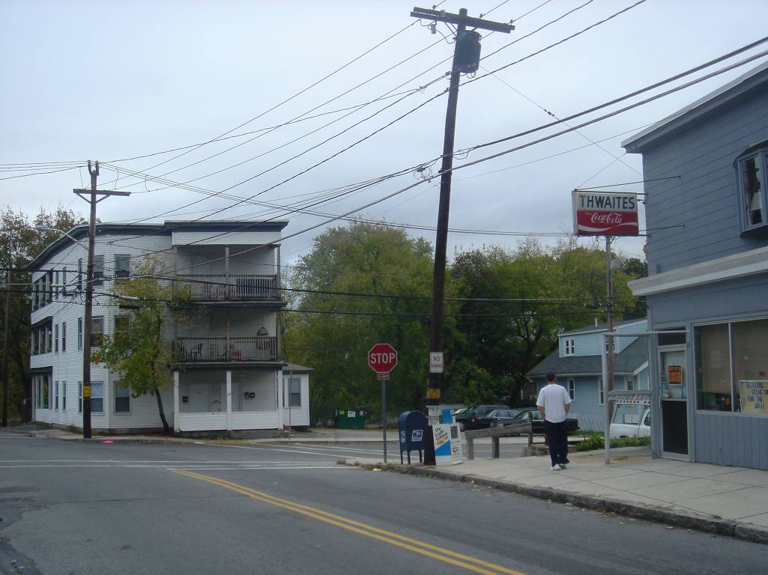

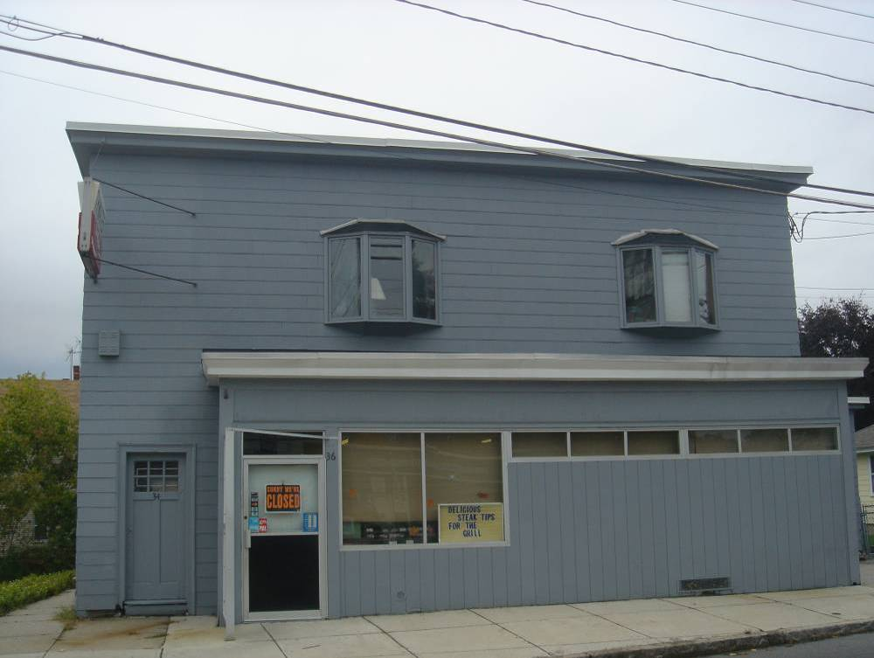

- Grocery store: El Rincon Supermarket
- Location: 205 Broadway, Lawrence
- General observations: $364K in sales. Pretty shady-looking shopping center…

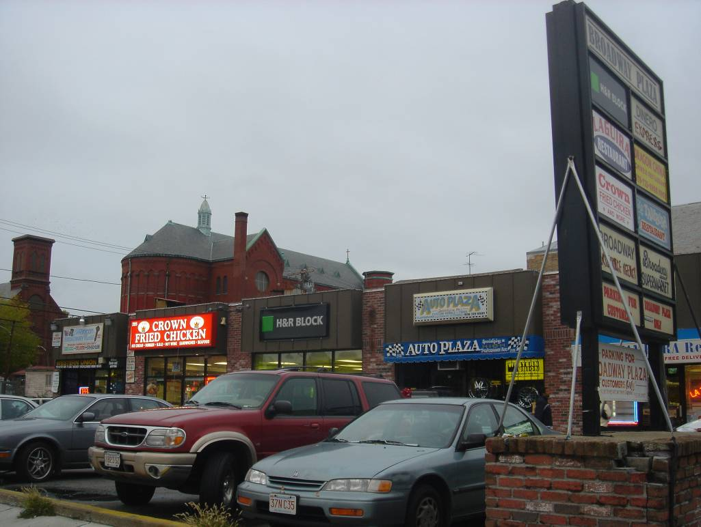
El Rincon is in left-most corner
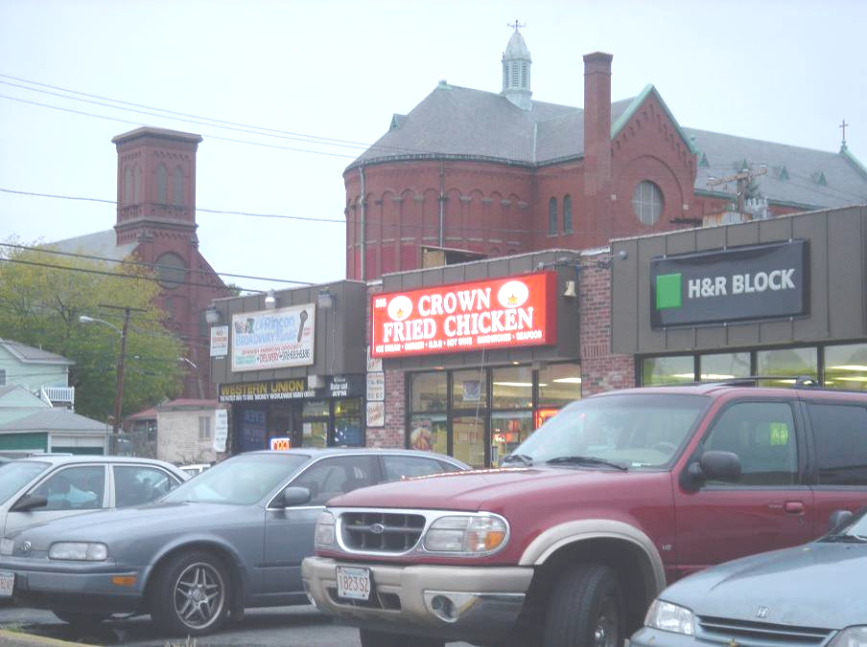

- Grocery store: El Rincon Supermarket
- Location: 473 Haverhill, Lawrence
- General observations: $728K in sales. Very bright neon signs, pretty well frequented, small parking lot about 12 spaces

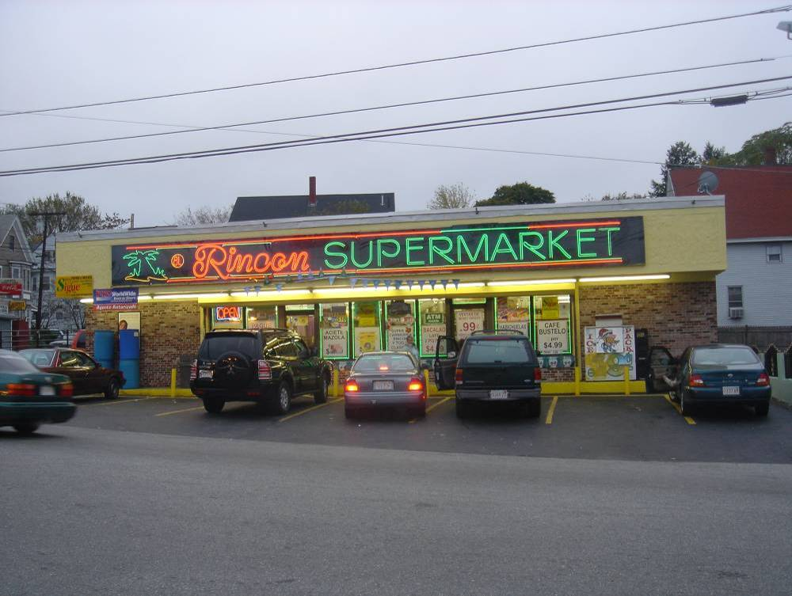
Appendix B: Other Potential Public Assistance

The following represent alternative financing opportunities, either through community development lending and investing (via commercial banks or community development investment funds) or through governmental grants and funds. These are not essential for the success of the project, but rather represent opportunities to either augment returns or improve the condition of existing commercial buildings in the area.

Renewal Communities Program
Lawrence is one of forty cities nationwide to receive the Renewal Communities designation. As part of this designation, Lawrence businesses are eligible for various subsidized financing options, including tax deductions, employment credits, or construction deductions (credited as a tax deduction for store renovations, etc.). This program is known as being particularly complicated to utilize, however, it is a program we will be pursuing as part of our subsidized financing strategy.

Small Business Revolving Loan Fund
The Small Business Revolving Loan Fund is designed to promote the growth of businesses committed to Lawrence through gap financing. The activity undertaken must benefit persons of low and moderate income and/or aid in the prevention or elimination of slum and blight. This program is expected to leverage, but not replace, private sector financing through a partnership in the overall financing requirement. This program may benefit some of our potential in-line retail tenants.
Max Loan - $50,000
Min Loan - $5,000
Term - 5 years
Interest Rate - Tied to prime rate
Uses - Real Estate or Equipment Purchases, Working and Start Up Capital

Section 108 Financing
Section 108 Financing is large project financing at below market rates and provides communities with a source of financing for economic development projects. All projects and activities must either principally benefit low- and moderate-income persons, or aid in the elimination or prevention of slums and blight, or meet urgent needs of the community. Since our site is located in a moderate income census tract, it may qualify for this financing. The principal security for the loan guarantee is a pledge by the City of its current and future CDBG funds. Additional security will also be required to assure repayment of the guarantee obligations, including assets financed by the guaranteed loans. The maximum repayment period for a Section 108 loan is 20 years. This program is expected to leverage, but not replace, private sector financing through a partnership in the overall financing requirement.

Facade Improvement Program
The Facade Improvement Program provides up to 50% of the funding (to a maximum of $5,000) for commercial loan improvements for businesses to improve their facades. Eligible improvements include exterior painting, repainting, cleaning; replacement of original architectural features; removal of existing signs; installation of new signs; landscaping; and architectural and related fees not exceeding 10% of total facade renovation cost. The Facade Improvement Program provides 5 year deferred loans (grants if still at that location after 5 years) of up to a $5,000 maximum to each property. This program could be utilized by prospective new tenants or to encourage retail across the street to improve their facades.

Economic Opportunity Area Tax Incentive Program
For projects located within an Economic Opportunity Area (EOA) which retain or create jobs and create additional tax value in that property, a company may apply for certification of the project. Certification by the City and State will qualify the company for State and Municipal tax incentives. Additional incentives are given for projects which are aimed at abandoned buildings.

District Improvement Financing Program
The District Improvement Financing Program (DIF) is a public financing alternative available to all cities and towns in the Commonwealth that have projects meeting DIF regulations and guidelines. It enables municipalities to fund public works, infrastructure, and development projects by allocating future, incremental tax revenues collected from a predefined district to pay project costs.

DIF is locally driven and approved by the Economic Assistance Coordinating Council (EACC). The municipality must define the district and document a development program describing, among other things, how the DIF will encourage increased residential, commercial and industrial activity within the district. It must also detail the project improvements, financing plans, and community benefits. After the local public hearings and approvals, the municipality must submit an application to the EACC for final approval prior to implementing the program.

Appendix C: Residual Land Value Analysis

- Broadway Center – Base Case

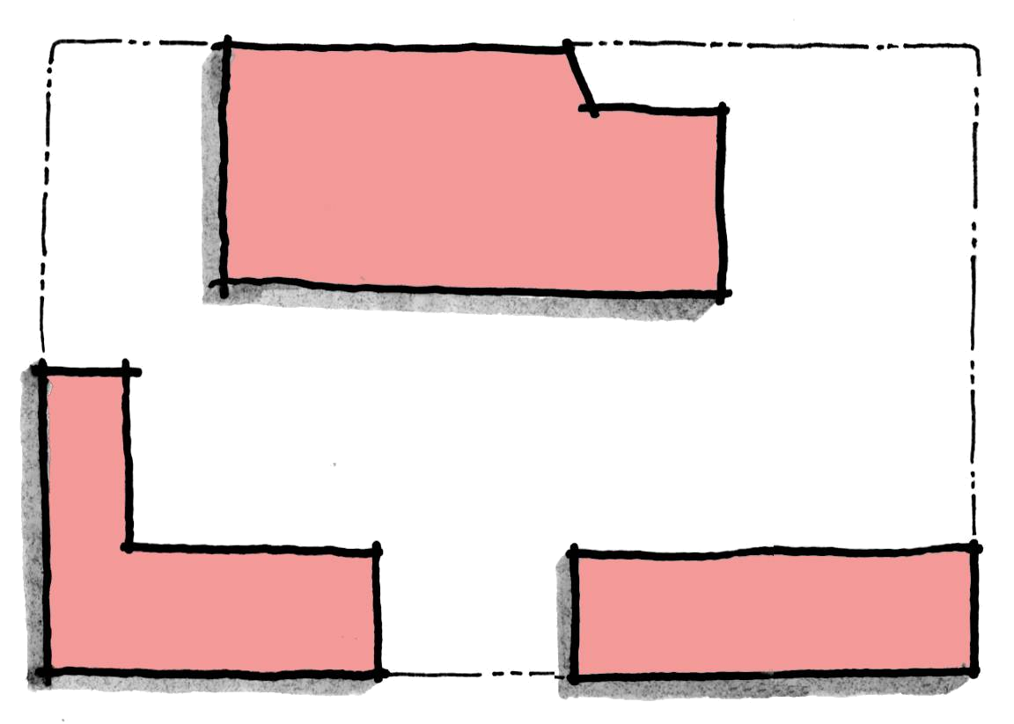
Base Case Site Plan
 | SF | PSF | $
NNN Retail
Grocery | 45,000 | $9.00 | $405,000
In Line | 47,920 | $12.00 | $575,040
 | 92,920 | $10.55 | $980,040
less Vacancy @ 5% |  |  | $49,002
Stabilized NOI |  |  | $931,038
Cap Rate |  |  | 7.0%
Stabilized Project Value |  | $143 | $13,300,543
Total Hard and Soft Costs |  | $142 | $13,161,931
Residual Land Value |  |  | $138,612

Development Costs
 | SF | PSF | $
Hard Costs- Grocery | 45,000 | $100 | $4,500,000
Hard Costs- In Line | 47,920 | $110 | $5,271,200
Soft Costs |  | $10 | $929,200
Tenant Improvement |  | $10 | $929,200
Construction Loan Interest |  |  | $569,831
Site Work |  |  | $962,500
Total Hard and Soft Costs |  | $142 | $13,161,931

- Broadway Center – Second Story

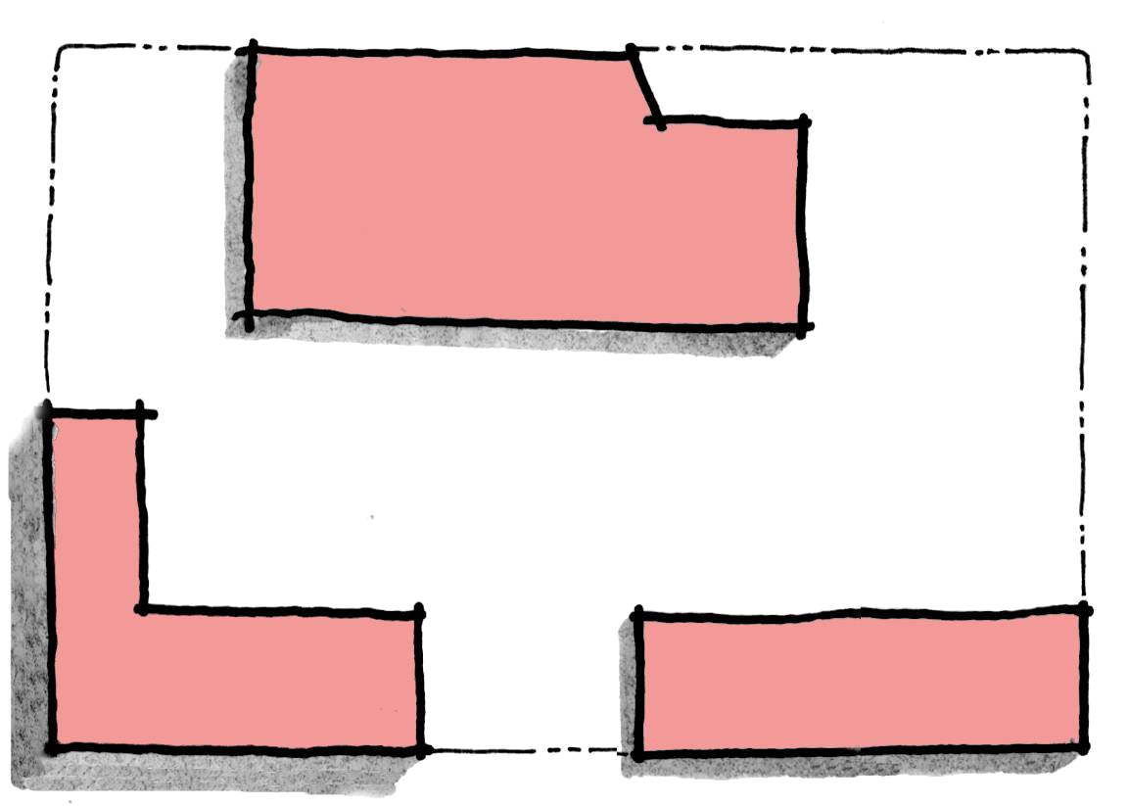
Second Story Site Plan
 | SF | PSF | $
NNN Retail
Grocery | 45,000 | $9.00 | $405,000
In Line - 1st Story | 47,920 | $12.00 | $575,040
In Line - 2nd Story | 25,920 | $10.00 | $259,200
 | 118,840 | $10.43 | $1,239,240
less Vacancy @ 5% |  |  | $61,962
Stabilized NOI |  |  | $1,177,278
Cap Rate |  |  | 7.0%
Stabilized Project Value |  | $142 | $16,818,257
Total Hard and Soft Costs |  | $147 | $17,484,091
Residual Land Value |  |  | -$665,833

Development Costs
 | SF | PSF | $
Hard Costs- Grocery | 45,000 | $100 | $4,500,000
Hard Costs- In Line | 22,000 | $110 | $2,420,000
Hard Costs- 2-story In Line | 51,840 | $125 | $6,480,000
Soft Costs |  | $10 | $1,188,400
Tenant Improvement |  | $10 | $1,188,400
Construction Loan Interest |  |  | $744,791
Site Work |  |  | $962,500
Total Hard and Soft Costs |  | $147 | $17,484,091

- Broadway Center – Three pads

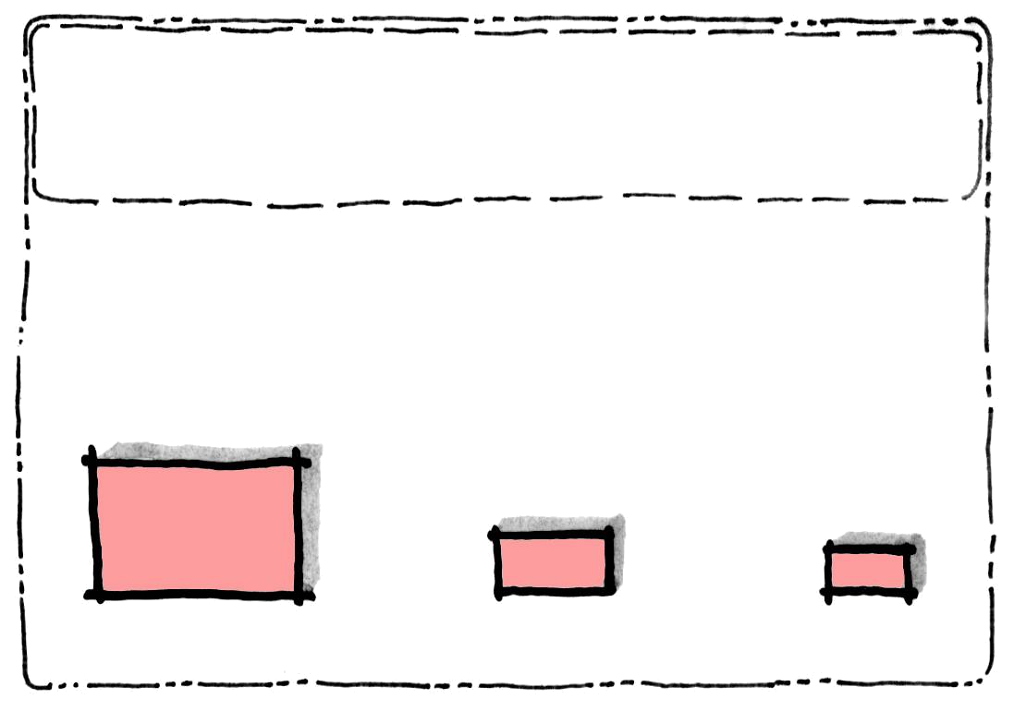
Three pads Site Plan

 | SF | PSF | $
NNN Retail
Pharmacy Pad | 13,000 | $17.00 | $221,000
2 Additional Pads | 7,000 | $24.00 | $168,000
 | 20,000 | $19.45 | $389,000
less Vacancy @ 5% |  |  | $19,450
Stabilized NOI |  |  | $369,550
Cap Rate |  |  | 7.0%
Stabilized Project Value |  | $264 | $5,279,286
Total Hard and Soft Costs |  | $179 | $3,589,000
Residual Land Value |  | $85 | $1,690,286

Development Costs
 | SF | PSF | $
Hard Costs- Pad | 20,000 | $120 | $2,400,000
Soft Costs |  | $10 | $200,000
Tenant Improvement |  | $10 | $200,000
Construction Loan Interest |  |  | $189,000
Site Work |  |  | $600,000
Total Hard and Soft Costs |  | $179 | $3,589,000

- Broadway Center – Hybrid Case

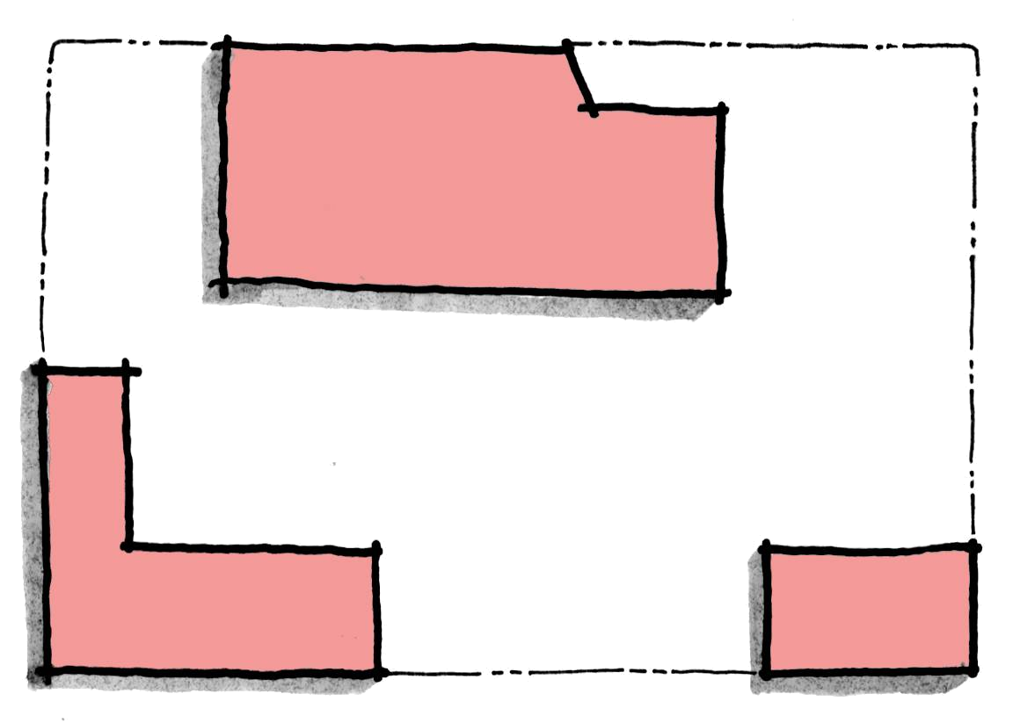
Hybrid Case Site Plan

 | SF |  | PSF |  | $
NNN Retail
Grocery | 45,000 |  | $9.00 |  | $405,000
In-Line | 25,920 |  | $12.00 |  | $311,040
Pharmacy Pad | 10,000 |  | $24.00 |  | $240,000
 | 80,920 |  | $11.81 |  | $956,040
less Vacancy @ 5% |  |  |  |  | $47,802
Stabilized NOI |  |  |  |  | $908,238
Cap Rate |  |  |  |  | 7.0%
Stabilized Project Value |  |  | $160 |  | $12,974,829
Total Hard and Soft Costs |  |  | $144 |  | $11,641,631
Residual Land Value |  |  |  |  | $1,333,198
Note: Assumes grocery store lease does not exclude pharmacy on same site.
Development Costs
 |  | SF |  | PSF |  | $
Hard Costs- Grocery |  | 45,000 |  | $100 |  | $4,500,000
Hard Costs- In Line |  | 25,920 |  | $110 |  | $2,851,200
Hard Costs- Pharmacy Pad |  | 10,000 |  | $120 |  | $1,200,000
Soft Costs |  |  |  | $10 |  | $809,200
Tenant Improvement |  |  |  | $10 |  | $809,200
Construction Loan Interest |  |  |  |  |  | $509,531
Site Work |  |  |  |  |  | $962,500
Total Hard and Soft Costs |  |  |  | $144 |  | $11,641,631
Summary of Residual Land Value Analyses

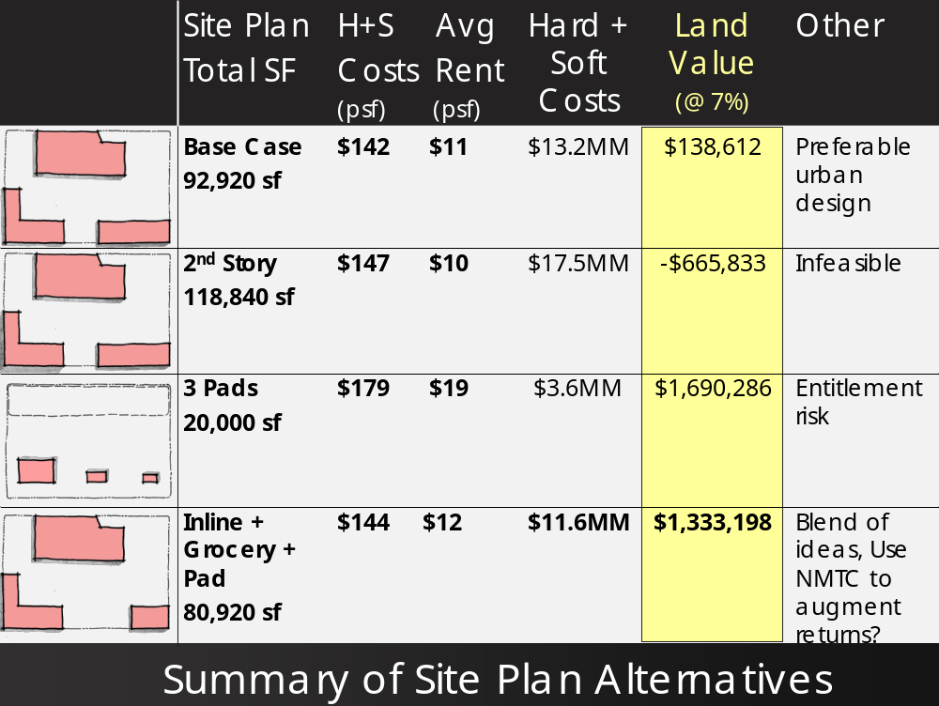
Appendix D: 10-Year Cash Flow Analysis (without NMTC)

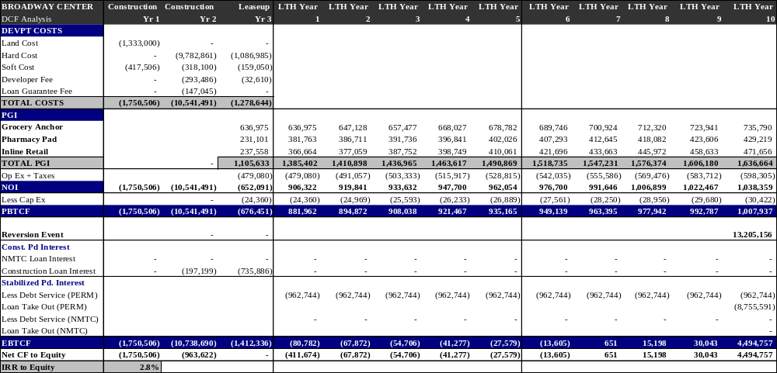
Appendix E: 10-Year Cash Flow Analysis (with NMTC)

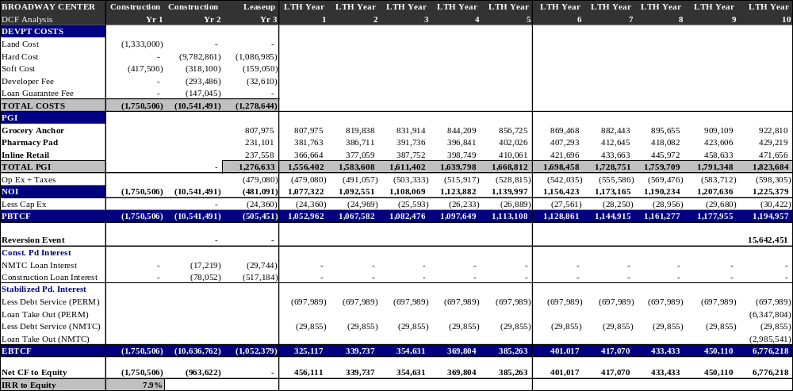

Google Earth elevation measurement.
Conversation with Brian Leaf and Carolyn Hall, Office of Planning and Community Development, November 8, 2005.
Ibid. The center has attracted upwards of 60 youth on a busy day.
Conversation with Yanni K Tsipis.
Conversation with the Lawrence Planning Department.
Underground storage tanks of 2,600, 4,000 and 10,000 gallons were removed prior to 1998.
Email from Yanni K. Tsipis November 14, 2005
Conversation with Yanni K Tsipis.
Conversation with Brian Leaf and Carolyn Hall, Office of Planning and Community Development, November 8, 2005.
Municipalities include Amesbury, Andover, Boxford, Georgetown, Groveland, Haverhill, Lawrence, Merrimac, Methuen, Newbury, Newburyport, North Andover, Rowley, Salisbury, and West Newbury.
http://www.mvpc.org
As defined by the MVPC, “Blue Collar” jobs include Farming, Fishing, Forestry; Construction, Extraction, Maintenance; Production, Transportation, and Material Moving
Conversation with MVPC, March 16, 2006.
Loop anchors include Super Stop & Shop Supermarket, Home Depot, Borders, Old Navy, Loews Theater, and Marshalls; major restaurant chains include Macaroni Grill, T.G.I. Fridays, and Bugaboo Creek. See http://www.attheloop.com for more information.
Conversation with Methuen City Planner, Fall 2005.
http://www.boston.com/education/mcas/scores2005/10th_grade_passing_trend.htm
MVPC traffic specialist.
Linear Retail contacts included William J. Beckeman (President and CEO), Aubrey Cannuscio (Partner, Senior VP – Acquisitions), and James Clifford (VP – Acquisitions). Online sources included CoStar, Black’s Guide, and LoopNet.
Conversation with William J. Beckman, President and CEO of Linear Retail, March 13, 2006.
Claritas reports ages of dwelling units by decade back through the 1940s, but prior to this decade, it lumps all dwelling units into one category—built in or before 1939.
Massachusetts Department of Workforce Development, MassStats, estimated 2005 median family income (http://massstats.detma.org/websaras/index.asp)
US Census, 2004 American Community Survey.
InfoUSA estimate, 2005.
Economic and Planning Systems, Inc., August 2004.
Food Marketing Institute website, October 2005
Claritas Report, pp. 20, 39.
Reilly Factor formula is: = [(Distance between two locations) / (1 + (Pop A / Pop B) ^ (1 / 2))], where Pop A is the larger population. The result is the smaller density location’s distance it is able to capture retail sales. For a more detailed description, see Benjamin T. Brubaker’s 2004 MSRED thesis entitled, “Site Selection Criteria in Neighborhood shopping Centers: Implications for Real Estate Developers.”
Market Basket executive.
Household figure estimate from InfoUSA.
Competitor sales data from InfoUSA.
ULI Dollars & Cents of Convenience Shopping Centers, 2004.
ULI Dollars & Cents of Convenience Shopping Centers, 2004.
Non-retail establishments include a Methuen community center, a church, cab service, apartments, automobile body repair shop, and a recycling center.
InfoUSA estimated sales volume based on reported sales taxes.
Claritas data, November, 2005.
Conversations with MassInnovation and Lawrence Community Works representatives who live in the trade area (Fall 2005). Sovereign Bank is located at 555 Broadway in Lawrence, Massachusetts.
Lawrence and Methuen Planning Departments, Fall 2005.
InfoUSA, March 18, 2006.
Claritas Holy Family Hospital, Lawrence General Hospital, Merrimack Valley Dialysis Center, Northeast C-Med, Northeast Rehabilitation Health Center, and Yankee Alliance. Source: InfoUSA, March 18, 2006.
http://www.glfhc.org
Various conversations with Lawrence Community Works throughout Fall of 2005.
InfoUSA, March 18, 2006.
Lawrence Planning Department, Fall 2005.
Conversations with Eastern Development, MassInnovation, and Linear Retail during the Fall of 2005.
City of Methuen, Comprehensive Zoning Ordinance, effective August, 1989, p.40.
City of Methuen, Site Plan Approval for Non-Residential Buildings, Section XII
Only convenience stores have a higher requirement of 5 spaces per 1,000 square feet. Since we are not contemplating a convenience store at this time, we have not applied this ratio. Grocery store requirements are not specifically broken out in the parking code, so we have applied the highest general category of 3.33 spaces per 1,000. Should higher parking be required to accommodate the grocery store, we plan on applying for ‘Shared Parking’ permission, under which we can make the argument that not all uses will have equal frequency during various times of day and thus, the overall parking requirement can be reduced. In addition, we may make the case that adjacent on-street parking (total 94 spaces) could be included in our overall parking ratio analysis, thereby meeting the higher requirements.
Yanni Tsipis, Meredith & Grew.
Tamar Kotelchuck, Lawrence Community Works.
Tom Maher, Eastern Development; Bill Beckeman, Linear Retail.
Meredith & Grew, Eastern Development, Linear Retail.
The Urban Strategy America Fund provides equity capital to relatively inexperienced development teams. Per conversation with Amanda Strong, MIT CRE alumna.
Commercial Multiple Listing Service, Linear Retail, Eastern Development.
As indicated in the assumptions, a 10% vacancy loss is applied to the inline rental income throughout the leaseup period on whatever portion of the retail space is currently leased.
To calculate the project’s cost of capital, we have assumed a 10% cost of capital for the equity and 7% for the debt in accordance with the construction loan’s interest rate.
Tamar Kotelchuck, Lawrence Community Works. Also Merrimack Economic Development Council: http://www.merrimackvalley.info/realEstate/renewal-comm.html.

