McCormick Hall Cookbook 2002

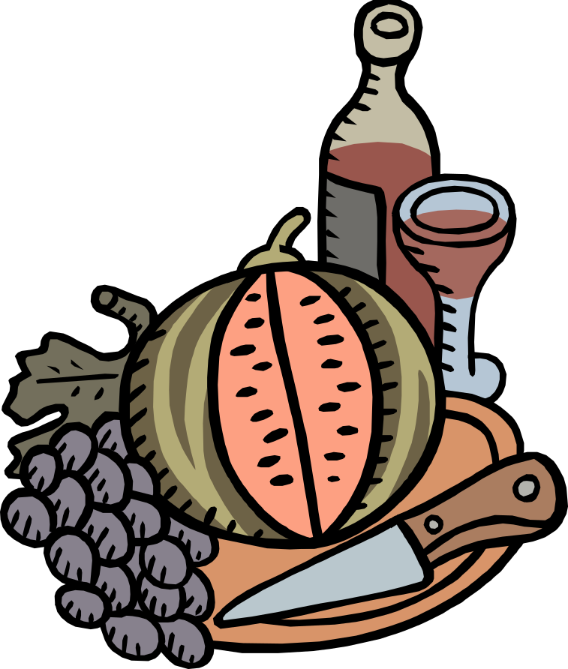

17.A20 Write Your Own Cookbook Seminar

Prof. Charles Stewart III & Kathy Hess

Housemasters & Faculty Advisors
Monica Sircar, Editor
Associate Advisor; MIT Class of 2004

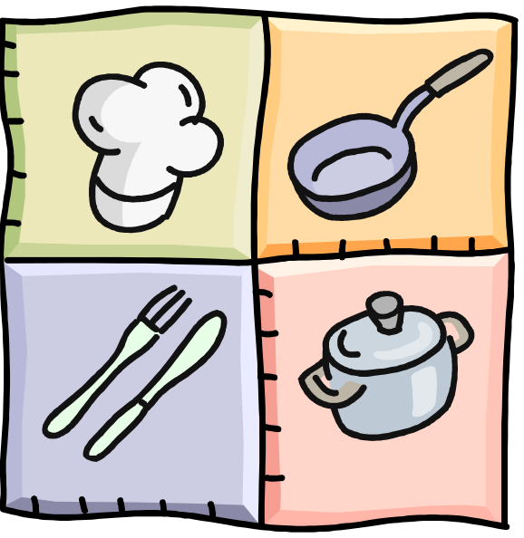

Compiled by:

Atiya Hasan
Lily Huang
Vivian Leung
Sarah Mahlstedt
Sonal Patel
Jennifer Sauchuk
Sarah Sheppard
Jacqueline Tio
Deborah Watkins
Hannah Yun
Taste-tested by:
Bridget Brett

Table of Contents

Page Page

Introduction 5

Beverages

Very Berry Smoothie 7

Sherbert Punch 8

Soups & Salads

Poppy Seed Salad 10

Layered Gazpacho Salad 11

Pear Soup 12

Creamy Tomato Soup 13

Chicken Noodle Soup 14

Vegetable Soup 15

Red Bean Soup 16

Ratatouille 17

Appetizers

Guacamole 19

Grilled Vegetables 20

Scallion Pancakes 21

Wontons 22

Quiche 23

Apple Bacon Quiche 24

Entrees

Grilled Cheese Sandwiches 26

Baked Macaroni & Cheese 27

Fetuccini Alfredo 28

Tomato & Egg Noodles 29

Pesto Pasta 30

Sweet Potato Casserole 31

Apricot Yogurt Curry 32

Chicken Curry 33

Korean Barbeque Beef 34

Chicken Parmigiana 35

Pasta Caprese 36

Lettuce Wrap 37

Desserts

Ambrosia 40

Chocolate Trash 41

Fruit Pizza 42

Baked Apple with Maple Sauce 43

Maple Caramel Apples 44

Xi Mi Lu 45

Oatmeal Cookies 46

Chocolate Zucchini Brownies 47

Rich and Tender Yellow
Layer Cake 48

Chocolate Cream Frosting 50

Puff Pastry Fruit Tart 51

Apple Crisp 52

Banana Nut Bread 53

Mini Cheesecakes 54

Tiramisu 55

Introduction

What better way to forget about the cares of the day than to roll up your sleeves and start cooking with friends!
These recipes represent just this attitude. They all were tried out at various meetings of our freshman advising seminar, “Write Your Own Cookbook” in the Fall term of 2002.
The seminar worked this way: Each week two of the seminar participants were responsible for leading the afternoon’s session. Each leader was responsible for two recipes. She researched the recipe, did the shopping, and then got us cooking. Afterwards, reflecting on what had happened in the kitchen, she revised the recipe for inclusion in this book. In most cases, she added a paragraph to describe the recipe’s origin or something we learned while cooking.
Cooking is a great way to lose yourself—in the food, in the technique, and in the friendships being made around the stove. And, of course, the best part is the end, when you get to eat it!

-Charles Stewart III and Kathy Hess, Seminar Leaders

Beverages


Very Berry Smoothie
3 cups frozen berries (raspberries, blueberries, blackberries, etc., as desired)
2 cups vanilla yogurt
2 cups fruit juice
1. Measure out the frozen berries and put into blender.
2. Place yogurt inside blender with fruit.
3. Pour juice into berry-yogurt mix.
4. Blend all ingredients, first on low speed, then progressing to higher speeds until entire mixture appears evenly dispersed (may require some shaking).
5. Pour into cups and serve cold, makes 4 servings.
6. Repeat if more is desired.
After the long, hot summer days, a smoothie is the best way to complement a summer food course. Smoothies were offered to freshmen in countless ways over the first few weeks of school, and our love for these smoothies gave us the idea to make them as part of our meal. Smoothies can be made with dairy products, fruit juice, or both; we choose to include the yogurt along with the juice, and the results showed that this was a wise decision. Many students sampling the smoothies commented on how they liked it because of the rich yogurt taste that made the smoothie thick and creamy.

Adapted from Stonyfield Farm’s Berry Smoothie Recipe

< http://www.stonyfield.com/Recipes/>.



– Hannah Yun
Sherbet Punch

12 oz. can orange frozen concentrate 2-liter bottle of Ginger Ale
12 oz. can frozen yellow lemonade half gallon carton rainbow sherbet
12 oz. can frozen grape juice

1. Pour ¾ of each can of concentrate into a large bowl and mix well. Make sure all frozen pieces are broken up.
2. Add 5 cups of water and stir.
3. Pour mixture into punch bowl.
4. Add ice and 1 bottle ginger ale to punch.
5. Add scoops of sherbet.
6. Serve.



– Jenn Sauchuk

Salads & Soups

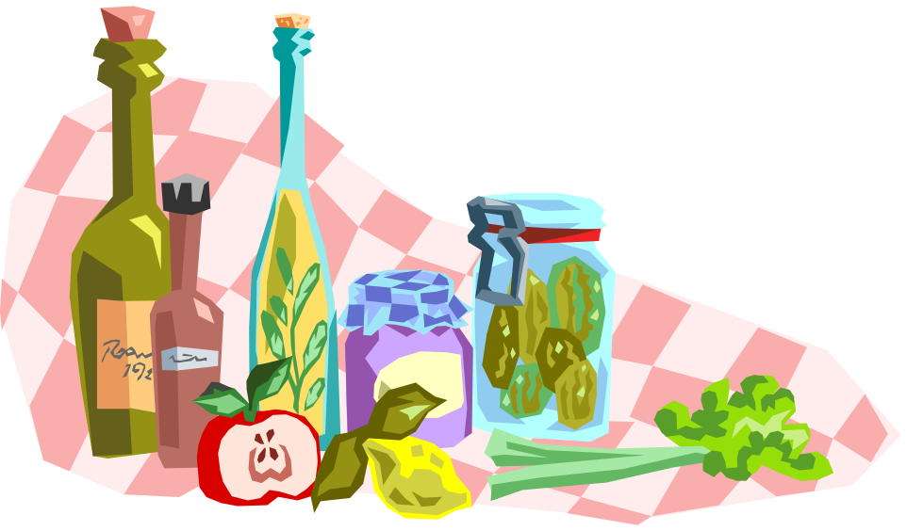
Poppy Seed Salad

1 cup sugar 2 tbsp. poppy seeds
½ tsp. salt Boston lettuce
1 tsp. dry mustard red leaf lettuce
½ tsp. paprika Mandarin oranges
½ cup cider vinegar Fresh strawberries, sliced
1 ½ cup salad oil

1. Mix sugar, salt, mustard, paprika and vinegar together.
2. Add oil slowly, whisking constantly.
3. Add poppy seeds and mix.
4. Serve poppy seed dressing on top of tossed lettuce, oranges and strawberries.
We discovered that the most important factor in successfully preparing the salad dressing for this recipe is to follow the directions and add the oil slowly while whisking. If you do not do this, the oil and vinegar will not mix properly. In addition, one must add the poppy seeds immediately after whisking the oil into the vinegar mixture. This prevents the oil and vinegar from re-separating.
Oil and vinegar do not mix due to their repulsive properties. Oil, a fat, is hydrophobic, so it tends to repel vinegar, which is a water-based substance. It takes a lot of energy to successfully mix the two. This energy is supplied by the rigorous whisking.
This entire process, called emulsification, helps to disperse and suspend one of the liquids within the other. In the case, this is accomplished by whisking rapidly while adding the oil to the vinegar. To complete the emulsification process, a third ingredient, an emulsifier, is added. The poppy seeds serve as an emulsifier in our recipe and stabilizes the mixture.
This recipe has been passed around from family to family, so the original source is unknown.

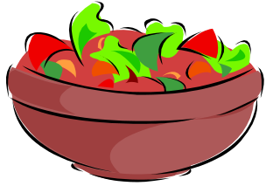

– Sarah Mahlstedt
Layered Gazpacho Salad
1 ½ cups red bell pepper, diced 3 tbsp. shallot, finely chopped
1 ½ cups yellow bell pepper, diced 3 cups tomato juice
1 ½ cups orange bell pepper, diced 12 tbsp. red wine vinegar
2 cups cucumber, sliced 6 tbsp. olive oil
3 cups plum tomato, diced black pepper, freshly ground
¾ cup red onion, chopped
1. Wash all vegetables and wipe clean.
2. Cut the peppers into quarters and dice.
3. Peel, seed, and slice the cucumber.
4. Cut and dice the plum tomatoes.
5. Peel and chop the red onion; peel and finely chop the shallot.
6. In a small bowl, whisk together tomato juice, vinegar, olive oil, and ground pepper.
7. Layer the vegetables into a glass bowl with shallots between the layers.
8. Pour tomato juice mixture over the vegetables.
9. Serve cold.
Adapted from a Sheila Lukins recipe.


– Sarah Sheppard
Pear Soup
1 large white sweet onion 1 tbsp. butter
2 lbs. light yellow sweet potatoes 1 tsp. white pepper
1 ½ qt. chicken broth 2 Bartlett pears (½ lb. ea.)
½ tsp. dry thyme leaves 2-3 tbsp. fresh limejuice
pot large bowl
sieve/strainer food processor
1. Chop the onion.
2. Peel and cut the sweet potatoes into one-inch cubes. When cubed, soak in water to prevent discoloring.
3. Heat chicken broth on stovetop.
4. Sauté chopped onion and dry thyme leaves in butter over medium heat for about 5 minutes, until onions are limp. Stir them occasionally as they cook.
5. Drain potatoes and add them to the onion, along with the broth and white pepper.
6. Peel and core a Bartlett pear and add it to the mixture. Cook until the potatoes are very tender, about 20-25 minutes.
7. Pour soup mixture through a strainer, reserving the liquid in a large bowl. Return liquid broth to the pot.
8. In the food processor, pureé the potato-pear mixture until smooth, then return it to the broth. Add limejuice to taste.
9. Peel and core another Bartlett pear and cut into about 20-25 thin wedges. When the soup is poured into bowls, add these wedges to each bowl, along with some finely julienned strips of lime peel.
Courtesy of Dr. Robert Himmer

– Atiya Hasan
Creamy Tomato Soup
2 tbsp. Butter 2 tbsp. tomato paste
2 tbsp. olive oil 1 tsp. sugar
1 large onion, chopped 3 cups vegetable broth
1 tbsp. garlic, minced 1/8 tsp. ground cloves
2 tbsp. flour salt and pepper, to taste
3 1/2 pounds ripe tomatoes, chopped 1/2 cup whole milk
1. Melt the butter with the oil over low heat in a pot.
2. Add the onion; wilt over low heat for 8 to 10 minutes. Add the garlic during the last 2 minutes, stirring. Sprinkle with flour and cook 3 minutes longer, stirring.
3. Add the tomatoes, tomato paste, sugar, and broth. Bring to a boil, reduce heat to a simmer and cover; cook over medium-low heat for 30 minutes. Season with cloves, salt, and pepper. Remove from heat and cool slightly.
4. Purée the soup in a food processor. Pour through a strainer into a pot. Stir in the half-and-half.
5. Warm the soup before serving.

Epicurious.com
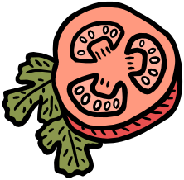

– Atiya Hasan
Chicken Noodle Soup
6 small green onions (use white part only) 2 cans chicken broth (14.5oz)
2 tbsp. olive oil 1 cup pasta
4 carrots 1 tsp. salt
3 stalk celery ¼ tsp. black pepper
½ tsp. dried thyme 2 12 oz. chicken breast, sliced
2 bay leaves 6 cups water

1. Cut carrots and celery lengthwise in half, then crosswise into ¼ inch slices
2. In soup pot, heat oil over med-high until hot. Add green onions, carrots, celery, thyme and bay leaves, and cook 7 minutes or so until vegetables are tender-crisp. Stir every once in a while as cooking.
3. Add broth, pasta, salt, pepper and water; heat to boiling over high heat.
4. Reduce heat to medium-low and simmer covered for 5 minutes or until pasta is just cooked.
5. Increase heat to medium and add chicken. Cook about 5 minutes more until chicken loses its pink color.
6. Discard bay leaves and serve.
My hometown, Boulder, Colorado, is located at an altitude of 5,380 feet. This means that cooking takes significantly longer than it does here. While making this Mahlstedt family chicken soup, I was struck by the drastic difference in how long it took to prepare the soup compared to back home.
At sea level, water boils at approximately 100ºC. At higher altitudes, the temperature of boiling water decreases. In Denver (which is located at still a lower altitude than Boulder), the approximate temperature of boiling water is 95 ºC. This drastic difference can be attributed to differences in atmospheric pressure. A lower pressure (at higher altitudes) means that the energy of the water molecules must be lower for evaporation. Hence, the water temperature is lower. Since the water temperature is lower at high altitudes, the time required to cook anything is longer. The normal way to make up for this difference in water temperature at high altitudes is to either cook food longer or raise the oven temperature. In the case of the chicken noodle soup, you must simply be more patient and wait for the food to cook.
– Sarah Mahlstedt
Vegetable Soup
3 onions 2 potatoes
4 carrots 2 zucchini
¼ cup barley (soak in water for one hour) salt
1. Peel and chop the onions and carrots.
2. Stir fry the onions and carrots a little bit.
3. Add the barley into the pot, and cover the vegetables with water.
4. Peel and dice the potatoes.
5. When the water has boiled, add the potatoes, add water to cover the vegetables.
6. Turn the fire to low.
7. Peel and chop the zucchini.
8. Wait about 30 minutes, until the potatoes are almost done.
9. Add the zucchini.
10. The soup is done when the zucchini is just softening.
11. Add salt.

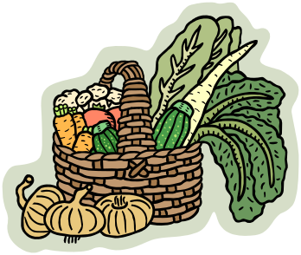

– Vivian Leung
Red Bean Soup
12 oz. Red beans
3/8 cups sugar

1. Soak the beans for one hour
2. Put beans in a pot, cover with water, fire on high
3. When the water boils, start simmering
4. Beans are done when they split.
5. Add sugar

This soup can be cooked with tapioca, barley or lotus seeds.

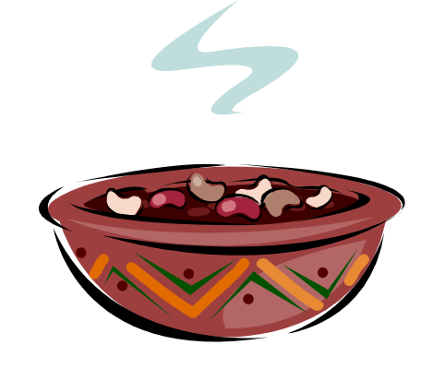

– Vivian Leung
Ratatouille
10 tbsp. oil 2 medium eggplant, chopped
2 large onion, chopped 1 tsp. basil
2 green pepper, chopped 2 cup tomato juice
4 cloves garlic, chopped or pressed 2 tbsp. vinegar
4 tomatoes, chopped 4 tsp. salt
4 zucchini, chopped 1 tsp. pepper

1. Sauté 4 tbsp. oil, onion, green pepper and garlic for three to five minutes.
2. Add the tomatoes, zucchini, eggplant, basil, tomato juice, 6 tbsp more oil, vinegar, salt and pepper and simmer, stirring occasionally until mixture thickens and vegetables are soft (15-20 minutes or so). The longer you heat the soup, the thicker it will get.
3. Serve hot with the pita bread to dip in it.
Our Special Blend, A Cookbook. Easter Seal Rehabilitation Center of Eastern Fairfield County, Inc. Hart Graphics, Austin, TX, page 247. 1984.
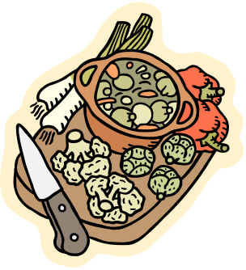

– Sarah Mahlstedt

Appetizers


Guacamole
1 small onion, minced 2 medium tomato
2 small garlic cloves, minced 2 tsp. salt
2 4-oz. cans of mild green chilies, chopped tortilla chips
4 medium avocados coriander leaves (optional)
4 tablespoons of lemon juice
1. Mince the onion and garlic cloves, chop the chilies and set aside.
2. Cut the avocados in half lengthwise. Remove the seed and peel.
3. Peel and dice tomato.
4. Mash the avocados in a bowl with the lemon juice.
5. Stir in salt, tomato, onion, garlic and chilies.
6. Put into a bowl and decorate with coriander leaves.
We basically followed the recipe except we used 3 tomatoes instead of 2 and that we felt that 4 tablespoons of lemon juice were not enough and so, we added a little more according to the taste.
We also fried our own chips instead of just buying a bag of some at the store. We cut up a bag of tortillas into four equal triangles. Then we fried them in a pan filled with one inch of canola oil. The oil had to be a temperature of 350 degrees Farenheit before we could put the tortilla pieces inside. When the tortilla triangles began to turn a deeper brown we removed them from the pan using tongs, and placed them on paper towels, which would suck up the excess oil. Finally, we sprinkled salt over them and put them in a bowl.
Adapted from The Good Housekeeping Illustrated Cookbook



-Deborah Watkins

Grilled Veggies

assorted veggies (peppers, squash, zucchini, portabella mushrooms & eggplant)
2 Ziploc bags
Balsamic vinegar
olive oil

1. Cut the peppers, squash, and zucchini in half.
2. Cut the stems off of the portabellas.
3. Skin the eggplant and cut it in to slices longwise.
4. In one Ziploc bag mix equal parts of balsamic vinegar and olive oil. This
should be just enough to cover the squash, zucchini, and peppers.
5. In the other bag, mix two parts olive oil, one part balsamic vinegar. This should be just enough to cover the portabellas and eggplant.
6. Keep the vegetables in the Ziploc bags for about 15 minutes.
7. Grill until tender.
Original recipe from the Sheppard family
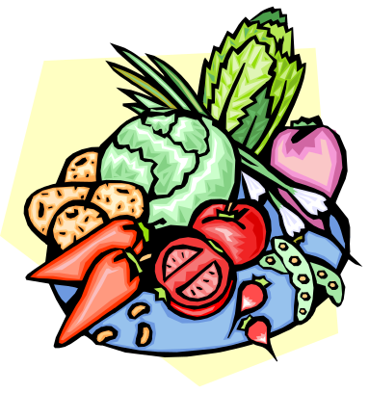
- Sarah Sheppard
Scallion pancakes

2 ¼ cups flour chopped scallions
1 egg salt
2/3 cups water or milk oil

1. Mix the flour, egg and water together. The dough should have the consistency of pizza dough.
2. Separate the dough into chunks, each a bit smaller than a tennis ball.
3. Roll out a ball of dough.
4. Spread oil, salt, scallions.
5. Reroll.
6. Fry in oil (not deep fry).



– Vivian Leung

Wontons

1 package wonton wrappers 4 leaves cabbage, finely chopped
2 tsp. cornstarch 4 bread pieces as crumbs
2 tsp. cooking wine 2 eggs
2 tsp. soy sauce 2 lbs. ground pork
1 1/2 tsp. salt

1. Combine everything except wonton wrappers thoroughly.
2. Mix a little flour and water together, so it looks opaque but it is not a paste.
3. Place about a teaspoon of mixture in the middle of a wonton wrapper.
4. Dip finger into flour-water mixture and skim along half the edge of the wonton wrapper.
5. Fold the wrapper in half so it seals.
6. Flip the back up and wrap the wrapper around the meat.
7. Place on a cookie sheet covered with wax paper.
8. Store in the fridge or freeze. Do not cover until fully frozen, and then place in ziploc bag.
9. Cook by frying in oil and then steaming in water (halfway up wontons) for about five minutes, then browning more and turning them over.
10. Make soup by boiling wontons for about 7 minutes in water with a little bit of soy sauce.

Recipes makes about 90 wontons.


Courtesy of Sui Yen Wang, Sarah Sheppard’s grandmother.
Quiche

8 egg whites
¾ tsp. salt
400ml water (an equal volume to the volume of egg whites)

1. Beat/whisk the egg whites
2. Add water, salt, and stir
3. Heat up a double boiler
4. When the water boils, put in the egg mixture.
5. Wait until eggs are solid (~20 min.)
6. Serve with a layer of spinach or shredded scallops (something with a thick
sauce)



– Vivian Leung
Apple Bacon Quiche

2 pie crusts ½ cup cottage cheese
6 eggs 1 ¼ cup milk
2 apples ¼ tsp. salt
12 strips of bacon ¼ tsp. nutmeg
1 cup cheddar cheese, shredded

1. Fry the bacon until crisp and crumble.
2. Beat/whisk the eggs.
3. Combine the eggs, milk, cheeses, salt and nutmeg.
4. Line two pie pans with the pie crusts.
5. Peel and dice the apples, add to the egg mixture.
6. Pour the mixture into the pie pans.
7. Bake at 400 degrees for 40 min. or when top is golden brown and a toothpick comes out cleanly.



– Vivian Leung

Entreés


Grilled Cheese Sandwiches

2 slices cheddar, American, or Swiss cheese
2 slices white bread
2 tablespoons butter

1. Put the cheese between the slices of bread.
2. Heat 1 tablespoon of the butter in a skillet and when melted add the sandwich.
3. Gently press down with a spatula once or twice during the grilling.
4. When one side is golden, add the remaining tablespoon of butter, turn the sandwich over, and brown.
Onion-Cheese Sandwich: Follow the recipe for Grilled Cheese Sandwich, but lightly coat 1 slice of bread with Dijon mustard. Sauté 3 to 4 slices onion in butter and put on top of the cheese. Cover and grill.
Tomato-Cheese Sandwich: Follow the recipe for Grilled Cheese Sandwich, but add two thin slices tomato to the sandwich before grilling.

Epicurious.com

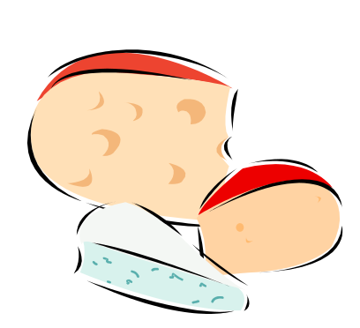

– Atiya Hasan
Baked Macaroni and Cheese
2 cups (4 ounces) elbow macaroni For topping:
2 large cloves garlic, cut lengthwise into slivers 1/3 cup sharp cheddar cheese, shredded
2/3 cup milk 1/3 cup Parmesan cheese, shredded
2 tbsp. margarine or butter 1/5 cup bread crumbs
2 cups shredded sharp white cheddar cheese 1/3 tsp. butter, cut into pieces
1/2 tsp. white or black pepper
2 tbsp. snipped fresh parsley

1. In a large saucepan or pasta pot, bring 3 quarts water to a boil.
2. Add pasta and garlic slivers. Reduce heat slightly.
3. Boil uncovered for 8-10 minutes, or until al dente, stirring occasionally. (Or, cook according to package directions.)
4. Immediately drain.
5. Return pasta and garlic to warm pan.
6. Add milk.
7. Cook on low heat for 2-3 minutes, or till all of the milk is absorbed by the pasta.
8. Add margarine or butter, cheese, pepper, and parsley.
9. Stir mixture gently till cheese is melted. If mixture seems dry, add more milk.
10. Transfer to baking pan.
11. In a small bowl, stir together the cheeses and bread crumbs.
12. Sprinkle evenly over the macaroni.
13. Dot with butter.
14. Bake until the top bubbles and begins to form a crust, 15-20 minutes; cover the top with aluminum foil if it begins to brown too much.
15. Remove from the oven and let stand for about 5 minutes before serving.
– Sonal Patel

Fettucine Alfredo

16 oz. heavy cream 3 tbsp. flour
8 oz. light cream 8 oz. parmesean cheese, grated
4 tbsp. butter 1 lb. fettucine

1. Cook pasta.
2. Melt butter in saucepan, add flour, stir, cook until brown.
3. Add both creams, stir until very thick.
4. Stir in parmesan cheese until melted.
5. Add sauce to drained pasta, toss to coat.
6. Serve

Recipe is best when made with Parmegiano Regiano.

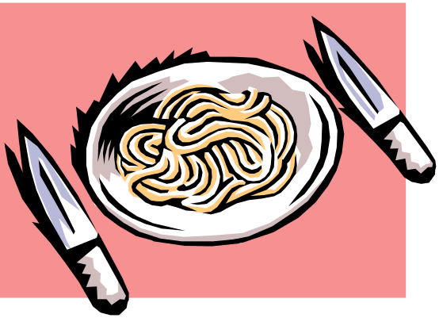

Courtesy of Peter Sheppard.
Tomato Egg Noodles
noodles soy sauce
5 eggs green onion
tomatoes vegetable oil
salt
1. Boil the noodles in water.
2. Beat the eggs thoroughly.
3. Chop the green onions and slice the tomatoes into large chunks.
4. Cook about half the green onions in a wok, then add the eggs. Cook until eggs are fluffy. Then push eggs to one side of wok.
5. Add tomatoes to other side of wok; try to keep the tomatoes from mixing with the eggs (to preserve the eggs’ color), add soy sauce to taste to the tomatoes (usually just enough to turn them a deeper red). After tomatoes soak up soy sauce, you can mix the eggs and tomatoes. Cook until tomatoes are limp. Add salt to taste.
6. Add remainder of green onion.
7. Strain noodles, and pour eggs and tomatoes over noodles. Serve in bowls.
This dish was one of the first real foods that Lily learned to make; she describes it as the ultimate comfort food since her mom used to make it all the time. She loved the awesome taste that belies the simple and fast preparation. In her opinion, the egg and tomato combo is one of the few things in Chinese cooking that is universally understood; since believe it or not, even rice is regional (Southern Chinese usually subsist off steamed buns or other doughy concoctions while Northern Chinese use rice as a staple). She is actually surprised that Western cooking uses the egg and tomato combination so sparringly.


– Lily (Jie) Huang
Pesto Pasta

2 loosely packed cups fresh basil leaves, big stems discarded, rinsed and dried

salt to taste

1/2 to 2 cloves garlic, crushed and peeled
2 tablespoons pine nuts, lightly toasted in dry saute pan

1/2 cup extra-virgin olive oil, or more

1/2 cup freshly grated parmesan cheese

1 pound pasta (I prefer penne)

Equipment: Large pot, long-handled spoon or tongs, colander, cutting board, knife, serving bowl, measuring cups and spoons, small saute pan, towel or salad spinner, food processor or blender, grater (if using blender; the cheese can be grated with the food processor before being combined with other ingredients).

1. Combine the basil, salt, garlic, nuts, cheese, and half the oil in a food processor or blender.

2. Process, stopping to scrape down the sides of the container occasionally, and adding the rest of the oil gradually. Add additional oil if you prefer a thinner mixture.

3. Cook pasta in large pot of boiling salter water until just tender, but still firm to bite.

4. Drain, toss hot pasta with pesto, and serve,

I like to make a double or triple batch of this and freeze what I don't use right away. I freeze the pesto in ice cube trays. After the pesto is frozen the cubes can be popped out and stored in the freezer in a sealed container. The best way to defrost the pesto is to place the frozen cubes into the serving bowl and place the bowl over the pot of water being heated to cook the pasta.

The pesto can be stored in the refrigerator for a couple of weeks. However, the part exposed to air will discolor. To prevent this pour a thin film of olive oil over the surface. Make this in the summer when basil is plentiful and cheaper.

Use real parmesan cheese, freshly grated; it does make a difference.

The best way to peel garlic is to first use the side of a chef's knife to crush the clove, then the tough outer layer will peel right off.

Modified from How to Cook Everything by Mark Bittman

–Kathy Hess

Sweet Potato Casserole
2 tbsp. cornstarch 2 tbsp. butter
40 oz. can sweet potatoes 1 cup cornflakes, crushed
¾ cup sugar 1 cup coconut
2 eggs, well beaten ½ cup brown sugar
1 cup milk ½ cup chopped pecans
½ tsp. cinnamon ½ cup butter

1. Dissolve the cornstarch in a tiny bit of milk to make a thick liquid.
2. Drain half of the syrup in the sweet potatoes can.
3. Beat the potatoes, sugar, eggs, milk, cinnamon, butter and cornstarch mixture in an electric mixer.
4. Pour mixture into 7x11”casserole dish.
5. Bake for 25 minutes at 400ºF, or until the casserole is thick.
6. While baking, put the cornflakes, coconut, brown sugar, pecans and remaining ½ cup butter in a pot.
7. Heat over low heat until the butter melts and the brown sugar is fully mixed in.
8. Take out the sweet potatoes, spread the pecan mixture on top and put them back in the oven for 15 minutes.
While making this recipe, we learned that if you bake it in a deeper pan than suggested, the baking time required will increase substantially. The mixture will be watery when you first put it in the oven, but it will thicken eventually. It is probably best to just go by the thickness of the sweet potato mixture as opposed to the time when deciding when to add the topping.

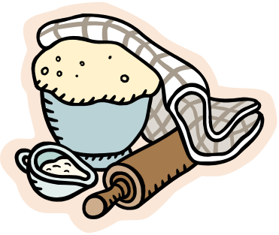

– Sarah Mahlstedt
Apricot Yogurt Curry
2/3 cup long grain rice 1 medium apple, cored
1/2 cup chopped onion 1/4 cup raisins
2 cloves garlic, minced 1/3 cup water
1 tablespoon curry powder 1/4 teaspoon salt
1 tablespoon margarine or butter 1/2 cup plain low-fat yogurt
8 oz. boneless chicken breasts 2 tablespoons cornstarch
1/4 cup apricot preserves
1. Cook rice according to package directions, except omit salt and butter. Cover; keep warm.
2. Meanwhile, in a large nonstick skillet cook onion, garlic, and curry in margarine until onion is thoroughly cooked.
3. Push onion mixture to side of skillet. Cook chicken in skillet over medium heat until it is no longer pink. Stir together chicken and onion mixture.
4. Snip any large pieces in preserves. Stir preserves, apple, raisins, water, and salt into the chicken mixture.
5. Stir together yogurt and cornstarch. Stir into chicken mixture. Cook and stir until thickened and bubbly.
6. Serve over rice.
Lily chose to make this dish because the refreshing qualities of the fruit and yogurt act as an interesting counterbalance to the spicy kick of the curry itself, adding another dimension to the curry - one that is milder and slightly less threatening. The amount of yogurt versus the amount of curry powder that we had to add was a precariously walked tightrope. Too much yogurt resulted in too sour of a taste that masked all other tastes. Too much curry powder added dry hotness without any dimension. Overall, I believe this curry is better than a lot of others that I've tried.
Recipe source: Better Homes and Gardens®. Copyright 2002. Meredith Corp.


– Lily (Jie) Huang

Chicken Curry
2 chopped fresh chilies 1/3 cup curry leaves
3 dry chilies 1 -1 ½ tbsp. curry powder
3 ½ tbsp. ground yellow ginger 1 can coconut milk
2 tbsp. pine nuts 3 tbsp. oil
1 garlic clove, finely chopped 1 lemongrass stalk, chopped
4 chicken thighs 2 tsp. salt
2 potatoes, skinned and chopped sugar
½ can pineapples 1-2 tsp. lemon juice
Cutting board Measuring spoons/cups
Chopping knife Mortar and pestle
Medium sized pot
1. To make paste, mash chilies, ginger, pine nuts and garlic.
2. Fry the spice paste in oil until fragrant with the stove on high.
3. Add chicken, potatoes, and half a can of coconut milk. Be careful not to burn the curry or potatoes by continuously stirring.
4. After 1 minute, turn the heat down to medium-high.
5. Add lemon grass, curry powder, curry leaves, and pineapple.
6. After 1 minute, turn heat down to medium but keep stirring
7. Simmer and stir until potatoes are soft. Take special care not to char curry/potatoes on the bottom or to over-boil the coconut milk.
8. Add the rest of the coconut milk, salt, sugar, and lemon to taste.
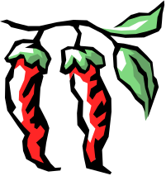

– Jacqueline Tio
Korean Barbeque Beef

½ cup soy sauce 2 lb. sirloin tips
¼ cup rice vinegar, unseasoned 2 small red Gala apples
1/3 cup scallion, chopped 1 firm mango, peeled & pitted
2 tbsp. sugar 2 tbsp. fresh lime juice
2 tbsp. garlic, minced 1 tsp. chili sauce to taste
2 tbsp. ginger, minced 60 Bibb lettuce, 3 to 4” leaves
1 tbsp. sesame oil
1 1/2 tsp. chili sauce
1. Make marinade by stirring together soy sauce, rice vinegar, scallion, sugar, garlic, ginger, sesame oil and chili sauce.
2. Trim beef and place in a glass dish.
3. Pour marinade over, keeping one fourth of mixture.
4. Marinate at room temperature for about an hour, turning occasionally.
5. Preheat broiler. Broil steak on rack of a broiler pan 2 to 3 inches from heat until slightly charred, 2 to 3 min. on each side.
6. Let steak stand for 5 min.
7. Cut cross wise into 1/4 inch slices. Place on serving platter. Pour remaining marinade over the beef.
This recipe can be served at room temperature.
For individual appetizers:
1. Cut fruit into 1 by 1/4 inch sticks.
2. Toss together with juice and chili sauce and season with salt.
3. Divide beef among lettuce leaves.
4. Top with fruit and sesame seeds.
Modified Gourmet 1999.
-Sarah Sheppard
Chicken Parmigiana

1/4 cup milk vegetable oil
1 egg, slightly beaten pasta sauce
1/3 cup grated Parmesan cheese mozzarella cheese
1/3 cup dry bread crumbs cooked pasta (optional)
2 whole chicken breasts, skinned & boned

1. Preheat oven to 350ºF.
2. In small bowl, combine milk and egg.
3. In another bowl, mix parmesan cheese and bread crumbs.
4. Cut each chicken breast into 4 pieces (make sure they’re not too thick; if they are, you might want to slice them in a way to make them thinner).
5. Dip chicken in milk and egg, roll in cheese-crumb mixture, and brown the chicken pieces in oil in a frying pan.
6. Pour pasta sauce into a 13x9" baking dish (enough to cover bottom of dish), and place chicken on top of sauce.
7. Pour another layer of sauce on top of chicken, and cover with thin slices of mozzarella cheese.
8. Bake chicken for 15-20 minutes (or however long it takes till cheese is melted).
9. Let cool, serve with pasta if desired.



- Sonal Patel
Pasta Caprese

1 1/2 pounds plum tomatoes, 2 teaspoons red wine vinegar
seeded, coarsely chopped
1/2 cup chopped fresh basil
8 ounces fresh mozzarella cheese,
cut into 1x1/2-inch strips 3 tablespoons extra-virgin olive oil

12 ounces penne pasta

Equipment: Large pot, long-handled spoon or tongs, colander, cutting board, knife, serving bowl, scale (or a good sense of one pound of tomatoes).

1. Mix tomatoes, mozzarella, oil, and vinegar in medium bowl. Season with salt and pepper. Let stand 1 hour at room temperature. Mix in basil.

2. Cook past in large pot of boiling salted water until just tender, but still firm to bite. Drain. Return past to pot. Add tomato mixture and toss gently to blend. Season with salt and pepper and serve.

Makes 4 servings.

Pasta Caprese is best made in the late summer when the tomatoes are juicy ripe and the basil is plentiful. The recipe just doesn't work with hothouse tomatoes.

Fresh ground pepper is a great addition.

From Bon Appetit, May 1997

-Kathy Hess
Lettuce Wrap

2 green onions 2 tsp. cornstarch
1 can water chestnuts (small) 1 tbsp. water
1 head lettuce, coarsely chopped 1 tbsp. soy sauce
1 cup corn oil 1/4 tsp. cayenne pepper
1 oz. bean thread noodles (white) 2 tbsp. oyster sauce
1/3 cup walnut pieces 1 tsp. Sherry/imitation brandy
1 tbsp. garlic, minced 1/4 tsp. sugar
12 oz. pork, ground 1 tsp. sesame oil

Wok scissors (to cut noodles)
metal strainer

1. Cut green onions into pea-sized pieces.
2. Drain and chop coarsely the water chestnuts.
3. Detach lettuce leaves from core, wash and dry them gently. Arrange lettuce leaves
around the edge of a large platter.
4. Heat oil in wok until it is about to smoke.
5. Tear bean thread noodles apart and cut with scissors into small portions. Carefully put a portion of the noodles into the hot oil. (They will expand dramatically!) As soon as they expand, turn them over and cook the other side briefly. *Make sure all noodles have expanded. Drain noodles and remove to a bowl lined with several layers of paper towels. Cook the remaining noodles in the same way and then crunch them and put them into the center of the serving platter, surrounded by the lettuce leaves.
6. Put the walnuts into a strainer and immerse them into the hot oil. They will brown very quickly. Be careful they do not burn. Remove them to a paper towel, drain well and chop into coarse pieces.
7. Remove all but 2 tsp. of oil from the wok.
8. Sauté the minced garlic and chopped green onions until lightly browned.
9. Add the ground pork and sauté until it loses its pink color and starts to brown. (Add some sesame oil to the pork if you would like it to be more flavorful.) Use a large spoon to remove as much grease as possible from the pork mixture.
10. Add the chopped water chestnut and chopped lettuce to the pork mixture. Mix well.
11. Mix cornstarch and water.
12. Combine the soy sauce, cayenne, oyster sauce, sherry, sugar and sesame oil; stir into the cooking mixture and cook for two minutes, stirring constantly. Remix the cornstarch mixture and add to the middle of the wok. Stir constantly, blending other ingredients into cornstarch mixture and simmer three more minutes.
13. Pour the cooked dish on top of the bean thread noodles on the serving platter.
14. Sprinkle the walnut pieces on top and serve at once.

To eat: Place a lettuce leaf on your plate. Add sauce to taste (hoisin sauce). Put a spoonful of the pork mixture and noodles in the middle of the leaf. Fold the leaf up and enjoy!

Modified from online source titled: My Mother’s Lettuce Packages

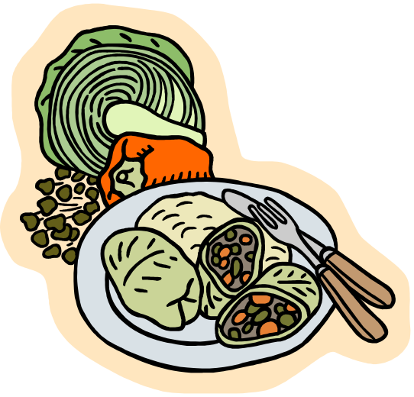

– Jacqueline Tio

Desserts
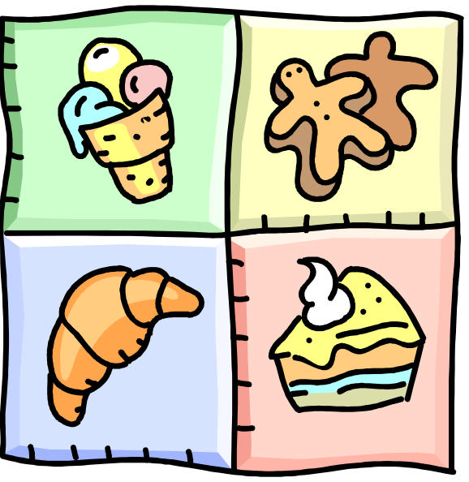
Ambrosia

2 large cans pineapple tidbits or chunks (halved) 3 cups mini marshmallows
4 cans mandarin oranges (11 oz. each) 2 cup coconut
2 cup maraschino cherries 2 cup light sour cream

1. Drain the pineapple, mandarin oranges and maraschino cherries and place in a large bowl.
2. Add the mini marshmallows and coconut.
3. Fold in the sour cream.
4. Chill until ready to eat.

While making this recipe, we learned that you want to be very thorough draining the fruit. Otherwise, this is a very simple recipe.

Recipe from Our Special Blend, A Cookbook. Easter Seal Rehabilitation Center of Eastern Fairfield County, Inc. Hart Graphics, Austin, TX, page 287. 1984

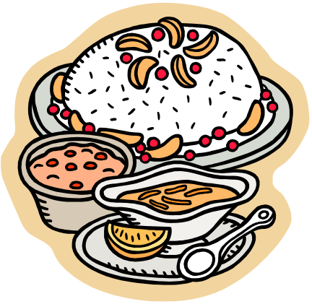

– Sarah Mahlstedt

Chocolate Trash
2 1/2 cups Crispix cereal 1 cup dry roasted peanuts
1 cup Cheerios cereal 1 cup M&M’s
1 cup salted pretzels 12 oz. semisweet baking chocolate

1. Mix Crispix, Cheerios, pretzels, peanuts, and M&M’s in a large bowl.
2. Use a double boiler and melt chocolate in a pot over the stove at a medium-low setting until it’s pourable.
3. Pour melted chocolate over cereal mix. Stir so that everything is totally covered.
4. Put mix on wax paper or cookie sheet about the size of a scoop.
5. Let dry for about 20-30 minutes or put in fridge for faster drying.

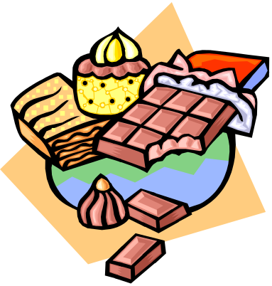

– Jenn Sauchuk
Fruit Pizza

flour kiwis
18-oz. roll refrigerated cookie dough roll bananas
8-oz. package cream cheese, room temperature canned pineapple, sliced
7-oz. jar marshmallow cream apple jelly
strawberries

12-inch diameter pizza pan electric beater

1. Preheat oven to 350°F.
2. Beat cream cheese in medium bowl until smooth.
3. Beat in marshmallow cream. Let stand at room temperature.
4. Flour the pizza pan.
5. Cut cookie dough roll crosswise into 1/3-inch-thick slices; arrange closely on prepared pans.
6. Bake crusts until deep golden brown; about 15 minutes. Transfer to rack. Using edge of metal spatula, press in edges to evenly round out crust. Cool completely.
7. Peel kiwis and bananas.
8. Cut all fruit into slices.
9. Spread cream mixture over cooled crusts, filling evenly, and leaving a ½-inch plain border.
10. Top cream with fruit as desired.
11. Melt apple jelly in microwave; with brush, lightly spread melted jelly over fruit.
12. Refrigerate and serve.

Epicurious.com Bon Appétit 2001

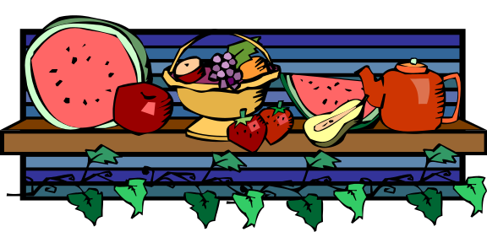

Baked Apple with Maple Yogurt Sauce

4 large McIntosh Apples 2 tablespoons cinnamon
1/2 cup brown sugar, packed 1/3 cup yogurt
¼ cup raisins

1. Core apples and remove top inch of peel. Make a shallow cut through skin around center of each apple to prevent skin from bursting.
2. Place apples upright in baking dish or pie plate.
3. In a small bowl, combine brown sugar, raisins, and cinnamon. Spoon into centers of each apple.
4. Add water to cover bottom of dish.
5. Bake, uncovered in 375ºF for 25 to 30 minutes until apples are tender when pierced with a toothpick.
6. Combine the yogurt and maple syrup to make the sauce. Pour over the baked apples.
This was supposed to be the slightly more sophisticated dessert of the day. Lily says she picked it mainly because all of the ingredients invoked visions of a warm hearth surrounded by happy people in chunky, turtle-necked sweaters. On the test run, she found that she absolutely detests nutmeg. According to her, it made the apples taste like lemon bathroom cleaner, so she altered the recipe. This recipe turned out to be her favorite!
From The Gazette, 91/03/06. Recipe via Meal-Master (tm) v8.02



– Lily (Jie) Huang
Maple Caramel Apples

1 lb. dark brown sugar 1 tbsp. unsalted butter
1 ½ cup maple syrup 10 Gala Apples, chilled
½ cup heavy cream
candy thermometer skewers

1. In a deep heavy saucepan, combine the brown sugar, maple syrup, and cream, and cook the mixture over moderate heat, stirring and washing down any sugar crystals clinging to the sides of the pan with a brush dipped in cold water, until the sugar is dissolved.
2. Bring the mixture to a boil and boil it, undisturbed, until a candy thermometer registers 250ºF.
3. Remove the pan from the heat, add the butter, and swirl the pan gently until the butter is melted. Let the maple caramel cool for 5 minutes.
4. Push a wooden skewer through the length of each apple, and dip the apples into the maple caramel, coating them well and letting the excess drip off.
5. Put the apples on buttered baking sheets until the maple caramel is cool and firm. Serve immediately.
Unleash your inner child! After all, what better time of year to celebrate the yet untainted side of us than Halloween? What better time to play creative games with caramel and Nutella® than today? Lily wanted people to have fun with this recipe, banish inhibitions, and dip like they've never dipped before. Everyone had a lot of fun plus it was healthy. As they say, an apple a day, keeps the doctor away☺.
Recipe by COOKING LIVE SHOW #CL8747 From: "Angele And Jon Freeman"


– Lily (Jie) Huang
Xi Mi Lu (Roughly translated into Tapioca Dessert)

1 bag tapioca pearls 2 cans coconut milk
1 taro 1 ½ bag rock sugar
milk Craisins (if desired)

1. Put the tapioca pearls in a pot of water and boil. Stir continuously to preventing burning. When the pearls turn mostly clear with only a speck of color in the middle, turn the stove off. Strain the pearls.
2. Meanwhile, peel and dice the taro. Add the taro to a large pot of milk and boil.
3. Add tapioca pearls when they are ready.
4. When the taro is soft, add the coconut milk and the rock sugar. Stir continuously. 5. When the mixture comes to a boil again, turn off the stove.
6. Spoon into a serving bowl, add the cranberries, and serve.

Lily discovered this recipe from her aunt during a Thanksgiving party. She describes this as a feel good recipe that gave her a good excuse to use lots of taro - one of my favorite ingredients. She greatly enjoyed the versatility of this dish as either soup or dessert.

Source: Lily’s Aunt (also served by some Chinese restaurants in lieu of fortune cookies)

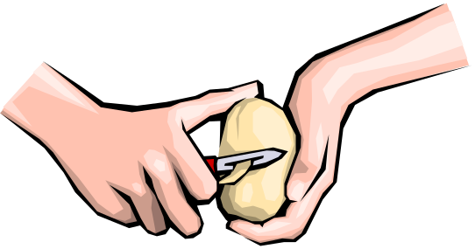

– Lily (Jie) Huang
Oatmeal Cookies

1 cup butter 1 1/4 cups flour
¾ cup brown sugar ½ tsp. baking soda
½ cup white sugar ½ tsp. salt
1 tsp. vanilla 4 cups oatmeal
2 tbsp. water 2 cups golden raisins
1 egg

1. Cream butter with sugars.
2. Add vanilla, water, and egg. Mix well.
3. Mix flour with baking soda and salt.
4. Add flour mixture to butter mixture and stir in.
5. Add oatmeal and raisins and mix.
6. Drop by tablespoons onto cookie sheet and bake 15 min. at 350˚F.



Courtesy of Christine Wang.
-Sarah Sheppard

Chocolate Zucchini Brownies

2-2 ½ cups grated zucchini/carrots 2 cups flour
½ cup ripe banana, mushed 1 ½ tsp baking soda
1 tbsp. water ½ tsp salt
2 tsp. vanilla 1/3 cup cocoa powder
¾ tsp. cinnamon 2/3 cup sugar

1. Mix zucchini, banana, water, vanilla and cinnamon in a large bowl.
2. Separately mix flour, baking soda, salt, cocoa powder and sugar.
3. Fold dry ingredients into the wet mix; batter will be stiff.
4. Bake in a nonstick 9 x 13” pan at 350ºF for about 25 minutes or until toothpick comes out clean.

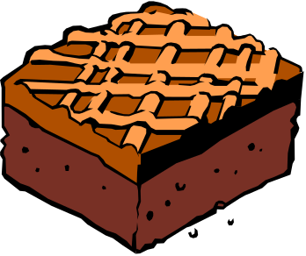

– Jacqueline Tio
Rich and Tender Yellow Layer Cake

Makes two 9-inch cakes

4 large eggs, room temperature

1/2 cup whole milk, room temperature

2 teaspoons vanilla extract

2 1/4 cups sifted plain cake flour

1 1/2 cups sugar

2 teaspoons baking powder

3/4 teaspoon salt

1/2 pound (2 sticks) unsalted butter, softened, each stick cut into 8 pieces

Prepare the oven

1. Adjust oven rack to lower-middle position and heat oven to 350 degrees.

Prepare the pans

2. Generously grease two 9-by-1 1/2-inch cake pans with vegetable shortening and cover pan bottoms with rounds of parchment paper or wax paper. Grease parchment rounds, dust cake pans with flour, and tap out excess.

Combine the ingredients

3. Beat eggs, milk, and vanilla with fork in small bowl; measure out 1 cup of this mixture and set aside.

4. Combine flour, sugar, baking powder, and salt in bowl of standing mixer fitted withpaddle attachment; mix on lowest speed to blend, about 30 seconds.

5. With mixer still running at lowest speed, add butter one piece at a time; mix until butter and flour begin to clump together and look sandy and pebbly, with pieces about the size of peas, 30 to 40 seconds after all butter is added.

6. Add reserved 1 cup of egg mixture and mix at lowest speed until incorporated, 5 to 10 seconds.

7. Increase speed to medium-high (setting 6 on KitchenAid) and beat until light and fluffy, about 1 minute.

8. Add remaining egg mixture (about 1/2 cup) in slow steady stream, about 30 seconds.

9. Stop mixer and thoroughly scrape sides and bottom of bowl.

10. Beat on medium-high until thoroughly combined and batter looks slightly curdled, about 15 seconds longer.

Bake the batter

11. Divide batter equally between prepared cake pans; spread to sides of pan and smooth with rubber spatula.

12. Bake until cake tops are light golden and skewer inserted in center comes out clean, 20 to 25 minutes. (Cakes may mound slightly but will level when cooled.)

13. Cool on rack 10 minutes.

Remove cake from pan

14. Run a knife around pan perimeter to loosen.

15. Invert cake onto large plate, peel off parchment, and re-invert onto lightly greased rack.

16. Cool completely before icing.

We tried this recipe alongside a box mix. In all honesty, this cake from scratch was only marginally better than the box mix, and a lot more work.

From The Best Recipe, Boston Common Press, 1999, pp. 469B470

–Charles Stewart
Chocolate Cream Frosting

Makes about 3 cups

1 1/2 cups heavy cream

16 ounces semisweet chocolate, chopped fine
1/3 cup corn syrup

1 teaspoon vanilla extract

1. Place chocolate in heatproof bowl.

2. Bring heavy cream to boil in small saucepan over medium-high heat; pour over chocolate.

3. Add corn syrup and let stand 3 minutes.

4. Whisk gently until smooth; stir in vanilla.

5. Refrigerate 1 to 1 1/2 hours, stirring every 15 minutes, until mixture reaches spreadable consistency.

From The Best Recipe, Boston Common Press, 1999, pp. 469B470

–Charles Stewart

Puff-Pastry Fruit Tart with Almond Cream

1/2 17 1/4-oz. package puff pastry sheets 3 tbsp. whipping cream
1 egg, beaten 1/2 cup apricot jam
1 7-oz. package almond paste assorted fresh fruit, sliced

1. Preheat oven to 400°F.
2. Cut 3/4-inch-wide strip off each side of pastry and set aside. Roll out 9 1/2-inch square of pastry on work surface. Glaze edges of square with beaten egg.
3. Arrange 3/4-inch-wide strips atop edges, forming raised border. Brush border with glaze. Pierce center of pastry all over with fork.
4. Bake for about 25 minutes until pastry is golden brown.
5. Blend almond paste and cream in processor until almost smooth.
6. Spoon almond filling into center of tart and spread evenly.
7. Bake for 5 minutes.
8. Transfer to rack and cool.
9. Arrange fruit decoratively atop tart.
10. Melt jam in small saucepan over low heat, stirring frequently. Brush jam glaze over fruit.
11. Cut tart into squares and serve.
From: Bon Appétit May 1993. Jackie O'Halloran


– Jacqueline Tio
Apple Crisp

1 cup all-purpose flour 4 cups apples
3/4 cup oatmeal 1/2 cup white sugar
1 cup brown sugar 1 tbsp. cornstarch
1 tsp. ground cinnamon 1/2 cup water
½ cup butter, melted 1/2 tsp. vanilla extract

1. Preheat oven to 350ºF (175ºC).
2. Grease inside of baking dish.
3. Peel, core, and slice apples into thin pieces.
4. In a medium bowl, combine flour, oats, brown sugar, cinnamon and melted butter. Stir until crumbly.
5. Press half the oat mixture into a 9x13 inch baking dish.
6. Cover oat mixture with sliced apples.
7. In a medium saucepan, combine white sugar, cornstarch, water and vanilla. Cook on high heat, stirring, until thick and clear, about 10 minutes.
8. Pour cornstarch mixture over apples.
9. Cover apples with remaining crumble mixture.
10. Bake in preheated oven 45 minutes, until bubbly and golden.
The apple crisp appeared to be our most popular recipe of the day. Everyone thoroughly enjoyed it, most students deciding to have seconds and thirds until the food disappeared. Apple crisp can be made in any season of the year, but they are especially delicious towards the end of summer and beginning of fall as apples ripen and become delicious.
While making this recipe, we learned that the cornstarch mixture best thickens when it comes to a boil over the stove. As steam causes water to rise and leave the mixture, the fluid thickens and clears up. We also learned that baking the apple crisp in a glass dish is quicker than doing so in an aluminum dish.
Adapted from www.allrecipes.com online cookbook.

- Hannah Yun
Banana Nut Bread

3 bananas 1 tsp. salt
2 eggs 1 tsp. baking soda
2 cups flour 1/2 cup chopped walnuts
¾ cup sugar

1. Mix bananas and eggs in a bowl. Make sure the bananas are well mashed.
2. In a separate bowl, sift together flour, sugar, salt, and baking soda. Add this to the banana-egg mix from step 1.
3. Add 1/2 cup chopped walnuts. Stir well.
4. Put in a buttered 9 x 5” pan. Bake at 350ºF for 60 to 70 minutes.

Adapted from Fannie Farmer Boston Cooking School Cookbook.

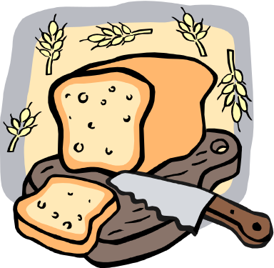

– Jennifer Sauchuk

Mini Cheesecakes

1 package of vanilla wafers 2 tsp. vanilla
1 stick of butter 1/2 cup sugar
1 lb. (16 oz) cream cheese about 25 foil baking cups
2 eggs 3 cans of different pie filling

1. Take package of wafers and crush up finely. Mix in melted butter with a fork.
2. Beat cream cheese until smooth. Add in eggs, vanilla, and sugar, and then beat for about 5-6 minutes.
3. Put baking cups into muffin pan. Fill bottom of each baking cup with wafer mix about 1/4 to 1/2 of the way up. Make sure to pat down wafer mix in each cup.
4. Take about 2 tablespoons of the cream cheese mix and fill cups almost up to the top.
5. Bake in oven at 325ºF for 25 minutes.
6. Cool then put one pie topping on each mini cheesecake.



– Jennifer Sauchuk
Tiramisu

6 egg yolks 1 cup whipping cream, whipped
½ cup sugar 32 ladyfingers, split in half
1/3 cup cognac/brandy 3 tsp. instant coffee in ¾ cup water
2 cups (15 oz.) ricotta cheese 1 tbsp. unsweetened cocoa

1. In double boiler, whisk together egg yolks, sugar, and cognac. Whisk constantly for about 2-3 minutes, until mixture has thickened. Cool.
2. In electric mixer, beat yolk mixture and ricotta cheese on medium speed until blended.
3. Fold in whipped cream.
4. Place 32 ladyfinger halves in bottom on 13x9-inch pan, cut side up and brush with half of coffee.
5. Spread half of ricotta mixture on top.
6. Repeat with remaining ladyfingers, coffee, and ricotta mixture.
7. Chill 1 ½ -2 hours.
8. Dust with cocoa powder before serving.

The actual preparation of the tiramisu went pretty smoothly, with very few changes made in the original recipe. However, we did have to adjust the amount of rum essence and the number of ladyfingers we used. The rum essence was a lot stronger than we expected, and therefore we added less than the recommended amount (between ¹/₃ and ½ teaspoon; we used only ¼ teaspoon).
As for the ladyfingers, since we put the tiramisu in a circular dish (as opposed to a 13x9-inch pan), we used as many as would cover the bottom of the dish evenly, and often broke some into smaller pieces to fill in any large gaps. The ladyfingers we used were also pretty narrow, so there was no need to split them in half. After making the dish, I learned that vanilla essence can also be used as a substitute for the alcohol or rum essence; using vanilla might have worked out better, since the rum essence tasted a bit artificial and strong. But overall, I’d say it was a success!

- Sonal Patel



Bon Apetit!

