DYNAMIC SAFETY ANALYSIS OF THE SABR SUBCRITICAL TRANSMUTATION REACTOR CONCEPT

T. S. Sumner, W. M. Stacey and S. M. Ghiaasiaan
Georgia Institute of Technology
Atlanta, GA 30332 USA
September, 2009

Abstract
The transient response of the SABR subcritical, sodium-cooled, TRU-fueled, fast transmutation reactor design concept ensuing from several accident initiation events has been simulated. The results establish such things as the number of primary loop pumps that could fail or the magnitude of flow reduction in the intermediate loop heat removal capability due to either pump failure or intermediate heat exchange failure that could be tolerated without core damage, the consequences of loss of electrical power, and the consequences of control rod ejection or neutron source excursions. Suggestions are offered for design changes to improve the already good safety characteristics of the design concept.

Preprint of paper submitted to Nuclear Technology
I Introduction
As the United States begins expanding its fleet of nuclear reactors, there will be increasing pressure to deal with the rapidly growing quantity of nuclear waste. One possibility is to recycle the long-lived transuranic isotopes in spent nuclear fuel and put them back into reactors as fuel. By separating the transuranics (TRU), many with decay times far greater than a hundred thousand years, from the spent nuclear fuel (SNF) discharged by Light Water Reactors (LWR), it is possible to fuel Advanced Burner Reactors (ABR), while reducing the amount of long-lived SNF that must be stored as high level waste. Transuranics with enormously long decay times could be transmuted into fission products, most of which have half-lives of less than a few hundred years.
Instead of the traditional once-through nuclear fuel cycle currently employed in the US, repeated reprocessing and recycling of spent fuel and the remaining transuranics would significantly decrease the amount of waste that must be stored long after the reactor is shut down. By using a subcritical reactor with a neutron source, longer fuel residence times and hence far deeper burns of the transuranics can be achieved because in subcritical reactors the neutron source can be increased to compensate for the loss of neutron multiplication. With a strong enough neutron source, the material radiation damage limits become the limit for the fuel cycle. No longer constrained by criticality, subcritical reactors can obtain significantly longer fuel residence times.
One such subcritical transmutation reactor concept is the Subcritical Advanced Burner Reactor (SABR) that has been developed at the Georgia Institute of Technology¹. SABR is a loop-type sodium-cooled fast reactor with a tokamak D-T fusion neutron source which is capable of burning up to 24% of the transuranics over an 7.7 year fuel residence time. The amount of TRU burned in SABR in a single fuel residence time is limited by the radiation damage accumulation in the structural and cladding materials, but with repeated reprocessing and refabrication, more than 90% of the TRU could be burned.
SABR’s variable-strength tokamak D-T fusion neutron source² is based on the physics and technology that will be demonstrated in the International Thermonuclear Experimental Reactor³ (ITER), which will begin operation in 2017 and will be capable of producing up to 500 MW of power. Since ITER will serve as a prototype for the SABR neutron source, SABR could be operational within 15-20 years after ITER.
In general, fast transmutation reactors fueled entirely with transuranics would not have the large negative Doppler coefficient provided by ²³⁸U and would have a smaller delayed neutron fraction than a reactor fueled with ²³⁵U and ²³⁸U, resulting in some possible safety issues. The smaller delayed neutron fraction would lead to a smaller reactivity margin to prompt criticality. However, because subcritical reactors operate at such a large negative reactivity, negative $9.26 initially in the case of SABR, the margin to prompt criticality is increased dramatically, providing subcritical reactors with a major safety advantage, relative to critical reactors, against inadvertent reactivity insertions. The introduction of a neutron source does, however, introduce additional possible safety issues.
We have undertaken a set of dynamic safety analyses of the SABR subcritical fast burner reactor concept in order to investigate the dynamic safety characteristics of subcritical, transuranic-fueled fast reactors subjected to a variety of possible accident initiation events. The initial studies⁴ emphasized the modeling of the fusion neutron source dynamics and the reactor neutron dynamics using a relatively simple representation of the reactor heat removal system. The definition of the SABR core heat removal system including an intermediate heat exchanger has now been developed. The coupled dynamics of the reactor core with a fixed neutron source and the sodium heat removal system now has been modeled with the RELAP5-3D reactor dynamics code⁵. The purpose of this paper is to report the results of this initial study of the accident dynamics of a subcritical, transuranic-fueled, sodium-cooled fast reactor with a tokamak D-T fusion neutron source.
Section II contains an overview of the SABR design. Section III describes the calculational model used to simulate transients in SABR. Section IV contains the results of the transient simulations of accidents initiated in SABR by a variety of events, and finally Section V includes a summary and conclusions about the safety characteristics of SABR.

II SABR Design Overview
The Subcritical Advanced Burner Reactor is a loop-type sodium-cooled, metal-fueled, fast transmutation reactor, with a variable strength tokamak D-T fusion neutron source. A simplified, three-dimensional view of the design is shown in Figure 1. Outside the toroidal tokamak fusion plasma chamber is a 62 cm thick annular fission core. Both the fusion plasma and fission core are surrounded by reflector, tritium-breeding blanket and shield regions, the combined thickness of which is 80 cm. Sixteen D-shaped superconducting toroidal field magnets surround both the fusion plasma chamber and fission core, as well as the reflector, breeding blanket and shield. Figure 1 does not show the plasma’s divertor system, the sodium coolant pipes nor the control rod drives.
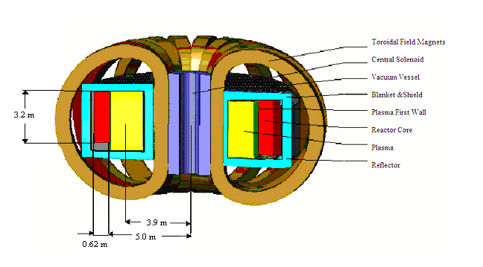Figure 1: SABR Configuration

SABR is designed to transmute the TRU in SNF to reduce geological high-level-waste storage requirements, in the process producing 3,000 MWt, which is then converted into electricity. SABR’s 3.2 m tall fission core is composed of 2 m of active fuel, a 1 m fission gas plenum and a 20 cm reflector capping the fuel pin. There are 271 fuel pins in each of the 902 hexagonal fuel assemblies, which are arranged vertically in four annular rings on the outboard of the plasma chamber. Each pin is 4 mm in diameter composed of transuranic/zirconium fuel and is clad in ODS steel. In addition to the 902 fuel assemblies, there are also sixteen control rod assemblies composed of boron carbide that provide about $9 of negative reactivity.
SABR’s metallic fuel has an initial weight percent composition of 40Zr-10Am-10Np-40Pu. This fuel composition, which is under development at ANL, was chosen because of its high thermal conductivity, high fission gas retention and its ability to accommodate high actinide density. Zirconium was added to the fuel to create a small negative Doppler feedback coefficient, to provide stability during irradiation and also to increase the melting temperature of the alloy to 1,473 K.
SABR’s fusion neutron source² is capable of generating up to 500 MW. Table 1 below lists the required fusion power levels for the fission core to maintain 3,000 MWt at Beginning of Life (BOL), Beginning of Equilibrium Cycle (BOC) and End of Equilibrium Cycle (EOC) as well as the effective multiplication constant of neutrons born in the fission core, k_{eff}, and the multiplication constant in the fission core of the neutrons produced in the fusion neutron source, k_{m}.

Table 1: Required Fusion Neutron Source Strength vs. TRU Fuel Cycle⁶
 | BOL | BOC | EOC
k_{eff} | 0.972 | 0.894 | 0.868
Reactivity ($) | -9.26 | -35.2 | -43.8
k_{m} | 0.913 | 0.753 | 0.676
Required P_{fus} (MW) | 73 | 242 | 370

To cool the reactor, a three loop cooling system is utilized with sodium in the primary and intermediate loops and water in the secondary loop. Heat generated in the fission core is transferred through four intermediate straight-tube heat exchangers to sodium in the intermediate loop. The hot sodium in the intermediate loop then converts water in the secondary loop to steam, which then passes through turbines to generate electricity. Sodium in the primary loop flows through the core at 8,695 kg/s in a total flow area of 7.5 m². At steady-state the inlet temperature to the core is 650 K and the outlet temperature is 923 K. Because it is difficult to adequately mix all of the sodium prior to the inlet plenum, the sodium travels through two separate circuits in the primary loop. Each circuit has four electromagnetic (EM) coolant pumps and two intermediate heat exchangers (IHX) for a total of eight primary coolant pumps and four IHX. Figure 2 illustrates the coolant flow path that was used in the RELAP5-3D calculational model with each pump in the figure representing four pumps and each heat exchanger representing two heat exchangers.
Fission
Core
P
I
H
X
Source Neutrons
P
I
H
X
Figure 2 Sodium Heat Removal System for SABR

III Dynamics Calculation Model
Transients develop differently for critical and subcritical systems. In a critical system, a small introduction of positive reactivity will lead to a prompt jump of the fission power followed by a gradual power increase due to the decayed neutrons. Positive reactivity insertions larger than the delayed neutron fraction will make the reactor prompt supercritical, leading to a rapid exponential power increase. Negative reactivity insertions in a critical system will cause a prompt drop in fission rate followed by a further decay of the fission rate on the delayed neutron time scale. Negative reactivity feedback mechanisms can counter these reactivity changes and bring the reactor to critical at a different power level, and control rods can be used if these feedback effects are insufficient.
Reactivity insertions in subcritical systems, however, will always lead to new steady-state power levels as long as the neutron source remains active and the reactor remains subcritical. No matter how large the negative reactivity insertion, the reactor will continue to generate some power in the presence of a neutron source. While shutting off the neutron source is a quick and effective way to reduce the fission core power level to decay heat levels, there does not appear to be an inherent negative feedback mechanism for shutting off the neutron source during a fission power excursion.
Dynamics calculations for SABR during various transient conditions were performed using the thermal hydraulics code RELAP5-3D⁵, which is able to couple the power generation of the fission core with the thermal hydraulics of the heat removal system. The ATHENA version of RELAP5-3D allows for the simulation of liquid metal coolants such as sodium. Through a series of connected one-dimensional volumes and junctions, the hydrodynamic state of the sodium coolant can be calculated at all points in the system. Using the point kinetics Equations 1 and 2, RELAP5-3D is able to calculate the total power level of the reactor, which determines how much power is generated in the fuel pins and how much heat is transferred to the coolant.

(1): 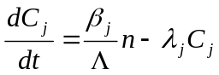

(2): 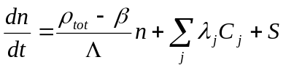
Here 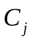 represents the delayed neutron precursor population, 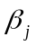 represents the fraction of fission neutrons resulting in the formation of a delayed neutron precursor in group “j” (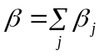), 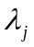 is the delayed neutron precursor decay constant, is the neutron density in the reactor, and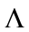is the neutron lifetime in the reactor. The total reactivity, ρ_{total}, is the sum of the subcritical reactivity, the reactivity due to feedbacks and any external reactivity insertions such as control rod withdrawal. Changes in the density of the coolant as well as the temperature of the fuel pins can be used to calculate the reactivity feedbacks.

(3): 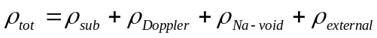

The fusion neutron source is incorporated into the calculations through the source density term, S, in the point kinetics equations. RELAP5-3D calculates the necessary source strength required for steady-state operation at the beginning of the simulation. Unfortunately this number cannot be changed during the RELAP5-3D simulation to represent changes in the neutron source strength. However, changes in the source strength can be simulated indirectly by calculating changes in the external reactivity that would produce the same change in neutron density.
The power distribution in the fission core throughout the transient simulations has been calculated by ERANOS⁷ and represented in the RELAP5-3D calculations using peak and average power fuel assemblies, which allows for the calculation of the maximum and average axial and radial temperature distribution of the fuel pins. The conditions of the reactor coolant throughout the transients can be tracked through the core, primary coolant loop piping, intermediate heat exchanger and other coolant loops in the system. Heat generated in the fuel pins is calculated as a function of the core power level and then transported across the fuel pins into the coolant and circulated to the heat exchanger coolant pipes, etc. Figure 2 illustrates the coolant flow path that was used for the RELAP5-3D calculations. The two coolant flow paths represent the two separate circuits in the primary coolant loop. Each pump in the figure represents four EM coolant pumps while each heat exchanger represents two IHX in the RELAP5-3D model.
Axial and radial power peaking factors for the fission core were generated using the ERANOS code system⁷. The axial pin power distribution was assumed to be sinusoidal. Reactivity feedback coefficients for Doppler and Sodium Voiding were also generated using ERANOS and are given in Table 2⁸. The Doppler coefficients are negative but very small. The positive BOL and EOC sodium voiding worths are small but positive. The delayed neutron parameters were found using the variational analysis code VAREX⁹ and are given in Table 3.
Table 2: Reactivity Feedback Coefficients
 | BOL | BOC | EOC
Doppler (Δk/ΔT_{fuel}) | -2.32E-8 | -8.62E-7 | -9.81E-8
Sodium Voiding (Δk/ΔT_{cool}) | 6.01E-6 | 2.78E-5 | 8.87E-6

Table 3: Delayed Neutron Parameters
Group | β_{i} | λ (1/s)
1 | 8.308E-5 | 1.324E-2
2 | 7.623E-4 | 3.019E-2
3 | 5.836E-4 | 1.166E-1
4 | 1.059E-3 | 3.133E-1
5 | 4.139E-4 | 1.046
6 | 1.069E-4 | 2.837
Total | 3.009E-3 | -

IV Accident Simulations
A. General Considerations
Two types of accidents are simulated to determine the dynamic safety characteristics of SABR. Accidents affecting SABR’s heat removal capability in the fission core are:
- Loss of Coolant Mass Flow (LOFA),
- Loss of Heat Sink (LOHSA), and
- Loss of Power (LOPA).
Accidents that affect the neutron population of the fission core are:
- Accidental Reactivity Insertions, and
- Accidental Increases in Fusion Generated Source Neutrons.
Simulations of the fusion neutron source indicate that simply turning off the plasma heating power source will cause the fusion neutron source to be reduced to a negligible level within a few seconds (on the energy confinement timescale). This type of reduction in neutron source strength reduces the power in the reactor core to the decay heat level in a few seconds.
We have not attempted to simulate detection of accidents and shutdown of the neutron source to drop the power level quickly to decay heat levels. Rather we have assumed that the transients are undetected and left the neutron source on (except of course in the loss of power accident). The results give us insight into the consequences of undetected/uncorrected accidents and also provide an indication of how much time is available for detection and correction before core damage occurs. Because RELAP5-3D does not allow a time-dependent neutron source, we are unable to calculate the time evolution of those accidents involving inadvertent transients in the plasma power output, but we were able to calculate the bounds of such accidents. Accidents were simulated at three different points during the fuel cycle: Beginning of Life (BOL), Beginning of Equilibrium Cycle (BOC), and End of Equilibrium Cycle (EOC).
The main criterion used to determine if the core had reached a limiting condition during an accident is whether the fuel had exceeded its melting temperature of 1,473 K at any location, which would cause core damage. A secondary failure criterion that was monitored was whether the coolant had exceeded its boiling temperature of 1,156 K. If the coolant begins to boil during a transient, this does not necessarily mean that core damage will occur, because corrective measures could lead to decreased core temperatures and the sodium vapor would return to its liquid phase. On the other hand, fuel melting cannot be reversed and will lead to significant down time and repairs for the reactor, if not permanent shutdown. During the initial scoping simulations⁴ it was found that the sodium boiled before the fuel melted in all accidents that reached limiting conditions.
Melting of the ODS cladding is not considered because the 1,800 K melting temperature of ODS steel is far greater than the 1,473 K melting temperature of the fuel, which will always be hotter than the cladding. Cladding creep is also not considered because it occurs at relatively high temperatures and is only an issue if the clad remains at elevated temperatures for extended periods of time. Because damage to the core due to eutectic melting between the cladding and the fuel is not well understood and, as with the cladding creep, occurs at elevated temperatures over longer periods of time, the eutectic limit is not considered as a constraint in the accident scenarios.
In order to fully understand how different transients affect SABR, it is useful first to look at SABR’s typical operating parameters during steady-state. Table 4 lists some of the important temperatures in the fission core during normal 3,000 MW operation at the three reference points during the fuel cycle.

Table 4: Steady-State Operating Parameters
 | BOL | BOC | EOC
Coolant Inlet Temp (K) | 650.0 | 650.0 | 650.0
Average Coolant Outlet Temp (K) | 942 | 942 | 942
Max Coolant Temp (K) | 942 | 942 | 971
Max Cladding Temp (K) | 957 | 956 | 986
Max Fuel Temp (K) | 1,006 | 1,048 | 1,087
Average Coolant Temp (K) | 815 | 815 | 815
Average Cladding Temp (K) | 824 | 824 | 824
Average Fuel Temp (K) | 838 | 838 | 838
Radial Power Peaking | 1.26 | 1.80 | 1.96

Because of the SABR core’s relatively thin annular geometry and the presence of a neutron source on the inside, the fission core will experience higher radial power peaking values than normally found in fast reactors. Special attention must be given to the coolant inlet channels to ensure that the outlet temperature of the hot assemblies is not too close to the coolant boiling temperature. During BOL and BOC operation, it is possible to achieve similar outlet temperatures for both hot and average assemblies by modifying the channel inlet flow conditions to provide more coolant mass flow to the necessary assemblies. Because the fuel is not shuffled between BOC and EOC operation, care must be taken when selecting the flow inlet conditions for BOC operation to ensure that the hot assembly outlet temperature at EOC is not too high.
The preliminary safety and dynamics analyses⁴ for SABR indicated that the best way to affect small changes to the power level in the fission core is with control rods, while fully shutting down the reactor can only be accomplished by turning off the neutron source⁴. The plasma power balance is maintained by an external source of heating power, which can be switched off essentially instantaneously, after which the plasma cools on the energy confinement time scale, which is about 1 second. Turning off the plasma auxiliary heating for the neutron source will lead to a negligible neutron source in less than three seconds, which would cause the fission power level to promptly decrease to decay heat levels, 7.1% of the steady-state power level. Turning off the plasma heating power serves as an excellent rapid scram system for a subcritical reactor.

B. Loss of Flow Accident
A Loss of Flow Accident (LOFA), often due to pump failure, is an accident in which the reactor core experiences less coolant mass flow, resulting in inadequate heat removal of the heat generated in the fuel pins, leading to significant increases in the fuel temperature. For a uranium fueled reactor with a large negative Doppler feedback, this increase in fuel temperature will lead to a significant negative reactivity insertion and a consequent decrease in fission power. However, the Doppler Coefficient in a TRU-fueled transmutation reactor such as SABR is small. During a LOFA, if neither coolant nor fuel failure occurs, the reactor will reach a new equilibrium where the power produced in the core is removed in the heat exchanger.
A significant problem encountered when designing any reactor is ensuring that a decrease in coolant mass flow is distributed over the whole core and not over a few assemblies. The problem is getting the coolant to mix in the structure and piping below the active region of the core so that if one coolant loop experiences decreased flow, the change is spread over all the assemblies. This problem is more difficult in SABR due to the annular nature of the core and the presence of the neutron source which prevents a cylindrical mixing area below the core.
Loss of Flow Accidents were simulated as the complete failure of one or more of the four primary loop pumps, while the neutron source remains active. These simulations assume that the coolant leaving the four pumps in each half of the reactor is adequately mixed before flowing back through the core. Control rods can be used to decrease the core fission power level, but as long as the neutron source remains on there will be significant fission power production. Shutting off the neutron source is the best and only way to counteract the effects of a LOFA without the use of auxiliary pumps or restarting the failed pumps.
A series of pump failure transients have been simulated without control action to turn off the neutron source in order to determine the amount of time that would be available to detect the accident and shut down the neutron source before core damage occurred. For an accident that results from the failure of a single primary loop coolant pump, SABR can survive without sustaining fuel melting or coolant boiling during all reference points during the fuel cycle (BOL, BOC and EOC). The highest coolant and fuel pin temperatures, 1,068 and 1,172 K, respectively, were experienced at EOC, but these temperatures were far below the coolant boiling and fuel melting temperatures of 1,156 K and 1,473 K, respectively.
If two or more pumps in the same side of the primary loop were to fail, however, the coolant mass flow rate would decrease too much to adequately remove the heat generated in the fuel pins. During BOL operation, there would be at most 13.2 seconds after the loss of the two pumps before the onset of coolant boiling. This time drops to 7.1 seconds for the loss of two pumps during EOC operation. The decreased time before coolant boiling at EOC is due to the higher outlet temperature for the hot assemblies during steady-state EOC operation. Fuel melting did not occur after the failure of two coolant pumps on the same side of the primary loop. Figure 5 illustrates the maximum coolant and fuel temperatures during a 25% and 50% LOFA. Fuel melting was only experienced 15.5 seconds after three of the four coolant pumps on the same side of the primary loop have failed at BOL. There are only 9.7 and 8.4 seconds after the start of the transient at BOC and EOC, respectively, before fuel melting occurs. At this point SABR would have sustained irreversible damage to the core.
Because SABR cannot withstand multiple pump failures without at least the coolant boiling, the pumps in the primary loop should be kept on separate systems so that a failure of one pump is unlikely to be followed by a second pump failure. Once a single pump failure is detected, most likely by the detection of decreased coolant mass flow, the fusion neutron source should be turned off or reduced until the problem can be corrected. The remaining pumps would be able to provide enough coolant mass flow so that the broken pump can be isolated and repaired. Table 5 summarizes the maximum temperatures reached during these accidents and the increase in fission power due to reactivity feedbacks.
Future work performed on designing SABR's heat removal system must ensure that a loss of pumping power in a coolant loop does not lead to stagnant coolant in any one reactor region.
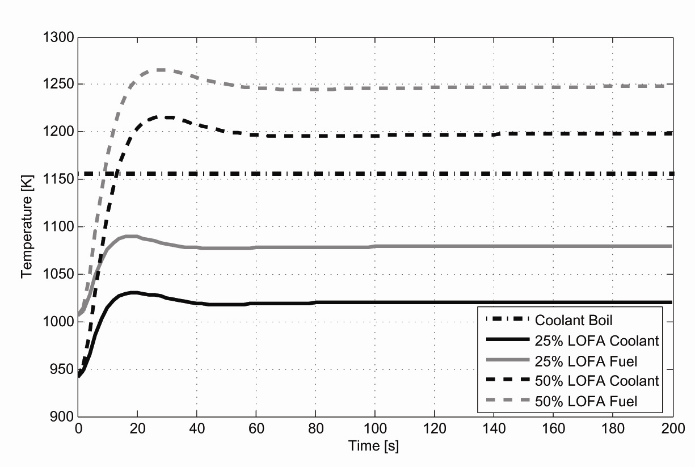
Figure 5: Max Coolant and Fuel Pin Temperature During 25% and 50% LOFA at BOL with Neutron Source

Table 5: Loss of Coolant Mass Flow Accident Summary
 | BOL | BOC | EOC
25% LOFA
Max Coolant Temp (K) | 1030 | 1032 | 1068
Max Fuel Temp (K) | 1090 | 1126 | 1172
Time until Coolant Boiling (s) | ∞ | ∞ | ∞
Time until Fuel Melting (s) | ∞ | ∞ | ∞
50% LOFA
Max Coolant Temp (K) | 1216 | 1217 | 1266
Max Fuel Temp (K) | 1266 | 1302 | 1360
Time until Coolant Boiling (s) | 13.2 | 9.6 | 7.1
Time until Fuel Melting (s) | ∞ | ∞ | ∞
75% LOFA
Max Coolant Temp (K) | >1,156 | >1,156 | >1,156
Max Fuel Temp (K) | >1,473 | >1,473 | >1,473
Time until Coolant Boiling (s) | 8.4 | 5.7 | 4.9
Time until Fuel Melting (s) | 15.5 | 9.7 | 8.4
(Note: Coolant boiling occurs at 1,156 K and fuel melting occurs at 1,473 K)

C. Loss of Heat Sink Accident
A Loss of Heat Sink Accident (LOHSA) is any transient that results in an unanticipated decrease in the overall heat transfer rate of the intermediate heat exchanger (IHX). This decrease could be a result of a line break in the intermediate loop, decreased coolant flow in the intermediate loop or a physical break in the IHX. Without adequate heat removal, primary loop temperatures will continue to increase until either a new steady-state is reached or core failure is experienced. SABR’s positive sodium voiding reactivity feedback will lead to a further increase in the fission power.
Because simulating a physical break of the heat exchanger is difficult, the decrease in the IHX heat transfer rate was represented by a decrease in the coolant mass flow of the intermediate loop as a result of a failure of one or more coolant pumps in the intermediate loop. As with other accidents, shutting down the neutron source is the best and fastest way to prevent core damage due to a LOHSA. The accidents were simulated without any control action, in order to determine the amount of time available to detect the accident and shut down the neutron source.
During all three reference points in the fuel cycle (BOL, BOC and EOC) SABR can withstand without coolant boiling or fuel melting up to a 50% LOHSA, which corresponds to half of the intermediate loop coolant pumps failing. At EOC, the maximum coolant temperature reaches 1,132 K, which is close to the sodium boiling temperature of 1,156 K.
Anything greater than a 50% LOHSA will ultimately lead to both coolant boiling and fuel melting. For a 75% percent LOHSA, there will be at most 44.9 and 146.6 seconds before the coolant boils and the fuel melts, respectively. During a complete LOHSA, those times drop to 24.2 and 56.5 seconds. As with the primary loop pumps, despite the fact that the reactor can survive more than one intermediate loop coolant pump failing, the pumps should be kept on separate systems so that the likelihood of more than one pump failing is minimal. The maximum coolant and fuel temperatures during various LOHSA are illustrated in Figure 6. The results of these accidents are summarized in Table 6.
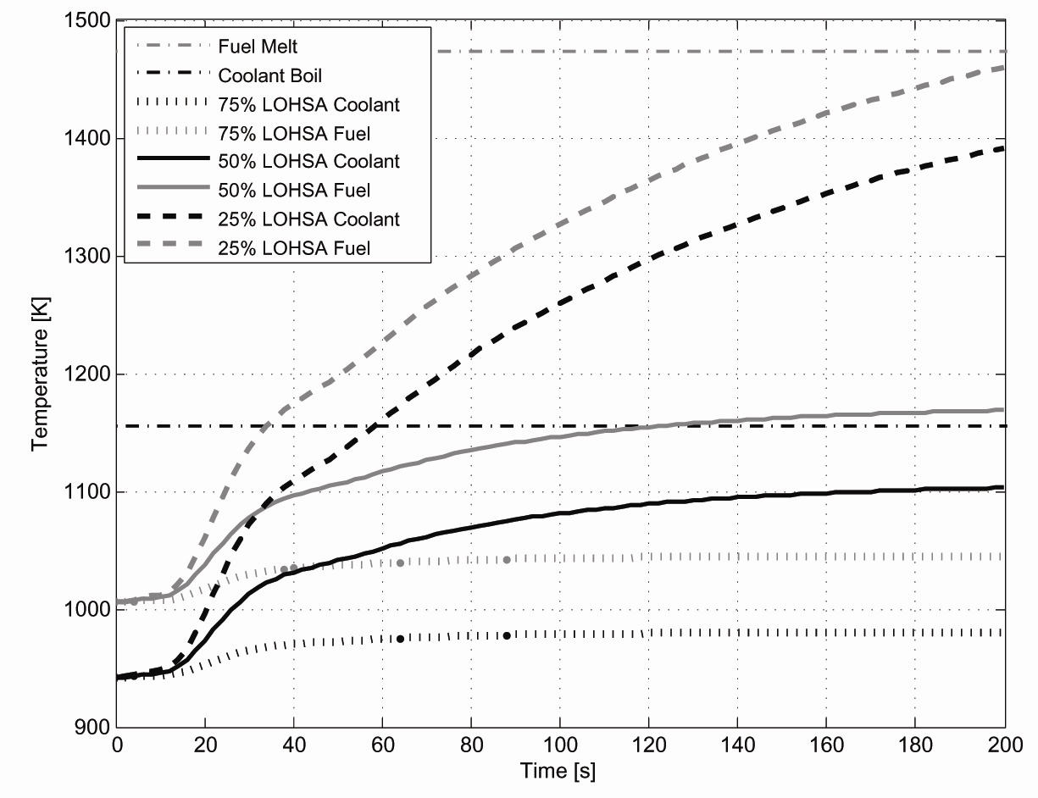
Figure 6: Maximum Coolant and Fuel Pin Temperature During 25, 50 and 75% LOHSA at BOL with Neutron Source

Table 6: Loss of Heat Sink Accident Summary
 | BOL | BOC | EOC
25% LOHSA
Max Coolant Temp (K) | 981 | 981 | 1,009
Max Fuel Temp (K) | 1,045 | 1,080 | 1,118
Time until Coolant Boiling (s) | ∞ | ∞ | ∞
Time until Fuel Melting (s) | ∞ | ∞ | ∞
50% LOHSA
Max Coolant Temp (K) | 1,107 | 1,108 | 1,132
Max Fuel Temp (K) | 1,173 | 1,208 | 1,243
Time until Coolant Boiling (s) | ∞ | ∞ | ∞
Time until Fuel Melting (s) | ∞ | ∞ | ∞
75% LOHSA
Max Coolant Temp (K) | >1,156 | >1,156 | >1,156
Max Fuel Temp (K) | >1,473 | >1,473 | >1,473
Time until Coolant Boiling (s) | 58.6 | 54.1 | 44.9
Time until Fuel Melting (s) | 217.7 | 170.7 | 146.6
Complete LOHSA
Max Coolant Temp (K) | >1,156 | >1,156 | >1,156
Max Fuel Temp (K) | >1,473 | >1,473 | >1,473
Time until Coolant Boiling (s) | 29.7 | 26.4 | 24.2
Time until Fuel Melting (s) | 70.6 | 61.0 | 56.5
(Note: Coolant boiling occurs at 1,156 K and fuel melting occurs at 1,473 K)

D. Loss of Power Accident
A Loss of Power Accident (LOPA) is an accident where power to SABR’s auxiliary systems is lost, meaning all coolant pumps turn off. Heating power to the plasma also turns off. This accident is similar to a complete Loss of Flow Accident with immediate corrective measures. When plasma heating power is lost, the neutron source will quickly shut down, as discussed above, leaving a subcritical fission core without the source neutrons necessary to remain at steady-state. The power level in the fission core will quickly decrease to decay heat levels. Decay heat production in the core is initially 212 MWt, or 7.1% of the steady-state power level. Before coolant mass flow has a chance to significantly reduce, the core will quickly cool down. But as the coolant mass flow decays away, the core will begin to heat back up. If natural circulation does not provide enough coolant mass flow, the core will overheat and eventually the coolant will boil and the fuel will melt.
Because the source shuts off so quickly in SABR during a LOPA, the fission power is able to decay away faster than the coolant mass flow, leading to only a small increase in core temperatures. The maximum coolant temperature reached during BOL is 1,054.1 K while the maximum fuel pin temperature reaches 1,057 K, both an acceptable margin below their respective failure points of 1,156 and 1,473 K. The BOC and EOC maximum coolant temperatures are 1,103 and 1,130 K, which are closer to but still below the sodium boiling temperature. The maximum temperatures for a LOPA during EOC operation are higher due to the higher steady-state hot assembly temperatures.
Even though the coolant during a Loss of Power Accident reaches a maximum temperature close to the coolant boiling temperature, core temperatures quickly decrease until natural circulation begins to cool the decay heat produced in the reactor. Ten minutes after the LOPA is initiated, core temperatures are all less than 850 K and they continue to decrease. The maximum coolant and fuel temperatures during a LOPA are illustrated in Figure 7. The results of this accident are summarized in Table 7.
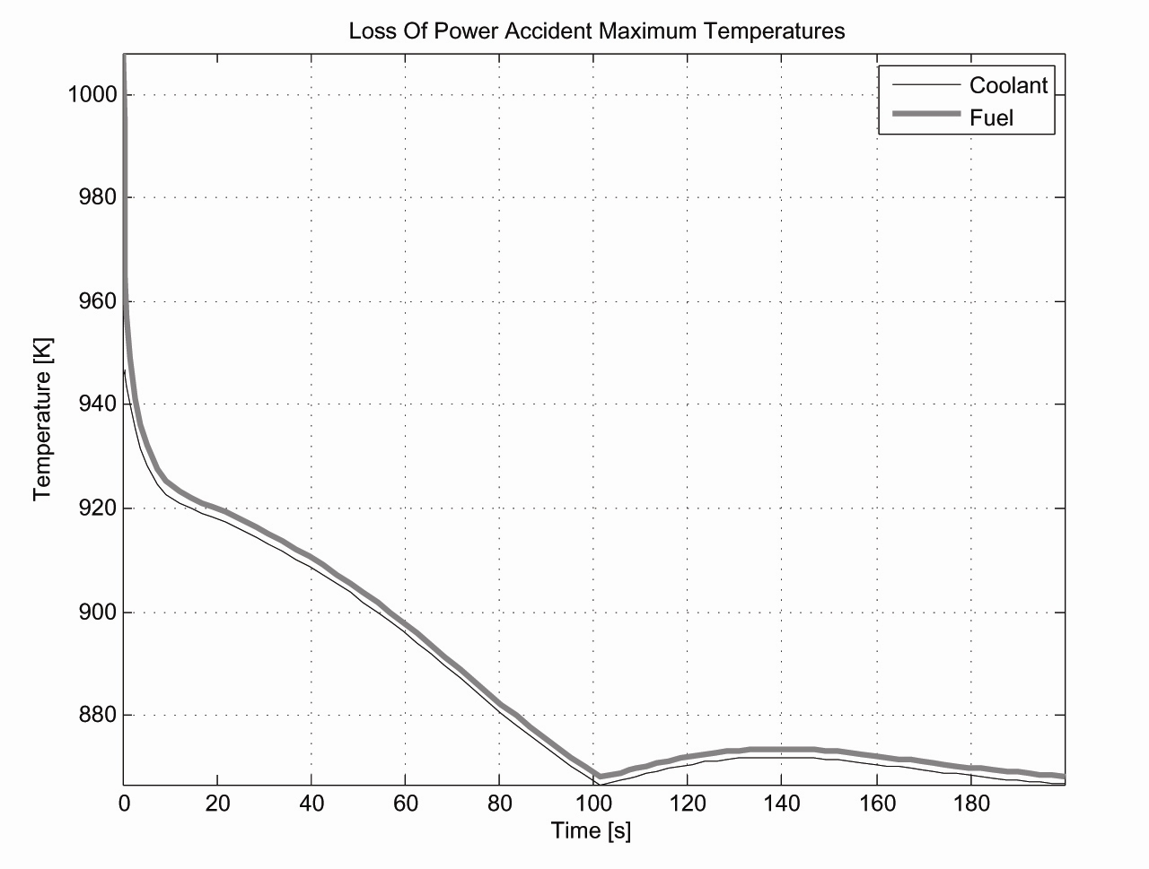Figure 7: Max Fuel and Coolant Temperatures During LOPA at BOL without Neutron Source

Table 7: Loss of Power Accident Summary
 | BOL | BOC | EOC
Max Coolant Temperature (K) | 947 | 1,103 | 1,068
Max Fuel Pin Temperature (K) | 1,008 | 1,106 | 1,083

E. Worst Possible Control Rod Accident
In a critical system, even the smallest reactivity insertion can lead to a steady power increase in the absence of control mechanisms or negative feedback. Reactivity insertions in a subcritical system will, however, always lead to a new steady-state power level as long as the reactor remains subcritical. In SABR, the most reactive condition occurs at BOL with entirely fresh fuel in the reactor. At this point the reactor is negative $9.26 subcritical and k_{eff} is 0.972. It would require an enormous positive reactivity insertion to reach criticality.
If during BOL operation the sixteen control rods were fully inserted the reactor would be operating at negative $18.26 subcritical. In order to maintain 3,000 MWt, the fusion neutron source strength would have to be nearly doubled by the operator. If the control rods were then fully removed at this point and k_{eff} = 0.972 reestablished, the new steady-state power level in the fission core would be 5,884 MWt. The peak fuel temperature would increase to 1,345 K, still below the melting temperature of 1,473 K, but the coolant temperature would exceed its boiling point of 1,156 K in less than 13 seconds. SABR could withstand this accident without experiencing fuel melting, however, the occurrence of sodium boiling in the fission core necessitates that changes be made to the reactor design to minimize the magnitude of this accident. It should be noted that this accident is highly implausible, but it was simulated as it is the worst possible accident related to reactivity insertions.
One solution is to decrease the worth of the control rods. Because large negative reactivity insertions from the control rods are not necessary to control or shut down the reactor, a lower total control rod worth could be utilized to eliminate the potential of damage from this accident scenario. Past studies⁴ of SABR’s safety characteristics concluded that a total control rod worth of approximately half the BOL subcritical reactivity would result in maximum coolant temperatures just below boiling during this accident.
Another method to prevent the possibility of damage from this accident is to decrease the BOL effective multiplication constant. The original SABR design used a maximum value for k_{eff} of 0.95, as compared to the current value of 0.972, and was able to withstand this accident without the occurrence of either fuel melting or coolant boiling. Future iterations of SABR will likely utilize both methods to provide a significant safety margin against damage as a result of this highly implausible accident. The reactor is entirely safe from damage due to this accident occurring during BOC and EOC operation. A summary of the temperature and fission power increases for this accident is given in Table 8.
Table 8: Summary of Reactivity Insertion Transients
 | BOL | BOC | EOC
Control Rods Inserted, Fusion Power Increased to Compensate, Control Rods Removed
Max Coolant Temp (K) | > 1,156 | 1,015 | 1,035
Max Fuel Temp (K) | 1,377 | 1,148 | 1,173
Time to Coolant Boiling (s) | 12.6 | ∞ | ∞
Time to Fuel Melting (s) | ∞ | ∞ | ∞
Fission Power Increase (MW) | 2,884 | 754 | 600
Single Control Rod Ejection
Max Coolant Temp (K) | 963 | 947 | 975
Max Fuel Temp (K) | 1,031 | 1,055 | 1,093
Fission Power Increase (MW) | 190 | 48 | 38
(Note: Coolant boiling occurs at 1,156 K and fuel melting occurs at 1,473 K)

F. Control Rod Ejection
A more likely reactivity insertion would be the ejection of one control rod, which corresponds to a reactivity of $0.56. At BOL this would lead to an increase in fission power of only 190 MW. The peak coolant and fuel pin temperatures increase by only 21 and 25 K, respectively. The results of a single control rod ejection are summarized in Table 8. SABR could withstand the inadvertent ejection of a control rod from the core without sustaining permanent damage to the reactor.

G. Accidental Increase in Fusion Neutron Source Strength
Aside from increasing the reactivity in the fission core, the neutron population, thus the fission power level, can be increased by increasing the strength of the fusion neutron source. Note from Eq. (1) that the total neutron source in the reactor consists of three terms: prompt fission neutrons, delayed neutrons from the decay of delayed neutron precursors, and the fusion source neutrons.
It is possible, although unlikely, that an accidental increase in the plasma fueling source or the plasma heating source could cause an unintended increase in the plasma density or temperature, respectively, leading to an increase in the fusion power level and the fusion neutron source strength in the reactor core. It is also possible that changes in other plasma parameters that affect the particle and energy confinement, thus the fusion rate, could occur. Any change in plasma density or temperature would take place on the plasma confinement timescale of a few seconds.
As a concrete example, the SABR fusion neutron source has available six 20 MW lower hybrid electromagnetic wave launchers to provide auxiliary heating to the plasma. Not all of these launchers are needed for all conditions in the fuel cycle, so there is the possibility that an unused launcher is inadvertently turned on. In a similar vein, there are gas injectors for fueling the plasma which are not always needed, and one of these could inadvertently be opened.
Just as there are negative temperature feedback mechanisms that act to reduce the reactivity and thereby limit power excursions in fission reactors, there are also negative density and temperature feedback mechanisms—density limits and pressure (beta) limits¹⁰—that would act to reduce the energy and particle confinement and thereby limit power excursions in the fusion neutron source. As the density approaches the density limit or the pressure approaches the beta limit, the plasma confinement decreases strongly, thereby limiting positive excursions in density or temperature, provided that the plasma operating conditions are chosen sufficiently close to these limits. No attempt has yet been made to optimize the SABR neutron source operating point with respect to these density and pressure limits.
Because RELAP5-3D uses a constant value for the source term in the Point Kinetics Equations, it is impossible to capture all of the dynamics of the fusion neutron source for these calculations. For this reason, we first carried out a series of calculations⁴ using the point kinetics equations to represent the fission power level, the equivalent global plasma power and particle balance equations⁹ to represent the fusion neutron source dynamics, and a simple model for the sodium heat removal system. The density and pressure limits were represented by empirical expressions, but were not incorporated into the dynamics calculations. Rather, when one of these limits was surpassed it was assumed that the neutron source had been turned off by plasma confinement degradation.
The results of these calculations provided useful insights that guided subsequent RELAP5-3D calculations, but the quantitative results were questionable because of the simplified heat removal system model employed. In order to obtain a quantitative estimate of limiting temperatures and power levels in the fission core that might occur as a result of fusion source excursions, a second series of calculations was carried out with the more realistic RELAP5-3D model of the heat removal systems, using fixed plasma sources at various levels to determine the maximum fusion neutron source strength that SABR could tolerate without experiencing coolant boiling or fuel melting in the fission core.
The Greenwald Density Limit¹⁰ is a simple empirical fit that bounds the densities for tokamak plasmas. The plasma neutron source operating density was well below this limit and was not reached in any of the transients simulated.
The Troyon Beta Limit¹⁰ provides an upper limit on both the plasma temperature and the ion density, beyond which plasma stability and confinement are degraded. The plasma operating parameters used during BOL operation provided a large margin at steady-state before the Troyon Beta Limit was exceeded. However, the margin during BOC and EOC operation before the Troyon Beta Limit was exceeded was much smaller. It was apparent that optimization of the plasma current profile was necessary for BOC and EOC plasma operating parameters to allow for operation just enough below this limit to provide an inherent feedback against power excursions in the fusion neutron source due to inadvertent turn on of addition plasma heat sources⁴.
Simulations representing inadvertent increases in plasma fuel injection indicated that at BOL, BOC and EOC, SABR could withstand up to an 11%, 1% and 2% increase, respectively, in the plasma ion density before the Troyon Beta Limit was exceeded. When compared with the 12%, 17% and 19% increases that were required before coolant boiling occurred, it was determined that the Troyon Beta Limit provided a natural feedback mechanism that prevented reactor damage due to accidental increases in the plasma fueling rate. Ion density increases of 19%, 29% and 32% at BOL, BOC and EOC, respectively, were required before fuel melting occurred.
It should be noted that changes in the plasma ion density did not produce a linearly proportional change in the fusion power level. For a 5% increase in the plasma ion density at BOL, the fusion power increased by more than 20%. A 12% increase in the plasma ion density at BOL led to a nearly 60% increase in the fusion power level.
The second fusion transient that was examined for the fusion neutron source was an increase in the plasma auxiliary heating. This could result from one or more unused 20 MW heating launchers accidentally turning on. For the case of one extra 20 MW plasma auxiliary heating launcher turning on at BOL, SABR experienced a 41% increase in fusion power and maximum coolant and fuel temperatures of 1,079 and 1,142 K, respectively, both below their respective failure temperatures of 1,156 and 1,473 K. In every other case considered, whether it was two or more extra 20 MW auxiliary heating launchers or one extra 20 MW heating launcher at BOC and EOC, the Troyon Beta Limit was exceeded, indicating that the plasma energy confinement would have decreased and terminated the source excursion before any damage to SABR’s fission core occurred.
Because more complicated transients for the fusion neutron source could not be simulated with the RELAP5-3D model, the maximum allowable neutron source strength before either coolant boiling or fuel melting occurred was calculated. Table 9 lists the minimum fusion power levels that led to coolant boiling in the fission core. In all three cases the fusion power level must increase by more than 50% before coolant boiling begins. The corresponding maximum fuel temperatures calculated for an increase in the fusion neutron source power level at BOL, BOC and EOC were all more than 100 K below the fuel melting temperature of 1,473 K.

Table 9: Fusion Neutron Source Strength Increase Accident Summary
 | BOL | BOC | EOC
Steady-state Fusion Power Level (MW) | 73 | 242 | 370
Fusion Power Leading to Coolant Boiling (MW) | 121.2 | 398.1 | 563.9
Maximum Tolerable Increase in Fusion Power (MW) | 48 | 156 | 194
Maximum Fuel Temperature (K) | 1265 | 1336 | 1337
(Note: Coolant boiling occurs at 1,156 K and fuel melting occurs at 1,473 K)

- Summary and Conclusions
Loss-of-power (LOPA), loss-of-heat-sink (LOHSA), loss-of-flow (LOFA), control rod ejection, and neutron source excursion accidents were simulated using the RELAP5-3D code to model the reactor and heat removal systems dynamics, together with a plasma power and particle balance model for the neutron source dynamics. It was found that: i) the core power can be reduced to decay heat levels in a couple of seconds by turning off the neutron source heating power when any accident condition is detected; ii) a LOPA thus reduces the core to the decay heat level in a couple of seconds and natural circulation prevents core damage; iii) undetected LOFAs in which 50% of the primary coolant pumps fail can be survived without core damage, and only when 75% of the pumps fail does fuel melting occur (at 8.4 s); iv) an undetected LOHSA with 50% loss of sodium flow in the intermediate loop can be survived without core damage, and only with 75% loss of sodium flow in the intermediate loop does fuel melting occur (at 150 s); and v) neutron source excursions due to inadvertent increases in plasma heating or fueling could be limited by operation near inherent density and beta limits.
SABR can withstand without coolant boiling up to a quarter of the coolant pumps in either the primary or intermediate coolant loops failing. If any additional coolant pumps fail the coolant will either exceed or come very close to its boiling temperature. However, a failure of three-quarters of the coolant pumps in either the primary or intermediate coolant loops will result in fuel melting. With only about ten seconds before fuel melting begins, there is not enough time to for operators intervention to terminate the transient, and this indicates the need for an automatic control system.
Because SABR cannot sustain multiple pump failures without experiencing coolant boiling and possibly fuel melting, coolant pumps in both the primary and intermediate coolant loops should be kept on entirely separate electrical systems than any other pump to ensure that a failure of one pump is not likely to be followed by a second pump failure. After a single pump failure is detected, the neutron source should be quickly shut off. Even if all of SABR’s pumps fail, if the neutron source is shut down at the same time, natural circulation will provide enough coolant mass flow to remove the decay heat being generated in the fission core.
The other category of transients is those affecting SABR’s neutron population in the fission core. To prevent accidents related to inadvertent control rod removals from possibly causing coolant boiling in the fission core, two design changes are possible. The best option is to decrease the total control rod worth. Because control rods are only used for small changes in the fission power level and they are not essential to shut down the reactor, a decrease in control worth would not be a reduction in the SABR’s level of safety.
Rather large increases in fusion neutron source strength can be tolerated before coolant boiling or fuel melting occurs. Throughout the fuel cycle, it would take an increase of at least 50% of the neutron source strength before SABR’s heat removal system would be incapable of regulating core temperatures. In the case of EOC operation, the neutron source would have to exceed its maximum design strength before core failure occurs.
While some of the accidents simulated can cause damage in SABR if uncontrolled, core damage can be prevented for all transients by shutting off the neutron source. The fission core power level will quickly decrease to decay heat levels leaving at most 7.1% power and enough coolant mass flow from natural circulation to cool the reactor until whatever caused the accident can be corrected. Whether a pump or a heat exchanger fails or a reactor operator utilizes the control rods improperly, simply eliminating the source neutrons will allow for a safe progression of the ensuing accident.

ACKNOWLEDGEMENT
The first author wishes to acknowledge the guidance of W. Van Rooijen in the preliminary analyses reported in this paper.

References
- W. M. Stacey, et al., “A TRU-Zr Metal Fuel, Sodium Cooled, Fast Subcritical Advanced Burner Reactor,” Nuclear Technology, vol. 162, pp 53-79, April 2008.
- J. P. Floyd, et al., “Tokamak Fusion Neutron Source for a Fast Transmutation Reactor,” Fusion Science & Technology, vol. 52, pp 727-730, October 2007.
- “ITER – the way to new energy.” http://www.iter.org, August 2009.
- T. S. Sumner, “A Safety and Dynamics Analysis of the Subcritical Advanced Burner Reactor: SABR.” M.S. Thesis, Georgia Institute of Technology (2008).
- “RELAP5-3D Home Page,” August 2009. http://www.inl.gov/relap5/.
- C. M. Sommer, et al., “Fuel Cycle Analysis of the SABR Subcritical Fast Burner Reactor,” Nuclear Technology, (in preparation, 2009).
- CEA, ERANOS 2.0 Documentation du code.
- C. M. Sommer, Georgia Tech, personal communication (2009).
- W. M. Stacey, Fusion Plasma Physics. Weinheim : Wiley-VCH Verlag GmbH & Co. KgaA, 2005, p. 475.
- ibid. Chapter 18.

