- Introduction
In many pressure vessel filling operations, the evaluation of success or failure is often difficult. Any direct measure of pressure requires either the installation of a gauge in every unit, which can be expensive and impractical, or is a destructive measure that involves puncturing the vessel in some form. One major downside to any destructive testing method is the existence of a certain degree of doubt as to whether or not the contents of the ruptured vessel truly reflect the state of the undamaged vessel. This comes in addition to two further concerns - both 1) the actual loss of the vessel itself - which in some low-quantity applications may be unacceptable – and 2) the potential contamination of the contents of the vessel – which could range from undesired pollutants in mechanical applications to potentially deadly foreign matter in biological applications.
If presented with a case of a valuable container than we cannot sacrifice filled with contents that cannot be contaminated, the search must continue for other externally measurable variables that give rise to pressure detection. As the pressure inside the can rises, the vessel responds elastically (assuming the vessel is properly designed to not fail), and there is a direct relationship between hoop strain and internal pressure as determined by simple constitutive strain theory. The experiment is based upon this relationship.

- Theoretical Analysis
  - Hoop Strain
In treating the can as a thin-walled pressure vessel (where the thickness of the wall is negligible in comparison to other significant dimensions) a simple material relation between pressure and strain can be derived. Consider the following free body diagram of a half-cross-section of the can, with pressure p, diameter D, tension T and wall thickness t:
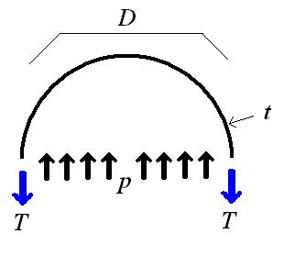
Figure 1: Can Cross Section Free Body Diagram

The net upward pressure force per unit height pD must be balanced by the downward tensile force per unit height 2T, a force that can also be expressed as a stress, σ_{hoop}, times area 2t. Equating and solving for σ_{h} gives

σ_{h} = pD
2t (1)

Similarly, the axial stress σ_{axial} can be calculated by dividing the total force on the end of the can, pA=pπ(D/2)² by the cross sectional area of the wall, πDt, giving:

σ_{a} = pD
4t (2)

For a flat sheet in biaxial tension, the strain in a given direction such as the ‘hoop’ tangential direction is given by the following constitutive relation - with Young’s modulus E and Poisson’s ratio ν:

ε _{h} = 1(σ_{h} – νσ_{a})

E (3)

Finally, solving for unknown pressure as a function of hoop strain:

p = (4Et) ε _{h}
D 2-ν (4)

  - Strain Gages
A strain gage is a variable resistive element that takes advantage of the geometric and physical basis of resistance. As the strain gage undergoes strain in its sensitive direction, the diameter of the extremely thin (0.056mm for the strain gages used in this lab) longitudinal wires changes slightly, giving a change in overall strain gage resistance. Resistance of a conductor of length L, cross-sectional area A, and resistivity ρ is

R = ρL
A (5)

Consequently, a small differential change in ΔR/R can be expressed as

ΔR = ΔL - ΔA + Δρ

R L A ρ (6)

Where ΔL/L is longitudinal strain ε, and ΔA/A is –2νε where ν is the Poisson’s ratio of the resistive material. Substitution and factoring out ε from the right hand side leaves

ΔR = (1+2ν + Δρ ) ε
R ρε (7)

Where Δρ/ρε can be considered nearly constant, and thus the parenthetical term effectively becomes a single constant, the gage factor, F_{g}

ΔR = F_{g} ε
R (8)

  - Wheatstone Bridge
Also known as a Full-Wave Bridge Circuit, the Wheatstone bridge used in lab is shown below with an overlaid schematic.

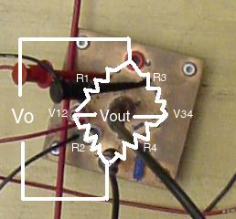
Figure 2 – Wheatstone Bridge

V_{out} can be readily deduced as V₃₄-V₁₂ and by taking each half bridge to be a simple voltage divider V_{out} can be evaluated as:

V_{out} = R4 V_{o} - R2 V_{o}
R3+R4 R1+R2 (9)

Given that R1=R3=R4=R_{o}, and R2 (the strain gage) = R_{o} + ΔR, substituting into equation (9) using equation (8) with algebra yields:
V_{out} = - Fg ε V_{o}
4
- Experimental Procedure

  - Apparatus

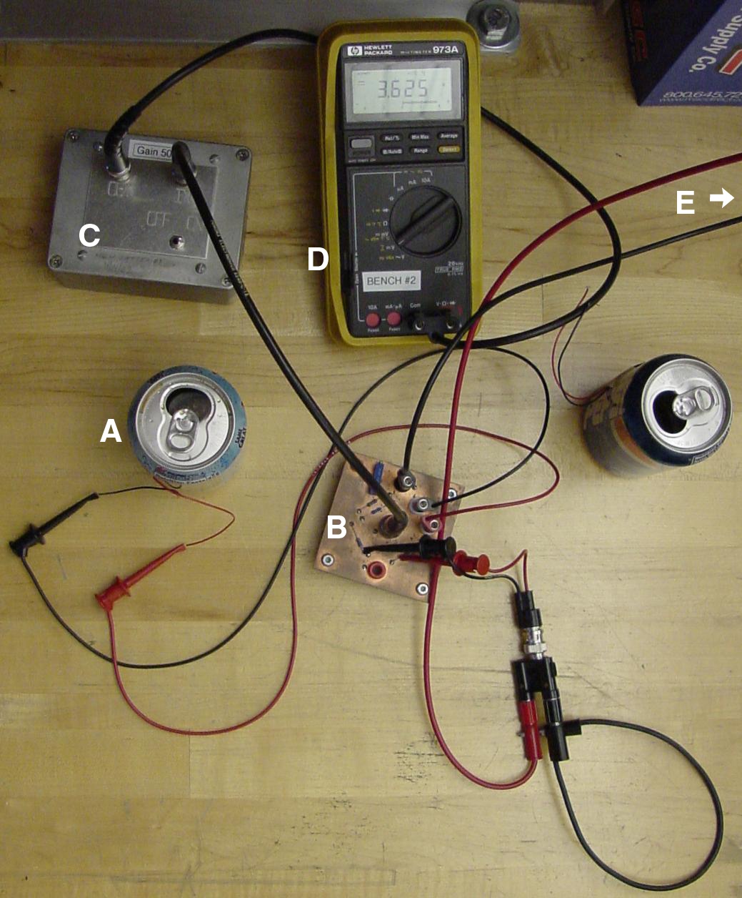
Figure 3: Top down view of lab setup

3.1.1 Strain Gages
Two Measurements Group, Inc.CEA-13-240UZ-120 constantan alloy strain gages were used, each with a 120.0 Ohms resistance and a 2.085 gage factor at room temperature (24ºC). Labeled ‘A’ in Figure 3, both were mounted with their sensitive direction along the circumference of the can.

3.1.2 Wheatstone Bridge
A wheatstone bridge was provided for use in this experiment, labeled ‘B’ in Figure 3. It is a four-resistor resistive divider, with two static resistors, a variable potentiometer as a trim resistor, and the strain gage acting as the fourth resistor.

3.1.3 Laboratory Amplifier
An amplifier was also provided for this experiment, during which the precise gain was determined. The amplifier is labeled ‘C’ in Figure 3.

3.1.4 Digital Multimeter and Power Supply
A Hewlett Packard 3616A DC Power Supply (‘E’, Figure 3) and a Hewlett-Packard 973A Handheld Digital Multimeter (‘D’, Figure 3) were respectively used to produce and measure voltages.

  - Methods
    - Prepare Can and Bond Gage
The soda can was cleaned, dried, and the desired surface site was sanded to abrade the surface and give purchase for the bonding agent. The strain gage was placed on adhesive tape and held upside down and adjacent to the desired measurement site. M-Bond 200 catalyst was applied to the strain gage, and the tape was flipped over and held for one minute. Leads were soldered to the pads of the strain gage.

    - Calibrate Laboratory Amplifier
The laboratory amplifier was supplied a known voltage through a simple voltage divider that approximated the voltage seen across the Wheatstone bridge. The output was measured and the precise gain determined.

    - Preparation and Balancing of Wheatstone Bridge
The strain gage and 10V DC were connected to the Wheatstone bridge, and the unamplified output voltage was trimmed to within 0.1mV of zero. Subsequently the amplifier was connected to the output of the bridge, and the amplified output was trimmed to within 20mV of zero.

    - Opening of Soda Can
With the bridge balanced and the soda can closed, the amplified bridge voltage was recorded. The can was then opened and a new voltage reading due to the change in strain gage resistance was recorded and used to compute internal pressure.

- Results
  - Can Dimensions
Pepsi Can Thickness (mm) | Pepsi Can Diameter (mm)
0.099 | 66.02
0.110 | 66.06
0.101 | 66.05
0.100
0.106
Average: 0.103 mm | Average: 66.04mm
Diet Pepsi Can Thickness (mm) | Diet Pepsi Can Diameter (mm)
0.105 | 66.03
0.097 | 66.00
0.095 | 66.13
0.098
0.096
Average: 0.098 mm | Average: 66.05mm

  - Amplifier Calibrations
Lab Amplifier Serial Number | NA2
R1 resistance (Ohms) | 5.03e6
R2 resistance (Ohms) | 1.20e3
Vs voltage (V) | 4.99
Vin voltage (mV) | 1.185
Vout voltage (Volts) | 0.600
Gain (Vout/Vin) | 504

4.3 Bridge Balancing
Calibration Resistance(Ohms) | 120.9
Measured Amplified Vout (Volts) | 9.06
ΔR (Ohms) | 0.9
R_{o} (Ohms) | 120
Calculated Vout (Volts) | 9.44
Percent Difference (%) | 4.19

  - Gage Readings and Calculated Strain, Pressure
Quantity | Pepsi Can | Diet Pepsi Can
V_{o} Can Closed (mV) | 2.05±0.1 | 3.0
V_{o} Can Open (V) | 3.17 | 3.337
“ | 3.27 | 3.337
“ | 3.24 | 3.337
V_{o} Open Average: | 3.23 | 3.337
Strain (no units) | -0.002189 | -0.0012718
Pressure(kPa) | 316.0 | 316.2

  - Pertinent Values
Youngs Modulus- Aluminum (GPa) | 69
Poission’s Ratio – Aluminum (1) | 0.35
Gage Factor | 2.085

- Discussion and Conclusion
5.1 – Theoretical Comparisons and conclusion
The laboratory handout gave a theoretical internal pressure range of 250-700 kPa, which clearly brackets our results. There is also fairly low relative uncertainty in our results. The only measurement taken with some noticeable degree of uncertainty was the amplified voltage for the open can of regular Pepsi. The fluctuations in this measurement were on the order of 100mV, which by the theoretical methods laid out corresponds to only 10kPa. This uncertainty is approximately 3.16% of the full calculated pressure. This lends credibility to the calculated pressures, and our very similar results coupled with this small relative uncertainty leads to the conclusion there exists no verifiably discernable difference in the internal pressure of diet and regular Pepsi

5.2 – Discussion of Malfunctioning Wheatstone Bridge
Closer examination of the Wheatstone bridge (Figure 2, and element B of Figure 1) shows that power was not simply hooked up to the bridge – there is an extra BNC cable with miniclips connected to two elements on the board as opposed to a banana clip going to the intended terminal. This terminal is the negative side of V_{o} for the bridge, and throughout our experiment the output of the amplifier, hence the output of the bridge, would drop to ambient levels (a few millivolts). The only part of the experiment in which this flaw was not caught was the closed can voltage readings. A reading of a few millivolts (<20mV) was expected, with fewer being better, so what was actually somewhat amplified ambient voltage noise was perceived as an actual reading. This is not to say the bridge was not balanced, as it was known the bridge was functioning during the balancing of the bridge to a few millivolts difference. It is safe to say this malfunction does not negate the results and conclusions of this experiment.

References
Hunter, I.W. and Hughey, B.J. Experiment #3: Estimation of Internal Pressure Within an Aluminum Soda Can, Laboratory Handout, 2.671 Measurement and Instrumentation, MIT, Spring 2003

