- Introduction
One of the many unique and interesting features of certain Shape Memory Alloys – such as Nickel Titanium (NiTi, also known as Nitinol) – is superelasticity. This superelasticity arises from the alloy’s ability to assume two different crystal forms – the stronger high-temperature Austenite form, and weaker low-temperature Martensite form. As the wire is subjected to stress, there is a stress-induced formation of Martensite at temperatures above its normal formation temperature. As small sections of the wire transition to the weaker Martensite form, the wire becomes much more elastic. As the change to Martensite was artificially stress-induced above its normal temperature, when the stress is removed, the Martensite transitions back into the stronger Austenite form. This stretch/relaxation behavior gives the wire rubberlike properties and high elasticity – allowing strain on the order or 10%, compared to less than 1% for standard metallic wires. The lab quantifies the pertinent values to capture the nature of this elastic behavior.

- Theoretical Analysis
  - Superelasticity in Nickel-Titanium Wires
The unique properties of Nickel Titanium and other shape memory alloys hinge on the transition between two crystallographic phases. The first phase is Austenite, a denser, stronger face-centered cubic crystal structure that is native to higher temperatures. The second phase, Martensite, is a crystal that is both larger in volume and less densely packed. Martensite is also weaker (more ductile and elastic) and native to lower temperatures.

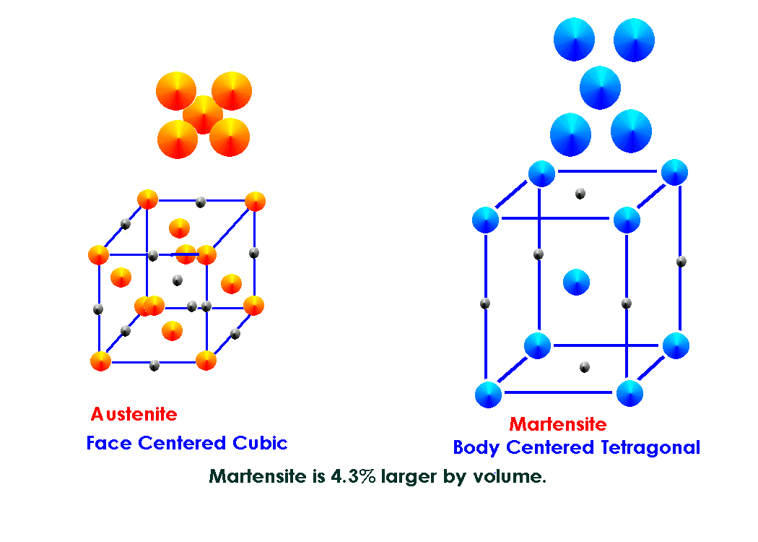
Figure 1: Austenite versus Martensite (http://www.metal-ear.com/images/ausmart.gif)

The Martensite form pertinent to the study of shape memory alloys is a special form known as a thermoelastic Martensite, which are characterized by a low crystallographic energy. That is to say, the transformation to and from Martensite takes a relatively small addition of energy, by temperature or stress, and this small energy barrier leaves the reaction reversible. Stressing a superelastic wire causes the denser Austenite crystal forms to transform into the looser packed Martensite form at a temperature where the Martensite is not native. This microscopic transformation accumulates along the length of a macroscale shape memory alloy element, giving rise to macroscopic strain. This strain is fully recoverable when the stress on the Martensite is relieved, the energy removed, and the Austenite form recovered.

  - Four-Wire Resistance Measurement
When measuring resistance using a multimeter and two leads, the resistance of the leads is in series with the measured load, and will be erroneously included in the result. When measuring elements with a resistance on the same order as that of the leads, or when general high-precision resistance measurements are needed, a four-wire measurement technique can analytically remove the resistance of the leads. The setup entails two leads attached to each end of the resistance to be measured. Resistance measurements for the four binary combinations of lead pairs that bridge the element, combined with the two measurements that simply cross the leads on either side and not the element provide enough equations to solve precisely for the five unknown resistances – the four leads and the element.

- Experimental Procedure
  - Apparatus

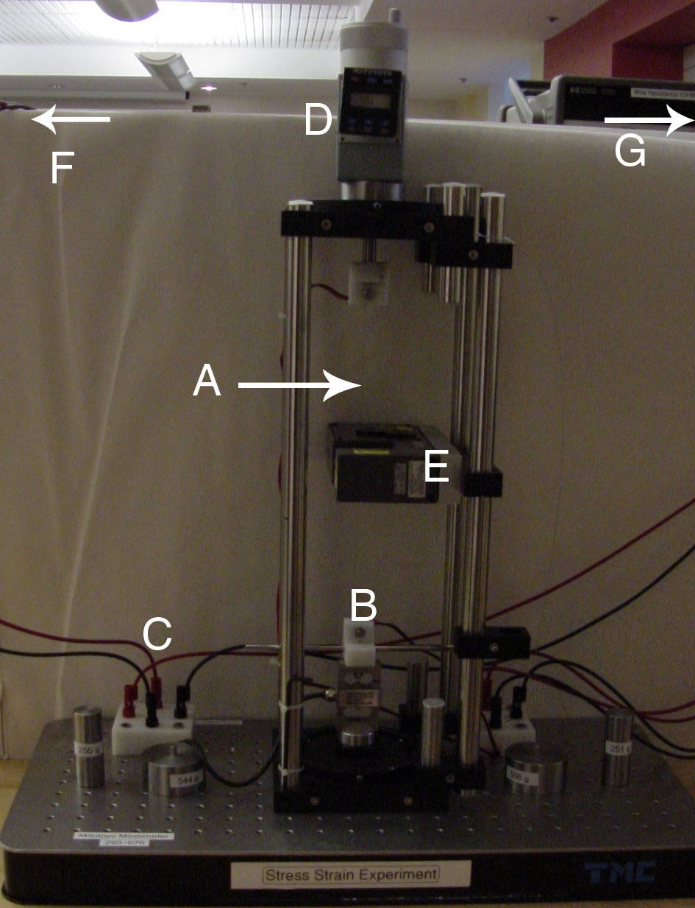
Figure 2: Top down view of lab setup

    - Superelastic Nickel-Titanium Wire
The tested material was a Nickel-Titanium (NiTi, trade name Nitinol) superelastic wire, with an Austenite-Martensite transition temperature of 15ºC, labeled ‘A’ in figure 2

    - Load Cell and Full Wave Bridge
One OmegaDyne, Inc Model LC101-100 S-beam load cell was used to measure the tensile load applied to the wire. The serial number of the load cell was 144472 and it has a specified load range of 0 to 100 lb (45.5kg). The S-beam configuration was show to be highly insensitive to torque. The load cell (figure 3 below and ‘B’ in figure 2 above) signal was fed into a full wave bridge (‘C’ in figure 2).

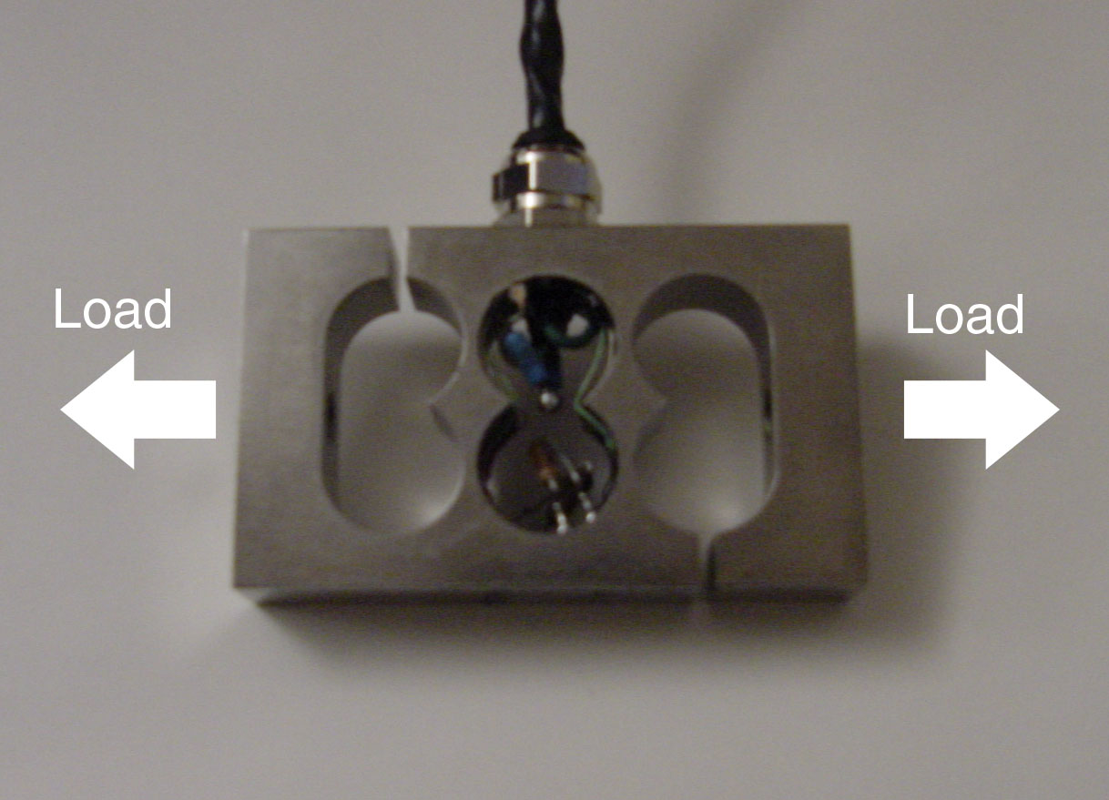
Figure 3: OmegaDyne, Inc LC101-100 Load Cell

    - 50mm maximum travel micrometer with Mitutoyo gauge
The micrometer with precision gauge was used to apply and measure exact displacements, and reliably increment the strain of the wire. The wire was firmly anchored to the movable head of the micrometer, and the body of the micrometer was firmly mounted on the same frame as the lower end of the wire. The micrometer is shown in figure 2, labeled ‘D’

    - Mitutoyo LSM-500 Laser Scan Micrometer
The diameter of the wire was measured with the Mitutoyo LSM-500 Laser Scan Micrometer, shown as ‘E’ in figure 2. The wire passed through the measurement field of the LSM-500, and the LSM-6000 measuring unit (‘G’ figure 2, off screen) acquired a multi-trial average diameter- displaying digits out to 1e-5mm, or 10 nm

    - Hewlett Packard E3610A Power Supply
and 2x 34401A Digital Multimeters
A Hewlett Packard E3610A power supply (‘F’ in figure 2) supplied voltage to the load cell’s full wave bridge. Two Hewlett Packard 34401A Digital Multimeters were used (‘G’ in figure 2) – one used to read the resistance of the wire using a four-wire measurement technique, and the other to read the output of the load cell.

  - Methods
    - Calibrate Load Cell
Masses were hung from the sides of the load cell and the resultant voltage was recorded. The acquired data was used to produce a voltage sensitivity in mV/N-m. The no-load load cell voltage was recorded. A further range of masses were hung to acquire a force-voltage conversion factor.

    - Collect Data
Data collection for each point was comprised of the micrometer reading, load cell output, nitinol wire resistance, and laser measurement of wire diameter. Prior to data collection the micrometer was used to tension the wire until the load cell voltage changed by 0.005mV to ensure the wire was seated and in tension. The micrometer was zeroed and data was collected over seven regimes:
- Austenite Elastic Zone in increasing tension
0.5mm steps
- Austenite-Martensite transition plateau in increasing tension
2mm steps
- Martensite Elastic Zone in increasing tension to 8% strain
0.5mm steps
- Martensite Elastic Zone in decreasing tension
0.5mm steps
- Martensite-Austenite transition plateau in decreasing tension
2mm steps
- Austenite Elastic Zone in decreasing tension
0.5mm steps
- Martensite Zone from 8% strain to failure
0.5mm steps
- Results
 | Accepted Min | Accepted Max | Experimental | Percent Error
Young's Modulus - austenite [Pa] |  | 8.30E+10 | 3.996E+10 | 51.900
Young's Modulus - martensite [Pa] | 2.80E+10 | 4.10E+10 | 1.967E+10 | 29.75% Below
Yield Strength [Pa] | 1.95E+08 | 6.90E+08 | 5.330E+08 | Within Range
Ultimate Tensile Strength [Pa] |  | 1.90E+09 | 1.625E+09 | 14.5
Elongation at Failure [%] | 5 | 10 | 11.78 | 27.8
Poisson's ratio - austenite [1] |  | 0.33 | 0.46 | 39.4
Poisson's ratio - martensite [1] |  | 0.33 | 0.279 | 15.5
Resistivity - no strain [microohm-cm] |  | 100 | 120 | 20.0
Resistivity - max strain [microohm-cm] |  | 80 | 146 | 82.5
Work In [N*mm] |  |  | 224.6
Work Out [N*mm] |  |  | 124.3
Net Work [N*mm] |  |  | 100.3
Heat Engine Efficiency [%] |  |  | 44.66
Average Gage Factor |  |  | 0.3

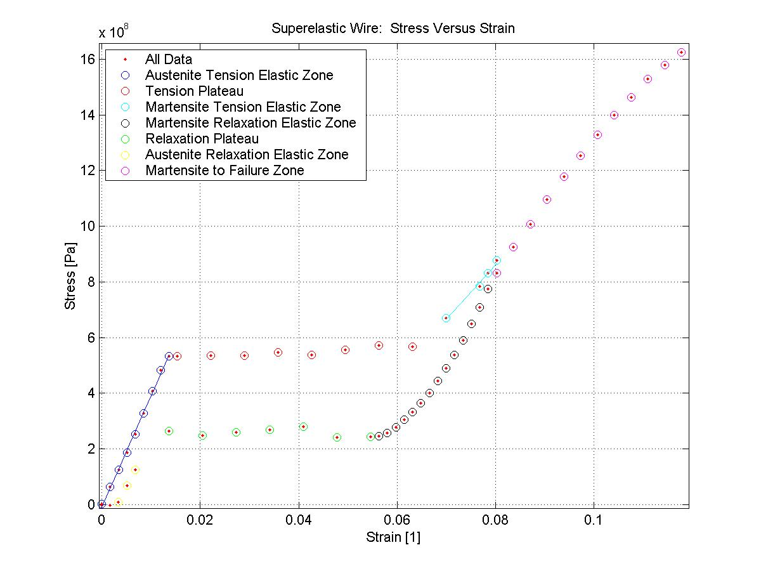
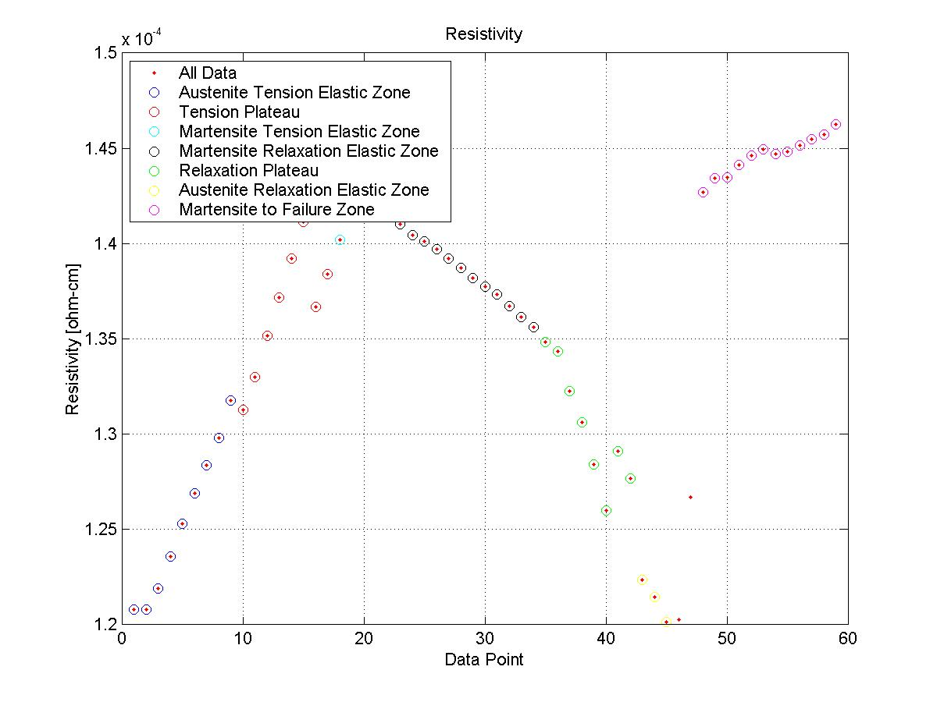
- Analysis and Discussion
  - General Error
The accepted results for many of these categories are wide ranges or round numbers – there appears to be a lot of leeway in determining the material constants pertinent to NiTi allow. Our Young’s Modulus for austenite is a factor of 2 less than the expected value. The transformation temperature for this wire is 15ºC – it seems possible that we were not dealing with a wire that was fully austenite when under no load. Were it not completely austenite, it would exhibit martensite characteristics such as a lower elastic modulus, as seen here. Instrument error seems unlikely – the micrometer is simply read, and is known to be accurate, as is the laser micrometer. Four-wire resistance measurement is also very accurate. The only remaining measurement is that of the load cell voltage. The only suspect area of this measurement would be errors due to torque sensitivity. The torque sensitivity was found to be 0.006 mV/N-mm, and the highest load recorded was 27.5N at 1.95mV. At that voltage and sensitivity, a torque of 3.25 N-mm could induce 1 percent error, or the measured load acting at 0.118mm off-center. The wire mount could conceivably be 2 mm off center, and induce 20% error, however the off-center distance was not recorded. While torque sensitivity probably induced some error, I think the larger source lies somewhere in the inexact behavior of the NiTi wire. On a side note, I am also confused that resistivity for martensite is lower, as ours increased monotonically with strain. Also, our error for the Young’s modulus of martensite is compounded by the fact we have very few points in that region, because we could not go back and refine the sampling after we missed the start of the martensite elastic region.
  - NiTi Strain Gage
The Nickel-Titanium wire gives a low gage factor – 0.3 This indicates that it undergoes a large amount of elongation for a relatively small change in resistance. Aside from some odd behavior at low strains (the gage value overshoot 0.3 and then settles) the NiTi wire would do well in the 3-10% strain range as it stays at a constant gage factor – therefore it would be a useful strain gage for certain geometries and configurations.
  - NiTi Heat Engine
The NiTi wire can be considered a heat engine of sorts, due to the hysteresis evident in the stress-strain curve. Considering a force-displacement curve instead (a close analog to the stress-strain curve, just mildly distorted), the area between the two curves can be seen as the work lost per cycle to various phenomenon – internal damping in the wire, and the production of noise and heat. A simple trapezoidal sum under the upper points of the force-displacement curve gives us the work in, and a similar sum for the lower points gives us the work recovered during relaxation of the wire. Essentially, with repeated cycling of loading and unloading the wire, energy represented by the area between the curves is transformed from mechanical work into essentially heat energy.

References

Austenite versus Martensite – Internet Picture: URL: http://www.metal-ear.com/images/ausmart.gif , 4-3-03.

Introduction to Shape Memory and Superelasticity. Shape Memory Alloys, Inc. c1999. URL: http://www.sma-inc.com/SMAandSE.html , 4-4-03

Hunter, I.W. and Hughey, B.J. Stress Strain Experiment, Laboratory Handout, 2.671 Measurement and Instrumentation, MIT, Spring 2003

Selected Properties of NiTi Shape Memory Alloys, Inc. c1999. URL: http://www.sma-inc.com/NiTiProperties.html 4-3-03

Shape Memory Alloys, Shape Memory Alloys, Inc. c1999. URL: http://www.sma-inc.com/SMApaper.html 4-3-03

A1: Load Cell Calibration

Torque sensitivity: 0.006mV/N-mm

Load[N] downward | Voltage [mV]
2.5 | -0.091
5.45 | -0.293
5.33 | -0.289
10.78 | -0.662
13.29 | -0.832
15.79 | -0.999
0 | 0.074

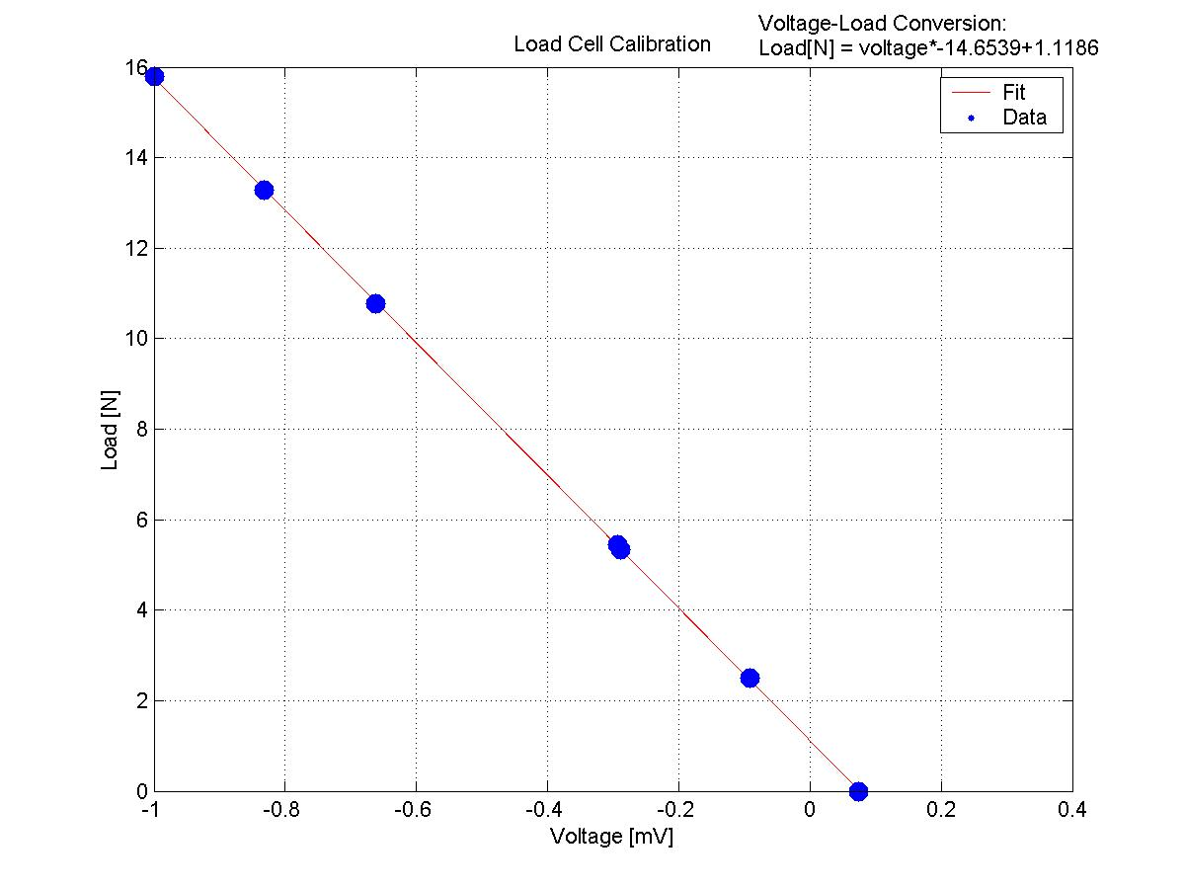

A2: Raw Data

Initial wire diameter: 0.1538mm
Initial wire length: 293m

Notes: Voltage-Force Conversion in Appendix 1
Strain = distance/293
Stress = Force/(d^2/4)

distance (mm) | load cell output (mV) | Force (N) | resistance (Ω) | strain | stress (N/m2) | diameter (mm)
0 | 0.078 | 0.0244042 | 19.05 | 0 | 1313597.732 | 0.1538
0.501 | 0.153 | 1.1234467 | 19.11 | 0.001709898 | 60558029.77 | 0.15369
1 | 0.233 | 2.2957587 | 19.34 | 0.003412969 | 123895146.3 | 0.1536
1.509 | 0.312 | 3.4534168 | 19.67 | 0.005150171 | 186637672.9 | 0.15349
2.003 | 0.394 | 4.6550366 | 20.01 | 0.006836177 | 252005132.3 | 0.15336
2.5 | 0.487 | 6.0178493 | 20.34 | 0.008532423 | 326463222.1 | 0.1532
3.001 | 0.587 | 7.4832393 | 20.65 | 0.010242321 | 406702367.8 | 0.15306
3.514 | 0.682 | 8.8753598 | 20.94 | 0.011993174 | 482866571.3 | 0.15298
4.002 | 0.75 | 9.871825 | 21.16 | 0.013658703 | 533794565.4 | 0.15345
4.501 | 0.743 | 9.7692477 | 21.27 | 0.015361775 | 532055131.2 | 0.1529
6.501 | 0.744 | 9.7839016 | 21.75 | 0.022187713 | 534179979.8 | 0.15271
8.507 | 0.746 | 9.8132094 | 22.24 | 0.02903413 | 535569675.8 | 0.15274
10.5 | 0.76 | 10.018364 | 22.72 | 0.035836177 | 546766276.1 | 0.15274
12.5 | 0.75 | 9.871825 | 23.2 | 0.042662116 | 538486626.6 | 0.15278
14.5 | 0.771 | 10.1795569 | 23.69 | 0.049488055 | 555709126 | 0.15272
16.505 | 0.76 | 10.018364 | 24.17 | 0.056331058 | 572329137.2 | 0.14929
18.5 | 0.754 | 9.9304406 | 24.66 | 0.063139932 | 568067018.9 | 0.14919
20.503 | 0.872 | 11.6596008 | 25.24 | 0.069976109 | 669583543.4 | 0.1489
22.5 | 1.004 | 13.5939156 | 25.78 | 0.076791809 | 783505589.6 | 0.14863
23 | 1.06 | 14.414534 | 25.93 | 0.078498294 | 831474329.6 | 0.14857
23.5 | 1.111 | 15.1618829 | 26.07 | 0.080204778 | 876116243.2 | 0.14844
22.997 | 0.992 | 13.4180688 | 25.78 | 0.078488055 | 773995174.6 | 0.14857
22.501 | 0.917 | 12.3190263 | 25.62 | 0.076795222 | 709452535.2 | 0.14869
22 | 0.847 | 11.2932533 | 25.468 | 0.075085324 | 650203357 | 0.14871
21.5 | 0.777 | 10.2674803 | 25.32 | 0.07337884 | 589874995.4 | 0.14887
20.999 | 0.715 | 9.3589385 | 25.16 | 0.071668942 | 536740717.1 | 0.149
20.5 | 0.659 | 8.5383201 | 25.01 | 0.06996587 | 489217985.5 | 0.14907
20 | 0.606 | 7.7616634 | 24.84 | 0.068259386 | 444062484.7 | 0.14918
19.497 | 0.555 | 7.0143145 | 24.68 | 0.066542662 | 400821172.6 | 0.14927
19 | 0.512 | 6.3841968 | 24.53 | 0.064846416 | 364423435.3 | 0.14935
18.5 | 0.473 | 5.8126947 | 24.36 | 0.063139932 | 331002544.2 | 0.14953
17.995 | 0.441 | 5.3437699 | 24.2 | 0.061416382 | 304177665.1 | 0.14956
17.5 | 0.41 | 4.889499 | 24.02 | 0.059726962 | 277799363.6 | 0.1497
17 | 0.385 | 4.5231515 | 23.85 | 0.058020478 | 256642154.9 | 0.1498
16.5 | 0.373 | 4.3473047 | 23.66 | 0.056313993 | 246500084 | 0.14985
16 | 0.368 | 4.2740352 | 23.53 | 0.054607509 | 242248563.9 | 0.14988
14 | 0.366 | 4.2447274 | 22.98 | 0.04778157 | 240202637.7 | 0.15
12 | 0.414 | 4.9481146 | 22.51 | 0.040955631 | 279558771.6 | 0.15012
10 | 0.4 | 4.74296 | 21.97 | 0.034129693 | 267789525.6 | 0.15017
7.999 | 0.39 | 4.596421 | 21.44 | 0.027300341 | 259861846.8 | 0.15007
6 | 0.388 | 4.5671132 | 20.91 | 0.020477816 | 247406607.6 | 0.15331
4 | 0.41 | 4.889499 | 20.43 | 0.013651877 | 263459640.9 | 0.15372
1.997 | 0.233 | 2.2957587 | 19.47 | 0.0068157 | 123846763.9 | 0.15363
1.5 | 0.162 | 1.2553318 | 19.18 | 0.005119454 | 67307543.19 | 0.1541
0.993 | 0.088 | 0.1709432 | 18.98 | 0.003389078 | 9186968.042 | 0.15392
0.5 | 0.073 | -0.0488653 | 18.97 | 0.001706485 | -2626499.839 | 0.15391
-0.006 | 0.072 | -0.0635192 | 18.98 | -2.04778E-05 | -3247891.461 | 0.1578
23.504 | 1.061 | 14.4291879 | 26.02 | 0.08021843 | 831312129.9 | 0.14866
24.504 | 1.171 | 16.0411169 | 26.29 | 0.083631399 | 926173140.2 | 0.1485
25.5 | 1.262 | 17.3746218 | 26.48 | 0.087030717 | 1006824159 | 0.14823
26.5 | 1.365 | 18.8839735 | 26.73 | 0.090443686 | 1096209978 | 0.1481
27.5 | 1.457 | 20.2321323 | 26.98 | 0.093856655 | 1177648800 | 0.1479
28.5 | 1.543 | 21.4923677 | 27.17 | 0.097269625 | 1253205236 | 0.14777
29.5 | 1.627 | 22.7232953 | 27.31 | 0.100682594 | 1329834995 | 0.1475
30.5 | 1.703 | 23.8369917 | 27.49 | 0.104095563 | 1398802620 | 0.1473
31.516 | 1.777 | 24.9213803 | 27.68 | 0.10756314 | 1464424405 | 0.1472
32.5 | 1.847 | 25.9471533 | 27.9 | 0.110921502 | 1528852310 | 0.147
33.5 | 1.9 | 26.72381 | 28.11 | 0.114334471 | 1578907725 | 0.1468
34.509 | 1.95 | 27.456505 | 28.36 | 0.117778157 | 1625517334 | 0.14665

