Job Aid 03 Violations Comparisons

USE
This report can be used to gain insight into the progress MIT is making with respect to reducing and mitigating risk exposure. The report provides an overview of violations remediation/mitigation progress.
INFORMATION
Violation count and comparison over time.
RELATED PROCESSES
- Process 5: Periodic Compliance Reviews
SPECIFIC SCENARIOS
- N/A

Step | Description | Screenshot
1 | Navigate to the ‘Reports and Analytics’ tab.
2 | Click on the ‘Violations Comparisons’ report located in the ‘Access Dashboards’ section.
3 | The report will show risk violations information over time, across all systems (to which GRC is connected) on a monthly basis, at the user level. The count will be given by permission (i.e. each instance of a violation will be counted, even if it is a repeated violation for a user).  The report data must be appropriately filtered to provide information that can be of use to MIT. | 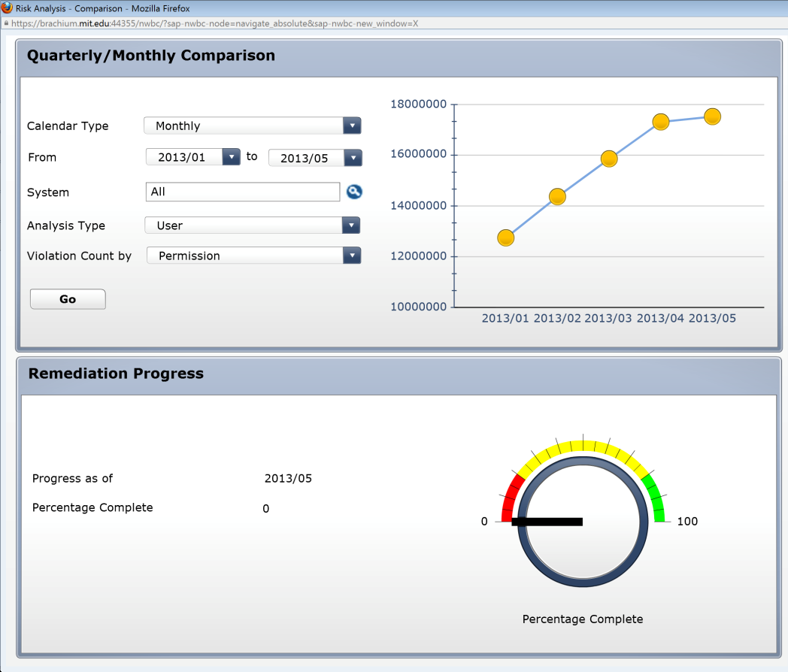
4 | In the report filters section, click on the drop down for ‘Calendar Type’ to select the reporting periods by which data will be reported. In this case, ‘Monthly’ is selected.
5 | In the report filters section, click on the drop down for ‘From’ to select the start of the time period for which data is required. In this case, ‘2013/01’ is selected. Next, click on the drop down for ‘to’ to select the end of the time period for which data is required. In this case, ‘2013/05’ is selected.
6 | In the report filters section, select the System for which information is required. Click on the Search icon next to ‘System’. Since the desired selection is PS1 (Production), select the Connector for PS1; if necessary, ‘*PS1*’ can be used as search criteria to find the correct connector for PS1. Click on ‘OK’.
7 | In the report filters section, click on the drop down for ‘Analysis Type’ to select the Security Object (User, Role or Profile) for which data is required. In this case, ‘User’ is selected.
8 | In the report filters section, click on the drop down for ‘Violation Count by’ to select the count methodology required for the report. In this case, ‘Access Risk’ is selected to count unique violations per User.
9 | Click on ‘Go’ to execute the report based on the criteria that have been defined.
10 | The report shows the steady decrease in Access Risk violations in MIT’s Production System since the start of the SOD/GRC initiative. A cleanup of the majority of the VPF Areas has yeilded a cleanup of 12% of the PS1 system. | 