Job Aid 04 Access Rule Library

USE
This report can be used to understand MIT’s GRC rule set. The report provides an overview of risk rules in GRC.
INFORMATION
Rule count by risk level and process.
RELATED PROCESSES
- Process 5: Periodic Compliance Reviews
SPECIFIC SCENARIOS
- Step 5A: Analyze report data by Risk Level. (Pie Chart)
- Step 5B: Analyze Access Rules by Business Process. (Table)
- Step 5C: Analyze report data by Business Process. (Bar Graph)

Step | Description | Screenshot
1 | Navigate to the ‘Reports and Analytics’ tab.
2 | Click on the ‘Access Rule Library’ report located in the ‘Access Dashboards’ section.
3 | The report will show information on rules that are defined within all rule sets within the GRC environment. | 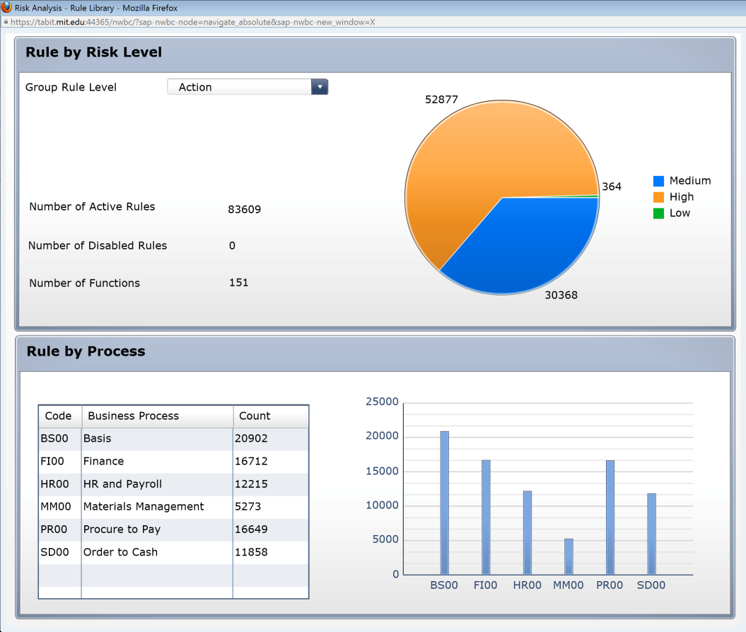
4 | The report data can be filtered to provide information pertaining to rules that are specific to Actions and Permissions. The report can also be filtered to provide information on Critical Actions, Critical Permissions, and Access Risks, including how many of each exist. In this case, ‘Actions’ is selected.
5A-1 | Analyze report data by risk level.  Scroll over the different pieces of the pie chart to see information about unmitigated violations at each risk level.  Click on the ‘Low’ risk level piece of the pie chart for more information about rules that pertain to Low Level Risks.
5A-2 | Analyze the data. This data can also be exported. See the ‘Export Data from GRC’ reference document (R8) for further information.  Access Risk ID: The 4-digit ID representing each Low Risk (as defined in the standard rule set) for which violations exist  Description: Business description of the Access Risk  Business Process: The 4-digit ID representing the Business Process to which the Access Risk has been mapped in the standard rule set  Business Process Description: The business description for the Business Process to which the Access Risk has been mapped in the standard rule set  Risk Level: The risk level defined for each Access Risk in the standard rule set  Active: Whether the rule is active  Rule Count: The number of rules for each Access Risk that exist
5A-3 | Click on the ‘Rule Count’ link for each Access Risk to view the actual rule definitions. In this case, clicking on ‘3’ for Access Risk ‘F009’ shows the details of the 3 rules that make up that Risk.
5B-1 | Analyze Access Rules by Business Process.  Scroll over the different line items of the Business Process Table to see information about rules for Risks mapped to each Business Process.  Click on the ‘HR and Payroll’ Risk row of the Table for more information about rules for HR/Payroll Risks.
5B-2 | Analyze the data. This data can also be exported. See the ‘Export Data from GRC’ reference document (R8) for further information.  Access Risk: The 4-digit ID representing each Finance-Risk (as defined in the standard rule set) for which violations exist  Description: Business description of the Access Risk  Business Process: The 4-digit ID representing the Business Process to which the Access Risk has been mapped in the standard rule set  Business Process Description: The business description for the Business Process to which the Access Risk has been mapped in the standard rule set  Risk Level: The risk level defined for each Access Risk in the standard rule set  Active: Whether the rule is active  Rule Count: The number of rules for each Access Risk that exist
5C-1 | Analyze report data by Business Process.  Scroll over the different bars of the Business Process Bar Graph to see information about Rules for Risks tied to each Business Process.  Click on the ‘FI00’ Risk bar of the Graph for more information about Rules related to Finance Risks.
5C-2 | Analyze the data. This data can also be exported. See the ‘Export Data from GRC’ reference document (R8) for further information.  Access Risk: The 4-digit ID representing each Finance-Risk (as defined in the standard rule set) for which violations exist  Description: Business description of the Access Risk  Business Process: The 4-digit ID representing the Business Process to which the Access Risk has been mapped in the standard rule set  Business Process Description: The business description for the Business Process to which the Access Risk has been mapped in the standard rule set  Risk Level: The risk level defined for each Access Risk in the standard rule set  Active: Whether the rule is active  Rule Count: The number of rules for each Access Risk that exist

