Job Aid 05 SUIM Roles by Role Name

USE
This report can be used to understand the mapping between single and composite roles. The report displays which single roles are assigned to a composite role.
INFORMATION
Report shows:
- List of transaction codes included in the roles
- Other composite roles which have a selected single role
- Users assigned to the roles
RELATED PROCESSES
- Process 1: New or Amended Roles
SPECIFIC SCENARIOS
- N/A

Step | Description | Screenshot
1 | In SAP R/3 EEC– use transaction code SUIM.  Then click on the ‘Roles’ node and double click on the option for “By Role Name”  Or use Transaction Code  - S_BCE_68001418 | 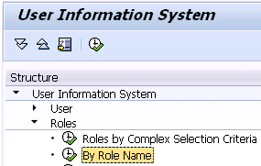
2 | Select the Composite Role or Roles to be analyzed  – e.g. Z_VPF*  Also, check the “Composite Roles” selection only, so that single roles are not listed at this point. | 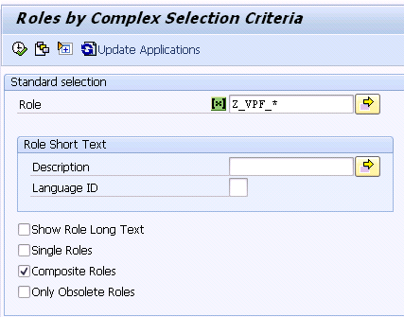
3 | The report will show a list of Composite Roles matching the selection criteria. It shows :  - Role id  - Role name  From this report, you can drill down to get the following information :  - Administrative Details  - Transaction Assignments  - Contained Single roles  - Users Assigned the composite role | 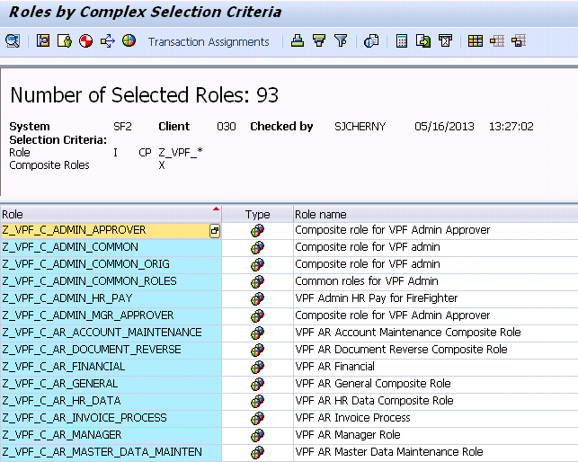
3a | ADMINISTRATIVE DETAILS  Double click on a Composite role or  Click on a Composite Role to highlight it, then :  Menu : GoTo Display details  or Icon  To exit back to the list, click on  Back (F3).  Click on Roles tab to see a list of roles – but this the long way – see 3.c instead. | 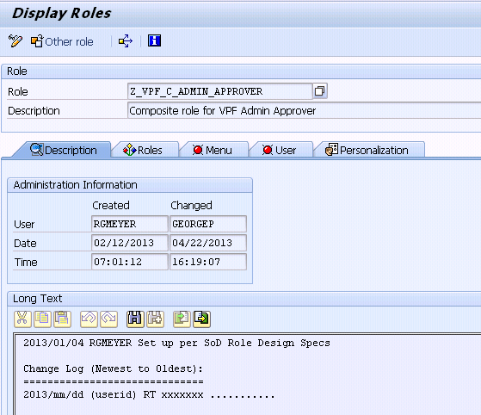
3b | TRANSACTIONS  For the Transaction List , click on a Composite Role to highlight it, then :  Menu : Role Transaction Assignments  or Icon  There is no more drill down from here.  To exit the list, click on  Back (F3). | 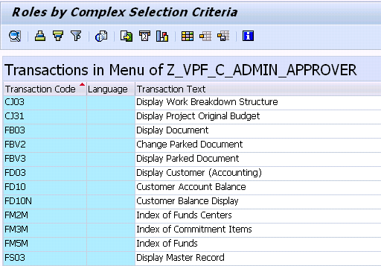
3c | ROLES CONTAINED  For the quick Role List , click on a Composite Role to highlight it, then :  Menu : Role Contained Single Roles  or  Click on Icon  To drilldown further on the single role – see Step 4 for details.  To exit the list, click on  Back (F3). | 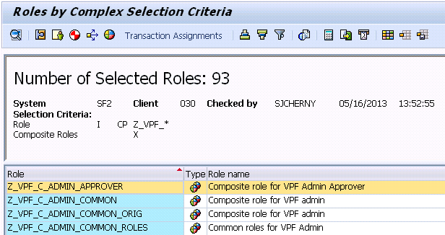
3d | USERS ASSIGNED  Menu : Role User Assignment  or  Click on Icon | 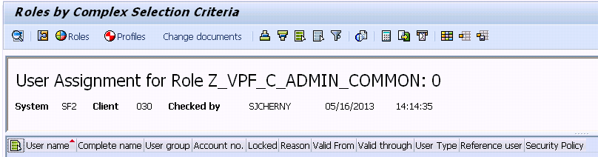
4 | From the list of Single Roles you can click on a role to highlight it and use the icons or menu to :  - Display (Administrative) Details  - See transactions for the single role.  - Find which other Composite Roles include this single role | 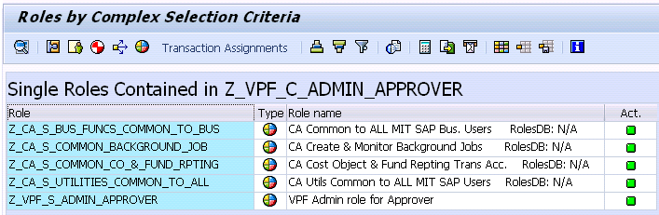
4a | DATE LAST CHANGED  Click on a role to highlight it  then  Click on Icon or use Menu : GoTo Display (Administrative) Details  Or double click on the role.  To exit, click on  Back (F3). | 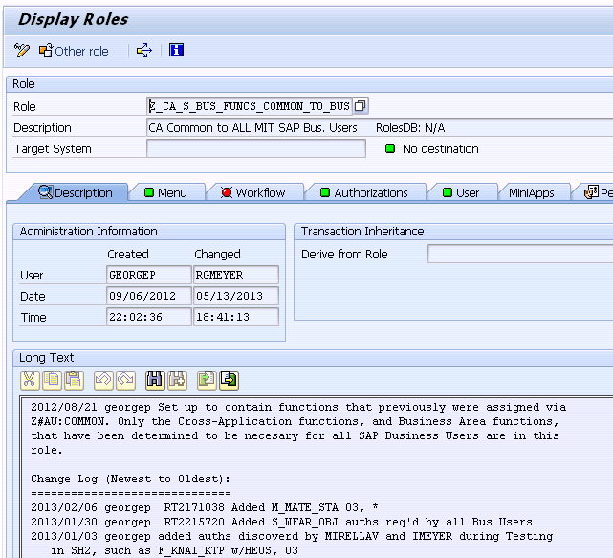
4b | TRANSACTION ASSIGNMENT  Click on a role to highlight it  then  Click on Icon  or use Menu : Role Transaction Assignments  To exit, click on  Back (F3). | 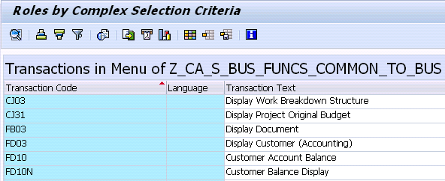
4c | WHERE USED IN COMP ROLES  Click on a role to highlight it  then  Click on Icon  To exit, click on  Back (F3). | 