Job Aid 06 User to Role Relationship

USE
This report can be used to determine all users assigned to the roles for which each Role Owner is responsible, and also to review this access.
INFORMATION
List of all users with access to a particular role or set of roles.
SPECIFIC ACTIONS COVERED
- Navigating to the report (steps 1-2).
- Setting up a variant for the roles in your area (steps 3-7).
- Setting up a background job using your variant (steps 8-10).
- Reviewing the background job (steps 11-15).

Step | Description | Screenshot
1 | Navigate to the ‘Reports and Analytics’ tab.
2 | Click on the ‘User to Role Relationship’ report located in the ‘Role Management Reports’ section.
3 | Select the system for which information is required. In this case, the selection is PS1.
4 | Select whether to include information on role assignments which have expired for users (i.e. that have assignment end-dates prior to the current date). In this case, the selection is ‘Yes’.
5 | Add a line item for each role that you are responsible for.  For example, if you are the Role Owner for AR, you would add 24 lines for the following:  - Z_VPF_C_AR_ACCOUNT_MAINTENANCE  - Z_VPF_C_AR_DOCUMENT_REVERSE  - Z_VPF_C_AR_FINANCIAL  - Z_VPF_C_AR_GENERAL  - Z_VPF_C_AR_HR_DATA  - Z_VPF_C_AR_INVOICE_PROCESS  - Z_VPF_C_AR_MANAGER  - Z_VPF_C_AR_MASTER_DATA_MAINTEN  - Z_VPF_C_AR_POST_DOCUMENT  - Z_VPF_C_AR_RDBP  - Z_VPF_C_AR_SENIOR_FINANCIAL  - Z_VPF_S_AR_ACCOUNT_MAINTENANCE  - Z_VPF_S_AR_ARCH_INV  - Z_VPF_S_AR_CR_ZC10  - Z_VPF_S_AR_DOCUMENT_REVERSE  - Z_VPF_S_AR_FINANCIAL_LCP1_ACC  - Z_VPF_S_AR_GENERAL  - Z_VPF_S_AR_HR_DATA  - Z_VPF_S_AR_INVOICE_PROCESS  - Z_VPF_S_AR_MANAGER  - Z_VPF_S_AR_MASTER_DATA_MAINT  - Z_VPF_S_AR_POST_DOCUMENT  - Z_VPF_S_AR_RDBP  - Z_VPF_S_AR_SOD_REPORTING  If you are not aware of the scope of roles within your responsibility, please reach out to your BA/BSA Support Team for this information.
6 | Copy and paste the name of the roles into each row, based upon the list of roles for which you are responsible.  The search option can also be used to search for a role. Please refer to the ‘Search for Input Values’ reference document (R3) for further information.
7 | Enter a name for your variant in the ‘Save Variant as’ field in the bottom right corner of the report and click on ‘Save’.  You have now created a variant with all of the roles in your area. As this list of roles may change (old roles may become obsolete, new roles may be added), it is critical that your variant for this report is updated accordingly and your background job rescheduled with the new variant, or the report will no longer report accurately for your area. | 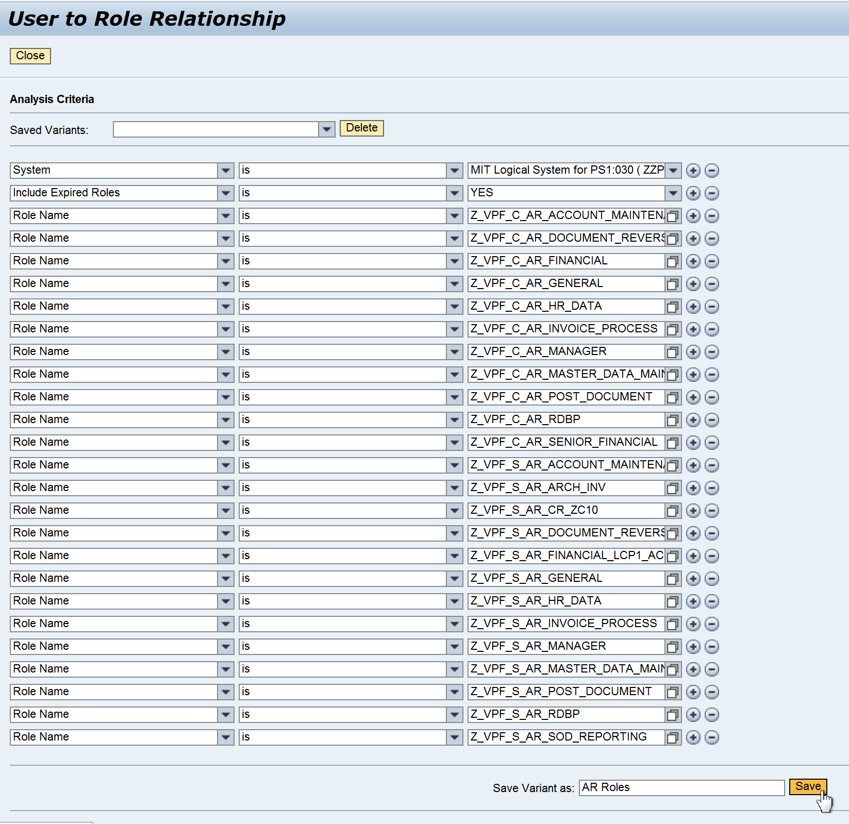
8 | Rexecute the report and select the variant you created. Validate that the variant was correctly created with all roles for your area.
9 | Select ‘Run in Background’. | 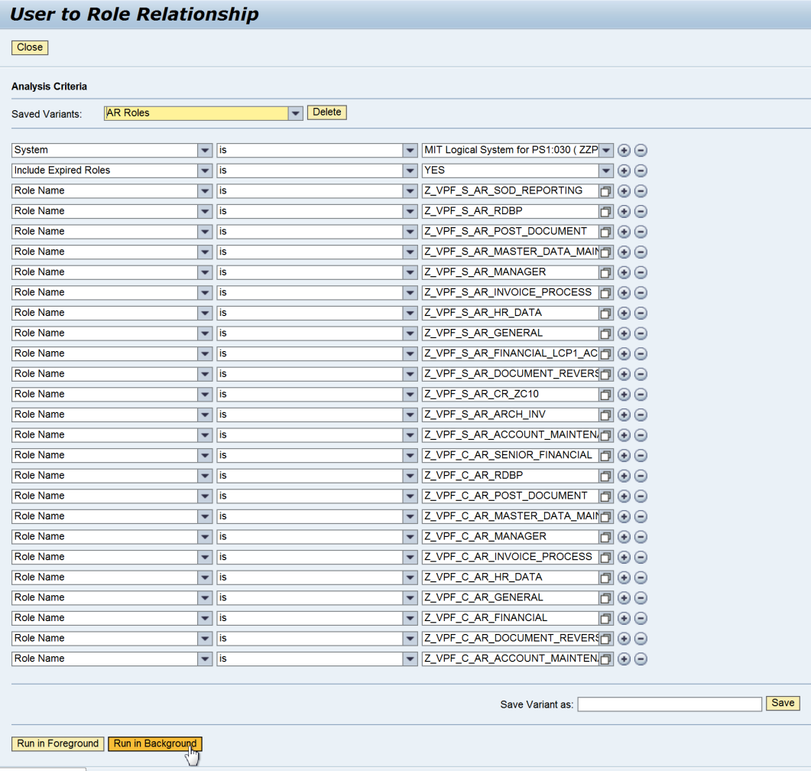
10 | Define the schedule for your background job. The criteria shown will schedule a job for a period of one year, to execute on the first of every month.
11 | Once you are expecting the job to have run, navigate to the ‘Access Management’ tab.
12 | Click on the ‘Background Jobs’ link under ‘Scheduling’.
13 | Select the job which you wish to view. Ensure that the status of the job is ‘Finished’ and that you are selecting the correct job for the period you wish to review. In this case, we will find the job based on the name we defined in step 10.  Click on the ‘View Results’ button.
14 | The report results will be displayed. In order to make review of User Access easier, it is helpful to sort the results by Role Name.  Click on the ‘Role Name’ header to sort the list by role. | 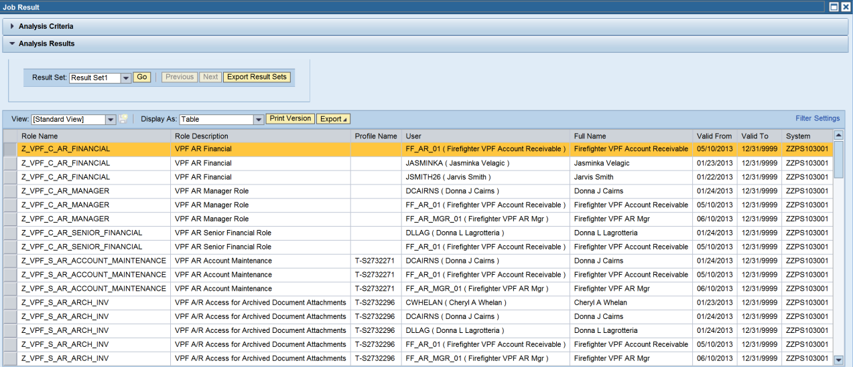
15 | For each role, review the report to ensure that the correct people have access. You should review:  - Any users who have left your area but who still have access to your roles  - Any users outside your area who have been assigned access to your roles  - All users in your area have roles that align to their CURRENT jobs and responsibilities | 