Job Aid 06 User to Role Relationship

USE
This report can be used to determine all users assigned to a role.
INFORMATION
List of all users with access to a particular role or set of roles.
RELATED PROCESSES
- Process 1: New or Amended Roles
SPECIFIC SCENARIOS
- Step 5A: Analyze for a single role.
- Step 5B: Analyze for multiple roles by specific role names.
- Step 5C: Analyze for multiple roles by using a wild card (*) in the role name.

Step | Description | Screenshot
1 | Navigate to the ‘Reports and Analytics’ tab.
2 | Click on the ‘User to Role Relationship’ report located in the ‘Role Management Reports’ section.
3 | Select the system for which information is required. In this case, the selection is PS1.
4 | Select whether to include information on role assignments which have expired for users (i.e. that have assignment end-dates prior to the current date). In this case, the selection is ‘Yes’.
5A-1 | Analyze for a single role. Add the role name. In this case, ‘Z_VPF_S_AR_GENERAL’ was typed in. The search option can also be used to search for a role. Please refer to the ‘Search for Input Values’ reference document (R3) for further information.
5A-2 | Run the report in the foreground. If the report is expected to yield a large amount of data, execute the report by running a background job. See the ‘Execute a Background Job’ reference document (R5) for further information.
5A-3 | Analyze the data. This data can also be exported. See the ‘Export Data from GRC’ reference document (R8) for further information.  Role Name: SAP role name  Role Description: Business name for SAP role  Profile Name: Name of SAP profile associated with SAP role (technical information)  User: User ID of the user with access to the role  Full Name: User name of user with access to role  Valid From: Date on which assignment of the role to the user begins  Valid To: Date on which assignment of the role to the user ends  System: The system in which the role is assigned to the user
5B-1 | Analyze for multiple roles by specific role names. To do this, we can add the first role name. In this case, ‘Z_VPF_S_AR_GENERAL’ was typed in. The search option can also be used to search for a role. Please refer to the ‘Search for Input Values’ reference document (R3) for further information.  Next, add an additional Search Line. See the ‘Add or Remove Search Lines to a Report’ reference document (R2) for further information.
5B-2 | Add the additional role name. In this case, ‘Z_VPF_S_AR_MANAGER’ was typed in. The search option can also be used to search for a role.
5B-3 | Run the report in the foreground. If the report is expected to yield a large amount of data, execute the report by running a background job. See the ‘Execute a Background Job’ reference document (R5) for further information.
5B-4 | Analyze the data. This data can also be exported. See the ‘Export Data from GRC’ reference document (R8) for further information.  Role Name: SAP role name  Role Description: Business name for SAP role  Profile Name: Name of SAP profile associated with SAP role (technical information)  User: User ID of the user with access to the role  Full Name: User name of user with access to role  Valid From: Date on which assignment of the role to the user begins  Valid To: Date on which assignment of the role to the user ends  System: The system in which the role is assigned to the user
5C-1 | Analyze for multiple roles by using a wild card (*) in the role name. In this case, ‘Z_VPF_S_AR*’ is the selection.  Alternatively, the operand for the ‘Role Name’ search criteron can be changed from ‘is’ to ‘starts with’/‘contains’ and ‘Z_VPF_S_AR’ can be used as the selection.
5C-2 | Run the report in the foreground. If the report is expected to yield a large amount of data, execute the report by running a background job. See the ‘Execute a Background Job’ reference document (R5) for further information.
5C-3 | Analyze the data. This data can also be exported. See the ‘Export Data from GRC’ reference document (R8) for further information.  Role Name: SAP role name  Role Description: Business name for SAP role  Profile Name: Name of SAP profile associated with SAP role (technical information)  User: User ID of the user with access to the role  Full Name: User name of user with access to role  Valid From: Date on which assignment of the role to the user begins  Valid To: Date on which assignment of the role to the user ends  System: The system in which the role is assigned to the user | 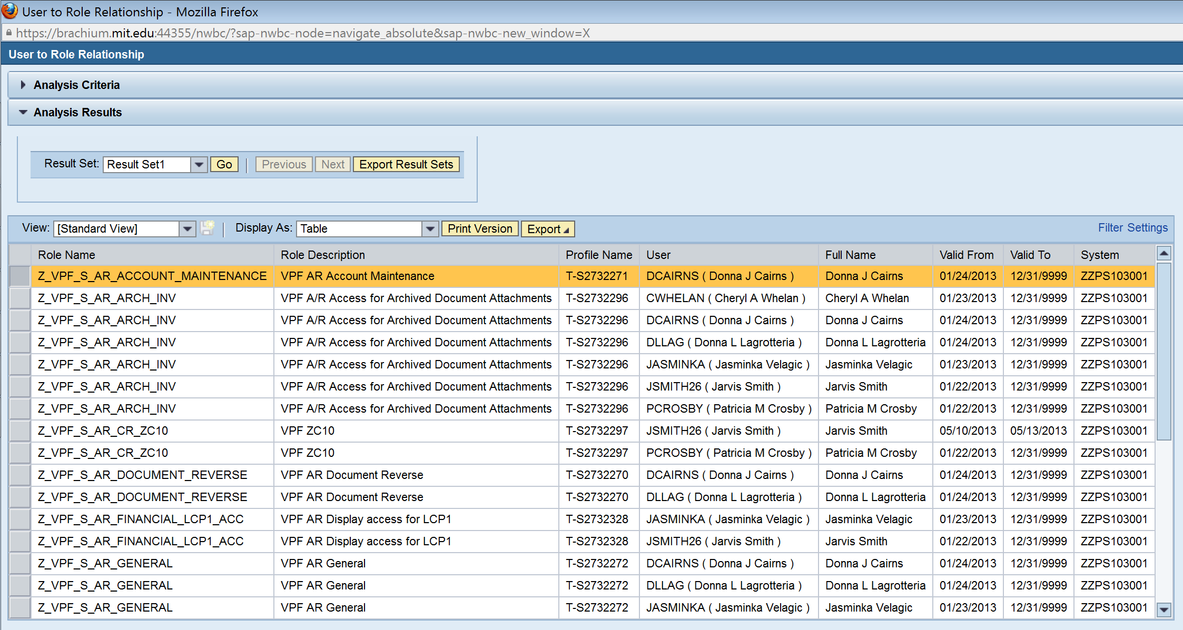
5C-4 | Sorting on role by clicking on the ‘Role Name’ column header will show the users grouped by role. | 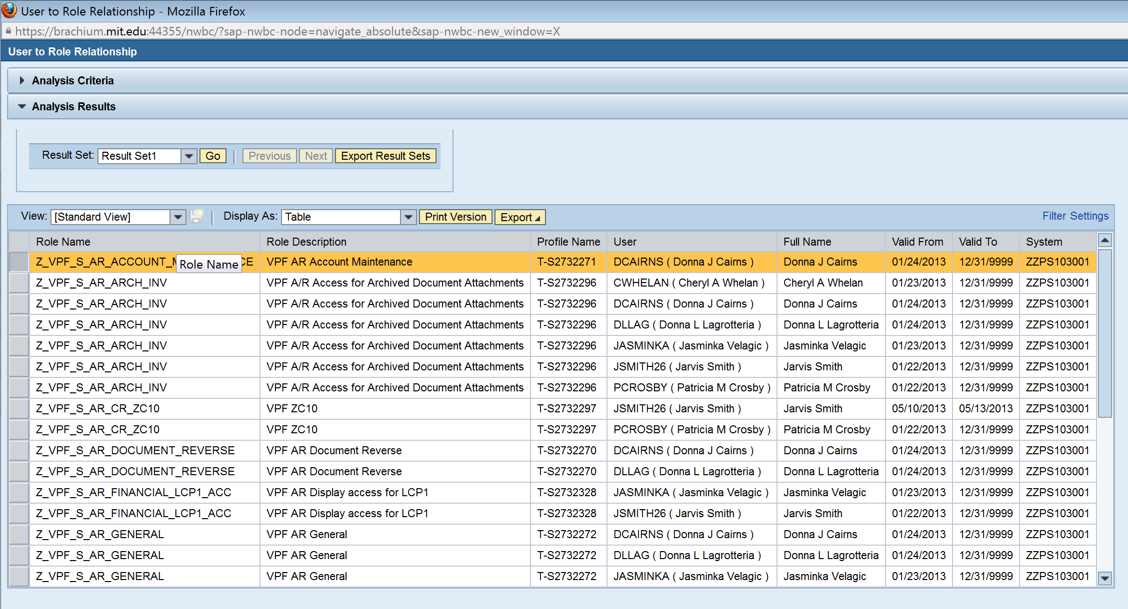  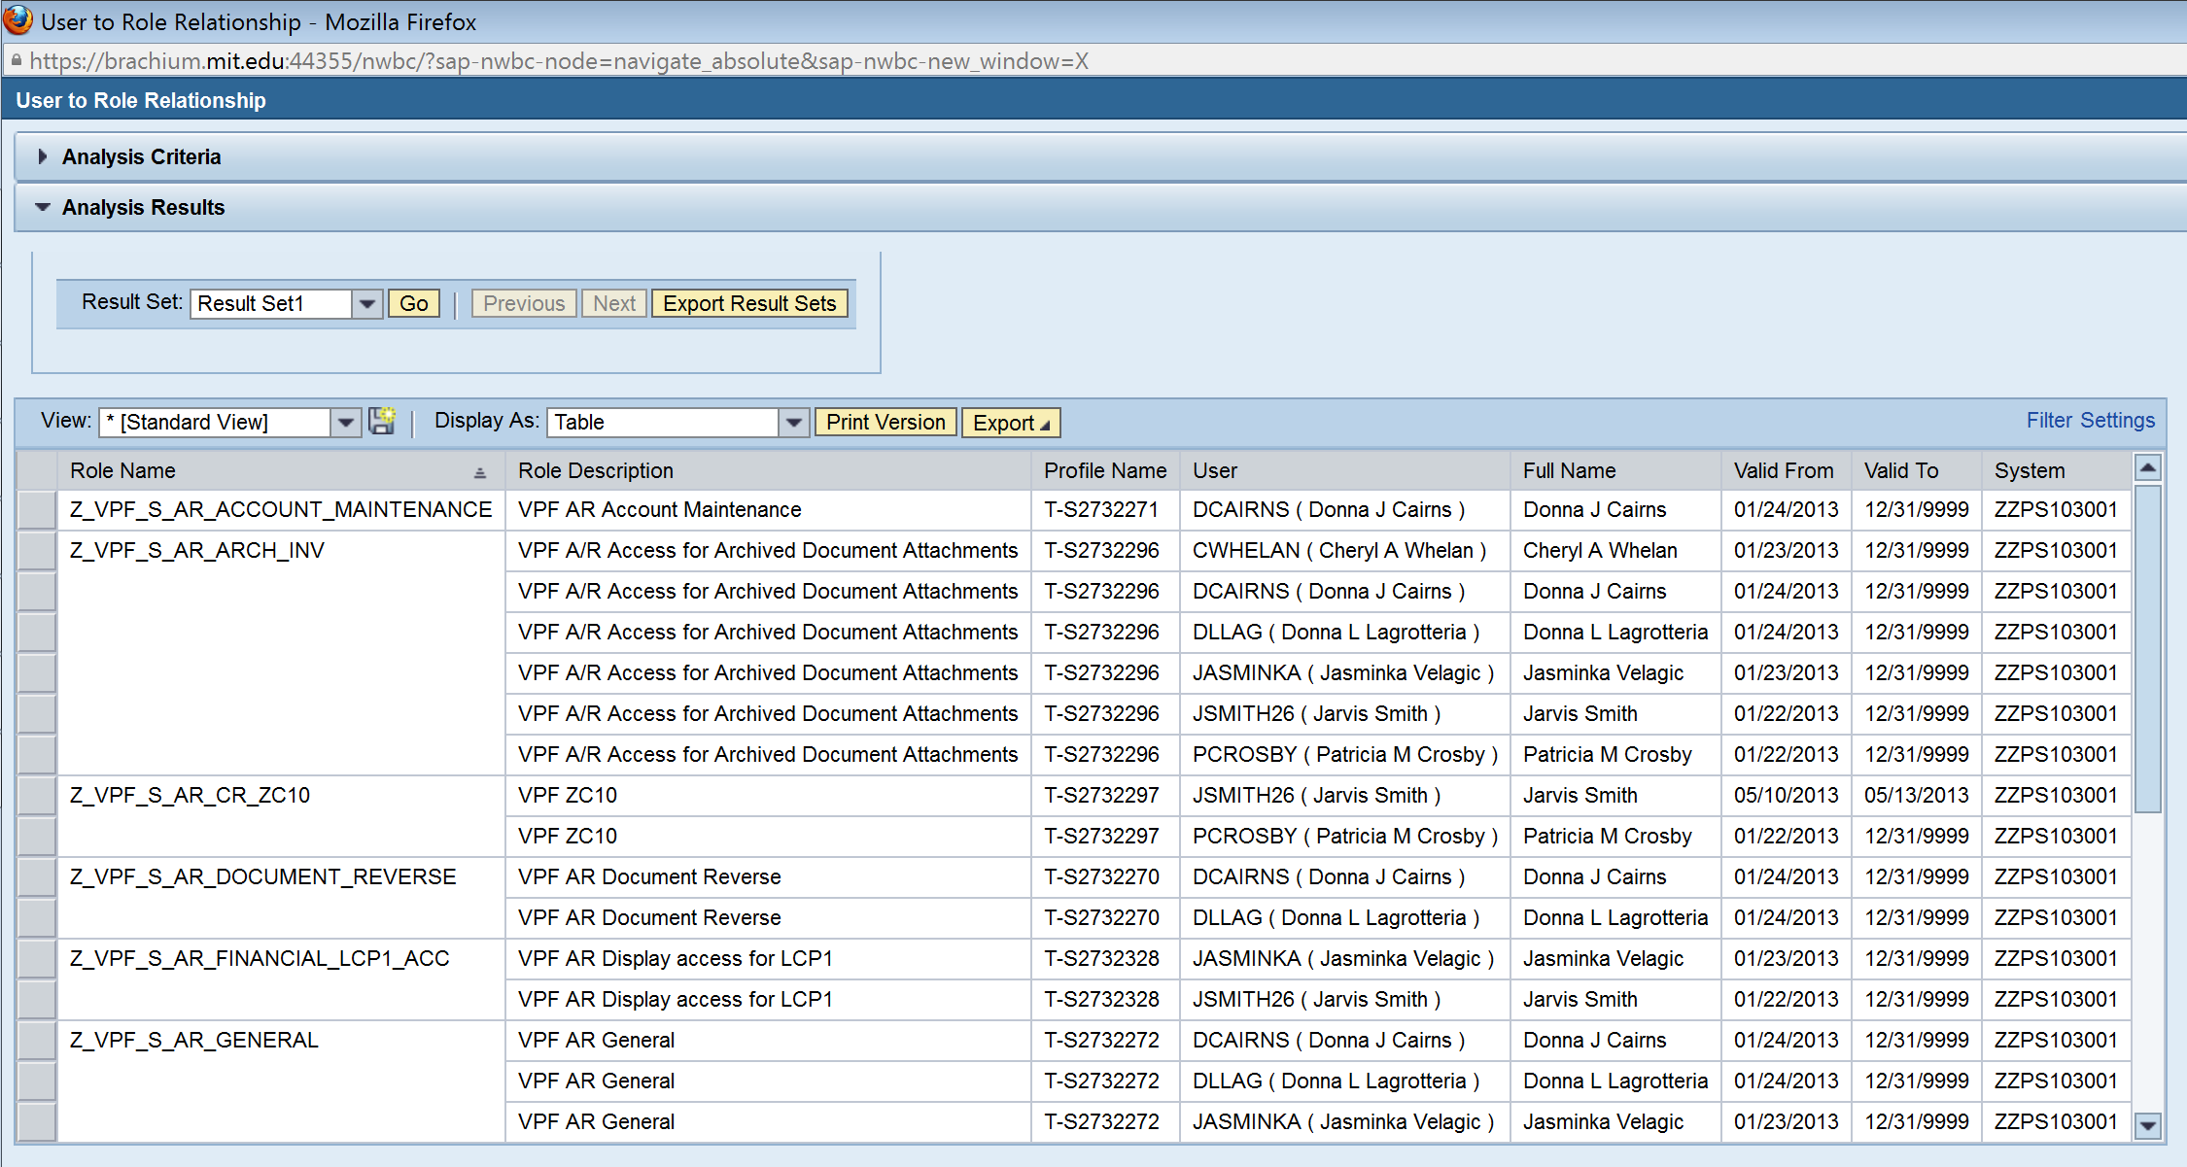
5C-5 | Sorting on user by clicking on the ‘User’ column header will show the roles grouped by user. | 