Job Aid 08 SUIM Users by User ID

USE
This report can be used to display which roles users have and compare their access by sorting by role.
INFORMATION
Roles and profiles assigned to users.
RELATED PROCESSES
- Process 1: New or Amended Roles
SPECIFIC SCENARIOS
- N/A

Step | Description | Screenshot
1 | In SAP R/3 EEC– use transaction code SUIM.  Then click on the “User” node and then “Users by Complex Selection Criteria” – then finally double click on the option for “ByUserId”  Or use Transaction Code  - S_BCE_68001394 | 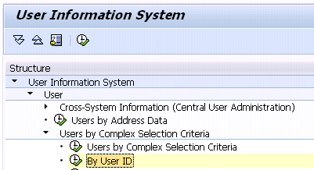
2 | Select the Users to be analyzed  Use the “Multiple Selection” button to specify the users, then to save and exit the multiple selection screen. | 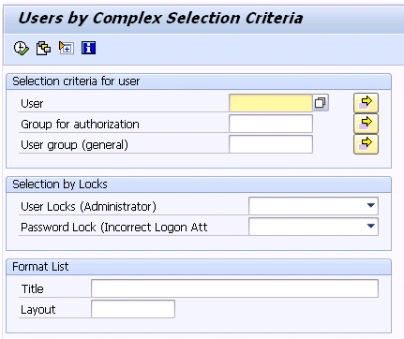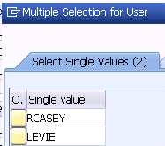
3 | The report will show a list of Users matching the selection criteria. It shows :  - User Id and name  - User Group  From this report, you can drill down to get the role assignments. | 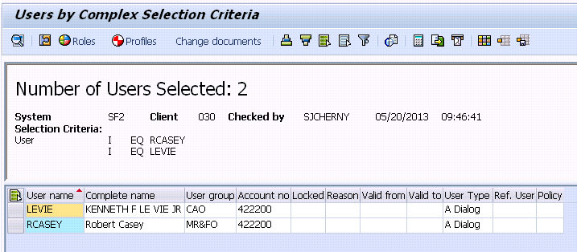
4a | Click on to select both (all) users | 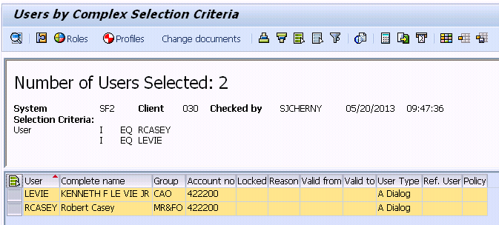
4b | Click on to list all the roles for the selected users | 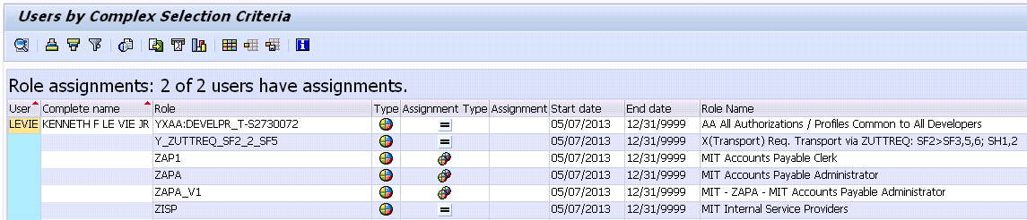
4c | Click on the Role Column header and then click on the Sort (Ascending) icon .  This gives a list of Users per role showing :  - User Id and name  - Role Id and name  - Type of role  - Composite  - Single  - Start & end date  Analysis : either one or both the users have a role.  There is no more detailed drilldown from this report. | 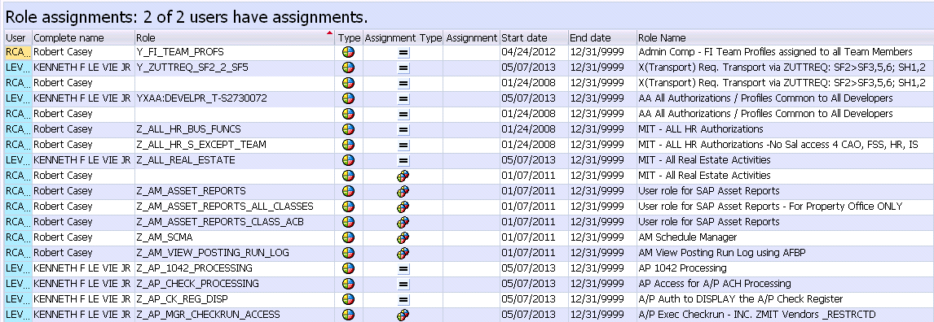
4d | If this report is to be used frequently, change and save display layout.  Use the standard layout management icons :  Example layout – sorted on Role then User | 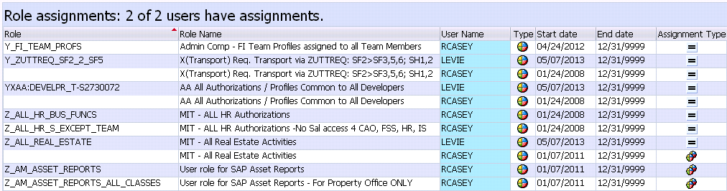
5a | Back to the User list – an alternative display for a single user shows all profiles (not just those from roles)  Click on to select both (all) users  Then click on to list the profiles | 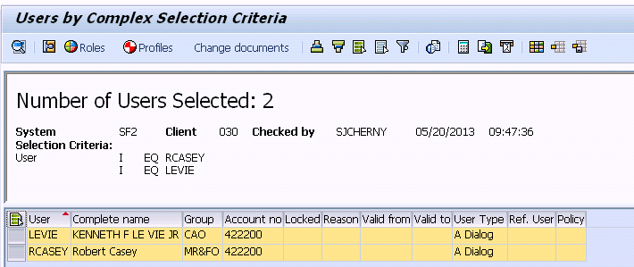
5b | Report shows :  - User Id  - User Group  - Profile Id  - Profile text (may include Role Id if generated from a role)  Note :  The profiles starting with “Z” are mostly related to manual profiles (MIT Custom RolesDB assignment)  The profiles starting with “T-S” are from the SAP Profile Generator (based on SAP Security Roles – one profile per role). | 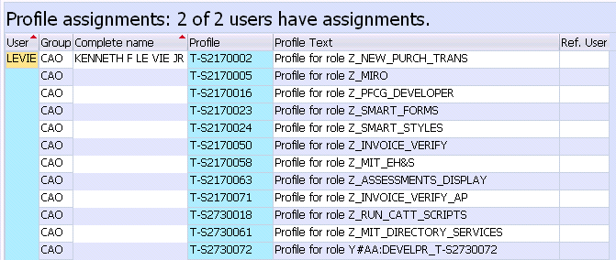
5c | Sort by Profile / User columns to get a different view.  Only one or both the users have the profiles. | 