Job Aid 15 Role Level Simulation

USE
This report can be used carry out simulations at the role level for the purpose of understanding whether the addition or removal of certain access either creates or eliminates SODs and other risks.
INFORMATION
New risk violations that will result due to changes to roles.
RELATED PROCESSES
- Process 1: New or Amended Roles
- Process 2: Mitigation Analysis
SPECIFIC SCENARIOS
- Step 15A: Simulation by Action (transaction).
- Step 15B: Simulation by Role.
- Step 15C: Simulation by Profile.

Step | Description | Screenshot
1 | Navigate to the ‘Access Management’ tab.
2 | Click on the ‘Role Level Simulation’ report located in the ‘Access Risk Analysis’ section.
3 | In the ‘Analysis Criteria’ section, select the System for which information is required. Since the desired selection is PS1 (Production), ‘*PS1*’ was typed in as the system.  The search option can also be used to search for the correct system. Please refer to the ‘Search for Input Values’ reference document (R3) for further information.
4 | Run a simulation for a single Role.  Add the Role. In this case, ‘Z_VPF_S_AR_GENERAL’ was typed in. The search option can also be used to search for an ID. Please refer to the ‘Search for Input Values’ reference document (R3) for further information.
5 | In the ‘Analysis Criteria’ section, click on the ‘-‘ at the end of the ‘Risk by Process’ row to remove the row for that search criterion; this criterion is not needed for this scenario.
7 | In the ‘Analysis Criteria’ section, select the ‘Risk Level’ drop down and select the risk level for which information is required. In this case, ‘All’ was selected so that the report evaluates for all risk levels.
8 | In the ‘Analysis Criteria’ section, select the ‘Rule Set’ drop down and select the Rule Set against which the report should be executed. In this case, ‘Global’, the MIT Rule Set, was selected. Unless advised otherwise, the selection should always be ‘Global’ for this report.
10 | In the ‘Report Options’ section, select the first drop down for ‘Format’ and select the level of detail at which information is required. In this case, the default setting, ‘Summary’, was not changed.
11 | In the ‘Report Options’ section, select the second drop down for ‘Format’ and select the type of information that is required. In this case, the default setting, ‘Business View’, was not changed.
13 | Analyze for SODs (excluding false positives).  In the ‘Report Options’ section, select the dial button for ‘Access Risk Analysis’. Next, select the type of analysis that is required. The options available are:  Action Level: SODs at the transaction level (will include false positives eliminated at the authorization level)  Permission Level: SODs at the authorization level  Critical Action: Critical transactions that limited/no users should have  Critical Permission: Critical authorizations that limited/no users should have  Critical Role/Profile: Critical Roles/Profiles that limited/no users should have  In this case, ‘Permission Level’ was selected so that the report will show SODs that exist at the Permission Level.
12 | In the ‘Report Options’ section, check ‘Show All Objects’ under ‘Additional Criteria’. This will ensure that Users with no violations are explicitly listed as such (i.e. ‘No Violations’ will be listed as a line item for such users’ IDs).
14 | The analysis criteria has now been defined. Click on ‘Next’ to define the simulation criteria.
15A-1 | Simulation by Action (transaction).  On the ‘Actions’ tab, click on ‘Add’ to define transaction simulation criteria.
15A-2 | Click the drop down on the ‘System’ field and select the system from which a transaction must be added. The user for the simulation exists in PS1; however, the simulation criteria can be from any system connected to GRC. In this case, PS1 is selected.
15A-3 | Add the transaction. In this case, ‘FB01’ was typed in. The search option can also be used to search for an Action. Please refer to the ‘Search for Input Values’ reference document (R3) for further information.  NOTE: If transactions should be excluded from the Role for the simulation, the ‘Exclude Values’ box must be checked. Otherwise, any added transactions will be added to the Role for the simulation.
15A-4 | Run the report in the foreground. If the report is expected to yield a large amount of data, execute the report by running a background job. See the ‘Execute a Background Job’ reference document (R5) for further information.
15A-5 | Analyze the data. This data can also be exported. See the ‘Export Data from GRC’ reference document (R8) for further information.  Any orange line items represent risks occuring due to simulation criteria.  Role Name: SAP role name  Access Risk ID: The 4-digit ID representing each medium-risk (as defined in the standard rule set) for which violations exist  Risk Description: Business description of the Access Risk  System: The system in which the role is assigned to the user  Rule ID: The ID representing the particular rule that was triggered for that Risk  Risk Level: The risk level defined for each Access Risk in the standard rule set  Action: SAP transaction  Action Description: SAP transaction name  Control: The 10-digit ID representing the Mitigating Control applied for the User with the Access Risk  Control Description: Business description of the Mitigating Control  Monitor: The user ID of the Monitor responsible for the Mitigating Control  Monitor Name: Name tied to the user ID of the Monitor  Business Process: The 4-digit ID representing the Business Process to which the Access Risk has been mapped in the standard rule set  Business Process Description: The business description for the Business Process to which the Access Risk has been mapped in the standard rule set | 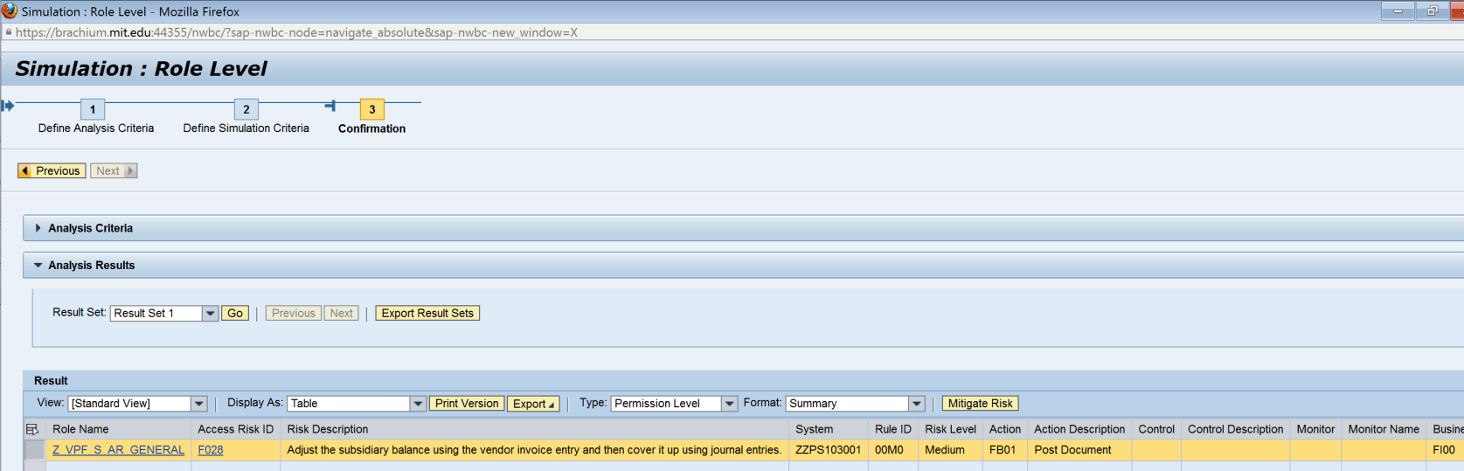
15B-1 | Simulation by Role.  On the ‘Roles’ tab, click on ‘Add’ to define role simulation criteria.
15B-2 | Click the drop down on the ‘Role Type’ field and select ‘Technical Role’. For role-based simulation criteria, unless otherwise advised, the selection will always be ‘Technical Role’. | 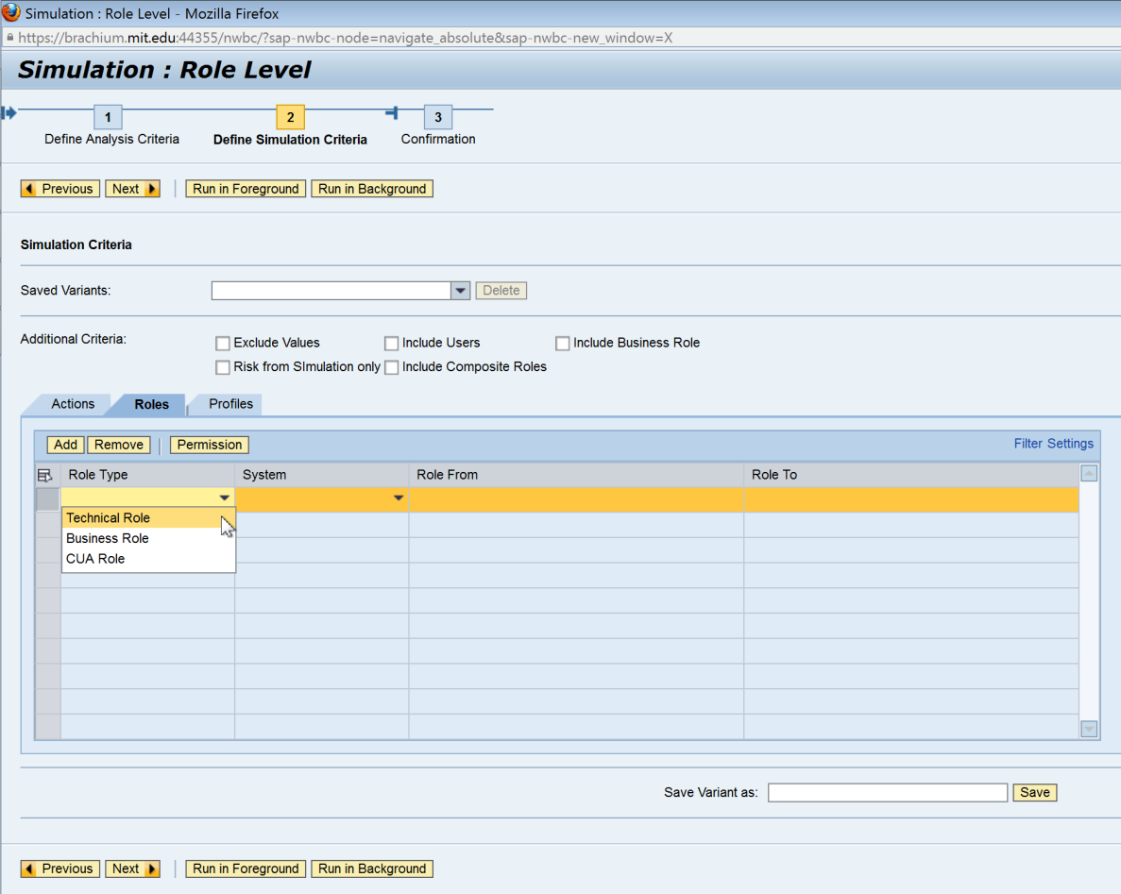
15B-3 | Click the drop down on the ‘System’ field and select the system from which a technical role must be added. The user for the simulation exists in PS1; however, the simulation criteria can be from any system connected to GRC. In this case, PS1 is selected. | 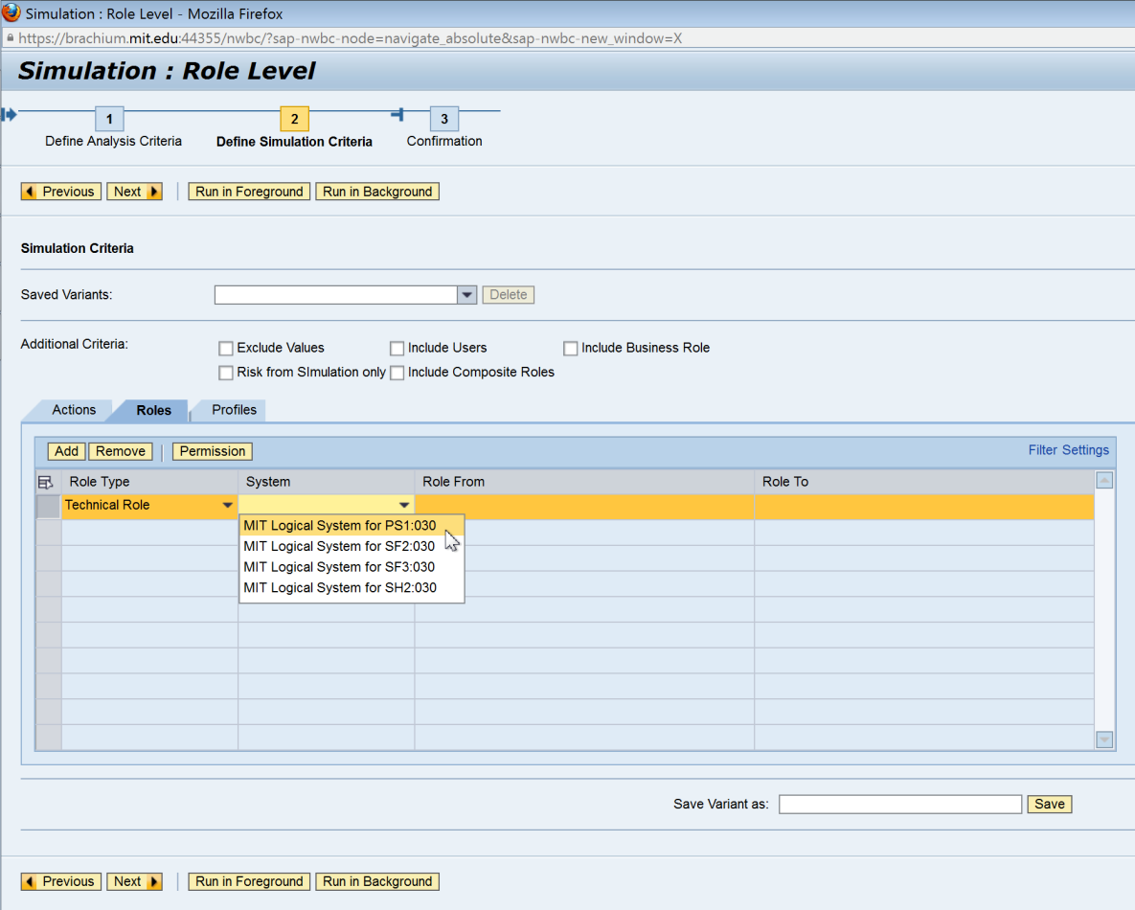
15B-4 | Add the role. In this case, ‘Z_VPF_S_AR_MASTER_  DATA_MAINT’ was typed in. The search option can also be used to search for a Role. Please refer to the ‘Search for Input Values’ reference document (R3) for further information.  NOTE: If the added role’s authorizations should be excluded from the original role for the simulation, the ‘Exclude Values’ box must be checked. Otherwise, authorizations from any added roles will be added to the original role for the simulation. | 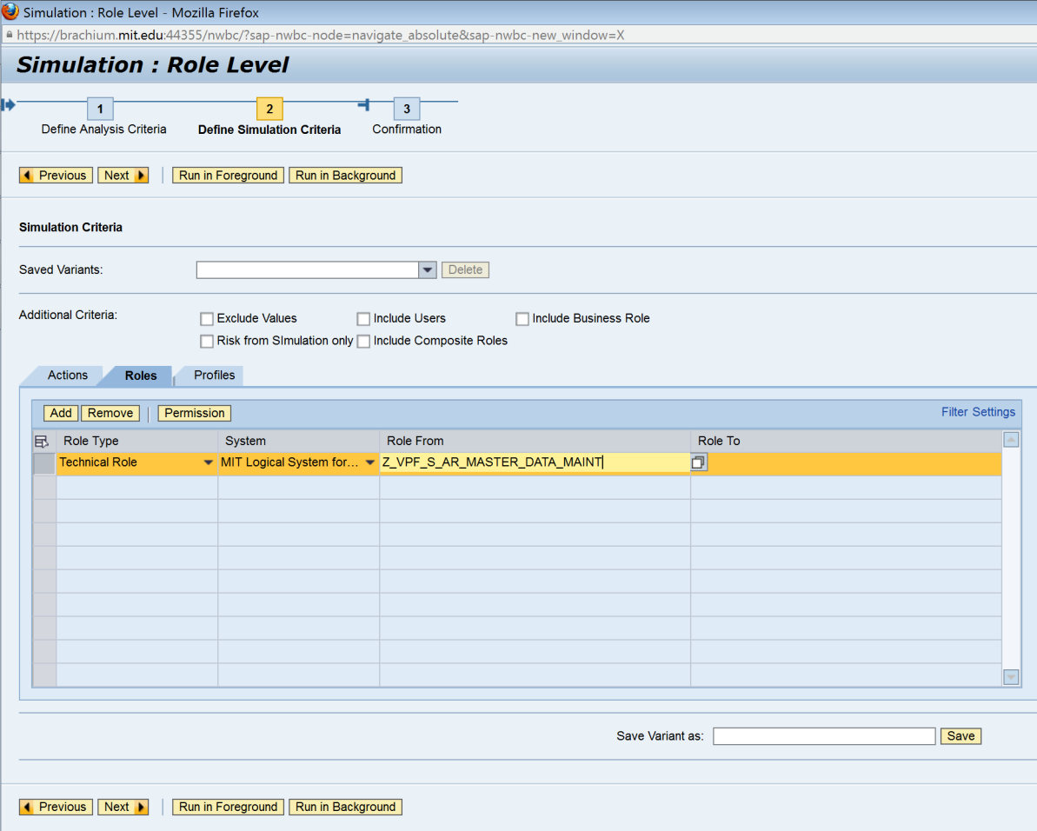
15B-5 | Run the report in the foreground. If the report is expected to yield a large amount of data, execute the report by running a background job. See the ‘Execute a Background Job’ reference document (R5) for further information. | 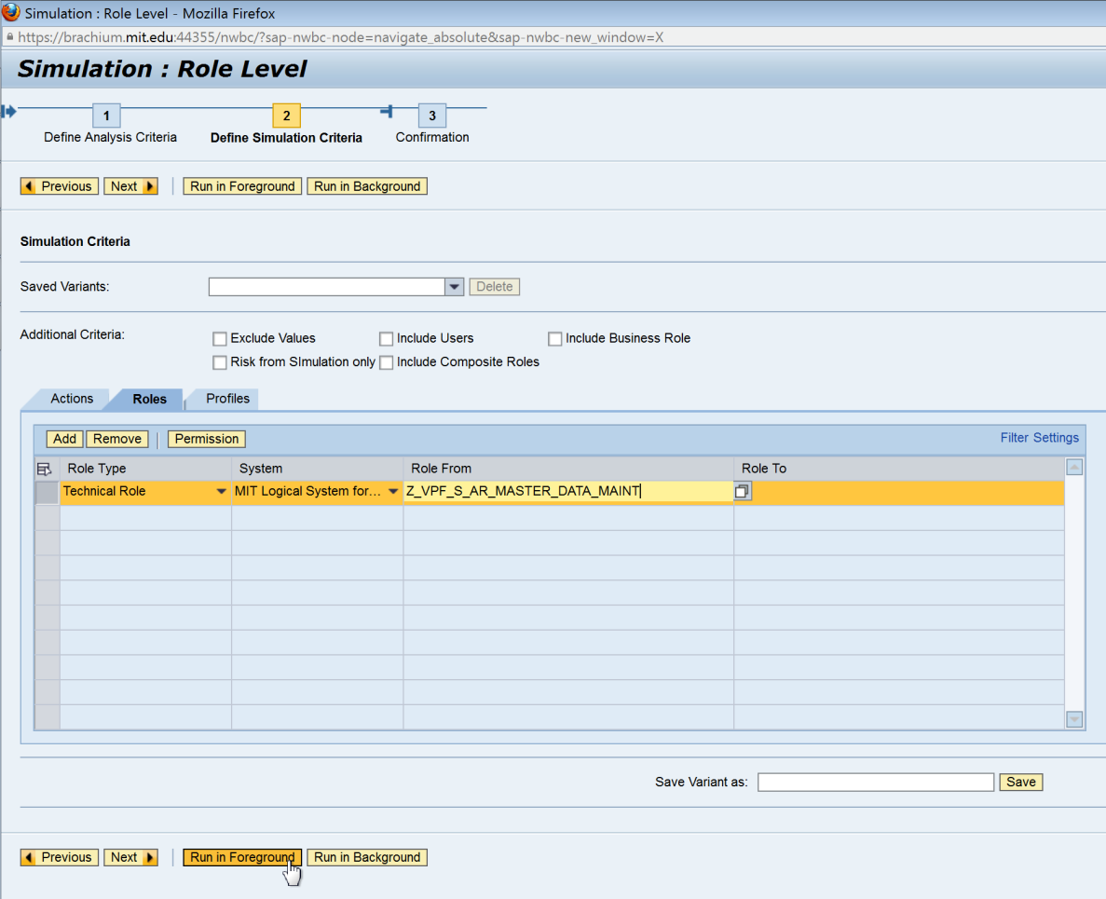
15B-6 | Analyze the data. This data can also be exported. See the ‘Export Data from GRC’ reference document (R8) for further information.  Any orange line items represent risks occuring due to simulation criteria.  Role Name: SAP role name  Access Risk ID: The 4-digit ID representing each medium-risk (as defined in the standard rule set) for which violations exist  Risk Description: Business description of the Access Risk  System: The system in which the role is assigned to the user  Rule ID: The ID representing the particular rule that was triggered for that Risk  Risk Level: The risk level defined for each Access Risk in the standard rule set  Action: SAP transaction  Action Description: SAP transaction name  Control: The 10-digit ID representing the Mitigating Control applied for the User with the Access Risk  Control Description: Business description of the Mitigating Control  Monitor: The user ID of the Monitor responsible for the Mitigating Control  Monitor Name: Name tied to the user ID of the Monitor  Business Process: The 4-digit ID representing the Business Process to which the Access Risk has been mapped in the standard rule set  Business Process Description: The business description for the Business Process to which the Access Risk has been mapped in the standard rule set | 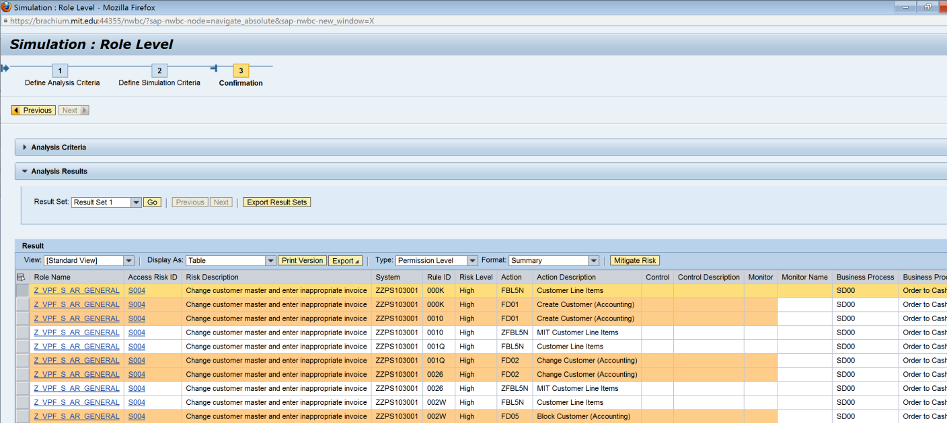
15C-1 | Simulation by Profile.  On the ‘Profiles’ tab, click on ‘Add’ to define profile simulation criteria.
15C-2 | Click the drop down on the ‘System’ field and select the system from which a profile must be added. The user for the simulation exists in PS1; however, the simulation criteria can be from any system connected to GRC. In this case, PS1 is selected.
15C-3 | Add the profile. In this case, ‘Z#DP:JV’ was typed in. The search option can also be used to search for a Profile. Please refer to the ‘Search for Input Values’ reference document (R3) for further information.  NOTE: If the added profile’s authorizations should be excluded from the original role for the simulation, the ‘Exclude Values’ box must be checked. Otherwise, authorizations from any added profiles will be added to the original role for the simulation.
15C-4 | Run the report in the foreground. If the report is expected to yield a large amount of data, execute the report by running a background job. See the ‘Execute a Background Job’ reference document (R5) for further information.
15C-5 | Analyze the data. This data can also be exported. See the ‘Export Data from GRC’ reference document (R8) for further information.  Any orange line items represent risks occuring due to simulation criteria.  Role Name: SAP role name  Access Risk ID: The 4-digit ID representing each medium-risk (as defined in the standard rule set) for which violations exist  Risk Description: Business description of the Access Risk  System: The system in which the role is assigned to the user  Rule ID: The ID representing the particular rule that was triggered for that Risk  Risk Level: risk level defined for each Access Risk in the standard rule set  Action: SAP transaction  Action Description: SAP transaction name  Control: The 10-digit ID representing the Mitigating Control applied for the User with the Access Risk  Control Description: Business description of the Mitigating Control  Monitor: The user ID of the Monitor responsible for the Mitigating Control  Monitor Name: Name tied to the user ID of the Monitor  Business Process: The 4-digit ID representing the Business Process to which the Access Risk has been mapped in the standard rule set  Business Process Description: The business description for the Business Process to which the Access Risk has been mapped in the standard rule set | 