So you’re making a template from scratch in Diva….Create an Experiment book. In the Browser window, highlight your name and click the brown book icon (next to the file folder icon). A.
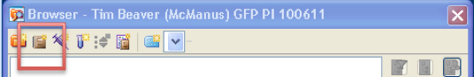
- Right-click the Experiment and click Rename. Type your First and Last Name, PI, Fluorophores, and Date. B.
- Create a specimen under your open experiment book. (Highlight the Experiment book and go up and click the syringe icon to create a specimen). C.
- Rename the specimen, the Date: mmddyy. D.
- Highlight the specimen and click the “+” sign just to its left
- Click the tab to the left of Tube_001 until it turns green. E.
- Rename Tube_001 to the name of your first tube (for instance, Negative Control). F.
- Go to the Cytometer window and click the Parameters tab. G.
- Click “H” and “W” for FSC and SSC H.
Create Forward Scatter and Side Scatter plots on the sheet
- Click the dot plot icon on the Global Worksheet window (next to the cursor icon). I.
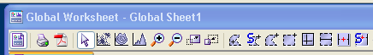

- Click the top left corner of the white sheet to create a plot.

- Change the y axis to read ‘SSC-A ‘ J.
- Create 2 more identical plots to the right of the first plot.
- Change the middle plot to have the x parameter be FSC-W (Click FSC-A and choose FSC-W) K.
- Change the far right plot to be SSC-W vs SSC-H.
- Click the dot plot icon I. and click in the grey area. L. The plot should read FCS-A vs FCS-H. When you run your sample, make sure the cells make a 45˚ angle from bottom left to upper right. If it’s not 45˚ already, go to the Laser tab in the Cytometer window. M. Adjust the FSC Area Scaling up or down by .01 at a time.
Create Fluorophore plots
- Click the dot plot icon I. and click the white sheet below the top left plot. Drag its corner to slightly enlarge it. Change the x and y axes to be the fluorophores you’re using. (For example: FITC-A vs PE-A).
Create Histograms
- Click the Histogram icon (the ‘mountain peak’ next to the magnifying glass icon) N

- Click in the grey area of the sheet. It should say FSC-A. O.
- Click the Histogram icon again and click on the white sheet. Change the x axis to your fluorophore (for instance: FITC-A). Create a Histogram for each fluorophore you have.
- Right click the top left plot and click “Show Population Hierarchy”
You have made a template! Now run your controls, and adjust the voltages in the Parameters tab, to make sure that your cells are falling where you want them to on the plots. Draw gates. P. Happy Analyzing!

