Bates Research and Engineering Center
Massachusetts Institute of Technology
8/31/2017
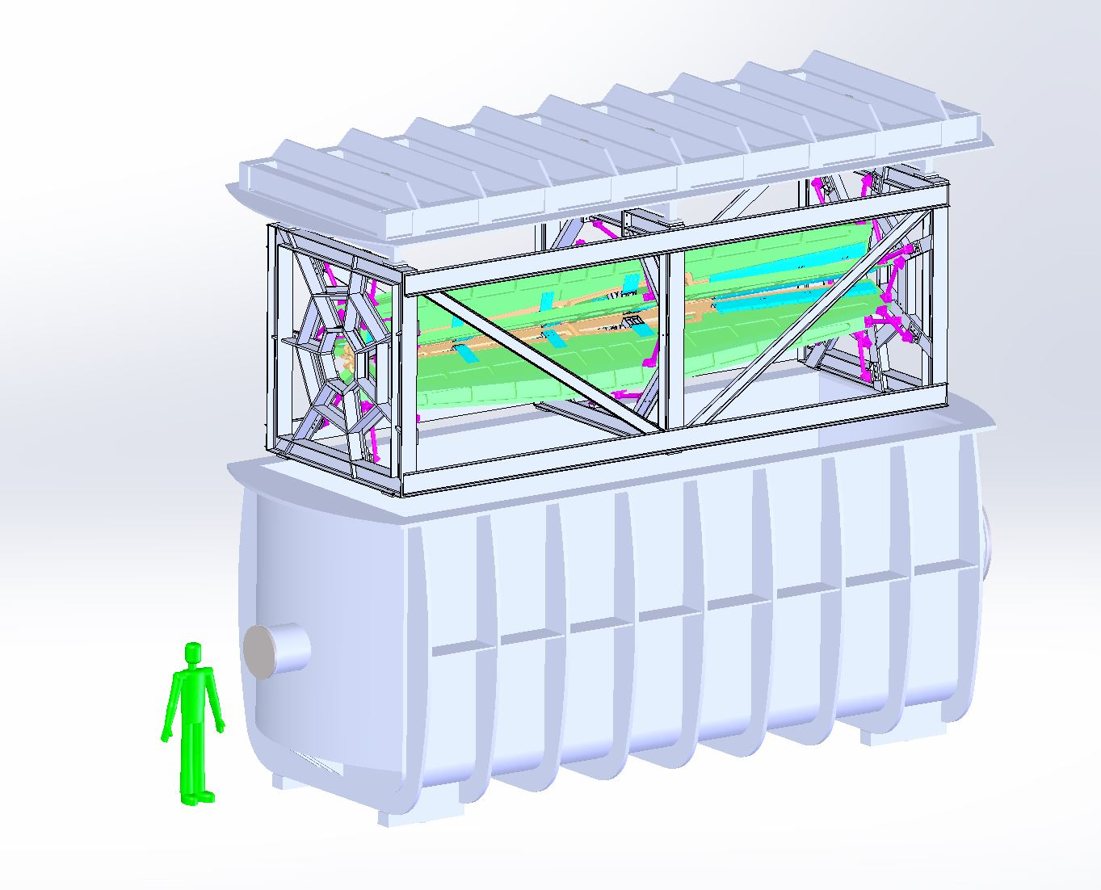
MOLLER Spectrometer Magnets and Collimators Preliminary Engineering
Introduction
Preliminary engineering at MIT Bates has completed baseline designs of the upstream torus, collimators and alignment, hybrid coil cooling and fabrication, hybrid chamber and integration into Hall A. Strategic choices were made during this phase to focus on higher risk items to mitigate risk in order to execute a successful experiment. The hybrid coil is a defendable design that meets the mechanical, thermal, alignment, and physics requirements for the MOLLER experiment. Following is a summary report of work done at MIT Bates during this preliminary phase.
Preliminary Hybrid Coil Engineering
The baseline design for the Jefferson Lab Moller Hybrid coil used a smaller 5.8mm square conductor. For the latest version of the prototype coil, an 11.8 x 10.3 mm rectangular conductor with a 6.0mm (.235”) hole is being used (Luvata #9298). The same number of NI (turns times current) is used and the outside coil dimensions remain the same. The goals of using the larger conductor are to limit the water connections, simplify the coil winding while retaining the same NI used in the particle tracking calculations and analyses.
A prototype full scale downstream hybrid coil is being fabricated by Everson Tesla, PA and will be tested to full current to test coil performance and the temperature distribution within the coils during operation.
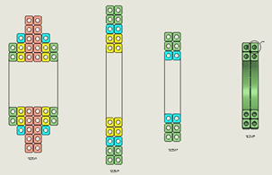
Figure 1. Hybrid Coil Cross Sections

General
The coil will be divided into four cross sectional areas labeled A-A, B-B, C-C, D-D. Section A-A is nearest the target and D-D is nearest the detector. Special care was used to fit the current conductor into the allowable envelop and to make as smooth transitions of the conductor as possible in the out of plane bends.

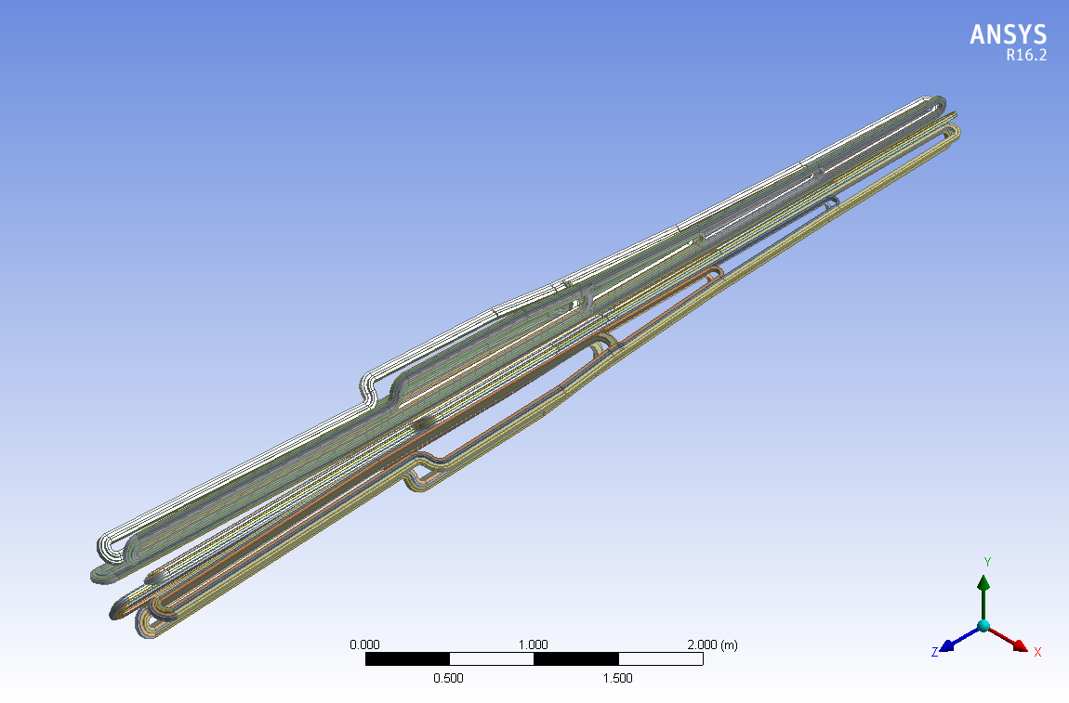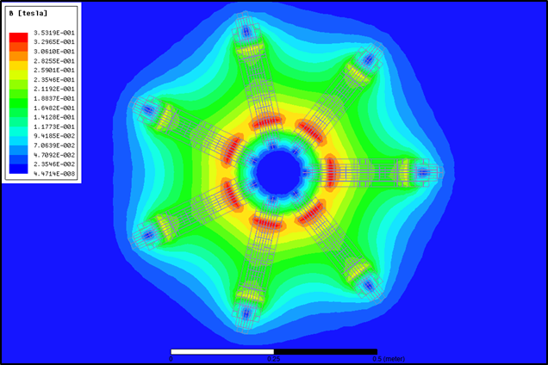
Figure 2. Hybrid Coil Magnetic Model and Results

General Conductor Parameters
Conductor size Luvata #8298 | 11.8 x 10.3 rectangular | Cooling hole=6.0mm (.235”)
Conductor cross section | 92.0 square mm | .143 square inches
Hole cross section | 28.26 square mm | .044 square inches
Resistance (conductor) |  | 56 ohm/ft. x 10E-6@20C  62 ohm/ft. x 10E-6@50 C  +0.393% per C coefficient
Weight |  | .55 lbs./ft.
Maximum Current density - J | 21 amps/square mm | 13.5 kAmps/square inch

Winding Details
Coil Area | Total NI | Coil NI | Turns/Amps | Power | Water flow/deltaT
A-A | 7,750 | 7,750 | 4/1,938 amps | 42 kW | 4 gpm/40C
B-B | 10,600 | 2,850 | 2/1,425 amps | 10 kW | 2 gpm/19C
C-C | 16,860 | 6,260 | 4/1,565 amps | 19.6 kW | 4 gpm/19C
D-D | 29,160 | 12,300 | 10/1,230 amp | 25 kW | 3 gpm/31.5C

Total power and Water
Total power per coil set & hybrid | 96.6 kW | 663 kW per total - 7 coils
Water flow per coil & hybrid | 13 gpm | Use 100 gpm
Average bulk delta T coil & hybrid | 28 C | same

Pressure Drop and Velocity in Coils
A-A | B-B | C-C | D-D
234 psi (for 2 paths) | 198 psi | 166 psi | 196 psi
15 ft./s (4.6 m/s) | 15 ft./s ( 4.6 m/s) | 15 ft./s (4.6 m/s) | 11 ft./s (3.4 m/s)

Prototype Magnet Details
In the reference section of this document are the drawings which were made for the coil fabrication. They are complete helix wound coils with power and water connections. The original prototype bid came in too high to be feasible so some compromises were made to lower the cost substantially while allowing for a useful test. The most important cost saving compromise was to make the coil utilizing a B-stage process made without a vacuum mold. This would still allow the coils to be electrically and thermally tested. This would also answer questions on coil stiffness and conductor placement tolerances.
This approach uses larger conductors that have less turns but achieve the same NI as the baseline design. This also assumes 4 separate power supplies that power different segments of the 7 coils. The prototype coil should answer any outstanding questions of fabrication and current density. A plan to work with Everson to engineer a solution to divide up the flow paths into more parallel paths on A-A to lower pressure drop is in process. We are also working with Stony Brook to develop a test plan and help with infrastructure for testing the prototype.
Hybrid Coil Manufacturing Plans
We have incorporated manufacturer’s suggestions along with extensive experience at Bates to determine the appropriate coil manufacturing process. The coils will be wound around an internal mandrel and double wrapped with fiberglass insulation to achieve the final configuration. The wrapped coil will then be placed in a vacuum mold for impregnation with epoxy. We are designing the coils for a high radiation environment (10⁸ grays) and thus have picked appropriate materials. This is a process we have used for other large coils on several projects with excellent results.

Hybrid Coil Support Structure
A conceptual design of the MOLLER coil supports and frame has been completed. During the design process, several concepts were considered including placing the magnet in atmosphere with a 7-segment beam pipe and placing the magnet in a helium bag. Ultimately, the decision was made to place the entire magnet in a large vacuum chamber. The design of this chamber is discussed in a latter subsection of this document.
The magnet consists of 7 racetrack-type coils. These coils are each connected to a strong, rigid “strong-back”, or coil carrier, which provides the additional stiffness required to accurately hold the coils in place against gravity and magnetic forces. Each coil must be independently adjustable in position with six degrees-of-freedom to achieve the desired magnetic field uniformity. To achieve this, the coil & carrier assemblies are connected to the support frame via 6 adjustable struts each, arranged such that adjustment in all 6 degrees of freedom is possible, while minimizing coupling between adjustments in different dimensions. Struts are oriented with 3 tangential, 2 radial, and 1 longitudinal.
Hybrid Coil Carriers
The coil supports were designed based on experience with the Qweak and BLAST toroids. In contrast to those projects, MOLLER requires a much smaller radial range for particle tracks passing between the coils, so very little space is available there to add structural material. The bulk of the coil carriers must exist radially outwards from, rather than between, the coils. Increasing the overall radius of the magnet increases the force due to atmospheric pressure and thus structural requirements and cost of the vacuum chamber. Therefore, much effort was placed into optimizing the shape of the carriers to minimize deflection while limiting the overall size of the assembly. The carriers are designed for maximum stiffness to minimize deflection of the coils, while still staying outside the envelope of scattered Moller and ep electrons. The carriers will be made of large, machined aluminum strong-back which serve as a “spine” for loads and coil services. They will bolt to each coil through a number (likely 4-6 per side) of removable side plates, attached with silicon-bronze bolts. The connections to the coils will be such that radial and tangential motion is completely constrained, while in the longitudinal direction, only one pair of side plates will provide constraint, with the others allowing slight change in length as the coil temperature changes. This length change is expected to be less than 4.5 mm (over 7 m of coil length) at operating temperature. Struts are connected to the carrier by small clevis assemblies and titanium pins. The loads experienced by the carriers are due to the weight of the coil (~200 kgf) and the magnetic centering forces (~3000 lbf). Additionally, they may be subjected to tangential loads due to an unbalanced coil. Analysis of our current design predicts deflections on the order of 1.0-1.5 mm due to the coil carriers alone; further deflection due to frame and strut loading is to be expected. Stresses in the carrier are also low, roughly 40 MPa near the pre-loaded bolts.
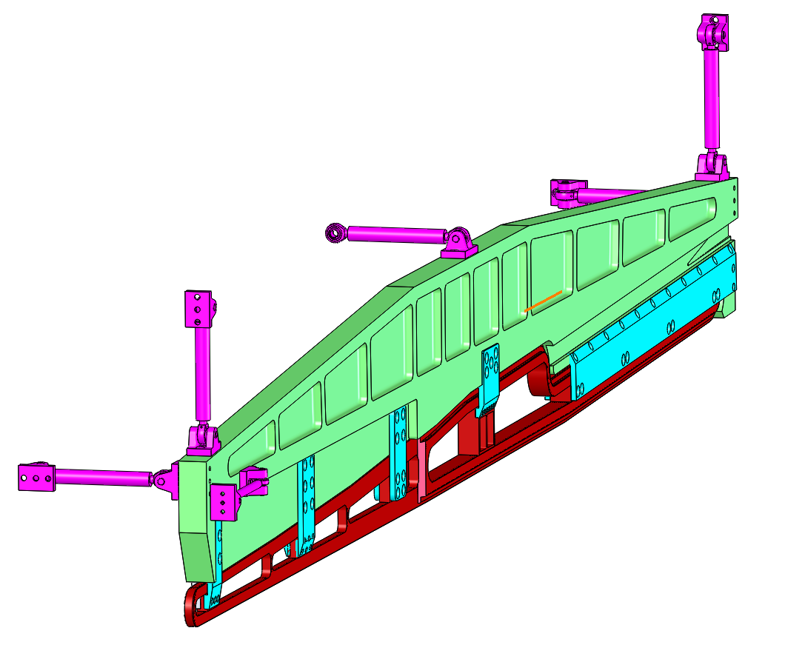
Figure 3. Hybrid Coil Strong-back Support Structure

Hybrid Toroid Support Frame
The MOLLER Hybrid Toroid support frame is an open, space-frame type design, possessing 42 connection points for the coil struts, as well as 4 connection points for hanging the frame inside the vacuum enclosure. It is made of commercially available 6061-T6 aluminum extrusions and bare plates, formed into three box sections (upstream, middle, and downstream) oriented perpendicular to the beamline, with trusses on either side connecting the three sections. The majority of connections are welded. Bolted connections will employ silicon-bronze fasteners which are as strong as grade 5 steel bolts but are non-magnetic. A single removable section of the frame allows all coils to be installed from above using the Hall A crane. Due to the large range of adjustment of the struts, dimensional tolerances between sub-weldments (and even within sub-weldments) may be fairly generous (on the order of 0.25”). The approximate mass of the frame is 1400 kg.
The magnet will be placed in vacuum and therefore, care is being taken to minimize the amount of surface area and trapped gas volumes within the frame. Several iterations have been analyzed in an attempt to minimize deflections, size, and complexity. The most recent analysis, which includes the coil carriers, strut supports, and all weight and gravity loads, predicts about 3 mm deflection (maximum) of the carriers. Stresses in the frame are on the order of 20 MPa. This small magnitude of stress is to be expected from a deflection-driven design.

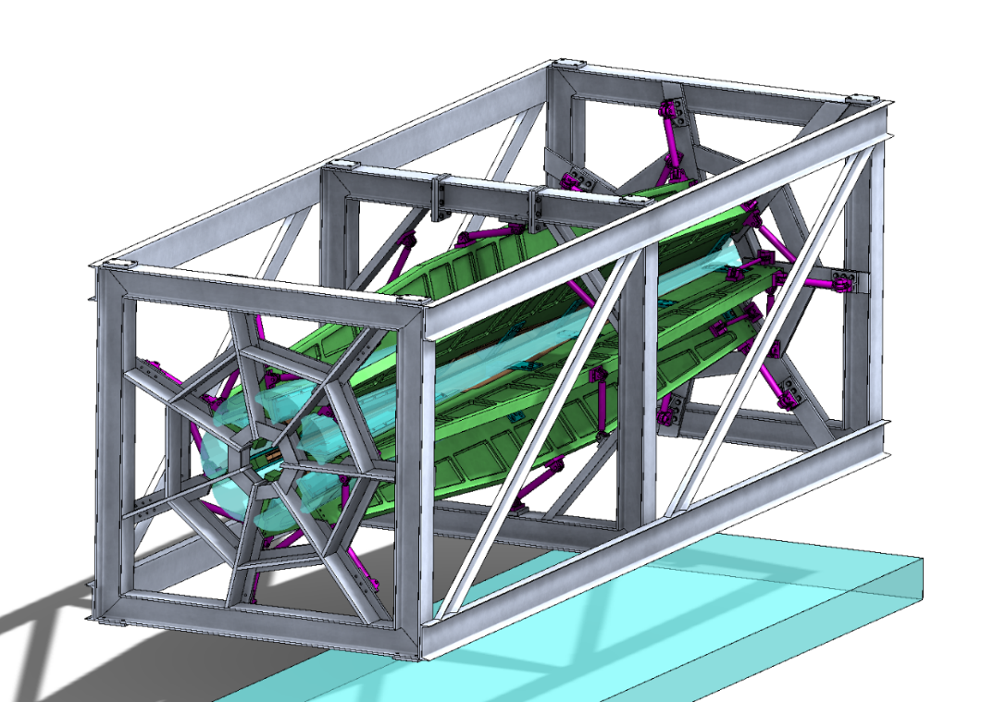

Figure 4. Hybrid Coil and Coil Carriers in Support Frame

Hybrid Toroid Services
Cooling System
The water cooling requirement for the Hybrid Toroid will be met by the design of a stand-alone self-contained water cooling system. The requirements for this water system are to supply > 1 megohm-cm deionized (DI) water with a total cooling capacity of less than 1 MW at a maximum pressure up to 250 psig.
The Jefferson Laboratory water cooling system supplies 500 GPM through 8” diameter cooling lines at a supply temperature of 85 ºF and return temperature up to 110 ºF. This gives a delta T of 25 ºC at 13.8 ºC which results in 1.8 MW of cooling. The Hall A water supply will be used to cool the compressors of a condenser-less chiller that is both skid-mounted and uses multiple compressors to allow for redundancy and efficient reduced load operations. This chiller will supply water that is 10 ºC. It is expected that the cooling lines will require insulation to limit condensation within Hall A.
City water will be run through a DI filter tank with a flow rate of less than 5 GPM to initially fill the system. Then, the closed loop water systems will be designed to allow approximately 1-2% of the system flow to be continuously polished by both DI and deoxygenated resins. Many years of experience with accelerator water systems at MIT-Bates and SLAC [ref-SLAC blue book chapter 24] show that it is easy to maintain >1 megohm-cm deionized water using this amount of bypass water through the resins. In addition, the entire flow will be mechanically filtered using cartridge filters with temperature and resistivity monitoring. A variable frequency drive controller will be used to control the main pump flowrate and to fine tune the system. Overall system pressure will be controlled by a bypass control regulator valve and then individual supplies to equipment will be supplied with water pressure regulators to set and limit the required pressure if it is less than the overall system pressure. The entire system will have individual flow meters to remotely monitor the flow to all circuits in the loop. In addition, flow limit switches will be installed in each loop to interface with the hardware interlock system.
Because the Chiller will be located within Hall A, special options will be selected to minimize vibration and ambient noise. The water connections to the chiller and manifolding within Hall A will be rigid stainless steel pipe with Victaulic type fitting which will allow for simplified disassembly of the water system during time that Moller is removed from the beamline.
In summary, the water cooling system of the Moller experiment is crucial to the success and long term reliability of the experiment. The engineers for the experiment plan to design a cooling system that will be specific to Moller toroid operation. The design of the water cooling system needs to be closely coordinated with Jefferson Lab Hall engineers and the site Facility engineers.
DC Power Supplies for Moller Hybrid
The two possible configurations for the Hybrid coils use 4 separate power supplies that each power a given section for each of the seven coils. This configuration allows for fine tuning of the magnetic field to match experiment requirements. The power supplies are high constant current supplies that supply up to 800 kW of power, combined. The highest currents we will use are up to 2000 A. The input AC will be 480 V, 3 phase.
While not a COTS (commercial off the shelf) device, this type of supply is common in accelerator systems. It is envisioned that the power supply will monitor the delivered current by using a current monitor with approximately 0.01% accuracy at the nominal full current. Physics requirement will have to be studied closely to define the correct current stability requirements prior to power supply selection.
The power supplies will be selected in conjunction with the DC Power Group at Jefferson Lab.
Upstream Torus Engineering
A preliminary design of the Upstream Torus has been done. The following figures have a CAD model and specifications for this design. More engineering needs to be done towards a final design.
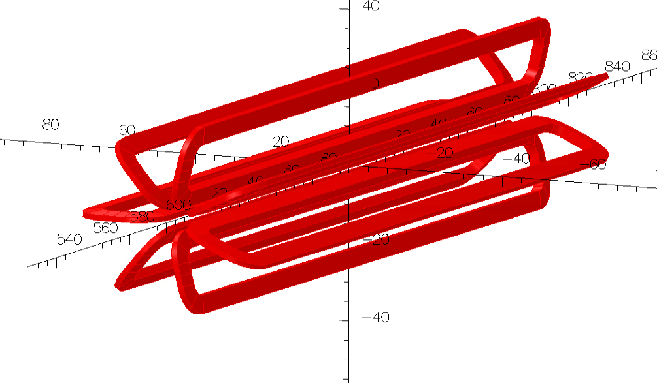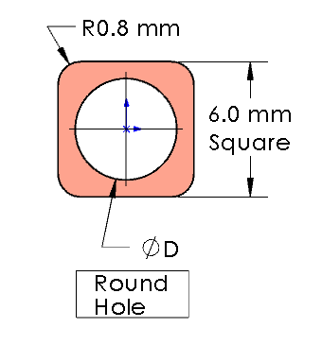
Figure 5. CAD Model of Upstream Torus and Conductor
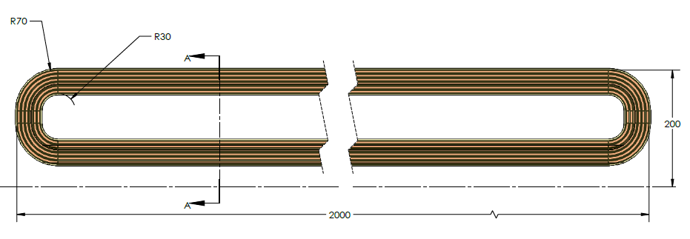
Figure 6. Upstream Torus Dimensions

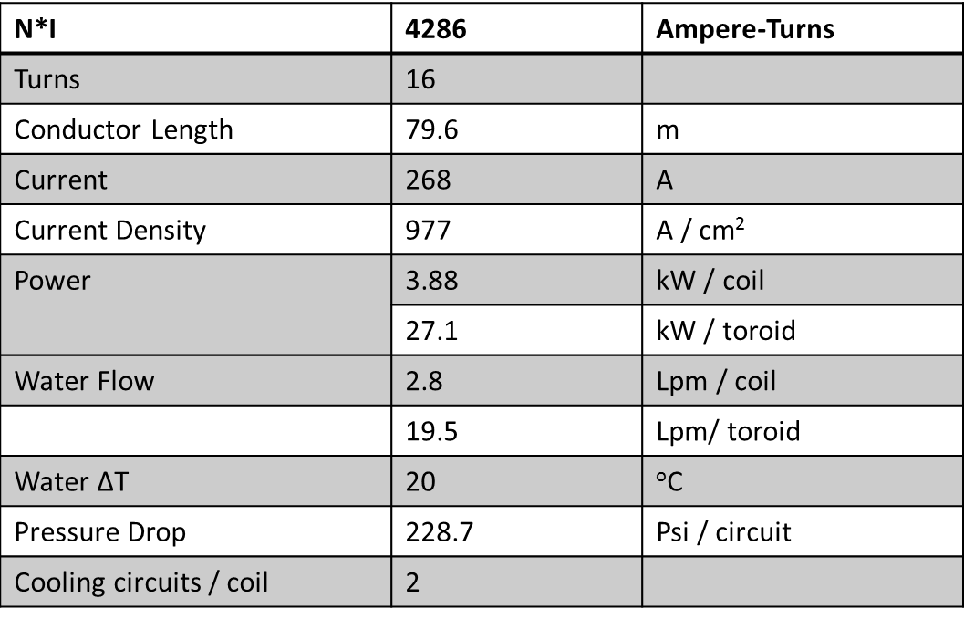

Figure 7. Upstream Torus Specifications

Vacuum Enclosure
The design of the hybrid magnet along with physics considerations has presented challenges for the vacuum system design. Several solutions were considered to minimize scattering in this region. One solution included vacuum chambers between the magnets with the appropriate windows. This was considered too complicated and also difficult to implement without compromising the physics. Another solution that is still an alternative is to use helium bags in this region. This still has the potential to compromise the physics due to scattering issues. The baseline we are pursuing is a large vacuum chamber that encloses the entire Hybrid Toroid that then connects to the rest of the vacuum system for the experiment. This eliminates any scattering issues and maximizes the acceptance between the coils.
The vacuum chamber for the Moller hybrid magnet is designed to allow the coil frame assembly to be supported from the top lid of the chamber. This configuration allows for several advantages. The coil and support package can be assembled and aligned outside of the chamber to the fiducials in the top flange so that global alignment can use the top flange for a reference. This configuration also includes the ability to have electrical and water services for the coils connect through top flange. This allows all connections to be made before inserting the coils into the vacuum chamber. These connections will have manifolds in the chamber to reduce the hose and cabling services routed to the coil package in the facility hall. Finally for maintenance and repair purposes the coil package can be conveniently removed and re-inserted without having to disturb the beam line. The design of the vacuum chamber has gone through several iterations. The initial design required an extensive gusseting system to get stresses to an acceptable level. The feature of everything being supported from the top lid also imposes a deflection constraint so that the top lid requires a higher stiffness. This is to ensure that we can maintain alignment of the coils after pumping down the system. Due to the amount of welding required, the stress limit had to be sensitive to the aluminum having reduced yield strength near the weld.
The chamber is currently designed using 6061-T6 aluminum. The yield stress limit is 240 MPa and 105 MPa across welds. Results from finite element analysis indicate maximum stress levels of 120 MPa in the bulk and 60 MPa near the welded sections. Global deflections of the vacuum chamber walls are on the order of 3 mm. Deflections at the support points of the coil package on the top flange are sub-millimeter.
In meetings with vendors who have extensive experience with chambers of this size, we were advised to eliminate stainless steel as an option. This was due to the cost of the raw materials in this size range hence aluminum is the material of choice. The vendor also had advice about chamber geometry (curved sections where possible) and gusseting. These were all incorporated in the latest design. Below is an exploded view of the chamber and coil package.
The vacuum system will consist of cryogenic panels (LN2) incorporated into the chamber walls with supplemental turbo and roughing pumps to achieve appropriate vacuum levels (10⁻⁷ torr). This will necessitate periodic regeneration of the cryogenic system. The design also includes a double o-ring seal for the top flange for redundancy as well as robustness. These seals will be replaced during annual maintenance periods. All supplemental pumps will be “dry” to minimize contamination.
In conclusion the Moller Hybrid Coil vacuum chamber design is at a point where the stress and deflections are well understood and controlled. At this point the design is mature and we have obtained budgetary bids, to date the quotes we have range from $600,000 to $1,600,000. Due to the size of this chamber there are limited shops that can do the fabrication. We anticipate cost savings upon design iterations with manufacturers.
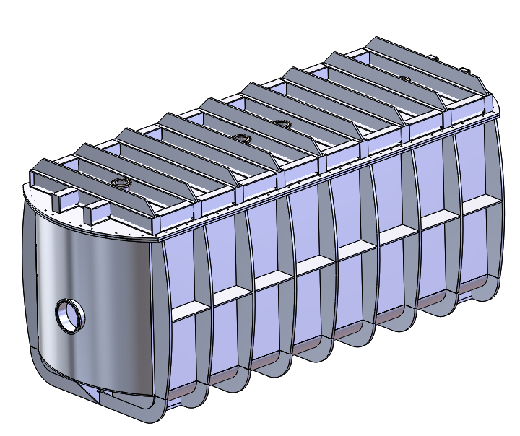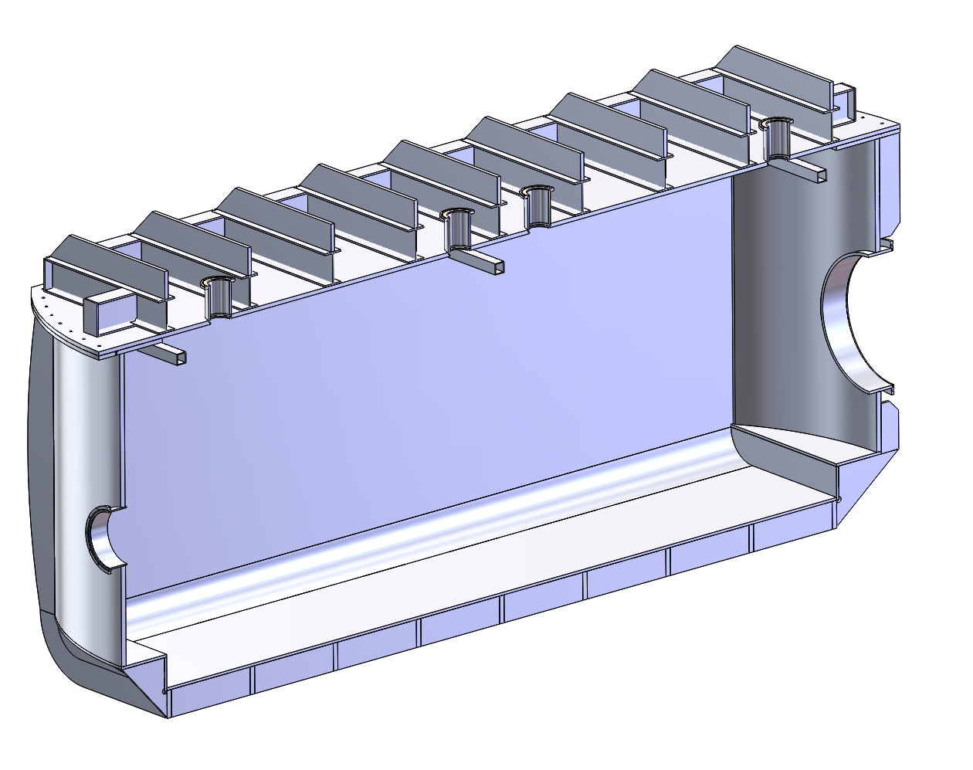

Figure 8. Hybrid Coil Vacuum Chamber with Section View

Site Engineering Considerations
Assembly and Alignment
The positions of the detectors and magnet coils will be set based on the scattered particle envelopes. The envelopes are defined by the positions of the collimators. Therefore, it is paramount that the position of the collimators with respect to the beamline, target, and each other is established and known to a high level of accuracy. Positioning of the coils will then be such that they are completely within the shadow defined by the collimators. Further adjustment of the coils to optimize the magnetic field can only occur within this small range.
Studies [Juliette Sensitivity Studies (my data are from 23Jan2013 Talk)] show that the tightest position constraint is the radial position, followed by roll, at 2.9 and 6.2 mm, respectively (based on an allowed asymmetry error of δA = 0.1 ppb). Allowable errors for other orientations are much higher, therefore, a baseline requirement of 2.9 mm positional and stability accuracy will be enforced.

To measure the position and orientation of the coils, fiducial marks will be installed such that they can be seen during all phases of assembly. The alignment will be continuously checked throughout the assembly process in collaboration with the JLab survey & alignment group. This includes surveying the vacuum chamber to the hall, the coils to the chamber lid, and finally checking the chamber lid to hall. The position of fiducials on the coils will be monitored as the frame is being populated, after installation into the vacuum chamber, and after pump down of the chamber.

 | Asymmetry (δA = 0.1 ppb) [23 Jan 2013 JM talk]
Direction | Large Range (higher order fit) | Small Range (linear fit | Old (over linear range) | Minimum
Z (cm) | -9.73 | -8.89 | -9.24 | -9.73
R (cm) | 0.28 | 0.29 | 0.29 | 0.28
T (cm) | -6.37 | 19.11 | -12.89 | -12.89
Roll (cm) | 0.62 | -1.37 | 1.59 | -1.37
Yaw (cm) | 9.73 | 2.9 | 9.72 | 2.9
Pitch (cm) | -4.46 | -3.29 | -4.58 | -4.58

We plan to deliver a carefully designed and tested lifting fixture for manipulating coils with the Hall A frame. We also expect to provide stands that will allow safe and easy staging of the coil + carrier assemblies prior to installation in the frame.

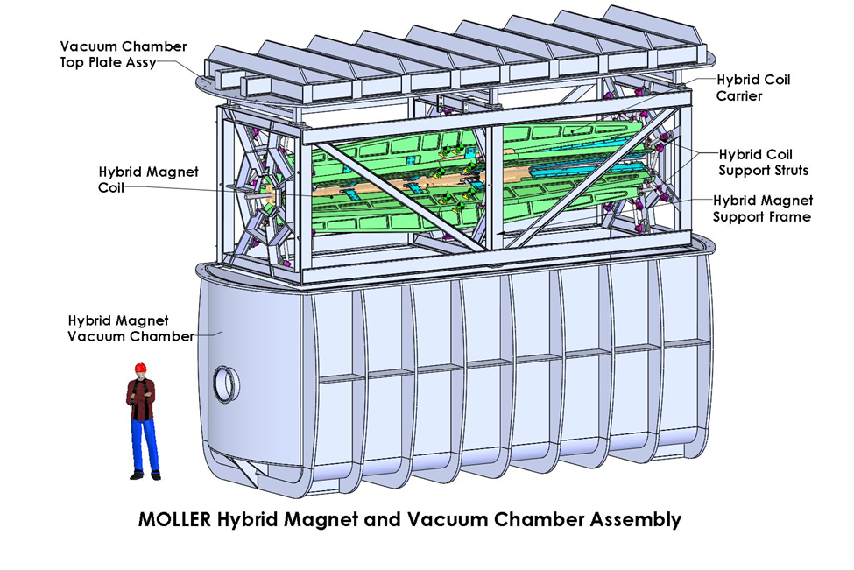Figure 9. Moller Hybrid Assembly

Collimation System
The collimation system will consist of 4 collimators that will intercept scattered beam and define the acceptance of the spectrometer. We will be using the cooling system for the magnets due to the activation of the water and low temperature necessary. The mounting and cooling scheme will be oriented in phi to be in the sectors occluded by the coils. The following figures describe the preliminary engineering done so far.
Collimator Power [Rakitha Talk 06Aug2015, MOLLER_12GeV Merging Collimators Update – 3]:
 | Total | e- | e+ | Gamma
Collimator | (W) | (W) | (W) | (W)
1 | 5334 | 3520 | 1649.3 | 160.7
2 | 1079.1 | 731.5 | 311.3 | 35.3
4 | 221.6 | 148.6 | 65.7 | 7.2
5 | 28.9 | 19.1 | 8.9 | 0.9
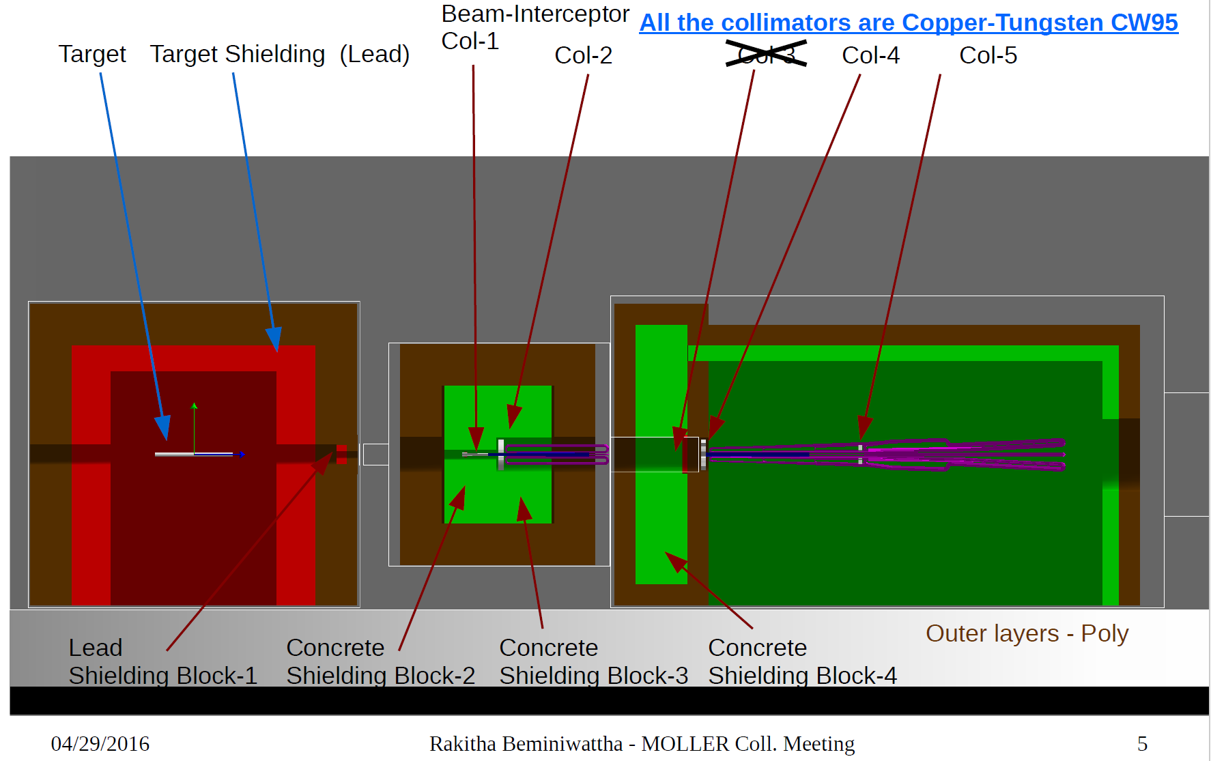
Figure 10. Schematic of Collimators and Their Locations

Collimator 1 will be rigidly mounted to a 16” beam pipe with the downstream end allowed to slide in “Z” to accommodate thermal growth. It will have a 7-spoke all aluminum support placed in the shadow of the collimator fins. The chamber will have a 6 strut system for alignment to the Upstream Torus.
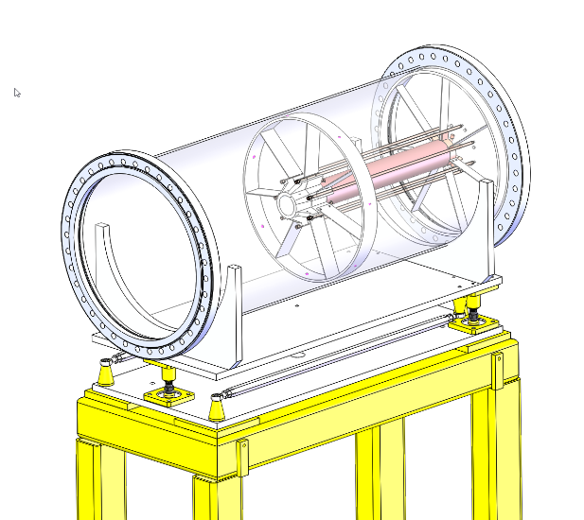
Figure 11. Collimator 1 with Support System
Collimators 2 and 4 will have tungsten petals with a copper body and take 2KW and 200 W respectively.
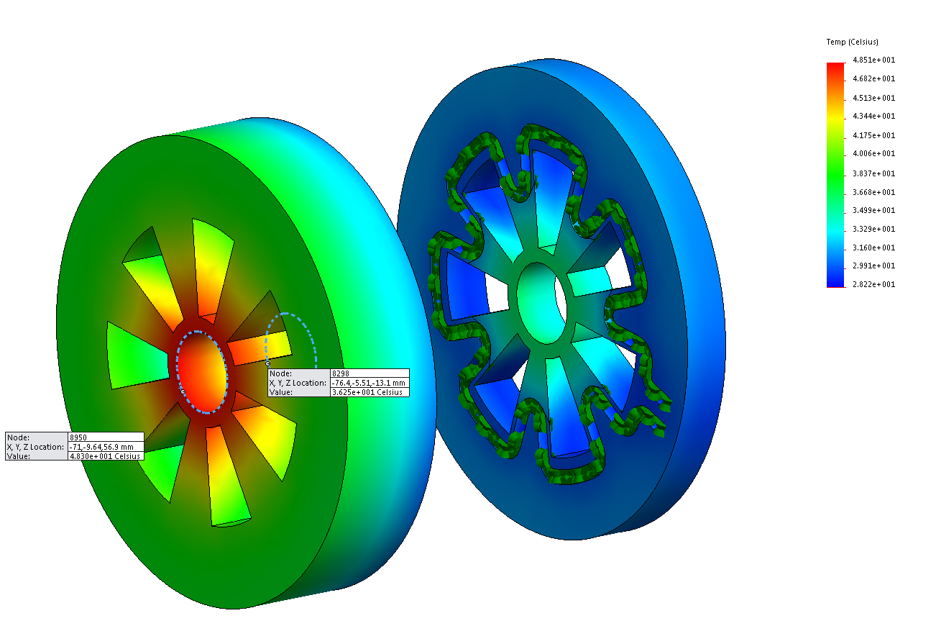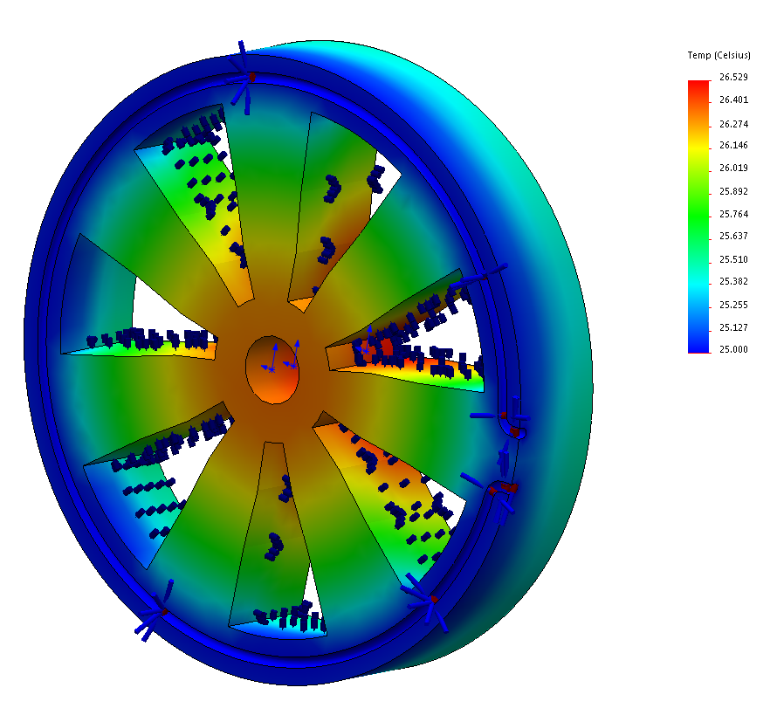
Figure 12. Collimators 2 and 4 Thermal Analyses
Summary
Preliminary engineering at MIT-Bates has completed baseline designs of the upstream torus, collimators and alignment, hybrid coil prototype, hybrid coil cooling and fabrication, hybrid vacuum chamber and integration into Hall A. Strategic choices were made during preliminary engineering design to focus on higher risk items in order to mitigate that risk and execute a successful experiment. The Hybrid coil is a defendable design that meets mechanical, thermal, alignment, and physics requirements for the MOLLER experiment. This will be confirmed empirically when we perform the testing on the prototype later this year.

Reference Material

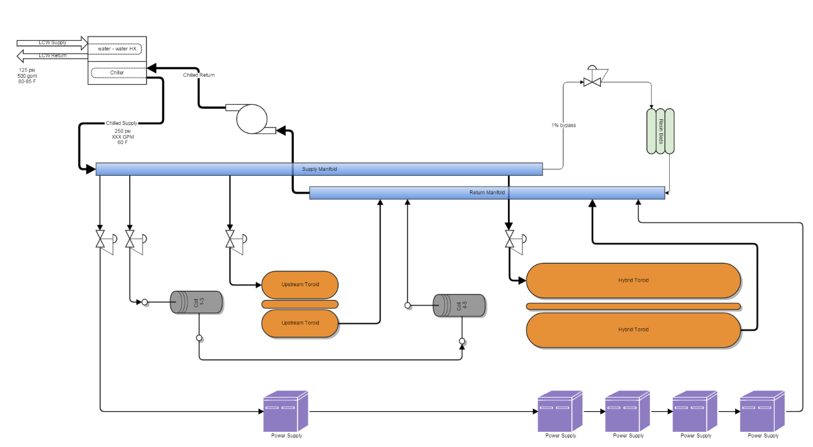
Figure13. Cooling System Schematic

Prototype Hybrid Coil Drawings

Specifications
Parameter | Value | Unit | Notes
Vacuum Camber Lid mass | 10,500 | lb.
Vacuum Chamber Base mass | 27,800 | lb.
Vacuum Chamber Assy mass | 38,300 | lb.
Magnet Support Frame mass | 3400 | lb.
Coil mass | 177 | lb. | Each (x7)
Coil + Carrier Assy | 1,575 | lb. | Each (x7)
Hybrid Toroid Magnet Assy | 14,700 | lb.
Hybrid Toroid Complete Assy | 53,000 | lb. | Coils + vacuum chamber
Water per coil | 12 | GPM | Hybrid only
Total water for Hybrid Magnet system | 120 | GPM | Estimate, including upstream coils and collimators
Water system pressure | 250 | PSIG
Power per coil | 109 | kW
Total Power for Hybrid Magnet | 761 | kW

