Taxes and Financing Decisions



Jonathan Lewellen & Katharina Lewellen

Overview

Taxes and corporate decisions

What are the tax effects of capital structure choices?

How do taxes affect the cost of capital?

How do taxes affect payout decisions?

How do taxes affect firms’ real investment decisions?

Trade-off theory

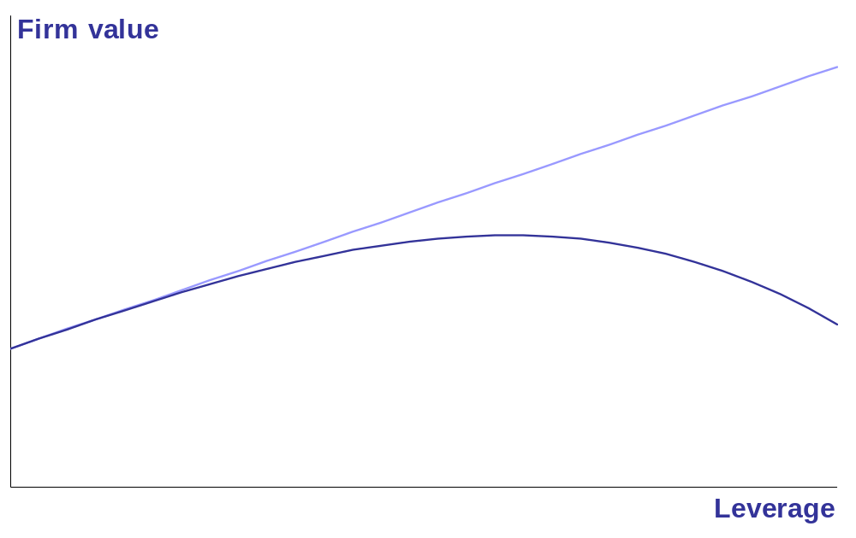
Target capital structure
V_{U} + tax shields
V_{U} + tax shields – distress costs
Debt vs. equity: (1 – τ_{d}) vs. (1 – τ_{c})(1 – τ_{e})

Main argument

Internal equity is cheaper than external equity

Cash distributions trigger personal taxes

Tax deferral benefit of retained earnings helps offset the tax disadvantage of equity

Our goal

Quantify this effect

Study the impact on capital structure, payout policy, and the cost of capital
Example

Firm has $1

Distribute now
Investors get (1 – τ_{e}), grows to (1 – τ_{e}) [1 + r (1 – τ_{i})]

Distribute next year
Grows to 1 + r (1 – τ_{c}), investors get (1 – τ_{e}) [1 + r (1 – τ_{c})]

Retaining better if τ_{c} < τ_{i}
Internal equity has tax benefits if τ_{c} < τ_{i}

Trade-off: accelerate taxes vs. double taxation

Example

This paper

Clarify and generalize this idea (the example makes strong implicit assumptions)

Miller (1977): (1 – τ_{c}) (1 – τ_{e}) > (1 – τ_{i})?

Understand the implications for a firm’s capital structure, payout policy, and cost of capital

Overview

Clarify the literature

Capital structure
Miller (1977), Hennessy and Whited (2004)

Dividend taxes
King (1974), Auerbach (1979), Poterba and Summers (1985)

Outline

Simple model with two periods

Discuss the literature

Implications for corporate behavior

Empirical estimates of the tax costs of equity

Model

Study tax effects

No agency conflicts, information asymmetries, or distress costs

t = 1

t = 0
Investment opportunity, Y

Raise D₀, S₀

Cash: C₀ = D₀ + S₀ – Y
Project pays Y + P₁

Repay debt

Equity distribution, δ₁

Raise D₁, S₁

Invest cash in riskless asset
t = 2
Liquidation

Assumptions

Debt is short term

Risk neutral investors, interest rate = r

Project return P₁ > Y r [no bankruptcy]

Taxes

Corporate tax rate is τ_{c}, personal tax rates are τ_{i}, τ_{dv}, τ_{cg}

Capital gains taxed on realization (trading at t = 1 exogenous)

Liquidating dividends not taxed on portion that represents capital repayment
Assumptions

Classic tax system

Corporate profits, after interest, taxed at τ_{c}

Personal income taxed at τ_{i}, τ_{dv}, τ_{cg}

Imputation system

Personal tax credit for corporate taxes already paid on dividends

Effectively: τ_{dv} = 1 – (1 – τ_{i}) / (1 – τ_{c})

Model

Exogenous trading

t = 0
t = 1
t = 2
Investors:

Trade α of their shares

Realize gains of α (V₁ – S₀)

Tax basis = (1 – α) S₀ + α V₁

Model

Taxes

t = 0
t = 1
t = 2

Corporate tax

Capital gains tax on a fraction of shares

Personal tax on dividends / repurchases
No taxes
Corporate tax

Personal tax on dividends / liquidating repurchase

Tax effects

Debt financing

New external equity

Internal equity / retained earnings

Cashflows

Firm’s cashflows

Arrival to date 1: C₁ = Y + P₁ (1 – τ_{c}) + (C₀ – D₀) [1 + r (1 – τ_{c})]

Exit from date 1: C₁′ = C₁ + D₁ + S₁ – δ₁

Arrival to date 2: C₂ = (C₁′ – D₁) [1 + r (1 – τ_{c})]

Transactions at date 1

Proposition

Issuing debt to hold as cash (i.e., to invest in the riskfree asset) has no effect on value, regardless of tax rates

Implications

Debt does not create value, via interest tax shields; only important if it changes equity

Using cash to pay down debt doesn’t affect value either

In transactions with equityholders, it doesn’t matter where cash comes from or goes to

Equity financing at date 1

External equity

Raise S₁ at date 1

Shareholders’ CF₂ = π₂ + S₁ [1 + r (1 – τ_{c})(1 – τ_{e})]

τ_{e} is either τ_{cg} or τ_{dv}

NPV

Invest S₁ = $1 in the firm: 1 + r (1 – τ_{c})(1 – τ_{e})

Invest $1 outside the firm: 1 + r (1 – τ_{i})

Equity financing at date 1

Proposition 2 (Miller)*

If the firm uses repurchases, the tax benefit of external equity is:

PV(S₁) = S₁ 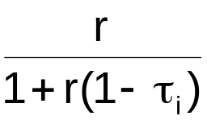[(1 – τ_{c})(1 – τ_{cg}) – (1 – τ_{i})]

If the firm uses dividends, the tax benefit of external equity is:

PV(S₁) = S₁ [(1 – τ_{c})(1 – τ_{dv}) – (1 – τ_{i})]

Equity financing at date 1

Internal equity: retained earnings vs. repurchases

Distribute all cash at date 1

t = 1: CF₁ = C₁ – τ_{cg} (C₁ – S₀)

Fully retain, distribute at date 2

t = 1: CF₁ = – α τ_{cg} (V₁ – S₀)

t = 2: CF₂ = C₂ – τ_{cg} (C₂ – TB₁)

[V₁ = PV(CF₂)]
Equity financing at date 1

Proposition 3

The tax benefit of internal equity at date 1, or the PV of retained cash vis-à-vis a share repurchase, is

PV(RE₁) = RE₁ 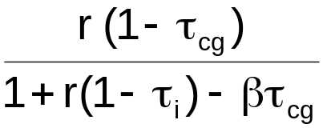[(1 – τ_{c})(1 – βτ_{cg}) – (1 – τ_{i})]

where β = TB₁ / V₁, the tax basis relative to current price when the firm doesn’t repurchase

β determines how much tax is triggered by repurchase at t = 1

Equity financing at date 1

Case 1: β = 0 [α = 0, S₀ = 0]

Internal equity has tax benefit (better than debt) if τ_{c} < τ_{i}

PV(RE₁) = RE₁ 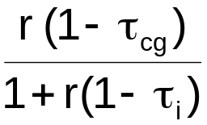[(1 – τ_{c}) – (1 – τ_{i})]

Trade-off

If firm distributes at date 1, shareholders get C₁ (1 – τ_{cg}), grows to C₁ (1 – τ_{cg}) [1 + r (1 – τ_{i})]

If firm retains the cash, it grows to C₁ [1 + r (1 – τ_{c})], shareholders get C₁ (1 – τ_{cg}) [1 + r (1 – τ_{c})]

Equity financing at date 1

Case 2: β = 1 [accrual taxation, α = 1]

Internal and external equity are equivalent

PV(RE₁) = RE₁ 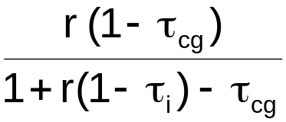[(1 – τ_{c})(1 – τ_{cg}) – (1 – τ_{i})]

≈ RE₁ [(1 – τ_{c})(1 – τ_{cg}) – (1 – τ_{i})]

Intuition

Payout triggers no new taxes → no deferral benefit

Shareholders pay tax on first-period earnings regardless of payout decision
Equity financing at date 1

Proposition 4: Retained earnings vs. dividends

With dividends, the tax benefit of internal equity at date 1, or the PV of retained cash vis-à-vis dividends, is

PV(RE₁) = RE₁ 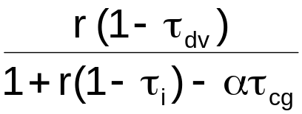[(1 – τ_{c})(1 – ατ_{cg}) – (1 – τ_{i})]

Observations

1 – τ_{dv} in numerator not 1 – τ_{cg}

α not β in brackets

Tax cost of dividends depends, in sign, on τ_{cg} not τ_{dv}

Equity financing at date 1

Why is ατ_{cg} important?

Suppose α = 0

Example from introduction: dividend tax is a sunk cost

PV(RE₁) = RE₁ 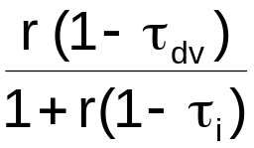[(1 – τ_{c}) – (1 – τ_{i})]

If α > 0

Same except shareholders also pay capital gains taxes at t = 1 determined by α τ_{cg}

Interpretation

Impact on capital structure?

Impact on payout policy?

Impact on the cost of capital and investment?

Capital structure

Trade-off theory

No distinction between internal and external equity

Target leverage ratio

Tax cost of equity depends on (1 – τ_{c})(1 – τ_{e}) – (1 – τ_{i})

[τ_{e} ambiguous; avg. of τ_{dv} and τ_{cg}]

Capital structure

Our results

Internal equity generally less costly than external equity

Equivalent only if α = β = 1 and either

1: Firms use repurchases

2: Firms use dividends and τ_{cg} = τ_{dv}

[with dividends, internal equity is cheaper if α τ_{cg} < τ_{dv}]
[King, 1974; Auerbach, 1979]

Capital structure

Our results

Incentives to lever up smaller than often assumed

For firms with internal cash, trade-off between debt and retained earnings, not debt and new equity

Dividends: (1 – τ_{c})(1 – ατ_{cg}) – (1 – τ_{i})
Neither depends on τ_{dv}

Repurch: (1 – τ_{c})(1 – βτ_{cg}) – (1 – τ_{i})

Profitable firms (w/ internal cash) should have lower leverage

Internal equity may have tax benefits even if firms never want to issue new equity

Capital structure

Our results

No target debt ratio

Debt ratio should be a function of internal cashflows

Leverage up when the firm has a cash deficit, down when it has a cash surplus

Pecking order?

Payout policy

Dividend puzzle

Form: why do firms use dividends not repurchases?

Timing: why do firms pay dividends vs. retain the cash?

τ_{dv} vs. τ_{cg}

Observation 1
Retaining good if (1 – τ_{c})(1 – ατ_{cg}) – (1 – τ_{i}), which doesn’t depend on dividend taxes

Observation 2
Inconsistent with view that profitable firms have too little leverage
Cost of capital

Trade-off theory

WACC =  (1 – τ_{c}) r_{D} +  r_{E}

Cost of capital

Our results

Cost of capital also depends on the firm’s mix of internal and external equity

 | Dividends | Repurchases
External equity | r (1 – τ_{i}) / (1 – τ_{dv}) | r (1 – τ_{i}) / (1 – τ_{cg})
Internal equity | r (1 – τ_{i}) / (1 – ατ_{cg}) | r (1 – τ_{i}) / (1 – βτ_{cg})

Cost of internal equity doesn’t depend on τ_{dv}

Investment-to-cashflow sensitivity

Cost of capital ≠ expected stock return

Literature

Hennessy and Whited (2004)

Dynamic model
Taxes, uncertainty, issuance costs, bankruptcy costs

Flat tax on distributions, no other personal taxes
In essence: firms use dividends and α τ_{cg} = 0

Maximizes the tax advantage of retained earnings
Drives many of their dynamics
Same as example in introduction: retaining better if τ_{c} < τ_{i}

Literature

Trapped equity

Auerbach (1979), Poterba and Summers (1985)

Dividend policy is irrelevant even with taxes

Equity value = 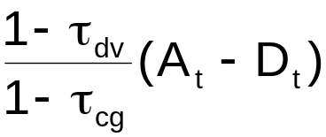

If pay $1 today, shareholders get 1 – τ_{dv}

If retain, value goes up by 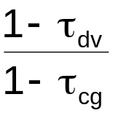; after capital gains taxes = 1 – τ_{dv}

Implication: τ_{dv} doesn’t affect cost of capital or investment
Literature

Our results

Trapped equity only if tax rates are just right: only if internal equity has zero tax costs

Miller-like equilibrum: (1 – τ_{c})(1 – ατ_{cg}) = (1 – τ_{i})

Even if trapped equity doesn’t hold, τ_{dv} does NOT affect the cost of internal equity

If retained earnings or debt is the marginal source of funds, τ_{dv} doesn’t affect investment decisions

Empirical results

Estimate tax costs of equity for a large sample of U.S. firms

Tax costs depend on
Tax rates
Interest rates
Fraction of capital gains taxed each period / tax basis of shares

Perspective of representative investor
Typical tax rates
Average tax basis of all shareholders

Tax rates, 1966 – 2003

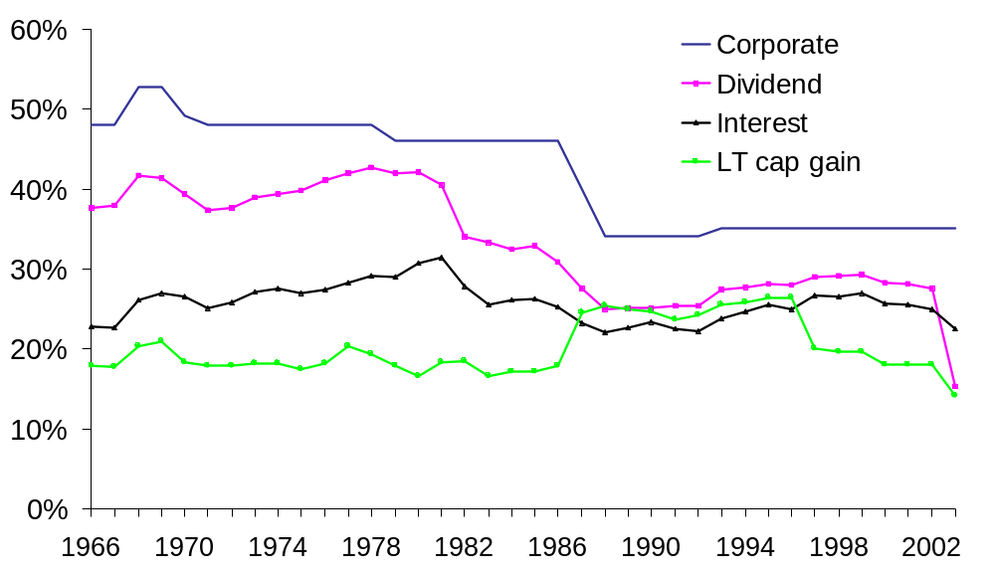

Tax basis of shares

Tax basis = average purchase price

Estimate using prices and trading volume

Proportional trading
All investors holding a stock are equally likely to sell

Different propensities to trade
Recent purchasers are more likely to sell than long-time investors

Trading probabilities

Ivkovic, Poterba, and Weisbenner (2004)

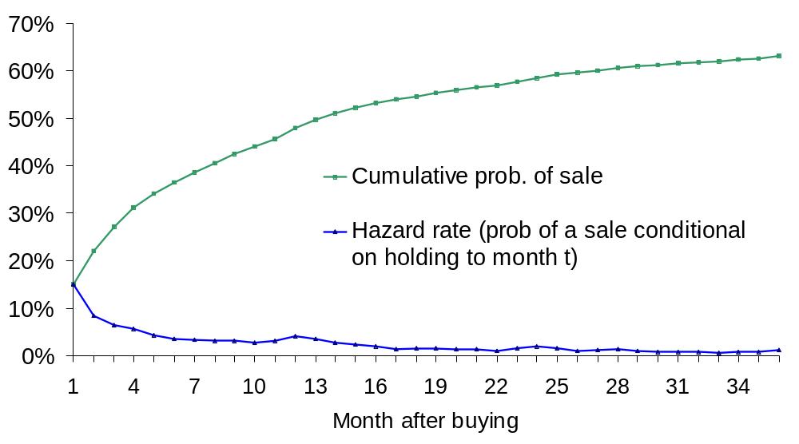
Tax basis of shares

Proportional trading

Tax basis evolves as TB_{t} = v_{t} P_{t} + (1 – v_{t}) TB_{t-1}

Recursively substituting:

TB_{t} = 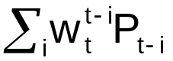

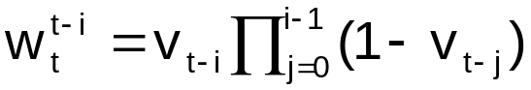

Examples

TB₁ = v₁ P₁ + (1 – v₁) TB₀
TB₂ = v₂ P₂ + (1 – v₂) v₁ P₁ + (1 – v₂)(1 – v₁) TB₀
:

Tax basis of shares

IPW hazard rates

Hazard rates, h_{i}, imply that trading volume evolves as

v₁′ = h₁
v₂′ = h₁ v₁′ + h₂ (1 – v₁′)
v₃′ = h₁ v₂′ + h₂ (1 – h₁) v₁′ + h₃ (1 – h₂) (1 – v₁′),

Infer the fraction of shares held today that were bought last month, the month before, and so on

Treat abnormal trading volume in three ways

Ignore completely
Scale hazard rates up and down
Scale hazard rates down, truncate volume at predicted level

Data

1966 – 2003

7,066 NYSE and Amex stocks on CRSP

Daily (proportional) and monthly (IPW hazard rates) data

α is annual trading volume

Truncate estimates of α and β at one

Trading volume and tax basis, 1966 – 2003

Pooled time series and cross section of monthly estimates

Variable | Mean | Std | Q1 | Median | Q3
Trading volume | 0.47 | 0.32 | 0.20 | 0.38 | 0.72
Estimates of β, assuming the initial basis = .5P₁
Proportional | 0.85 | 0.18 | 0.72 | 0.92 | 1.00
IPW | 0.77 | 0.22 | 0.59 | 0.80 | 1.00
IPW scaled | 0.80 | 0.20 | 0.64 | 0.84 | 1.00
IPW truncated | 0.73 | 0.23 | 0.54 | 0.73 | 1.00
Estimates of β, assuming the initial basis = P₁
Proportional | 0.88 | 0.16 | 0.79 | 0.98 | 1.00
IPW | 0.81 | 0.21 | 0.64 | 0.88 | 1.00
IPW scaled | 0.85 | 0.18 | 0.72 | 0.94 | 1.00
IPW truncated | 0.80 | 0.22 | 0.62 | 0.87 | 1.00
Tax basis, 1966 – 2003

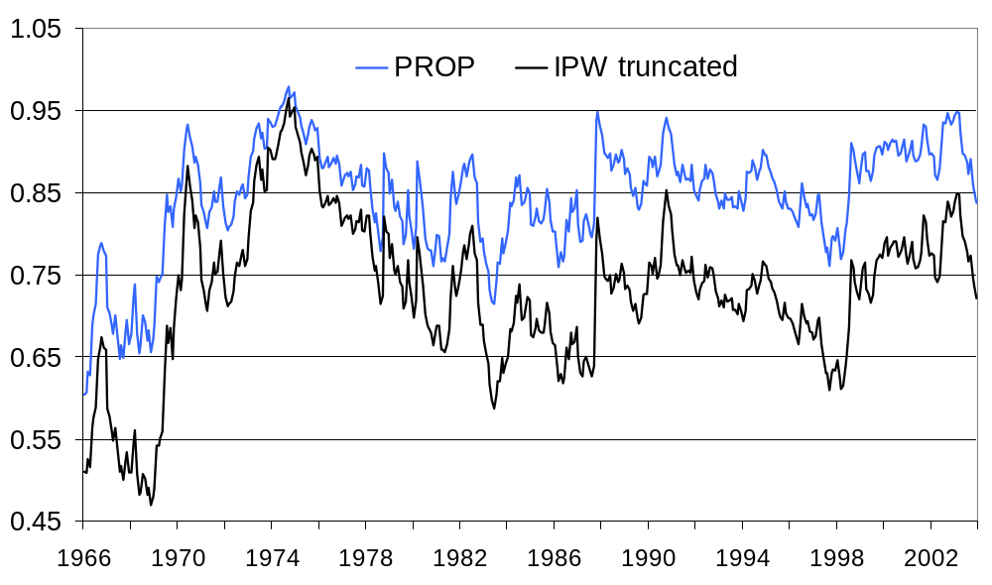

Trading volume, 1966 – 2003

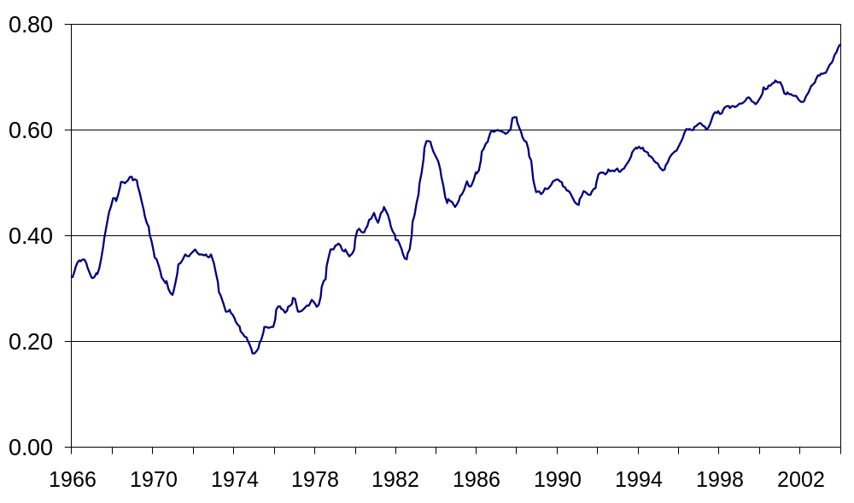

Tax costs of equity

If firms use dividends

External: [(1 – τ_{c})(1 –τ_{dv}) – (1 – τ_{i})]

Internal: [(1 – τ_{c})(1 – ατ_{cg}) – (1 – τ_{i})]

If firms use repurchases

External: [(1 – τ_{c})(1 –τ_{cg}) – (1 – τ_{i})]

Internal: [(1 – τ_{c})(1 – βτ_{cg}) – (1 – τ_{i})]

Tax costs of equity, 1966 – 2003

Pooled time series and cross section

 |  | τ_{c} = top |  |  | τ_{c} = .66 top |  |  | τ_{c} = .33 top |  |  | τ_{c} = 0
 | β est. | Mean | Std |  | Mean | Std |  | Mean | Std |  | Mean | Std
Tax costs if firms use dividends (%)
External | -- | -2.31 | 1.07 |  | -1.70 | 0.82 |  | -1.11 | 0.59 |  | -0.52 | 0.39
Internal | -- | -1.02 | 0.45 |  | -0.42 | 0.30 |  | 0.17 | 0.32 |  | 0.76 | 0.49
Tax costs if firms use repurchases (%)
External | -- | -1.80 | 0.72 |  | -1.05 | 0.39 |  | -0.31 | 0.23 |  | 0.42 | 0.45
Internal | Prop | -1.62 | 0.68 |  | -0.87 | 0.38 |  | -0.15 | 0.29 |  | 0.58 | 0.52
 | IPW | -1.54 | 0.68 |  | -0.80 | 0.39 |  | -0.07 | 0.31 |  | 0.66 | 0.53
 | IPW-scale | -1.57 | 0.67 |  | -0.82 | 0.38 |  | -0.10 | 0.30 |  | 0.63 | 0.53
 | IPW-trunc | -1.51 | 0.67 |  | -0.76 | 0.38 |  | -0.03 | 0.32 |  | 0.69 | 0.54

Tax costs of equity, 1966 – 2003

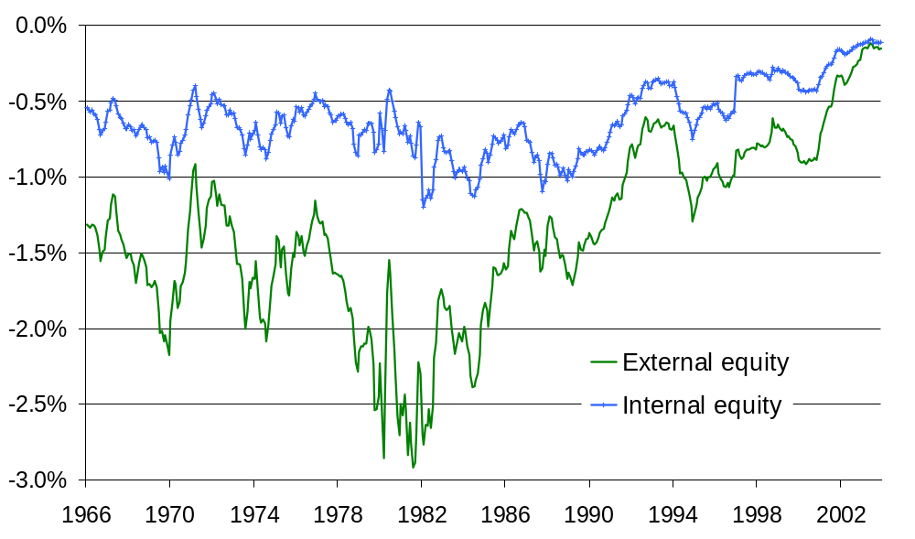

Summary

Debt vs. internal equity vs. external equity

Tax advantage of internal equity depends on capital gains taxation

Implications for capital structure, payout policy, and cost of capital

