Using Dealmaster Pro with PlayBridge Dealer4
Pete Matthews, March 19, 2008; minor updates July 3, 2009

Required Software
Obtain and install:
- The Dealer4 software that came with your PlayBridge Dealer4.
- Dealmaster Pro, $60 from Ward Software, http://www.dealmaster.com/.
- CutePDF Writer, free from http://www.cutepdf.com/.
- Adobe Acrobat Reader, free from http://www.adobe.com/.

Primary File Formats
Four file formats are handled by both Dealmaster Pro and the PlayBridge Dealer4 software:
.BRI Dealer4, Autodealer, and BridgePartner (the Dealer4 default)
.BRE Autodealer
.DUP Duplimate (older DOS format, good for ACBL-generated deals, works with ScoreBridge)
.PBN Portable Bridge Notation (includes GIB)

Other formats: Dealmaster Pro will also “Import” these other formats: .DLM (Duplimate for Windows), .CDS, .LIN (Bridgebase), and an exported Dealmaster Profile. You can create files in various formats from DM Pro, by checking the “Create Files for…” box (instead of Print North…) - see “Create the Hand Records” below. Any file that can be loaded into Dealer4 can be saved in the formats above.

Dealer4 Setup
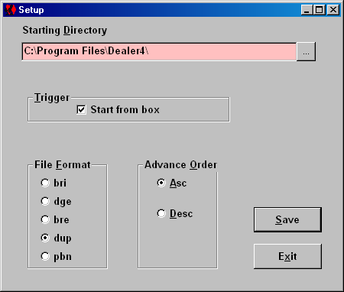
One time only, start the Dealer4 software and click Setup on the Dealer4 main menu (see “Deal the Cards”).
- Select one of the four primary deal types (any here except .dge), and
- click Save.
Choose any one primary file format, and try to stick to it. Choose the format that is most likely to be used by your bridge organization. I used .dup for a year, but now use .pbn – I may use it with a free program called ACBLmerge.

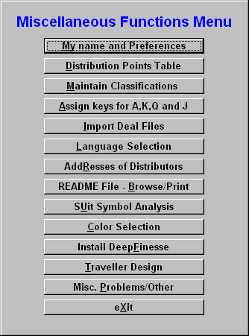
Dealmaster Pro Setup
One time only, start the Dealmaster Pro software (see “Generating Random Deals”), and click Miscellaneous on the main menu.
Then, in turn, click
- My Name and Preferences,
- Language Selection, and
- Misc. Problems/Other

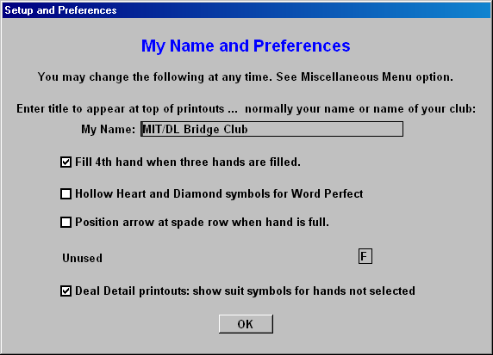
Enter the name of your bridge club as My Name, and click OK.
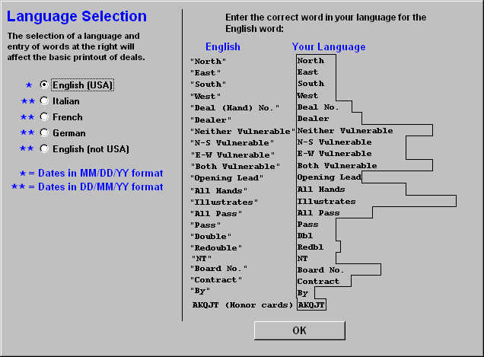
Select your Language. If not English (USA), you may need to enter the information on the right. Click OK when done.
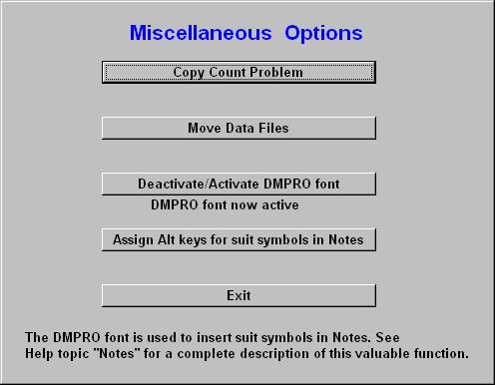
Be sure that DMPRO font now active is displayed. If not, click Deactivate/Activate DMPRO font, and then Exit.

Generate Random Deals into a Deal File
Skip this section, if you already have a deal file in one of the four primary file formats.

The Dealer4 software may generate random deals, but you really need other software for that, such as Dealmaster Pro. This powerful program has a quirky interface, but ultimately it will produce top quality hand records, including analysis by Deep Finesse. (If you teach bridge, you should appreciate the ability to create a library of categorized hands for lessons, but that’s beyond the scope of this article.) For our purposes, the best thing to do is to limit use of DM Pro to the distinct operations required. To generate the deals for one session:

- Start Dealmaster Pro.

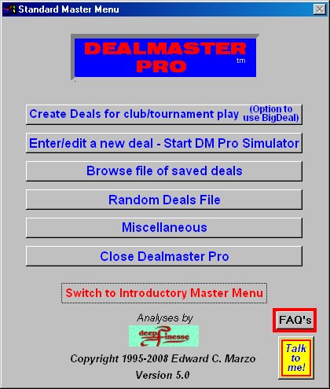
- Click the first option on the main menu: Create random deals for club/tournament play.

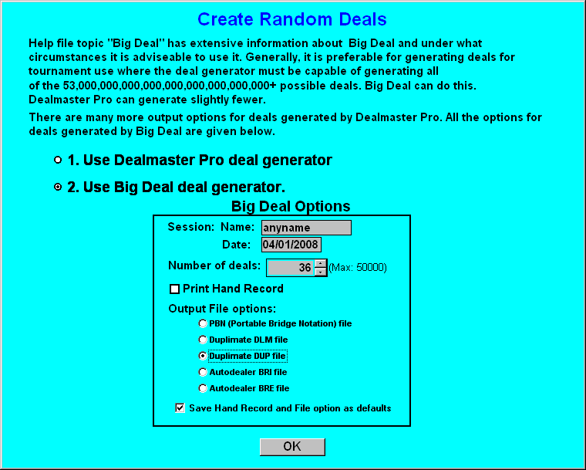
- Select 2. Use Big Deal deal generator, and then:
  - Enter any name (won’t be saved in the deal file)
  - Specify the date of the game
  - Enter the number of deals (likely 36 or 32)
  - Do not check Print Hand Record
  - Select one of the four primary file formats (e.g. Duplimate DUP file)
  - Check Save Hand Record and File option as defaults
  - Click OK
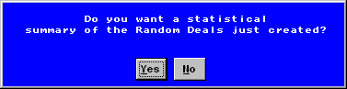
- Click NO, do not show a statistical summary.

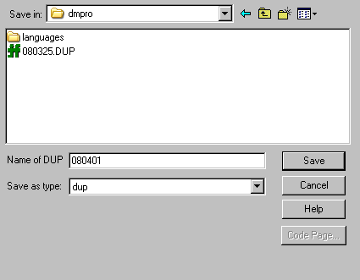
- Save the deal file:
  - Name the deal file. For use with ACBLscore,YYMMDD or YYMMDDs (where s is M, A, E or L) is appropriate – 080401 is for April 1, 2008.
  - It’s best to use the default DM Pro directory, C:\dmpro.
  - Click Save.
In subsequent steps, this deal file will be used to both create the hand records and deal the hands.

Create the Hand Records
Creating the hand records takes quite a bit of computer processing. You could do this in the step above, but you would not get the deal file until the very end. Separating the steps allows you to start the hand records, and deal the cards while waiting.
- Start DM Pro, if not already started (see “Generating Random Deals”).
- Click the Miscellaneous option (see “Dealmaster Pro Setup” above).

- Click Import Deal Files.

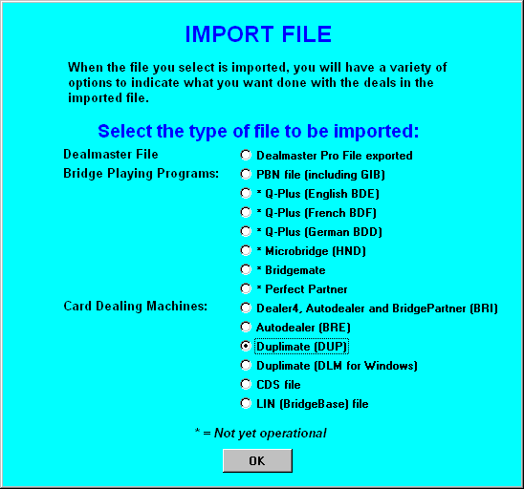
- Select your deal file type, and click OK.
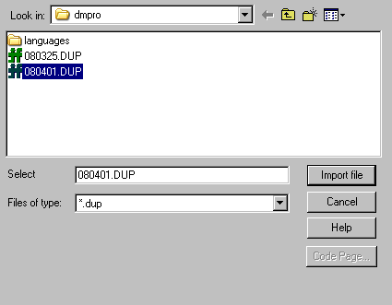
- Select the deal file, and click Import File
- Click OK, if a blue informatory screen appears.
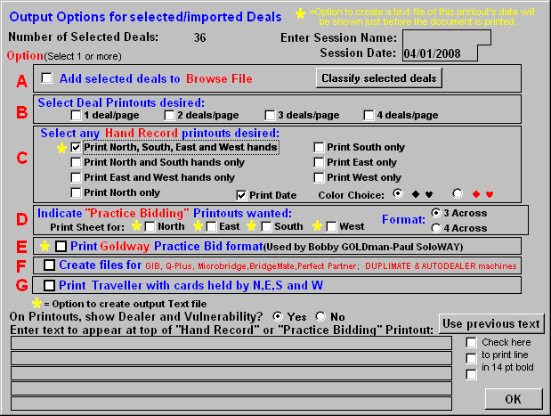
- Be sure to get this page right:
  - Leave the Session Name blank
  - Change the Session Date to the date of the game
  - Check Print North, South, East and West Hands
  - Click OK
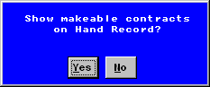
- Click Yes, show makeable contracts on Hand Record.

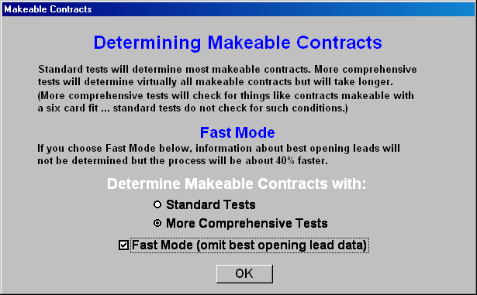
- Select More Comprehensive Tests, not Fast Mode, and OK.
Note: A comparison of the results with Fast Mode checked and unchecked, showed no difference in makeable contracts for a set of 36 boards, but I no longer check this box. The comprehensive tests check 6-card fits.

Computation of the makeable contracts will begin. It’s probably time to deal the cards (see below). Just let the computation continue, no matter how long it takes.
Usually, I prepare a bunch of deals in advance, so that I can deal and print quickly.

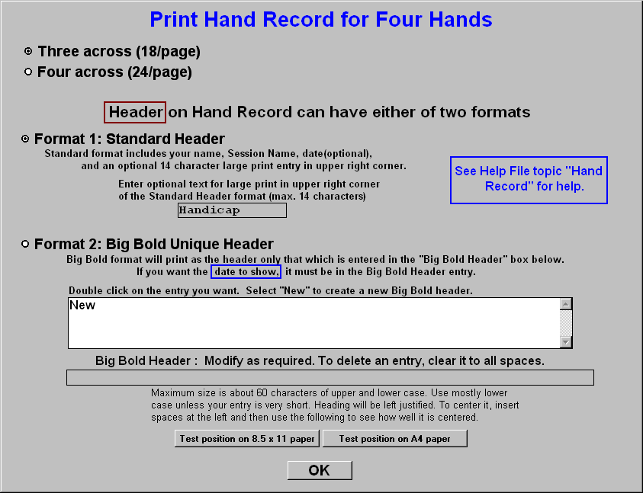
- When computation of the makeable contracts completes, this box will appear - be sure to get this right, there’s no going back:
  - Select 3 across (18/page), unless you are doing only 24 boards.
  - Select Format 1: Standard Header
  - Enter the type of game in the box under the Format 1 bullet, e.g. Handicap
  - Click OK.
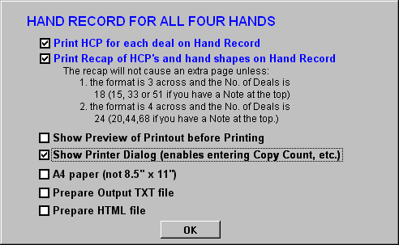
- Check the box for Show Printer Dialog (enables entering Copy Count, etc.). In Europe, you probably want to check A4 paper (not 8.5” x 11”). Click OK.
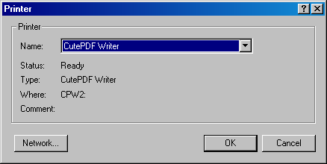
- Select CutePDF Writer as your printer, and click OK. Then click OK again on the following:
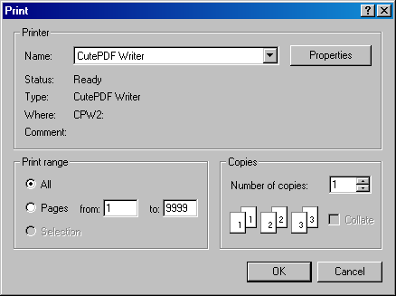
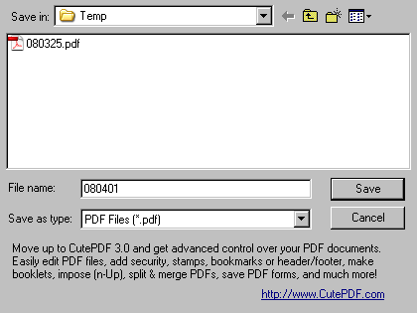
- Save the PDF file to disk:
  - Name the resulting PDF file (YYMMDD or YYMMDDs, for consistency with ACBLscore)
  - Select the output directory (for example, C:\Temp)
  - Click Save
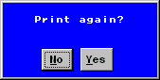
- Click NO, do not print again.
- Exit, Close Dealmaster Pro.

Deal the Cards
Pay attention to your posture to avoid repetitive strain or back injury!
I use flip-open boards. (If you don’t have them, an assistant can definitely speed up the process, by removing cards from boards for you.) Here’s my method of setting up the area for dealing:

- Start the Dealer4 software.
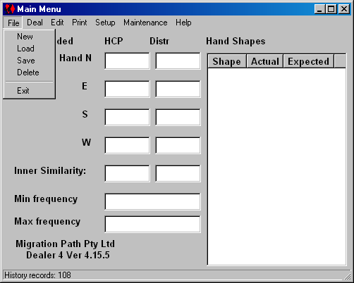
- Select File – Load.
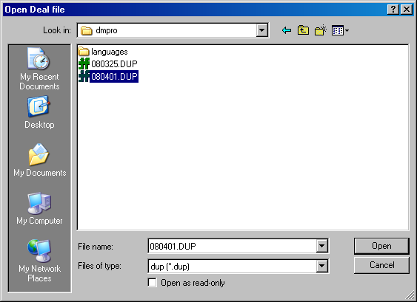
- Browse to where the deal file is (C:\dmpro), select the file, and click Open.
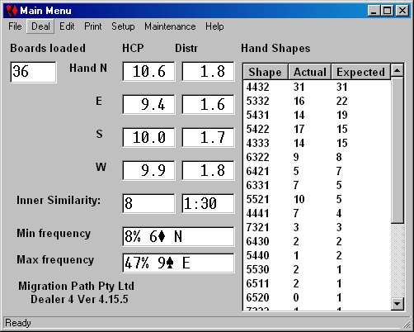
- Click Deal. Click Deal again on the next window:
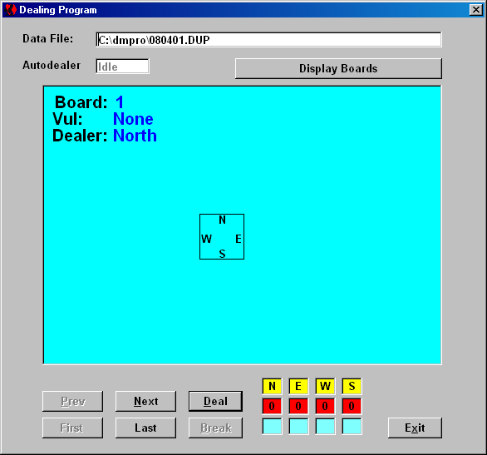
- Clear the area to the left and right of the monitor, push the keyboard and monitor back to allow 10+ inches (.25m), and set the PlayBridge Dealer4 machine back against the keyboard. Be sure it’s connected to the computer and powered on. A good 60 inches (5 ft, 1.5m) of width is useful, with you in the center, in front of the machine, with an extra 4 inches (.1m) in front of that.
- Connect the machine to power and the computer.
- Check that the lens is clean. If not, use compressed air or a soft brush to clean it.
- Get all 36 boards out and stack them up to your right, 12 to a stack, north pointed away from you, board 1 on top and nearest.
- Remove the cards from the last two boards (35 & 36), and put them into the hopper, face down. This rotates the decks, so that they will wear evenly.
- Remove the cards from board 1, and put them onto the hopper. They won’t fit, but the extra weight will help.
- Continuing for all boards:
  - Insert the open, empty board into the machine
  - Grab the next board, and put it on your lap, opening away from you
  - Remove the cards, two hands at a time, stacking them in front of the machine (to reduce wear on the joint, I don’t open the board at this time)
  - Put the new cards onto the hopper
  - Look through the top – if a card is leaning, push the top of the board down, and either poke the card down with a finger, or jiggle the aluminum flip plate until the card drops (see “The Flip Plate” below).
  - Remove the board from the machine, snap it securely closed, and stack it to the left, upside down - make three stacks of 12 boards, neatly enough that they do not fall over.
The machine may have trouble with warped cards, especially if bowed up in the middle. Bend the cards down in the center, or hold them down lightly, if cards do not feed. While the last board is dealing, it helps to press down lightly on the middle of the deck with a finger nail.

Errors Detected by Dealer4 Software
After correcting any of these errors, you will usually have to click Continue, or press the Start button on the front left of the machine.
Card Recognition Error: The machine could not recognize a card. Check the bottom card (might be a Joker or upside down), the lens, and that there is sufficient weight on the hopper.
Card Feed Error: Usually, this means that the card on the bottom is not straight and flat, but it could indicate a card jam. Check the bottom card and the feed area.
No Card Box: The machine does not detect the presence of a bridge board, (or the flat dealing plate). Jiggle or press the board in firmly.
Lost Communication: Check both ends of the USB cable. Jiggle it or move to another port, if necessary.

The Flip Plate and Leaning Cards
The flip plate, on models designated “PlayBridgeDealer4” instead of just “Dealer4”, is intended for use with flip-open boards. It generally improves the alignment of cards into the boxes of the board. However, it also contributes to the possibility of leaning cards.
The Dealer4 will not normally deal while the flip plate is raised, because card jams would result. You should be able to deal onto the flat plate with the flip plate in place, but you will have to raise the flip to remove the cards, and lower the flip for the next deal.
To remove the flip plate, from the designer’s instructions:
- Open the flip plate.
- Using small pliers, remove the springs from both sides.
- From the left side, remove the screw that is holding the flip plate in position.
- Slide the flip plate off the right screw (it is not required to remove the right screw).
- Be careful to save the plastic washers on both sides.
- When the plate is removed, you cannot deal because software will issue a "Flip Plate Open" Error. To override it, first connect the machine to power and the computer. Click Maintenance on the Dealer4 software main menu. Check Disable Flip Plate Switch, and click on Save Parameters.
To reinstall the flip plate, reverse the above procedures. Dealing with the flip open (failing to reset the Maintenance option) will result in major card jams.
To reduce the likelihood of leaning cards, be sure the card width adjustment on the machine is not too tight (which could cause cards to twist, when dealt), and use sufficient pressure in the hopper, as recommended above. Clean cards should help.
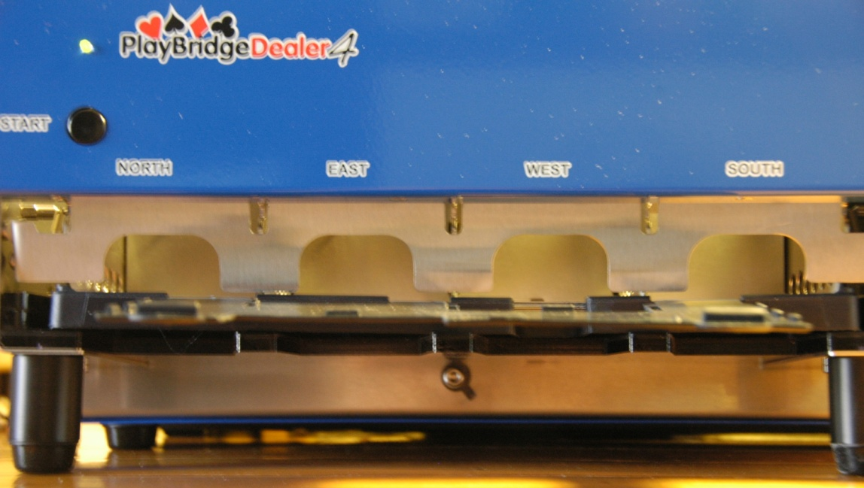
My Dealer4 with spring-loaded aluminum “flip plate” and navy blue “new generation” bridge board in place. The Dealer4 software requires the flip plate to be down, whether dealing into a board or onto the plastic plate. Poke a finger through a hole or tap the side of the board to clear leaning cards.
For the first year with the Dealer4, I used Grimaud barcode cards that I got with with a Duplimate. At the end of that year, these cards had been used perhaps 60 times over two years. They still had some life in them, but being thicker and now slightly warped, they tended not to fall cleanly into the card boxes, as well as the occasional leaner. I replaced the Grimauds with ACBL cards, which are thinner: they rattle in the card boxes. Leaners are now very rare, and only an occasional shake or tap is needed to get the cards to nestle into the card boxes.

Final Check
When done dealing, remove the North hand from the next to last board (35) and check the spade suit against the hand records. This assures that the board set and hand records correspond, and that the cards were really dealt into the correct boards. (Early on, I had the hands and boards get out of sync a couple of times, especially when dealing onto the plate. The latest version of the Dealer4 software has eliminated this problem, but this check is easy.)

Examine and Print the Hand Records
Open the PDF file with Adobe Acrobat Reader, examine the results, and print as desired. If your printer will print two-sided automatically, then you probably don’t need to know anything more.
If you have a 1-sided printer, open the paper tray (or feeder), take out a sheet of paper, write a word on it in pencil, put it back, and print something on it. Open the tray and use tape to label the inside to describe where the top of the page will print. This will come in handy for a number of applications.
Now, use this technique to print two-sided hand records:
- Click on the displayed first page, just in case.
- Click the Printer icon (File-Print).
- Select Current Page, select the desired number of copies, and click OK.
- Take the output, square the pages, and insert them into the paper tray, ready to print side two.
- Scroll to the end of the file in Acrobat Reader, and click on the second page, just in case.
- Click the Printer icon (File-Print).
- Select Current Page, confirm the desired number of copies, and click OK.

