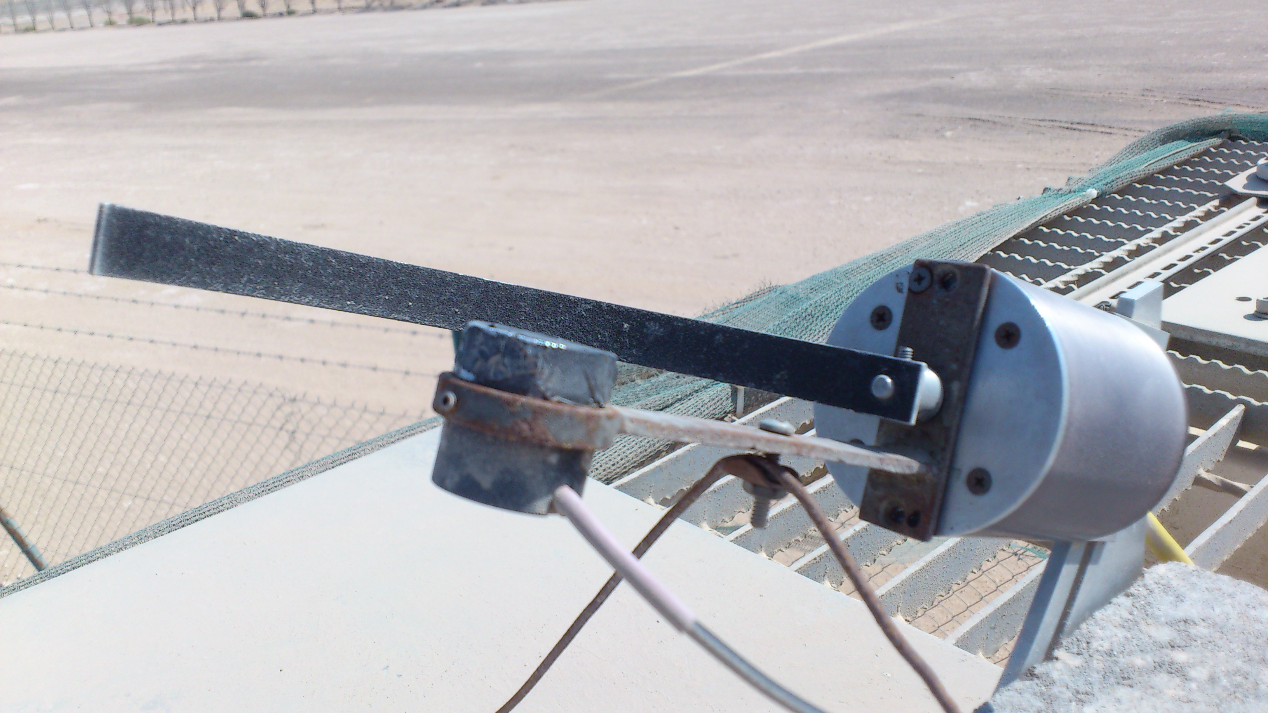

Next up 2012.11.01 after stiffenig Licor bracket and ireplacing 3k with 2k resistor. 4,5,6-point moving averages; then –point with endpoints halved:

20121102

