Simulation Studio
To start a multizone building project:
- Start the Simulation Studio. File ->New->Building Project (Multizone).
- Follow the instructions. Once you are done with the wizard, your project will be created. 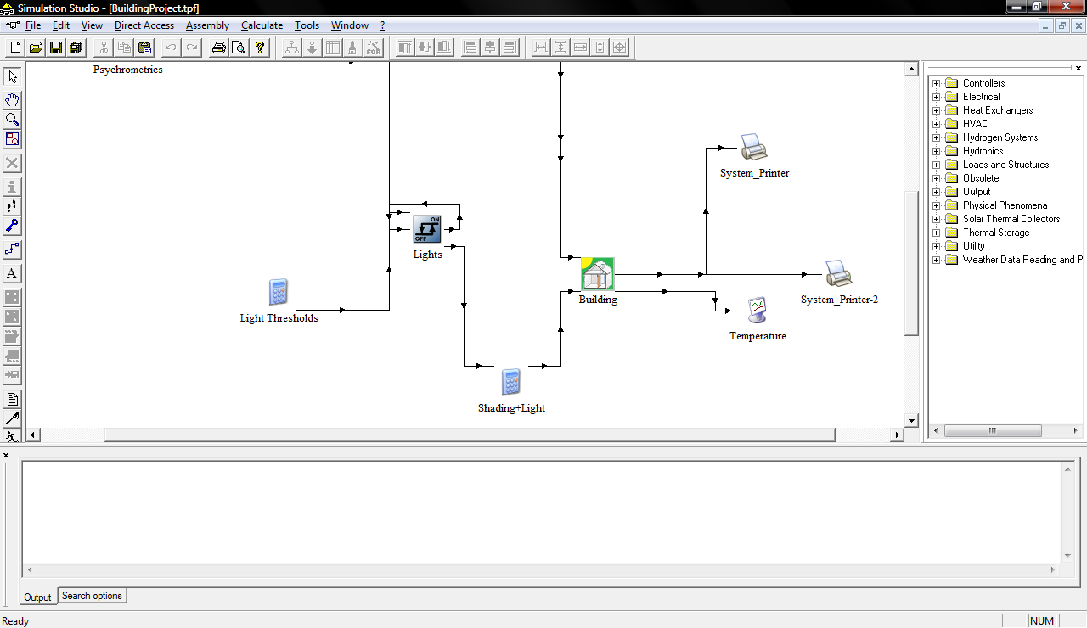
- Your Type 56 icon is the one called “Building”. You may right click it to modify your building model in TRNBuild. Just right click and select “Edit Building”. More on TRNBuild later.
- You can click the lines between two components to alter the flow of information between them. For example, you can click the line between the “Building” component and “Temperature” component to choose which parameters are plotted (“Temperature” is a plotting component). 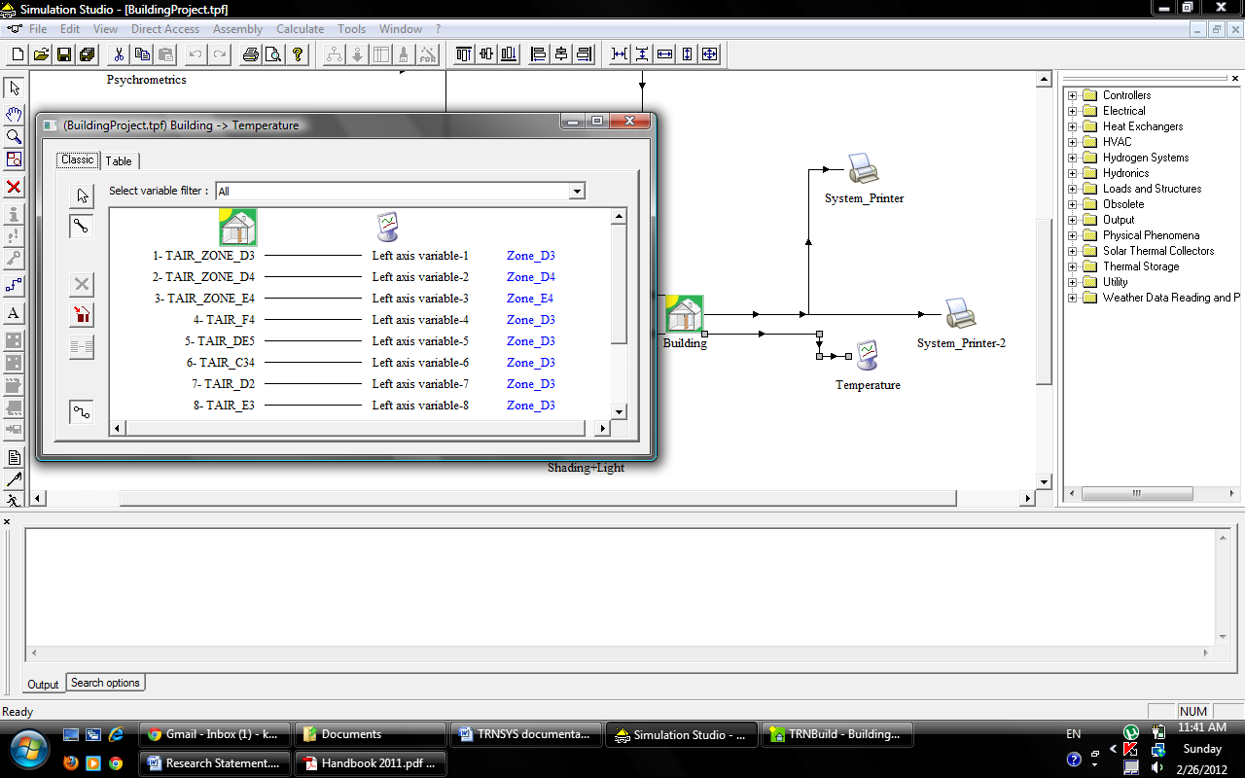
- Double click “Building” in order to view its properties. Here, you can go to “output” and tick the “print” box in order for the output to be printed to a text file. This is useful for copying data into Excel. Otherwise all you get is the graph.
- Each printing component can only print 10 parameters. If you choose to print more than 10 outputs, a new printing component will be created. Make sure to change the associated text file of the new printing component, however, because the default will always be the same.
- In order to change the text file to which a printing component prints, double click a printing component and select “External Files”. Proceed to change the file name.
TRNBuild
- If you right click “Building” and choose “Edit building”, your Type 56 model is opened for modification using TRNBuild.
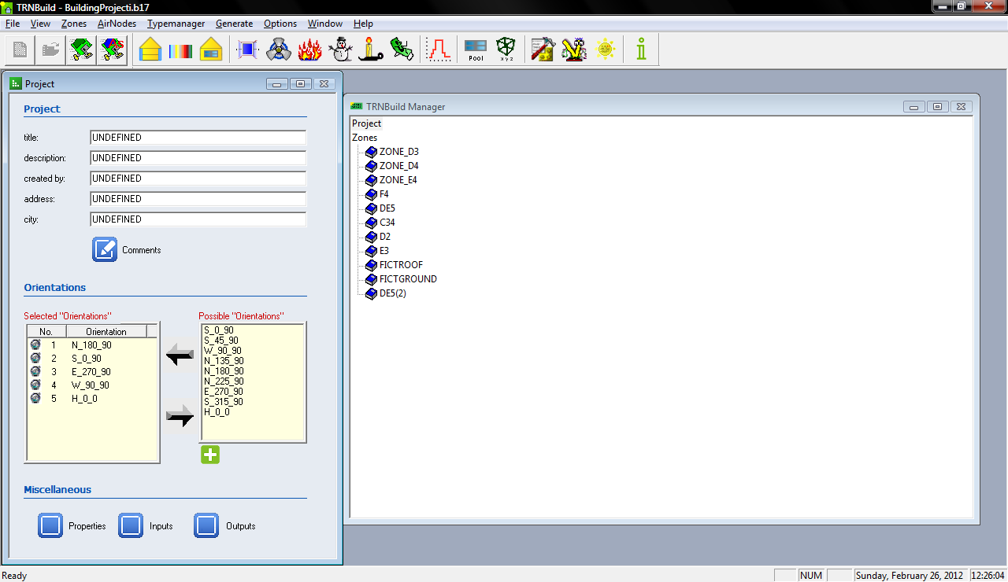
- I never managed to get the max. heat load calculation to work (on the top, 3rd button from the right), but that’s fine because it is of no use to us. It provides a static calculation, and we need to account for transience. In order to obtain a useable value of max. heat load, we get TRNBuild to output hourly heat loads, and then manually find the maximum.
- Click on “Outputs” shown in the previous screenshot to define the model’s outputs. Use this to get hourly values of heat load. QSENS is the needed parameter. 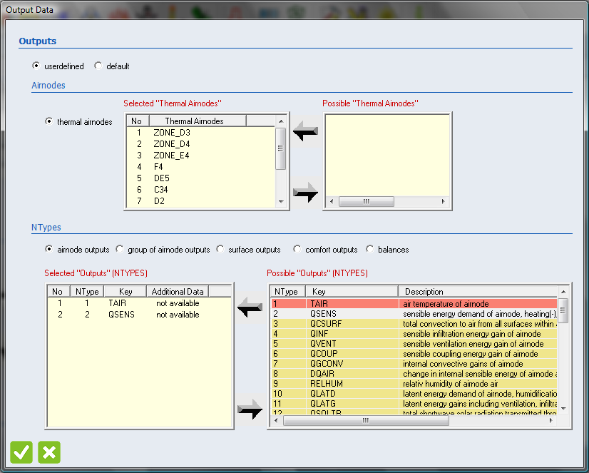
- You may click any zone to modify it. 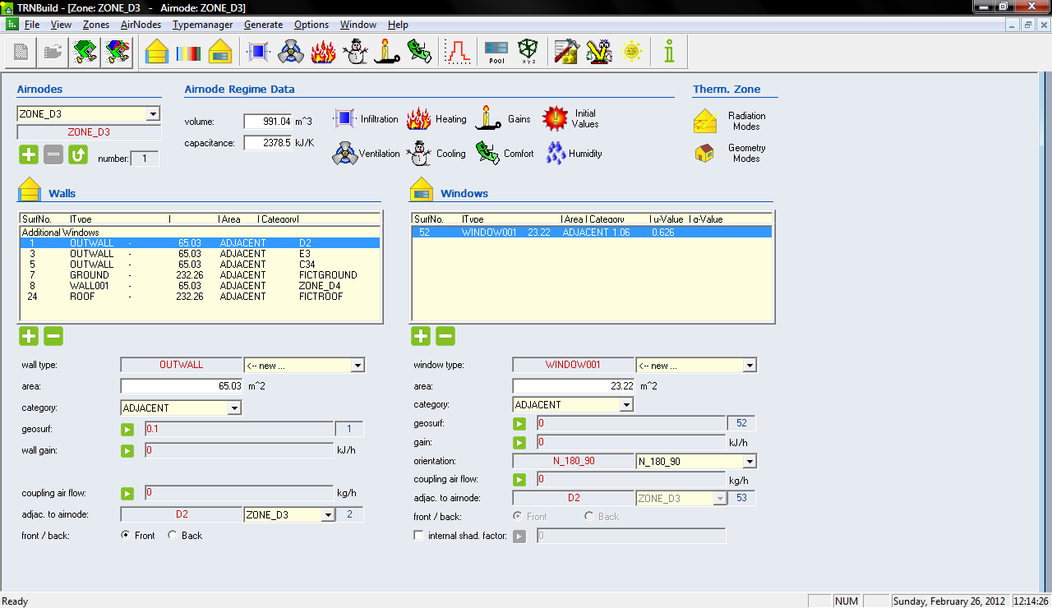
- Right click the wall type (OUTWALL in this case) to change the wall properties. Note that all OUTWALLs will be affected. Same applies to windows.
- You may change any other properties of the zone here.

Building the Three-Zone Model

Here’s how to build the three zone model that I’ve been working on, as a precursor to the field station model. We are starting with this simple model to make sure we know how everything works, so that modeling the field station will go (relatively) smoothly.
- Start the Simulation Studio. Create a new multizone building project.
- Select the zones you need in the wizard. We have three ‘real’ zones (I used D3, D4 and E4), and 7 ‘fictitious’ zones (I used C3, C4, D5, E5, F4, E3, and D2). The fictitious zones are only used to set the boundary conditions of the walls of the real zones. Instead of setting the wall temperature of a real zone to a certain value, we set the air temperature of the corresponding fictitious zones to the desired value. I later learned we could have just defined walls as boundaries, and fix their temperatures. You may want to experiment with doing that. If so, fictitious zones would not be needed. You would just model the three real zones.
- Proceed with the wizard, and set the dimensions of the zones. Dimensions are like those in Tauha’s EQuest two-zone model. You have to convert them all to m instead of ft. For convenience: Height= 4.267 m, Width=Length=15.24 m.
- Set the rest of the parameters in the wizard as needed. I have grown accustomed to setting everything as zero in the wizard and just adjusting everything as needed in TRNBuild. Since I was also only interested in the step response, almost everything would stay set to zero anyway.
- Now that we are done with the wizard, the project is built on the simulation studio. Right click the building component and select “Edit Building” to launch the building model in TRNBuild.
- Once in TRNBuild, DON’T FORGET TO CREATE ROOFS. TRNSYS builds zones without roofs by default. I don’t know why. Make sure to add a wall to account for the roof. Set the roof wall type as “external” for now.
- Now we need to create two new zones: fictitious zones for the roof and ground. 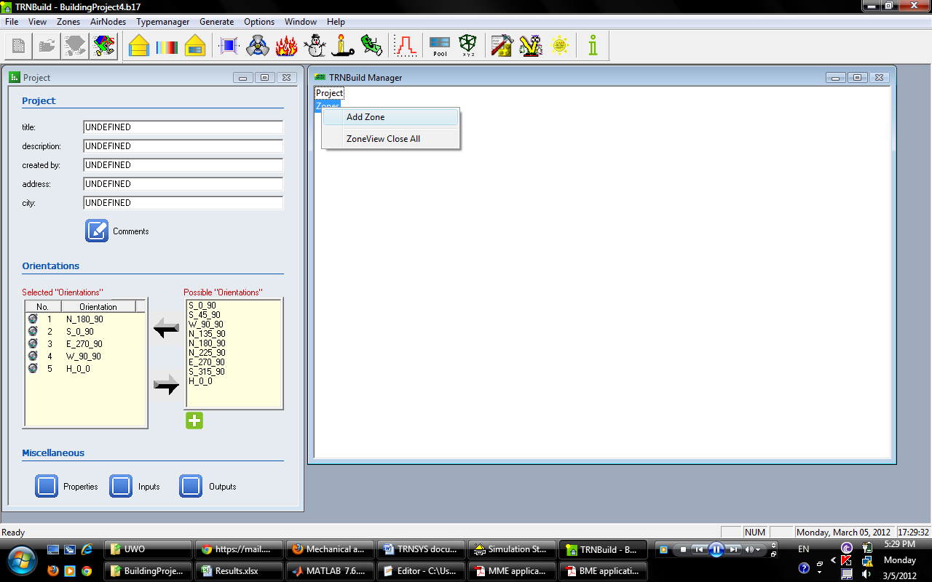

- Once these zones are created, go to your real zones and set the ground and roof to be adjacent to the fictitious roof and ground, instead of “external” and “boundary” respectively. All walls of the real zones should now be adjacent to another zone.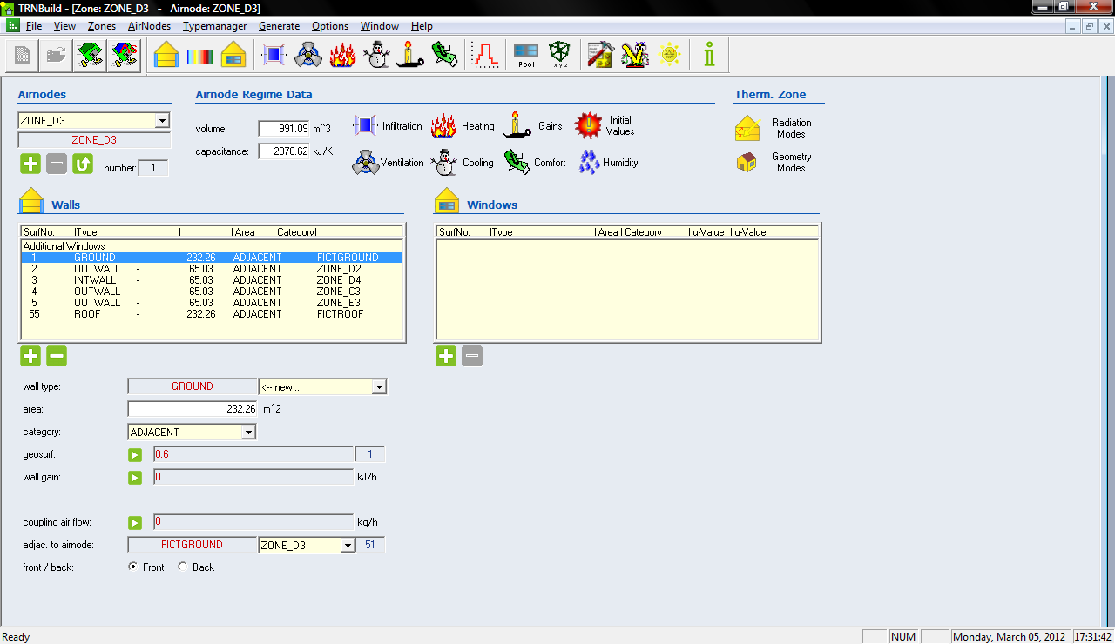
- Also don’t forget to create roofs for the fictitious zones. This is as simple as adding an “external” wall to each fictitious zone.
- For the fictitious ground zone, the roof is adjacent to the real zones’ ground (try to imagine it). For the fictitious roof, the ground is adjacent to the real zones’ roof.
- Set the initial conditions of all zones as temp=0 C. Everything else should be off or zero, including infiltration, heating, cooling, internal gains, etc.
- DON’T FORGET TO SET THE TEMPERATURE OF “BOUNDARY” WALLS TO ZERO. The default temperature value of a “ground” boundary wall is 15 C. This will mess up your step response. Set it to zero.
- With that, you should be ready to start running your model (conduct simple checks like checking the number of walls for each zone, making sure all walls on a real zone are adjacent to another zone, etc.)
- Note that a LOT of options don’t actually work in TRNBuild, particularly zone options in the right click menu shown in the screenshot below.
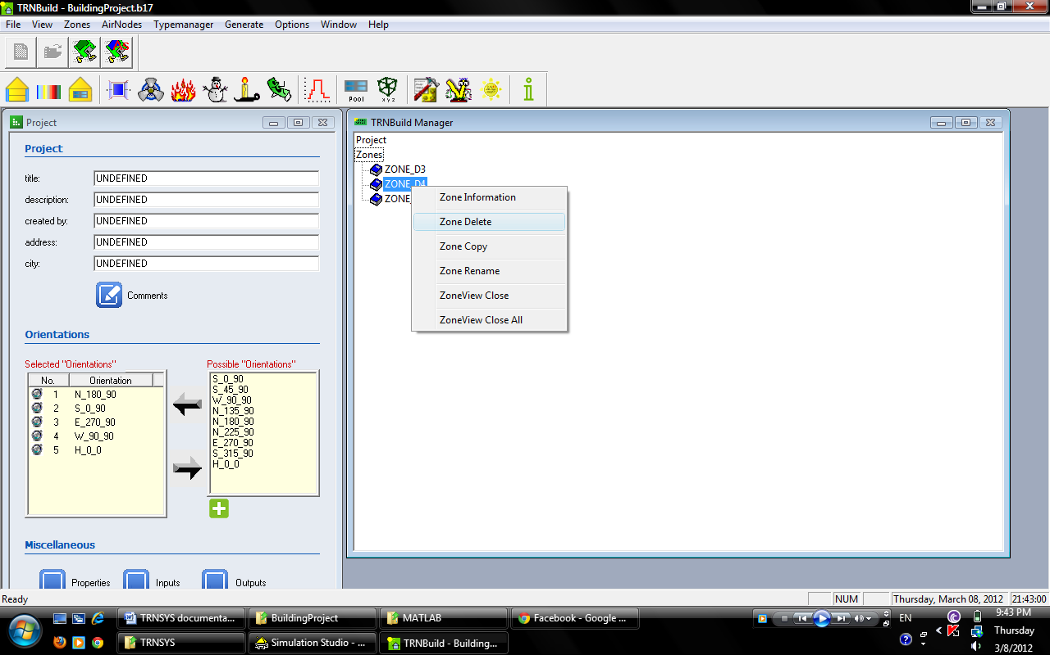
None of the options in this menu work. You can NOT delete or rename a zone once it is created.

