Introduction
Low-lift cooling is a highly efficient cooling strategy conceived to enable low or net-zero energy buildings. The ultimate goal of this program, begun in 2006 at a National Laboratory, is to develop commercially implementable systems that can meet the high cooling energy savings potential shown to exist across many climate zones and building types (Jiang et al. 2007, Armstrong et al. 2009a,b, Katipamula et al. 2010).

A low-lift cooling system consists of a high efficiency low-lift chiller, radiant cooling, thermal storage, and model-predictive control to pre-cool thermal storage overnight. Dehumidification is usually provided by a separate system, e.g. DOAS.

In a high performance building with moderate peak daily cooling load, integral thermal storage can be accomplished with thermo-active building systems (TABS). In a standard TABS implementation pipe loops are embedded in concrete floor decks to allow active charging of building thermal capacitance. This approach can be applied easily to new construction, or to existing buildings undergoing a deep retrofit, where a thin “topping” slab can be applied to existing infrastructure.

The present work extends the previous MPC formulations in three ways. First, where previously only single zone systems were model we now treat multiple zones served by a single chiller or outdoor unit. Second separate control of TABS and direct cooling terminal units such as efficient hydronic or DX fan-coil, radiant panels, near-surface capillary tubes, and chilled beams are addressed. Third, a suboptimal, heuristic control scheme that eliminates the high dimensional search of the rigorous formulation is developed and tested.

Literature review.

2. Zone Model and Control Algorithm
The first part of this section will describe how the modeling methods developed in previous work have been refined to be applicable to multi-zone buildings with the full range of thermal loads and zone diversity. The second part will describe how to implement the rigorous model-predictive algorithm in the case where an optimization solver is available. The third part of this section will describe a simplified control algorithm that avoids the need for an optimization solver by bracketing the allowable cooling rates to meet comfort conditions and meet the load most efficiently by delivering the total daily load at the lowest possible average energy input ratio (EIR) within the allowed operation region.

2.1 Transient Thermal Response Model of Multi-zone Building
The operative temperature of each zone in a building changes based on the temperatures of adjacent zones (such as other spaces of the building or the outside conditions) and thermal inputs to the zone (such as internal loads [lights, plugs, occupants], solar loads, or mechanical system heating and cooling rates). A data-driven model of building temperature response is required that can be identified from conventional BAS sensor inputs, weather, and measured or estimated internal loads. The resulting model can then be used to predict zone temperatures throughout the building by driving it with forecast weather and internal loads and any hypothetical sequence of control actions.
In a single-zone building with a single heating, ventilation and air conditioning (HVAC) system, the operative temperature of the zone, T_{o}, can be predicted by a comprehensive room transfer function (CRTF, Seem 1987), of the following form:

(1)

The operative temperature of a single zone at time K can be predicted from measured values of its past operative temperature, and measured and predicted values of external climate temperature and thermal loads, including internal loads, occupant loads, diffuse and direct solar loads, and mechanical system loads.
A few changes and additions to equation (1) are required to make it applicable to a complete low-lift cooling system in a multi-zone building. In low-lift cooling, latent loads are met using a dedicated outdoor air system (DOAS) with efficient dehumidification, such that the relative humidity of the zone is kept low enough to prevent condensation on the cold surface of the radiant cooling system and maintain comfort. To improve control of operative temperature, fast acting sensible cooling equipment such as hydronic or DX fan coils, radiant panels or surfaces, or chilled beams may be provided. To account for the sensible cooling rate delivered by the fast terminal equipment and DOAS, multiple mechanical systems as shown in Figure 0, may be included in the temperature response model.

Furthermore, low-lift cooling may be applied to multi-zone buildings in which different internal loads, mechanical heating or cooling, and operative temperatures may exist in each zone. A refined temperature response model that includes multiple zones (three are used as an example) and the effect of the DOAS by allowing for an arbitrary number of mechanical systems in each zone may be written as follows:

(2)

where, similar to equation (1), the operative temperatures at the next timestep K are predicted from measured values of past operative temperatures along with measured and forecast values of external climate temperature and relevant thermal loads. In this case, mechanical system loads are included from R mechanical systems, which might include the DOAS, and operative temperatures are predicted for Z zones. The equation can be used to predict zone operative temperatures T_{oj,k} for each zone j.

At steady state, with no thermal loads and all temperatures equal, constraints on the coefficients of equation (2) are apparent, consistent with Armstrong et al. (2006a,b). These constraints are given by the following equation for all zones j, where o_{jj,K} = -1 for all zones:

(3)

The prediction of zone operative temperatures presented above provides only part of the information (the cooling rates needed to maintain thermal comfort conditions) required to implement model-predictive control of precooling. The other information required for model-predictive control in low-lift cooling is a model of the power consumption of the low-lift chiller. Physics-based models of low-lift chillers have been presented in Armstrong et al. (2009a, b) and Zakula et al. (2011), which require information about the chiller compressor speed, condenser flow rate, evaporator flow rate, condenser fluid entering temperature, and evaporator fluid entering temperature to predict low-lift chiller cooling capacity and power consumption. For a given cooling rate, external climate temperature (which is equivalent to the condenser air entering temperature for an air-cooled chiller), and chilled-water return temperature (which is equivalent to evaporator fluid entering temperature), there is an optimal combination of compressor speed, condenser fan speed and evaporator flow rate that meet the desired cooling rate with minimum chiller input power.

If chiller capacity schedule is to be optimized over a 24-hour horizon, then predictions of predictions of external climate temperature T_{x} and chilled-water return temperature T_{chwr} are required. In cases where building thermal mass provides thermal energy storage through a radiant concrete structure (such as a TABS), the chilled-water return temperature depends on the thermal state of the TABS thermal energy storage (TES). An internal concrete-core temperature can be measured, T_{cc}, to represent the thermal state of the TABS-TES. Future values of T_{cc} must also be predicted, along with zone operative temperatures, to predict T_{chwr}, evaporating temperature T_{e}, and ultimately chiller input power P_{ch}. To predict T_{cc}, T_{chwr}, T_{e}, and P_{ch}, additional models of building thermal response are required.

The TABS-TES system can be treated as an Nth order thermal model, similar to the building zones, but with fewer thermal inputs. The TABS-TES system inputs include the temperatures on either side of the concrete slab and any radiant thermal loads impinging directly onto the surfaces of the slab from internal or solar loads. The resulting transfer function representation of concrete-core temperature response is:

(4)
where Q subscripts i, p, d, D and m refer to internal gains, people, diffuse solar, direct solar and mechanical which may be positive for heating or negative for cooling.

At steady state, the constraints on the coefficients are as follows (similar to equation (3):

where κ_{j,K} = -1 (5)

The coefficients of equations (2) and (4) can be identified from training data collected from sensors installed in a building. For example,

- globe temperature sensors may be employed to measure operative temperature,
- thermistors may be installed in the TABS to measure concrete-core temperature,
- internal loads can be estimated from measurements of electrical consumption in each zone and zone occupancy sensor,
- solar loads can be measured through irradiance sensors measuring diffuse and direct solar components, and
- mechanical system heating and cooling rates can be measured using flow and temperature measurements or estimated using models of system performance as a function of controlled variables.

The chilled-water return temperature to the chiller evaporator, T_{chwr}, is now needed to estimate evaporating temperature T_{e} and chiller power consumption P_{ch}. The evaporator return water is a mixture of the chilled-water returned from each zone in a TABS and, neglecting pipe losses, can be calculated as follows:

(6)
The chilled-water return temperature from each zone, T_{chwr,z} can be calculated using a quasi-steady state representation of the concrete-core system as a heat exchanger with a uniform temperature T_{cc,z}, calculated using equation (4) for a given cooling rate. At quasi-steady state, the following engineering relation for heat exchanger effectiveness can be applied to the zone TABS (Armstrong et al. 2009a):

or (7)

At the evaporator, ignoring any superheating, a similar heat exchanger equation can be employed to represent the effectiveness of the chiller evaporator:

or (8)

Substituting equation (7) into equation (6) yields the following equation for chilled-water return temperature, where aggregate heat exchanger effectiveness and mass-flow weighted concrete-core temperature have been defined to simplify the equation as follows:

(9)

Using equations (8) and (9), the following relation can be found for the chilled-water loop temperature difference:

(10)

Furthermore, the total cooling rate delivered by the chiller can be calculated with the following equation:
(11)

The mass flow weighted concrete-core temperature is still unknown, because the zone concrete-core temperatures T_{cc,z} depend on the chiller cooling rate, which can only be computed once the evaporating temperature T_{e} is known. The zone concrete-core temperatures T_{cc,z} must be predicted from zone cooling rates and the other variables in equation (4). One final relation closes the loop between choices of control variables for the low-lift chiller, such as compressor speed, condenser fan speed, and evaporator flow rate (zone pump speeds in a multi-zone TABS), and the temperature response of the building and TABS. From equations (6), (7) and (8), along with the observation that total chiller cooling rate must equal the sum of the zone cooling rates, the following relationship can be found for zone chilled-water return temperatures and the chilled-water supply temperature relative to zone concrete-core temperatures, evaporating temperature, and the total chiller cooling rate.

(12)

A model of chiller power consumption and cooling capacity is also required, which can be created from measurements (Gayeski et al. 2011a) or physical models (Zakula et al. 2011) and represented by curve-fit performance models:

(13a)
(13b)
or
(14)

In equations (13) functions f and g are quad-cubic polynomials for power consumption or cooling capacity at a given time K as a function of chiller compressor speed, condenser fan speed, external climate temperature (condenser air temperature), and evaporating temperature at timestep K. Alternatively (14) is a tri-cubic for energy input ration in terms of capacity and the two temperature conditions. These curves are described in more detail in Section 3.

2.2 Multi-zone Low-lift Cooling Model-predictive Control Optimization
To predict the temperature response of the building zones and the power consumption of the chiller at a future timestep K, the following procedure may be followed using the equations above.

1. Select desired chiller capacity and zone chilled-water pump speeds.
2. Initially, assume an evaporating temperature based on current mass-flow weighted concrete-core temperatures and total chilled-water mass flow rate.
3. Compute chiller power consumption from equations (13) or (14) forecast external climate temperature and assumed evaporating temperature from step 2.
4. Assume the zone cooling rates are equivalent to the following:
(15)
5. Compute the zone operative temperatures and concrete-core temperatures at the next timestep from equations (2) and (4) using the estimated zone cooling rates from step 4.
6. Compute the zone chilled-water return temperatures and chilled-water supply temperature from equation (12), and compare calculated zone cooling rates with estimated zone cooling rates.
7. Iterate steps 2 through 6 until the assumed zone cooling rates and the evaporating temperature equals the calculated zone cooling rates and evaporating temperature in equation (12).

Procedure is repeated for each hour given a schedule of 24 future hourly zone cooling rates. An objective function that penalizes chiller power consumption, deviations of zone operative temperatures from thermal comfort constraints, and chiller evaporating temperatures that approach freezing can be expressed as:

(16)

where P_{ch,τ} is the chiller power consumption at time τ, P_{o,τ} is the operative temperature penalty at time τ, and P_{e,τ} is the evaporating temperature penalty at time τ. The operative temperature penalty and evaporating temperature penalty are computed from the following equations:

(17)

(18)

A generalized pattern search (GPS) algorithm is used to find the optimal solution, of (16) using (13) (Gayeski 2010; Gayeski et al. 2011b) and a gradient search usibg (14) with a simplified TES model (Armstrong 2009b). The control variables to be optimized include 24 compressor speeds, one for each of the 24 hours of the forecast, and 24 times Z chilled-water pump speeds, one for each zone at each of the 24 hours. The optimization problem is thus a 24 times (1+Z) dimensional problem. If one includes fast terminal equipment it is a 24(1+2Z) dimensional problem.

2.3 Simplified Low-lift Cooling Model-predictive Control Algorithm
A less computationally intensive simplified approach to the model-predictive control optimization problem is desired . Even if a BAS supports industrial strength optimization methods, a simplified control algorithm will increase the speed at which the optimization can be performed, making it more suitable for real-time optimization. This section describes such a simplified method.

In a low-lift cooling system with TABS, the choice of zone precooling rate at any given hour affects the optimal choice of zone cooling rate at any future hour because it affects the concrete-core temperature response and subsequently the allowable evaporating temperature of the chiller. This in turn affects the chiller efficiency at future hours. In a single zone system Tcc can be used as a condition for the static-optimized chiller but in a multi-zone system a chiller performance map with 2+Z inputs becomes cumbersome. This complication seemingly prevents decoupling of the static chiller control optimization from the model-predictive control optimization. To decouple, the allocation of cooling rate by zone and corresponding flow rates must be moved to the MPC precooling optimization problem and the chiller map put in terms of Te.

However, in a properly designed and controlled TABS, the concrete-core temperatures, and thus chilled-water return temperature should not vary by more than a few degrees as the slab is precooled. By neglecting the impact of chilled-water return temperature on evaporating temperature and assuming a constant or slightly decreasing chilled-water return temperature over the course of the day (which may vary with cooling rate), the more significant terms of outdoor air temperature and part-load fraction can be dealt with separately in a model-predictive control optimization. The secondary static optimization of compressor speed, condenser fan speed, and chilled-water pump speed can then be performed at each timestep to determine the most efficient way to meet the loads determined by the model-predictive control algorithm.

Utilizing this constant core temperature assumption, the EIR as a function of forecast outdoor air temperature and cooling rates can be assembled into a chiller performance lookup table, describing chiller EIR as a function of time and cooling rate (or part-load fraction), and evaporating temperature. A typical daily performance table that provides the optimal static chiller EIR as a function of cooling rate and time of day is plotted below in Figure 1. The x-axis is the hour of the day, the y-axis is the cooling rate delivered at each hour, and the z-axis is the EIR at each hour for a given cooling rate. The variation in EIR in the time direction results from the time trajectory of outdoor temperature.
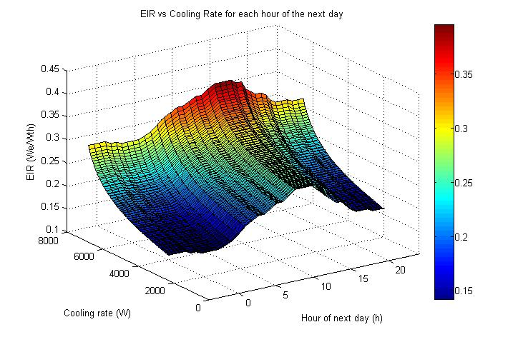
Figure 1. EIR (reciprocal of coefficient of performance - COP) for each hour of the outdoor temperature prediction horizon as a function of cooling rate

The thermal comfort constraints on each zone can also be simplified. In the rigorous control algorithm, the zone operative temperature trajectories are calculated for each candidate concrete-core hourly precooling rate schedule. The resulting temperature trajectories are penalized for excursions from the allowed comfort region. In the simplified approach, upper bounds on the hourly cooling rates and lower bounds on precooling delivered through each hour are determined. These bounds correspond to the minimum and maximum comfortable temperature in the zone. This is accomplished by first calculating the instantaneous cooling trajectories required to meet an upper operative temperature constraint and a lower operative temperature constraint. These instantaneous load schedules can be calculated using conventional multi-zone CRTF models identified from building data. Once these upper and lower bound direct cooling load schedules have been determined, they can be converted to a concrete-core precooling rate schedule using transfer function coefficients for both the instantaneous cooling loads and concrete core precooling rate schedule in the CRTF functions. This conversion shifts the chiller loads to earlier in the day and flattens out its peaks, as shown in Figure 2. The TABS can be designed to shift typical load profiles throughout the cooling season to an appropriate distribution, e.g., so the precooling rate peaks occur at the same hour as the typical cooling season minimum daily outdoor temperature.

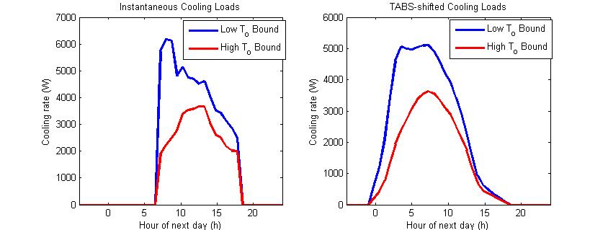
Figure 2. Bounding instantaneous cooling load profiles (left) and corresponding TABS-shifted precooling rate profiles (right)

Any concrete-core precooling rate schedule below the blue load profile on the right will not over-cool a zone. If the cumulative cooling load delivered up to a given hour is as much as that delivered by the red cooling load profile, the zone will not be under-cooled. This approach achieves a major simplification in that the operative temperature response to every candidate cooling rate profile need not be calculated at every timestep to determine whether comfort conditions are met. Any precooling rate schedule that adheres to the constraints described above should maintain comfort conditions for that zone. The total cooling load on the chiller plant is the sum across all zones served by the plant, which yields similar minimum and maximum cooling load profiles for the entire cooling plant.

Superimposing Figure 2 on Figure 1, Figure 3 shows the benefit of the TABS. The original cooling load profiles, (dotted lines), delivered by a system without TABS-TES span the periods of the day with the highest outdoor temperatures and highest EIRs (lowest COPs). The TABS-shifted precooling rate schedules, the solid lines, span early hours of the day when the EIRs are lower (COPs higher) and greater chilled efficiencies are possible.

Once these two bounds are set, an optimal precooling rate schedule (the red line) can be determined that is within the bounds of the maximum precooling rate schedule and provides at least the required cumulative load at each hour. Graphically, this can be thought of as filling the basin in Figure 1 such that the net cooling load is equivalent to the minimum base load, but the hourly precooling rate profile is constrained by the maximum precooling rate profile. This concept is shown in Figure 3, where the simplified optimal hourly cooling load is shown as a red line. The optimal load schedule stays within the maximum hourly precooling rate schedule, which limits the hours of operation and lowest achievable EIR in the early morning hours, and continues to cool up to a constant EIR where the remaining base cooling load can be met most efficiently, as reflected by the load schedule following the contour lines of the EIR map.

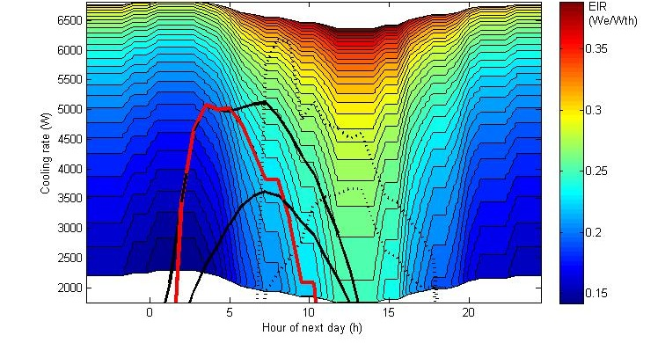
Figure 3. Contour map of possible EIR at each cooling rate for every hour of the day superimposed with the maximum and minimum instantaneous cooling load profiles (dotted lines), TABS-shifted precooling rate profiles (solid black lines), and simplified optimal precooling rate schedule (solid red line)

The procedure illustrated above greatly simplifies the determination of the near optimal precooling rate schedule for a low-lift cooling system. The procedure requires that the chiller controller contain a three-dimensional lookup table for the chiller EIR as a function of cooling rate, evaporating temperature, and outdoor air temperature. By assuming that the change in chilled-water temperature is negligible over the day, or that it is steadily decreasing by a few degrees, another three-dimensional lookup table (Figure 3) can be created from the original lookup table whenever a new optimal precooling rate schedule is required.
The maximum and minimum instantaneous cooling load schedules are identified from CRTFs and converted to TABS charging rate, or precooling rate, schedules using conduction transfer functions (CTFs) for the concrete slabs. The maximum precooling rate schedule constrains the allowed region within the time-of-day look up table, shown in Figure 4. The final step is to use the lookup table to determine the near optimal precooling rate schedule, within the allowed region, which provides the minimum cumulative cooling load. This is accomplished by summing the cooling rates at each hour along rows of the lookup table equal to or below a candidate maximum EIR for the day. The maximum EIR is increased (moving up a row in the lookup table) until the total minimum cooling load is met by the sum of all the loads at every hour at or below that maximum EIR.
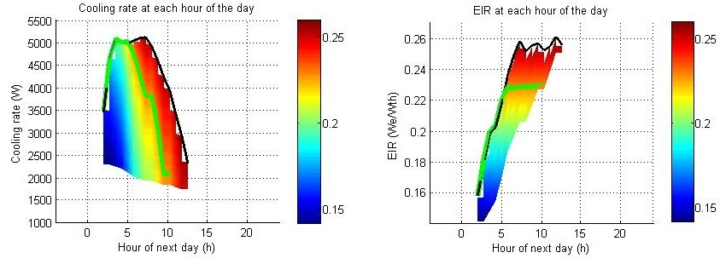
Figure 4. Optimal cooling rate (left) and EIR (right) at each hour of the day within the allowed region of operation (color map)
The result of this process is illustrated in Figure 5. The cumulative cooling load delivered for each candidate maximum EIR within the allowed region is shown on the left. The optimal operating point is the point with the lowest maximum EIR for the day that achieves the minimum cumulative cooling load for the day. The cumulative cooling delivered up to each hour of the day, bounded by the minimum and maximum cumulative cooling loads at each hour, is shown as a black line in the center graph. Finally the resulting chiller power consumption is shown on the right.
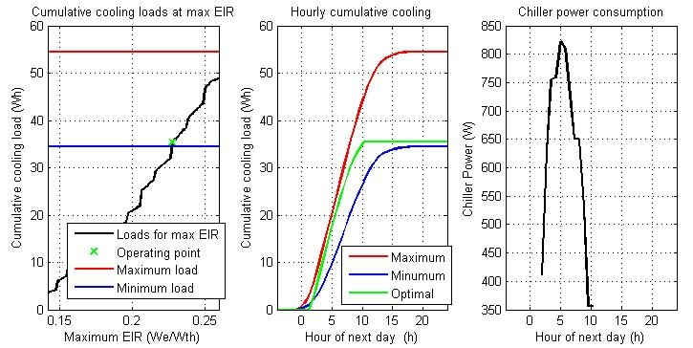
Figure 5. Cumulative cooling load for a given maximum EIR (left), optimal cumulative precooling rate at each hour of the day (center) and optimal chiller power consumption at each hour of the day

2.3.2 Summary of Low-lift Cooling Model-predictive Control Algorithm
The algorithms developed by Armstrong et al. (2009a) and Gayeski (2010) have been expanded to apply to multi-zone buildings with solar, occupant, and internal loads and in which zones may interact. These algorithms have been simplified by assuming the variation in chilled-water return temperature over a day is negligible relative to the variation in outdoor temperature and part-load ratio of the chiller. This assumption permits the creation of hourly chiller performance lookup tables from which an optimal low-lift precooling rate schedule within a comfort constrained region can be found by inspection. The comfort bounds are determined by linear CRTF and CTF models, which are simple sum-products of zone temperature and cooling flux histories. The resulting simplified algorithm requires only mathematical functions such as sum, product, minimum and maximum, the creation and evaluation of three-dimensional lookup tables, and a one-dimensional search over a finite number of contour lines. The process is repeated hourly as measured core temperature and operative temperature updates are received from each zone.
2.4 Annual Energy Use

4. Implementation in Commercial BAS
To test the model-predictive control algorithms and associated data-driven temperature response models described above, two Building Controls Virtual Test Bed (BCVTB) (LBNL 2011) files have been created to simulate the model identification process for a TABS building with low-lift cooling and the control algorithm commanding the prototype chiller controller. To test the model identification methods described in Section 2, a model of a three-zone building with a low-temperature radiant system in each zone has been adapted from EnergyPlus, which simulates a low-lift cooling system with TABS. A MATLAB® code identifies the multi-zone temperature response models described in equations (2) through (12) from this building simulation.

The BCVTB runs the EnergyPlus model to simulate the low-lift cooling system and, at each timestep, passes ‘measured’ data from EnergyPlus to MATLAB®. The MATLAB® code then identifies the coefficients of data-driven models, shown in equations (2) through (12) of the building simulated in EnergyPlus. These CRTF models are then available to predict the temperature response of the building (in this case the simulated building in EnergyPlus) to predicted conditions and any future sequence of control actions. The CRTF models can thus be used, along with the chiller performance map described in Section 3, to inform the simplified low-lift control algorithm. A screen shot of the low-lift system model identification test in BCVTB, using EnergyPlus and MATLAB®, is shown in Figure 10.

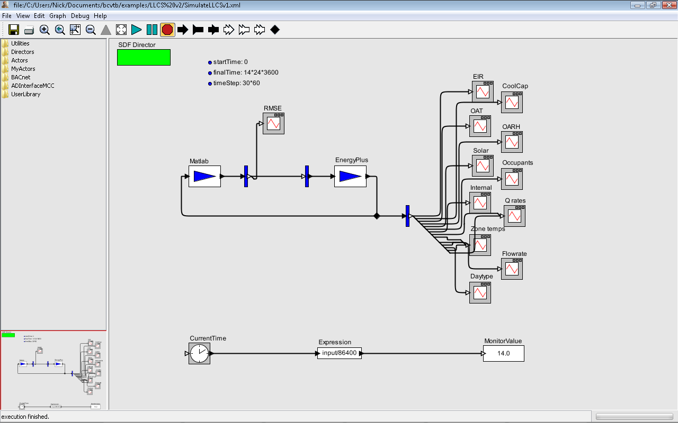

Figure 10. BCVTB simulation for low-lift cooling model identification

To test the simplified low-lift cooling control algorithms and test communication with the prototype low-lift chiller controller from a BAS, a second BCVTB model was created hat utilizes MATLAB® to simulate the building performance, based on the identified CRTF models and low-lift chiller model, and a BACnet writer to communicate with the NCE25 supervisory controller from which commands can be sent to the prototype chiller controller. An image of this BCVTB system is shown in Figure 11.

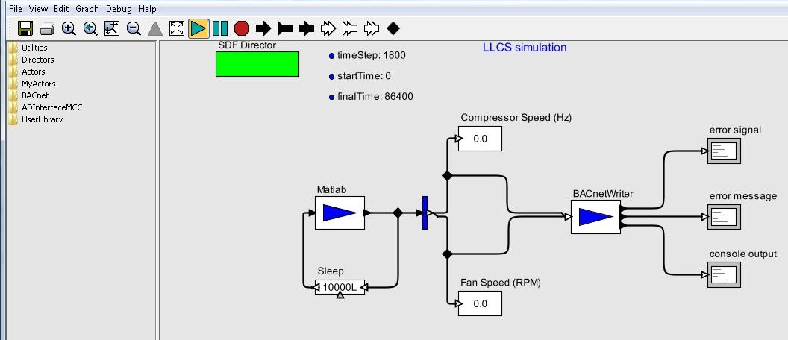

Figure 11. BCVTB simulation for simplified low-lift control implementation through the NCE25 to the prototype chiller controller

The BCVTB system shown above simulates the performance of a multi-zone building with low-lift cooling and the performance of its low-lift chiller in MATLAB®. The simulation can be configured to run for any period of time, such as 1 day or 1 week. At each simulation timestep, compressor speed and condenser fan speed commands are displayed and sent over BACnet to the NCE25 controller. Trending from the NCE25 controller of the compressor and condenser fan speed points are shown in Figure 12. The NCE25 controller can then communicate these commands to the prototype controller over an RS485 connection. To couple the simulation with the actual prototype controller and low-lift chiller, the simulation can be paused for an arbitrary period to allow the chiller to operate at the specified conditions for a given amount of time. Such a simulation could be deployed on a real building, with the prototype low-lift chiller and controller, to allow for model-predictive control from the BCVTB.

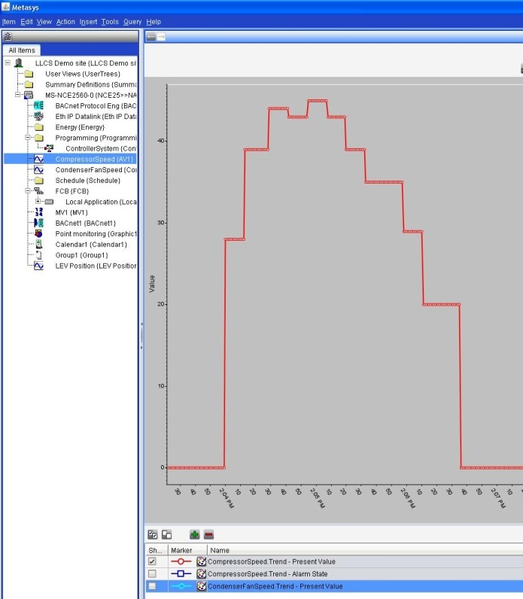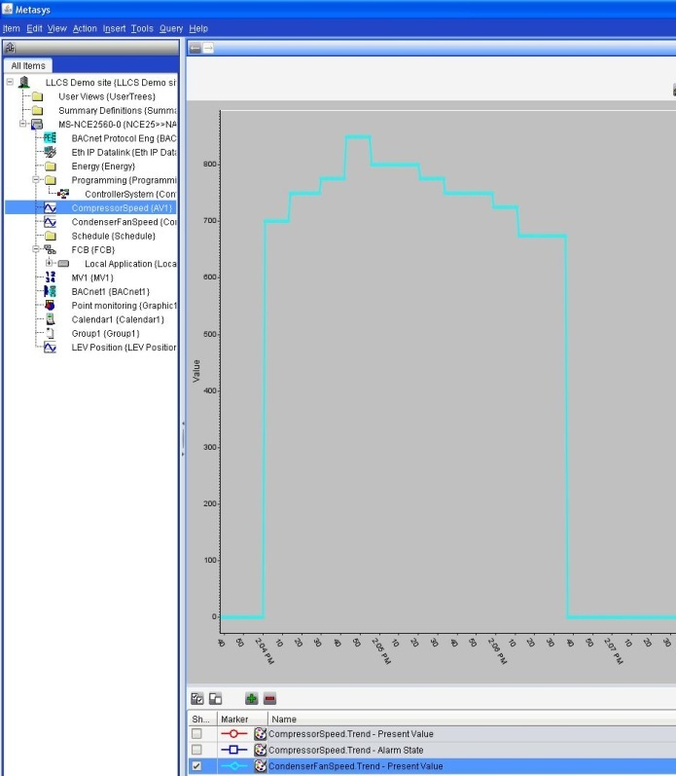

Figure 12. Compressor speed (left) and condenser fan speed (right) point trending in the NCE25 BAS controller, receiving commands over BACnet from the low-lift control algorithm implemented in MATLAB® through the BCVTB

Ultimately, the simplified low-lift control algorithm can be implemented as a program in a commercial BAS that allows for simple math functions and lookup tables described in the previous section. For development and demonstration purposes, allowing for control algorithm testing and modification through the BCVTB is a natural first step towards coding the algorithms in a BAS.

Another path for implementation of the low-lift control algorithm is to embed the algorithm in the low-lift chiller controller itself. The controller chip would receive the necessary measured inputs from the BAS, identify a data-driven model of the zones the chiller serves, and utilize a pre-configured lookup table of chiller performance to perform the simplified model-predictive control optimization.

An additional implementation option is to separate the model-predictive supervisory control logic from the chiller and BAS entirely by leveraging new technologies such as cloud-computing. A cloud-based supervisory control platform, with computational resources to implement complicated model-predictive control algorithms, could be connected to a BAS to communicate high-level logic on a daily basis to command the low-lift chiller. This approach would require a fail-safe low-lift control algorithm which, for example, delivered a sub-optimal base cooling load to the building in the event communications failed.

6. Summary
In this research a simplified control algorithm and prototype low-lift chiller controller suitable for model-predictive supervisory control of low-lift cooling systems have been developed to support a field test. The work addresses two barriers to achieving commercially viable low-lift cooling systems. The first barrier is the lack of low-lift chillers that can operate efficiently over a wide range of part-load capacity and at low pressure ratios and the ability to be controlled externally for static optimal control under a given set of temperature and load conditions. The second barrier is the lack of a simple low-lift cooling model-predictive control algorithm for TABS-based multi-zone buildings that can be implemented in a commercial BAS. The research addressed these barriers through four tasks.

in Section 2, the control algorithms developed by Armstrong et al. (2009a,b) and Gayeski (2010) were expanded to include all expected loads in a typical multi-zone building and simplified to exclude complex optimization solvers so that they can be readily implemented in a BAS. The simplified predictive pre-cooling control algorithm includes predictions of thermal loads such as solar, occupant, internal, and temperature-driven loads for a multi-zone low-lift cooling system. The algorithm has been simplified to allow for implementation in a BAS using simple look up tables and conventional math functions.

in Section 3, a prototype low-lift chiller controller was designed and fabricated to operate a commercially available variable-speed chiller through supervisory commands from a BAS. Redwire, LLC in collaboration with KGS designed, fabricated and tested a low-lift chiller control board that can control a suitable condensing unit as a low-lift chiller. Condensing units with inverter/permanent magnet-motor-driven rolling-piston compressors were selected because of their ability to operate efficiently over a wide speed range and at very low pressure ratios. The prototype controller can accept commands wirelessly or over an RS485 connection from any BAS controller.

supervisory control commands from the simplified low-lift control algorithm were communicated from the BCVTB via BACnet to a commercial BAS controller, which can communicate with the prototype chiller controller. In lieu of a low-lift cooling system in a real building, an EnergyPlus simulation was used to identify CRTF models of the zone temperature response of a building with a concrete-core radiant floor. BCVTB and MATLAB® were used to simulate the operation of the low-lift chiller driving the CRTF zone temperature response models and to implement the simplified low-lift cooling control algorithm. Commands at each timestep were communicated to the NCE25 supervisory BAS controller. The simplified model-predictive control algorithm for 24-hour ahead near optimal capacity dispatch includes only lookup tables for chiller performance and conventional math functions, which could be implemented in a modern BAS.

References
Armstrong P.R., S.B. Leeb, and L.K. Norford. 2006a. Control with Building Mass – Part I: Thermal Response Model. ASHRAE Transactions Vol. 112(1).

Armstrong P.R., S.B. Leeb, and L.K. Norford. 2006b. Control with Building Mass – Part II: Simulation. ASHRAE Transactions Vol. 112(1).

Armstrong, P.R., W. Jiang, D.W. Winiarski, S. Katipamula, L.K. Norford, and R.A. Willingham. 2009a. Efficient Low-Lift Cooling with Radiant Distribution, Thermal Storage and Variable-Speed Chiller Controls – Part I: Component and Subsystem Models. ASHRAE HVAC&R Research, 15(2):366-401.
Armstrong, P. R., W. Jiang, D.W. Winiarski, S. Katipamula, L.K. Norford, and R.A.Willingham. 2009b. Efficient Low-Lift Cooling with Radiant Distribution, Thermal Storage and Variable-Speed Chiller Controls – Part II Annual Energy Use and Savings. ASHRAE HVAC&R Research, 15(2):402-432.

Gayeski, N.T. 2010. Predictive Pre-cooling Control for Low-Lift Radiant Cooling Using Building Thermal Mass. Ph.D. Dissertation. Massachusetts Institute of Technology, Cambridge Massachusetts.

Gayeski, N.T.,T. Zakula, P.R. Armstrong, and L.K. Norford. 2011a. Empirical Modeling of a Rolling-Piston Compressor Heat Pump for Predictive Control in Low-Lift Cooling. ASHRAE Transactions 117(2).

Gayeski, N.T., P.R. Armstrong, and L.K. Norford. 2012. Predictive Pre-cooling of Thermo-active Building Systems with Low-Lift Chillers. HVAC&R Research DOI: 10.1080/10789669.2012.643752

Jiang, W., D.W. Winiarski, S. Katipamula, and P.R. Armstrong. 2007. Cost Effective Integration of Low Lift Cooling Technologies. PNNL-17157. Pacific Northwest National Laboratory, Richland, Washington.

Katipamula, S., P.R. Armstrong, W. Wang, N. Fernandez, H. Cho, W. Goetzler, J. Burgos, R. Radhakrishnan, and C. Ahlfeldt. 2010. Cost-Effective Integration of Efficient Low-Lift Baseload Cooling Equipment. PNNL-19114. Pacific Northwest National Laboratory, Richland, Washington.

Lawrence Berkeley National Laboratory (LBNL). 2011. Building Controls Virtual Test Bed. Lawrence Berkeley National Laboratory, Livermore, California. <https:// http://simulationresearch.lbl.gov/bcvtb>

Zakula, T., N.T. Gayeski, P.R. Armstrong, and L.K. Norford. 2011. Variable-Speed Heat Pump Model for a Wide Range of Cooling Conditions and Loads. HVAC&R Research, 17:5, 670-691

Using standard or simplified formulas for incident radiation on vertical surfaces with shading

