Abstract

Introduction

Problem Statement
Discuss the background of the Beam Down Solar Thermal Concentrator (BDSTC) at Masdar and our need to verify the results and create an accurate way to determine radiation available for collection

Strategic Method
The creation of an accurate flux mapping measurement system is critical to verify the designed parameters of the BDSTC.
- Through understanding of the Beam Down Instrumentation and proper thermal regulations to mitigate erroneous readings (HFS Model, CCD Camera Cooling)
- Proper calibration of instruments (HFS, Reflectivity of Receiver)
- Data Collection at Ideal Days (High DNI, Low atmospheric haze)
- Creation of Correlation Factor (HFS/CCD) (W/cd) to transform the luminance map (cd/m2) to a flux map (W/m2)
- Account of potential errors in measurements
- Lambertian Testing of Ceramic Tile Receiver
- Optical Model of Plant
- OLS Model
- Lessons Learned

Thesis Outline
The second chapter is comprised of a brief literature review of the past and present research of the Beam Down Tower concept and related works. Following this is an explanation of the basics of Flux Mapping for Concentrated Solar Power plants with descriptions of all of the related instrumentation necessary to conduct the studies. Finally, a through comparison is made between the numerous other studies which have undertaken flux mapping experiments in the past which will provide a basis for the flux mapping study presented in this body of work. Make sure to highlight the key differences between prior designs and the Beam Down, most notably the increased factor of Cosine loss, which is not present in Dish Concentrators and a small consideration for northern field towers.
The third chapter provides a description of the Beam-Down Solar Thermal Concentrator currently located at Masdar City, UAE. The experimental setup follows which discusses the instrumentation used and data collection methods employed in order to create flux maps.
The fourth chapter presents the initial measures from the Heat Flux Sensors and the CCD camera in attempts to generate a viable comparison ratio to convert the luminance data into a feasible flux map. However, unlikely trend and data structure make a simple comparison impossible. Initial theories were formed to explain the reasons for the data structure which yield in a plausible reason for the discontinuity.
The fifth chapter is a discussion on the reason for the errors, which his evident due to a non-Lambertian Reflectance. A reflectivity test is performed to characterize the reflection profile of the receiver and a geometrical model of the Beam-Down plant is created to best estimate the reasons for the AM/PM differences and magnitudes of the ratios.
The sixth chapter combines the Lambertian Reflectivity test and the optical model into a Least Squares Analysis to determine the contributions of the both the Lambertian and non-Lambertian reflection to the actual radiation measured by the CCD camera.
Finally, in chapter seven, the conclusion of the work succinctly summarizes the overall assessment of the Flux Mapping study and its challenges. Future work provides a brief analysis to the next phases of research at the Beam Down, which include receiver design and optimization.

Literature Review

Beam Down Tower (History, Prior Research, Current Plants, etc)
The first “Beam Down” concept was pioneered by Ari Rabl (Tower Reflector for Solar Power Plant) in 1976. In this work, a simple analysis was provided which laid the ground work for the current Beam Down tower located at Masdar City. The original design consisted of a number of first-stage Fresnel reflector (heliostats) located at ground level. These heliostats actively tracked the sun as it moved throughout the day and reflected the radiation towards a desired focal point in the center of the heliostat field (generally located directly above the receiver). As the reflected radiation travels towards the focal point, it is re-reflected by a second stage reflector located at a desired distance between the ground and focal point. It is situated in such a way that the reflections will “Beam Down” towards the ground at low incident angle. The secondary reflection point is the second focal point in a hyperbola pair, the desired geometry set up for a Beam Down Tower design. A collection of compound parabolic concentrators (CPC) i.e. optical funnels, are located the second focal point to further increase the concentration levels from 100 suns to upwards of 2500 with proper sizing and convection loss minimization.
This concept does, however, have some draw backs which must be brought to attention. The primary issue is the need for a set of secondary mirrors. When the reflected radiation from the heliostats reached central tower, flux concentrations can reach the upwards of 100 suns. While this is a promising first concentration effort, this amount of radiation can lead to high thermal stresses if too much energy is absorbed. To mitigate this, the reflectivity of the mirrors must be at minimum above 90% and constant cleaning is necessary to remove any dust cementation (which will contribute to increase radiation absorption).
Secondly, as mentioned above, a third set of reflectors (CPC) are needed for the final concentration. The reason for this need is that the concentrated solar radiation begins to defocus after the secondary reflection due to the finite size of the sun. To refocus the radiation to high enough levels for efficient solar-to-thermal conversion, a set of CPCs are used, but not without increased optical losses from the extra reflections. However, the use of a cavity receiver (as specified in the paper) in advantageous over other open receivers from typical power tower systems due to the decreased area exposed to the atmopshere, and thus less thermal losses to the environment.
Rabl provided a basic thermal analysis of the plant with a number of assumptions for the maximum concentration factor, mirror reflectivity, transmissivity of the optical glass for convection suppression of the CPCs and absorptivity of the cavity receiver. This model produced an optical efficiency of 72% with absorbable energy density of 108 W/cm2 (assuming 1000 W/m2 of Direct Normal Insolation) and thermal losses of only 16 W/cm2.
Further analysis on the Beam Down configuration has been conducted by a number of research institutes in recent years. A comparison paper between the standard “Solar Power Tower” and the “Beam Down Tower” (Comparative performances of tower top and tower reflector, Segal, Epstein) was drafted by the researchers at the Weizmann Inst which pitted the two technologies against each other with similar sized heliostat fields and cavity receivers. The studied indicated that as the heliostat field increases in size, the Beam Down Tower gradually outperformed the traditional tower in net energy incident on the receiver. However, this analysis was completed without cost considerations. Kirbus et al. (1997 A Solar Driven Combined Cycle Power Plant) conducted a feasibility study for a solar driven beam down combined cycle and indicated that high performance and low installed cost may be achieved. Optimum plant size was not accessed, although initial estimates placed a cost feasible plant was between 100 and 200 MWe.
An in depth optical study of the Beam Down Tower (The optics of the Solar Tower Reflector, Segal, Epstein, 2000) was conducted in 2000 to assess the two main types of conical figure (ellipsoid and hyperboloid) secondary reflector. A variety of different configurations were analyzed, ranging from both concave and convex concentrators at various locations above and below the primary focus point. In addition, analysis was conducted on non-symmetrical heliostat fields (the most commonly constructed). Results indicated that there is a tradeoff between peak flux concentration incident on the receiver, tower height and tower width, all of which will affect the cost and thermal efficiency of the plant.
Most recently, and most important to the research at Masdar, were two the paper written by Tamaura et al. from the Tokyo Institute of Technology. The first report, (Novel Beam Down System for Solar Power Generation, a new version of the Beam Down plant was conceived which replaced the single hyperboloid mirror as previously reported (source) with a multi-ring central reflector comprised of flat and highly reflective individual mirrors. A full 360 degree field was simulated with the in-house SENSOL software developed by SENER. Feasibility studies on a 120 MWt plant estimated that the plant could produce electricity at just over 8 cents/kWh.
The second paper (Demonstration of Tokyo Tech Beam-Down Solar Concentration Power System in 100 kW Pilot Plant) laid the ground for the plant currently researched at the Masdar Institute. The central reflector was constructed of the multi-ring design to simulate a hyperboloid. The reason for this design was to attempt to mitigate the thermal cycling stresses on the secondary mirrors which could lead to mirror degradation and thus decreased flux concentration on the receiver. The multi-ring concept may increase ventilation to improve heat removal and provide a more lightweight frame structure. From this, the cost reductions of the central reflector tower might reduce capital expenditures from ½ - 1/3 as compared to conventional towers.
Primary heliostats were gang-type with 42 individual facets summing to nearly 8.5 m² of surface area. This design was chosen due to their ability to operate in high winds and to test their feasibility for a future 20 MW plant. The receiver, located at the second focal point was a sandblasted ceramic tile surface which was used in tandem to compare the flux distributions with the simulations results of the in-house TSUBAME-sol.

Flux Mapping (Basics)
Concentrated Solar Radiation flux mapping is one of the most important and critical exercises to assess the peak flux and net thermal energy of any CSP concentrator. In addition to these main uses, it can be helpful in accessing individual heliostat efficiency, absorber efficiency, and determine optical spillage errors.
Solar flux measurements and mapping can be a tricky process which involves a host of different methods and instrumentation, but the general process remains relatively the same. One set of tools are denoted as “Thermal Measurement Tools,” which include heat flux sensors, absolute cavity radiometer, and calorimeters. These tools are used a produce a value of thermal energy incident at a discrete point or over a surface, respectively. A secondary set of tools can be referred to as “Optical Measurement Tools,” which rely on the brightness of reflected radiation from a Lambertian surface to be recorded by a CCD camera. Since the brightness levels have been shown to be linearly proportional to radiative flux (Kaluza, Neumann,1998), this measurement system can provide a continuous map of flux values across the entire receiver surface. An infrequently used but still valid third method of flux measurement relies on photodiode based measurement devices which have extremely high response time and provide current output which is then interpreted as a flux through a conversion factor.

Thermal Measurement Tools

Heat Flux Sensor
A Heat Flux Sensor (HFS) is a thermal based device which is often used in solar radiation concentrators to provide information about the discrete incident radiation on the surface. The devices work through a process known as the Thermoelectric Effect, which occurs when there are two dissimilar metals are in contact (called a thermocouple pair). Based on the temperature of the metals and the Seebeck coefficient between the metal pair, a voltage can be measured. The HFS takes advantage of this phenomenon by being constructed in a manner which allows one side to be heated by the absorbed radiation and the other cooled (often by water). The difference in temperatures induces a voltage which is then calibrated to a certain solar flux level.
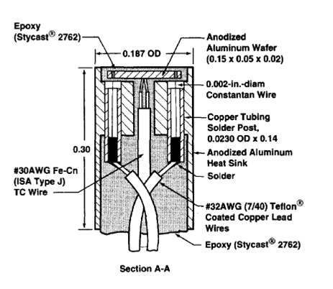
(taken from “How the Schmidt-Boelter Gauges Really Work” – Kidd-Nelson)

There are two main types of HFS used for flux mapping, the Gardon Gauge and Schmidt-Boelter. Both of these sensors have similar body compositions, which consist of a copper core, cooling water lines and a flat black painted center which houses the dissimilar metal pair. The Gardon Gauge (Gardon, 1953), has a constantan metal foil disc at the center of the HFS which serves as the other dissimilar metal (with copper being the first). Copper wires are installed at the center of the foil disc and to the body of the HFS. When solar radiation is incident on the HFS, the black painted constantan disc absorbs the radiation and increases its temperature, which forms the “Hot” junction with the copper wire attached at its center. The “Cold” junction is where the copper body attaches to the edge of the foil disc, which is regulated to nearly the temperature of the cooling water. The two different temperatures drive the thermoelectric effect and provides information on the solar radiation incident on the surface. The main difference in the Schmidt-Boelter HFS is that combines a number of thermocouple pairs (normally 40) into a thermopile. These pairs swap Hot/Cold side which will increase the sensitivity of the sensors by providing an output voltage that increases by a factor of the number of thermocouple pairs (How a SB gauge really works). These gauges are often used in lower flux applications.

Calorimeter
A calorimeter is another thermal device which relies on the change of a fluid temperature to determine the net solar flux incident on the receiver. Often, a calorimeter is a black painted (high absorptivity) metal (high thermal diffusivity) body with fluid inlet and outlet ports. As radiation is being absorbed by the calorimeter, thermal energy is transferred to the fluid. The measured temperature difference between the two fluid streams, along with the measured mass flow rate, re-radiation/convection losses can be combined in a heat balance to determine the incident radiation on the receiver. Oftentimes, an ambient temperature calorimeter test is conducted where the flow rate is very high. This will allow the receiver surface temperature to remain relatively cool and decrease the radiation losses often associated with high temperature calorimetry. A well characterized and designed solar calorimeter can be found in (Jaramillo et al. – A Flat Plate calorimeter for concentrated solar flux evaluations)

Absolute Cavity Radiometer
The final and most complete device for thermally measuring the quantity of concentrated solar radiation is the absolute radiometer. The original device, designed by J.M. Kendall of the Jet Propulsion Laboratory (JPL), is the primary standard for accurate heat flux measurements and calibration of other radiometers (HFS).
The device is comprised of a gold plated thermal guard which surrounds an internally blackened, isothermal cavity receptor (Kendall, The JPL Standard Total Radiation Absolute Radiometer). When radiation is incident on the aperture, the black cavity absorbs the energy and raises the temperature, read by a platinum thermocouple is located at the apex of the cavity. Wrapped around the metal core are a series of resistance wires which provide a heating effect. To calculate the incident radiation through the aperture, a current is passed through the heating wires until a null reading is recorded by the platinum thermocouple. At this moment, the energy absorbed by the cavity is equal to the thermal energy from the wires, which can be measured by the current and voltage provided. Through extensive calibration and optimization, accuracy of this device is within 0.5%. Due to the very high accuracy of this device, it is commonly used as a calibration source for thermal instruments in the solar industry.

Optical Measurement Tools

CCD Camera
The Charged Coupled Device (CCD) camera is at the heart of many flux mapping configurations. In the simplest form, an individual CCD element reacts to an input of light (photons). During a certain capture period (shutter or integration time) a number of photons intercept the CCD element. In turn, a charge is built up on the surface which is proportional to the number of intercepted photons. During the reading phase, the charge is discharged and the current is measured. The current can be interpreted as a certain luminance (cd/m2) based on the camera’s parameters.
This type of device is good for determining the quantity of solar radiation since the grayscale brightness of the receiver has been found to be linearly proportional to the incident radiation (Kaluza Neumann 1998). Also, it provides information about the radiation across the entire receiver which is very helpful when determining peak flux and energy distribution, since thermal based measurements can only provide discrete points of solar flux or cumulative surface energy. Often coupled with a CCD camera is the target with which the concentrated solar radiation is focused on, a Lambertian reflectance target surface.

Lambertian Target
A Lambertian Target is a white and diffuse reflecting surface commonly used in conjunction with a CCD camera for concentrated solar flux mapping studies. The target is generally constructed of a flat metal receiver (sometimes water cooled) with a solid ceramic or powered alumina or magnesium coating which provides the white reflective surface. In addition, the surface is relatively rough which aids in the diffuse reflectance. The most important aspect of the diffuse reflectance is that is follows Lambert’s Cosine Law to as great of a degree as possible. If the cosine law is properly followed, then any incident radiation at any AOI will have the same and repeatable diffuse reflectance pattern. From this, a proper brightness level can be calculated from the CCD camera and a Flux/Brightness correlation can be constructed and in turn a flux map.

Spectroradiometer
An uncommonly used device in concentrated solar flux measurements systems is a Spectroradiometer. This device measures the power of incident radiation as well as its spectral distribution.

Calibration/Errors Associated with Flux Measurement Systems for CSP facilities

Difference between HFS and CCD Spectrum
One of the key hurdles in using HFS/radiometers and CCD cameras for flux mapping in a CSP facility is the spectral mismatch between the two sensors. The HFS is a spectrally broadband device which absorbs radiation between 300-2500 nm at a fairly constant absorbtivity, which is well over 98% of the solar spectrum (SMARTS). The CCD camera however has a much narrower band of measurement capabilities with varying responses to the wavelengths between the visible and NIR frequencies (300-1000 nm). Since the HFS is a broadband device, the more critical characterization for a flux mapping study lies in the CCD spectral characterization.
If the solar spectrum was constant over the day, the spectral mismatch would not be an issue. A relative value between the CCD camera and HFS output could be calculated and then used thorough the entire day. However, the spectrum does change as a function of air mass (AM) and atmospheric conditions due to beam attenuation at varying wavelength. Generally speaking, as the AM increases, the visible light is more readily scattered or absorbed by the atmosphere as compared to the IR radiation. This means at a higher AM, the HFS will still absorb nearly all of the changing radiation but the CCD camera will only record the visible, a relatively smaller number. Due to this discrepancy, the HFS/CCD ratio will increase as a function of AM.
A seminal paper discussing the spectral characteristics of a CCD camera was written by (Kaluza, Neumann – Measurement of Solar Radiation with CCD Cameras). In this paper, a LOWTRAN model was used to determine the spectral composition and power of DNI of a variety of AMes between one and five. These values were integrated over the total spectral frequency for a total energy on the receiver. The CCD camera’s spectral response was obtained through the manufacturer. The response was then multiplied by the solar DNI spectrum (only between 300 and 1100 nm) and integrated. These results were then compared at the five different AMes. Setting each integral to 100% at 1 AM, change in the relative signals can be seen below:

 | AM 1 | AM 1.5 | AM 2 | AM 3 | AM 4 | AM 5
Total Power (%) | 100 | 93 | 71 | 53 | 41 | 32
Camera Signal (%) | 100 | 93 | 69 | 48 | 34 | 24
Difference (%) | 0 | 0 | -4 | -9 | -16 | -23
Table – Reproduced from Kaluza, Neumann

A similar difference has also been reported by Ulmer et al. (Beam Characterization and Improvement…..) which calculated the change of calibration factor to 8.5% at AM2, 15% at AM3, 19% at AM4 and 21% at AM5. Two years later, Ulmer et al. (Calibration corrections of solar tower flux) reported that for the same incident flux density, the camera signal increases by 10% from AM1 to AM4.
Both of the aforementioned papers discussed the inconsistent change of the solar spectrum due to various atmospheric conditions. Many factors (humidity, aerosols, etc) can change hourly and have an impact on the spectral distribution of the DNI. This can affect the change of calibration factor percentages from day to day measurements. To minimize this difference, the use of bandpass filters was recommended. Kaluza et al. showed a decrease in difference between the “Total Power” and “Camera Signal” to 9 % (as compared to 23) at AM5 using a filter at 700 and 750 nm. Ulmer et al. (Calibration corrections of solar tower flux) applied a KG3 filter during their experiments and reduced the error due to changing AM to +2% when extrapolated out to AM4.

HFS Error in flux measurements
Heat Flux Sensors themselves have measureable error due to a number of reasons when dealing with solar radiation measurements. The first and more notable error occurs from the type of black coating used on the HFS coupled with the lab calibration of the device. There are two main types of black paint coatings used for HFS, Zynolyte and Collodial Black. Zynolyte is a preferred coating due to its rough surface and high absorbtivity (Ballestrin et al, 2003 – Systematic error in the measurement of very high solar irradiances). But, above 3500 kW/m2, colloidal black is used, albeit at a lower absorbtivity. The calibration procedure is a cause of the error due to the black paint coating’s change of absorbtivity as a function of wavelength. Zynolyte has a hemispherical absorptance of 0.95 (VIS, NIR), but only 0.86 in the FIR to 8000 nm (Ulmer et al. Calibration correction of solar tower) and Collodial Black (0.78, 0.61) respectively. (Ballestrin et al, 2003)
The calibration is conducted by subjecting the HFS to blackbody radiation at 850 C, which has emitted frequencies between 1000 and 8000 nm. Since the solar spectrum is predominately between 300 – 2500 nm, there is a serious spectral mismatch issue. When applying the absorptance values w.r.t. the frequency of incident radiation, Zynolyte systematically overestimated radiation by 3.9% (Ulmer et al, 2004) and 3.6% (Ballestrin, 2003). Collodial Black is significantly worse, with overestimating the radiation by 27.9%. (Ballestrin, 2003)
Another potential source of error for HFS is due to the angular response of the coating and geometry. Up to an AOI of 35 degrees, response is nearly perfect. When the radiation AOI is greater than 35, systematic error could overestimate the solar radiation by up to 5.3% (Ulmer et al, 2004).
Windowed HFS (often quartz) introduces a new set of issues which seem to compound the error associated with solar measurement applications. Quartz has high transitivity between 250 to 3500 nm, ideal for the solar spectrum, but non-ideal for 850 C blackbody calibrations. As such, the quartz window absorbs a significant amount of radiation during calibration, which in turn emits a fraction of that energy back to the HFS. This effect overestimated the error of over 100% due to the spectral absorptance differences and 27% from angular response issues. Net error can reach +9.4% over estimation for bare HFS and over 130% for windowed HFS. (Ulmer et al, 2004). These large errors call for specific calibration of HFS in the solar environment.

HFS Calibration for Solar application
An initial paper written by Mulholland et al. (Flux Gage Calibration for Use in Solar Environments) lays the ground work for common calibration methods used today. A 60 m solar tower with 221 north field heliostats (Sandia National Laboratory) was used to calibration 24 sensors. For each of the 24 sensors, 36 data points were collected from a range of 20% to 120% of the HFS rated value. Each collection point was also validated with a 1500-sun Kendall Absolute Radiometer, which has an error of less than 0.5%. Regression analysis was conducted to produce a LSQ equation of:
$$mV = B_{o}+ B_{1}*q$$

with “mV” denoted the measured millivolt output of the HFS and “q” as the incident heat flux density. Calibration results indicated that all of the HFS overestimated the incident radiation anywhere from 7-30%.
A similar study was conducted to compare an array of different radiometers to the Kendall Absolute Radiometer under concentrated solar radiation. As expected, the devices (one calorimeter, 4 HFS) overestimated the incident radiation. The calorimeter performed the best, with only 0.4% error, where as the four HFS varied in error between 2.1 and 13.2%
As showed in the two prior works, using the factory calibration for HFS in solar applications is a poor choice and analysis must be conducted to calibrate the devices for solar applications.

Collection of different setups
Discuss the number of different Flux mapping methods – Compare/Contrast

Experimental Setup

The Beam-Down Solar Thermal Concentrator

The Beam Down Solar Thermal Concentrator (BDSTC), residing in Masdar City, Abu Dhabi, UAE was designed and constructed to concentrate 100kWt of solar radiation at a peak flux of up to 100 kW/m². The design of the BDSTC was crafted by the Tokyo Institute of Technology (Tamaura et al. Demonstration of Tokyo Tech Beam-Down Solar Concentration Power System in 100kW Pilot Plant) and engineering by Mitsui Engineering and Shipbuilding (MES). The goal of this plant was to test the feasibility of the design for not only stand alone use but for a utility scale 20 MWe plant.
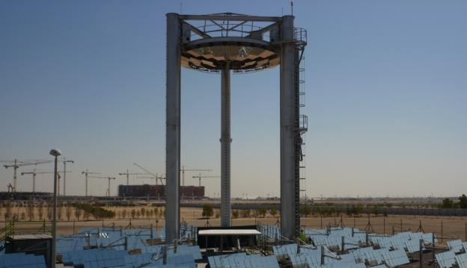

Heliostats
The BDSTC is comprised of 33 individual tracking heliostats (HS). Within each HS, there are 42 individual mirror facets with dimensions of 45 cm by 45 cm, giving each total HS a reflective surface area of 8.5 m². Therefore, the total BDSTC has a net reflective surface area of 280 m2. The 42 individual mirror facets are arranged in three tiers with each tier 6 mirrors wide and 2 deep. This type of heliostat design is normally referred to as “Ganged Type.”
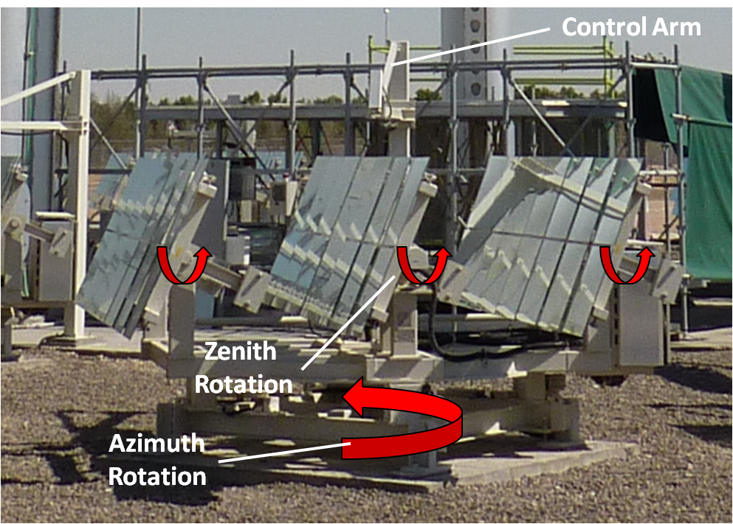
The three tiers of mirrors are all linked together and rotated about their axis through a linked stepper motor. This is the Zenith or Elevation tracking element. For Azimuth tracking, the entire heliostat is coupled to a rotating base which is also stepper motor controlled. Solar tracking is conducted through two methods. The first, and more crude, was commonly referred to as “Calendar,” mode, which rotates the heliostat in the proper zenith and azimuth directions based on the BDSTC geometries and the solar time and date. This method worked well, but there were still some problems due to misaligned mirrors and mechanical imperfections. To combat this, an “Active” tracking mode was installed which transitioned the “Calendar” mode into a feedback loop. A overreaching “Control” arm (Figure __) had installed solar tracker mechanism which would “view the sun” through the first reflection of the heliostat. If the center of the sun was not accurately placed in line with the solar sensor, a signal would be sent to the azimuth and zenith stepper motors to properly align sun in the center of the mirror. This correction was very obvious when it was taken out of “Active” tracking into “Calendar” tracking.

The heliostats were arranged within three zones, as divided between the posts of the Central Tower Reflector (North, East, West). There were three concentric rings of HS constructed, with ring “A” noted as the inner ring (6 HS), “B” as the central ring (15 HS), and “C” as the outer ring (12 HS). To increase the concentration levels on the receiver, each individual mirror was slightly canted inwards toward the center of the HS to create a shallow parabolic shape. Each individual ring (A,B,C) were canted at different angles to increase radiation density at the secondary reflector (to decrease the reflector size).

(Insert Picture of the control Panel of the BD computer)

Central Tower

The Secondary Reflector (SR) consists of three multi-faceted rings of high reflectivity mirrors, all of which is mounted on a 19 m tower. The rings of the SR correspond with the rings of the HS, so that every HS has a specific SR mirror to reflect off of. As with the HS, the static SR mirrors are angled in a specific way so that the reflected radiation is centered on the receiver. Manual adjustment methods are possible for better alignment. A novel feature of the SR is its ability to traverse up and down the tower, for greater ease of cleaning and maintenance.

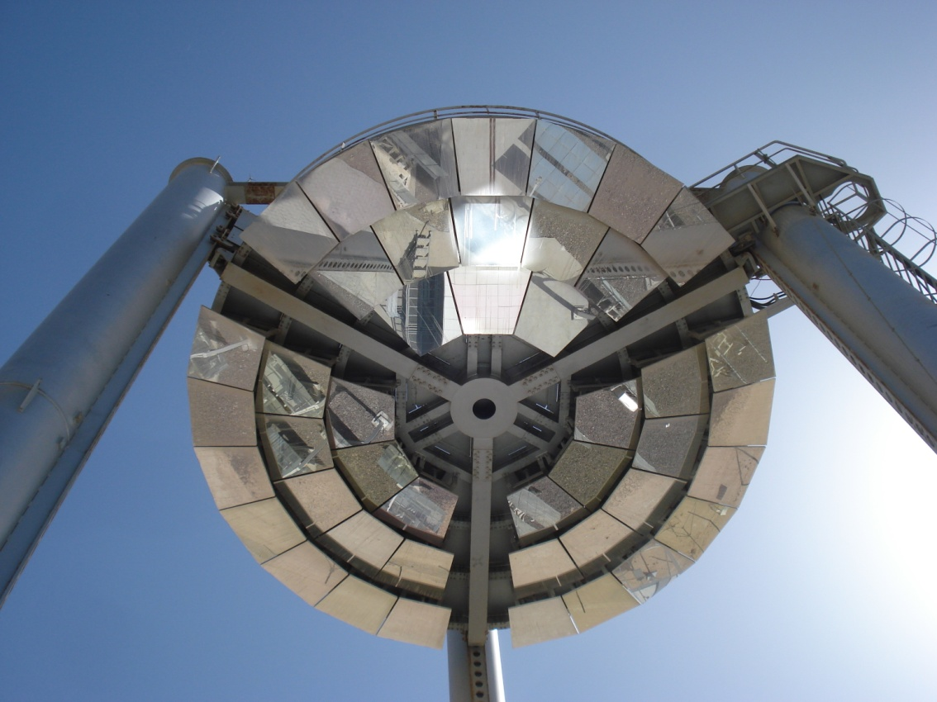

Target Receiver
After the two mirror reflections and concentrations, the radiation finally lands on a ceramic tile receiver at a height of 2m (The second focal point). The receiver is comprised on a metal skeleton base with insertion points for individual ceramic tile panels for easy set up. 256 individual ceramic tiles are used to cover the entire receiver which yields in receiver dimensions of a 4.8 m square.

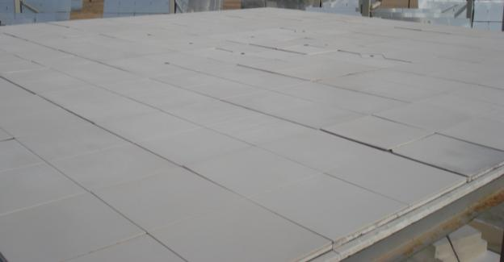

The reflectivity characteristics of the ceramic tiles are of great importance for the flux mapping study. As seen in many prior studies of flux mapping studies, the receiving source of radiation must exhibit a Lambertian type reflection/ follow Lambert’s Cosine Law. By definition, the Lambert’s Cosine law states that the measured radiation intensity by an ideal diffusing surface is directly proportional to the cosine of the angle between the observer’s line of sight and the surface normal (Photometria, 1760). Simply put, independent of the incoming radiation’s angle of incidence, the reflected radiation will have a measured maximum at θ = 0 and decrease by a function of cos(θ) until 90 degrees, where no radiation is measured.
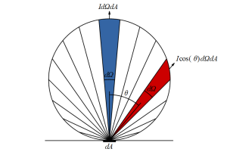
(Source: InductiveLoad – Wikipedia)----Source (http://wiki.naturalfrequency.com/wiki/Solar_Absorption)

This is a very important characteristic to have for a flux mapping study because the incident rays on the receiver come from a range of angles between 0 and 20 degrees. This angular difference is not an issue for the HFS, since its absorptivity is nearly independent of AOI. But, for the CCD camera, it only absorbs light along one specific angle. If we know how the reflected light will behave (i.e. by observing Lambert’s Cosine Law), we can correct for and difference in observation angle between the CCD camera the surface normal of the Lambertian target.
If the surface does not behave in a Lambertian manner, over or under measurements of the luminance could occur. In figure (__) the first plot is of a single ray reflected from a surface. Since we know the behavior of the reflection, and the location of the CCD camera w.r.t the reflection location, we can back calculate the actual incident radiation on the receiver through the equation:
I_{actual} = I_{measured}/cos(θ))

But, in the second plot in figure (__), the reflection is non-Lambertian and has a significant specular component (as noted by the non-circular reflectance pattern). As indicated, the measured level of light intensity is now greater (given the same input ray). This results in a greater brightness measurement from the CCD camera (if still applying Lambert’s Cosine Law), which will decrease the overall Flux/CCD ratio and thus give false interpreted reading when applying the ratio across the entire receiver.
To properly compensate for a non-Lambertian reflection, in depth knowledge of the specular and diffuse reflection characteristics must be know along with a high fidelity modeling which accurately predicts the concentrated radiation’s AOI at a specific location. As discussed later in this document, a reflectivity profile was created for the ceramic tile surface and was coupled with a simple optical model of the Beam Down plant, which was instrumental in characterizing the HFS/CCD ratio of the individual HFS.

The ceramic tiles used at the BDSTC were initially conditions to obtain the closest Lambertian reflection possible. Konica Minolta provided analysis on the initial batch of tiles. From an internal report, the best performer (with cost as a consideration) was a simple unglazed tile. An additional sandblasting process was used to further decrease specular reflection with results of only a ±3% deviation from Lambert’s Cosine Law.
The tiles were sandblasted a second time to restore the same finish due to environmental soiling. A simple reflectivity tests showed the tiles had been restored to nearly identical reflectivity as compared to the original, however, a full Lambertian profile was not obtained at that time. A full analysis can be seen in Appendix (Tile Reflectivity).

Instrumentation

Heat Flux Sensors
Eight Heat Flux Sensors were employed for the study supplied by the Medtherm Corporation to measure the value of incident solar radiation on the receiver. The inner rings of HFS (noted 1-4) were Gardon gauge type, while the outer ring (HFS5-8) were Schmidt-Boelter. The gauges were calibrated through an in-situ method as found in Appendix –(HFS Thermal Model), which incorporated thermal losses due to convection and radiation to achieve a more accurate value of incident radiation. The correct HFS measurements were used throughout the study to establish the HFS/CCD ratio.

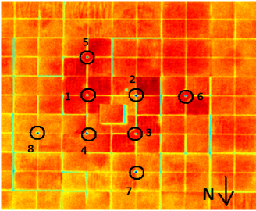

CCD Camera

The final data collection instrument for the flux mapping study was the CCD Camera (Konica Minolta CA-2000). The camera measured the brightness of the concentrated solar radiation in units of Candela per square meter (cd/m2) or luminance. These values, as captured in a 980 by 980 matrix, provided information as to the relative distribution of solar radiation incident on the receiver. The camera was mounted on top of the central reflector at a height of 14 meters. Also, a Neutral Density filter (ND-400) in installed on the CCD camera. This was to avoid any potential saturation of the signal at high flux levels. One image is shown below (under no concentration).
Thermal regulation of the CCD camera was critical for accurate and repeatable measurements. The sensing element in the camera, called the “Charged Coupled Device,” is greatly affected by temperature. As the temperature increases inside of the device, a greater “Dark Current” signal is produced. This can lead to higher or lower measurements than what is actually being measured. To mitigate this temperature induced error a thermal regulation setup was undertaken which controlled the temperature at 23±0.1 C. Please Refer to “Appendix –ZN Tuning of CCD” for the control procedure.

Spectroradiometer
As mentioned prior, there is a spectral mismatch between the radiation capture abilities of the HFS and the CCD camera. In addition, the solar spectrum is changing throughout the day, namely through a greater contribution of the radiation from the NIR at higher air masses. The HFS is not affected by this (since it absorbs nearly all NIR radiation) but the CCD camera is, since its capture range is only within the visible light spectrum. This change is measureable but the uniformity of the spectral composition across the receiver is in question. A traverse of the Spectroradiometer was conducted to determine the specular uniformity across the receiver. Results indicated that the radiation on the receiver was in fact very uniform. This means that the analysis between the individual HFS is consistent since the spectrum of incident radiation at each HFS location is the same as the reflected radiation being measured by the CCD camera. Thus, there will be even spectral mismatch between the HFS and CCD for all 8 HFS. The procedure and results are located in Appendix –(Spectral Uniformity).

Solar and Meteorological Data
Solar data was collected by a trio of instruments. The GHI measurements were obtained by both a Licor pyranometer (LP) and a ventilated Epply Precision Spectral Pyranometer (PSP). These instruments were located on a bench to the west of the Beam Down tower. During the AM, two shadows (caused from the BD tower) were observed by both devices. At this time, an essential Diffuse measurement was observed, and thus a GHI could be back calculated through the equation: GHI = DNI*Cos(Zenith)+Diffuse. The DNI measurement was collected by an Epply Normal Incident Pyroheliometer (NIP) attached to an EKO Instruments 1-arm 2-axis Solar Tracker. Other pertinent data was collected through a Campbell Scientific weather station, where Ambient Temperature, Relative Humidity and Wind Velocity. Also, second (ultrasonic) wind sensor was affixed close to the table receiver for a more accurate localized wind reading which was used in the aforementioned HFS model.

Data Acquisition

All of the aforementioned instruments and measurement devices (CCD Camera excluded), were connected to a suite of Campbell Scientific data collection devices, namely two CR1000’s and one AM25T. The master CR1000 was housed next to the solar radiation instruments. This CR1000 recorded the solar radiation data while serving as a junction hub for the slave CR1000 and AM25T. The slave CR1000, often referred to as the “CCD Cooling CR1000” was linked through the Tx and Rx channels of the device. This CR1000 controlled the cooling PID loop for the CCD camera and recorded the temperature data inside of the box. These values were constantly monitored throughout the testing period to ensure the average box temperature stayed at the 23 C set point. The AM25T was located under the tile receiver and served as the data collection hub for all 8 HFS and their respective outlet water temperatures, buffer water bulk temperature, T ambient and RH. These data were measured every second and an average of every 10 seconds was saved in the CR1000 memory. After each collection day, the data was downloaded and saved in a .txt format for easy Matlab conversion.

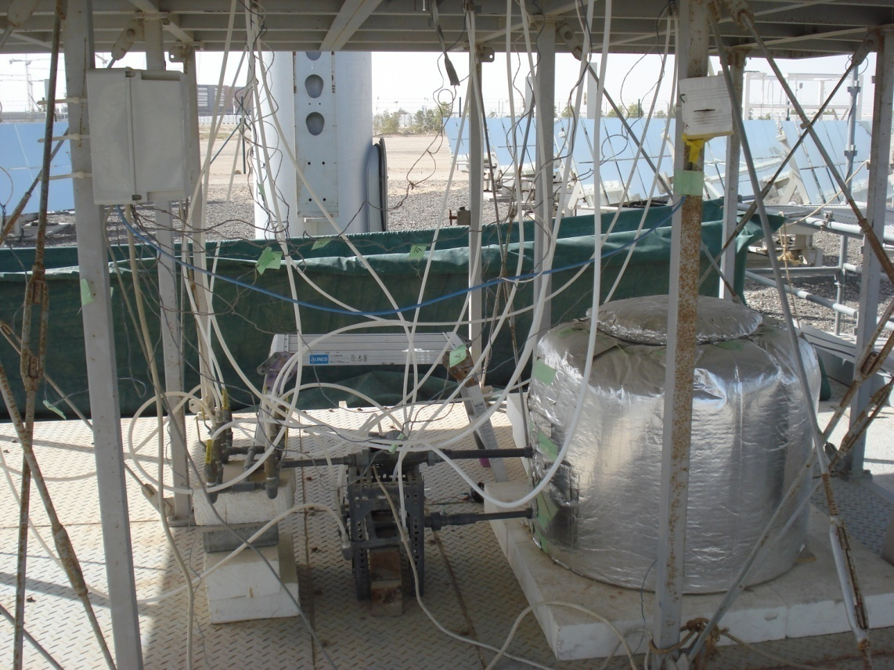

The CCD camera was linked to the Konica Minolta CA-S20w software which was designed for its suite of optical measurement devices. This software package allowed for camera calibration, data capture and analysis. To automate the image capture, an Excel Macro was written (Tokyo Tech) which allowed the user to input the desired data collection times. Data was saved within the CA-S20w program. For image processing, the same Excel Macro was used to extract the CCD image into a large .XLS file which was then easily converted into Matlab.

Testing Parameters and Preparation

For the final data collection, three nearly ideal days were desired. These days would have high peak DNI (~900 W/m²), minimal haze and as few clouds as possible. Fortunately, three of these days were available for testing over a four day time span, March 21, 23, and 24, 2011.
Mirror cleanliness was another critical issue to mitigate for proper data collection. The day before the initial set of data (March 20th), every primary HS was hand cleaned with water and a wiper. The secondary reflector was also hand cleaned with pressurized water. In addition, the solar measurement devices (PSP, LP, NIP) were also cleaned daily to decrease any errors from dust or dirt settling on the measurement surface. The difference between a clean and dirty secondary reflector is shown below. 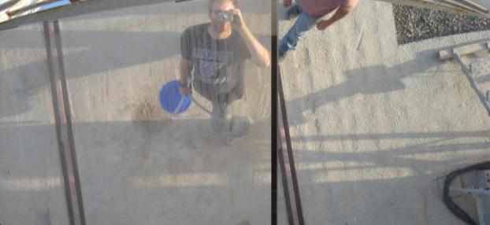

Other pre-data collecting procedures consisted of cleaning the tile receiver of any extraneous dust which may have settled during the previous day. An air gun was used with pressurized air to gently remove particles which may have decreased the tiles overall reflectivity. Sometimes during a high-dew point evening, condensation would form on the tile receiver over night. If observed, a handful of heliostats would be focused to evaporate the condensation.
Testing procedures for the three days remained consistent. Data collection began as early in the morning as possible. Generally, there was a fog induced haze in early morning, so data collection was typically started from between 60-90 minutes after sunrise. Thermal, solar, and meteorological data was collected every 10 seconds throughout the day. CCD data was collected every minute. Data collection commenced when incident levels of flux on the receiver failed to produce any concentration effect.

Initial Data Processing

After a full day of data collection, the mass of data underwent a copious amount of post-processing. The CCD camera luminous maps were eventually teased into an “.m” file through an hours long process converting the CA-S20w data into .XLS.
The CR1000 collected data was exported every night into a .txt file and then formatted into Matlab. Since the capture frequency of this data was 6 times greater than the CCD camera, a simple truncation script was written. The code averaged each 6 data collection points per minute into two samples (0,10,20 sec and 30, 40, 50 sec). Since the computer clocks between the CCD camera and CR1000 camera were synced, and the data capture time for the CCD camera was 35 sec, the first averaged time (0,10,20 sec) was used for the comparison. The other data was discarded. Solar pertinent data (zenith angle, azimuth angle, airmass, hour angle) were calculated using equations in “Solar Engineering of Thermal Processes.”

Flux Map Calculations
To create flux maps, a comparison between the HFS output and the luminance (as a function of time, AM, etc) were desired denoted HFS/CCD. However, the exact luminance value at the center of the HFS was impossible to calculate due to the high absorptivity of the sensor head. This difference can clearly be seen below. Instead, an average value was calculated by taking data from the four sides (of 9 pixels each, 36 total pixels) of the HFS and averaging them to generate an interpreted luminance. These locations were handpicked due to their proximity to the HFS and their relative reflective uniformity.
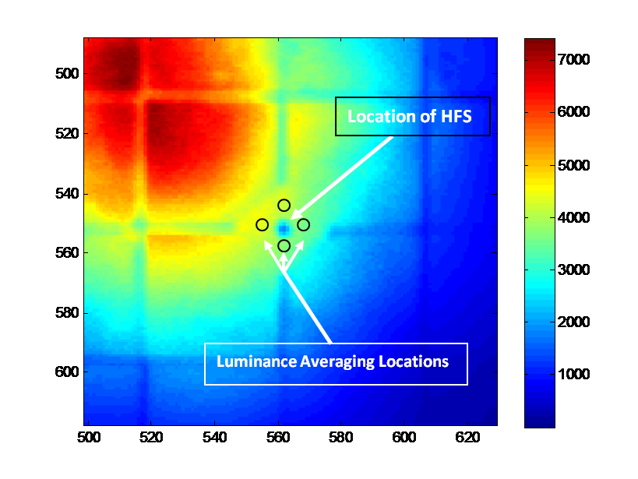

Once the average luminance values were calculated per minute and per HFS, a comparison could be made between the HFS output and the luminance output (HFS/CCD). The results of these comparisons are in the following chapter.

Initial Measurements

Heat Flux Sensor Data
The Heat Flux Sensor data below indicates consistent collection throughout the three days of data collection. The graph below provides the Heat Flux Sensor output after in-situ calibration. The plots are for all three days and divided individually by HFS w.r.t the azimuth angle of that day. The first day is red, second green, and third blue.

These data were expected due to the nearly clear skies for the collection. HFS 1-4 exhibited great flux since they were located closer to the centroid of the peak flux. One important observation about the above flux values is that they are generally not symmetric about solar noon (figure __). For instance, HFS 1 and 3 peak before solar noon and HFS 2 and 4 after. This is due to the comatic aberration or astigmatism commonly found in both Beam Down and Central Towers, chiefly caused from the changing focal lengths of the individual mirror facets due to the 2-axis tracking rotations. The luminance maps will confirm this later in the report.

Luminous Intensity
As previously described in the Experimental Setup, the Luminous Intensity measurement was taken as an average of four positions located as close as possible to the HFS. Below shows the inferred luminance values which correspond to the 8 HFS, respectively. It is clear to see that these two graphs appear extremely close and follow similar trends

Heat Flux to Luminance Relationship
The first step to determine their relationship is to create the most basic HFS/CCD correlation factor by simply dividing the HFS output by CCD output at their corresponding values. As noted in prior literature (Kaluza, Neumann) this ratio should be plotted against airmass and a general positively increasing trend should be observed (due to the relative increase in IR radiation which is not measured by the CCD camera). As an example, for HFS 1, this trend was observed below:
It is clear to see that the HFS/CCD ratio does have an increasing trend as a function of airmass. Also, all three days seems to be a fairly good agreement with each other. However, it is clear to see that there is some odd shape or trend, something akin to a “sideways horseshoe.” This trend can be observed in nearly all of the HFS trends. Plotted below are the 1st Day ratios for all HFS. Individual HFS plots are available in Appendix __.
While these results were promising since they did observe the general expected tends, the gap or offset between the two positive trending lines were not (denoted AM/PM difference). This is clearly shown in Figure (__) since the blue points are the AM data, and the red points the PM data. Furthermore, the mean values for all of the trends were largely different. At close to an airmass of one, the HFS/CCD ratio for HFS 1 and 4 is between 16 and 17 W/cd. For HFS 2 and 3, this value is much lower, close to 14 W/cd. The outer ring of HFS has an even lower ratio at 1 AM, with values between 12-14 W/cd. This is a cause for initial concern. The reason for concern is due to the typical method for converting luminance maps into flux map, which is only by multiplying the luminance map (cd/m2) by the conversion ratio (W/cd) and thus produces a flux map (W/m2). Applying a mean of 15 W/cd across the whole receiver at solar noon could yield in a 2 W/cd difference at some locations. Since luminance values around the inner ring sometimes peak at over 5000 cd/m², and error of nearly 10 kW might be expected, upwards of 20%.
To aid in the understanding of this data, the HFS/CCD ratio was plotted with respect to the solar azimuth angle, since this is a good measurements of the ratio as a function of time over the day. The below plot are the HFS/CCD ratios from the first day w.r.t. azimuth angle. All individual HFS/CCD plots are in Appendix(__).

These plots help to illuminate a key point. Within nearly all of the HFS, there is a sharp increase of HFS/CCD ratio toward the beginning and end of each day. But the more important part is the trend between these two large increases. We can begin to see some structure forming in the way these ratios are measured. For HFS 1 and 4, the minimum HFS/CCD ratio is observed prior to solar noon, near an azimuth angle near -60 degrees. For their counterparts on the west side of the receiver, HFS 2 and 3 have minimums after solar noon, near +20 degrees azimuth. A similar trend is noted along the outer ring. The two HFS on the Eastern side (5 and 8) show a minimum early in the day (-75 azimuth) and show a consistently increasing until sunset. The HFS7 of the western part of the outer ring shows the opposite, with a strongly decreasing trend as a function of azimuth angle. HFS6 is fairly neutral throughout the day. These trends are more clearly illuminated below. The HFS/CCD values have been offset by their minimum value to better represent their relative trending.
It is clear from the previous graphs that three important trends which need explanation are emerging in the HFS/CCD ratios. The first is quite simply the lack of consistency or non-uniformity between the mean HFS/CCD ratios. The inner ring of HFS generally tends to have a higher HFS/CCD ratio than compared to the outer ring. Secondly, there is a distinct difference between the AM and PM ratios, which cause the “sideways horseshoe” when plotted against the AM. The final trend consists of the positive and negative trends associated with the East and West side HFS, where the East generally trend positively w.r.t. azimuth as compared to the West which generally trend negatively.

Initial Theories
The initial attempt to understand the difference between the mean HFS/CCD ratios per HFS is better understood when looking at the ratios plotted against each w.r.t. airmass. For this plot, small bins were created as a function of airmass. i.e. for an airmass between 1 and 1.2, then 1.2 to 1.4, etc, an average HFS/CCD ratio was calculated. This essentially compressed the “sideways horseshoe” plot into one line.

From this figure, it is clear to see that each HFS has a very similar trend as a function of airmass. The main difference lies in the y-axis offset. When each ratio is normalized by its weighted mean (w.r.t airmass), the plots all congregated well together on a shared trend line. Since this HFS/CCD ratio is determined by two factors, and the trends are similar, one of two possible differences must be occurring to cause the offsets between the sensors.
The first difference might be a non-uniform reading of the HFS. If the optical measurement system is assumed to be operating without error, then the only cause for the different levels of HFS/CCD ratio must be caused by inconsistent measurement of the flux levels on the HFS. If the HFS reads higher than it should, than a higher HFS/CCD ratio is observed. But, this theory was initially ruled out due to a few factors. The initial reason was that the HFSs are broadband devices which absorb radiation at a near constant rate as a function of angle of incidence (AOI) of the radiation on the HFS surface and solar spectrum wavelength. Since the BDSTC refocuses light at an AOI of no greater than 25 degrees, the absorptivity of the device is considered constant over the test. Secondly, the cooling water system was uniform for each device. Each HFS received the same temperature of cooling water (due to the shared distribution lines), so there were no comparative thermal transients associated with the cooling load. Finally, each HFS underwent an in-situ calibration to compensate for the convective and emissive losses (Ref. Mokhtar) which more accurately provided an incident flux level at the sensor surface. From these three reasons, it was validated that the HFS measurements were consistent and uniform, and thus not a cause for the differences between the HFS/CCD ratios.
The only other factor would be an inconsistent reading from the optical measurement system, which is comprised of the CCD camera and diffuse reflecting surface of the ceramic tile receiver. With regards to the CCD camera, the measurement system was fairly well controlled and uniform for the measurement of the entire surface. Since the entire CCD camera and internal electronics were actively cooled to the manufacturer’s set point throughout the day, dark current was held constant through the day and would have affected each pixel to the same degree. The camera also conducted “dark” measurements during every collection point, which further mitigated dark current error. In addition, any optical aberrations due to the transmittance of the ND-Filter, airmass, etc were constant between all data collection points, so differences would have been universally observed (positive trends, but not inter-ratio offsets). Finally, this leaves us with the diffuse reflector, the ceramic tile receiver. This is the only point in the measurement system which could have had caused the non-uniformities between the HFS/CCD ratios.

Non-Uniformity Concerns of the Diffuse Reflective Tile Surface
There are two assumptions where were prior made in the analysis which are now under question, the reflectivity of the tiles (previously assumed to be uniform between all tiles) and the Lambertian reflectance (assumed to be Lambertian to within 2 %).
The basic reflectivity of the tiles was initially assumed to be consistent and uniform throughout the surface due to the same refurbishing efforts to clean the tiles (Appendix __). Initial tests showed that the newly sandblasted tiles had the same, if not slightly better reflectivity than the original tiles. The limitation of this initial verification test was the fact that it conducted on just one arbitrary tile from the receiver. As such, a more in depth analysis was need to determine the reflectivity of the tiles where were used for the average luminance calculations.
The initial calculations were completed through using an “ambient sun” test of the tiles just after solar noon. Under no concentration, the reflected light from the tiles should be nearly uniform when captured by the CCD camera since the incident radiation (GHI) is constant at the same time interval. An image of the calibration tiles is seen below. At first glance, you can visually note a color difference between the different HFS locations.
To create a relative reflectivity compensation factor for each HFS, a similar approach was taken to the measurement of average luminance for the full concentration studies. Using the same area calculations (9 pixels on the 4 locations around each HFS) an average luminance value was calculated for each area around all 8 HFS (32 total locations). This average marked the “Mean Luminance.” To understand a measure of greater or less reflectivity, each individual luminance measurement was divided by the “Mean Luminance,” which provided a relative reflectivity (RR). The results of this analysis are below.

Relative Reflectivity (per HFS) = Luminance average per HFS location / “Mean Luminance”
$${RR}_{HFS}= {{{Luminance}_{mean}}_{HFS}}/{{Luminance}_{mean}}$$

HFS Number | Relative  Reflectivity (%)
1 | 102.24
2 | 98.84
3 | 103.36
4 | 96.49
5 | 104.62
6 | 99.46
7 | 99.51
8 | 95.48

From this analysis, it is clear to see that there is a fairly significant difference in some of the reflectivities of tiles, upwards of nearly 10% when comparing HFS 5 and 8. To compensate for the difference in reflectivity, divide the measured CCD value by RR, which will normalize the RR to one and should in turn correct the CCD value. By dividing the CCD value by RR however, the total HFS/CCD ratio is essentially multiplied by the RR. The results of this adjustment are shown below.

The results of the tile reflectivity calibration were not as successful as initially hoped. The disparity between ratios from the individual HFS is still rather large. Also, it seems like the inner ring of HFS have a higher ratio (HFS 1,2,4) relative to the other five. This method of compensation may have not worked due to the relative insensitivity of the camera’s sensors w.r.t the incident radiation. The installed ND-400 filter was rated to protect the camera’s components under full concentration. When under ambient conditions, less that 1% of peak radiation output, the camera’s relative sensitivity is very low, and might not have been able to properly record the low flux levels. A second theory, which will be discussed later, is that there could be a significant component of spectral reflectance as part of the overall reflectance. If true, the reflectance measurement above would be an incorrect way to estimate local reflectivity.
A second method was employed to estimate the local reflectivity of the tiles at the locations of the luminance estimations. The spectroradiometer which was previously used to compare the reflectivity between the original and newly sandblasted tiles can also be used to determine the reflectivity of a sample between 400-1000 nm, well within the solar spectrum. This is done by first recording the “Counts” of a reference light and white reference sample (Spectralon). Then, the same reference light is placed on the tile location where the luminance values are determined and a reading is taken. The relative difference results in a percent reflectivity. The reflectivity curves are then multiplied by the normalized solar spectrum and the average provided a relative reflectivity for the tiles around each HFS.

Reflectivity Results
The results of the Spectroradiometer method yielded very similar results as compared to the CCD calibration for tile reflectivity. The relative results are shown below in Table (__).

HFS Number | Relative  Reflectivity (%)
1 | 101.64
2 | 96.74
3 | 101.68
4 | 97.67
5 | 103.1
6 | 98.59
7 | 101.97
8 | 98.62

After applying the reflectivity values to the luminance measurements, little changed in the trends and overall values of the HFS/CCD Ratio. While the reflectivity tests did provide some so insight to some of the differences, there is still a consistent issue with the varying level of ratio and the difference between the AM/PM trending between the HFS located on the East and West sides of the receiver. Another theory, briefly mentioned earlier, may explain these differences which are rooted in the initial assumption of a true Lambertian reflectance from the ceramic tile receiver.

Issue of non-Lambertian Reflectivity on a Diffuse Surface for the Beam Down
The assumption of a perfect Lambertian reflector is extremely useful for flux mapping studies since there is no need to fully model the incident radiation on the receiver. Since all radiation will be reflected in the same manner (AOI independent), it is easy to rectify the true radiation reaching the receiver. In addition, if the mean concentrated radiation ray AOI on a specific location changes over the day (due to E/W field Cosine losses and the Lambertian reflectance assumption is true), the measured value by the CCD camera will not change. But, if the mean radiation AOI changes over the day and has some non-Lambertian reflectivity, then the measured brightness by the CCD camera will not be properly compensated by the cos(θ) term in Lambert’s Cosine law. Instead, at the same value of incident radiation at a certain part of the day (AM vs PM), one brightness value will be measured higher, while the other lower. This is due to a non-Lambertian reflection of the tiles and the relative cosine losses from the East and West fields throughout the day and is a potential explanation for both the differences in the HFS/CCD ratio values and the AM/PM “sideways horseshoe” trend.

Reason why a non-Lambertian Reflection will affect the CCD readings
In the BDSTC, concentrated solar radiation is focused 360 degrees around the receiver. Because of this, some fields are more effective in the AM as compared to the PM (West Field and conversely with the East Field) due to the cosine loss. This means that in the early morning hours, the west half of the heliostats contribute a significantly higher fraction of radiation than the East field. The imbalance of radiation does not mean much in terms of total power or spectrum of the radiation, but is it a critical factor in determining the average AOI of radiation on any specific part of the receiver. For a more visual example, generalize that the BDSTC was compressed down to only two identical heliostats, one in the East and one in the West, as seen in figure __. In the early morning, when the sun is nearly at due east, the West heliostat cosine loss is significantly small than the East Field. As the light is concentrated from the heliostat, off of the central reflector and finally to the receiver, the AOI can be measured for any position on the receiver. Naturally, the magnitude of radiation from the West field is larger and thus the net radiation vector is skewed towards that direction. As time passes towards the end of the day, the East field’s cosine losses decreases while the West field increases. In the PM hours, the East field’s radiation vector is now dominant in the flux measurement and the mean radiation vector is skewed towards the East. From this analysis, it is clear and very important to know that as a function of the solar azimuth angle, the average AOI of radiation on the receiver changes over the day due to the respective cosine losses of the heliostats (or from the change of NSEW field efficiencies). Furthermore, the AOI will vary from different locations on the receiver.
This same effect is apparent in the North/South relationship as a function of zenith angle. But, this effect is not nearly as present due to the much smaller range of angles throughout the day, or the variation of field efficiencies of the North and South do not change as much as compared to the East/West. In fact, the difference between the North and South field is important too since the North field always has a greater contribution (i.e. lower cosine loss) than the south field because the zenith angle will never reach zero (at which time the cosine loss between the North and South field will be identical). In this case, the sensors on the North side should consistently have a higher measured luminance value (lower HFS/CCD ratio) than compared to the South side sensors.
The diagrams below help to illuminate to describe the change of AOI over the course of the day. In figure __A the sun is low in the sky at a high azimuth angle (early morning). The West heliostat contributes significantly more flux to the receiver than the East heliostat, as noted by the thickness of the lines. Three resultant radiation vectors are drawn below at approximately the correct AOI. Parts B and C of figure__ show the same trend at solar noon and later in the afternoon. Part B shows even contribution of flux from the East and West heliostat and the change of the radiation AOI at three points. Lastly, Part C demonstrates the change of radiation AOI in the late part of the day. Overall, it is clear to see that the concentrated radiation AOI changes as a function of azimuth (and zenith) angle and position on the receiver.
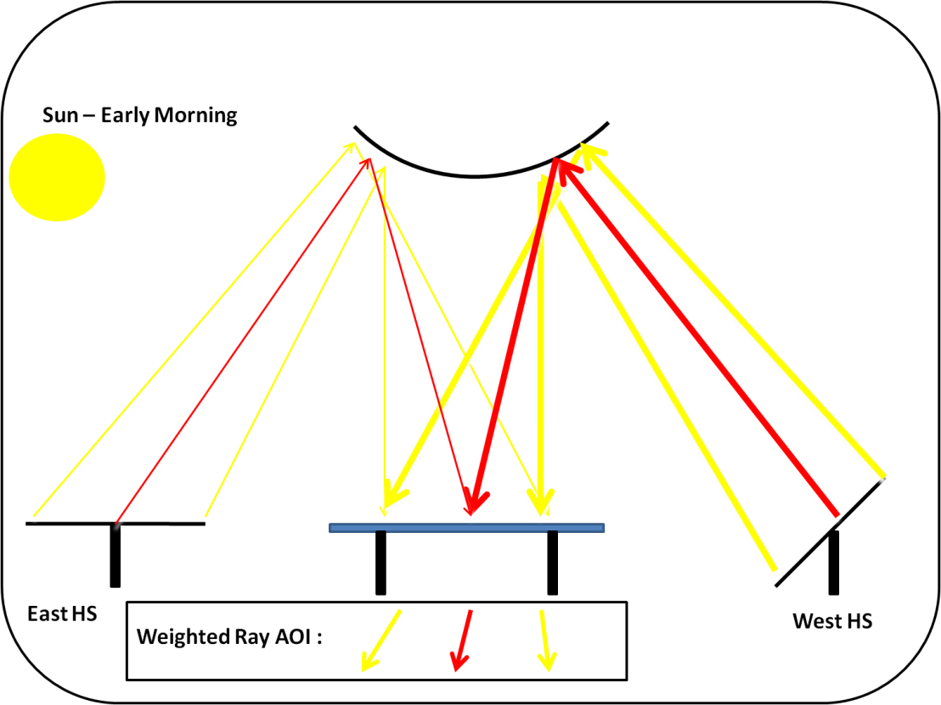
Figure __ A
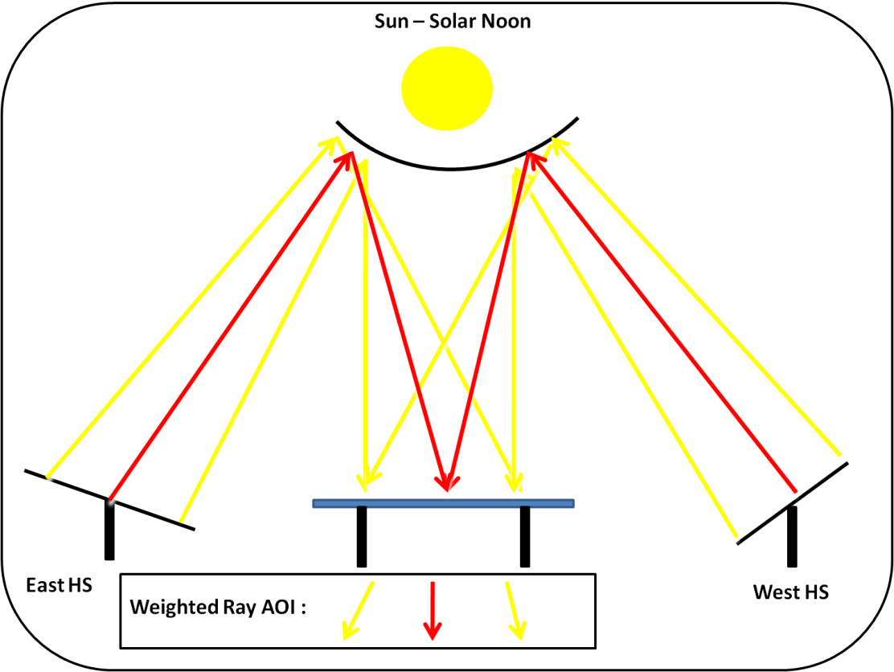
Figure __ B
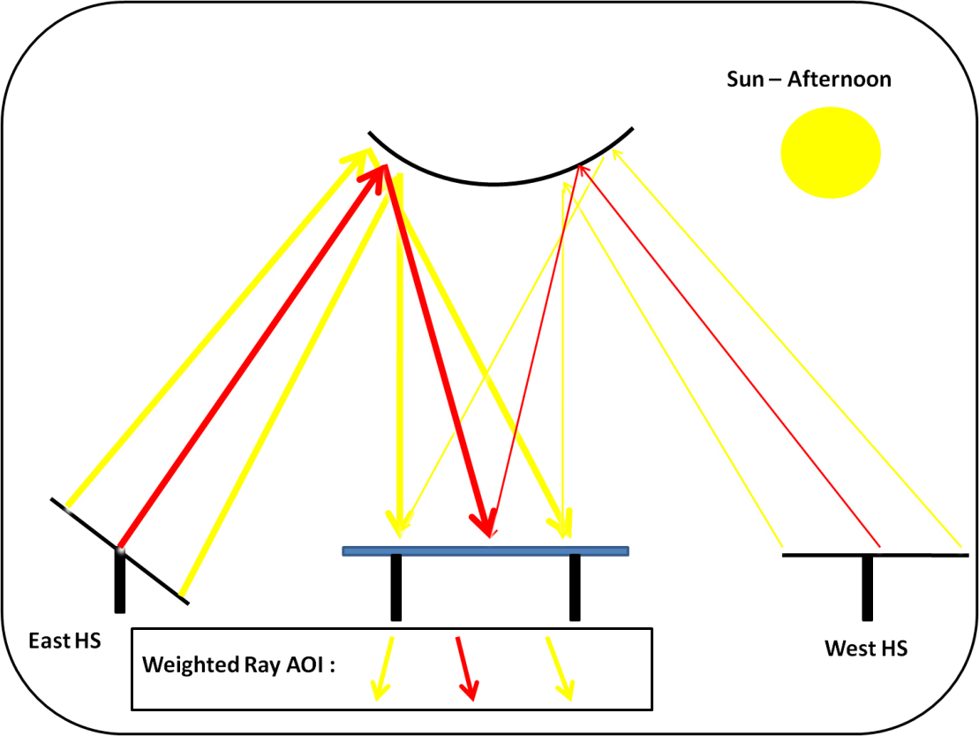
Figure __ C

Non-Lambertian Reflection of Tile Clues (ambient sun)
The initial clue that there might be a non-Lambertian component of the reflected radiation was first noticed under CCD camera images of the receiver during ambient sun conditions at high AOI. If the tiles were truly Lambertian, then the reflected radiation at a constant value (GHI) should produce luminous maps at near constant values throughout the receiver. However, this was not true. The figure below shows a luminous map during the early parts of the day, around 7:20 AM. At this time, the sun is in an east-southeastern position.
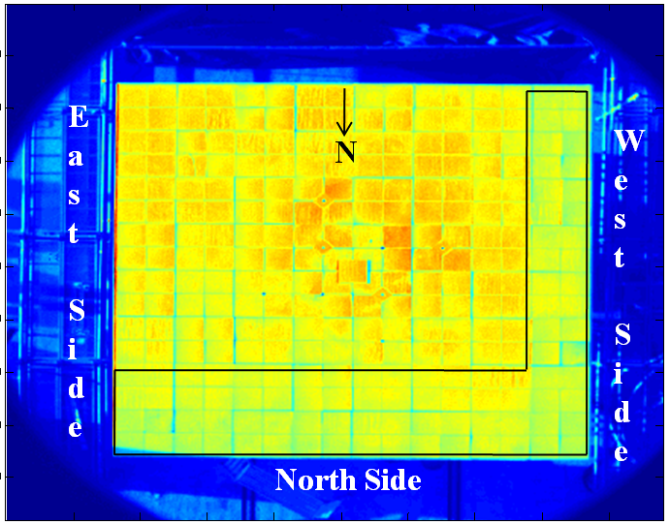
(Image- Morning Flux Map of Ambient Sun)

The column and row of tiles on the North and West part of the tile receiver are significantly lower than the rest. Non-uniformities are to be expected between each tile due to imperfections in the construction or the sandblasted surface. But, looking at the same ambient sun condition luminous map towards the end of the day reveals the opposite results (Figure __). Now the North and East part of the tile receiver are significantly lower than the rest. One first thought was that the reflectivity of the tiles was lower than the rest, but this didn’t explain how one side of the receiver was lower in the AM (West), and other during PM (East). The reflectivity had to remain constant throughout the day.

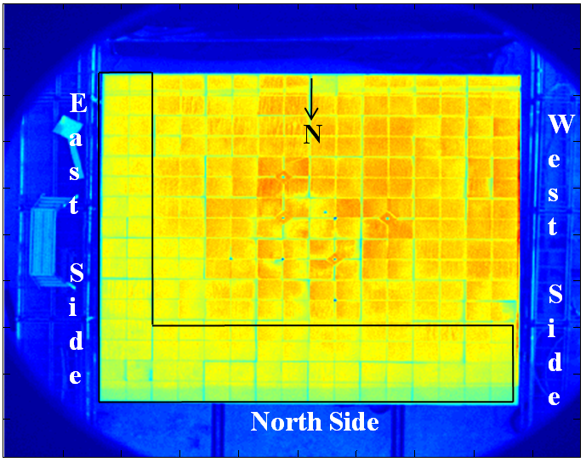
(Image- Afternoon Flux Map of Ambient Sun)

The more logical reason for this difference in measured luminance can be attributed to a significant amount of direction non-Lambertian reflection from the tile receiver. The figure below helps to elucidate this phenomenon. In the early parts of the day, the sun has a predominately east to south easterly position w.r.t. the receiver. The angle of incidence (θ) of the direct radiation is shown, along with the diffuse reflectivity distribution. Since the surface is not a true Lambertian surface, there is a significant non-Lambertian component to the reflection (noted by the oblong reflection, instead of a circle for a true Lambertian reflection). When observing the tiles closer to the southeast orientation, the magnitude of the ray which is measured by the CCD camera is fairly close to the peak ray (noted by the thick dashed line). When observing the rays further towards the northwest, the magnitude of the ray measured by the CCD camera is much smaller than the peak ray (thin dashed line). This is thorough evidence of a present non-Lambertian reflection from the tiles due to the fact that the luminance across the receiver at constant radiation input is not uniformly measured by the CCD camera.

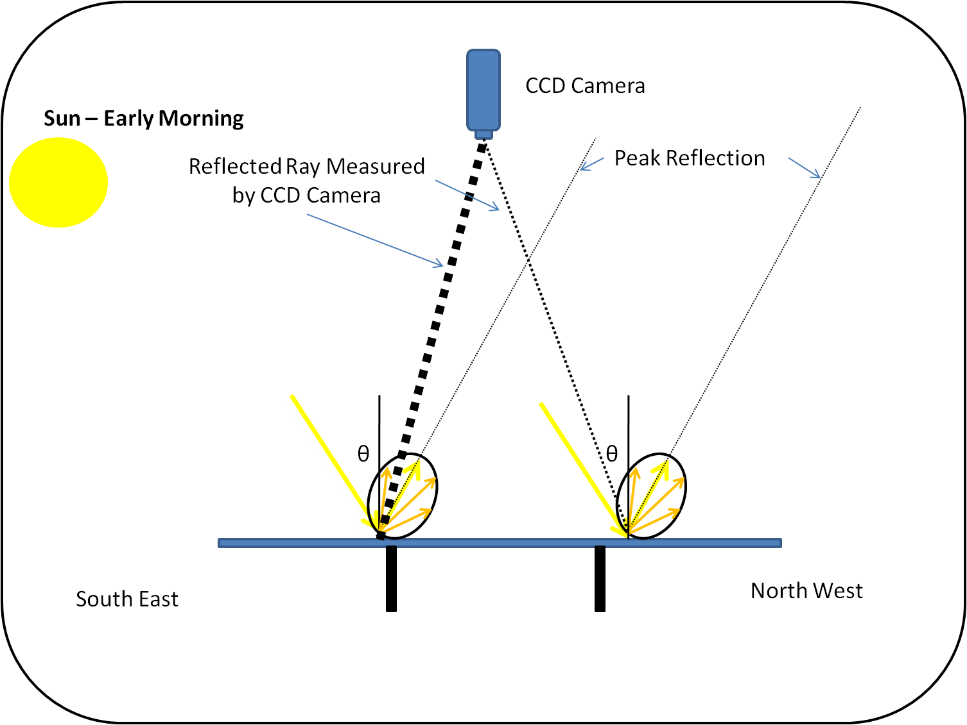

Theory of Specular or Back Reflectance on the HFS/CCD Trends
-Discuss the effect of a specular reflection (as shown above) and how this would actually be opposite of what is expected. The trends tend to show some sort of back reflectance to make the data make sense.

Affect of non-Lambertian Reflection and AOI on the Beam Down Design
The appearance of only one of the above issues would not be cause for alarm in the data analysis. For instance, if the tiles had a non-Lambertian reflection component but the AOI remained near constant (aka constant cosine loss/AOI) throughout the day (present in Dish concentrators and Towers with narrow north fields), then the ratio levels would remain similar throughout the AM and PM, and not cause the “sideways horseshoe trend”. This is due to the fact that the reflected radiation to the CCD camera is proportionally the same (w.r.t DNI) over the day and the fraction of non-Lambertian reflected radiation remains relatively constant. On the other hand, if the AOI changed over time with a perfect Lambertian reflectance, the reflected radiation would be constant due to Lambert’s cosine law and could be properly scaled by dividing the reflected radiation by cos(θ) between the HFS and CCD camera w.r.t surface normal. Unfortunately, both of these issues are present at the Beam Down.
Combining the two phenomena above (changing AOI) due to of differing field cosine losses and spectral reflectivity of the tiles) will create dissimilar HFS/CCD ratios when comparing them at the same air mass, but at different times of day (AM/PM). These phenomena will also induce lower HFS/CCD ratios in the northern side of the receiver and higher ratios in the south.

Rectification of Measurement Discontinuities
To properly rectify the issue of changing AOI and non-Lambertian reflectivity many further post-processing steps must be taken. To first determine the angle of incident of radiation on the receiver, an optical or geometrical model of the plant must be constructed. Second, a full characterization of the ceramic tile reflectivity distribution must be conducted. These efforts, present in the following chapter, were outside the initial scope of this body of work and raise a very important issue for flux mapping studies. The goal of this research was to provide a reasonable quick and accurate measurement setup which could provide a measurement of the peak and net flux on the receiver, along with its distribution. The optical model and ceramic tile surface characterization coupled with a Least Squares analysis will further elucidate the affect of a non-Lambertian reflected and provide evidence as to the reason for the HFS/CCD ratio dissimilarities.

Beam Down Optical Model
In order to gain an insight as to the measurement discrepancies between the individual HFS/CCD ratios and the AM/PM trending, a simple optical model of the BDSTC was constructed.
The model was entirely based on geometry of the plant and the reflections from the incident radiation from the heliostats and secondary reflector to the target receiver. First, the locations of the 33 heliostats were loaded into the model, indicated by the small squares circling the receiver in figure (__). The Coordinate System for this analysis is also noted in Figure (__), which is the standard positive values for the X and Y coordinates in the Cartesian system with the origin at the center of the plant. Phi ($φ$) is defined as starting at zero at due north and increases positively in the clockwise direction, used to denote the location of the HS w.r.t. the center tower.
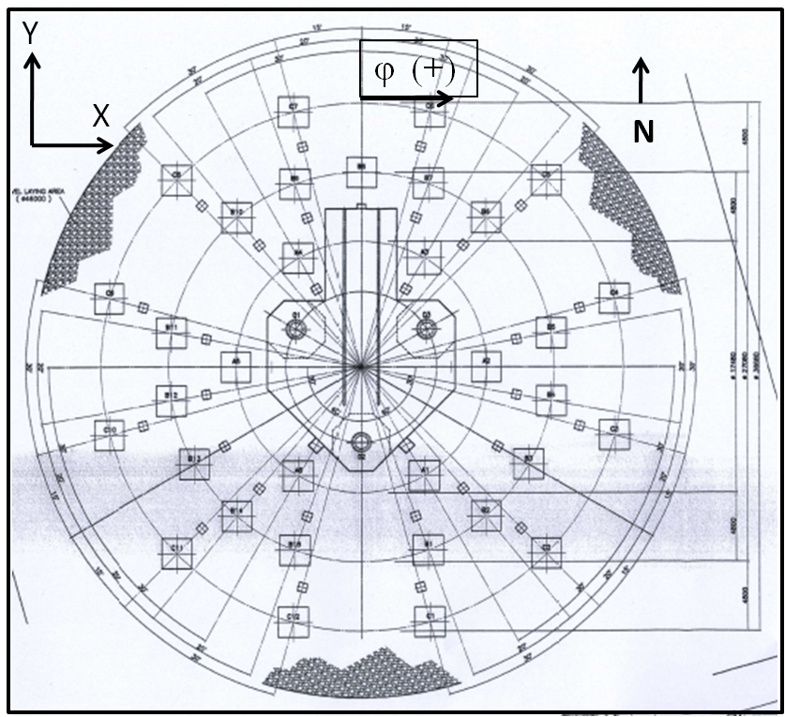
As noted prior, the relative cosine loss of each HS was critical in determining the change of AOI as function of time. The equation to determine the angle of incidence on the heliostats was acquired from Chen et al. 2006 (General Sun Tracking Formula for Heliostats with Arbitrarily Orientated Axes).
$${AOI}_{hs}=0.5*\cos^{-1}\left(-\sin{λ}* \left(\cos{ψ}*\cos{Δ}*\cos{ω}+\sin{ψ*\sin{Δ}}\right)-\cos{λ}*\sin{φ}* \cos{Δ* \sin{ω}}+\cos{λ* \cos{φ}* \left(\cos{ψ}*\sin{Δ-\sin{ψ* \cos{Δ* \cos{ω}}}}\right)}\right)$$

$$λ$$ | Elevation Angle of the HS w.r.t. Central Tower Focal Point
$$ψ$$ | Latitude Angle of Abu Dhabi
$$Δ$$ | Declination Angle
$$ω$$ | Hour Angle
$$φ$$ | Location of Heliostat about the central tower

By following this code, the respective angle of incidence between the sun and surface normal of the heliostat of the Beam Down tower were calculated for each HS over the day.
To fully estimate the radiation incident on the receiver per heliostat, two key parameters needed to be incorporated. The first and more easily calculated was the AOI on the receiver from the heliostat, which was calculated from the geometry of the plant and the location of the HFS. The second parameter was the mirror reflectivity, which is also a function of the AOI of the sun on the heliostat. The mirror reflectivity of both the primary heliostat and central reflector were determined by a simple spectral reflectivity test performed by a Lambda 1050, by PerkinElmer. Each sample was tested for reflectivity through a variety of angles, from 6 to 50 degrees AOI, by increments of five degrees, whose value was denoted by rho (ρ_{(hs)}).
The reflectivity was then superimposed by a sample DNI profile and then normalized to provide an average reflectivity used by the optical model to determine the actual radiation reflected by the heliostat and central reflector mirrors.
$$ρ_{{norm}_{hs}}=100*\sum_{λ=350}^{λ=2500}{norm\left(ρ_{hs(λ)}*{DNI}_{λ}\right)}$$

The equation yield an average reflectivity based on the beam radiation AOI on the heliostat which is seen below in Figure (__).
The central reflector mirror was specially designed to have high reflectivity across the solar spectrum and at high radiation angles of incidences, as seen in results from the Lamba 1050, in figure (__). Only three angles were tested, since the angles between the HS and CR were constant over the day. The same process was used to scale and normalize the reflectivity based on the DNI solar spectrum. The results were nearly constant at 88%, ($ρ_{{norm}_{CR}}$) and for simplicity was used for three rings of the Central Reflector.

The final model to determine the fraction of energy (Radiation incident on receiver vs. solar DNI) to reach the receiver is below in equation (__). These values, referred to as the “Heliostat Efficiency, were determine for every heliostat at every time step over the day.
$$η_{HS}= ρ_{{norm}_{CR}}*ρ_{{norm}_{hs} }* \cos{{AOI}_{hs}}$$

For the model used above, the “Heliostat Efficiency” value was used as the magnitude of the reflected solar contribution incident on the receiver. A quick look at the relative contribution of each field below illustrates the already know change of field contribution as a function of time.

One key assumption for this simplification was that the heliostats had both a flat mirror and a constant focal length. The first, which negates the canting angle of the individual heliostat mirrors, was assumed to allow for one simple cosine term to be calculated for the whole HS. The constant focal length assumption was made for model simplification and speed, since the actual focal length for each individual mirror changes slightly as the tracking system rotates throughout the day.

Now that the magnitude of solar contribution for each HS has been calculated for each data collection point throughout the day, the angle of incidence of radiation (directional vector) for each HS was determined. The directional vector was again calculated through a series of geometric calculations. Since it was assumed that a given heliostat provides nearly the same direction of radiation to the central reflector and that every heliostat produces an equal Gaussian distribution (and size) of concentrated flux on the receiver, a simple equation was developed to determine the AOI of based on both heliostat location and location on the receiver.
From the figure below, the AOI (θ) at three different points (-1.25 m, 0 m, 1.25m) were selected to calculate the AOI based on the receiver height and location of the central reflector mirror with a simple trigonometric calculation. The three AOI calculations with their respective distances were then plotted and a best fit equation was formed (near perfect linearity). This was then used to calculated the AOI at any location on the receiver, and for all three central reflector
rings.
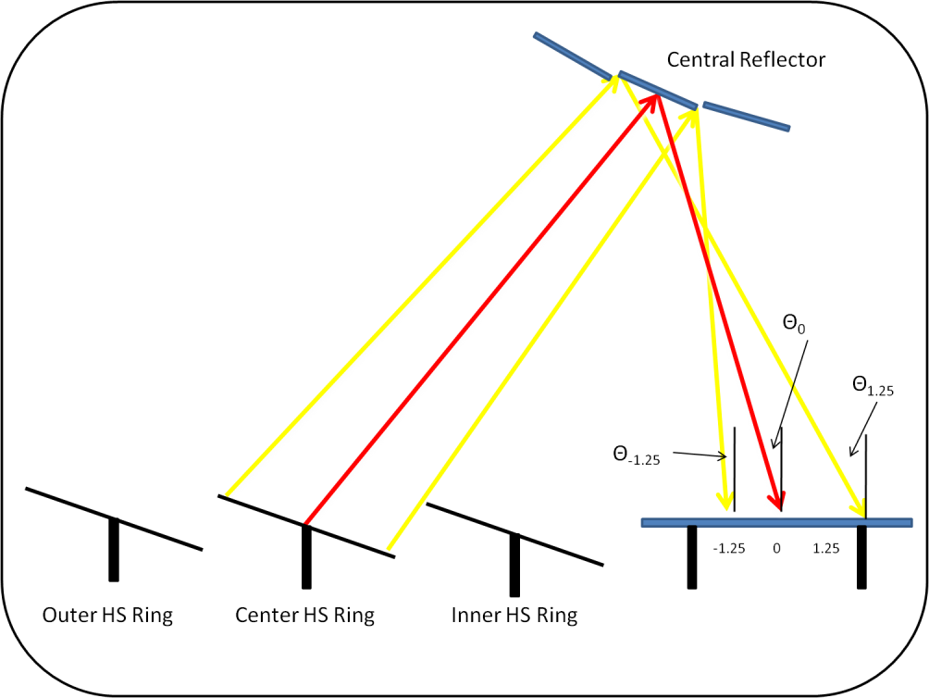

The governing AOI equations are below. The “sign(x/y)” term is used to denote the slope of the equation, which will change dependent on the position of the HS w.r.t. the location on the receiver.
Inner Ring | AOIx= | sign(x)*4.75.*xdist+6.437
Inner Ring | AOIy= | sign(y)*4.75.*ydist+6.437
Central Ring | AOIx= | sign(x).*4.562.*xdist+9.93
Central Ring | AOIy= | sign(y).*4.562.*ydist+9.93
Outer Ring | AOIx= | sign(x).*4.236.*xdist+13.36
Outer Ring | AOIy= | sign(y).*4.236.*ydist+13.36

The needs for both an “X” and “Y” AOI term is due to the fact that every heliostat has both an X and Y contribution of radiation on the receiver, and which are not always in the same direction. For instance, a heliostat located in the southeast corner of the plant would have a positive Y value for AOI, but a negative X, since this is the direction of the reflected radiation vector after the mirror reflection.

The next step in creating the model was to decompose all 33 vectors into their individual X, Y,and Z terms for easier vector addition which will eventually yield in a “Mean Incident Ray” of concentrated radiation at any location on the receiver. However, it is more readily desired for easy calculations to split each HS radiation contribution into two individual vectors, one which coincides with the X-axis, and the other the Y-axis. This was done to use the previously obtained AOIx/y equations for simplification. For instance, HS 2 (A2) has a location of due East w.r.t. the receiver, so the flux contribution is purely along the X-axis and no decomposition was needed. The same can be said for HS 14 (B8), which due North of the receiver and is purely along the Y-Axis.
To properly determine the magnitude and direction of radiation along the two axes (while conserving the AOI), a simple decomposition routine was determined. In Figure (__) an example of a ray of radiation from one HS with a known AOI (θ) and direction (φ) from the X and Y location of the specific HS w.r.t the receiver. From this, the individual components (X,Y,Z) were able to be calculated through the equations below.
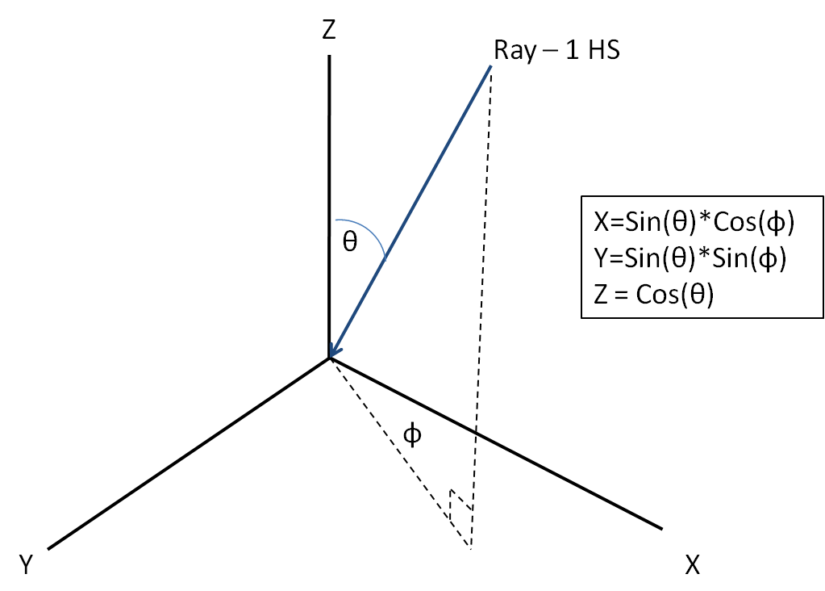
To split this single ray into two vectors, a simple angular decomposition was used and shown in Figure(__).
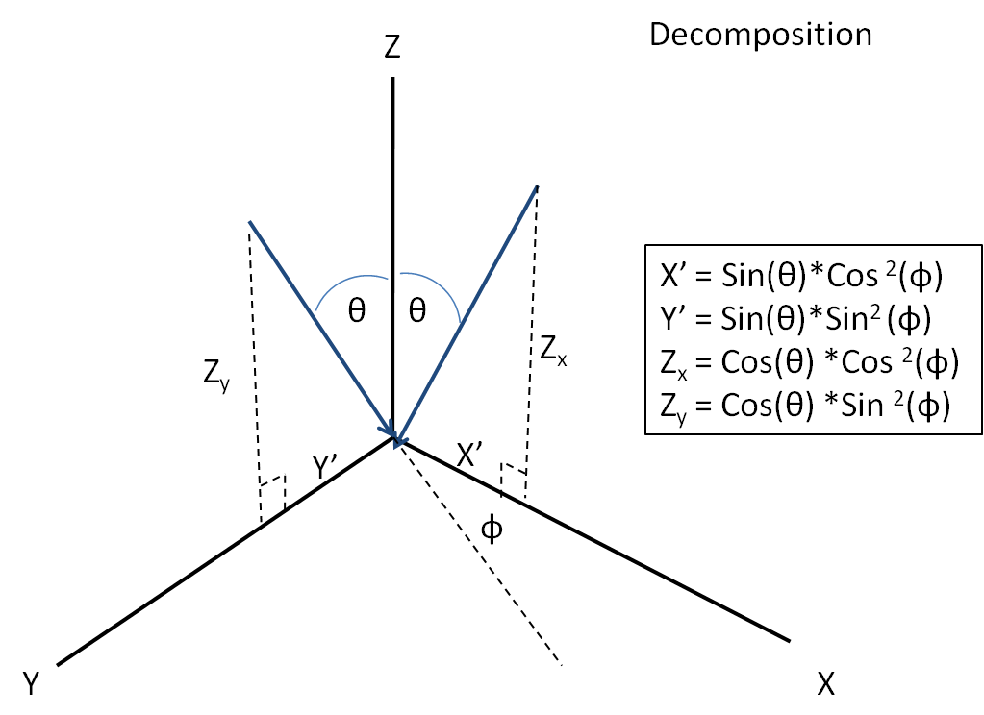
For the final contribution of each decomposed ray to the overall mean ray, the vectors were multiplied by the “Heliostat Efficiency” (η_{HS}) and summed together at each time step for all 33 HS and at each location of the HFS. The final equation for each vector’s contribution is below.
$${Z_{x}}_{hs}=η_{HS}*\cos{θ_{hs}*}{\left(\cos{φ_{hs}}\right) }^{2} \\ {Z_{y}}_{hs}=η_{HS}*\cos{θ_{hs}*}{\left(\sin{φ_{hs}}\right) }^{2} \\ {X^{'}}_{hs}=η_{HS}*\sin{θ_{hs}*}{\left(\cos{φ_{hs}}\right) }^{2} \\ {Y'}_{hs}=η_{HS}*\sin{θ_{hs}*}{\left(\sin{φ_{hs}}\right) }^{2}$$
The overall “Mean Ray” is a linear summation of each of the individual components ($X^{'}, Y^{'}$, $Z_{x}+Z_{y }$) of all 33 HS for one time step. The AOI of the “Mean Ray” on the receiver (at every HFS) is acquired through trigonometry of the three vectors below in Equation (__).
$${AOI}_{{Mean Ray}_{HFS}}= \tan^{-1}\left({\sqrt{\sum_{HS=1}^{HS=33}{X^{'} } + \sum_{HS=1}^{HS=33}{Y^{'} }}}/{\sum_{HS=1}^{HS=33}{\sqrt{{Z_{x}}^{2}+{Z_{y }}^{2}} }}\right)$$

The direction of the Mean Ray also changes over the course of the day, which was calculated by the following formula (Equation (__). The direction, termed Theta (θ) is zero at north, and increases in the clockwise direction.
$$θ_{{ Direction Mean Ray}_{HFS}}= \tan^{-1}\left({\sum_{HS=1}^{HS=33}{Y^{'} }}/{\sum_{HS=1}^{HS=33}{X^{'} }}\right)$$

The results of the optical model for the mean AOI and Direction (θ) for all eight HFS are show below, in Figure (__). The results show that the Mean AOI and Mean Direction (θ) are changing over the course of the day which will in turn affect the reflectivity profile of the reflected light measured by CCD due to the assumed Non-Lambertian reflectivity characteristics, which will be elucidated in the next section.

Lambertian Reflectivity Analysis
To elucidate the actual reflectance profile of the sandblasted ceramic tile surface (or the deviation from the Lambertian reflectance assumption), a bidirectional reflectance function (BDRF) was calculated. An experimental rig was designed in such a manner to calculate this function.

Lambertian Reflectivity Experimental Setup
The first part of the experimental setup was the use of a collimated beam light source. Since a white light source was not available in a laboratory setting, a high power laser was used (488 nm, blue, 480 mW). The beam of light was expanded to 75 times its original area due to the large surface roughness of the tile, which helped to average the reflectance profile due to variable sizes peaks and valleys on the sample. The same test was conducted with a red laser operating at 786nm which yielded similar results below, which lends credibility that the reflection from the ceramic tile surface is not spectrally sensitive.
The high powered laser produced light onto the ceramic tile, which simulates the direct beam radiation caused by a single HS reflectance onto the receiver surface. The sample was mounted in a goniometric rotation device which allowed for variation between -45 to 45 degrees from tile sample surface normal, which represents the different AOI from by the heliostats at different locations on the receiver.
The reflected light receiver/detector, an integrating sphere attached to a spectroradiometer, was used to determine the amount of reflected light at a desired location. This location was varied by rotating the detector about the ceramic tile, which was fixed to a rotating arm at a rigid length. Another goniometer was affixed to the ground which provided the difference of the detector location w.r.t surface normal of the ceramic tile (Denoted θ_{detector}).

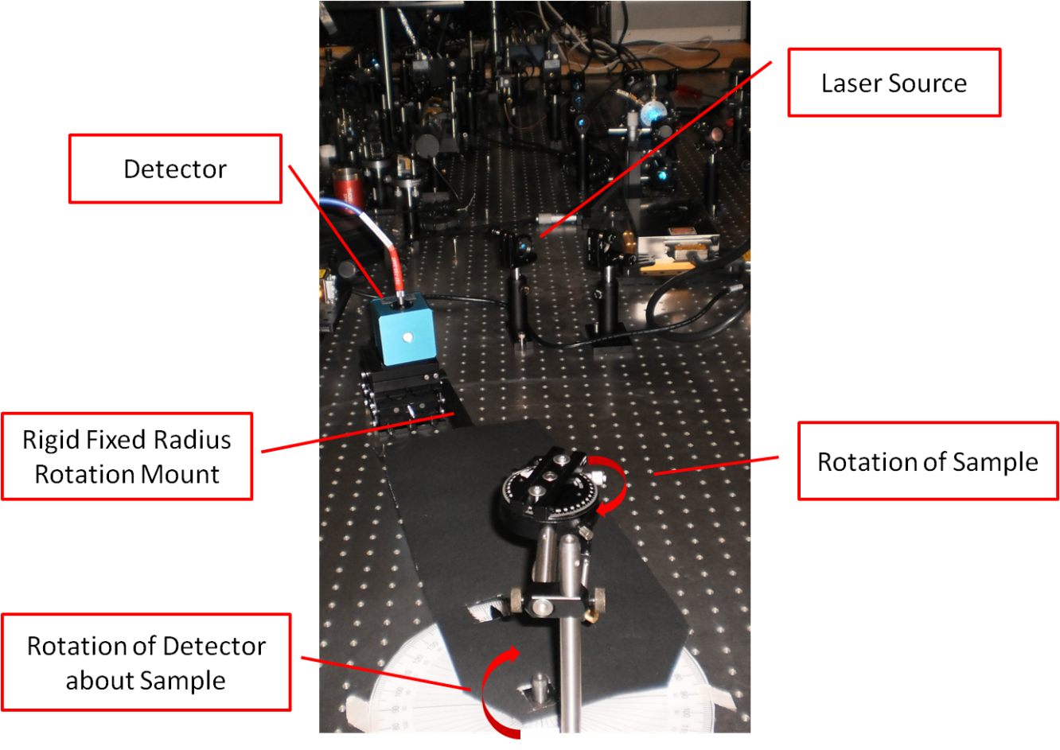

To adequately characterize the sample and obtain a BDRF, a combination of different tile sample angles and detector angles were tested. Four different AOI were tested which well represented the AOI found at the Beam Down, which were 10, 15, 20, and 25degrees. The detector location angles (θ_{detector}) were also varied at five degree intervals from ±2*AOI from the sample surface normal. Five samples were taken at detector interval to show measurement repeatability. The range was chosen so that both the potential spectral and back reflectance profile could be observed. A figure of these angles is below (Figure(__)).

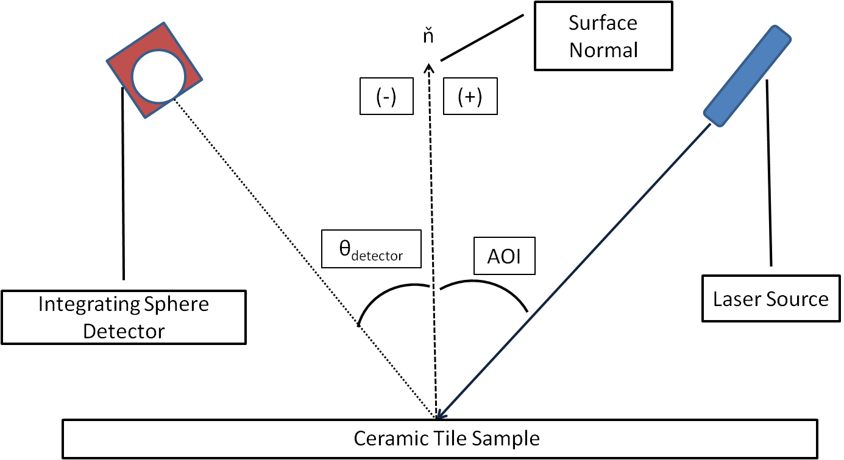

Lambertian Reflectivity Results
The first test was at zero AOI. Since the detector is physically obtrusive when (θ_{detector}) = AOI, there are no results at that specific location. The results below, in Figure (__) indicate that Lambert’s Cosine Law is slightly skew from a perfect cosine response (derived from a best fit cosine curve to the data). The reflection in the direction of the light source (zero AOI) is higher than predicted, as measured by the number of photons captured by the integrating sphere during the one second integration time. At angles greater than 25 degrees from the AOI, the reflected radiation is less than predicted by Lambert’s Cosine Law. This was the first reflectivity based indication that the perfect Lambertian assumption may not be valid for the ceramic tile receiver surface.

The same procedure was carried out for the other test runs at the various AOI. The mean cosine law that was used above and acquired through best fit analysis to minimize the error was used for the standard comparison against a perfect Lambertian Cosine Reflectance. The AOI direction is from the positive (right) hand side of the graphs. The results below in Figure (__) indicate that is a large deviation from the Lambertian assumption, and it is highest in the direction of the laser source.

This trend can be seen across all of the tests, with the peak deviation at approximately at the angle of the source laser. These results are very promising since they indicate a “Back Scattering effect,” which was initially postulated to explain the non-symmetrical trends of the HFS/CCD ratio about solar noon. In Figure (__), the percent deviation from the Lambertian is shown, along with the black error bars. A black line is drawn at the AOI of the beam, which helps to show that the peak deviation is about this point, which can reach a maximum error of nearly 20% from the Lambertian assumption.

Upon further review of the error, a clear trend in the error is emerging. There appears to be sinusoidal function which could be able to fit the error well and if so, a best fit function of the error could be applied to the data to return the reflection close to the Lambertian reflection. The model which was chosen to model the error is noted in Equation (__).
$$Error=A*\sin\left(B*θ_{detector }+C\right)+D$$
This formula was inserted into the Curve Fitting toolbox in MATLAB to determine the model coefficients. The model parameters, resulting model, and residual plots are noted below in Table (__) and Figures (__).
AOI | A | B | C | D | RMSE
10 | 0.0964 | -2.966 | -39.37 | -0.0728 | 0.01684
15 | 0.1049 | -3.03 | -27.59 | -0.0684 | 0.01537
20 | 0.0135 | -2.781 | -24.83 | -0.0692 | 0.01417
25 | 0.1205 | -2.603 | -17.98 | -0.06133 | 0.011

The resulting models described the error very well, but only at the discrete intervals at 10, 15, 20 and 25 AOI. At the Beam Down, the radiation AOI on the receiver varies widely between 5 and 25 degrees, so one single error equation needed to be developed which is modified by both the AOI and the (θ_{detector}). The single Lambertian error equation was developed by comparing the model coefficients w.r.t. the respective AOI. A crude linear relationship was developed for each model coefficient as a function of AOI, seen in Table (__).

$${Error}_{Total}=A*\sin\left(B*θ_{detector }+C\right)+D$$
A | AOI*0.001418+0.08151
B | AOI*0.02676-3.3133
C | AOI*1.33-50.868
D | AOI*0.0006774-0.079822

The test the feasibility of the new model coefficients, the new model was used to estimate the deviation from Lambertian error along with the RMSE. As seen below in Figure (__) the newly modeled error is still a very good fit as compared to the original error data.

To validate the error of the universal model, a comparison between the old and new RMSE yielded in a small percentage change, show in Table (__). The Universal Model only changed the RMSE of up to 7% at the 20 AOI test, with the rest lower. From this, the model will be robust enough to apply to the entire range of AOIs found in the Beam Down Optical Model.
AOI | RMSE Original | RMSE Universal Model | Percent Change
10 | 0.01684 | 0.0166 | 1.43%
15 | 0.01537 | 0.0163 | 6.05%
20 | 0.01417 | 0.0152 | 7.27%
25 | 0.011 | 0.01103 | 0.27%

The final step in validating the error fitting model to correct for a Lambertian reflectance was the application of the Universal Model to the initially collected data and to compare it to the perfect Lambertian reflection. The corrected results below (Figure (__)) in green visually indicate a much closer adherence to Lambert’s Cosine Law (blue) than compared to the original data (red).
Another comparative error and RMSE test were performed to observe the change in error from the initial data collection to the model correction. The percentage error from the original deviation (blue) and error corrected deviation (red) are shown below in Figure (__) and it is clear to see the significant decrease in residuals after applying the error model to the initial data. Error from the initial Lambertian assumption was very large, up to 25% in some instances. But, after the correction, error was reduced to below 5 % in most cases. It is most important to see the deviations from Lambertian between ±5 degrees of the surface normal, since the CCD camera location is within this range for the 8 HFS. From the figure below, the error is less than 5% between this range for all four AOI measurements and corrections.
The RMSE results below, Table (__), indicate a large decrease from the original RMSE (Data – Lambertian Assumption) to the error modeled (Data+Error Model – Lambertian Assumption). The results are promising as the error from Lambertian is significantly decreased and the error is fairly well centered about the zero deviation point.

Back Scattering Discussion and modeling
Talk about the quantity of back scattering and how it has been modeled and proven before for highly rough and diffuse surfaces and that our findings are in line with prior research.

Error Modeling Conclusions
The Error Modeling procedure produces a single function which helps to predict the error caused from a non-Lambertian reflection. The function, a BDRF, has two inputs, the AOI of the source light on the surface, and the location of the detector w.r.t. the normal vector of the surface (θ_{detector}). When both angles are know (as are calculated in the Beam Down Optical Model), the error BDRF is applied to the actual reflectance and compensates accordingly to estimate a Lambertian reflectance. By combining the Optical Forward Model and Lambertian Reflectance BDRF, the modeled radiation which is detected by the CCD camera can be estimated and will provide further evidence that the non-Lambertian reflection on the ceramic tiles is the main cause of the dissimilarities between the HFS/CCD ratio for the AM/PM and also between the HFS themselves.

Beam Down Least Squares Model
A least squares analysis was chosen to elucidate the quantity of a non-Lambertian reflectance due to the large data set and its ability to determine the quantity of reflected radiation to the CCD camera using the data already collected at the Beam Down. Equation (__) is the Ordinary Least Squares (OLS) equation. The following Equations (____) are supporting the OLS, for ease of reading and explanation.

$${Luminance}_{{CCD_{t=n}^{t=end}}_{HFS1} }={ B}_{o}+ B_{1}*HScont*\cos{{AOI}_{CCD}} + B_{2}*HScont*{{Error}_{Total}}+ B_{3}*\ln\left({Airmass}_{n}\right) + B_{4}*{\ln\left({Airmass}_{n}\right)}^{2}$$

$${HScont}_{n}= {Scale}_{m,n}*\sum_{m=1}^{33}{* ρ_{mirror}^{m,n} *\cos{{AOI}_{HS}^{m,n}}*\cos{{AOI}_{Receiver}^{m,n} }}$$

$${Scale}_{n}= \frac{{HFS}_{1}^{n}}{\sum_{m=1}^{33}{ ρ_{mirror}^{m,n} *\cos{{AOI}_{HS}^{m,n}}*\cos{{AOI}_{Receiver}^{m,n} *{DNI}^{n}}}}$$

$${Error}_{Total}=A*\sin\left(B*{θ_{detector }}_{m,n}+C\right)+D$$
$$A={{AOI}_{Receiver}}_{m,n}*0.001418+0.08151$$
$$B={{AOI}_{Receiver}}_{m,n}*0.00.02676-3.3133$$
$$C={{AOI}_{Receiver}}_{m,n}*1.33-50.868$$
$$D={{AOI}_{Receiver}}_{m,n}*0.0006774-0.079822$$

The OLS equation is comprised five key terms. The first is simply a column of ones. The second is considered the Lambertian Reflectance term, since it includes the $\cos{{AOI}_{CCD}}$ factor. The third term is the non-Lambertian or Error term, which was derived in the previous section. The 4th and 5th terms are factors of the air mass.
The Lambertian and non-Lambertian Reflectance term have an included $HScont$ term which was derived from the Beam-Down Optical Model. At a given time step (n) and for a given HFS and HS (m), a specific mirror reflectivity, AOI_{HS} and AOI_{Receiver} are calculated. Also at the given time step, the HFS(n) output and Solar DNI(n) are also included. The first calculated part of the $HScont$ term is the ${Scale}_{m,n}$ factor. At a given time step, the contribution of every heliostat is calculated through the denominator term and increased by the DNI. These values are then summed together to provide a value of concentrated radiation on a specific point. However, there is a discrepancy between the summation and the actual Heat Flux recorded at this point (as measured by the HFS). By dividing the actual HFS value by the modeled incident radiation, it allows for a compensation factor for the model imperfections and will properly scale the rest of $HScont$ term to an equal level of the luminance of that measured by the CCD Camera. To finalize the calculation of the $HScont$ term, the ${Scale}_{m,n}$ factor is multiplied by the summation of the individual HS mirror reflectivity, HS Cosine Loss and the cosine of the AOI_{radiation} on the receiver. The finalized $HScont$ term is then multiplied by Lambert’s Cosine Law of the angle between the HFS location and the CCD camera location (AOI_{CCD}), which estimates the actual reflected radiation incident on the receiver as seen by the CCD camera. This final term is inserted into the OLS equation for (e1,n) and this process is continued for all of the data collected over the day.
The non-Lambertian Reflectance calculation undergoes the same process to calculate the $HScont$ term and includes the ${Error}_{Total}$function as prior calculated in Section (__). The combination of these two terms over the course of the day will provide the (e2,n) terms for the OLS. The last two terms for the OLS are the “airmass” terms. A natural log was taken due to its similarity to the increasing trend of the HFS/CCD ratio as it departures from Solar Noon. This increasing departure is caused from the spectral mismatch between the HFS acceptance range (300- 2500nm) and the CCD camera (300-~800 nm), due to the spectral composition increasing its IR fraction at the air mass increases. At higher air masses and higher level of IR radiation, the CCD camera does not record as much luminous as the HFS. Since the CCD camera output is in the denominator, the ratio will increase since the CCD signal is decreasing relative to the HFS signal. By incorporating the two air mass terms into the OLS, this increasing trend is partially compensated for.

Least Square Modeling Results
The goal of the OLS was to create a model (based on both Beam Down data and an Optical Forward Model) which could reasonable estimate the reflected light measured by the CCD camera, which received both a Lambertian and non-Lambertian reflection from all 33 HS. The results were divided amongst the three separate days of data collection and individually of the 8 HFS. The reason for the separation of the three days is due to the changing atmospheric conditions which will affect the DNI solar spectrum and thus, the ratio of IR light absorbed by the HFS, but not by the CCD camera. HFSs were also individually analyzed because due to their different position on the receiver, which in turn had varying proportions of Lambertian and non-Lambertian reflectance. Examples will be highlighted in this section, but the complete modeling effort is found in Appendix (__).

Model Residuals
The percentage error residuals of the modeled Luminance vs. CCD measured Luminance are presented below for all 8 HFS for the three days in Figure (__), with respect to the Lambertian reflection. The results are fairly promising indicating the vast majority of the model predicting the measured Luminance within 10% error, with most within 5% (as noted by the black horizontal lines. There was limited structure in the residuals. The highest point of error occurred at the points of the lowest radiation which correspond to the earliest and latest parts of the day. This higher level of error could be explained by the large assumptions from the Optical Beam Down model. During these periods of the day, there is a very high level of non-symmetry of the concentrated solar radiation on the receiver, due to comatic aberrations. The optical model does not account for this and will provide highly erroneous estimates of the radiation on the HFS.

HFS/CCD Ratio Comparison
The second important test to determine the validity of the OLS procedure was to compare the modeled HFS/CCD ratio (Actual HFS Data / Modeled Luminance Data) with the original HFS/CCD ratio, as seen below in Figure (__), for Day 3 only. The modeled HFS/CCD ratio appears to have satisfactorily estimated the measured HFS/CCD ratio. The results for HFS 1-4 appear to be very good, which is also a possible product of the fairly smooth nature of the curve. For HFS5-8, the results do not seem as impressive, but this could also be an artifact of the more noisy or inconstant ratio.

Statistical Comparisons
It is important to compare the different indicators of statistical validity for the OLS model.

Model Coefficients
 |  | B0 | B1 | B2 | B3 | B4
HFS 1 | D1 | 91.073 | -0.794 | -5.191 | -168.972 | -13.991
 | D2 | -392.036 | -0.690 | -4.600 | 485.901 | -256.799
 | D3 | 428.972 | -1.471 | -9.282 | -511.957 | 102.071
HFS 2 | D1 | -342.149 | -0.033 | -0.686 | -482.299 | 427.383
 | D2 | -177.869 | 0.249 | 1.095 | -387.000 | 276.454
 | D3 | 155.465 | 0.724 | 4.013 | -791.178 | 552.339
HFS 3 | D1 | 1143.609 | -0.367 | -2.583 | -1617.359 | 613.082
 | D2 | 742.033 | -0.690 | -4.613 | -986.087 | 350.019
 | D3 | 490.445 | -0.557 | -3.849 | -1102.940 | 599.510
HFS 4 | D1 | 89.928 | -0.592 | -4.025 | 88.971 | -263.850
 | D2 | 93.585 | -0.208 | -1.634 | 233.101 | -317.746
 | D3 | 90.229 | -0.183 | -1.472 | 211.179 | -336.019
HFS 5 | D1 | 244.883 | -2.797 | -17.279 | -401.594 | 183.663
 | D2 | 185.109 | -4.314 | -26.561 | -319.860 | 159.824
 | D3 | 123.888 | -2.626 | -16.326 | -239.256 | 125.124
HFS 6 | D1 | 25.248 | -0.091 | -1.032 | -70.643 | 17.778
 | D2 | 62.208 | -0.181 | -1.507 | -106.564 | 48.315
 | D3 | 45.513 | -0.061 | -0.806 | -116.077 | 72.397
HFS 7 | D1 | 219.197 | -1.354 | -8.617 | -280.839 | 95.516
 | D2 | 247.144 | -0.835 | -5.393 | -289.486 | 95.309
 | D3 | 288.423 | 0.625 | 3.625 | -405.995 | 167.047
HFS 8 | D1 | 152.439 | 0.040 | -0.053 | -70.774 | -24.538
 | D2 | 101.660 | -0.121 | -1.023 | 32.225 | -74.759
 | D3 | 110.533 | 0.063 | 0.167 | 16.293 | -86.928

T-Statistics
 |  | e0 | e1 | e2 | e3 | e4
HFS 1 | D1 | 2.093 | 15.358 | 16.631 | 2.803 | 0.478
 | D2 | 10.160 | 15.750 | 17.413 | 9.695 | 10.557
 | D3 | 7.257 | 22.150 | 23.228 | 5.642 | 2.343
HFS 2 | D1 | 8.479 | 0.677 | 2.313 | 8.281 | 11.787
 | D2 | 5.659 | 7.794 | 5.672 | 8.719 | 10.189
 | D3 | 5.412 | 11.161 | 10.198 | 14.328 | 13.352
HFS 3 | D1 | 26.495 | 4.974 | 5.667 | 28.863 | 20.307
 | D2 | 23.142 | 12.621 | 13.678 | 23.763 | 14.473
 | D3 | 6.376 | 4.711 | 5.251 | 10.352 | 11.960
HFS 4 | D1 | 3.834 | 15.026 | 16.601 | 2.350 | 11.155
 | D2 | 4.348 | 5.841 | 7.458 | 7.037 | 15.121
 | D3 | 4.620 | 3.574 | 4.667 | 5.234 | 11.075
HFS 5 | D1 | 25.619 | 49.677 | 50.208 | 22.925 | 18.637
 | D2 | 16.053 | 54.915 | 55.116 | 16.982 | 15.981
 | D3 | 18.236 | 39.526 | 40.155 | 18.118 | 14.761
HFS 6 | D1 | 6.331 | 3.148 | 5.962 | 9.236 | 2.851
 | D2 | 17.395 | 7.054 | 9.745 | 15.621 | 8.306
 | D3 | 14.112 | 2.051 | 4.537 | 16.042 | 11.176
HFS 7 | D1 | 34.732 | 10.186 | 10.526 | 26.234 | 14.219
 | D2 | 41.603 | 6.021 | 6.317 | 27.657 | 13.381
 | D3 | 38.082 | 3.278 | 3.086 | 30.176 | 18.069
HFS 8 | D1 | 29.198 | 1.271 | 0.272 | 11.025 | 5.493
 | D2 | 25.197 | 5.172 | 7.000 | 6.471 | 18.416
 | D3 | 18.526 | 2.307 | 0.974 | 2.040 | 13.715

RMSE | D1 | D2 | D3
HFS 1 | 32.9531 | 31.9297 | 28.1982
HFS 2 | 62.0891 | 42.4574 | 55.3205
HFS 3 | 46.905 | 40.2137 | 43.9361
HFS 4 | 36.6275 | 32.8814 | 38.1113
HFS 5 | 10.7644 | 12.2904 | 8.7074
HFS 6 | 12.2481 | 11.3928 | 9.8478
HFS 7 | 10.7137 | 12.0582 | 11.9343
HFS 8 | 8.667 | 7.9 | 9.8876

Other Interesting Findings
An interesting comparison was made between the modeled value of non-Lambertian reflectance w.r.t. the value of the Lambertian reflectance. Figure (__) below shows the ratio to non-Lambertian reflectance to Lambertian Reflectance plotted against the air mass, for the Day 3 data. The value of the ratio appears to correlate well with the degree of separation between the AM and PM HFS/CCD ratio when also plotted against air mass. For instance, HFS 2 exhibited a limited amount of AM/PM scattering, which indicates a lower degree of non-Lambertian reflectance, and is why the ratio for HFS 2 is the lowest of the 8 HFS. On the contrary, HFS 8 has exhibited a high degree of difference between its AM and PM ratio, and this is illuminated by having a higher ratio than the others. These results help to provide increasing support that the non-Lambertian reflections contributed to the differences between the AM/PM trends of the HFS/CCD correlation.

Discussion

Overall Assessment of Flux Mapping and its Challenges

Imperfect Lambertian Surface

AM/PM Differences due to AOI and Cosine Loss

Optical Model Limitations and Errors relative to Actual Data

HFS Errors

CCD Camera Challenges (Filters, position)

Measurement of Spectrum – Intraday Atmospheric Differences

Comparison of the BD to its Designed Parameters
The easiest remedy to this problem is to ensure the Lambertian surface generates a reflection as true to the Cosine Law as possible and as such, the selection of the proper surface (for its ability to withstand thermal stresses, avoid soiling, and maintain a constant mean reflectivity) is absolutely critical. A second remedy is the correct location of CCD camera for a desired viewing angle of the receiver. Although no surface exhibits a perfect Lambertian reflectance, there are some AOI which follow the Cosine Law very closely. Since approximate AOI of the concentrated radiation are know, an optimized position can be determined to minimize specular reflectivity.

Conclusion and Future Work

Summary

Recommendation for Future Flux Mapping Studies

Future Work

