Table of Contents

CHAPTER 1 3
Motivation 3
Problem definition 5
Solar-cooling system components 7
1. Beam-down 7
2. Triple Effect Absorption chiller 8
3. PCM Storage system 8
CHAPTER 2 – LITERATURE REVIEW 10
Sensible heat storage 11
Liquid media 12
Solid media 13
Chemical heat storage 13
Latent heat storage 15
Different configurations of LHS units 21
Analytical and numerical solutions for PCMs 23
CHAPTER 3 –BEAM DOWN PILOT PLANT 26
Concept 26
Beam-Down Solar Thermal Concentrator (BDSTC) 27
Heliostat Field 29
CHAPTER 4 – TRIPLE EFFECT ABSORPTION CHILLER 31
Solar cooling 31
Triple-effect absorption chiller 35
CHAPTER 5 – HEAT STORAGE MODELING 37
Concept 37
Overview of the phenomena involve in a phase change 38
Conduction-Dominated Phase Change 39
Analytical model 40
Numerical solution using Finite Difference Method (FDM) 44
Numerical solution using Finite Element Method (FEM) 49
Governing equations 50
Preliminary Design 55
Comparison of the results using a FME and a FDM 58
Finding the storage device optimal configuration 61
Mesh size and Elements 64
Water inlet velocity 66
Effect due to the variation in number of fins 69
CHAPTER 6 - SOLAR COOLING SYSTEM 71
Cooling supply profile 71
Power supplied by the Beam Down 73
BIBLIOGRAPHY 78
GLOSSARY 82

CHAPTER 1

Motivation

Cooling supply has become in the last years a topic of great interest in the Middle East region since conventional cooling technologies are characterized by high energy consumption causing high electricity peak loads. According to the International Energy Agency (IEA), air-conditioning is the dominant energy consuming service in building in many countries. The specific case of the city of Abu Dhabi is not an exception, where the cooling demand is a major component in the electricity load leading to a large technical as well as economical stress on the electrical system. In an effort to predict energy used for cooling supply a model was developed by our research team at LENS (the Laboratory for Energy and Nano-Science) [1]. This work was motivated by technology and policy questions germane to both supply and demand. It was found in this study that temperature and humidity were the largest factors influencing cooling load. Furthermore, it was found that electrical use for cooling on Abu Dhabi Island corresponded to over 40% of the total annual electrical load in 2008 and over 60% of electricity use on the peak day of 2008.

Figure 1 shows the seasonal variation of electrical demand of Abu Dhabi. The seasonally varying component of demand is mainly cooling; the cooling demand is further divided into responses, represented by areas between the curves, to ambient temperature, specific humidity, vertical component of direct normal irradiation and diffuse irradiation.

Figure 1-1. Contributions of different weather parameters to the electricity consumption [1]

On the other hand, an abundant supply of solar radiation is available in Abu Dhabi; therefore, it is logical to propose the use of solar energy to contribute in the supply of air-conditioning. In order to properly size and design a solar cooling plant, the aggregate cooling loads should be based on all of the significant load predictors. This was the motivation that led LENS to develop a new study where a methodology for assessing solar cooling technologies is proposed taking into account technical as well as economic aspects such as cooling demand time series, solar resource availability, climatic conditions, component cost and component performance characteristics [2]. The authors of this work compared 25 feasible combinations of solar energy collection and cooling technologies, including solar thermal and solar electric cooling options thereby extending the assessment of solar cooling technologies through concentrated solar power plants. The final result can be observed in figure 2 which shows each solar collection technology combined with the best cooling technology it could interface with, based on the operation temperatures.

Figure 1-2. Summary of solar cooling paths [2]

Problem definition

The high cooling demand together with the vast supply of solar resource in Abu Dhabi, and more generally in the Middle East, suggests that solar energy for cooling is a highly practical approach. Meteorological data shows that Abu Dhabi has a yearly sum of around 2044 (KWh/m²) of global solar irradiation on a horizontal surface and direct normal irradiation of around 1800 (KWh/m²) [2]. On the other hand, electricity consumption in this region is growing considerably and is on track to exceed planned generation capacity. Solar thermal cooling is not a new concept; nevertheless, it has been gaining relevance in recent years because of its potential to provide efficient cooling at low costs without generating CO₂ emissions. However, solar energy is a time dependent resource and therefore a disparity exists between energy generation and demand, therefore heat storage plays a key role in reducing excess energy production. It also provides the system with a degree of independence from the solar input, but the level of this independence is related to the size of storage employed. Indeed, a very high capacity of thermal storage is required to completely decouple supply from demand. For these reasons, a new storage alternative is necessary. Of the possible options, phase change materials (PCMs) seem the most promising because of its higher storage density compared with sensible heat storage. In addition, PCMs have very small temperature differences between charging and discharging modes; the process may be considered as isothermal, which reduces thermodynamic (availability)losses.

The purpose of this document is to analyze a PCM storage unit using water as a transport fluid in connection to an absorption chiller. The solar thermal energy is harnessed using the Beam-down pilot plant in Masdar City (Figure 3). A model is developed and simulations carried out with commercial software (MatLab and COMSOL Multiphysics) using two different numerical methodologies in order to test the behavior of these three elements together. The current project combines these three units aiming at the provision of round-the-clock cooling to Masdar City without producing emissions. Therefore, for this project a dynamic model of the thermal behavior of the latent heat storage (LHS) unit is required.

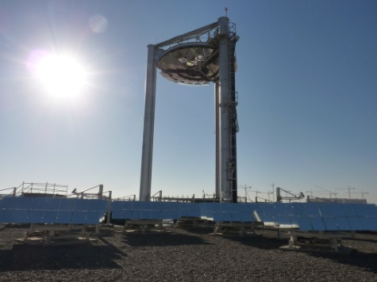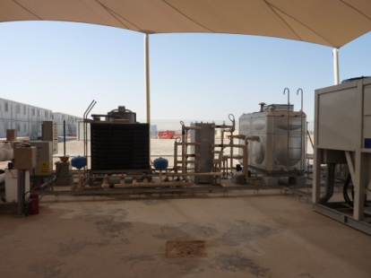
Figure 1-3. Beam-down pilot plant and absorption chillers at Masdar test site

Solar-cooling system components

Beam-down

The Beam-down pilot plant at Masdar City is designed to provide a nominal power of 100 kWth .The beam-down configuration at Masdar uses a central reflector which consists of multiple flat mirrors to approximate a hyperboloid to redirect beam radiation reflected from each heliostat to a common focal point. The use of separate mmirrors on the central reflector permits ventilation between the rings, has a light frame structure and reduces the wind loads. The Masdar beam down design is also unusual in its use of a level heliostat field comprising three concentric rings of heliostats. This arrangement is not optimal for commercial plants but is well suited to the research activities for which the plant is intended.

Triple Effect Absorption chiller

Absorption chillers provide chilled water by using heat instead of electricity; by utilizing absorbent fluid and a refrigerant, they transfer thermal energy from the heat source to the heat sink. The triple-effect absorption chiller at Masdar transfer heat to the absorbent solution through four major components: an evaporator, absorber, generator and condenser.

PCM Storage system

In each array of tubes, the PCM is sandwiched in the annulus formed by two concentric tubes while the transport fluid, usually steam, water or oil flows through the inner core. For example steam produced by the Beam-down test facility may be used to to charge a PCM store and the stored heat can later run an absorption chiller. The plant design integrating the PCM storage unit with an absorption chiller and with the Beam-down pilot plant is shown in Figure 1-4.


Solar Field

Charging mode
Discharging mode
PCM Storage Unit
Drum
Condenser
Evaporator
Pump
Heat Exchanger
Desorber
Pump
Absorber
Cooling System
Figure 1-4. Solar thermal cooling plant design incorporating a PCM storage unit.

CHAPTER 2 – LITERATURE REVIEW

Throughout history energy has been used in different forms; as mechanical energy, as electrical energy, as heat, etc. However, in recent years energy has become a fundamental factor to define people’s standard of living. Heat and cold storage did not play a significant role before, for most people in everyday life. This changed in recent times when the demand for comfort in domestic buildings increased. Moreover, thermal energy storage plays a very important role in many energy systems. In solar systems, in order to use the excess energy produced while solar resource is available, heat storage is employed so that energy can be utilized during low availability. In that way the mismatch between supply and demand can be overcome. The use of energy storage results in a more energy efficient and cost effective system. There are two situations in which the stored energy can be used, these are: during night time or during unpredictable cloudy days. Therefore, the use of storage is essential if the intention is to develop a 24/7 solar system.

three main approaches for storing heat are: sensible heat storage where thermal energy is stored by changing the temperature of a storage medium, latent heat storage where the heat transfer occurs when a substance changes from one phase to another and finally chemical heat storage. The last type of storage is by means of chemical reactions, it is necessary that the chemical reactions involved are completely reversible. These 3 approaches are going to be explained in this section, nevertheless this document is going to be focused on explaining latent heat storage since it seems to be the most promising technique . This is due to the fact that larger amount of energy can be stored using latent heat than sensible heat in the same unit volume. Also, although chemical storage is a very interesting option and it has big potential, is still in a very early stage.

The storage process involves three main steps: charging, storing and discharging. There are a large variety of choices of storage media depending on the temperature range and application and the appropriate selection will depend on cost-benefit considerations, technical criteria and environmental criteria [3].

Sensible heat storage

By far the most common thermal energy storage is as sensible heat. It is called sensible heat when by increasing the temperature of the storage medium it is produced an increment in energy. The ratio of stored heat ΔQ to the temperature rise ΔT in the heat capacity C of the storage medium; ΔQ=C* ΔT= m*c* ΔT

Sensible heat storage is perhaps the simplest way of storing thermal energy. Some examples of the most common storage medium are: water, molten salt, oil, rock beds, bricks, sand, etc. Considerations that have to be taken into account in order to choose a medium are:

- Cost of the medium
- Operational temperature range
- Thermal conductivity and diffusivity
- Pressure and pressure vessel geometry
- Compatibility among materials
- Stability
- Heat loss coefficient as a function of the surface areas
- Need for and ability to provide thermal stratification

Liquid media

If the storage medium is a liquid such is water, molten salt or mineral or synthetic oil, a thermal stratification may be established in the tank because of the differences in density between hot and cold fluid. At low temperature water is a great storage media because of its high specific heat, low price and general availability. However, the range of temperature before it becomes steam is low (25°C to90°C) then when it becomes vapor a costly pressure vessel is needed [4].

For high temperature storage the most typical substitutes for water are oils and molten salt. Although their heat capacities are 25-40% of that of water on a weight basis these substitutes have lower vapor pressure and they can operate at temperatures greater than 300°C [4]. However, oils are very expensive and above about 400ºC most organic oils tend to decompose, therefore fluids such as molten salts, liquid metals and air (with an air-rock storage medium) are commonly considered. Molten salt is an excellent thermal storage medium. A mixture of 60% sodium nitrate and 40% potassium nitrate is commonly used. It is non-flammable and nontoxic and it is liquid at atmospheric pressure so there is no need for pressurize the system. Moreover, it can be used as both the transport fluid for the solar field and as storage medium thus eliminating the need for expensive heat exchangers. Unfortunately, it has potential corrosion problems and presents a relatively high freezing point which makes it more complex to deal with. On the other hand, sodium hydroxide has a relatively higher melting point (320 °C) and can work at temperatures up to 800°C, however there is difficulty in containing it at high temperatures and it is highly corrosive [4].

Solid media

Materials for solid media thermal storage are usually employed in the form of packed beds and require a fluid to transport and exchange heat. Their main advantages are their low cost and high working temperatures. The most common materials are rocks, bricks, sand, and concrete. These materials do not freeze or leak, energy can be stored at low temperature but also at high temperature.Concrete has a high specific heat and good mechanical properties, its coefficient of thermal expansion is near that of steel and it has high mechanical resistance to cyclic thermal loading [3]. Primary issues include maintaining good contact between the concrete and piping (when direct contact is not used), and the heat transfer rates into and out of the solid medium [6].

Chemical heat storage

When a chemical reaction takes place, there is a difference between the enthalpy of the substances present at the end of the reaction and the enthalpy of the substances at the start of the reaction. This enthalpy difference is known as heat of reaction. Any chemical reaction with high heat of reaction can be used for thermal energy storage as long as the product can be stored and the heat stored is released during the reverse reaction [17]. In a chemical heat storage system thermal energy is used to break chemical bonds in a reversible way. The rupture of the chemical bond requires large quantities of energy input, thus resulting in thermal energy storage. The heat produced by the solar collector field is used to produce the chemical reaction in the substance, if this reaction is completely reversible the thermal energy can be recovered completely by the reverse reaction.
There are many reasons why this method has attracted the attention of scientists, some of these are:

- Large quantities of energy to be stored in small quantities of material.
- The reverse, the energy-releasing chemical reaction, rarely proceeds at room temperature. Therefore, the energy can be stored indefinitely, without energy loss, at ambient temperatures.
- Because of very high energy density and stability at low temperatures of some chemical energy storage systems, the stored thermal energy can be transported.

Although chemical energy storage is a very attractive option, it is furthest from being developed to the point of practical use in a solar thermal energy system. As of 2011 there is no chemical energy storage system that has been tested in a commercially viable solar thermal energy system [5].

An example of a chemical storage research system developed at The Australian National University (ANU) is shown in Figure 2-1. The cycle is driven by heat from a paraboloidal dish concentrator of around 20m² with a 15kW receiver/reactor.
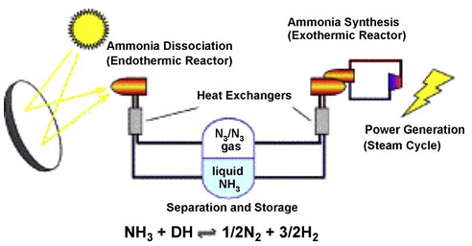

Figure 2-1. Scheme of installation of a parabolic through power plant with chemical storage system [18].

Latent heat storage

Latent heat is associated with the energy required to convert a solid material to liquid, or a liquid material to gas. A large amount of rnergy is required for the phase transition of the material over a narrow range of temperature;. This is why latent heat storage systems provide higher energy storage density when compared with conventional sensible heat storage systems; they require a smaller weight and volume of material for a given amount of energy.
Furthermore, latent heat storage systems have the capacity to store heat at relatively constant temperature which is the phase change temperature of the material. This temperature interval represents an important criterion for the selection of the phase change material since the phase transition must occur within limits useful for the application [7].

Table 2-1 shows a comparison of energy storage densities from different methods. It shows that PCMs can store about 3 to 4 times more (in some cases even 15 times more [4]) heat per volume than the one stored as sensible heat in solids or liquids within a temperature interval of 20°C. On the other hand, we can see that chemical energy in gasoline shows a storage density about 100 times larger than that of PCM. Furthermore, table 2-1 also shows a comparison with the storage of electrical energy since currently a big part of the energy is delivered to the end user as electricity. In comparison with latent heat storage, batteries show smaller or comparable storage densities.

 | MJ/m³ | kJ/kg | Comment
Sensible heat
Granite | 50 | 17 | ΔT=20°C
Water | 84 | 84 | ΔT=20°C
Latent heat of melting
Water | 306 | 330 | melting temperature 0°C
Paraffins | 180 | 200 | melting temperature 5°C-130°C
salt hydrates | 300 | 200 | melting temperature 5°C-130°C
Salts | 600-1500 | 300-700 | melting temperature 300°C-800°C
Latent heat of evaporation
Water | 2452 | 2450 | ambient conditions
Heat of chemical reaction
H₂ gas (oxidation) | 11 | 120000 | 300K, 1bar
H₂ gas (oxidation) | 2160 | 120000 | 300K, 200 bar
H₂ liquid (oxidation) | 8400 | 120000 | 20K, 1bar
fossil gas | 32 | - | 300K, 1bar (Diekmann et al.1997)
Gasoline | 33000 | 43200 | (Diekmann et al.1997)
Electrical energy
Zinc/manganese oxide battery | - | 180 | (Diekmann et al.1997)
Lead battery | - | 70-180 | (Diekmann et al.1997)
Table 2-1. Comparison of typical storage densities of different energy storage methods(3.6 MJ = 1kWh) [17]
A wide range of PCMs have been investigated, subdividing them in eutectics and mixtures (inorganic, organic and fatty acids) see Figure 2-2.

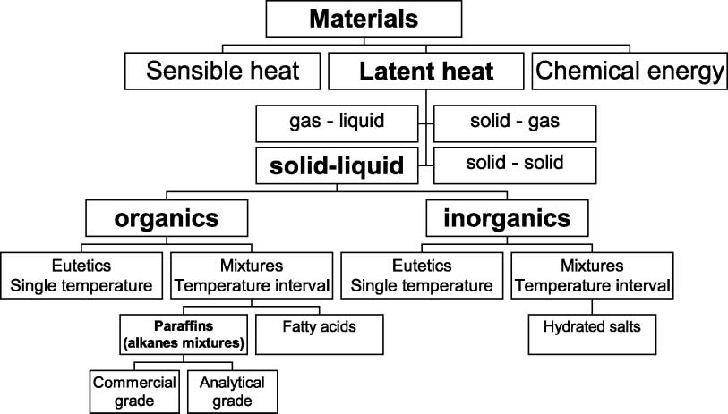

Figure 2-2 Classification of energy storage materials [9]

By far water is the best-known PCM. It has been used for cold storage for more than 2000 years. Today, cold storage with ice is state of the art and even cooling with natural ice and snow is used again [17]. Figure 2-3 shows the typical range of melting enthalpy and melting temperature of common material classes used for LHS. Paraffins, fatty acids, and sugar alcohols are organic materials. Salts hydrates are salts with a large and defined amount of crystal water. By looking at figure 2-3 we can see that the energy density is roughly proportional to the melting temperature in K and that PCMs can be used for a wide variety of applications where the operation temperature lies between -100 and 800°C.

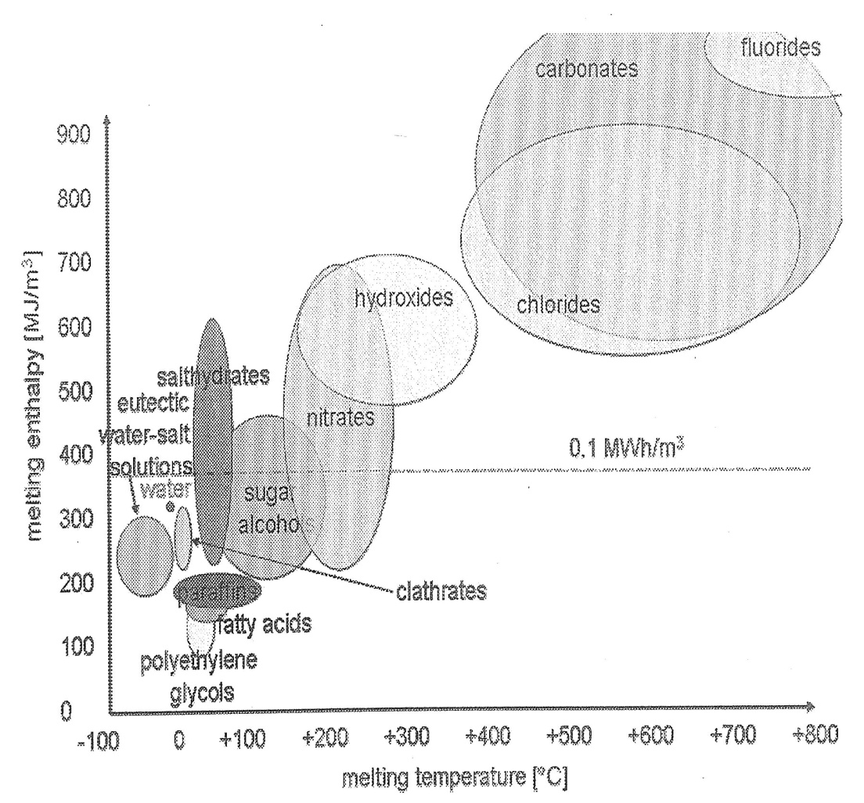
Figure 2-3 Classes of material that can be used as PCM and their typical range of melting temperature and melting enthalpy [17]

The main criteria in order to select a phase change material are [8]:

- The melting point lies in the desired operating temperature range.
- Possess high latent heat of fusion per unit mass.
- Has high specific heat to provide additional sensible heat storage effects.
- Has high thermal conductivity, so that the temperature gradients for charging and discharging the storage material are small.
- Shows little or no subcooling during freezing.
- Presents chemical stability, no chemical decomposition and corrosion resistance to construction materials.
- Contains non-poisonous, non-ﬂammable and non-explosive elements/compounds.
Also, the main difficulties of working with phase change materials for storing energy are [9]:

- Stability of properties under extended cycling, which can be solved using stabilizers and nucleating agents.
- Subcooling (as the melt is cooled, therefore, it does not solidify at the thermodynamic equilibrium melting point) and segregation, which is solved by adding crystallizing and nucleating agents.
- They present low thermal conductivity, which can be solved by mixing with metals.
- These systems usually require the use of a heat exchanger which increases the cost of the unit.

A number of technical and economic requirements, according to [17], have to be considered when designing a LHS unit.

Technical requirements, regarding the construction of a storage device, include:

- Small volume change during the phase change.
- Low vapor pressure. This is to reduce requirements of mechanical stability and leak-tightness imposed on the container of the PCM.
- Chemical stability of the PCM, for long lifetime of it.
- Compatibility of the PCM with other materials, for long lifetime of the container and or fins.
- Safety and environmental constraints.

Economic requirements, regarding the development of a marketable product, include:

- Low price in order to compete with other options of storage and also to be competitive with methods of heat and cold supply without storage at all.
- Good recyclability for environmental and economic reasons.

It is very common that a material is not able to fulfill all the requirements previously mentioned. Usually PCMs have very low thermal conductivity, inorganic PCM often show subcooling, not always there is compatibility with the container material, etc. Nevertheless, several strategies have been developed to cope with these problems. Cabeza et al. 2008 discusses these strategies in section 2.3.

Different configurations of LHS units

Once the PCM has been selected the geometry of the PCM container has to be considered along with its thermal and geometric parameters. In order to ensure long-term thermal performance of any PCM system the size and shape of the PCM container must correspond to the melting time of the PCM and to the daily insolation at a given location if the source of energy is a solar collector [8]. The most common configurations are cylindrical containers such as long thin heat pipes and shell and tube systems [10, 11] also rectangular containers (plates) [10, 11] and packed beds of spheres [11]. The PCM container configuration that has been most intensely analyzed by researchers and publications for storing heat is the shell and tube system, accounting for more than 70%; this may be due to the fact that heat loss from this configuration is minimal [8].

The main disadvantage of using PCMs for heat storage applications is their low thermal conductivity. To overcome these problems two approaches are being developed by DLR: one is to reduce the specific resistance for heat conduction in the PCM (external or internal arrangement), and the other to reduce the average distance for heat conduction within the storage material (Figure 2-4).

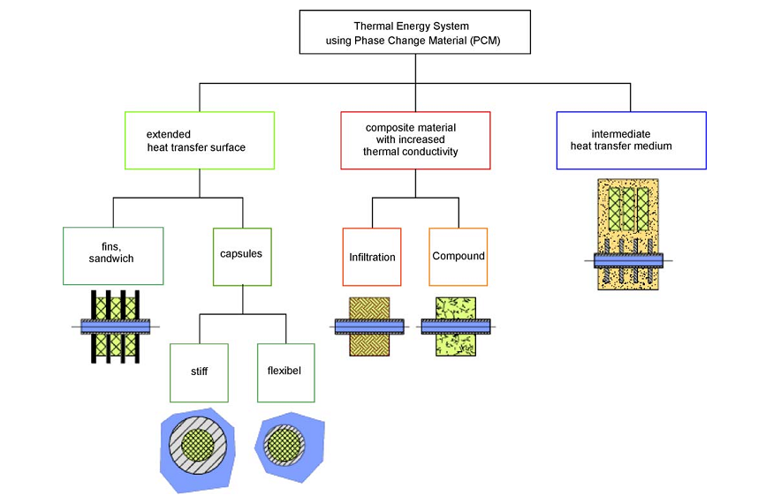
Figure. 2-4. Classification of PCM-storage concepts investigated in the DISTOR project [18].

Analytical and numerical solutions for PCMs

Although for fluids heat transfer mechanisms are dominated by conduction and convection, in the case of pure substances recent literature analyzes these systems by considering only conduction. The first studies in the matter were performed by Lame and Clapeyron in 1831 and Stefan in 1891, regarding the formation of ice [9]. After that numerous studies can be found describing melting and solidification processes for alloys, mixtures and many PCMs materials, evaluating the effects of density change, Biot number, convection, etc. In 1975 Goodling [12] examines outward solidification in a cylinder with constant heat flow in the inner wall doing a one dimensional analysis.
Shamsundar [13] evaluated a heat exchanger of shell and tubes and proposes a two-dimensional analysis considering the axial variation of the temperature. Later in 1989 Hunter [14] verifies that the enthalpy method is the most suitable for real substances presenting no alteration to the numerical scheme in the boundary. Lacroix [15] develops a theoretical model to predict the transient behavior of a shell-and-tube storage unit with PCM on the shell side and heat transfer fluid (HTF) inside the tubes using also the enthalpy based method. In 2006 Bony [11] describes a numerical model considering conduction and convection in a PCM storage system, including hysteresis and subcooling as well.

Probably the most important parameter when modeling a PCM is the relation between the location of the phase front at s and the time t. The different geometries resulting from an encapsulation or from a heat exchanger can lead to completely different variation of x with time.
Analytical solutions can give and important hint if for example encapsulations as flat plates, pipes, or spheres should be used in an application with respect to the desired time development of the heat flux. Despite this important and general information given by analytical solutions, it is important to keep in mind that strong limitations exist with respect to geometry and what is more important, with respect to thermal effects. These restrictions often lead to poor results when using analytical models to get quantitative information [17]. For example, often analytical models do not include sensible heat, only treat heat transfer by conduction and not convection, assume that the PCM is at the phase change temperature at the beginning, and that boundary temperatures are constant. Moreover, another restrictive limitation is the assumption of a sharp melting temperature (most materials have a melting range several degrees K). This assumption leads to significant errors if the temperature at the boundary comes close to the melting range. If the temperature of the boundary is very different from the melting range, this restriction is negligible. But then the sensible heat becomes significant and cannot be neglected any more.

For a detailed and more realistic analysis of real problems a different approach , the use of numerical models, is necessary. Numerical models are more flexible with respect to thermal effects and geometry. All heat storage problems are dynamic problems, therefore it is additionally necessary to find the solution in time.
The simulation of heat transfer in a PCM with a simple geometry can be accomplished with many mathematical and engineering software tools like MatLAB, Mathematica and EES. Also, results can be achieved with commercial CFD (computational fluid dynamics) software like COMSOL, FLUENT and ANSYS.

CHAPTER 3 –BEAM DOWN PILOT PLANT

The continuous increase in the level of greenhouse gas emissions and the increase in demand of energy due to the worldwide development are the main driving forces behind efforts to more effectively utilize various sources of renewable energy. Resulting also in seek for new technologies that use solar resource as motive energy. In addition to the aforementioned, the fact that in the Middle East region there is a large availability of solar radiation leads to the crucial importance of the development of CSP technologies. To this end, efforts have been launched in Abu Dhabi focused on harnessing new solar thermal technologies. Moreover, Masdar developed the first solar power station in the UAE, Shams I, with a capacity of 100MW using parabolic troughs.
In addition, in order to properly assess CSP options in the UAE, in 2009 in Masdar City a Beam-Down solar thermal concentrator was constructed in order to investigate the potential of the unconventional plant design.

Concept

The 100 kW_{th} Beam-Down solar thermal concentrator was proposed by Tokyo Institute of Technology (figure 1-3) with the objectives of testing several design concepts that may lead to the reduction in the overall cost of this type of technology, and investigating the feasibility of scaling the beam down concentrator to significantly higher capacities. The Beam-Down concept has been attracting the attention of researchers because of its advantage of placing the receiver on or near the ground avoiding the need of pump up the working fluid. The main differences of this technology in comparison with conventional designs are its optics, the multi-ring reflector design and the ganged-type heliostats. Historically the Beam-Down system was considered to be less competitive because the mechanical strength of the structure that supports the receiver needs maintain optical accuracy underwind loads; also, cooling is required to prevent overheating of the central mirror. The influences of wind and heat on the mirror may cause degradation of lower focus and ultimately reduce the collection efficiency [20]. The central reflector of the current design consists of multiple flat facets with the same focal point, providing a substantial cost reduction. The multi-ring concept allows for a lighter frame structure and ventilation between the rings, allowing heat removal and reducing the wind loads.

After receiving responsibility for the operation of the Beam-Down plant our team conducted a measurement study to characterize the plant and investigate its unique design aspects. A detailed description of the procedure for the plant characterization can be found in Marwan Mokhtar thesis [21]

Beam-Down Solar Thermal Concentrator (BDSTC)

The Beam-Down Solar Thermal Concentrator (BDSTC) has 280 m² of primary reflective area. This primary surface area is comprised of 33 2-axis tracking mirror assemblies (heliostats). The heliostats focus sunlight on one imaginary upper focal point, the radiation gets intercepted by a secondary central reflector on top of the tower to be then redirected to a lower focal point close to ground level see Figure ‎3-1.

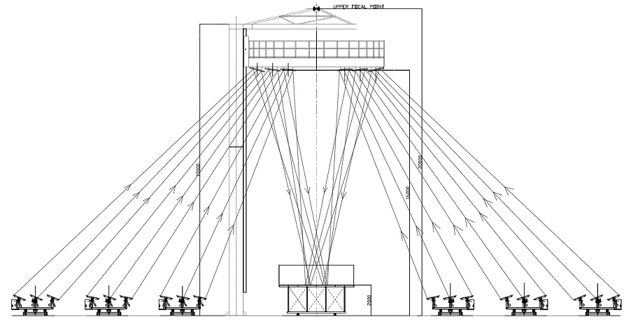
Figure ‎3-1 Vertical cross sectional view of 100kW pilot plant [22]

The main difference between the BDSTC and the concentrators in other systems such as those in conventional tower systems is that instead of collecting solar energy in the heat transfer fluid on top, the receiver is located below, close to ground. This is done by a secondary set of optics.

Furthermore, since all the radiation falls on the target from a narrow angle of less than 20º cavity receivers are well suited to be used in this configuration. The cavity receiver can have much lower thermal losses in comparison to open receivers commonly used tower plants, and can therefore achieve higher temperatures [23].

Heliostat Field

The heliostat field in the Beam-Down plant at Masdar consists of 33 ganged-type heliostats each of 8.505 m² reflector area. Heliostats are arranged in a surrounding field configuration in three main sectors of equal size; North, East and West (Figure ‎3-2). 6 heliostats are in the A line 17.480 m away from the origin, 15 heliostats are in the B line 20.080 m away from the origin and 12 heliostats in the C line 36.680 m away from the origin.
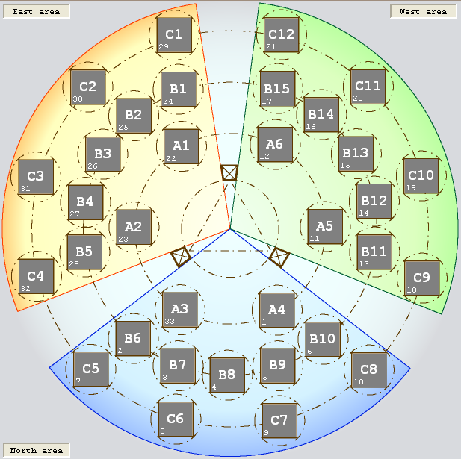
Figure 3-2 Heliostat Field Layout

Each heliostat has three banks of mirror facets (ganged), each bank having its own elevation axis of rotation (Figure ‎3-3). The banks are connected by links, therefore only one motor is necessary to control the elevation. There is a second motor in each heliostat which rotates the whole unit about its vertical axis in order to control the azimuth angle. Each mirror bank has 14 mirror facets (450 mm x 450 mm), in two rows. Except the bank in the middle, it has a central mirror and two half mirrors above and below it. The central mirror it is used to control the position of the heliostat at each moment of time together with the tracking sensor.
In order to reflect the largest amount of radiation to the central reflector the heliostats should continuously change their elevation and azimuth angles which is achieved with a solar tacking system. In addition, as the heliostat facets are flat, they have to be slightly tilted relative to each other to focus the solar radiation; this is called canting. The tilt angles of the mirrors depend on the distance between the heliostat and the focal point. For more details on the alignment of the tracking sensor and the heliostat canting please refer to chapter 6 Mokhtar [21].
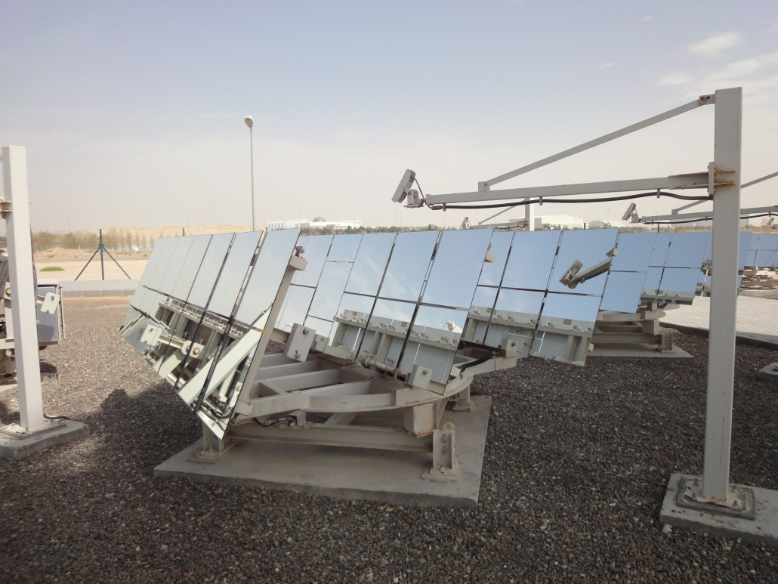
Mirror Banks
Tracking Sensor
Control Mirror
Elevation
Azimuth
Figure 3-3 heliostat and tracking sensor [21].

CHAPTER 4 – TRIPLE EFFECT ABSORPTION CHILLER

Solar cooling

The continuous increase in the cost and demand for energy has directed to more research and development to utilize available energy resources efficiently. In some ways, using solar energy is better for space cooling than for heating. As was discussed in chapter 1, the cooling load is strongly correlated with exposure of buildings to solar irradiation [1]. During the warmest months of the year there is high availability of solar energy. In addition to this, the efficiency of solar collectors increases with increasing insolation [26]. In other words, solar resource is generally most available when cooling is most needed.
Solar cooling can be achieved with different refrigeration cycles and it has been demonstrated to be technically feasible in the past. However, the use of these systems has not been very popular due to the unfavorable economics. Among the mostly used methods for solar cooling are vapor compression cycles, absorption-cooling cycles, and desiccant cooling [1]. The future of many of these methods will depend on developments beyond the cooling process itself. Solar cooling processes have been limited by temperature constraints on collectors’ operation. Also, as collector operating temperatures are pushed upward, storage may become a critical problem [27].

Absorption Cooling
The reason why solar energy is compatible with absorption cycles is because absorption air conditioning requires mostly thermal energy at temperatures that solar collectors can easily provide. Low and medium- temperature collectors have proved to be a good option for absorption air conditioning. However, solar cooling analysis has not really been focused for large scale applications.
The main difference between a conventional gas-fired absorption chiller and one using solar energy is the larger heat transfer area needed to make the cycle work using the lower driving temperature available in solar applications. Single, double or triple absorption chillers are used in different solar-thermal-cooling system designs; the multi-effect chillers are more efficient but need higher temperatures. Absorption chillers differ from vapor compression air conditioning only in the method of compressing the refrigerant [26].
According to Goswami (2008) the performance of an absorption cycle depends, among other things, on the two materials used for the refrigerant-absorbent pair. Desirable characteristics for this pair are:
- Absence of a solid-phase sorbent
- A refrigerant more volatile than the absorbent so that separation from the absorbent occurs easily in the generator
- An absorbent that has a strong affinity for the refrigerant
- Stability for long-term operations
- Nontoxic and nonflammable fluids
- Refrigerant with large latent heat so that the circulation rate can be kept low
- A low fluid viscosity that improves heat and mass transfer and reduces pumping power
- Fluids that do not have long-term environmental effects

The pairs that meet the requirements and are most commonly used are lithium bromide-water (LiBr-H₂O) and ammonia water (NH₃-H₂O). In the LiBr-H₂O system water is the refrigerant and LiBr is the absorbent, whereas in the ammonia-water system, ammonia is the refrigerant and water is the absorbent. Other refrigerant-absorbent pairs are [28]:

- Ammonia-salt
- Alcohol-salt
- Ammonia-organic solvent
- Sulfur dioxide-organic solvent
- Halogenated hydrocarbons-organic solvent
- Water-alkali nitrate
- Ammonia-water-salt

The thermal coefficient of performance COP is defined as the ratio of energy in the evaporation Q_{E}, to the energy into the generator Q_{G};

$$COP=\frac{Q_{E}}{Q_{G}}=\frac{cooling effect}{heat input}$$

The performance of an absorption chiller is affected by ambient conditions, similar to a solar field, andvariation of COP with ambient temperature is considered to be the dominant factor. For absorption chillers nominal COP at 30°C condenser temperature is typically 0.7, 1.4 and 2.0 for single effect, double effect and triple effect respectively [2].

COP variation with ambient temperate for a triple effect absorption chiller is shown below, this equation is applied when the difference between the nominal condenser temperature of 30°C and the ambient temperature is greater than 4°C, otherwise the COP is assumed to be the nominal COP [2].

$$COP=2.0*(-0.013*\left(T_{a}+4\right)+1.39)$$

where $T_{a}$ is the ambient temperature in C.

The following figure 4-1 shows few absorption chillers currently under development by different companies which provide different solution flow systems in their current double-effect systems. The prototype systems are expected to have cooling capacities in the rage of 352-1054 kW [29]

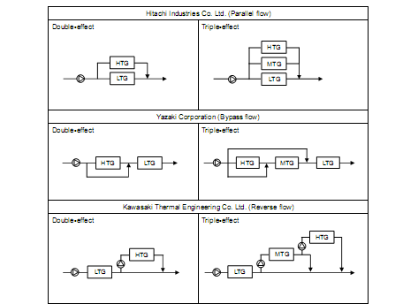
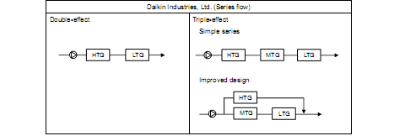
Figure 4-1 Existing double-effect flow systems and new triple-effect flow systems under development [29]

Triple-effect absorption chiller

The specification table for the triple-effect absorption chiller used in this document is shown below
Item | Specification
Maximum cooling capacity | 212.1 kW
Cooling COP | 2 (nominal)
High-temperature generator temperature | 220°C
Chilled water temperature (inlet-outlet) | 12-7°C
Power consumption | 106.1 kW

CHAPTER 5 – HEAT STORAGE MODELING

Concept

For many years researchers have been increasingly engaged by the challenges found in understanding phase change processes. This is not surprising considering the large number of applications in processes such as the melting of ice and freezing of water, metal casting, welding, coating and purification of metals, crystal growth for melts and solutions, nuclear reactor safety, etc. Moreover, modeling melting and solidification processes is also relevant to the design and development of efficient, cost effective latent heat storage systems. As was mentioned in chapter 1, the latent heat energy storage concept for storing and recovering heat has two undeniable advantages. Firstly, latent heat for most materials is much higher in comparison with their sensible heat, resulting in smaller mass of storage medium from a given quantity of thermal energy to store/recover. Secondly, this process occurs at a nearly constant temperature, which results in a more efficient operation for most thermal systems. A good understanding of the heat transfer processes involved is essential for accurately predicting the thermal performance of the system and for avoiding errors in the design of such units.

However, modeling the thermal behavior of a LHS system is much more complex than modeling sensible heat storage systems. Some of the problems associated are: nonlinear motion of the solid-liquid interface, the possible presence of buoyancy driven flown in the melt, the conjugate heat transfer between the encapsulated PCM and the HTF and the volume expansion of the material when the change of phase occurs [32]. For the last 20 years hundreds of papers have appeared in the literature dealing with the mathematical modeling of solid-liquid phase change heat transfer. General discussions of numerical techniques for the solution of these problems are presented in [33, 34, and 35]

The fast advances in digital computer technology achieved over the last years have elevated numerical simulation to the status of a third scientific method, complementing the two traditional methods of theory and experiment. Increasingly complicated processes may be realistically simulated numerically and often at lower cost than actual experiments, enabling us to better predict, understand and control them. Thus, numerical development and a strong driving force in the quantification and mathematization of science and technology. Computer simulations have become an essential part of science and engineering. Digital analysis of components, in particular, is important when developing a new technology or optimizing designs [33].

Overview of the phenomena involve in a phase change

Solid and liquid phases are characterized by the presence of cohesive forces keeping atoms in close proximity. In a solid the molecules vibrate around fixed equilibrium, while in a liquid they may skip between these positions. The macroscopic manifestation of these vibrations is what we know as heat or thermal energy, the measure of which is called temperature. Atoms in the liquid phase are more energetic (hotter) than those in the solid phase. Therefore, before a solid can melt it must gain a certain amount of energy to overcome the forces that maintain its solid structure. This energy is what we know as the latent heat of the material and represents the difference in thermal energy (enthalpy) levels between liquid and solid states. On the other hand, solidification of liquid requires the removal of this latent heat and the structuring of atoms into more stable lattice positions, in either case there is a major re-arrangement of the entropy of the material [33].

The subject of this section is the modeling and analysis of phase change process at the macroscopic level. The purpose of mathematical modeling is to quantify the process in order to be able to predict the evolution of the temperature field in the PCM and the HTF, the amount of energy used and stored, and any other quantity of interest. Thus the equations and conditions that express the physics of this process must be formulated under certain simplifying assumptions made in order to have a manageable problem.

Conduction-Dominated Phase Change

Due to the fact that most PCMs used in LHS systems have low thermal diffusivities the calculated heat transfer rates between the HTF and PCM may be inexact. As a result of this, predicting the thermal behavior of these systems becomes difficult. Therefore in order to overcome this limitation, the problem of heat transfer within the PCM container must be analyzed.

Heat transfer problems involving solid-liquid phase change are difficult to solve mainly because of the moving boundary that takes place between the solid and the liquid phase. The position of this boundary is not known, and must be determined as part of the solution, making phase change problems intrinsically nonlinear in nature. Although the moving boundary is the most significant problem, it is not the only one. Density changes in the PCM produce convective motion in the melt through natural convection, close-contact melting and volume changes. Complications also occur if there are subcooling/superheating effects, anisotropic phase change or phase change over an extended temperature range [32].

The model described in this document assumes that the heat transfer in the PCM is conduction dominated. From a mathematical point of view, buoyancy effects and the resulting natural convection motion in the liquid are tacitly ignored because they greatly complicate the analysis of predicting the interface position and heat transfer. From a physical point of view, this assumption is reasonable in order to avoid incongruent melting [32].

Analytical model

In the configuration that we are modeling, the PCM is sandwiched between two concentric tubes of inner and outer radii r_{i} and r₀, The outside walls of the cylindrical capsule are adiabatic (see Figure 5-1) Heat transfer fluid is running through the inner pipe. Heat is conducted through the PCM and eventually melting (storage) or solidification (recovery) is triggered at the boundary x=r_{i}. In order to reduce the computation time only one tube, only a single pipe with surrounding storage material is calculated. The energy stored by the system is then the product of the number of tubes by the energy stored in only one of these units. This approach does not take into account the amount of PCM material existing between the tubes. This amount of PCM is dependent on system configuration and arrangement of tubes and can be considered as extra storage capacity.

r_{i}
r₀

L

HTF
PCM

m
•
ro
PCM
L
Figure 5-1 Configuration of the storage block

For the development of the mathematical model, the following assumptions were considered [16]:

- Axial heat conduction is neglected since the HTF is considered isothermal along the tube. This in order to avoid a time-consuming computational solution of the PCM equations.
- Only heat transfer by conduction is considered. Convection during melting of the PCM is ignored because of its high viscosity.
- It is assumed that the PCM is homogeneous and isotropic.
- The thermal resistance on the wall in the tube is neglected.
- No PCM subcooling or degradation is considered.
- Heat conduction is axisymmetric around the tube.
The enthalpy solution approach is used to solve this problem. This approach is based on the fact that the energy conservation law, expressed in terms of energy (enthalpy) and temperature together with the equation of state contain all the physical information needed to determine the evolution of the phases [33]. By using the enthalpy-based method, the phase change problem becomes more tractable: the governing enthalpy equation is similar to the single-phase energy equation [16]. The unknown tube wall temperature between the HTF and the PCM is obtained from an energy balance at the wall. However, an iterative solution method is required.

The energy conservation equation for the PCM can be expressed in terms of the sensible enthalpy h [16 and 33]:

$\frac{∂h}{∂t}=\frac{1}{r}\frac{∂}{∂r}α\left(r\frac{∂h}{∂r}\right)+\frac{∂}{∂z}\left(α\frac{∂h}{∂z}\right)-ρ_{s}∆h_{m}\frac{∂f}{∂t}$ (5-1)

Here $α$ is the thermal diffusivity ($\frac{k}{ρ_{s}c_{s}}$ ), $ρ$ is the density of the solid phase and $∆h_{m}$ is the latent heat of fusion. The third term on the right side of Equation 5-1 comes from Crank’s formulation for which the total enthalpy is divided into sensible and latent heat components:

$H_{T_{PCM}}=h_{T_{PCM}}+ρ_{s}∆h_{m}f$ (5-2)
Where
$h_{T_{PCM}}=\int_{T_{m}}^{T}{ρ_{k}C_{k}}dT_{PCM}$ (5-3)

Where $ρ_{k}$ is the phase density, $C_{k}$is the phase specific heat and $f$ is the local liquid fraction.
The potential advantage of this formulation is that the enthalpy equation is cast in a standard form, with the problems associated with the phase change isolated in the source term $ρ_{s}∆h_{m}\frac{∂f}{∂t}$
The initial and boundary conditions are:

h( r,z,0)=h_{initial}
$\frac{∂h}{∂z}(r,0,t)=\frac{∂h}{∂z}(r,L,t)=\frac{∂h}{∂r}(r_{0},z,t)=0$ (5-4)

$k_{PCM}\frac{∂T_{PCM}}{∂x}(r_{i},z,t)=U_{HTF}\left(T_{PCM}-T_{HTF}\left(z,t\right)\right)$ (5-5)

Where $U_{HTF}$ is the convective heat transfer coefficient.

The temperature of the PCM, $T_{PCM}$can be retrieved from enthalpy definition Equation 5-3
Assuming that heat diffusion in the HTF is negligible with respect to advection, the energy balance for the flow channel yields the following equation:

${(ρC)}_{HTF}\left(πr_{i}^{2}\right)\frac{∂T_{HTF}}{∂t}=\left(2πr_{i}\right)U_{HTF}\left(T_{PCM}-T_{HTF}\right)-\dot{m}C_{HTF}\frac{∂T_{HTF}}{∂z}$ (5-6)

The boundary conditions for Equation 5-6 are:

$T_{HTF}\left(0,t\right)=T_{inlet}$ (5-7)

$\frac{∂T_{HTF}}{∂z}\left(L,t\right)=0$ (5-8)

Numerical solution using Finite Difference Method (FDM)

The computer simulation of a time-dependent process rests upon a discretized version of a mathematical model of the actual physical process. continuum quantities, such as energy and temperature, are replaced by their values at discrete points. Time itself is discretized, and the marching process takes place through discrete time steps. The time steps for a computer simulation must be small enough for us not to lose the feeling of continuity [33].

The idea of the enthalpy approach is very simple, direct and physical. The volume occupied by the phase change material is divided into a finite number of control volumes and applying energy conservation to each control volume yields a discrete heat balance [33].

Equation 5-1 and 5-6 are solved using a finite-difference solution method (FDM). The finite-difference equation for the PCM is obtained upon integrating Equation 5-1 over the control volume in the (x, y) plane depicted in Figure 5-2

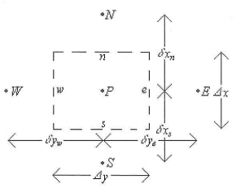
Figure 5-2 Grid point cluster (2D)

The resulting scheme has the form

$a_{p}h_{p}{=a}_{S}h_{S}+a_{W}h_{W}+a_{E}h_{E}+a_{N}h_{N}+b$ (5-9)

Where
$a_{S}= \frac{r_{S}^{}α∆z}{∆r_{s}}$ (5-10)
$a_{W}= \frac{r_{P}^{}α∆r}{∆z_{w}}$ (5-11)
$a_{E}= \frac{r_{P}^{}α∆r}{{∆z}_{e}}$ (5-12)
$a_{N}= \frac{r_{n}^{}α∆z}{{∆r}_{n}}$ (5-13)
$a_{p}{=a}_{S}+a_{W}+a_{E}+a_{N}+{a^{0}}_{P}$ (5-14)
${a^{0}}_{P}=r_{P}^{}\frac{∆x∆y}{∆t}$ (5-15)
$b={a^{0}}_{P}{h^{0}}_{P}+ρ_{s}∆h_{m}{a^{0}}_{P}({f^{0}}_{P}-{f^{k}}_{P})$ (5-16)

The central feature of the present enthalpy fixed grid technique is the source term b, (Equation 5-16). Here, ${h^{0}}_{P} and {f^{0}}_{P}$ represent the enthalpy and the local liquid fraction, respectively, from the previous time step. The last term in Equation 5-16 keeps track of the latest heat evolution, and its driving element is the local liquid fraction f. This fraction takes the value of one in fully liquid regions and zero in fully solid regions, and lies in the interval [0, 1] in the vicinity of the melting front. Its value is determined iteratively from the solution of the enthalpy equation. Thus, after the (k+1)^{th} numerical solution of the enthalpy equation over the entire computational domain, Equation 5-9 may be rewritten as

$a_{p}h_{p}{=a}_{S}h_{S}+a_{W}h_{W}+a_{E}h_{E}+a_{N}h_{N}+{a^{0}}_{P}{h^{0}}_{P}+ρ_{s}∆h_{m}{a^{0}}_{P}({f^{0}}_{P}-{f^{k}}_{P})$ (5-17)

If the phase change is occurring about the P^{th} node, i.e. $1≥f≥0$, then the k^{th} estimate of the liquid fraction need to be updated such that the left side of equation 5-17 is zero, that is,

$0{=a}_{S}h_{S}+a_{W}h_{W}+a_{E}h_{E}+a_{N}h_{N}+{a^{0}}_{P}{h^{0}}_{P}+ρ_{s}∆h_{m}{a^{0}}_{P}({f^{0}}_{P}-{f^{k+1}}_{P})$ (5-18)

Subtracting Equation 5-18 from Equation 5-17 leads to the following update for the liquid fraction at nodes where the phase change is taking place:

${f^{k+1}}_{P}={f^{k}}_{P}+\frac{a_{p}h_{p}}{ρ_{s}∆h_{m}{a^{0}}_{P}}$ (5-19)

The liquid fraction update is applied at every node after the (k+1)^{th} solution of the linear system (Equation 5-9) for h. Since Equation 5-19 is not adequate for every node, the correction

${f^{k+1}}_{P}=0$, if ${f^{k+1}}_{P}≤0$ or ${f^{k+1}}_{P}=1$, if ${f^{k+1}}_{P}≥1$

is applied immediately after Equation 5-19 The finite-difference approximation for the HTF equation (Equation 5-6) is

${\left(T_{HTF}\right)}_{P}=\frac{α{{\left(T_{HTF}\right)}_{P}}^{0}+c{\left(T_{HTF}\right)}_{W}+b{\left(T_{PCM}\right)}_{P}}{a+b+c}$ (5-20)

where $α={\left(ρC\right)}_{HTF}A/∆t$, $b=PU_{HTF}$ and $c=\dot{m}C_{HTF}/∆z$. Owing the fact that the PCM enthalpy (Equation 5-9) is tightly coupled with the HTF temperature (Equation 5-20) via the boundary condition (Equation before 5-5) at r=r_{i}, both finite-difference equations must be solved iteratively at each time step. At the given time, convergence is usually achieved after few iterations, that is when the change in internal energy of the system is equal to the total energy supplied (storage) or extracted (recovery) at the boundary separating the HTF from the PCM.

This numerical solution was solved using MATLAB. The global calculation procedure flow chart is depicted in figure 5-3.
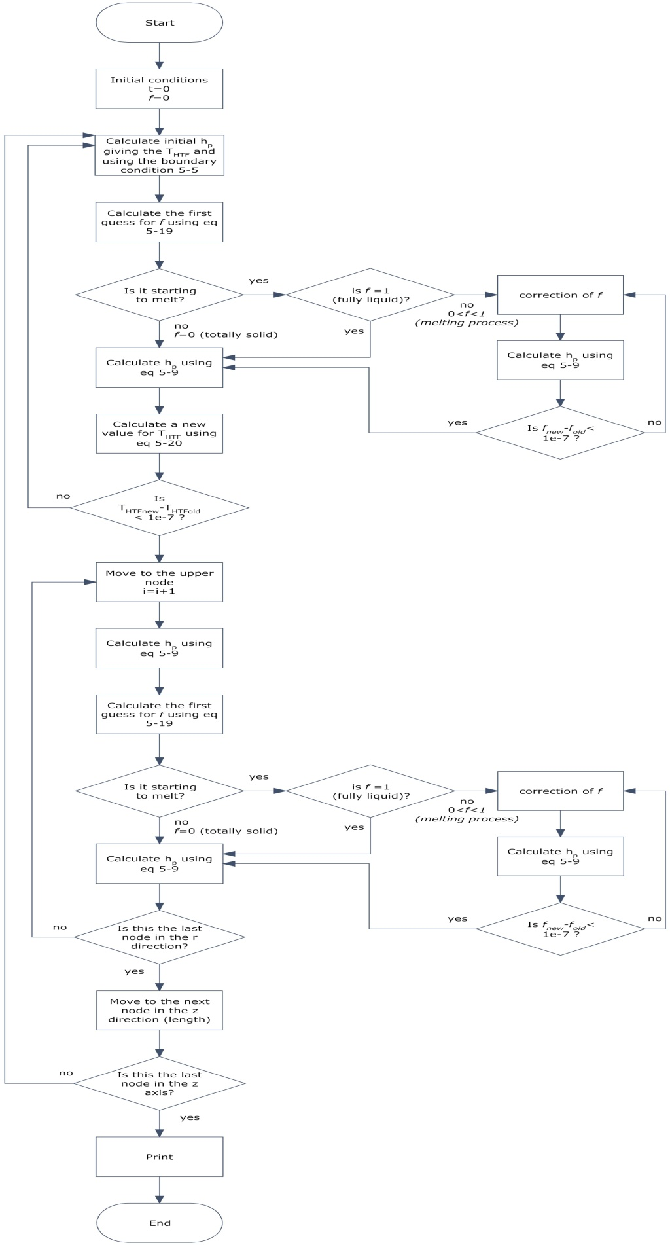
Figure 5-3 Flow chart

Numerical solution using Finite Element Method (FEM)

The finite element method (FEM) is a numerical technique use to find approximate solutions of partial differential equations (PDE) as well as of integral equations. The solution approach is based either on eliminating the differential equation completely (steady state problems), or exposing the PDE as an approximating system of ordinary differential equations (ODE), which are then numerically integrated using standard techniques such as Euler's method, Runge-Kutta, etc.
In solving PDE, the primary challenge is to create an equation that approximates the equation to be studied, but is numerically stable, meaning that errors in the input and intermediate calculations do not accumulate and cause the resulting output to be meaningless. There are many ways of doing this, all with advantages and disadvantages. The FEM is a good choice for solving partial differential equations over complicated domains, when the domain changes (as example during solidification), when the desired precision varies over the entire domain, or when the solution lacks smoothness. This is why the most attractive feature of the FEM is its ability to handle complicated geometries and boundaries with relative ease. While FDM is restricted to handle rectangular shapes and simple alterations, the handling of geometries in FEM is theoretically straightforward. On the other hand, one of the most attractive advantages of FDM is that it can be very easy to implement.

There are reasons to consider the mathematical foundation of the finite element approximation more accurate, for instance, because the quality of the approximation between grid points in FEM is often higher than in the corresponding FDM approach.

The starting point for the finite element method is a mesh, a partition of the geometry into small units of a simple shape, mesh elements. Once we have a mesh, we can introduce approximations to the dependent variables. The idea is to approximate our variables with functions that can be described with a finite number of parameters or degrees of freedom (DOF). Inserting this approximation into the weak form of the equation generates a system of equations for the degrees of freedom [36].
The commercial package that we decided to use for our model using the FEM is COMSOL Multiphysics. This multiphysics simulation software has a number of predefined physics interfaces for advanced fluid flow and heat transfer phenomena. Material properties, source terms and boundary conditions can all be arbitrary functions of the dependent variables. The material parameters and boundary conditions are specified using features in a number of physics interfaces. Each physics interface forms one or several PDEs and boundary conditions from these settings. Then software collects all the equations and boundary conditions formulated by the physics interfaces into one large system of PDEs and boundary conditions.

Governing equations

Four physical processes are simulated in order to study the energy storage process: fluid flow, heat transfer by conduction and convection, and phase change heat transfer [37].

- Fluid flow

To simulate the dynamic behavior of water flowing inside the copper pipe embedded inside the PCM storage tube, the continuity equation, as well as the Navier- Stokes equation, are solved simultaneously. The continuity equation is represented by:

$\frac{∂ρ}{∂t}+∇\left(ρu\right)=0$ (5-21)

Where ρ is the density of water and $\vec{ν}$ is the velocity vector.

The necessary Navier- Stokes equation in cylindrical coordinates, accounting for the conservation of momentum, is given by:

$\frac{ρDu}{Dt}=-∇P+μ∇^{2}$ (5-22)

Where P is the pressure in the fluid and μ is the viscosity of the water.

- Heat Transfer: Convection

Heat transfer from the water to the wall of the pipe happens by convection. In that case, the complete energy equation has to be solved for using the velocities found from the solutions of the equations of fluid flow. The software solves all the equations describing the heat transfer process by:

$ρCp\frac{DT}{Dt}=k∇^{2}T$ (5-23)

Where Cp is the specific heat of the material, k is the thermal conductivity of the material and T is the temperature. The effect of convection on the heat transfer process is taking care of by the total derivate of DT/ Dt.

- Heat Transfer: conduction

Heat transfer in the rest of the PCM is considered to be dominated by conduction. We can neglect the effect of convection in the melted PCM because of its high viscosity and also because the volume of PCM used in between the fins of the system is small. In that case, the heat conduction equation is solved by:

$ρCp\frac{∂T}{∂t}=k∇^{2}T$ (5-24)

- Heat transfer during Phase change

To model the heat transfer that takes place during melting of the material the following equation should be solved at the melting interface [30].

$-k_{l}{\frac{∂T_{m}}{∂x}}_{}=ρ∆h\frac{dX}{dt}$ (5-25)

Where k_{l} is the thermal conductivity of the liquid, T_{m} is the melting temperature, Δh is the latent heat of fusion and X is the position of the melting front. The term on the left-hand side of equation 5-25 represents the conductive heat flux absorbed at the phase change interface. Energy conservation at the interface requires that this flux absorbed at the interface be equal to the amount of heat taken due to the latent heat absorbed there, represented by the term on the right-hand side of the equation. However, this equation cannot be solved using COMSOL. Therefore this problem is dealt with by introducing a discontinuity in the specific heat Cp of the material. The specific heat of the PCM is modified using the latent heat of fusion of the PCM as 950 KJ/kg which melts over a 3 K temperature range (from 490 K to 493 K), the specific heat of the PCM is given by a numerical equation:

Cp = 1330 + 32996.67*(490<T)-32996.67* (T>493) (5-26)

Where C_{p} = C_{p,s} T<490ºK
C_{p,m} 490ºK<T<493ºK
C_{p,l} T>493ºK

C_{p,m} = Melting range; C_{p}= 32,996.67J/kg
C_{p,s} = Solid Phase; C_{p} = 1330 J/kg
C_{p,l} = Liquid Phase; C_{p}= 1330 J/kg
Δh= Latent Heat of Fusion= 95,000 J/kg
ΔT_{m}= Melting Temperature Range

C_{p,m} =+ C_{p} + Δh/ ΔT_{m} (5-26)
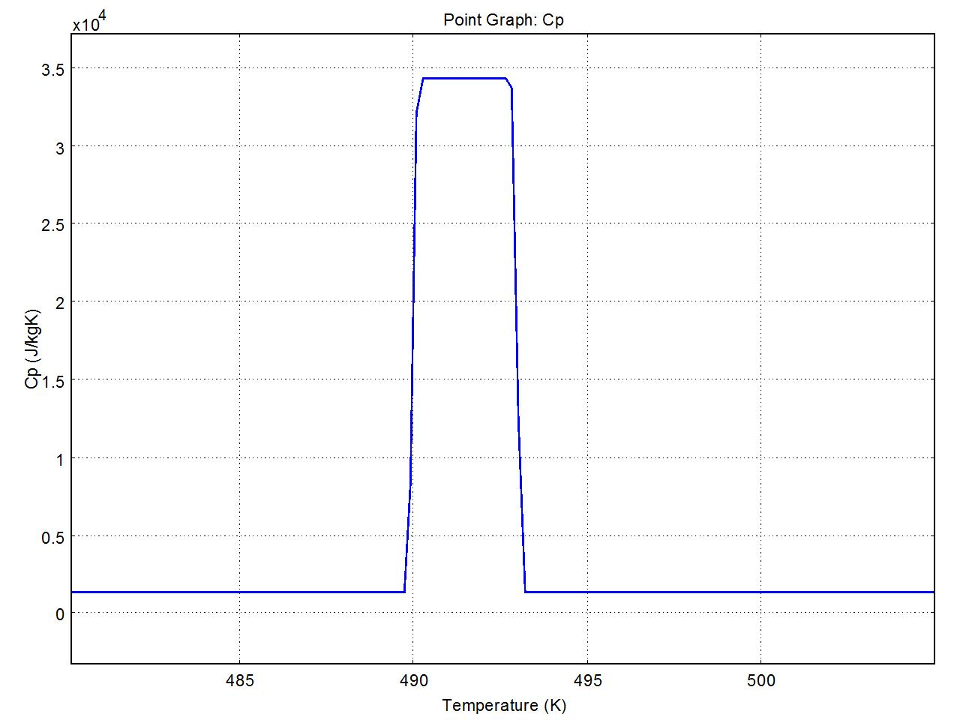
Melting range =ΔTm
from 490 to 493 K
Cp= 1330 + Latent heat/ΔT
FULLY SOLID
Cp = 1330 [J/KgK]
FULLY LIQUID
Cp = 1330 [J/KgK]
Figure 5-4 Modified Heat Capacity (Cp)

The properties of PCM used for both models are listed in Table 5-1 [3 and 8]

Symbol | Description | Value | Units
$$∆h_{m}$$ | Latent heat of fusion of the PCM | 95000 | $$\frac{J}{kg }$$
$$ρ_{PCM}$$ | Density of the PCM | 1880 | $$\frac{kg}{m^{3}}$$
$$c_{PCM}$$ | Specific heat of the PCM | 1330 | $$\frac{J}{kg K}$$
$$k_{PCM}$$ | Thermal conductivity of the PCM | 4 | $$\frac{W}{mK }$$
α_{pcm} | Thermal diffusivity | $$\frac{1}{598500 }$$ | $$\frac{m^{2}}{s }$$
$$T_{m}$$ | Melting Temperature of the PCM | 493 | K

Table 5-1 Properties of PCM

Preliminary Design

In order to have a preliminary design for the storage size and number of tubes the first thing we have to know is how much power we can get from the Beam-Down plant. By obtaining the area under the curve of figure 3-…… we have $\dot{Q}=901.39 [kWh]≈900[kWh]$ from which half is assumed to run the chiller and the other half goes to the storage block.
Maximum heat to store is assumed to be 1620[MJ] from multiplying $450 kW•hr×3600\frac{s}{hr}$
In order to calculate the total mass of PCM needed for storing that amount of energy we divide the maximum heat we can store by the latent heat of the PCM

$$\frac{1620×{10}^{6}[J]}{95×{10}^{3}[J/{kg}]}=17052.6\left[kg\right]=9.47[m^{3}]$$

Now we need to calculate the outer radius of the PCM tube, r₀, by using the following equitation 5-19 which shows the time evolution of the melting front position in the PCM, r(t),that is initially at the solid state and at the temperature equal to the melting temperature of the PCM [30]:

$2{\left(\frac{r(t)}{r_{i}}\right)}^{2}ln\frac{r(t)}{r_{i}}=\left(1-\frac{2}{Bi}\right)\left[{\left(\frac{r(t)}{r_{i}}\right)}^{2}-1\right]+4×Ste×Fo$ (5-27)

Where

$Bi=\frac{U_{HTF}×r_{i}}{k_{PCM}}$, $Ste=\frac{c_{PCM}\left(T_{HTF}-T_{m}\right)}{∆h_{m}}$, $Fo=\frac{k_{PCM}×t}{ρ_{PCM}×c_{PCM}×{r_{i}}^{2}}$

r₀ is obtained by solving equation 5-19 for$r_{i}=0.01m$, t = 6hr, $T_{HTF}=503K$, $T_{m}=493K$ and assuming an initial value for $U_{HTF}$
Once having an initial guess for the outer radius that can be melted after 6 hours we can calculate the mass of PCM per tube, as:

${Mass}_{1 tube}=ρ∙V=1880\left[\frac{kg}{m^{3}}\right]×π×\left({r_{0}}^{2}{{-r}_{i}}^{2}\right)×11[m]$ (5-28)

Dividing the total mass over mass per tube we obtain the total number of tubes. Then the mass flow rate is obtained assuming a $∆T=10K$, using the average heat flux ${\dot{Q}}_{ave}=41.54 [kW]$ and Cp_{water_at_503K}=4.98[kJ/kgK].

${\dot{m}}_{total for storage}=0.83411\left[\frac{kg}{s}\right]$ (5-29)

Now we can get the mass flow rate per tube by dividing the total mass flow rate over the number of tubes. Having the mass flow rate per tube we can calculate a more accurate convective heat transfer coefficient for the HTF and use it in equation 5-27. This by using the Dittus-Boelter correlation [31]:

$Nu=\frac{U_{HTF}×2r_{i}}{k_{HTF}}=0.023{(Re)}^{0.8}{Pr}^{0.4}$ (5-30)

$U_{HTF}=\frac{k_{HTF}×0.023{(Re)}^{0.8}{Pr}^{0.4}}{2r_{i}}$ (5-31)

where

$Re=\frac{\dot{m}×2r_{i}}{Aμ}$, $k_{HTF}=0.585\left[\frac{w}{mK}\right]$, $μ=1.04×{10}^{-4}\left[\frac{kg}{ms}\right] and Pr=0.85$

Equation 5-19 to equation 5-23 are solved until convergence is achieved for $U_{HTF}$

The final values obtained are shown in Table 5-2:

Symbol | Description | Value | Units
L | Length of the tube | 11 | m
$$U_{HTF}$$ | convective heat transfer coefficient of the HTF | 563 | $$\frac{W}{m^{2}K }$$
T_{HTF} | Temperature inlet of the HTF | 503 | k
ρ_{HTF} | Density of the HTF | 791 | $$\frac{kg}{m^{3}}$$
Cp_{HTF} | Specific heat of the HTF | 4980 | $$\frac{J}{kg K}$$
P_{HTF} | Pressure of the HTF | 50 | bar
$$r_{i}$$ | Radius of the tube | 0.01 | m
$$r_{0}$$ | Radius of the PCM | 0.055 | m
$$\dot{m}$$ | Mass flow rate of the HTF | 0.0232 per tube | $$\frac{kg}{s }$$
N | Number of tubes | 36
T | Melting time | 6.3 | hr

Table 5-2 Parameters for the preliminary design

Comparison of the results using a FME and a FDM

In the following section we show the results of the melting process model using both methods, FME and FDM, having the same inlet parameters. For the FDM solution MATLAB was used and for the FEM solution we used COMSOL Multiphysics.

Figure 5-5 shows the results obtained with the FDM solution after a simulation time of 6 hours. The x axis represents the length of the tube (1 meter) where the hot water is running and the y axis represents the melting front in cm of the PCM radius. The total radius of the PCM is 8 cm. It can be seen that after 6 hr of running hot water in the pipe at constant temperature, at 20 cm tube length 4.4 cm of PCM have been melted, at 40cm length 4.1 cm have been melted, at 60 cm length 4 cm have been melted and finally at 80 cm length only 3.9 cm have been melted.
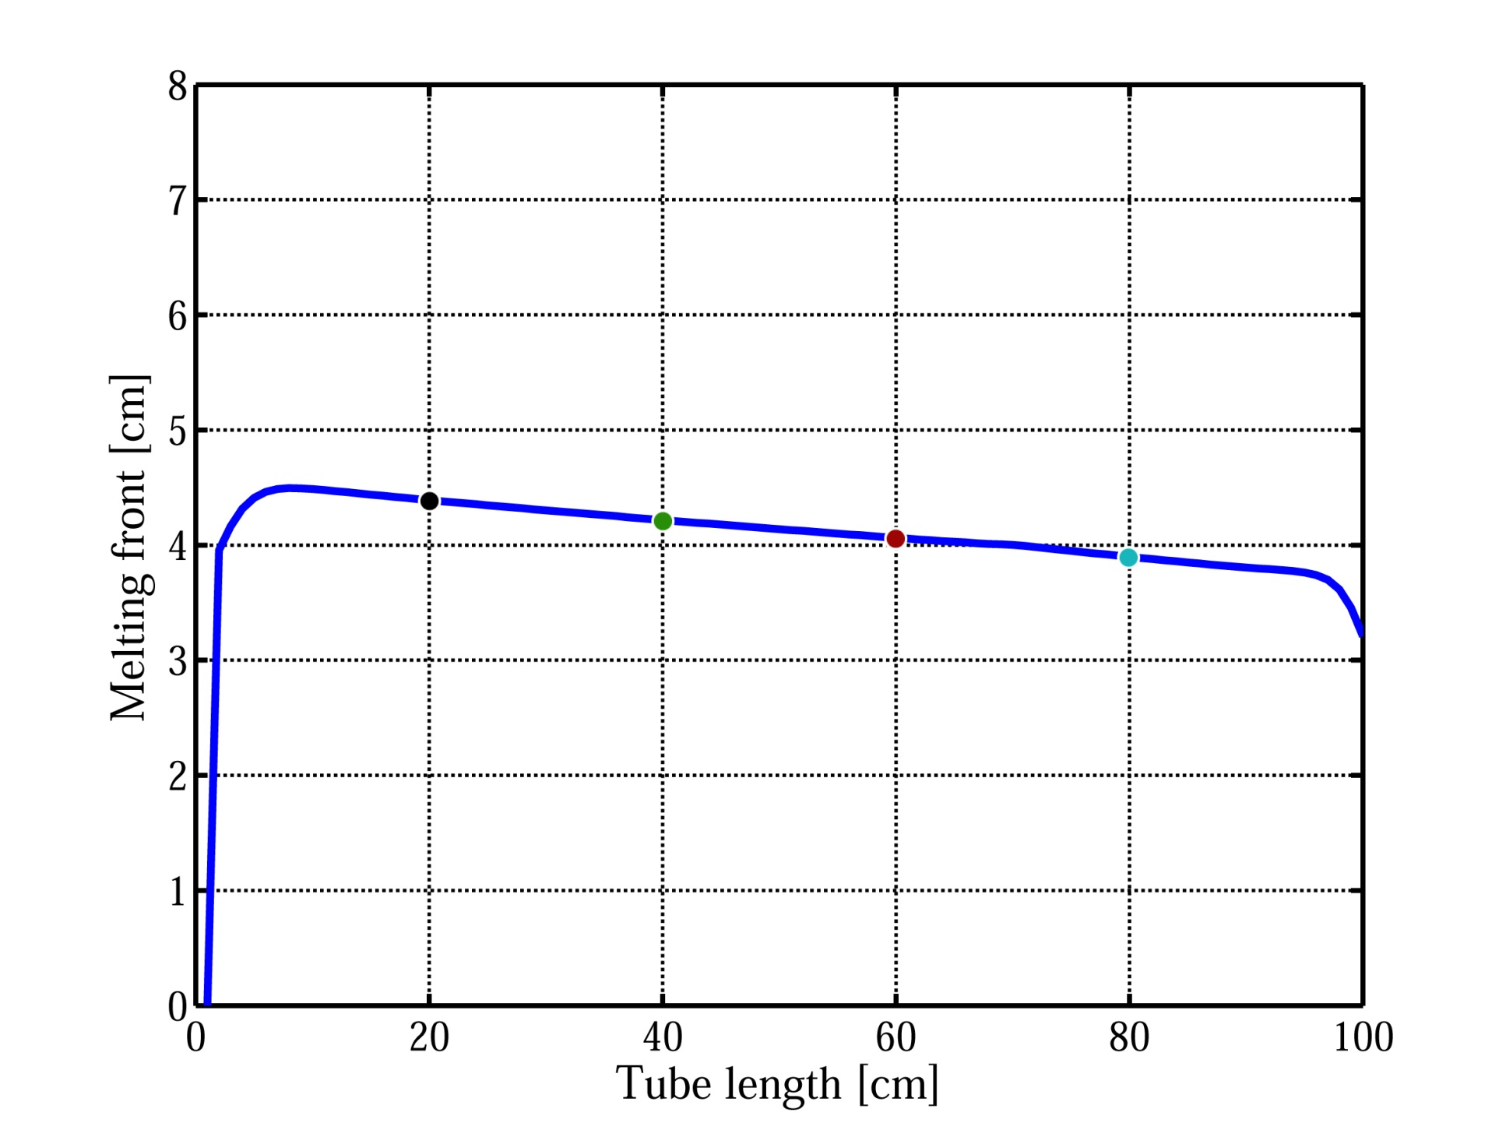
Cutline at 20cm
Melting front at r= 4.4 cm
Cutline at 60cm
Melting front at r= 4 cm
Cutline at 80cm
Melting front at r= 3.9 cm
Cutline at 40cm
Melting front at r= 4.1 cm
Figure 5-5 Melting front in the PCM after 6 hrs

Since by using COMSOL we cannot know what is the liquid fraction of the element and therefore we cannot plot the melting front, the way to know that the material is fully melted is by knowing the temperature value of the element. When the temperature of the element is above the melting range then we can say that it is completely melted. Figure 5-6 shows the temperature distribution along 4 cut lines located at 20, 40, 60 and 80 cm length of the tube (same locations of the cut lines as in the previous FDM results) after 6 hours simulated time. In this figure the x axis represents the radius of the PCM (8 cm) and the y axis represents the temperature distribution along each cut line. It can be seen that after 6 hr of running hot water in the pipe at constant temperature, at 20 cm tube length 4.5 cm of PCM have been melted, at 40cm length 3.9 cm have been melted, at 60 cm length 3.7 cm have been melted and finally at 80 cm length only 3.3 cm have been melted.
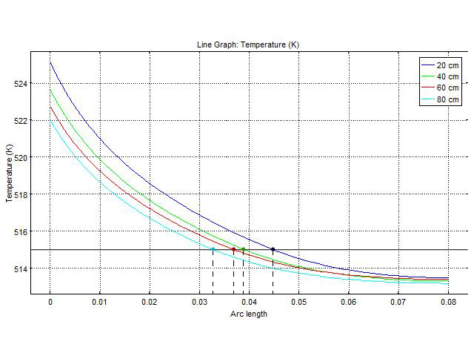
Cutline at 20cm
Melting front = 4.5 cm
Cutline at 40cm
Melting front = 3.9 cm
Cutline at 60cm
Melting front = 3.7 cm
Cutline at 80cm
Melting front = 3.3 cm
515
Melting Temperature line
Figure 5-6 Temperature distribution in the PCM after 6 hrs

The difference between both solutions is shown in the figure below (Figure 5-7)

Figure 5-7 Comparison of the results in using both methodologies

Probably the main factor for these discrepancies in the results for both methods is due to the simplifications done in FDM model in order to have a manageable problem, such as the size of the mesh nodes. While in the FDM we have a total of 900 elements in the FEM mesh we have 19,979 elements.

In the next section a sensitivity analysis is carried out in order to find an optimal configuration for our storage unit which improves the heat transfer properties in our device.

Finding the storage device optimal configuration

The sensitivity analysis that has been carried out takes into consideration on three main parameters:

- Mesh size and elements.
- Inlet Velocity of the fluid.
- Number of copper fins.

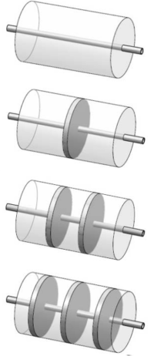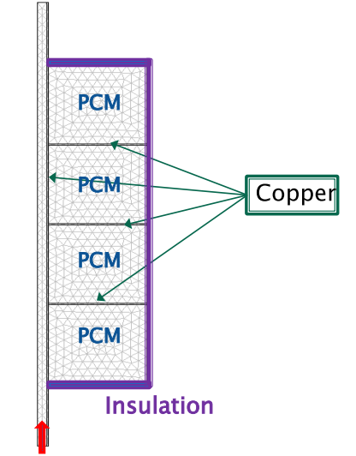
Hot water
Figure 5-8 thermal storage configurations based on the number of fins [37]

Figure 5-9 shows the enthalpy and the temperature distribution of the PCM. The phase change can be clearly observed in between the temperature ranges of 490ºK and 493ºK. The enthalpy of the surface shows a change of color from red to blue when the material completely melts; red means the material is still in the melting process. Since the Cp value is assumed to be the same when the material is totally solid or totally melted the sensible enthalpy (h = ρCpΔT) for both states is going to have a similar value, however, during the melting process, which takes place in a 3 degrees K range, the enthalpy is going to show a drastic change (red color) due to the addition of the latent heat.

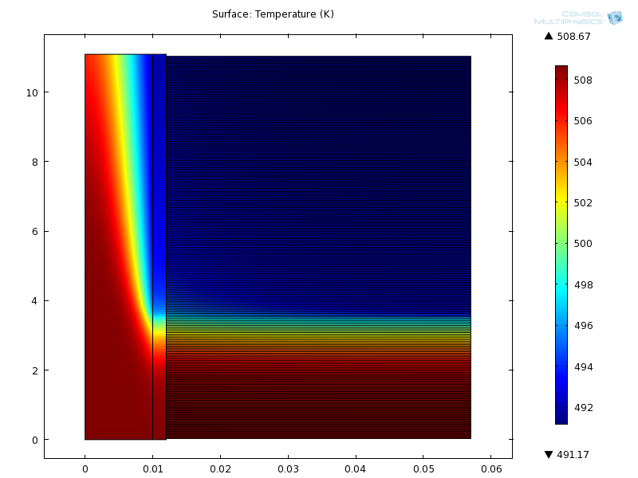
a)
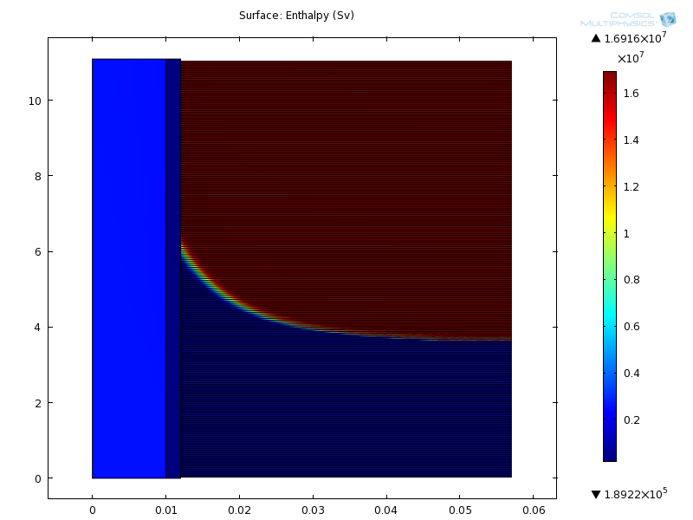
b)
Figure 5-9 a) Temperature distribution b) Enthalpy distribution

Mesh size and Elements

Table 5-2 shows the different mesh statistics analyzed for modeling using COMSOL.
Mesh Type | Extremely Fine | Normal | Coarser
Number of elements | 536,068 | 88,946 | 82,327
Triangular elements | 525,743 | 83,626 | 79,551
Quadrilateral elements | 10,325 | 5,320 | 2,776
Edge elements | 47,491 | 15,755 | 14,883
Vertex elements | 890 | 890 | 890
Mesh area | 0.6282 m2 | 0.6282 m² | 0.6282 m²
Table 5-2 Mesh statistics for fine, normal, coarse mesh

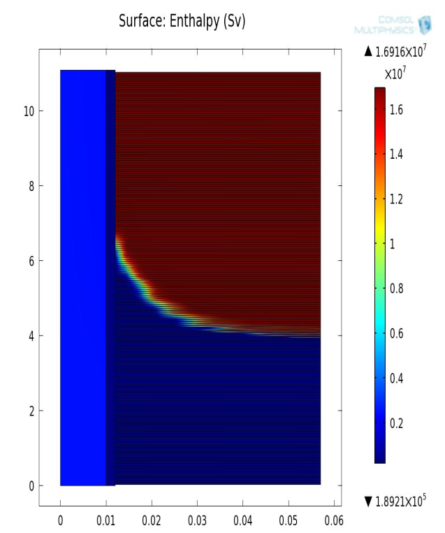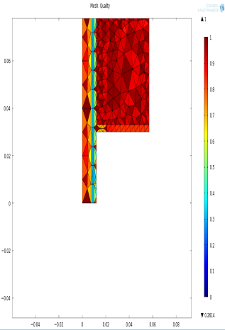
a)
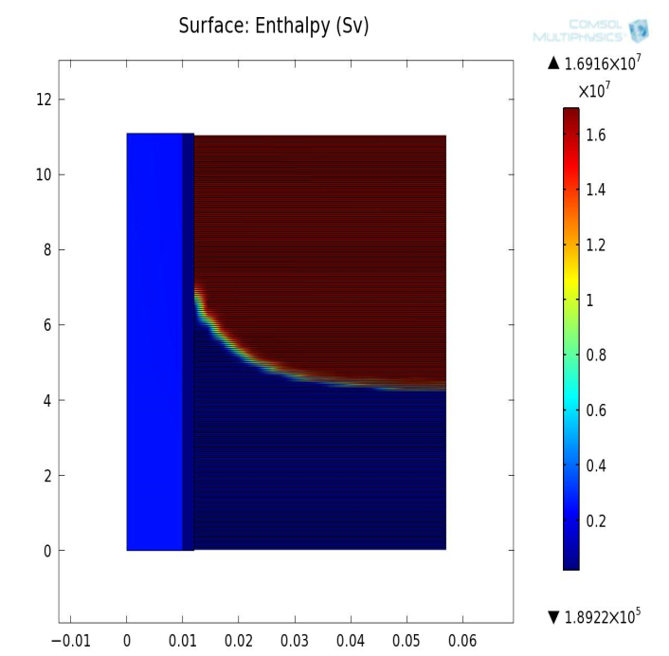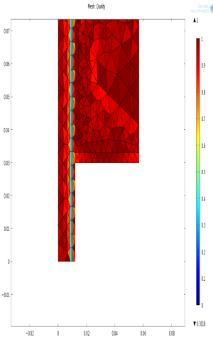
b)
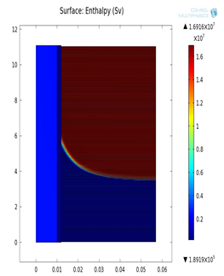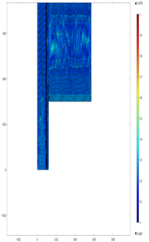
c)
Figure 5-10 Enthalpy distribution of a) Corse mesh, b) Normal mesh and c) Extremely fine mesh after 20700secs simulation time

In the previous figure 5-10 analysis of coarse, normal, and extremely fine mesh show the results for the enthalpy distribution of the PCM, the figures indicate that the extremely fine mesh has smooth transition from the solid to liquid phase.

Water inlet velocity

In our case, the inlet velocity is varied in terms of the mass flow rate that is divided into the different number of tubes in the storage block. The area and the number of tubes play an important role in determining the optimal velocity of the fluid flow.

Higher velocities show better heat transfer. However, higher velocity means less number of tubes since the total mass flow rate is divides by the number of tubes. We are looking to have as many tubes as possible because the higher the number of tubes the more PCM is available therefore we can store more energy. A balance between the number of tubes and enough velocity to melt the entire material has to be found. Figure 5-11 present the temperature distribution inside the storage tube with 20 fins per meter for various water inlet velocities: 0.0932 m/s (36 tubes), 0.0832 m/s (40 tubes), 0.0799 m/s (42 tubes) and 0.07629 m/s (44 tubes). It can be appreciated that the higher the velocity the better the temperature distribution, however the system having 44 tubes (0.07629m/s) eventually melts the entire material in the almost the time as the system having 36 tubes (0.0932m/s).

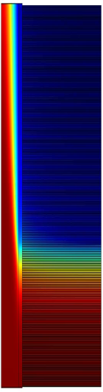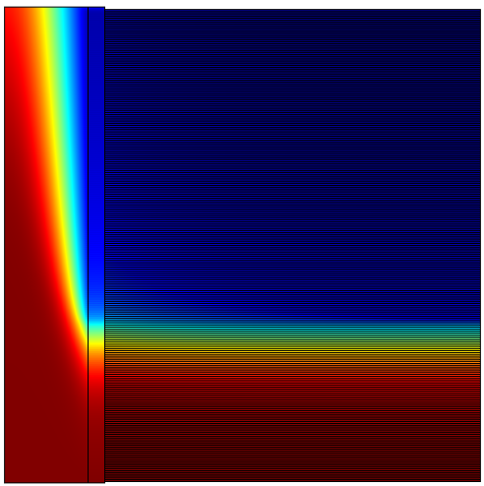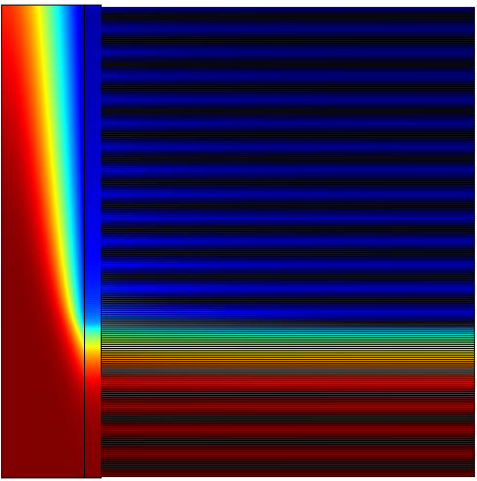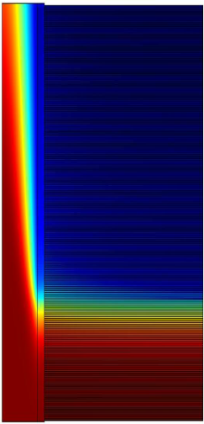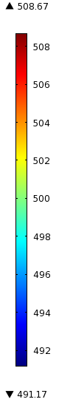
v = 0.0932m/s v = 0.0832m/s v = 0.0799m/s v = 0.07629m/s
Figure 5-11. Temperature distribution at different inlet velocities per tube

Figure 5-12. Radial temperature distribution with the variation in inlet velocity.

The above graph summarizes the simulation results by showing that the phase changing material reaches a higher temperature closed to the bulk fluid temperature at higher inlet velocity. This happens because the higher velocity results in greater Reynold’s number which increases the average Nusselt’s number for laminar flow which is given by the following equation:
$$\overline{{Nu}_{D}}=3.66+ \frac{0.065 \left(\frac{D}{L}\right) {Re}_{D }Pr}{1+0.04{ \left[\left(\frac{D}{L}\right){ Re}_{D }Pr\right]}^{2/3}}; {Re}_{D}<2300$$
Where D is the diameter of the tube and L is the length of the tube.
So as Re increases, the $\overline{{Nu}_{D}}$ increases as a result of which the heat transfer coefficient increases which is related to the Nusselt number by:
$$\overline{{Nu}_{D}}=hD/k$$

where k is the thermal conductivity of the material.

As the heat transfer coefficient increases, the convective resistance between the fluid and the tube wall decreases and hence the temperature difference between the mean fluid and the phase change material surrounding the copper tube decreases. This results in higher temperature of the material with higher velocity which is close to the mean temperature of the fluid.

Thus it is shown that the effect of variation in inlet velocity gives the right trend of temperature distribution at the fluid and wall interface as well as the phase change material.

Effect due to the variation in number of fins

Figure5 -13 represents the temperature distribution inside the cylindrical LHS system after 6 hours of constant charging when 0,5,10 and 20 fins per meter are used with constant inlet velocity of 0.07629 m/s. As seen from the figure, the increase in number of fins adds to the transferring of heat from the fluid to the material more effectively. Complete melting in the desired simulation time is obtained when having 20 fins per meter in a tube with 11 meters length; each fin has a thickness of 3mm.

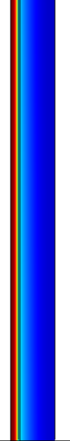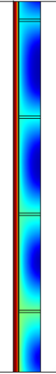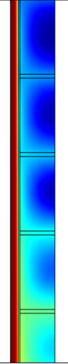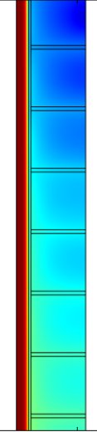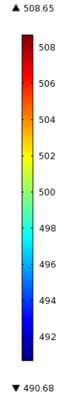
0 fins 5 fins 10 fins 20 fins

Figure5-13. Temperature distribution obtained after 6 hrs of charging with an inlet velocity of 0.07629 m/s

The above figure can be better explained with the help of the following curves shown in Figure 5-14

Figure15.Radial temperature distribution in the PCM with different number of fins.

The conductivity of PCM is very low due to which fins are required to ensure that all the PCM will reach the melting temperature. With 20 fins per meter, the PCM achieves greater temperature and the entire PCM melts at the desired melting time. The computation time for the melting of greater number of fins happened to be nearly three times higher due to the extremely fine mesh and it resulted in nearly similar temperature distribution as the model with 20 fins. Therefore, it would be optimal to consider 20 fins for every meter to obtain a fairly good temperature profile for the efficient heat transfer to the PCM.

CHAPTER 6 - SOLAR COOLING SYSTEM

Cooling supply profile

In order to obtain the cooling load profile of one office building in Abu Dhabi on the 21st of March 2011 (same day than the power data collected from the Beam Down) an office building is simulated using eQuest 3.64, using the weather data for Abu Dhabi as input, as shown in Figure 6-1 . ‘eQuest 3.64’ is the visual interface of building modeling program of the US Department of Energy named ‘DOE 2.0’
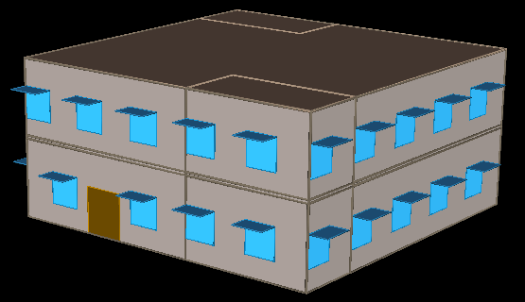
Figure 6-1 Two story office building modeled using eQUEST

The building envelope specifications are as follows:
- The window to gross wall area should not be greater than 35%
- Overhangs should be placed on east, west and south windows of the building with a projection factor (overhang depth/window height) of greater than 0.5
- Lighting devices should have an efficiency of 60 lumens/W
- The insulation and window resistances are specified as described in Table 6-1.

Building Element | Value
Roofs (W/m²K) | 0.2
Above-Grade Walls (W/m²K) | 0.28
Partitions (adjacent to  non-conditioned zones) (W/m²K) | 0.5
Slab-On-Grade Floors F-Factor (W/m²K) | 3
Opaque Swinging Doors (W/m²K) | 3
Window U-value (W/m²K) | 1.8
Table 6-1: Building Envelope Thermal Resistances

The office building modeled is a two story building with a total floor area of 232m². Each floor is divided into office space having a floor area of 195m², kitchen and restrooms with floor area of 18.58m² each. Windows are placed on the north, east and west walls of the building with overhangs having a projection factor (overhang depth/window height) of 0.6. Two doors are placed on the north and east sides of the building. Windows and doors are not specified on the south wall to minimize heat gain through radiation. The window to gross wall area is kept at 29%. The zone temperature is specified as 24°C. And the office space is designed for a total occupancy of 85 persons with 4.6m² per person. The results of this simulation are shown in table 6-2.

Power supplied by the Beam Down

When analyzed the data collected from the Beam Down it is possible to provide cooling to 4 buildings, like the one previously described, using the power supplied by the Beam Down and still having enough heat left to store for running the chiller when the Beam Down does not provide enough power.

Figure 6-2 Power data from the Beam Down collected on the 21st of March 2011

The cooling load per hour is shown in the following table 6-2:
Time | Cooling needed for one building  (Q_{evaporator})  [kW] | Cooling needed for 4 buildings  [kW] | Ambient temperature [C] | COP | Power needed to the Chiller generator [kW] | Power from the Beam Down [kW] | Power to store [KW]
1:00 AM | 0 | 0 | - | - | 0 | 0 | 0
2:00 AM | 0 | 0 | - | - | 0 | 0 | 0
3:00 AM | 0 | 0 | - | - | 0 | 0 | 0
4:00 AM | 0 | 0 | - | - | 0 | 0 | 0
5:00 AM | 0 | 0 | - | - | 0 | 0 | 0
6:00 AM | 0 | 0 | - | - | 0 | 0 | 0
7:00 AM | 0 | 0 | - | - | 0 | 26.4 | 26.5
8:00 AM | 0 | 0 | - | - | 0 | 61.5 | 61.5
9:00 AM | 0 | 0 | - | - | 0 | 88.9 | 88.9
10:00 AM | 0 | 0 | - | - | 0 | 111.4 | 111.4
11:00 AM | 45.3108 | 181.2 | 27.0 | 2.0 | 90.6 | 120.5 | 29.9
12:00 PM | 50.8248 | 203.3 | 27.0 | 2.0 | 101.6 | 127.0 | 25.4
1:00 PM | 53.0282 | 212.1 | 28.0 | 2.0 | 106.1 | 128.1 | 22.1
2:00 PM | 47.6328 | 190.5 | 27.0 | 2.0 | 95.3 | 112.7 | 17.4
3:00 PM | 46.755 | 187.0 | 27.0 | 2.0 | 93.5 | 84.7 | -8.8
4:00 PM | 45.2459 | 181.0 | 25.0 | 2.0 | 89.3 | 53.6 | -35.7
5:00 PM | 37.2483 | 149.0 | 25.0 | 2.0 | 73.5 | 19.2 | -54.3
6:00 PM | 29.606 | 118.4 | 25.0 | 2.0 | 58.5 | 1.1 | -57.4
7:00 PM | 25.0592 | 100.2 | 25.0 | 2.0 | 49.5 | 0 | -49.5

The total power needed for the Chiller generator is calculated with the equation 6-1
$COP=\frac{Q_{evaporator}}{Q_{generator}}$ (6-1)
Also if T_{condenser} +/- T_{ambient} >4, then
$COP=2*(-0.013*\left(T_{ambient}+4\right)+1.39$ (6-2)
Otherwise COP =2 [2].

From table 6-2 we can notice that all the power coming from the Beam Down from 7am until 10 am can go directly to the storage since there is no need for cooling supply. From 11 am until 2 pm there is some power coming from the solar plant left to store but it is mainly used to supply power to the chiller. However, from 3pm until 7pm the Beam Down cannot provide the power needed to fulfill the cooling demand, then the storage block (which is totally melted by then) starts to supply heat to the chiller generator.

Simulations were performed using COMSOL Multiphysics in order to obtain an optimal design for the storage block that can be totally melted with the power that is left from the Beam Down after supplying power to the chiller. The storage device was mainly melted using the thermal power from the solar plant 8am-12pm and the rest was stored in the form of sensible energy. Equation 6-3 was used for the simulations in order to close the charging mode loop:
$T_inlet \left(t_{2}\right)=\frac{{\dot{Q}}_{beam down}\left(t_{2}\right)}{\dot{m}Cp}+T_outlet(t_{1})$ (6-3)
Where T= temperature and t = time step

The optimal design found was:
Symbol | Description | Value | Units
L | Length of the tube | 11 | m
ρ_{HTF} | Density of the HTF | 791 | $$\frac{kg}{m^{3}}$$
Cp_{HTF} | Specific heat of the HTF | 4980 | $$\frac{J}{kg K}$$
P_{HTF} | Pressure of the HTF | 50 | bar
$$r_{i}$$ | Radius of the tube | 0.01 | m
$$r_{0}$$ | Radius of the PCM | 0.03 | m
$$\dot{m}$$ | Mass flow rate of the HTF | Changes with the cooling demand | $$\frac{kg}{s }$$
N | Number of tubes | 81
t | Melting time | 6 | hr
Q_{max} | Maximum heat possible to store in the way of latent heat | 399.94 | MJ

Figure 6-3 shows show the temperature distribution after 26460 [s] when the storage has been charged (melted), it can be seen the PCM temperature is above the melting temperature range (490 to 493 K)
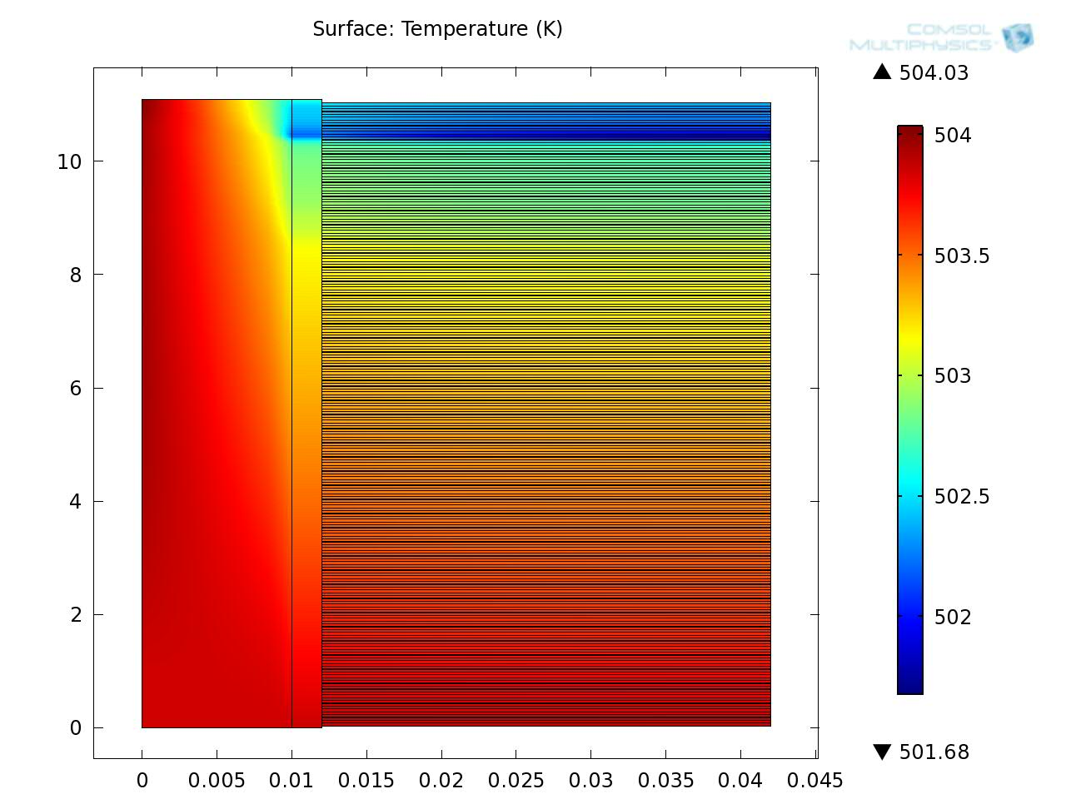
Figure 6-3 Temperature distribution of the final storage dosing after 26460 sec

Once the appropriate configuration for the storage block was obtained based on the maximum possible heat to store after fulfilling the cooling load required to the chiller for the 4 buildings, simulations were carried out to prove that storage can supply the rest of the power needed. Now the inlet temperature for the storage unit is considered constant (T_inlet = 483K) since it is coming from the chiller generator which it is assumed to have a constant ΔT and the mass flow rate changes every 30 seconds according to the cooling demand. Also, since the chiller needs a constant temperature inlet of 493 K (220°C) it is assumed that we have a temperature valve that controls the temperature of the water that is leaving the storage device before it enters to the chiller. The following figure 6-4 shows the temperature outlet of the storage from 3 pm until 8 pm. We can see that the temperature is always above 493 K which proves that we can easily run our chiller for the necessary hours even if we don’t have power coming from the Beam Down solar plant. The variation in the temperatures is due to the variations of the mass flow rate in the system due to the cooling demand rate and power supply by the Beam Down.

Figure 6-4 Storage temperature during the discharging mode from 3pm -8pm

BIBLIOGRAPHY

[1] M. T. Ali, M. Mokhtar, M. Chiesa, P. R. Armstrong, A cooling change-point model of community-aggregate electrical load, Energy and Buildings Journal,43 (2010) 28-37.
[2] M. Mokhtar, M. T. Ali,. S. Brauniger, A. Afshari, S Sgouridis, P. R. Armstrong, M. Chiesa, Systematic comprehensive techno-economic assessment of solar cooling technologies using location-specific climate data, Applied Energy, 87 (2010) 3766-3778.
[3] V. Morisson, M. Rady, E. Palomo, E. Arquis, Thermal energy storage systems for electricity production using solar energy direct steam generation, Chemical Engineering and Processing, 47 (2008) 499–507.
[4] A. Gil, M. Medrano, I. Manrtorell, A. Lazaro. P Dolado, B. Zalba, L. Cabeza, State of the art on high temperature thermal energy storage for power generation. Part 1- Concepts, materials and modellization, Renewable and Sustainable Energy Reviews, 14 (2010) 31-55.
[5] S. Hasnain, Review on sustainable thermal energy storage technologies, Part1: Heat storage, materials and techniques. Energy Conversion and Management, 39 No. 11 (1998) 1127-1138.
[6] SolarPACES, Power from the Sun, available at http://www.powerfromthesun.net
[7] D. P. Strigari, Development of a Concept for the Autarkic Energy and Water Supply of a Housing Estate in an Area with High Average Solar Irradiation, Vienna University of Technology, Master Thesis, May 2009.
[8] W. Steinmann, D. Laing, R. Tamme, Development of PCM Storage for Process Heat and Power Generation, J. Solar Energy Engineering, 131 (2009).
[9] F. Agyenima, N. Hewitt, P. Eames, M. Smyth, A review of materials, heat transfer and phase change problem formulation for latent heat thermal energy storage systems (LHTESS), Renewable and Sustainable Energy Reviews, 14 (2010) 615-628.
[10] B. Zalba, J. Marin, L. Cabeza, H. Mehling, Review on Thermal Energy Storage with Phase Change: Materials, Heat Transfer Analysis and Applications, Applied Thermal Engineering, 23 (2003) 251–283.
[11] B. Zivkovic, I. Fujii, An Analysis of Isothermal Phase Change of Phase Change Material within Rectangular and Cylindrical containers, Solar Energy, 7 (2001) 51-61.
[12] J. Bony, S. Citherlet, Numerical Model and Experimental Validation of Heat Storage with Phase Change Materials, Energy and Buildings, 39 (2007) 1065-1072.
[13] J.S. Goodling, M.S. Khader, Results of the Numerical Solution for Outward Solidification with Flux Boundary Conditions, J. Heat Transfer, ASME 97 (1975) 307-309.
[14] N. Shamsundar, R. Srinivasan, Analysis of Energy Storage by Phase Change with an Array of Cylindrical Tubes, Thermal Energy Storage and Heat Transfer in Solar Energy Systems, America Society of Mechanical Engineers, vol. 35, New York, 1978.
[15] L.W. Hunter, J.R. Kuttler, The Enthalpy Method for Heat Conduction Problems with Moving Boundaries, J. Heat Transfer, ASME, 11 (1989) 239-242.
[16] M. Lacroix, Numerical Simulation of a Shell-and-Tube Latent Heat Thermal Energy Storage Unit, Solar Energy, 50 (1993) 357-367.
[17] L. Cabeza and H. Mehling, Heat and cold storage with PCM, Berlin, Germany: Springer,(2008) ch 1,2 and 4.
[18] M. Medrano, A. Gil, I. Martorell, X. Potau, L. Cabeza, State of the art on high-temperature thermal energy storage for power generation. Part 2—Case studies, Renewable and Sustainable Energy Reviews, 14(2010) 56-72.
[19] A. Rable, Tower reflector for solar plant, Solar Energy, 18 (1976) 269-271
[20] M. Chiesa, Y. Tamaura, P. Armstrong, Concentrated Solar Power Deployment in the UAE: Research Need, Presented at the International Conference on Renewable Energy 2010 Al Ain, UAE.
[21] MARWAN THESIS
[22]O. Goebel, Shams One 100 MW CSP Plant in Abu Dhabi, Update on Project Status. In . France (2010).
[23] C. J. Winter, R. L Sizmann, L. L Vant-Hull, Solar power plants: fundamentals, technology, systems, economics. Springer-Verlag (1991).
[24] M. Mokhtar, I. Rubalcaba, S. Meyers, A. Qadir, P. Armstrong, M. Chiesa. Heliostat Field Efficiency Test of Beam Down CSP Pilot Plant Experimental Results. In . Perpignan, France, September 21 2010
[25] INCROPERA
[26] Y. Goswami, A. Vijayaraghavan, Handbook of Energy Efficiency and Renewable Energy, Boca Raton, FL: CRC Press, 2008, Ch 18 pp121-128.
[27] J. Duffie, W. Beckman, Solar Engineering of Thermal Processes, New Jersey: John Wiley & Sons, third edition (2006), Ch 15 pp579-585.
[28] R. Macris, T. Zawacki. Absorption fluid data survey: 1989 update/ Oak Ridge National Laboratory Report, ORNL/Sub84-47989/4 (1989).
[29] K. Mori, M. Oka, T. Ohhashi, Development of triple-effect absorption chiller-heater, Japan Gas Association, http://www.igu.org/html/wgc2003/WGC_pdffiles/10626_1045222692_11599_1.pdf
[30] N.Lior, in: F. Kreith (Ed), Melting and Freezing in the CRC Hand Book of Thermal Engineering, CRC Press Springer, 2000.
[31] A. Mills, Heat Transfer, New Jersey: Prentice Hall, second edition, 1999, Ch 4 and Ch 5.
[32] I. Dincer, M. Rosen, Thermal Energy Storage Systems and Applications, England: John Wiley & Sons 2002, Ch 7.
[33] V. Alexiades, A. Solomon, Mathematical Modeling of Melting and Freezing Processes, Washington DC: Taylor & Francis, 1993, Ch 1 and Ch 4.
[34] J. Crank, Free and Moving Boundary Problems, Oxford: Clarendon Press, 1984.
[35] V. Voller, An overview of numerical methods for solving phase change problems, in Advances in Numerical Heat Transfer, New York: Taylor & Francis, 1997, Ch 9.
[36] COMSOL MANUAL
[37] D. Groulx, W. Ogoh, Solid-Liquid Phase Change Simulation Applied to a Cylindrical Latent Heat Energy Storage System, Excerpt from the proceedings of the COMSOL conference 2009, Boston.

GLOSARY

Bi - Biot number
COP - Coefficient of performance
Cp - Specific heat [J/kgK]
CSP - Concentrated solar power
$f$- Local liquid fraction
FDM -Finite difference solution method
FEM - Finite element method
Fo - Fourier number
GPS - Global positioning system
h - Sensible enthalpy
HTF - Heat transfer fluid
LHS - Latent heat storage
ODE - Ordinary differential equations
PCM - Phase change material
PDE - Partial differential equations
TES - Thermal energy storage
T_{m} - PCM melting temperature
T_{HTF} - Temperature of the HTF
U_{HTF} - Convective heat transfer coefficient of the HTF
Ste - Stefan number

