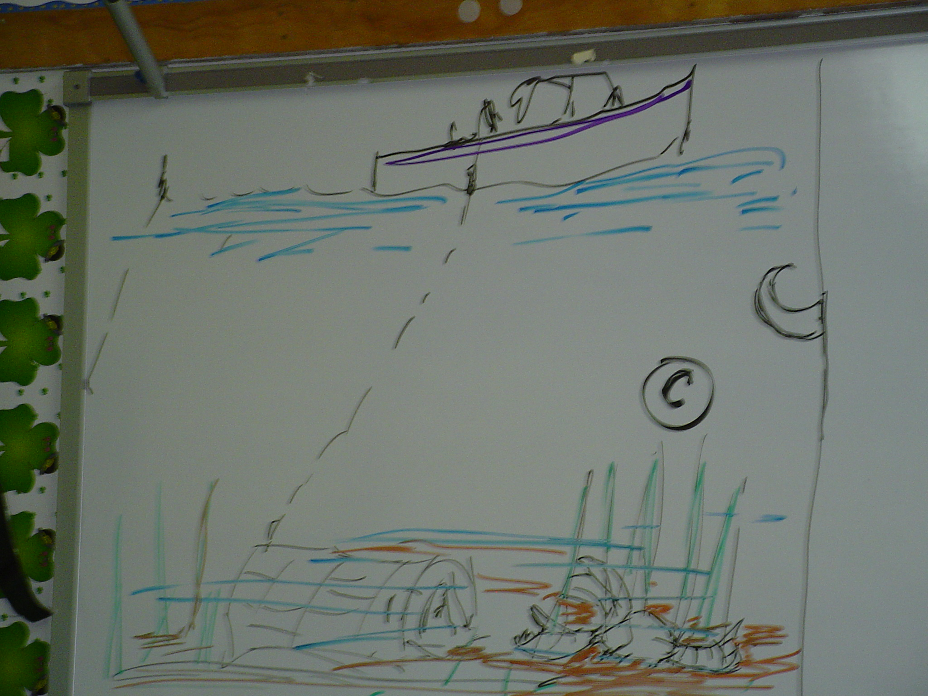

Captain Bruce and Mr. E ran over to look at the fish. Mr. E yells, “Wow! Those are baby sharks!”
“Well those are nice but I need to get back to lobstering!”
While Bob and Mr. E are admiring the baby sharks, Captain Bruce pulls up his first trap of the day. He sees an octopus attached to the trap. Just as he starts to tell the others about it, Mr. Z spits the cork out of his mouth. The cork hits the octopus!
The angry octopus squirts ink at Mr. Z. The ink covered the bubble gum. Right before their eyes an amazing thing happened! The ink caused some sort of chemical reaction. The bubble gum turned to a gas and evaporated! Mr. Z was free!
Captain Bruce tells Mr. Z, “Now that you are free, I could use your help. Go check the lobster in the trap. The measuring tool is in the cabin.”
Mr. Z gets the tool and opens the trap. Imagine his surprise when he suddenly realized he had been squirt by a lady octopus! Inside were three baby octopuses. One was a cute little white octopus. Along with the octopuses were a seahorse and the biggest lobster Mr. Z had ever seen!

