SIP.edu and Avaya Converged Communications Server
Candace Holman <holman@post.harvard.edu> (March 2005, November 2004)

Overview
Avaya agreed to help expand the Internet 2 SIP.edu project by constructing an LDAP plugin, known as the Handle-Based Dialing feature, that performs a similar function to one described in Columbia University’s SIP.edu deployment with SER. The Handle-Based Dialing feature is expected to become a feature of Avaya’s Converged Communications Server version 3.0 in Spring 2005.

In order to map email addresses to PBX extensions, a call that comes in to the Avaya SIP proxy will first attempt to deliver it to one of its own provisioned stations. If there is no provisioned station, the call is eventually handed off to the Avaya gateway connected by PRI to various other PBXs (traditional and IP-based).

In detail, when an inbound SIP call is made to an unprovisioned SIP extension, the Avaya Converged Communications Server (CCS), Avaya’s SIP proxy, passes control to the new LDAP plugin. The plugin converts the URI into an email address, looks it up in the LDAP directory, and returns a directory number that is converted to a number-based SIP URI.

As the last step, the number-based URI is routed through an Avaya Communication Manager (CM) IP-PBX gateway over an ISDN connection to either an IP PBX or a legacy PBX. The abstract architecture of the system is shown below.

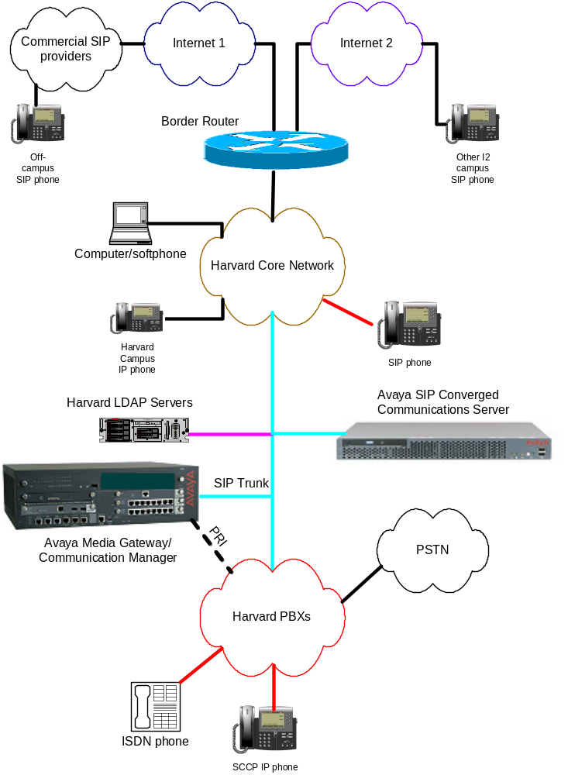

This documents covers the CCS SIP implementation and assumes that an Avaya IP-PBX is already installed.

Traditionally, Avaya has delivered a technician-assisted customer solution and guards configuration options with special access passwords for their technicians or authorized resellers. The Avaya user documentation is only beginning to come up to speed for self-maintaining customers, so use of this cookbook as a guide is recommended. The hardest part of the installation and configuration is getting console access and an administrative interface. There were also several required passwords missing from the documentation or listed incorrectly.

Contents
- Configuring Avaya Converged Communications Server
- Avaya SIP.edu LDAP Plugin
- Configuring Avaya Communication Manager 2.1.1
- Miscellaneous References for Harvard/Avaya SIP.edu

Contributors
Special thanks to the following people:

Harvard University
David Laporte, Patrick McEvilly – linux and network concepts
Jane Hill – directory concepts

Avaya
Bruce Mazza – project institution, project liaison
Michael West – developer, development liaison
Len Mahoney – technician, technical liaison

MIT
Dennis Baron – SIP.edu concepts, directory concepts

Configuring Avaya Converged Communications Server

I Architecture

The Avaya Converged Communications Server (CCS) performs SIP proxy, registration, and redirection functions. In this configuration guide, CCS runs with the S8300 Media Server (a module in the gateway with Avaya Communication Manager (CM) 2.0+ call processing software) to provide features that are not standardized for SIP, such as SIP and non-SIP endpoint interoperability and SIP and gateway interoperability. The Media Server is also known as a Primary Management Interface (PMI), a Communication Manager or a Media Gateway Controller. The G350 gateway is known as a Media Gateway and is a chassis that houses Avaya S8300 Media Server (the processor) and digital and analog circuit boards. This configuration guide may be applicable in other architectures that include CM s8500/s8700 or G650/G700 Media Gateways.

Both CCS and S8300 run on a modified version of Red Hat Linux 8.0-8. Updates to Red Hat Enterprise are scheduled for the CCS 3.1 release, which is expected late 2005.

The CCS serves as a Home/Edge hybrid server and will process requests from both the internal domain as well as forward requests to external domains.

II Requirements

The hardware for the CCS proxy server is an Avaya S8500 Media Server, which is based on an IBM x305. Since we are self-maintainers, and due to internal remote access policies, we chose to ignore any user manual comments about adding an IBM RSA module or USB modem. In order for Avaya Services to provide remote support, a modem or secure IP access is necessary.

- License and password files issued by Avaya representative and copied to the laptop to be used for installation/configuration. The file extensions are .lic and .pwd
- CDs or files issued by Avaya representative: Avaya-packaged Linux, CCS 2.1-35 or higher, CM 2.1.1 with patch, or higher version of CM, and CM 2.1 Installer, or equivalent to arrive at CM version 2.1.1 or higher.
- DB9-connector null modem cable
- Laptop PC for console access, set with IP Address 192.11.13.5, Subnet Mask 255.255.255.252. Also need monitor, keyboard, mouse during installation.
- Server needs: IP address, netmask, default gateway, hostname, domain, DNS server info

III Installation

- Configure Console (example is for Windows Hyperterminal)
  - Use serial cable/DB9 (aka null modem, or cross-connect C5 cable) connected from a laptop PC to the Avaya Services Port
  - Configure serial port for 9600 bits per second, 8 data bits, no parity, 1 stop bit, hardware flow control , vt100 emulation, and telnet terminal id vt100 (if necessary).
  - If the configuration in step b doesn’t work, use F1 to enter BIOS configuration on the server and set console redirect to 9600 baud (or adjust Hyperterminal to match the BIOS baud)

- Install Red Hat Linux packaged by Avaya
  - Boot from the provided Linux CD. See step 1c if this doesn’t appear on screen. It takes at most 3 minutes for the Services Port to be ready..
  - Use TAB and ENTER keys to navigate and select options during the installation, but most often just select the default
  - After the installation is finished, the Avaya Services Port will go out of service. Disconnect, change the console baud rate to 115200 and reconnect the terminal session.
  - Wait for the server to eject the CD and reboot on its own

- Install CCS software
  - At this point the Services Port no longer works. Plug into a keyboard/mouse/monitor
  - Reboot single user to set root password (hold shift key until LILO boot: prompt appears and type a1 single)
  - Reboot and login as root
  - Type ifconfig to get the MAC address of eth0
  - Type swversion and confirm these minimum versions:
Operating System: Linux 2.4.20-AV14 i686 i686
CCS Release String: CCS-2.1.0.0-35
Software Load: CCS02.1-01.0.035.0
  - Type ccsInstaller and enter the host configuration information: short hostname (no domain), DNS domain name, IP address, Subnet Mask, Gateway, DNS Server/s
  - Unless applicable, ignore the questions about RSA Card and answer High Availability = n.
  - Master Admin on this machine = y
  - Select the mvss password, but make sure it has only alphanumeric characters
  - Start CCS service now = y

- Post Installation Tasks
  - Login as admin/admin01
  - Type statapp to display the status of the CCS Server applications: Watchdog, Tracelogger, INADS AlarmAgent, CCS TrapAgent, GMM, SNMP Manager, ImLogger, SIP Server, and SME should all show “UP” and Mon may show “partially UP”
  - Type server to show the status of the CCS Server, which should include these statuses:
Mode: Active
Server Hardware: okay
Processes: okay

IV Configuration
- Login as admin/admin01 to the web interface http://hostname to configure the proxy
- Change admin password now.
- Launch the Administration Web Interface and configure:
  - Domain: choose Setup to setup the domain
  - Hosts
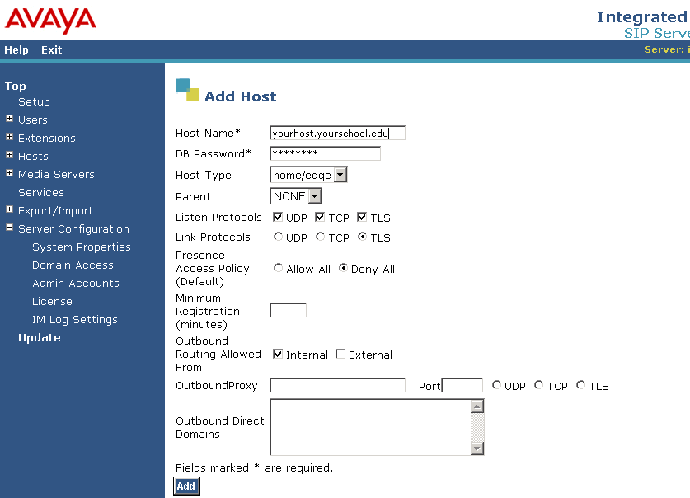
  - Default User Profile
  - Media Servers (if applicable)
  - Complete any other Setup screens that show under Setup
- License management
  - Choose Top – Server Configuration – Manage Licenses
  - Login to WebLM as admin
  - Enter license path of the XML license file (must reside on machine that is browsing this interface)
  - Click Install
  - Change the password
  - Choose Services and Stop Proxy Server and Start Proxy Server
  - Choose Hosts – Update all to save the change. Confirm that there are no errors.
- Adding Users
  - Choose Users – Add
  - Click Update, and a link “Update” will appear at the bottom of the left side Menu
  - After completing your changes, click the Update link from the left side Menu, to ensure your changes are permanent
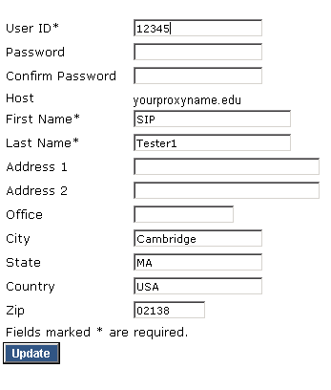

V References

- Avaya Converged Communication Server Installation and Administration, 555-245-705, August 2004
- Avaya CCS 2.1 Quick Setup, September 2004
- Avaya CCS 2.0 Quick Setup, June 2004

To obtain the latest versions of these Avaya documents, go to http://support.avaya.com and click on the link for documentation. Locate the page for Converged Communication Server.

Avaya SIP.edu Handle-Based Dialing service (LDAP Plugin)

I Architecture
The CCS Handle-Based Dialing service LDAP Plugin was written in C++ to act as a type of call-processing bridge when routing an incoming SIP URI to a destination. Given a SIP URI like sip:username@bigu.edu, the LDAP Plugin will convert it to an email address by removing the sip: prefix, and perform an LDAP query for a unique telephone number belonging to a person with that email address. The plugin bridge routine is used for routing calls only when there is no matching registrant on the CCS proxy.

II Requirements
- Avaya CCS proxy server installed and configured to run CCS 2.1.1 or higher version
- Anonymous or authenticated read access rights to a local LDAP server from the proxy server
- LDAP Plugin files: configuration file ldapmod.cfg and shared library module modldap.so
- Configuration file information as defined below

III Installation

- Login with privileged access.
- Define the module in the /usr/impress/sip-server/etc/modules.def file. (Note that modccsldap-params belongs in modules.def and not ccs.conf):

[modccsldap]
lib=modldap.so
path=/usr/impress/sip-server/module
interfaces=ContactResolver
instances=single

[modccsldap-params]
configFile=/usr/local/etc/ldapmod.cfg

- Add the configuration file parameters to /usr/impress/sip-server/etc/ccs.conf file. The LocationService alternateCondition parameter specifies the conditions in call routing that will invoke the module – – notfound in CCS database (URI doesn’t exist), nocontacts in CCS database (URI exists but person is not registered with the CCS proxy), or never to disable the module.

[LocationService]
AlternateLookupModule=modccsldap
AlternateCondition=nocontacts,notfound

For troubleshooting later:

[Tracing]
Enabled=true
TraceFile=/usr/local/etc/ccs.log
MaxFileSize=5000000
UseSeparator=true
ShowDate=true
All=off
; trace categories
LocationService=on
modccsldap=on

- Copy the modldap.so shared library to the /usr/impress/sip-server/module (Note that this is not /modules) directory. Remember to set the execute permissions.

- Login to https://hostname and use the Administration Web Pages to restart the proxy server service
  - choose Services – click Stop on Proxy Server, wait until the status is DOWN then click Start

IV Configuration

- Edit the ldapmod.cfg for your environment, following the formatting in the example file below:

version:3
onevalue:1
prefix:9
handler: yourCommunicationManager.domain.edu
database:yourldapserver.domain.edu
auth:your bind DN (e.g., uid=youruid,ou=yourauthou,o=youro,dc=yourdc)
passwd:yourbindpassword
base:your base DN (e.g. ou=yourbaseou,o=youro,dc=yourdc)
key:email
element:telephoneNumber

The unique fields can occur only once in the configuration file:

version – This specifies the LDAP version to use. This will be either a “2” or “3”. It is strongly recommended that “3” be used unless there is a specific reason to use “2”
onevalue – This specifies what to do when more than one telephoneNumber is returned for a single email. If "onevalue" is "1", then it will only return a value if a single value was found – returns nothing if multiple values were found. If "onevalue" is "0" then it will return the full list found. The functionality for a full list of telephoneNumber values may be implemented in the future to scroll through a list of telephoneNumbers to reach an intended user.
prefix –This specifies a string that is to be prepended to the phone number returned from the LDAP directory
handler – This specifies the Communication Manager server to use. Must be a fully qualified domain name, or an IP address

These fields occur for each LDAP database that is to be searched. If more than one is listed, make sure the group of fields is listed completely and in the order listed below.

database – The fully qualified domain name or IP address of the LDAP database server.
auth – The bind DN to use for the bind authorization. (optional)
passwd – The password to use for the bind authorization.(optional)
base – The base DN to use for the search.
key – The LDAP field name to search against.
element – The LDAP field name whose value is to be returned.

- Copy the ldapmod.cfg to /usr/local/etc
- Restart CCS to post the changes (login to admin web interface and stop and restart the proxy process)

V Testing and Troubleshooting
- Make sure system log files reflect that the service is running
  - look in the /usr/local/etc/ccs.log for entries similar to this:

AlternateLookupModule=modccsldap

AlternateCondition=nocontacts,notfound
loaded ContactResolver from module modccsldap
ContactResolver interface enabled for nocontacts=yes notfound=yes
establishing database connection
connect okay

- Make a call to a non-provisioned sip URI that is a facsimile of an email address that exists in the LDAP directory and check your trace file for correct entry. Make sure that the dial string is reflected properly in your dial plan:
  - tail -f /usr/local/etc/ccs.log should look similar to this:
sip:jstudent@big.edu not found, invoking alternate lookup module
0: value being used: +1 999 999 9999
result to return is sip:919999999999@yourCM.edu;transport=tls
module returned 1 contacts

VI References
- Avaya SIP Trial, Candace Holman, March 2004
- CCS-LDAP Plugin Requirements, Avaya BCSI Services Offer, Version 0.3, June 2004
- CCS/LDAP Plug In Installation, Avaya BCSI Services Offer, Version 0.2, September 2004
- SIP.edu Cookbook, http://web.mit.edu/sip/sip.edu/
- Columbia University’s LDAP Plugin: http://www.columbia.edu/acis/networks/advanced/sip.edu.html

Configuring Communication Manager 2.1.1 on an s8300

To implement traditional telephony features via gateway, at a minimum you must also configure a primary management interface (PMI), register the G350 to a Media Gateway Controller, configure SIP and ISDN trunks, and configure a SIP signal group.

To Configure the Media Gateway and Trunks, you will need to access the ANSI graphical interface called System Access Terminal (SAT) on the PMI. After configuring the PMI in step II, login to it and type sat. Use Esc-h for help, Esc-e to submit a change, and Esc-x to cancel. Type logoff to exit. The most common commands begin with add, change, display, and remove.

When you can access the SAT interface, verify that you have the required (licensed) access to configure these options by entering the command display system-parameters customer-options. Verify that you are able to administer IP trunks, SIP trunks, etc.

I Configure G350 using Avaya Installation Wizard
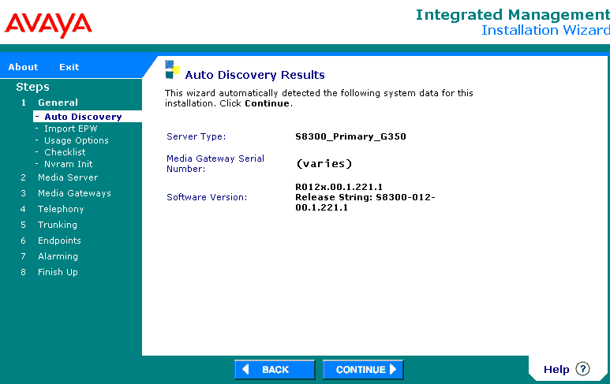

II Configure PMI
- login to the G350 and issue these commands
- interface vlan 1
- pmi
- exit
- Set mgc list [gateway ip address]
- copy running-config start-config
- show pmi
- show mgc list
- show running-config
- reset

III Configure Media Gateway and ISDN signal and trunk group

Collect info for media gateway – G350 serial number, name, IP address, media gateway controller IP address, modules. To get serial number from the gateway prompt type: serialnumber –l

Collect provider info for T1 – direction, service type, COR, etc. Connect the T1 interface to your provider and verify it is working.

- from the SAT prompt
- add media-gateway 1 (diagram avayaSATMediaGateway)
- add ds1 v2 (diagrams avayaSATDS1-1 and –2) Check with provider on how to set connect: pbx/network/host/etc, and interface: user/network/etc
- add signaling-group 1, group-type isdn-pri
- Add trunk-group 1, group-type isdn , service-type: public-ntwrk (check with provider)
- Change trunk 1 to set group member assignments: set 23 ports for a T1/PRI, with port name in format gateway:module:circuit so that port 1 in this case is numbered 001V201. Also indicate the proper signaling group to use.
- Add/change ars-analysis and set up the dialed strings that you want to route over the trunk (especially if there are restrictions)
- Change route-pattern 1 to set up a route pattern for this trunk. Use this to mark which digits of the dial string are routed over the ISDN trunk or for any special formatting or codes required by the provider.
- Change public-unknown-numbering and configure for your extensions so that they pass the complete caller id.

IV Configure SIP Signal and Trunk Group
- Display system customer-options – verify maximum administered sip trunks > 0 (page 2/10) and ip trunks = y (page 4/10)
- Change system features - set trunk-to-trunk transfer = all
- Change node-names ip [hostname] and set the host name and ip address of your CCS
- List node-names ip and verify an entry exists for procr with ip address of your gateway
- Change ip-network-region 1 = domain of the home proxy CCS as defined in the CCS Administration Web Interface under Server Configuration – System Properties
- Add signaling-group 2. You need at least one signaling group, but can add more if you have more than one SIP proxy server in your architecture.
  - Group Type: sip
  - Transport Method: tls
  - Near-end node: procr as verified in step 4
  - Far-end node: CCS entry as set in step 3
  - Near-end and far-end listen ports: these must match, default is 5061
  - Far-end network region: blank unless different than the CCS proxy’s network region
  - Far-end domain: blank
  - DTMF over IP: rtp-payload
- Add trunk-group 2. You need at least one trunk group, but can add more if you have more than one SIP proxy server in your architecture.
  - Group Type:sip
  - CDR Reports: y (if required for billing or auditing)
  - Signaling-group: 1 (as entered in step 2 above)
  - Service Type: public-netwrk (or check with provider)
  - Number of Members: sum of all sip trunk-groups, members cannot exceed system-parameters customer-options Max Administered SIP Trunks
  - Send name: y
  - Send calling number: y
  - Format: public (default for SIP, check with provider for recommended encoding of Numbering Plan Indicator)
  - Send connected number: y
  - Group Member assignments should fill automatically based on the number of members you entered
- Add/change route-pattern 2 to distinguish calls that will travel over the sip trunk. Set secure-sip:n (unless it’s supported)
- Add/change ars analysis for your numbered SIP extensions (if any)
- Add/change public-unknown-numbering to complete your dial plan for the SIP extensions

V References
- Administrator’s Guide for Avaya Communication Manager, January 2005
- SIP Support in Avaya Communication Manager 2.1.1 running on the Avaya s8300, s8500, or s8700 Media Server, 555-245-506, September 2004.

To obtain the latest versions of these Avaya documents, go to http://support.avaya.com and click on the link for documentation. Locate the page for Communication Manager.

Miscellaneous References

Mapping Dial Strings to Route Patterns
If you set up a SIP->PSTN trunk via G350 and Communication Manager, first set up a route pattern in SAT for the dialed strings you choose. Then make sure that you trunk your dialed strings to that route pattern. By default most dialed strings are denied a route. In this example, only one area code is represented on campus, but there are several exchanges.

Check dialed strings:
list ars analysis

Check route patterns:
list route-pattern

Set up a route pattern to route:
add/change route-pattern x

Set up the ARS dial strings to use that route pattern:
Add/change ars analysis [areacode] and indicate proper Min and Max digits, the route pattern number you set above, call type fnpa

CCS sipserver command usage

usage: sipserver
[ -s | --check-config ]
[ -c configFile | --config-file=configFile ]
[ -d | --daemon-mode ]
[ --home-dir=homeDir ]
[ --module-defs=modDefsFile ]
[ --module-dir=modDirectory ]
[ --quiet ]
[ --services-file=servicesFile ]
[ -s ssfConfig | --ssf-config=ssfConfig ]
[ -t | --trace ]
[ --trace-dir=ssfTraceDir ]
[ -w workDir | --working-dir=workDir ]
[ -h | --help ]

Upgrading from CCS 2.1 to a later CCS 2.1.x release
Perform this upgrade during a maintenance window, as it will cause interruptions in service. The server must be configured properly before upgrading. Caveats – I had to reset the phones afterward. It also erased all of my ldap plugin stuff, but I was able to revert to the previous boot partition.

- Open a management session to the CCS proxy server via web browser: http://hostname
- Login with your admin account and choose Launch Maintenance Web Interface
- Under Data Backup/Restore, choose Backup Now and backup your data using any of the given methods
- Under Miscellaneous, choose Download Files and download the tar.gz file, e.g. CCS02.1-01.0.038.0.tar
- Under Server Upgrades choose Install New Software and follow the wizard steps, choosing the software file you just downloaded
  - Choose software
  - Choose License Source – use current license or install a new one
  - Review Notices – review the notices carefully and take suggested measures where appropriate
  - Begin Installation – lists the options you chose and asks you to confirm
  - Install in Progress – review for errors as the installation proceeds
  - Reboot Server – confirm that you want to interrupt service by rebooting
  - Reboot in Progress – wait a few minutes and check the status of the reboot by pressing Continue. Do not exit the browser.
  - Update Tripwire Database
  - Install License Files - optional
  - Installation Complete
- Under Server Upgrades, choose make Upgrade Permanent
- Under Miscellaneous, choose Download Files and load your backup data tar.gz files
- Under Data Backup/Restores, choose View/Restore Data
- Choose Restore History to verify the data restoration
- Under Server, choose Software Version to verify the new software version

Directory Considerations

Harvard’s Directory Product Manager requested that we honor privacy settings on LDAP records. Harvard record components such as phone number and email address may be distinctly protected, so both phone and mail record privacy settings are honored for SIP.edu. If a user has a private email address, or a public email address but a private phone number, then a lookup for phone number via email address is not granted. The number of reachable parties fluctuates depending on how the end users have set their privacy flags.

