State ratings on Polling Place Contingency Plans

Of the 23 states that use DRE voting machines as a primary voting system in at least some precincts, only California, Indiana and Ohio have state-mandated requirements which satisfy most or all of the five best practices listed above, and were therefore rated excellent. The remaining states using DREs were rated needs improvement, generally good, or good, based on whether they required two, three, or four of the best practices, as more fully explained in Section II of the report. All states required more than one of the best practices, so no states were rated inadequate. Colorado, Delaware, Georgia, Louisiana, Nevada, Texas, Utah, Virginia, and West Virginia have no state-mandated requirement for emergency paper ballots to be available in precincts that use DRE voting machines.

Polling Place Contingency Plans
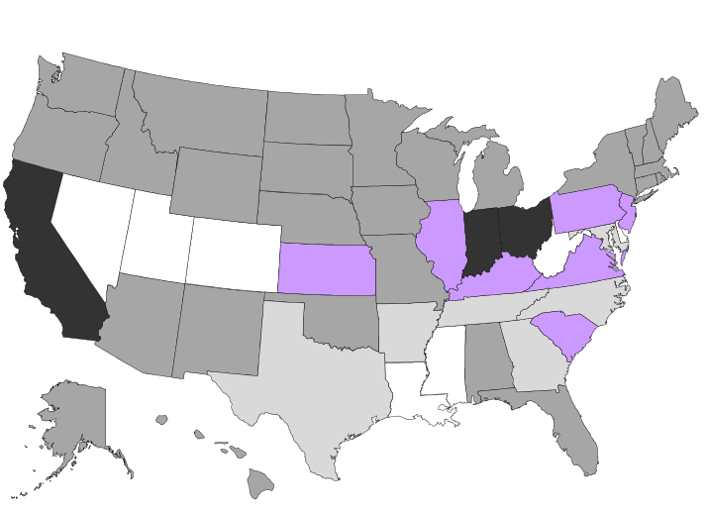
Needs Improvement Generally Good N/A Good Excellent

