Workshop: Using Visualization in Teaching Introductory E&M
AAPT National Summer Meeting, Edmonton, Alberta, Canada.
Organizers: John Belcher, Peter Dourmashkin, Carolann Koleci, Sahana Murthy

Electromagnetic Waves Supplementary Materials

Visualizations

You can find more visualizations at Light Visualizations.

ConcepTests

The following ConcepTests illustrate various aspects of traveling electromagnetic waves. They can be used both in class and on exams.

Wavelength and Wave Number The graph shows a plot of the function 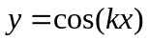.

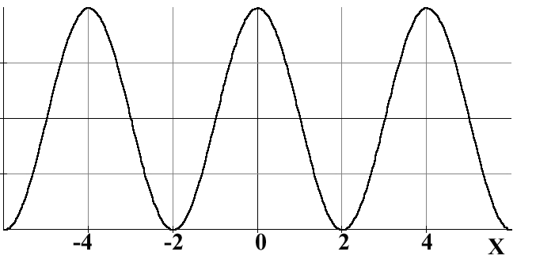
(m)
The value of k is

- 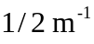
- 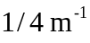
- 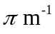
- 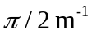
- I don’t know

Answer: 4. 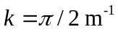. The wavelength (from the figure) is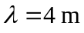l . Therefore 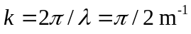 .So the function described by 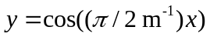 is equal to 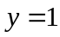 at 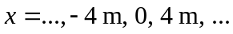

Propagating Plane E&M Wave The figure shows the E (yellow) and B (blue) fields of a plane wave. This wave is propagating in the

- +x direction

- –x direction

- +z direction

- –z direction

- I don’t know

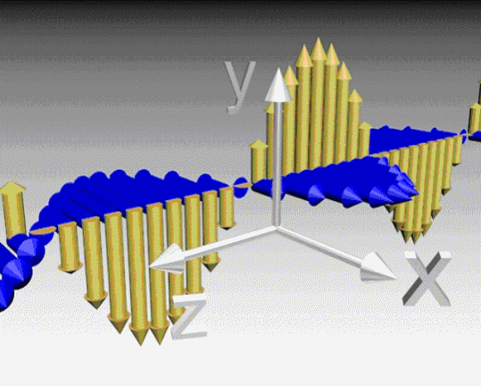

Answer: 4. The wave is moving in the –z direction. The propagation direction is given by the direction of E x B (Yellow x Blue)

Traveling Plane Electromagnetic Wave The B field of a plane EM wave is 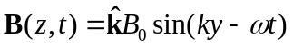. The electric field of this wave is given by

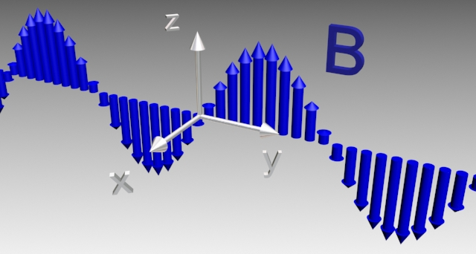

1. 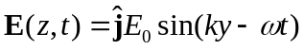
2. 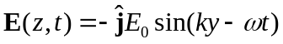
3. 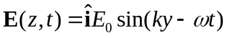
4. 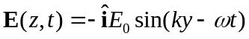
5. I don’t know.

Answer: 4. . From the argument of the 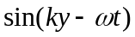, we know the wave propagates in the +y direction. So we have 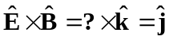 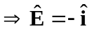.
Plane Waves: Consider a plane wave whose magnetic field is given by

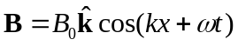.

Which is the corresponding electric field?

- 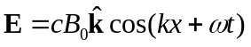.

- 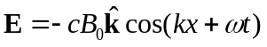.

- 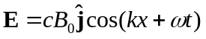.

- 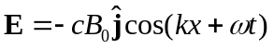.

- 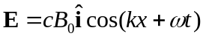.

- 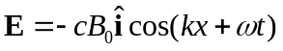.

Answer: 4.
Plane waves:

The magnetic vector of a plane electromagnetic wave is described as follows:
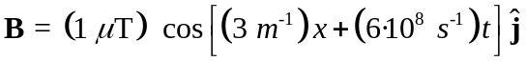
Fill in the blanks:

This wave is traveling in the ___-x_______ direction with speed _____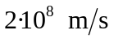____

The associated E field will have amplitude ____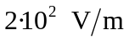_____ along the ___z_____ axis

The way to do this is to pattern match to 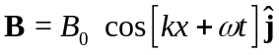. The fact that it is kx tells you it is moving along the x-axis and the + tells you it is moving in the negative direction (as t increases, x decreases to keep the argument constant). The speed is given by 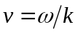. The E-field has magnitude 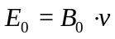 and points along an axis such that the direction of propagation is given by 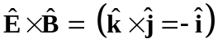.

Generating Plane Waves
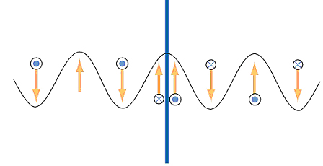
A plane E&M wave is generated by shaking a sheet of positive charge up and down. At the time shown

- The E field is oscillating into and out of the page and the sheet is moving up
2. The E field is oscillating into and out of the page and the sheet is moving down
3. The B field is oscillating into and out of the page and the sheet is moving up

4. The B field is oscillating into and out of the page and the sheet is moving down
5. I don’t know.

Answer: 4.

Presentation Material Problems:

Deriving the Wave Equation

In this question you are going to derive the wave equation – that is, prove that electromagnetic radiation as you have studied it in class is a natural outcome of Maxwell’s equations.

Consider a wave traveling along the x-axis, where the magnetic field is polarized along the z-axis and the electric field along the y-axis.

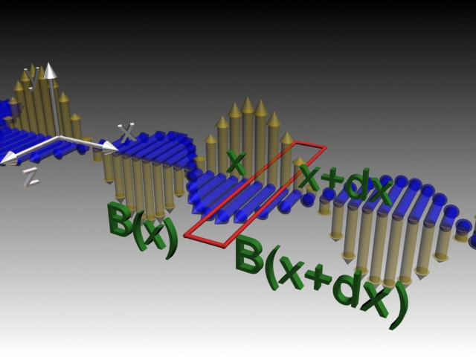
(a) Use the Ampere-Maxwell law (with the
rectangular loop pictured at right) to calculate a
relationship between the spatial derivative of the
magnetic field and the time derivative of the electric field.
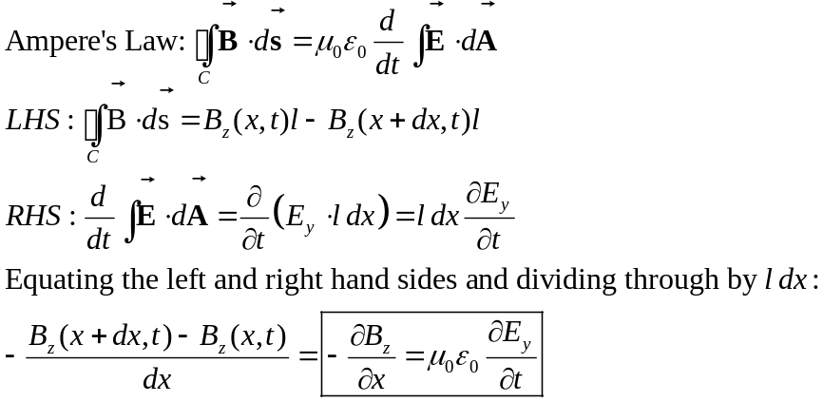

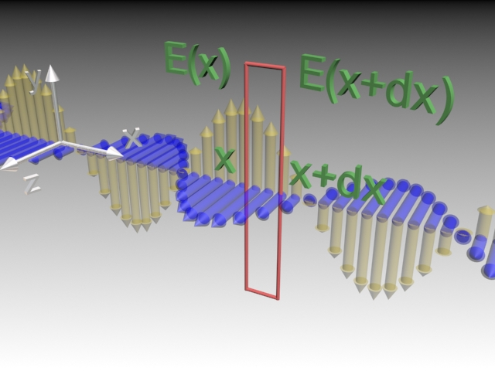

b) Use Faraday’s Law (with the rectangular loop pictured at left) to calculate a relationship between the spatial derivative of the electric field and the time derivative of the magnetic field.
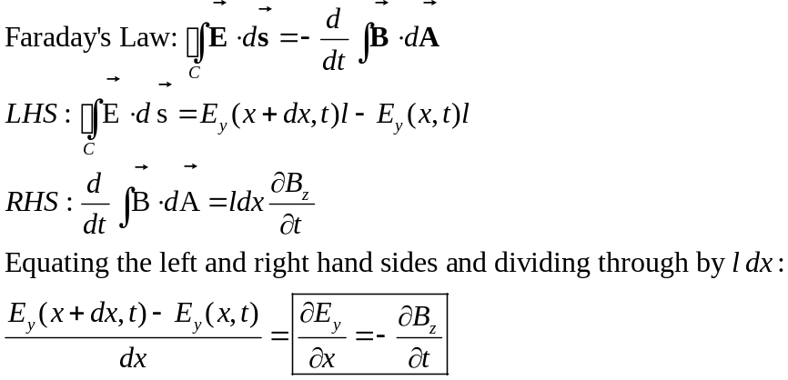

(c) Now you have two partial differential equations, relating spatial derivatives and time derivatives of E and B. Unfortunately they are coupled (that is, E depends on B and B depends on E). To solve these types of equations we need to decouple them – to get an equation that only has E in is, and another that only has B in it.

To do this, take an x-derivative of one of your equations and a time derivative of the other. Since the derivatives commute (that is, taking the space derivative followed by the time derivative is the same as taking the time derivative followed by the space derivative) you will find that you can substitute one equation into the other and get an equation that only has E in it or only has B in it. If you change which equation you do which derivative to you will get the other.

These two new equations are Wave Equations! They are second order differential equations (two spatial derivatives on one side, two time derivatives on the other).

Start with the two equations that we derived in (a) and (b):
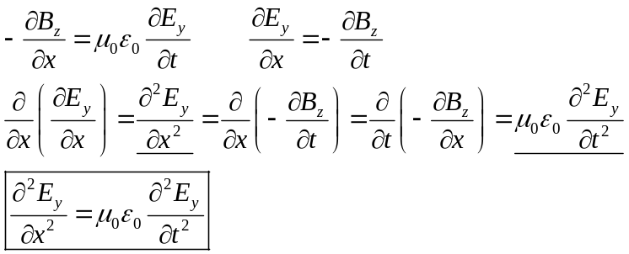
If we instead take the spatial derivative of the first equation we get our wave eqn for B:
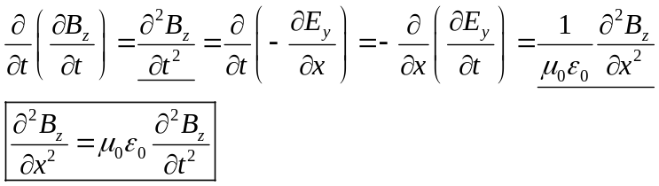
Note that these two equations are essentially “the same” – they only differ in which components of the electric/magnetic fields they show propagating.

(d) Finally, let’s prove that the pictured wave is actually a solution to the equations you just derived. We’ll just do the electric field. Write an equation (looking at the picture) for what E is as a function of time and position. Remember that it is a traveling wave (you should be able to tell from the picture in what direction it is traveling). You don’t know the amplitude, period or wavelength of the wave, just use variables for these, but make sure that your wave equation is satisfied (it should force a well-known relationship between your period and wavelength).
Looking at the electric field, it is a sinusoidal traveling wave polarized along the y-axis and traveling along the +x direction (we know it is +x because the cross product of E and B give you the direction of travel):
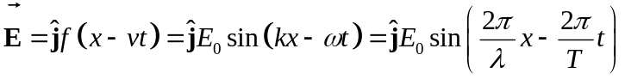
You could use any of these forms (or cosines). The first (with f(x-vt)) is completely generic while the next two assume a sinusoidal variation. Since no indication of the time of the picture was given, the phase (whether it is sin, cos or something in between) is undetermined. Since the question mentioned wavelength and period I’ll use the last form, substituting it into the wave equation for E we derived in (c):
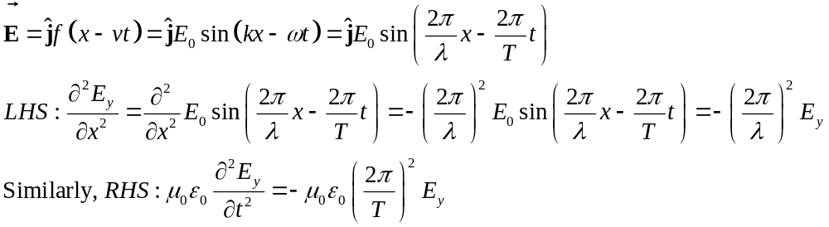
For the equation to be satisfied then we have:
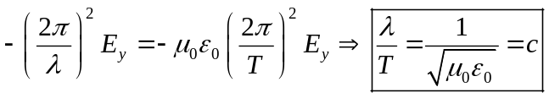
The ratio of wavelength to period is the speed of the wave which is the speed of light.

Electromagnetic Plane Wave

An electromagnetic plane wave is propagating in vacuum has a magnetic field given by

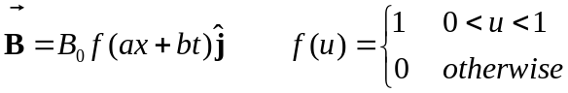

where a and b are positive quantities. The 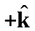 direction is out of the paper.

- What condition between a and b must be met in order for this wave to satisfy Maxwell’s equations?

Differentiating B_{y} with respect to x gives

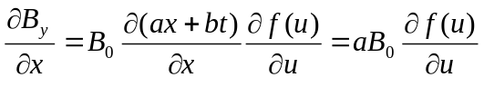
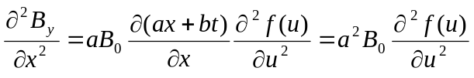

Similarly, differentiating B_{y} with respect to t yields

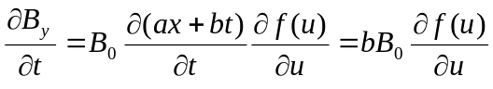
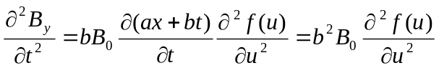

Thus,
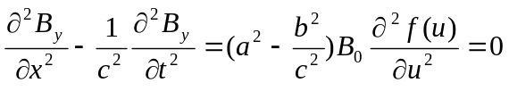
or

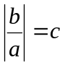
- What is the magnitude and direction of the field of this wave?

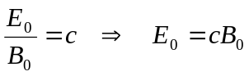

The electromagnetic wave propagates in the −x-direction with the 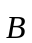 field pointing in the y-direction. Since the direction of propagation is along the direction of the cross product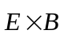, the electric field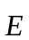 must point in the +z direction (so that 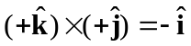).

- What is the magnitude and direction of the energy flux (power per unit area) carried by the incoming wave, in terms of B₀ and universal quantities?

Since 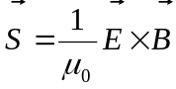 with and in phase, the magnitude of the Poynting vector is

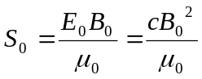

points in the direction of propagation (−x-direction).

- This wave hits a perfectly conducting sheet and is reflected. What is the pressure (force per unit area) that this wave exerts on the sheet while it is impinging on it?

With total reflection, the pressure exerted by the wave on a perfectly conducting sheet is

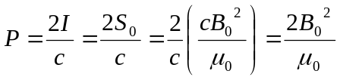

Wave Equation in Differential Form

Consider a plane electromagnetic wave with the electric and magnetic fields given by

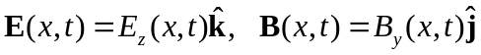

Applying arguments similar to that presented in Section13.4 of the Course Notes, show that the fields satisfy the following relationships:

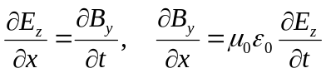

Consider a rectangular loop in the xz plane depicted in the figure below, with a unit normal 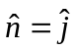.
x
z
y
B_{y}(x)
E_{z}(x)
E_{z}(x+Δx)
Δz
Δx

Using Faraday’s law

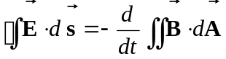

the left-hand-side can be written as

where we have made the expansion

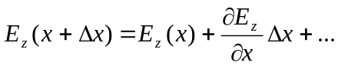

On the other hand, the rate of change of magnetic flux on the right-hand-side is given by

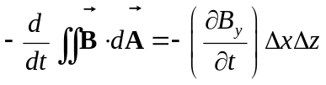

Equating the two expressions and dividing through by the area 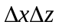 yields

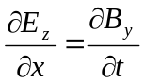

The second condition on the relationship between the electric and magnetic fields may be deduced by using the Ampere-Maxwell equation:

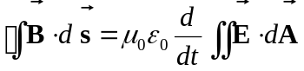

Consider a rectangular loop in the xy plane depicted in the figure below, with a unit normal 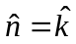.
y

Δx
B_{y}(x)

B_{y}(x+Δx)
E_{z}(x)
Δy

z

x

The line integral of the magnetic field is

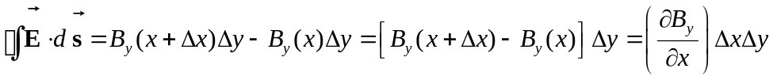

On the other hand, the time derivative of the electric flux is

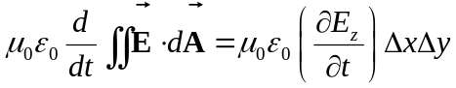

Equating the two equations and dividing by 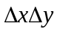, we have

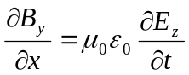

Traditional Analytic Problems:

Electromagnetic Waves The magnetic vector of a plane electromagnetic wave is described as follows:

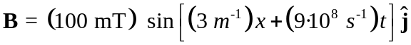

(a) What is the wavelength λ of the wave?

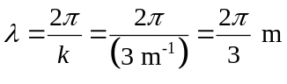

(b) What is the velocity of the wave?

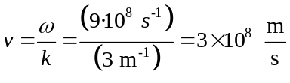

(c) Write an expression for the time & position dependent electric field of the wave.

(d) Show that for any point in this wave, the density of the energy in the electric field equals the density of the energy in the magnetic field.

It is easy to show this generically, recalling the relationship between the magnitude of the electric field and the magnetic field, and the value of the speed of light:

They are equal!

(e) What is the time-averaged total (electric plus magnetic) energy density u in this wave?

(f) This wave is totally reflected by a thin conducting sheet lying in the y-z plane. What is the resulting time-averaged radiation pressure on the sheet?

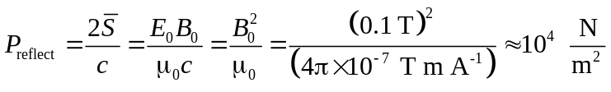

Standing Waves The electric field of an electromagnetic wave is given by the superposition of two waves

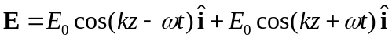.

You may find the following identities useful

.

- What is the associated magnetic field 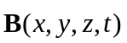?

Solution: The electric field in Eq. is the superposition of two traveling waves, one in the positive -direction and the other in the negative -direction. The amplitude of the associated magnetic field is diminished by a factor of 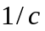. By the right hand rule, the magnetic field associated with the wave traveling in the positive -direction points in the 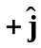 (when the cos factor is positive), and the magnetic field associated with the wave traveling in the negative -direction points in the 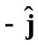 (when the cos factor is positive). Hence the magnetic field is given by

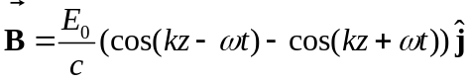

Using the identity in Eq. , Eq. can be rewritten as

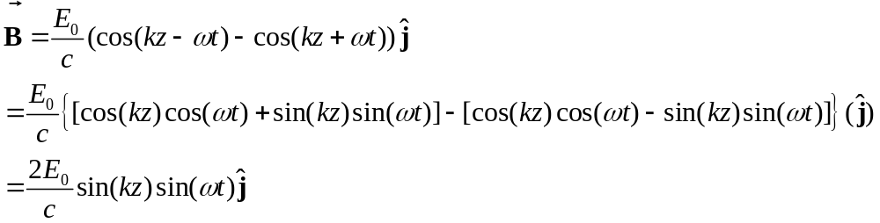

In a similar fashion, using Eq. , the electric field in Eq. can be rewritten as

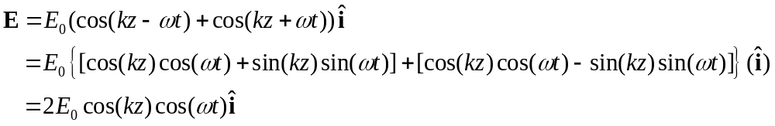

Equivalently, Faraday’s Law in differential form for the plane waves traveling in the 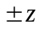-direction is given by

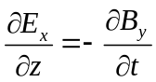

Eq. can be integrated with respect to time to find the electric field

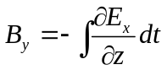.

The partial derivative in the integrand can be calculated using Eq. ,

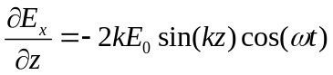.

Substituting Eq. into the integrand in Eq. and integrated yields

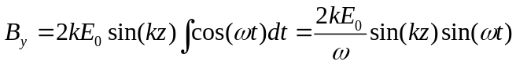.

Finally,
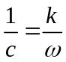.

Substituting Eq. into Eq. yields

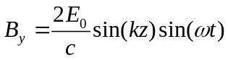,

in agreement with Eq. for the -component of the magnetic field.

- What is the energy per unit area per unit time (the Poynting vector ) transported by this wave?

Solution: The Poynting vector is given by

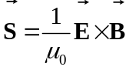.

Substituting Eq. and Eq. into Eq. yields

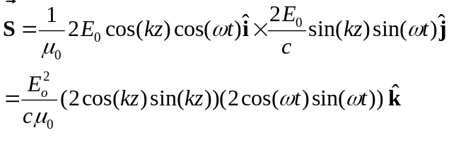.
Recall the identity

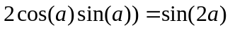.

Use Eq. twice in Eq. yields

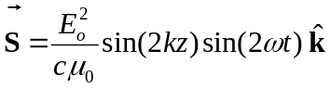.

- What is the time average of the Poynting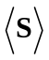 vector? Explain your answer, (note: you may be surprised by your answer, but try to explain it). Recall that the time average of the Poynting vector is given by

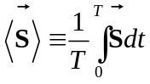.

Solution: Substitute Eq. into Eq. yielding

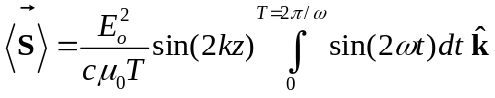.

Integrate Eq. finding

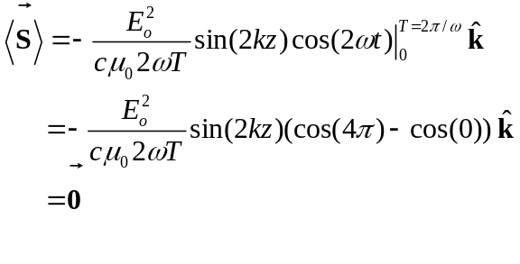.
Since the wave described by Eq. and Eq. is a plane standing wave, the wave is not propagating, therefore there is no time averaged energy transport.

Concept Rich Problems

Solar Observatory. Your project goal is to design a solar observatory that does not have to orbit but rather can just sit still relative to the sun. You decide that you want the observatory to be a solar sail ship such that the the gravitation force on the ship will balance a force that arises from radiation pressure on a perfectly reflective sail of area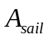. You need to estimate the mass 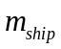 of the observatory to determine the minimum area 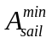 for the sail in order to exactly balance the attractive gravitational force from the sun.

Some possibly useful numbers: 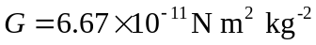, the speed of light is 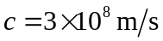. Sail materials have to be very lightweight. Current materials have surface mass densities of about 1 g/m², but proposed materials are projected to have densities as low as 0.05 g/m².The sun has mass 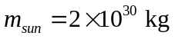 and radius 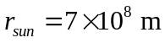. The time averaged radiative power of the sun is 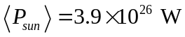 and has a rotation period of about 30 days.

Answer: We shall divide this problem into several questions that will lead us to finding the minimum area for the sail.

- How is the radiation pressure related to the time averaged Poynting vector 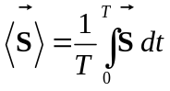 associated with the radiation from the sun?

- How is the radiation pressure related to the radiative force acting on the sail if we assume it is perfectly reflecting?

- What is the minimum area for the sail in order to exactly balance the gravitational attraction from the sun?

- We will then estimate the mass of the ship and determine the area of the sail.
.

The time averaged Poynting vector at the outermost part of Earth’s atmosphere is equal to the time averaged power of the Sun 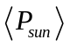 divided by the area of a spherical shell with radius equal to the distance from the Sun.

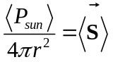.

The radiation pressure for a perfectly reflecting sail is given by

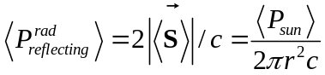
Since pressure is equal to force 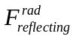 on the sail divided by the area of the sail , the force on the sail due to solar radiation is given by

. 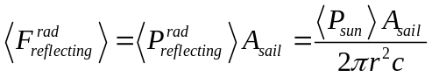

The gravitation force on the ship is
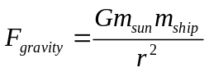

Assume that the radiation force balances the gravitational force,

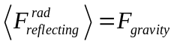.

then
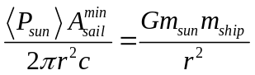.

So we can solve for the minimum sail area

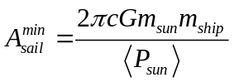.

Note that the ratio

Since this is more dense than the sail material itself, this can work. Let’s break the mass of the observatory into the part the equipment is in (which I’ll estimate has a mass of about 100 tons) and the sail itself, for which I’ll use a pretty realistic mass density of 0.5 g/m².

This corresponds to a sail that is 10⁴ m (10 km) on a side. This is large, but not totally unreasonable. And certainly if I made the payload lighter and used a lighter sail material this number would come down (1 metric ton and 0.05 g/m² leads to a sail less than a km on a side.)

Extra Note: We can easily get power from solar power. We might need 100 kW, but even as far away as the Earth we have 1.4 kW/m², meaning our sail will catch order 10¹¹ Watts! Even if we only absorb a small fraction of this we will still have plenty!

Solve the Energy Crisis Energy is probably the biggest issue facing the world right now (if you are looking for soething important to do, think about this – the very existence of human life may hinge on our solving this problem). In a nutshell, we currently use fossil fuel to generate energy. This creates greenhouse gasses, which lead to global warming.

a) What is the average power the average American uses (averaged over the year)? Include all energy use, not just electricity. What does that work out to for all of America?

There are several ways to think about this, here is one. I figure that personally I use 1-2 kW of electrical energy continuously (this is the equivalent of 10-20 100 Watt light bulbs, which when you add up the computer, lights, dishwasher, etc. seems reasonable). I also figure that I spend about the same amount per month in 4 other categories: gas (rather, my wife does since I take the train, but this is an average), heating my house, food and other expenses (clothing, etc). Clearly these expenses aren’t totally energy expenses and cost does not equal amount, but different types of energy have very similar costs and so I figure I must use around 5-10 kW of energy in total.

According to recent DOE numbers the average per capita energy use is 11 kW, about what I estimated. Since the US population is about 300 million, this corresponds to energy usage of about 3 TW (terawatts).

b) Let’s say that we want to get that all from nuclear power. Assuming that an average nuclear power plant generates 1 GW of power, how many do we need to power the US?

We would need about 3000 nuclear power plants to supply all of our energy. There are currently about 440 plants in the world, about 100 in the united states. So aside from safety and environmental issues, this would be a huge task to build up this many nuclear power plants.

c) If we were to get it from solar energy, how large an area would we need to cover with solar cells? The solar power at the earth is about 1.4 kW/m².

The most efficient solar cells today convert about 25% of incoming power to usable energy. Let’s be optimistic and say that doubles to 50% (this might actually be realistic), but then don’t forget that we only have sunlight about half a day. So 4x3 TW/1.4 kW/m² means we need 10¹⁰ m² which is about two million acres or about 4000 square miles or about three times the area of Rhode Islands (I think Rhode Island prides itself on being a useful unit of measure). This might actually be doable – there are vast tracts of open land in the Midwest that could probably be used pretty effectively.

d) What happens to these numbers if we also want power for China and India to use energy at the same per capita rate?

This is where things get dicey. The current population of China is 1.3 billion and of India is 1.1 billion, meaning that we will need to multiply the above numbers by 9 ((1.3+1.1+0.3)/0.3).

Of course, the current energy usage of these countries is currently much less than the US, with per capita usage about a tenth of ours in China and less than a twentieth in India. If they manage to rise to the US energy “standard of living,” which China has publicly stated as a goal, then we are in for some serious problems.

e) What will we need 30 years from now assuming current population growth rates?

The US has the highest fertility rate of the industrial world at about 2.1 births per woman. We have moderate immigration numbers of about a million a year. So the projected population in 2035 is about 400 million. The projected population of both India and China will be about 1.5 billion by that time. So this is an increase of another 25%. Compared to the numbers in (d) though, the issue isn’t so much population growth as per capita energy usage.

Amazing Communication Cell phones are pretty cool. So is the deep space network used to communicate with the voyager spacecraft (http://voyager.jpl.nasa.gov/news/profiles_dsn.html), which are currently about 80 AU away (1 AU = 150 million km). Let’s think about both.

a) About how much power does a cell phone use? Think about how often you need to charge your cell phone and how much energy could realistically be stored in it (see for example your work on problem 2)

Typical new cell phones broadcast at about ¼ Watt. Older mobile phones (as well as boosters for cell phones that some people get for their cars) broadcast at 3 W.

b) Assuming that most of the power from the cellphone is used in signal transmission (which is becoming a progressively worse assumption, but use it anyway), and knowing the average size of a cell phone cell (26 km²), what kind of signal strength (power per unit area) is needed at the receiver in order to still “have signal?”

We’ll pretend that the cell is circular (in reality they try to make them hexagonal). That means that you are never further than about 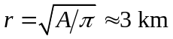from the base station. The signal strength at the base station could then be as weak as

c) Let’s compare that with a radio, to see if its in the same ballpark. FCC regulations prevent broadcasts at powers above 100 kW. How far away from a radio transmitter can you still hear the station? How much power density are you then receiving?

You might be able to hear a station about 200 km away. Beyond 100 miles the curvature of the Earth begins to kill you (FM radio waves go in a straight line and will just go off into space,as opposed to AM and CB radio waves that can bounce off the ionosphere and explain why you can occasionally get good signals from around the globe using those technologies).
So this is a little bigger than what we calculated in (b) but not outrageously out of line, especially considering that line of sight rather than power limitations are probably largely responsible for the loss of signal.

d) What kind of electric fields do these power densities correspond to?

From the Poynting vector:
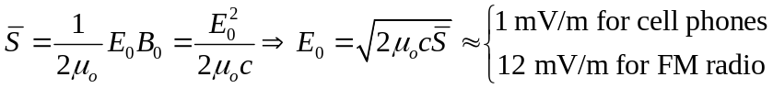

e) The voyager spacecraft have 20 Watt transmitters (3 meter dishes broadcasting at 2.3 GHz). The dishes are aimed at the Earth. How wide an angular dispersion could they have such that there is still enough power at the Earth to receive the signal?

It’s pretty amazing that you can use a 20 Watt transmitter from so far and still get a signal, but they can aim really well. What is the possible angular spread? We don’t want a power per unit area below about 1 nW/m², meaning the 20 W can spread out over 2 x 10¹⁰ m² (a circle of radius about 80 km), meaning an angular dispersion of:
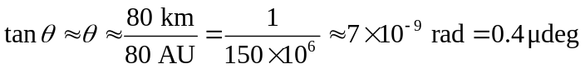
Pretty darn impressive, especially the part about aiming to that accuracy. I would guess that in reality they don’t do that well and instead have a much better receiving antenna, meaning that the signal could be a few orders of magnitude weaker, but I can’t find any info about that to confirm it. I do know, however, that the antenna for sending signals to spacecraft is big (70 m, 20 kW). Kind of sad that they don’t have the power of a good radio station, but the antenna is MUCH more directional.

