MEMBERSHIP FORM

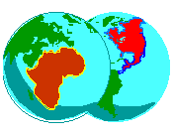BOSTON Pan-African Forum

web-site: www.bpaf.org.

Name _______________________________________________________________

Street Address ________________________________________________________

City _____________________________ State_________ zip _____________

Home Tel (_____) ____________________ Work tel: (____)__________________
Email (we do not share this address) _______________________________________

Active Member dues (# at $25_____ Student/Youth member (# at $15_______

Other contribution ____________
Amount remitted _____________ Check No. ______________ Date ______________

Make check to: BPAF Send to Willard R. Johnson, MIT E53-367 Cambridge, MA 02139
====================================================================

