“The Leavenworth Johnsons” descend from a “Madagascar woman” who had been enslaved in Vicksburg Mississippi as early as the 1850s, by an Irish immigrant butcher-shop owner, Joseph Butler, who was married to Catherine, and had sons named Joseph and Henry. The Madagascan is thought (@ Aunt Ethel, who told Willard Jr. this history while on her own death-bed) to have married someone named James Grimes, whom Ethel had heard perhaps was a Native American. They had a daughter “Betty” (short for Elizabeth), sometimes called “Banny,” that Ethel thought was because she was so short, like a “Bantam.” Many Madagascans were very short in stature.
Betty had a son Joseph, and a daughter Carrie (short for Catherine), perhaps sired by a member of the slave-owning Butler family. Ethel thought that relationship may have been amicable, because Betty never attempted to change the names of her two children, that were obvious Butler family names. Ethel had heard that the Butler family had wanted to send these two mixed-race children North, away from strictly segregated Mississippi, for schooling. Betty is thought to have feared that her children were being permanently taken away from her, and so gathered them and all they could carry and slipped away one night, to join what was perhaps one of the famous Mr. “Pap” Singleton’s “Exoduster” ships, and sailed north to Leavenworth Kansas. Betty then lived with a George Johnson, and her children took his family name. Betty later married a Henry Tomes. Years later, Joseph, who married Hattie McClanahan, had many children, including Myrtle, her first-born, who married Carl Russel Hardin, from whom the Hardin family of Michigan and California descend. Joseph and Hattie’s son Willard (Sr.) married Dorothy Stovall (of Humboldt, KS) from whom one branch of the Pasadena Johnsons descend. Carrie also lived with a Johnson, and had a son James, who was raised by his grandmother Betty, after Carrie left Kansas for as yet unknown parts. James married Florence White, from whom Edward Johnson and his Pasadena family descend.
The Hardin descendants have teamed with some of Edward Johnson descendants to self-published an interesting photo book of “The Leavenworth Johnsons,” from which the following photographs are copied.
Book cover 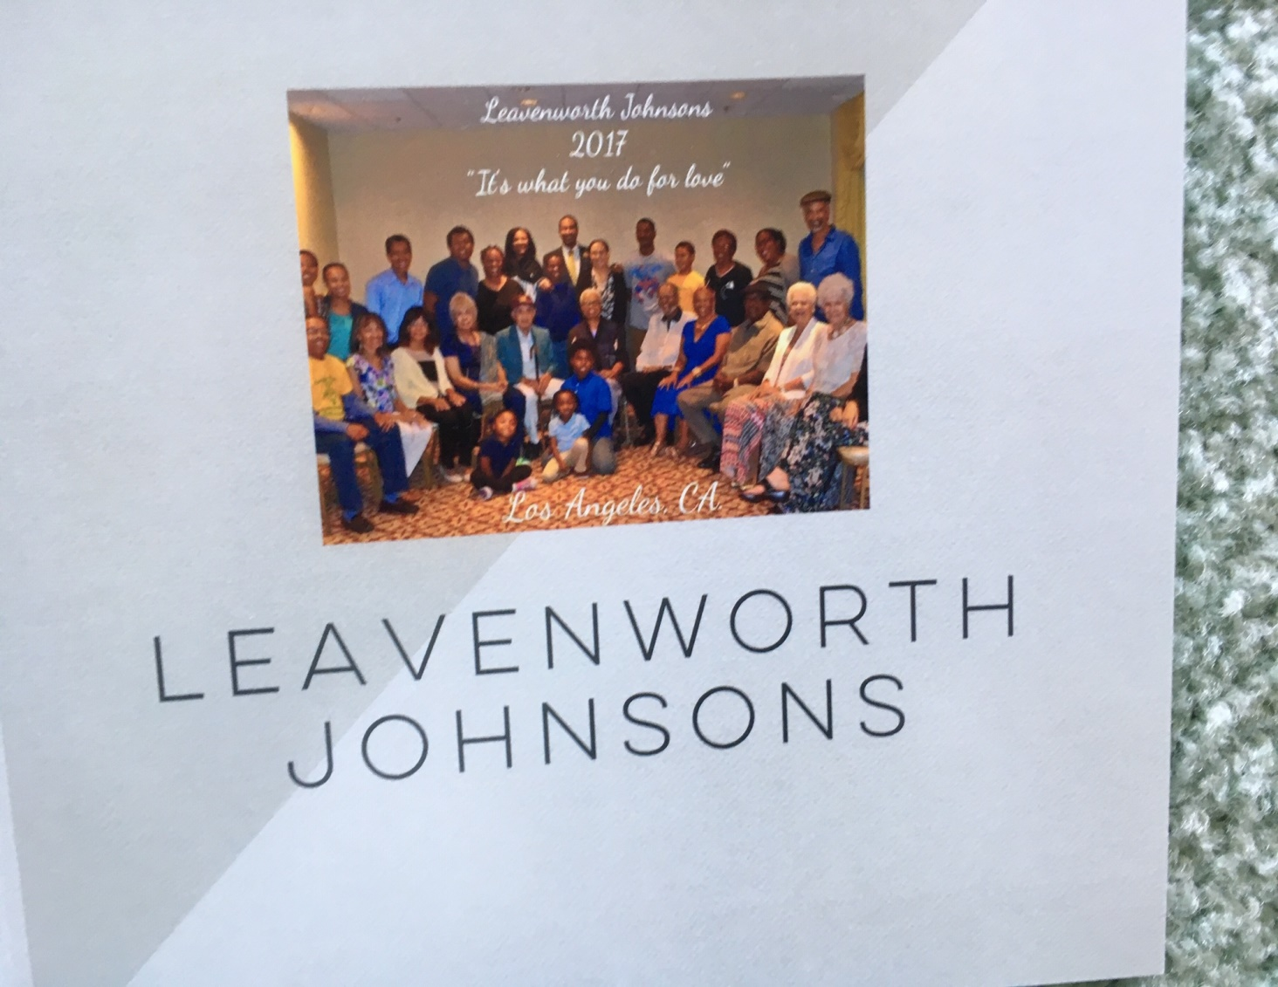
Edward Johnson’s family (photos of the rest and other branches of the family follow below) 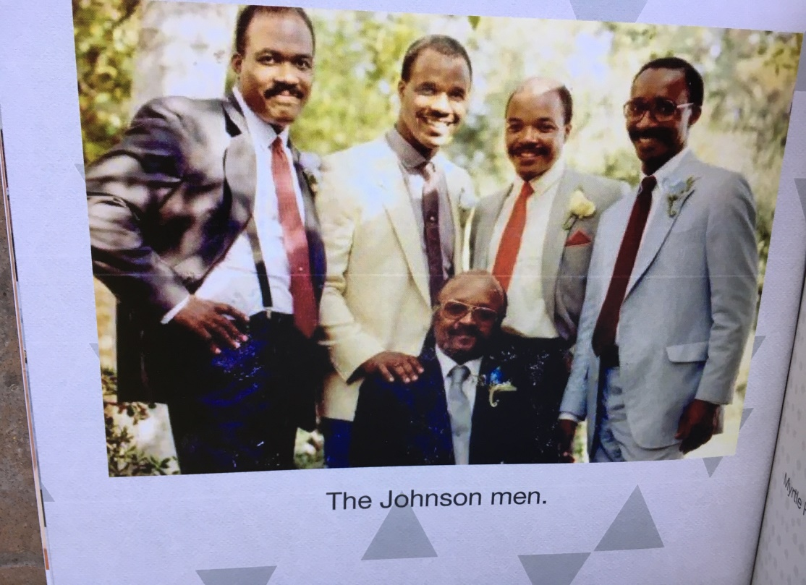

other family members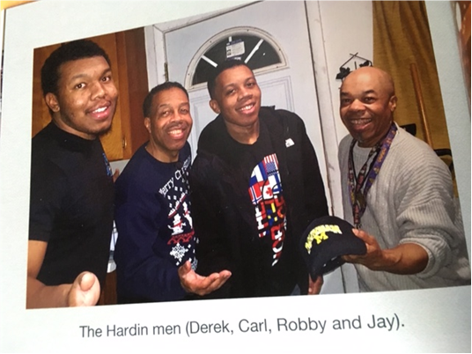

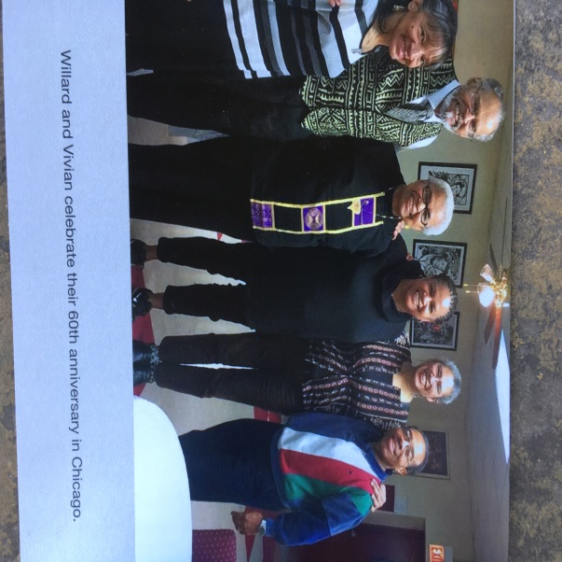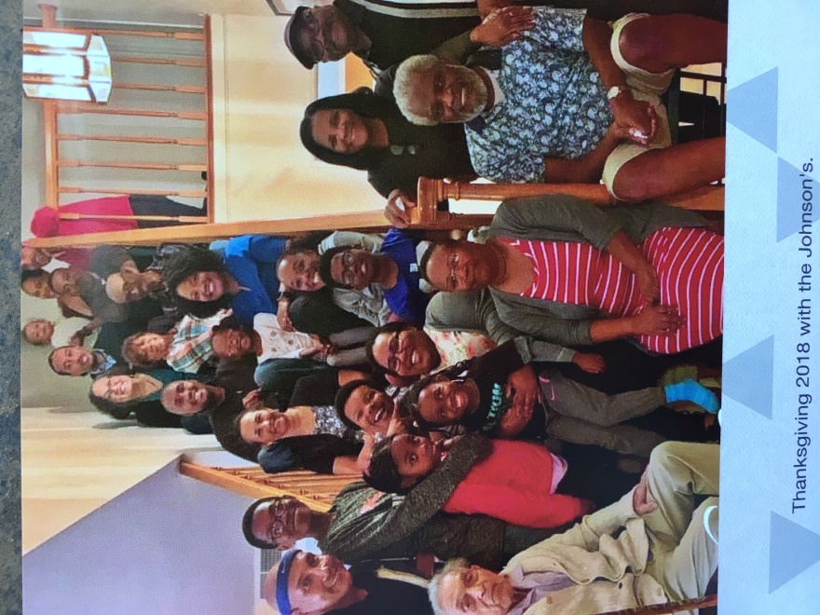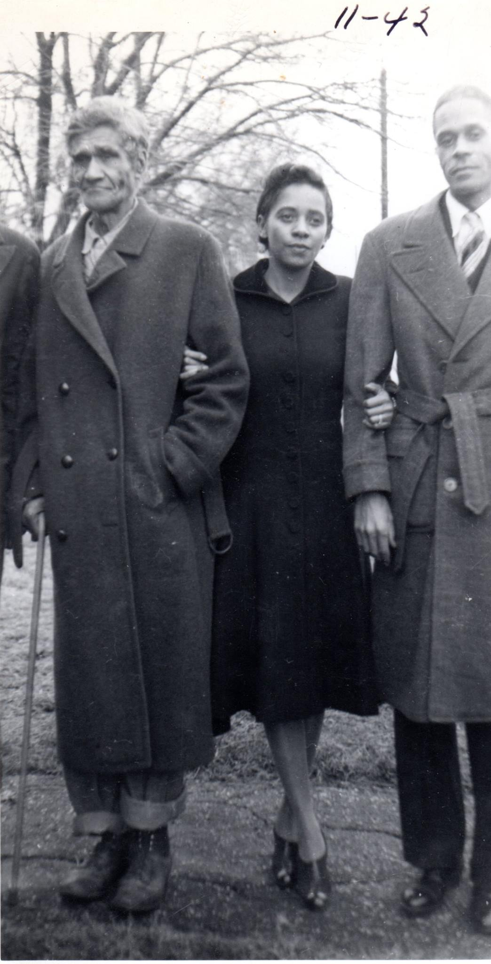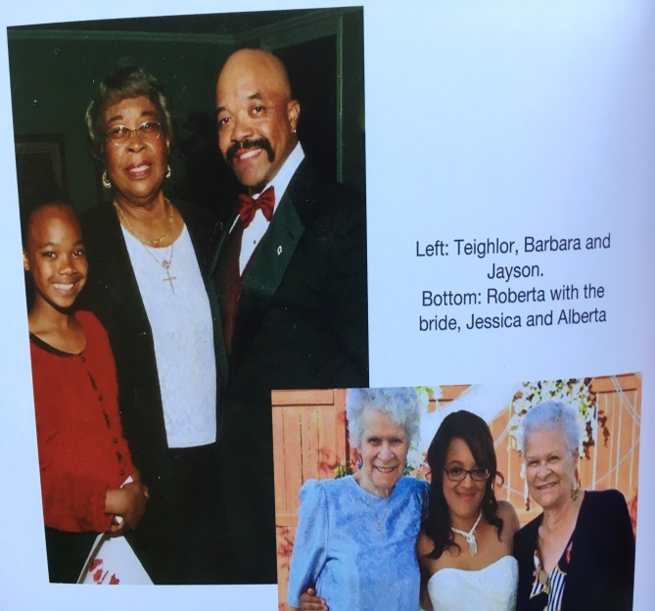
Joseph Sr., Fay Alberta and Willard Sr. (November, 1942) and members of the two Johnson branches in Pasadena
bel Joseph Sr., Fay Alberta and Willard Sr. (November, 1942)

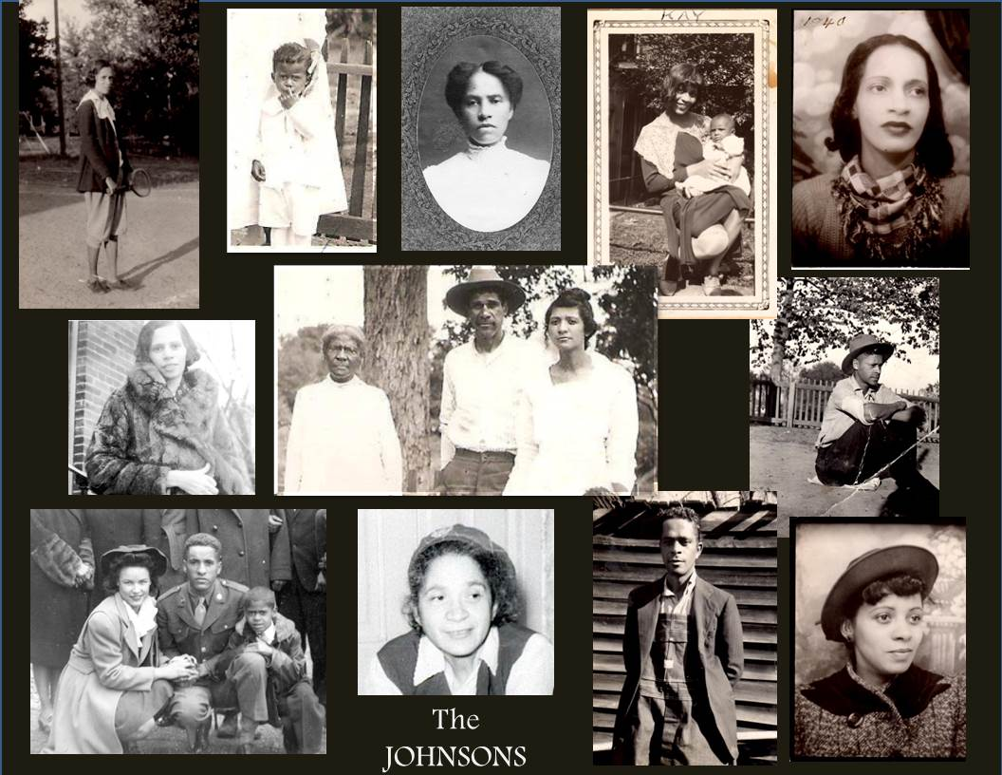
Line #1 l>r: Myrtle Hardin, Elmer White (son of Ethel Johnson), Hattie McClanahan, Carrie (Kay) Jacobs and Quincy, Nellie Bibbie.
Line #2 l>r: Hattie Williams, Elizabeth (“Betty,” daughter of Madagascar woman), son Joseph and his daughter Ethel, Willard Johnson sr (son of Joseph and Hattie)
line #3 l>r: June + Alfred Johnson, with Willard (Jr); Ethel (Johnson) Cherry , Joseph Johnson Jr. “Blue” brother of Willard Sr., Fay Alberta Maynard
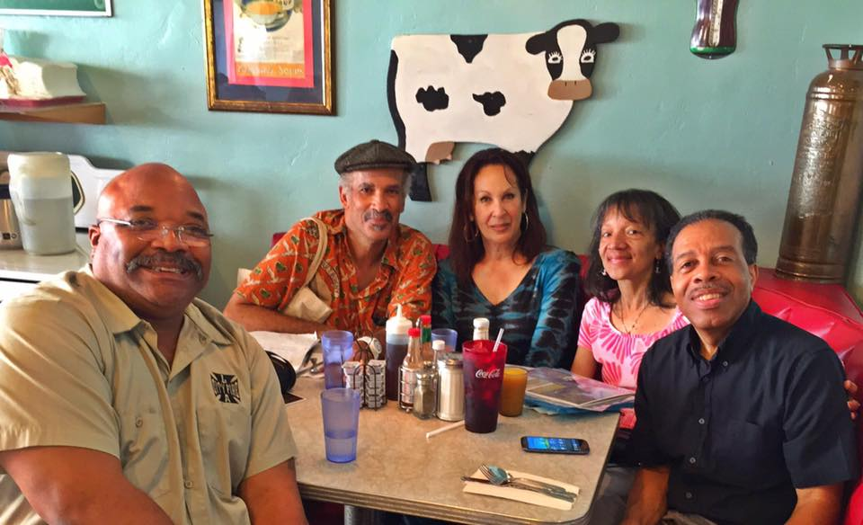
Jayson, Alfred Jr., Linda, Lana and Carl

Below, the many of the family members who have served in the US Armed Services
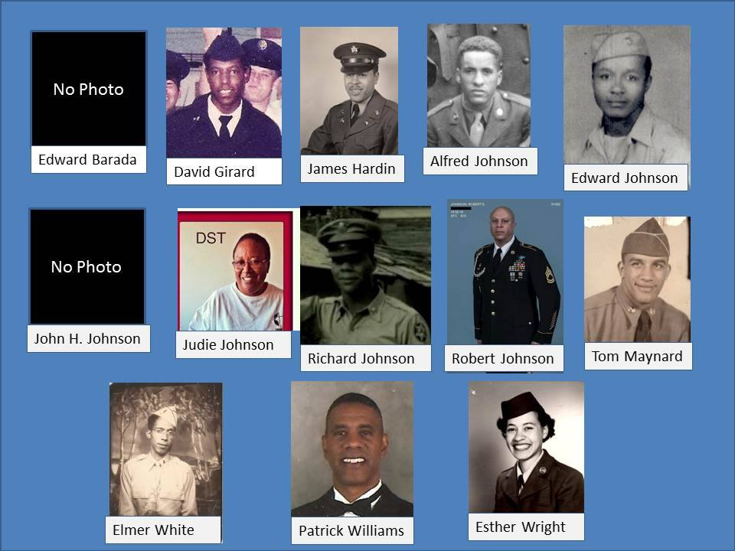
And, an all too-infrequent general family gathering
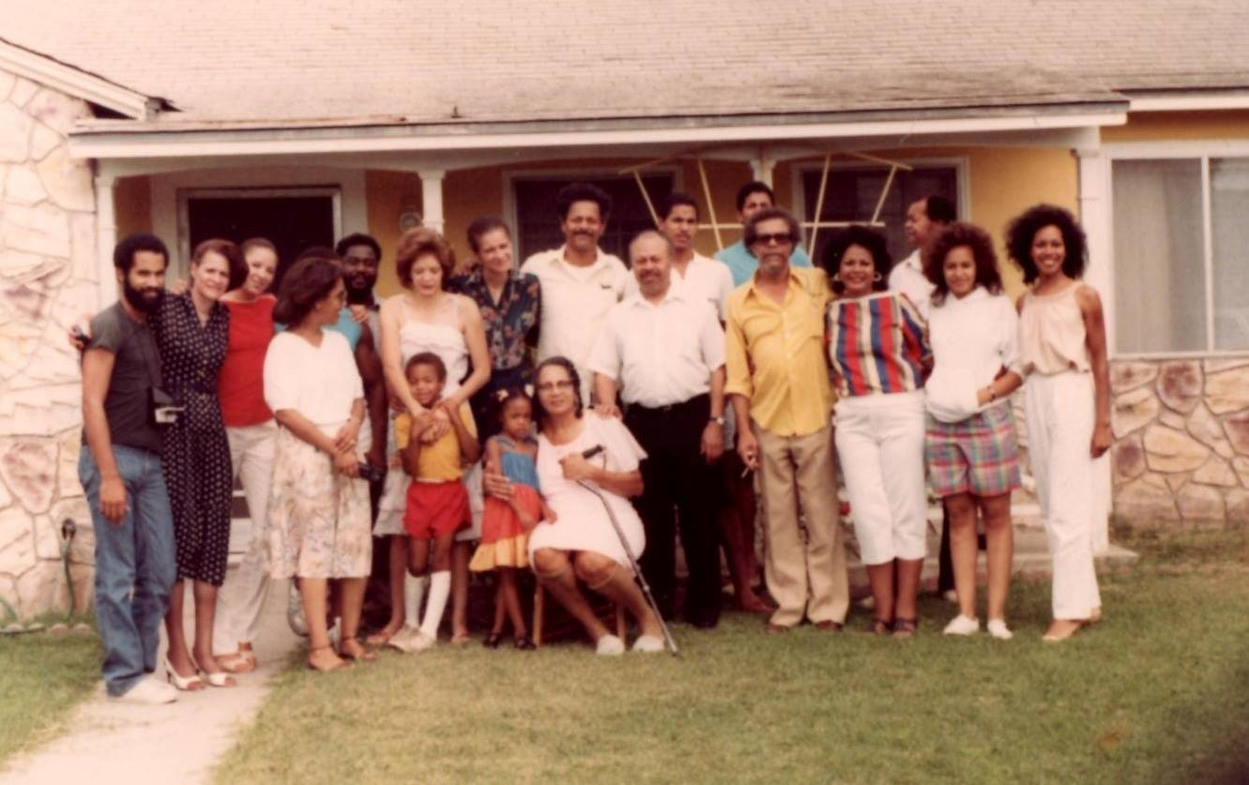
1983 family reunion at Nellie Bibbie’s home.
[Anyone interested to purchase the book from which these photos are taken, contact the KIAANAFH at the address for our President, listed on this website. If available, they will cost $24., and $2.75 for shipping]

