Bread Equipment
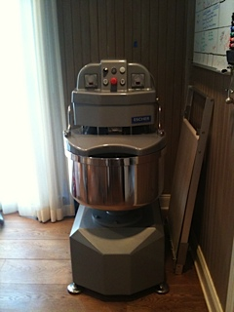
Mixer
1. Escher Fixed Bowl Spiral Mixer, M40P
Dimensions: 42” x 23” x 54” (depth x width x height)
Weight: 805 lbs
Electrical: 220V, 3 phase, 60 Hz
Starting AMP 117, running AMP 19.5
Motor horse power kw 2.0 (1st speed) to 3.7 (2nd speed)
Bowl motor kw 0.55
Dough capacity: 88 lbs
Other specs: Extra strong motors for American doughs; 2 speeds; Two way bowl rotation; Electronic timers

2. Piccolo 1 Modular Deck Oven
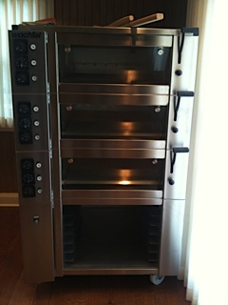
Dimensions: 49” x 39” x 67” (depth x width x height)
Add about 3 ft in depth to account for room needed in front to use long-handled paddle to remove bread
Oven
Weight: 990 lbs
Electrical: 220V, 60 Hz, neutral wire for single phase
Deck Connection Load (incl steam): 4.8 kw, 21.82 Amps
Plumbing: Each oven needs steam hose – kw 3/4'’ and 50mm drain line
Other specs: 3 Decks (ovens), each accommodates one 23”x30” pan or 5-6 loaves
Sits on stainless steel subframe with casters
Stone hearth baking surface
Glass doors
Internal Steam generators
Stainless steel exterior panels
Analog operator controls
Independent temperature controls per deck
Each oven has separate top and bottom heat controls
One canvas loader included

3. Miscellaneous Equipment
Count | Description | Dimension
1 | Workbench (fits six flour bins fit underneath) | 33” x 90”
2 | Wire cooling racks on casters, 5 shelves each | 35” x 18”
2 | Proofing racks on casters, 7 proofing boards each | 21” x 26”
1 | Oven Peel with 3' handle
16 | Bread pans, glazed, 8.5 x 4.5 x 2 3/4
16 | Round baskets, lined, 8 1/4", 1 lb
16 | Round banneton proofing baskets, 7". 1/2 lb
16 | Oval banneton proofing baskets, 1/2 lb
2 | Proofing rack covers, 4 corner zippers, clear
1 | Bench Brush
2 | 2 qt poly square containers with lids
1 | 12 qt poly square container with lid
6 | Scoops for ingred bins, clear, 64 oz cap
6 | Ingredient bin, casters, lids, 2-3/4 cu. Ft.
6 | Sheet pans, HD, 16 gauge Alum 18" x 26"
1 | Giant oven deck bus
1 | Pair leather oven gloves
2 | Baguette lifters
2 | Plastic containers for rising dough + lids
1 | Small rack on casters, with handle

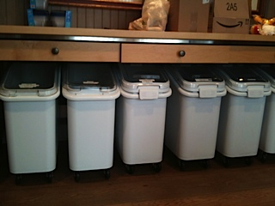
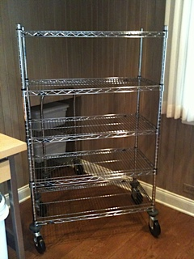
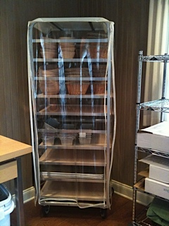
Cooling rack
Work bench and flour bins
Proofing rack

