The Electrostatic Pendulum
For equations I am using MathType 7.8.0.0.

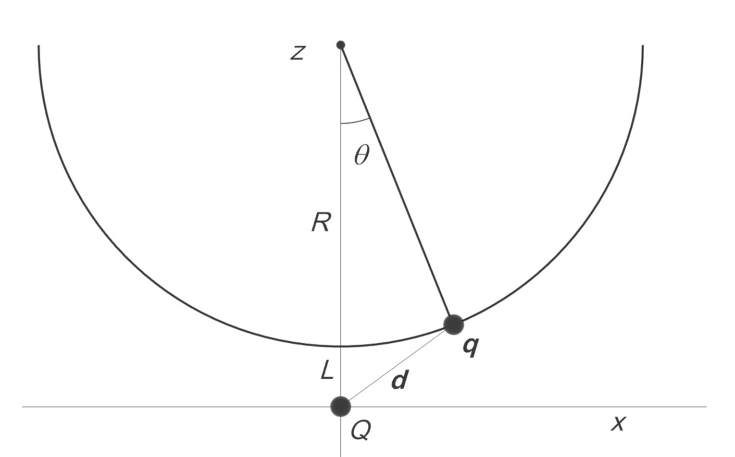
A charge q is located at in the presence of a stationary charge of the same sign Q sitting at the origin. The charge q swings on a pendulum of radius R under gravity. When the charge q is at the bottom its swing it is a distance L just above the charge Q.

The charge q is released at rest from the position . It ends up at rest just above the stationary charge Q.

(a) Use conservation of total energy to determine the ratio q/Q for this to happen, in terms of the parameters of the problem. Write your (dimensionless) answer in terms of the dimensionless ratio and the dimensionless ratio .

Answer:

Solution to (a):

Conservation of energy:

Because it is located on a circle of radius R whose center is at , we must have

So, conservation of energy becomes:
We evaluate the constant at t = 0, when the charge is at with zero velocity:
So we can now rewrite equation (1.4) as
For the velocity to be zero at , we must have therefore

(b) For the purposes of our problem, assume that the height of the support is 25 cm, and the length of the pendulum is 20 cm, so the distance L is 5 cm. The mass of the bob with the swinging magnet is 5 grams. The fixed charge is 0.211 . Using equation 1.10, calculate the value of the ratio q/Q needed to bring the swinging charge to rest just above the fixed charge.
Answer: 1.45
Solution to (b):

