The Magnetostatic Pendulum

Equations use MathType 7.8.0.0.

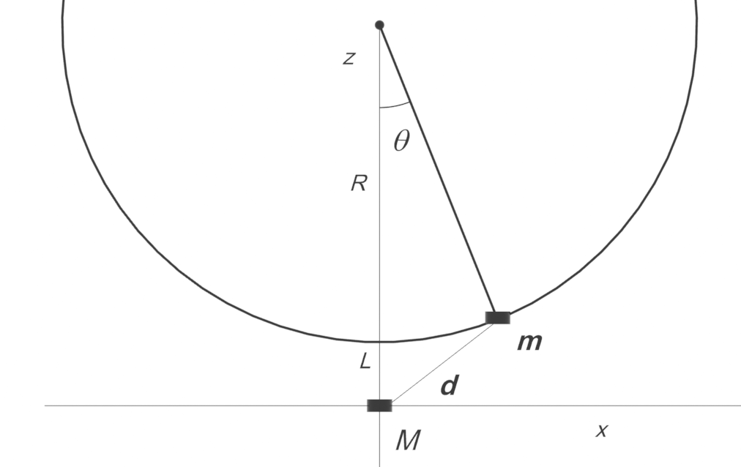
A magnetic dipole with mass is located at in the presence of a stationary magnetic dipole M sitting at the origin. The magnetic dipole moments are vertical and oppositely directed. The magnetic dipole m swings on a pendulum of radius R under gravity. When the magnetic dipole m is at the bottom of its swing it is a distance L just above the magnetic dipole M.

The magnetic dipole m is released at rest from the position . It ends up at rest just above the stationary magnetic dipole M.

(a) Use conservation of total energy to determine the ratio m/M for this to happen, in terms of the parameters of the problem. Write your (dimensionless) answer in terms of the dimensionless ratio and the dimensionless ratio .

Answer:

Solution to (a):

The magnetic field due to the dipole M is

Conservation of energy:

We want to write this in terms of the variable z only. Because the magnetic dipole m is located on a circle of radius R whose center is at , we must have
The conservation of energy becomes:
We evaluate the constant at t = 0, when the magnetic dipole is at with zero velocity:
We can now rewrite equation (1.7) as

For the velocity to be zero at , we have therefore

(b) A “real” magnetic dipole pendulum “toy” is shown in the figure.
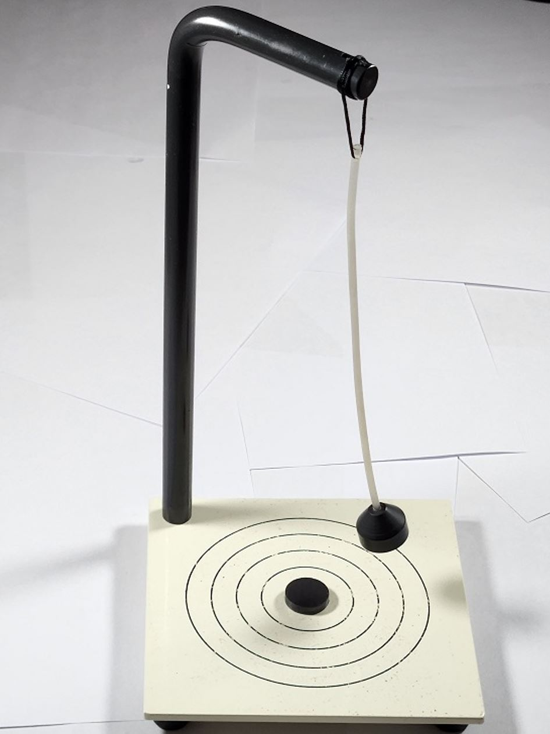
https://www.superteksci.com/product/magnetic-pendulum/
The two magnetic dipoles shown are identical but oppositely directed. The swinging dipole is not vertical, but we will assume it is to simplify mathematics.
For the purposes of our problem, assume that the height of the support in the toy is 25 cm, and the length of the pendulum is 20 cm, so the distance L is 5 cm. The mass of the bob with the swinging magnet is 5 g. The stationary magnet has a dipole moment of 2.24. Using equation 1.14, calculate the value of the magnetic moment of the swinging dipole m that will just bring the pendulum to rest when it is vertical. Remember to convert your units to MKS before calculating.
Answer:
Solution to (b):

